System Design -GPS Motion Tracker

1. Executive Summary:
Python implementation that depicts movement of a GPS sensor from different points across polygons and open 2D plane presenting its current state and shortest distance from the polygons. Plots the traversal as well as information on visual matplotlib 2D plane.
______________________________________________________________________

2. Requirements:

Context:
- A GPS sensor moves in 2D across two disjoint regions (A, B) or outside.
- You get shortest-distance-to-boundary values for each region with get_dist_a() and get_dist_b()
- Task: Run-time classification of region presence: In A, In B, or Outside.
Assignment:
Implement a real-time simulation that demonstrates your algorithm solution by:
- Generating sensor motion in 2D with distances (e.g., parametric path)
- Classifying position over time using get_dist_a() and get_dist_b() that return simulated shortest-distance values (no inputs); the simulation should reflect realistic real-world behavior (hint – movement has avg speed but it’s not constant)
- Showing run-time indication of In A / In B / Outside (no post-processing)
- Region sizes and shapes should be configurable in the code (hint – I don’t count script constants as configurable).
______________________________________________________________________

3. Approach
- Planned to have a disjoint region with configurability.
- Should suffice all possible shapes
  - Circle – need radius
  - Ellipse – need radii
  - Polygon – will cover all shapes with vertices
- Used In built Shapely module to cover all shapes.
- Provide Realistic motion
- Provide real time status updates
- Provide Graphical Visualization using matplotlib
- Provide Configurable Logging
- Generate Baseline code via AI tools and refactored to obtain desired output.
- Tests are pytest based test cases generated via AI tools for verification.

4. Architecture Diagram
Following is the representation of High-Level Design.
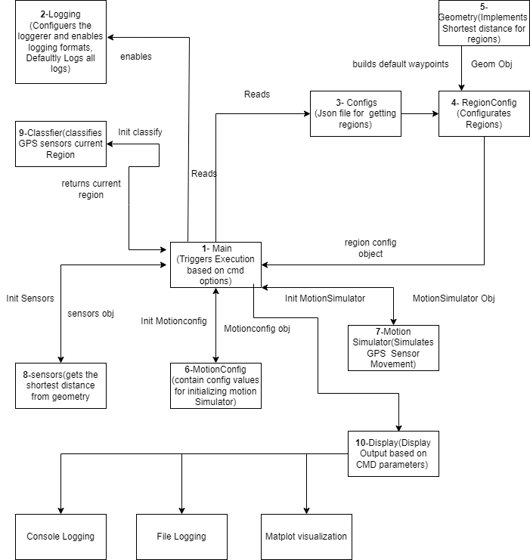
______________________________________________________________________

5. Work Flow
- Execution starts from Main.py (1)
- Configures Logging – Console Logging + File Logging is by default. (2)
- Reads Data from Region config Json Files (3).
- RegionConfig Class is instantiated with value from #3. (4)
- RegionConfig internally Instantiates Geometry Class using its object builds default waypoints (5). RegionConfig exposes multiple functions which get consumed in subsequent modules/classes.
- Instantiates MotionConfig Class and receives back MotionConfig object containing values for creating MotionSimulator Object (6)
- Instantiates MotionSimulator Class passing MotionConfig Object and receives back Motion Simulator Obj (7).
- Instantiates Sensors Module passing Object of #7 and receives back Sensor Object (8) which will run for Total Time duration with tick speed in a loop to get shortest distance to region A and region B and data is passed on to Classifier Object #9.
- Instantiates Classifier and receives back Classifier Object (9), Classifier Object returns Classification of In A/In B /Outside.
- Instantiates Display Object and renders output to desired mode (10) along with writing output to the logfile.
______________________________________________________________________

6. Code Organization Structure
Please find the source organization structure as below
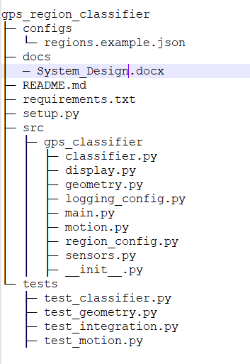

6. File Details- relative to root folder: gps_classfier
- Configs/region.example.json – contains regions specific data.
- Docs/System_Design,docs – contains documentation of the system design.
- Readme.md – Auto Generated mermaid document detailing about installation, options, command line argument details etc…
- Requirements.txt – contains list of pre requisites for module execution.
- Setup.py – contains information for generation install, sdist, bdist modes
- gps_classfier/main.py – contains the trigger point of execution along with other methods
- gps_classfier /logging_config.py: contains methods for configuring console and file logging
- gps_classfier /region_config.py: contains methods for configuring regions with default values of extracting them json file and populating them.
- gps_classfier /geometry.py: contains method for calculating shortest distance from each region.
- gps_classfier /motion.py: contains classes and methods pertaining to motionconfig and motionsimulator
- gps_classfier /sensors.py: contains classes and methods for sensors trajectory and obtaining shortest distance from regions
- gps_classfier /classfier.py: contains classes and methods for displaying the current positional state of the sensor.
- gps_classfier /display.py: contains classes and methods for displaying the content output based on user choice via command line arguments.
- tests/test_classifier.py: pytest module for testing the methods of classifier module
- tests/test_geometry.py: pytest module for testing the methods of geometry module
- tests/test_integration.py: pytest module for testing integrations
- tests/test_geometry.py: pytest module for testing the methods of motion module

