- Please replace the current Dark Mode / Light Mode list option in the mobile menu with a single toggle switch.
- Please add a “Related Courses” section at the bottom of the right sidebar on the course-details-2 page.
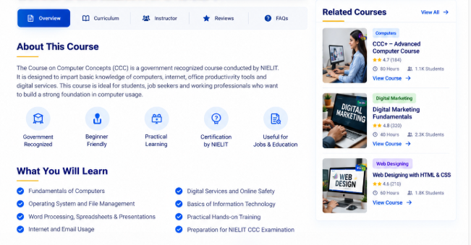

- In the Home-5 page, please add a new “News & Announcements” section.
  - Announcement
  - Important Dates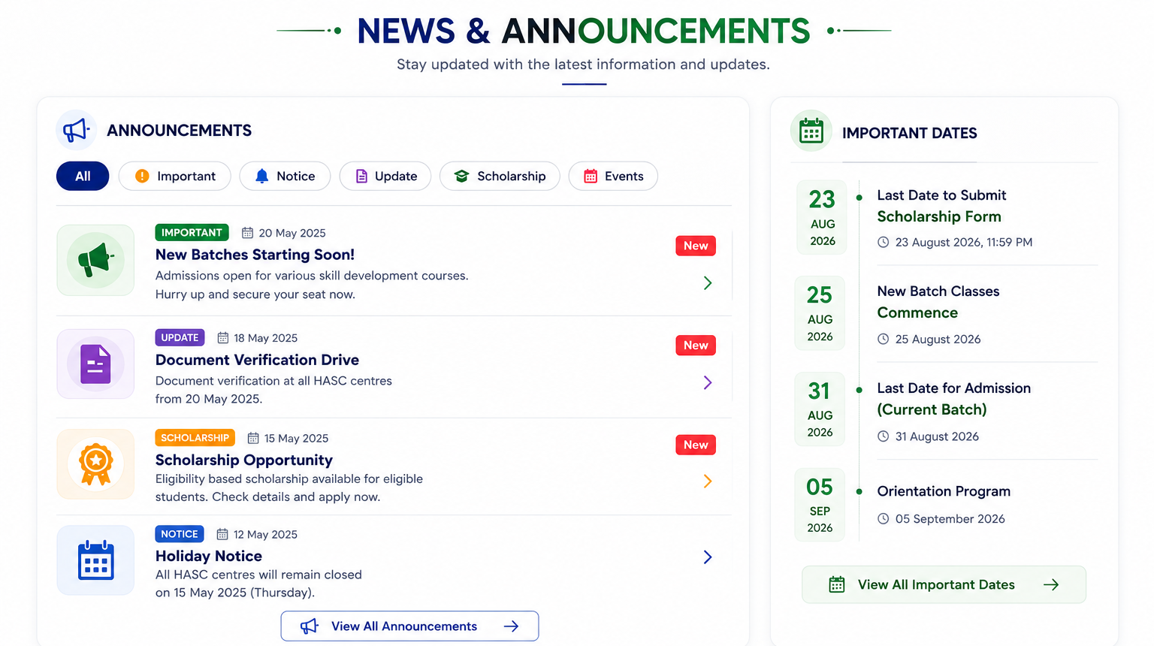

- In the Home-5 page, please add a new “Categories” section.
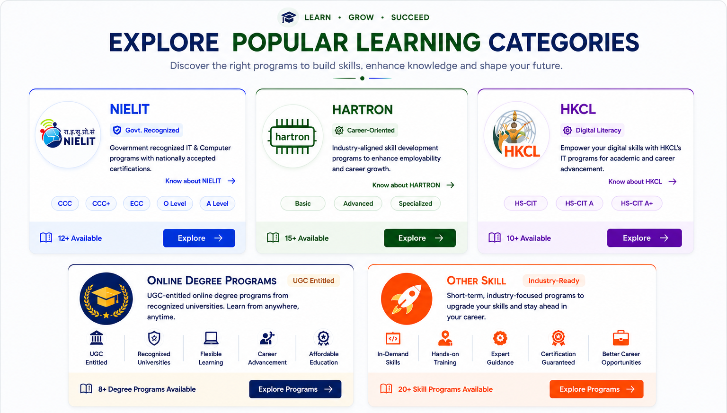

- In the Home-5 page, please add a new “Admission Process” section.
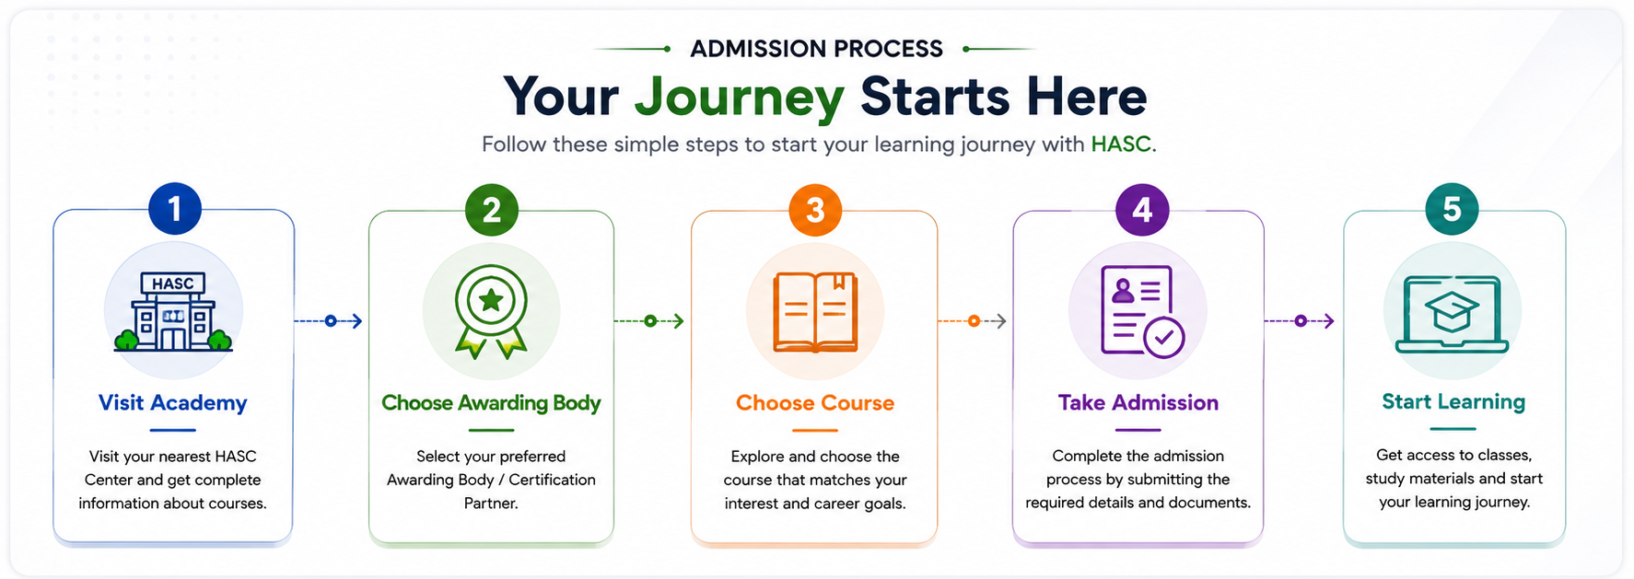
- In the Home-5 page, please add a new “Career Process” section.
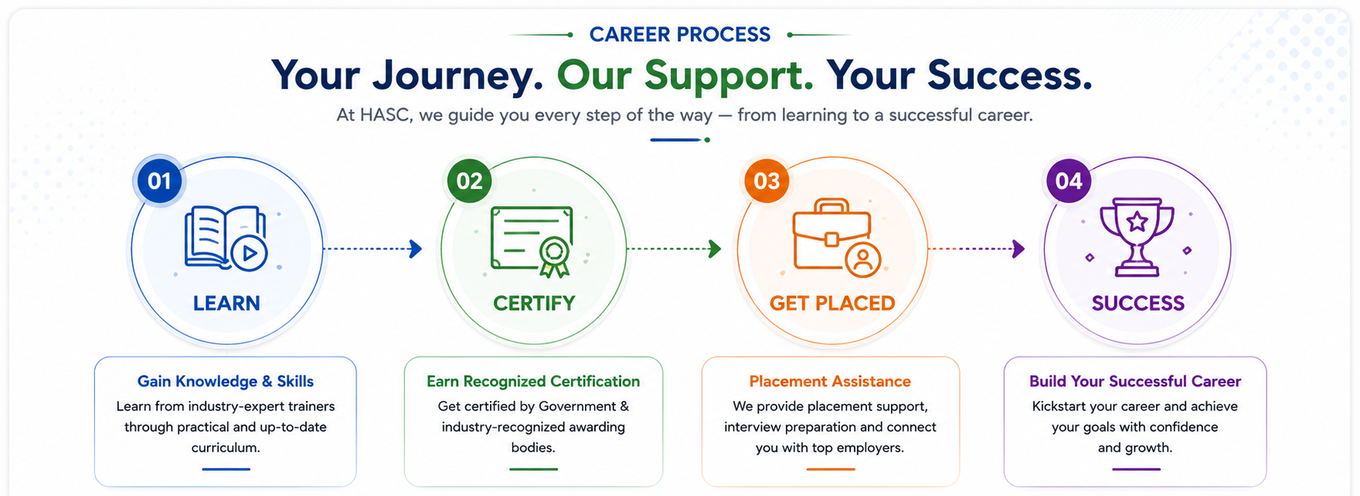

- In the Home-5 page, please add a new “Our Recognitions” section.

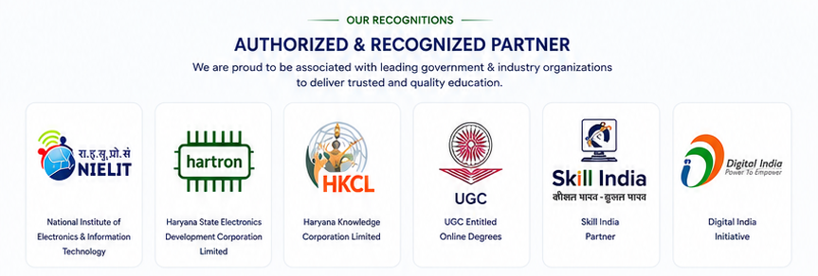

New Page Connect to point 3.2 Important Dates
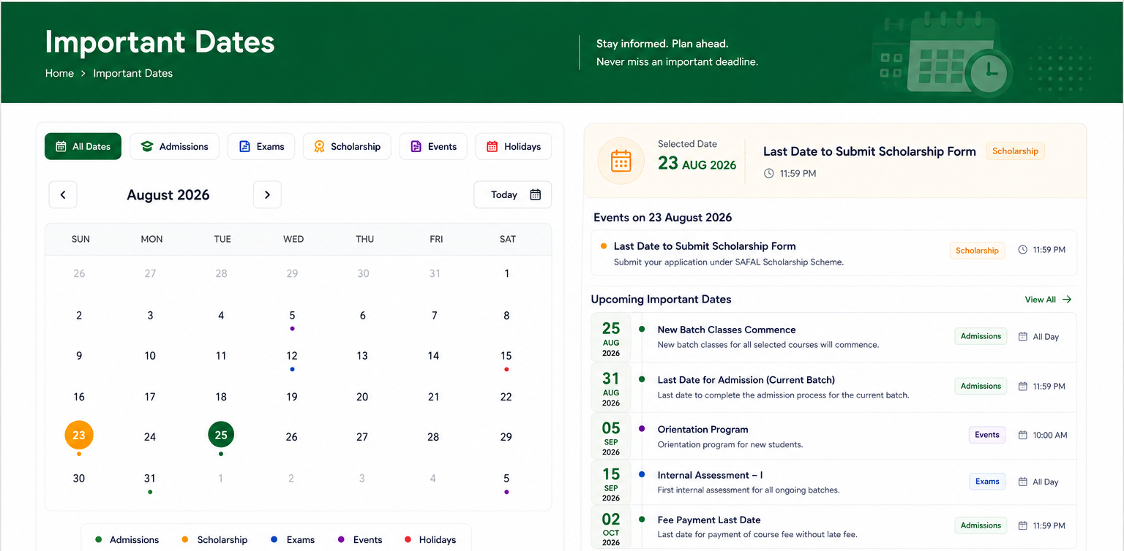

New Page Connect to point 3.1 Announcement
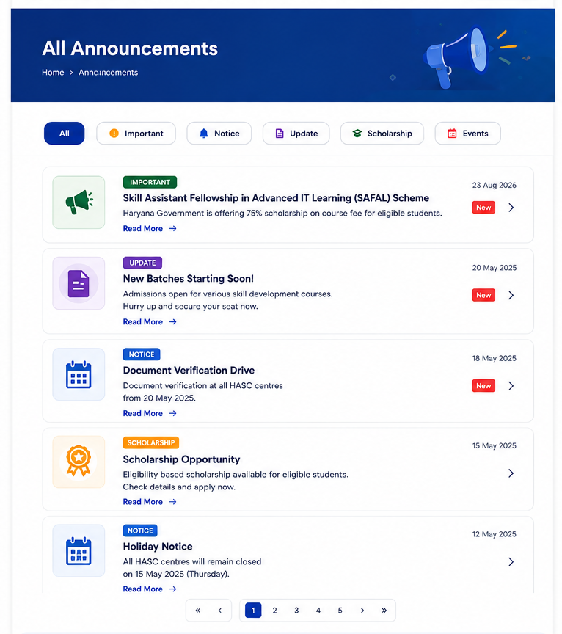
Scheme Page
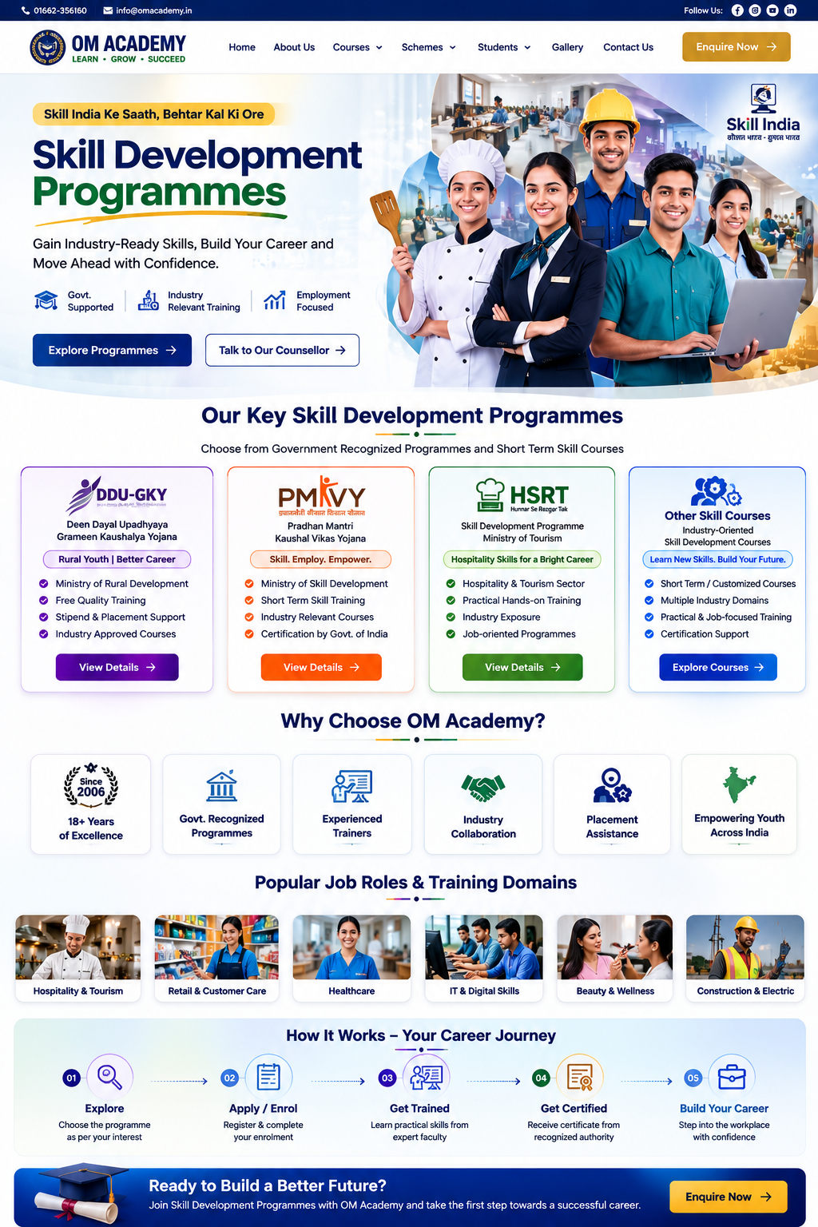
View Scheme Details
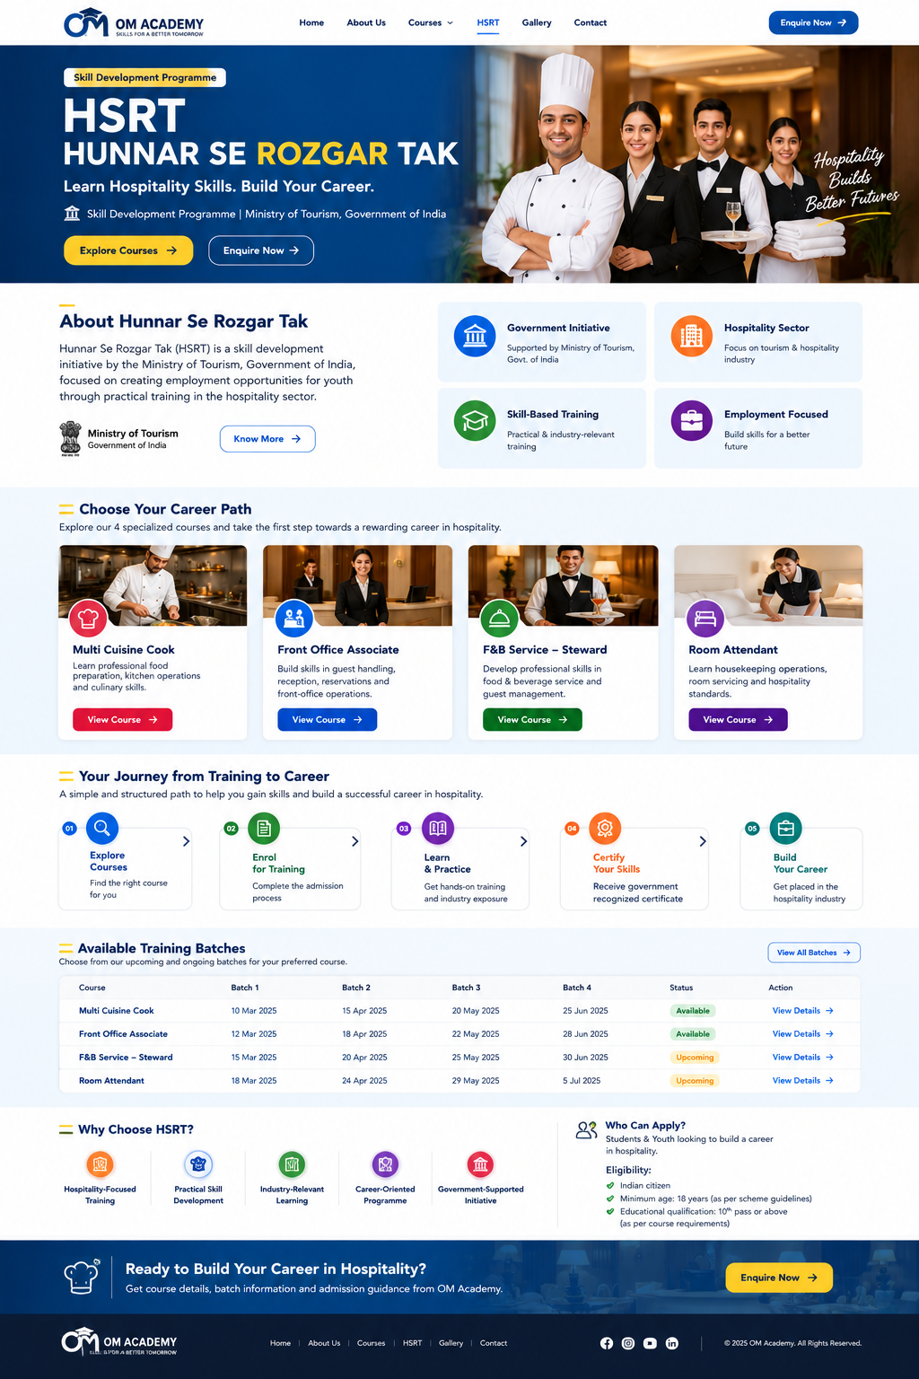
Gallery Page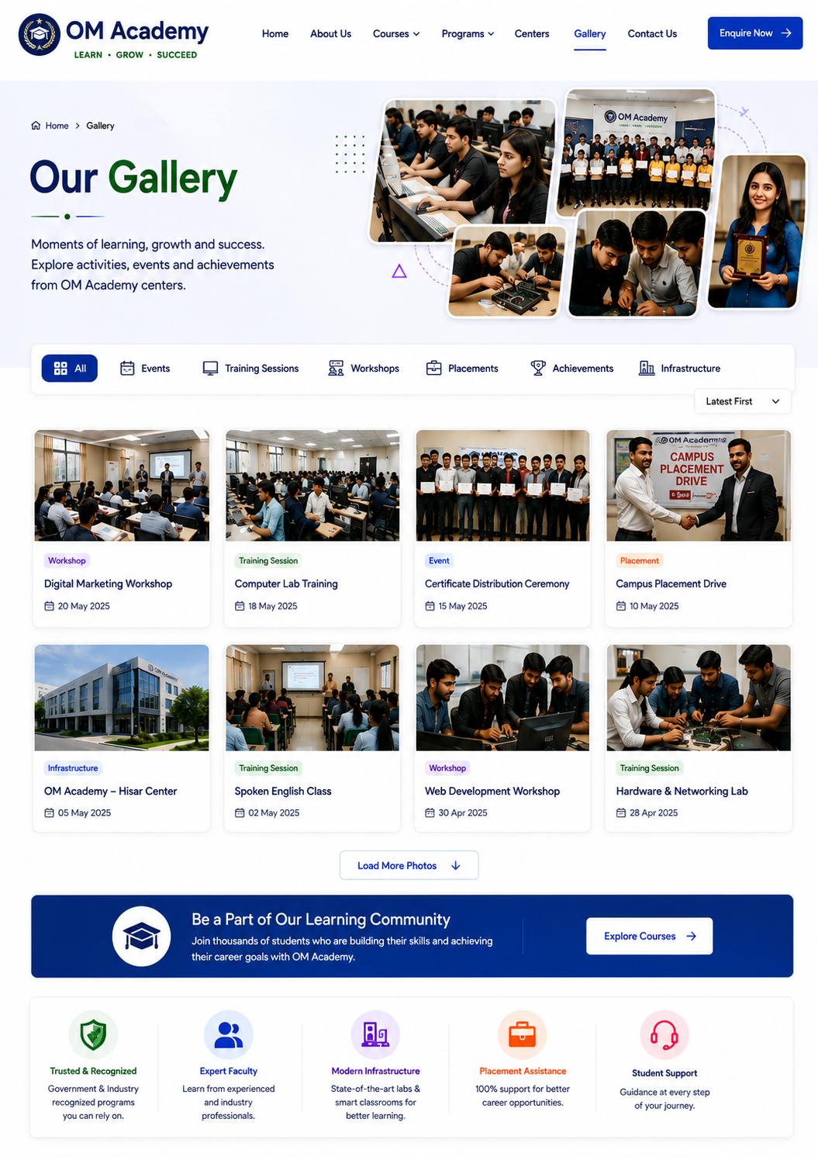
Enquiry Page
