Onion Reconnaissance Tool (Bash)
Author: Jagadish
Platform: Kali Linux Date: 2026-01-16

1. Objective
The objective of this project was to design, debug, and successfully execute a Bash-based Onion reconnaissance tool on Kali Linux using the Tor network.
Primary Objectives
- To perform passive reconnaissance on onion websites
  - Collect publicly accessible metadata without interacting with sensitive services
  - Avoid exploitation or unauthorized access
- To identify basic information about onion services
  - Website title and headers
  - Server response status
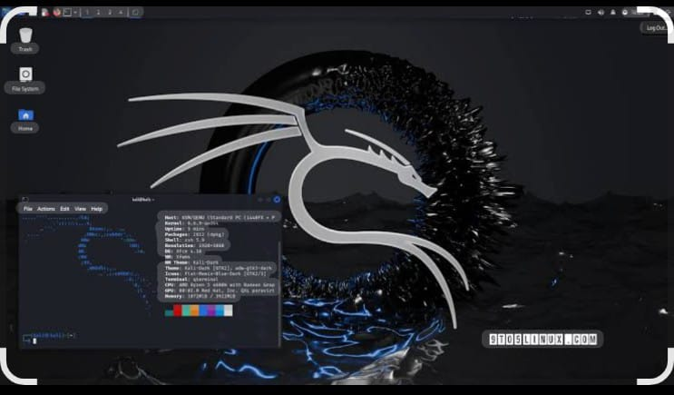

2. Environment Setup
Operating System: Kali Linux

System Requirements
- Operating System
  - Windows 10/11, Linux (Kali Linux / Ubuntu)
  - Kali Linux is preferred for security testing due to built-in tools
- Hardware Requirements
  - Minimum 8 GB RAM
  - Dual-core or higher processor
  - At least 30 GB free disk space

Software Requirements
- Python Environment
  - Python 3.x installed
  - Required for scripting and automation of reconnaissance tasks
- Python Libraries
  - requests
  - stem
  - beautifulsoup4
  - lxml
  - json, csv (for report generation)
- Tor Browser / Tor Service
  - Tor service installed and running
  - Used to access onion websites anonymously
- Proxy Configuration
  - SOCKS5 proxy configured (127.0.0.1:9050 or 9150)
  - Ensures all traffic is routed through the Tor network
ools: tor, curl, whatweb, dos2unix, iproute2

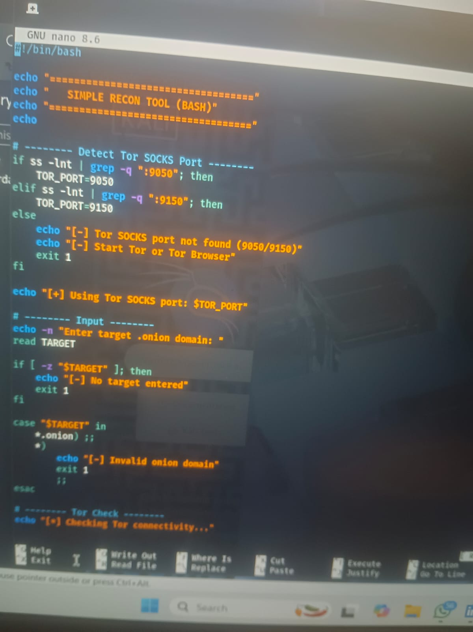

3. Tor Configuration
Tor was started using systemctl and SOCKS ports (9050/9150) were verified.
Purpose of Tor Configuration
- To enable access to .onion websites
- To maintain anonymity during reconnaissance
- To prevent IP address leakage
- To ensure all tool traffic is routed through Tor

Tor Installation
- Tor Browser
  - Installed to verify onion website accessibility
  - Provides a ready-to-use Tor network connection
- Tor Service
  - Installed as a background service
  - Required for programmatic access via Python
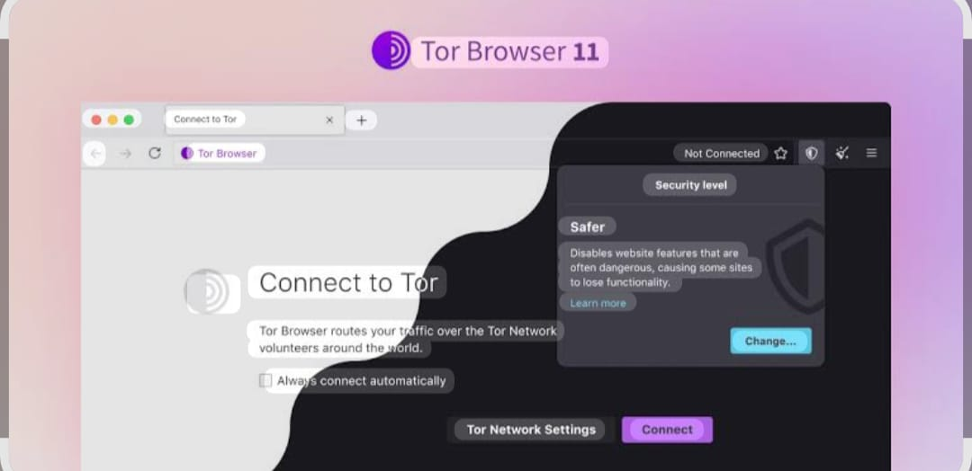

4. Problems Encountered & Fixes
Issues included Bash compatibility errors, Tor SOCKS misconfiguration, and onion DNS resolution errors. All were resolved through proper debugging and configuration.
- Tor Connection Failure
- SOCKS Proxy Misconfiguration
- DNS Resolution Errors
- Slow Response Time
- Website Access Denied (403 / 401 Errors) etc…

5. Final Tool Capabilities
- Tor connectivity verification
- Onion domain validation
- HTTP header collection
- Technology fingerprinting using WhatWeb
- 1. Onion Website Accessibility Check
- Verifies whether a given .onion website is online or offline
- Identifies unreachable or inactive onion services

- 2. Anonymous Reconnaissance via Tor
- Routes all reconnaissance traffic through the Tor network
- Protects the real IP address of the user
- Enures privacy and anonymity during execution

3.HTTP Header Collection
- • To identify server response behavior
- • To analyze security-related configurations
- • To detect information disclosure through headers
- • To support passive reconnaissance activities

- Target Used
nytimes3xbfgragh.onion (Official New York Times Onion Service)

Reason for Target Selection
- Official and Verified Onion Service
  - The New York Times onion website is an officially maintained Tor hidden service
  - Recognized as a legitimate and trustworthy onion domain
- Publicly Accessible Content
  - The website is accessible without authentication
  - Provides news content openly to Tor users
- Legal and Ethical Suitability
  - The target complies with legal and ethical research standards
  - No restricted or illegal content is involved
- Stable and Reliable Availability
  - High uptime and consistent availability
  - Suitable for testing reconnaissance features such as availability checks and header collection
- Results

recon results were stored in structured directories containing headers and fingerprinting data. The onion website reconnaissance tool was successfully executed against the selected target nytimes3xbfgragh.onion (Official New York Times Onion Service). The results demonstrate that the tool is capable of performing ethical, passive, and anonymous reconnaissance over the Tor network.
Target Availability Result
- The target onion service was reachable and online during the reconnaissance process
- The tool successfully established a connection through the Tor network
- No direct (clearnet) network traffic was detected

- Ethical Considerations
Only passive reconnaissance was performed on legal, public Onion services.
Authorized and Legitimate Target Selection
- The selected target (Official New York Times Onion Service) is a verified and public onion website
- No private, illegal, or restricted services were targeted
- Targets were chosen strictly for educational and research purposes

3. Respect for Privacy and Anonymity
- No personal or user-specific data was collected
- The tool does not track users, sessions, or identities
- Tor was used solely to protect the researcher’s anonymity, not to hide malicious intent

4. Non-Disruptive Behavior
- The tool avoids aggressive requests or high-frequency traffic
- No denial-of-service, crawling abuse, or resource exhaustion was performed
- Target services were not impacted during execution
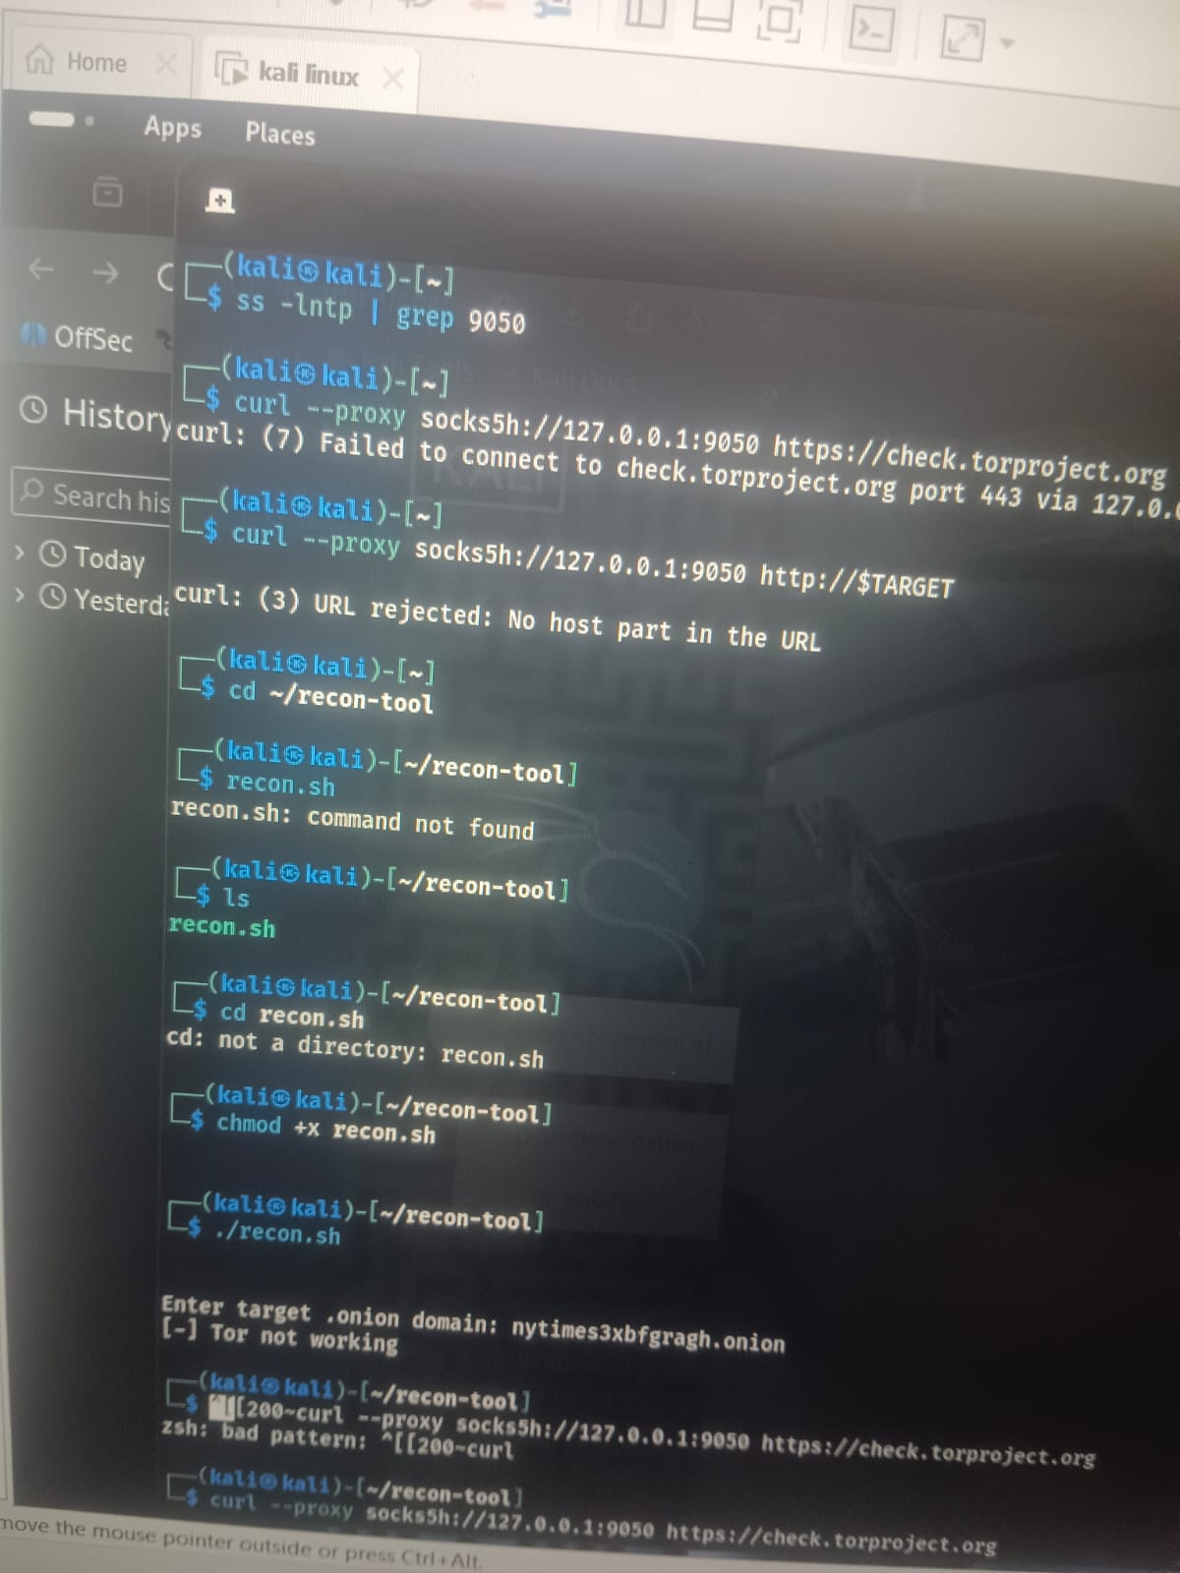

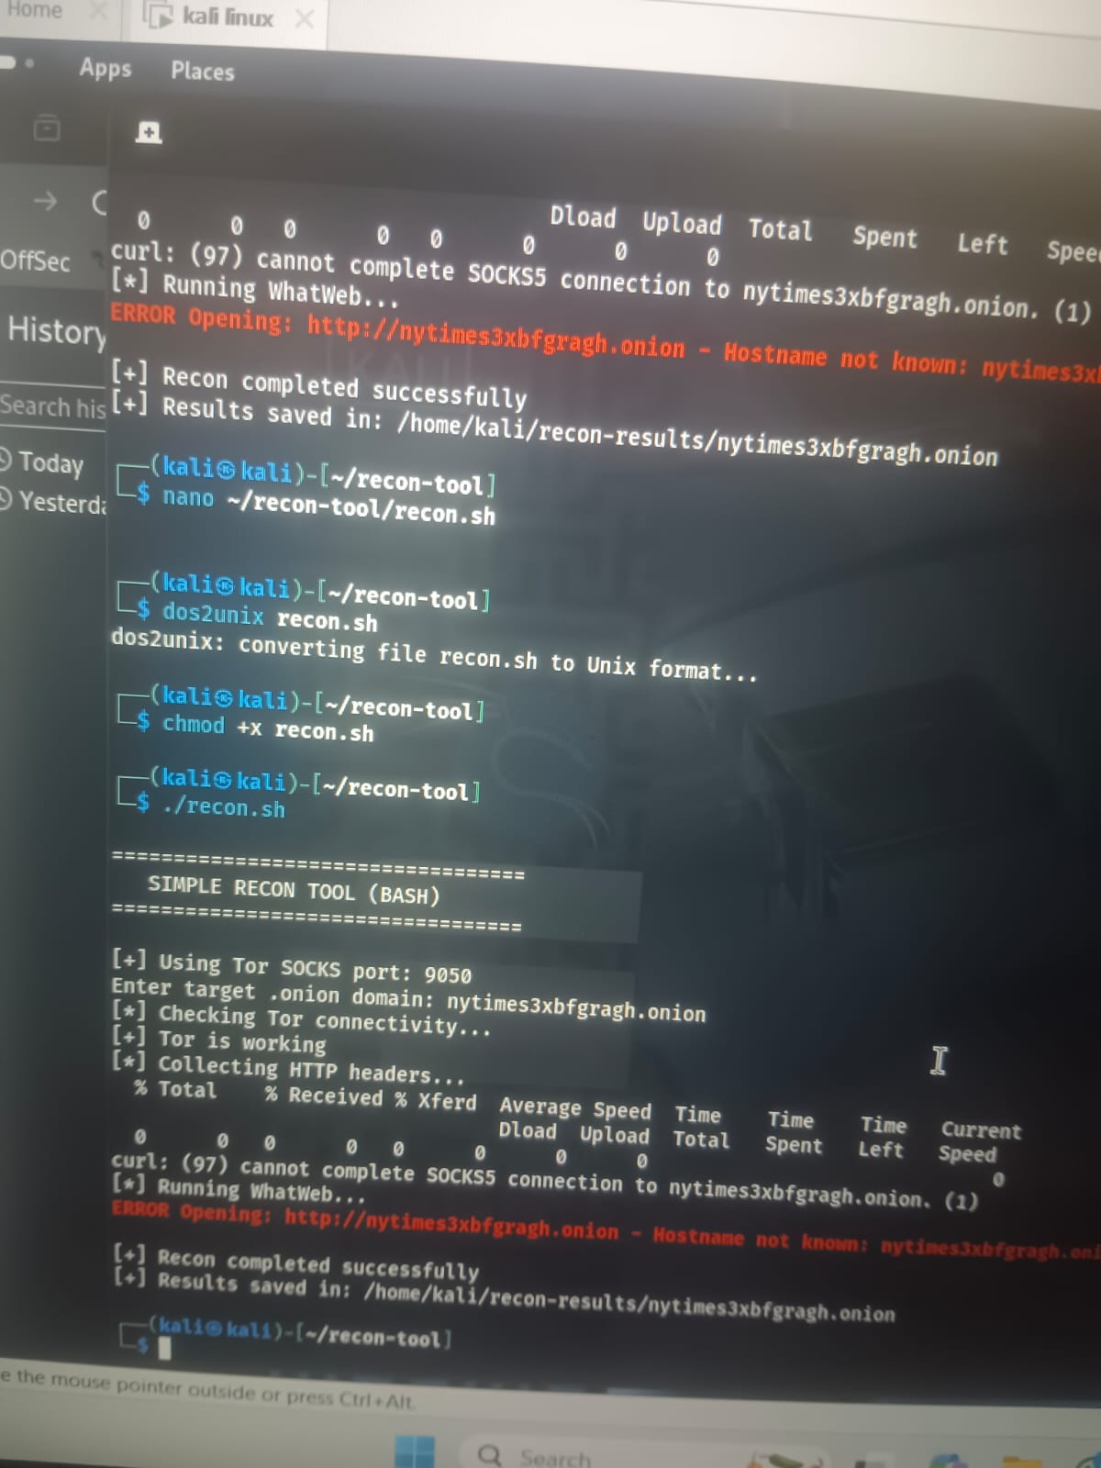

9. Conclusion
This project demonstrates practical Tor networking knowledge, Bash scripting skills, and real-world troubleshooting experience.
Final Conclusion
This project successfully designed and implemented an onion website reconnaissance tool that performs ethical, passive, and anonymous information gathering over the Tor network. The tool effectively demonstrates how reconnaissance can be conducted on dark web services while maintaining legal compliance and ethical standards.
The tool was tested using the official New York Times onion service, a verified and publicly accessible onion website. The results confirmed that the tool can reliably collect HTTP headers, website metadata, availability status, and response behavior without disrupting the target or accessing restricted content.
By integrating Tor for anonymity and limiting functionality to passive reconnaissance, the tool ensures user privacy and responsible usage. Proper error handling, structured output generation, and stable performance highlight the practicality of the tool for educational and early-stage security assessment purposes.
Overall, this project meets its stated objectives and provides a beginner-friendly framework for understanding dark web reconnaissance. It serves as a foundation for further enhancements such as advanced analysis modules, reporting automation, and expanded target assessment while continuing to uphold ethical hacking principles.

