**Stencyl game – basic instructions**

*About this package*

This package contains the necessary template to allow students to construct and modify a basic RPG-shooter game. In addition to a completely operational game file are the ‘cheat-sheets’ (images showing the structure of code blocks), and a complete game file that includes comments outlining basic functionality throughout the different elements of the game. *Ensure you download all files to a location you can find, to ease with extension installation.*

*Interpreting the game’s code*

The file “completeGameComments.stencyl” contains the complete game with commenting added to necessary code sections. The comments are to describe what is happening in the lines following the comment. Additionally, the ‘cheat sheets’ are also provided for students to reference their games against a working template.

*Installing the required extension*

Ensure you have a game open, then click the “Settings” button on the toolbar

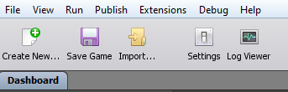

Select “Extensions” on the bottom-left of the pop up window, then “Install Extensions” on the top-right.

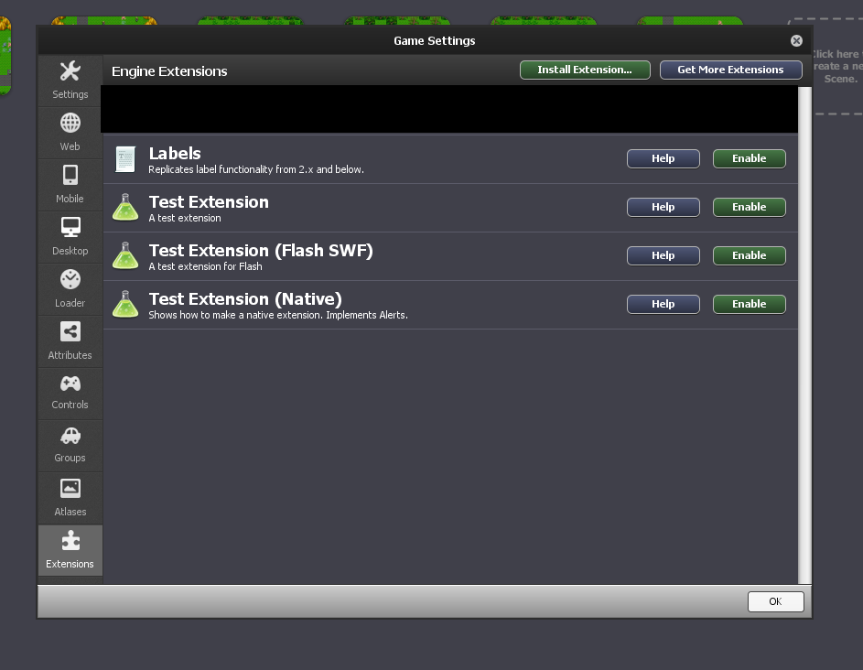

Now navigate to and select “extendedDataLatest.zip” (the “.zip” extension may or may not be visible, depending on your Windows settings).

Click ‘Open’, and the extension labelled “External Data” should now appear in the list. The button to the right of it should read *disable*, indicating that the extension is installed and working.

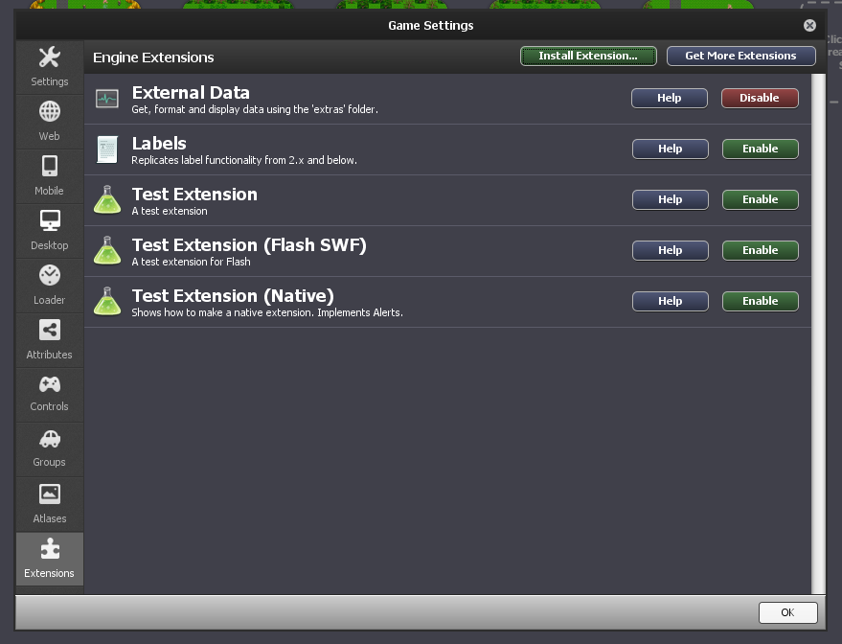

Now, from the top toolbar, select Debug > View > View Folder for this Game, as shown below:

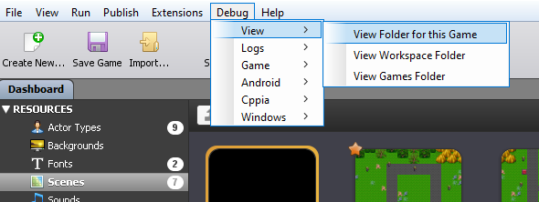

Windows explorer will now open, showing your game’s directory. Double click it’s folder, then create a new folder called “extra” (all lower case, without the quotation marks), as shown below:

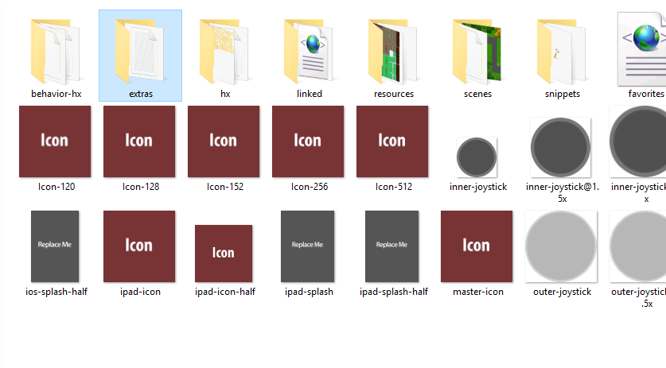

Double click on the folder you just created. Right-click, then hover over “New”, then select “Text Document”

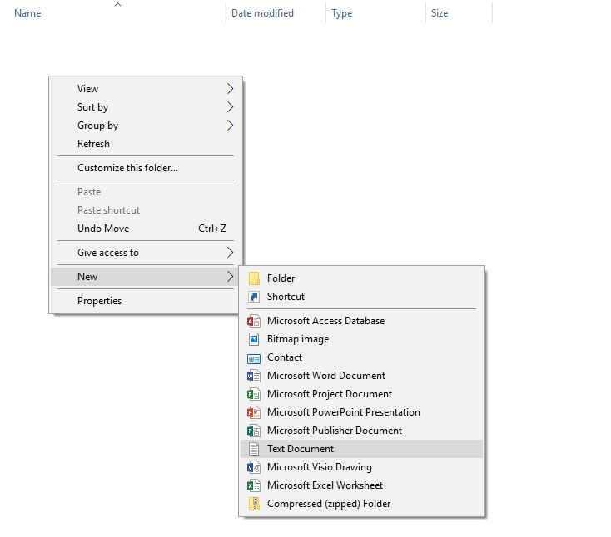

Name the text document “extRandomComments”, exactly as shown. Open the document and add random lines that will appear in the game, separating each quote with a new line (done by pressing the “Enter” key).

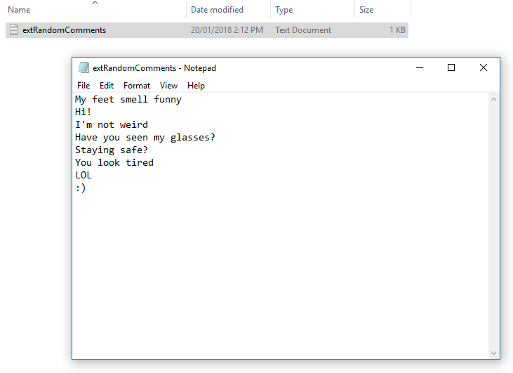

*Actors*

Actors are graphical representations of characters or objects within the game. In this case, they consist of the player’s character, enemy characters, equip-able boots for the player, a bullet, and some extra sprites for use in modifying the game.

*Behaviours*

Behaviours are elements that are attached to actors, and determine the actions or reactions they take within the game’s environment.

*Scenes*

Scenes are the environment where gameplay takes place. They can be modified or created anew to suit many game types.