**Stencyl game – how to play**

Controls include the following:

* Arrow keys for movement
* ‘F’ to fire
* ‘E’ to interact

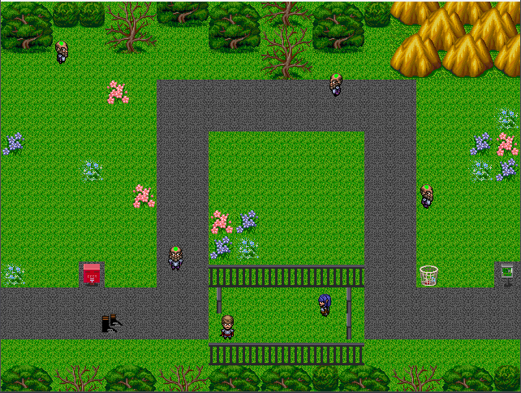

*The player’s character* can be controlled using the commands outlined above. Further, the player can move between scenes by following the path off the visible screen, which will move them to the following respective scene.

*Enemies* (NPCs with green orbs on their heads) are lethal to the player when touched. They walk for a time, stop, then choose a random direction and continue walking. They can be destroyed by firing at them.

There is one *interactive NPC* dressed in blue that will interact with the player when they walk up and press the *interact* key. They will say random lines of dialogue, which are read from a simple text document that the player can create or modify easily.