PROGRAM ACTIVITY PLAN

|  |  |
| --- | --- |
| Activity Name | Wearables |
| Style/Duration | 7 hours |
| Facilitators | Rein Turley |

Resources:

Downloading Driver:

<http://www.ftdichip.com/Drivers/VCP.htm>

Download Arduino:

<https://www.arduino.cc/en/Main/Software>

Processing Main Page

<https://processing.org/>

Schematic Fritz

http://fritzing.org/download/

Simple Circuit

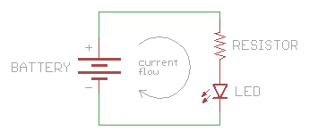img: sparkfun

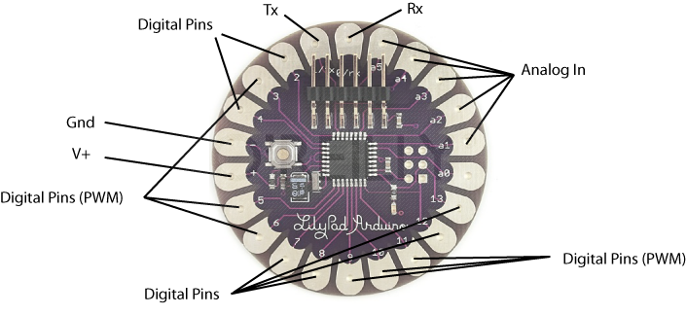

Buzzer Exercise

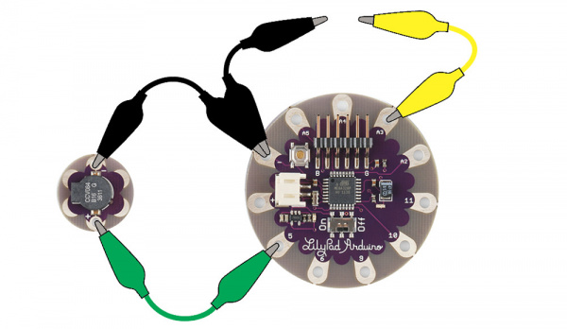img: sparkfun

Light Sensor Exercises

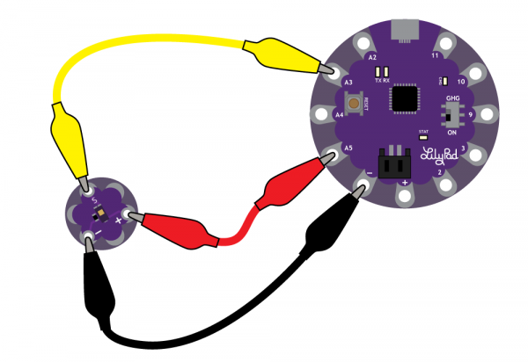img: sparkfun

Further Reading: (all free)

<https://www.sparkfun.com/>

<http://www.instructables.com/id/Lilypad-Projects/>

<http://leahbuechley.com/>

<http://sewelectric.org/diy-projects/>