**Outline of the Web development course for kids**

Date created: 03-10-2016

By Lavina R. Lobo

**Required Software**

Atom for editing (need list of plugins - I will provide these if you like)

An image editing tool (Which one?)

And a browser for output display & troubleshooting Chrome

**Day 1**

1. Becoming an Atom Guru!
   1. Walk through some plugins
   2. IDE tips/techniques
   3. Note - We can go through plugins as we need them to illustrate their effectiveness. This will only be a short walkthrough.
2. What is web development – What does it cover?

**Introduction to web development**

Web development includes all tasks required for building websites

This includes:

Web design – Creating the web page layout in HTML and CSS, creating and editing images and other media for the website, animations, interactivity

Web development – This includes coding the website to make it functional using a programming language, creating CMS (terminology), database connection.

Client and server-side scripting (explain) -  This includes using JavaScript for client side functionality and a programming language for server side coding

Databases – A place where data from the website is stored and retrieved.

Setting up servers – This includes setting up and environment including a combination of a web server, an application server and database server.

What about the client? UX? User centred design? At least we have to mention and put these in context.

The challenge with this part is to make it interesting and not long-winded and boring. We will need diagrams and interaction, even a participatory game if possible. Think outside the box. Obviously enough explanation is necessary - ‘enough’  being the keyword.

1. **Introduction to HTML5** - Responsiveness & bootstrap. We can show the effects of classes without even doing any CSS and then connect the dots later.

Good. This shows the power of CSS but make sure it is in context with the explanation of HTML first.

HTML stands for Hyper Text Markup Language. It’s a markup code (what is ‘markup’?) for building the structure of a web page and HTML5 is the latest version.

A piece of code would look something like this.

|  |
| --- |
| <!DOCTYPE HTML>  <html lang="en">  <head>   <meta charset="utf-8">   <title>The HTML5 Structure</title>   <meta name="description" content="The HTML5 Structure">   <meta name="author" content="NGCC">   <link rel="stylesheet" href="css/styles.css">  </head>  <body>   <script src="js/scripts.js"></script>  </body>  </html> |

It is both instructive and important to describe the ability of the browser to ‘read’ HTML. This places it’s importance into context. eg. the browser can spot errors easily.

This is where you can use a validity plugin (In Atom) to show the students how to ‘clean up’ their HTML.

**Responsiveness**: When a website design adapts to different devices, like tablets, smart phones, desktop monitors of different sizes to provide an optimal viewing experience, it is called a responsive website. Responsiveness aims at making the website fluid

**[I’m looking for a free image that shows different devices showing responsiveness]**

**You should show a website as well**

**Bootstrap**: It is the most popular HTML, CSS, and JavaScript framework for developing responsive web sites. It includes HTML and CSS based design templates which are easy to download and set up.

http://getbootstrap.com



1. Downloading and installing Wampserver, creating folders and saving files in them. **If we could do web servers it would we fantastic rather than file://**  **[This can be done using WAMP server or MAMP for Mac]**

Ok - I think this is a great idea and will really give the students some power. I assume we will download this all together and get it installed?

Download and install Wampserver  <http://www.wampserver.com/en/>

Download Atom https://atom.io/

Before building our first website, we need to get our files organized

Once wampserver is set up and turned on, create a folder named “MyWebsite” in C://wamp/www

We create two new folders within the “MyWebsite” named “css” and “js”

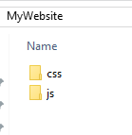

1. Creating our first HTML page and viewing it on a browser. **Do you know what this page will be? What about analogies ie. A tree? We could get an artist to illustrate the course. Good diagrams stay in the mind.**

**We should probably make the first page hello world but on apache**

Create your first HTML page by typing the following code in Atom

You can use Emmet here to illustrate the power of Atom plugins. Emmet enables you to write HTML very quickly.

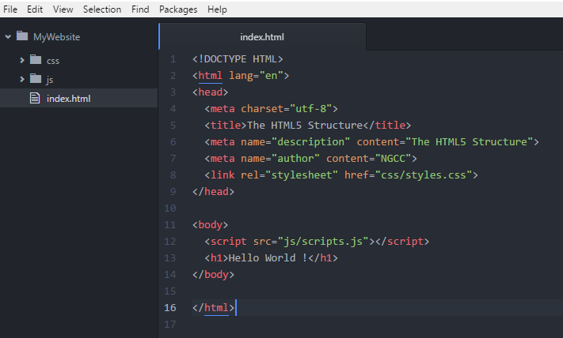

Save the page as index.html and view it on the browser

localhost/MyWebsite/index.html

You will need to provide a lesson on ‘localhost, 127.0.0.1 and loopback addresses’

Relating to the below - **we should illustrate a typical page/site and overlay the standard tags**

1. Examples and the use of HTML Tags – to include
   1. <html>
   2. <head><title>
   3. <body>
   4. <header>
   5. <footer>
   6. <nav>
   7. <p> paragraph
   8. <ul> and <ol> unordered and ordered lists
   9. <div>, <section>, <article>
   10. <a> hyperlink
   11. <img> image
   12. <table>
   13. <audio>
   14. <video>
   15. <section> **is more semantically correct than DIV. oh just saw that you included it!**

**[I will build a page for this]**

1. Introduction to CSS - **what are you covering in the introduction?**

CSS stands for Cascading Style Sheets. It is used for styling an HTML page.

The latest version is CSS3.

CSS is used to change the look and feel of a plain HTML page. This includes changing fonts, colours, spacing, positioning and more to create a consistent look for all pages.

It would be illustrative to show the same page both unstyled and styled to show what CSS can do. This creates understanding and gives context to CSS

A typical CSS code looks like this example below where the body background colour is set to blue

|  |
| --- |
| body {     background-color: blue;                 } |

1. HTML colour codes - **both hexadecimal and RGB**

The 6-digit representation of a colour is known as the hex code. Hex numbers use 16-digits.

We think and work in Base 10, computers work in Base 2 (binary), 8 (Octal) and 16 (Hexadecimal)

0 1 2 3 4 5 6 7 8 9 A B C D E F

For an example, here are the opposite ends of the colour scale:

FFFFFF - The code is equal to white which means the highest level of red, green, and blue.

000000 - The code is equal to black All three settings of red, green, and blue are set to a total absence of colour

FFFF00 – yellow

FF0000 – red

0000FF – blue

00FF00 – green

RGB

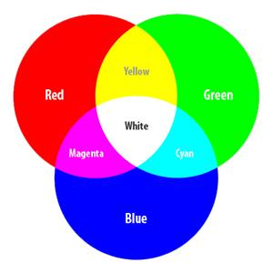

You don’t have to remember the colour codes. Usually a photo editing tool or a colour picker will help you pick colour codes. <http://www.colorpicker.com/>

Browsers also have colour pickers as add-ons to help you choose colours

1. Web design good practices. (I’m going to add points for these)
2. How to link an HTML file to a CSS file

Note that <style> and inline styles can also be used but using a separate style sheet is preferred for architectural reasons.

An external style sheet is linked to an HTML document through HTML's link element:

<link red=stylesheet href="css/style.css" type="text/css" >

The above line of code goes into the <head> tag in the HTML document

Create a CSS file in Atom and save it as styles.css. Save this file in the css folder.

Use the above line of code in the HTML document

1. Attributes in HTML tags

Attributes in HTML are name-value pairs used to define characteristics of an HTML element

For example:

|  |
| --- |
| <html lang="en"> |

In the above code “lang=en” is an attribute where the name is “lang” and the value is “en” denoting English.

1. Ids and classes (ids and classes can be explained while explaining CSS)
2. Encodings? ie UTF-8
3. When are we addingin Bootstrap?

**Day 2 [I will build an HTML page with the elements above in Day 1 and for day 2, build a CSS file that styles the same page]**

1. Applying CSS properties
   1. Font style, size, colour properties
   2. Image border/shading properties
   3. Div alignment properties
   4. Background image/colour
   5. Etc
2. Creating a form in HTML including
   1. Textboxes
   2. Radio buttons
   3. Checkboxes
   4. Datepicker (jQuery)
   5. Textarea
   6. Submit button

Do a super simple form. We don't need intricacies here. Let's connect it to an API to make it interesting- we can give them a choice of apis e.g. Soundcloud

1. Applying CSS to the form elements
2. Embedding a google map area - this can be one of the apis we use

**Day 3**

Project: Create your own website - are we fixing this to be an about me site or todo with a hobby? I think engaging what they are interested in is better and will be mor dynamic

1. Build a Prototype using paper and colour pencils
2. Build your logo using a photo editing application

They would essentially build a four-page website - will need to rethink the pages

Home, About Me, Gallery, Contact Us

I will build a template around which they can build their own website

They would include their own created logo and text.

The “About Me” page would be text based and a video – preferably one taken on their phone with their friends – embedded in the page

The gallery page would have their own images  - how will they source the images ?

The contact us page will include a small form and a Google map area