Smart Manager
Software Design Document

Version <2.4>
Revision History
Date | Version | Description | Author
<08/Nov/09> | 1.0 | This is the initial version based upon the domain analysis and R&D, may need to be revised with time | Sadia Manzoor
<16/Nov/09> | 1.1 | The changes are made after team’s review. | Aqib Javed  Burhan Rasool  Muhammad Imran Iqbal  Muhammad Rauf Ayub  Sadia Manzoor
<06/Dec/09> | 2.0 | - Changed the structure of the document  - Identified of objects  - Design rework | Burhan Rasool  Muhammad Rauf Ayub
<07/Dec/09> | 2.1 | - The changes are made after team’s review.  - Information regarding design pattern and framework being added | Aqib Javed  Burhan Rasool  Muhammad Imran Iqbal  Muhammad Rauf Ayub  Sadia Manzoor
<25/Dec/09> | 2.2 | - ERD added with Data dictionary.  - Sequence diagrams added | Aqib Javed  Burhan Rasool  Muhammad Imran Iqbal  Muhammad Rauf Ayub  Sadia Manzoor
<06/Jan/10> | 2.3 | - Modified ERD and Data dictionary.  - Sequence diagrams modified | Aqib Javed  Burhan Rasool  Muhammad Imran Iqbal  Muhammad Rauf Ayub  Sadia Manzoor
<20/Jan/10> | 2.4 | - Traceability Matrix.  - Sequence diagrams modified | Burhan Rasool  Muhammad Imran Iqbal

Table of Contents
1. Introduction 5
1.1 Purpose 5
1.2 Scope 5
1.3 Evolution of the Software Design Document 5
2. Design Consideration 5
3. Design Patterns & Framework 5
4. System Architecture Diagram 6
5. Modules Identification & Dependencies 7
6. Process Flow Diagram 7
7. Data Flow Diagram 8
8. Analysis of Objects 9
8.1 Identification of Nouns from Use Cases 9
8.2 Acceptance/Rejection of Common Identified Nouns & Attributes 11
8.3 Final List of Objects & Attributes 12
8.4 Identify of Association & Aggregation between Objects 15
8.5 Identification of Verbs from Use Cases 16
8.6 Final List of Objects, Attributes & Actions 18
9. Class Diagram 21
10. Database Design 22
10.1 Entity Relationship Diagram 22
10.2 Data Dictionary 23
10.2.1 Access Rights 23
10.2.2 Attendance 23
10.2.3 Budget Per Resource 24
10.2.4 Milestone 24
10.2.5 Milestone Tasks 25
10.2.6 Project 26
10.2.7 Resources 26
10.2.8 Roles 27
10.2.9 TaskDependencies 27
10.2.10 Tasks 28
10.2.11 TaskResource 29
10.2.12 TaskStatusReport 29
10.2.13 Users 30
10.2.14 RoleAccessRights 30
10.2.15 Roles 31
11. Sequence Diagrams 32
11.1 Assign Rights to Role 32
11.2 Create User 33
11.3 Login User 34
11.4 Punch In/Out User 35
11.5 Create Project 36
11.6 Update Project 37
11.7 View Projects List Detail 38
11.8 View Project Versions Detail 39
11.9 Create Milestone 40
11.10 View Milestones Info 41
11.11 Assign/Update Milestone Budget 42
11.12 Calculate Budget 43
11.13 Set Resource Cost 44
11.14 View Resource Info 45
11.15 Update Resource Cost 46
11.16 Create Task 47
11.17 View Project Tasks List 48
11.18 Edit Task 49
11.19 Update Resource 50
11.20 Alert for Delayed Task 51
11.21 Alert for Budget Over Consumption 52
11.22 Alert for Milestones Conflict 53
11.23 Calendar View 54
11.24 Auto Email Tasks to Resources 55
12. Traceability Matrix 57

Risk Management Plan Document

Introduction

Purpose
The purpose of this document is to enable the people currently developing the system and the ones who might work on the system in future to develop an understanding of the underlying architecture and design methodologies taken into consideration when developing it.

Scope
The scope of this document is to outline the high level and detail design of the project named as “Smart Manager”. The system is being developed to cater the needs of project managers for better managing their projects.

Evolution of the Software Design Document
The Software design document will be revised as needed.

Design Consideration

- All the users of the system are computer literate and familiar with the UML diagrams
- The client is fully aware of the actual project management practices being followed.
- The information provided by the perspective end-users as mentioned in the Software Requirements specification document will be correct.
- There would be no social and behavioral issues, which would motivate the end-user to fail the system.

Design Patterns & Framework
We will be using the rapid development framework of PHP, named CakePHP/Symfony, which provides an extensible architecture for developing, maintaining, and deploying applications. Using commonly known design patterns like MVC (Model-View-Controller) and ORM (Object Relational Mapping) within the convention over configuration paradigm.

System Architecture Diagram

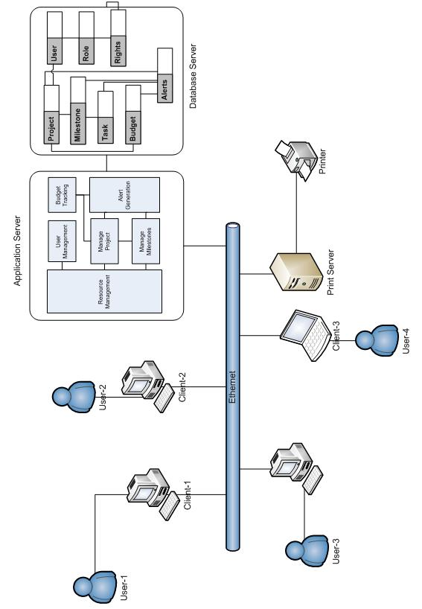

Modules Identification & Dependencies
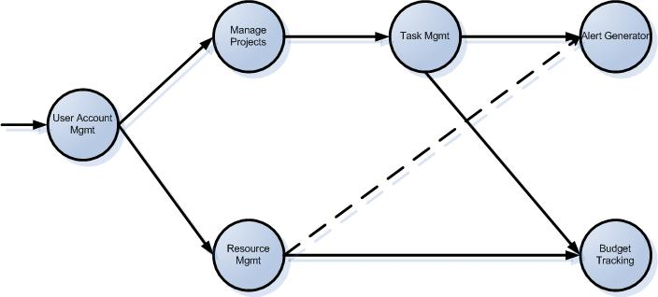

Process Flow Diagram

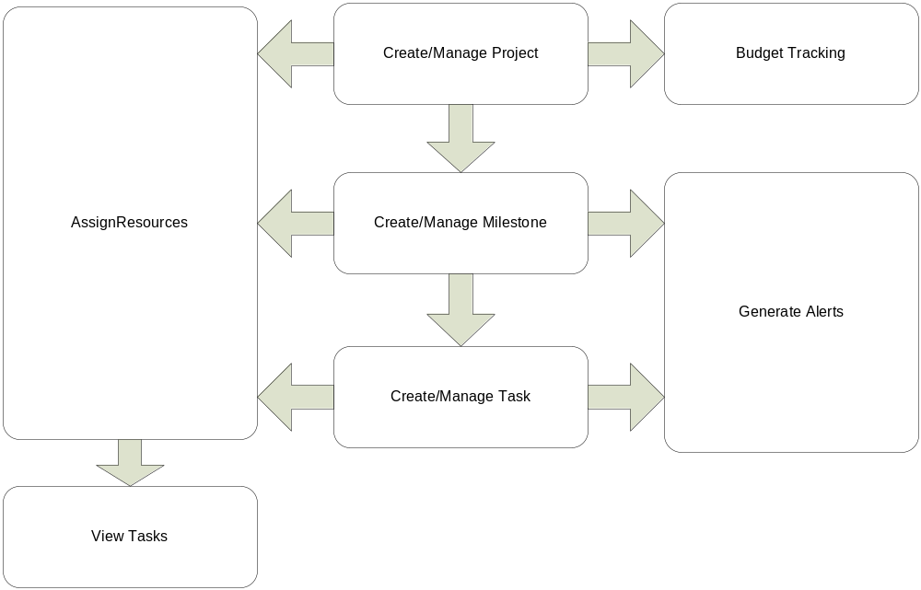

Data Flow Diagram

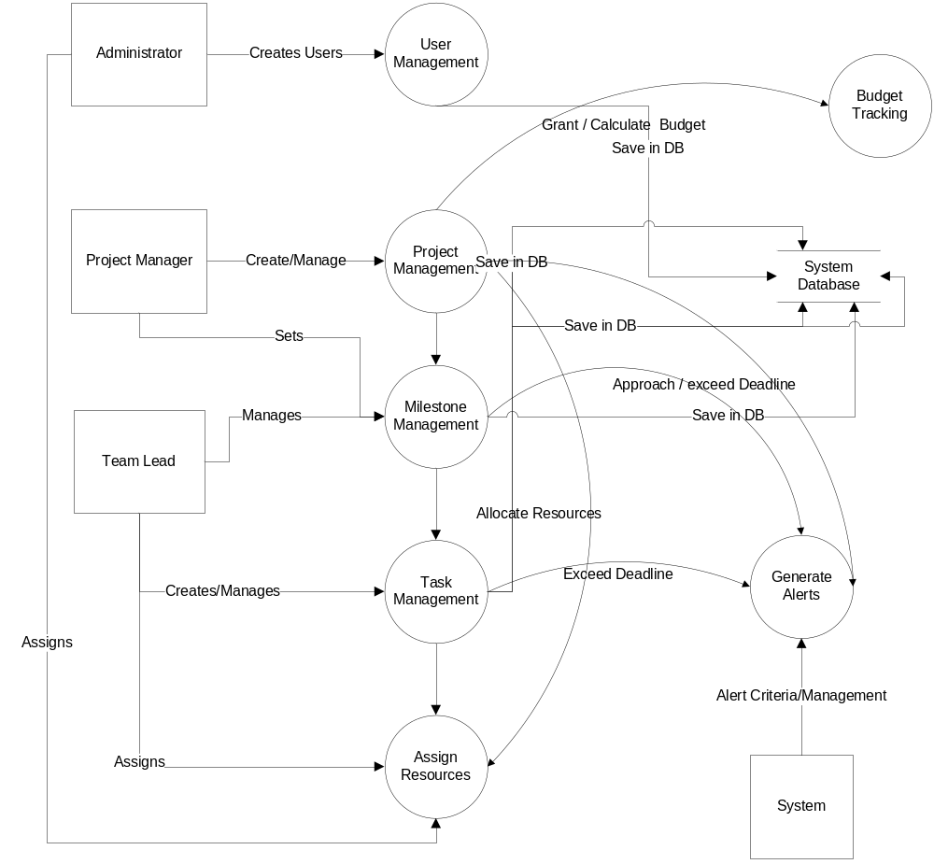

Analysis of Objects

Identification of Nouns from Use Cases
ID | Use Case | Description | Nouns
 | Define Role | Define the steps for successful Role creation in the system. | Administrator, user, name of role, system, interface, input, message
 | Create User | Define the steps for successful User creation in the system. | Administrator, option, menu, interface, role, status (Active/Inactive/Pending), email address, contact number, input format, field, email, user address, message,
 | Verify Email | Verify the email address entered when creating a new user. | Email address, link, interface, user information, user status, home page, login page, error message
 | Login | Define the steps required for the user to successfully log in to the system | User, system, admin, system url, database, rights, homepage, error message
 | Mark Attendance | Maintain the attendance record and the work hours put in by each user | user (PM/TL/Developer/Tester), check-in time, check-out time, system, interface
 | Create Project | create/add new Project | user (PM), system, rights, Name of the Project, database
 | Edit Project | Edit an existing Project | User, system, rights, name of project, database
 | Create Project Plan Versions | Allow the PM to create versions of a project plan. | System, user, Project manager, version, interface, milestone, task, database
 | View Project Plan versions | Allow the PM to view latest versions of a Project Plan | System, user, Project manager, version, interface, milestone, task, database
 | Create Milestone | Allow the PM to create the milestone | Project Manager, milestone, button, System, Name of the milestone, Due date, End date, Description, data, user, fields
 | View Milestone | Allow the PM/TL to view the list of milestones related to a specific project | Project Manager, Team Lead, list of milestones, add button, edit button, view button, active/inactive button, name, start date, end date, status, user
 | View tasks | Define the steps for the User to be able to view any tasks assigned to him | CEO, administrator, project manager, team lead, developer and tester, system, tasks, user
 | Create Tasks | Allow the PM to create/add new task against milestone | Project Manager, System, tasks, Short Summary, Description, Associated milestone, Priority, Start date, Expected end date, Actual end date, Assign to (list of team member), Dependency, Status against each task, data, user, fields
 | Edit Tasks | Allow the PM to edit existing task | Project Manager, System, tasks, Short Summary, Description, Associated milestone, Priority, Start date, Expected end date, Actual end date, Assign to (list of team member), Dependency, Status against each task, data, user, fields
 | Enter notes against particular task | Allow the users to write notes against a particular task | Project manager, team lead, developer, tester, QA officer, existing task, Short Summary  Description, Associated milestone (list of milestones for a projects), Priority, Start date, Expected end date, Actual end date, Assign to (list of team members), Dependency, Status against each task, List of notes, owner name, data, user
 | View task’s status report | Allow the user to view the status of each task associated with a particular milestone and specific to their roles. | CEO, project manager, team lead, developer, tester and QA officer, task, task status, user
 | View project status report | Allow the user to view the status report of each task. | CEO, project manager, reports, user, list of tasks, particular project or projects, particular resource or resources, (list of new, incomplete, complete, in progress and delayed tasks), given period
 | Assign cost (hourly rates) to resource | to assign the cost (hourly rates) amount to each resource (project manager, developers, testers, SQA manager) working on the project. | Project Manager, resource (project manager, developers, testers, SQA manager), System, Database, Project, Milestones, Cost
 | Edit cost (hourly rates)amount of resource | to edit the cost (hourly rates) amount that was assigned previously to a particular resource (project manager, developers, testers, SQA manager) working on the project. | Project Manager, resource (project manager, developers, testers, SQA manager), System, Database, Project, Milestones, Cost
 | Calculate consumed budget | to calculate the budget that has been consumed by each milestone of project | User (CEO, project manager, Administrator), Alert application, milestones.
 | Assign Resource(s) to Project | allow the user with PM role to assign/select resources for a particular project | User, rights, Project, resource, system
 | Assign Single Task to Resource(s) | allow the user with PM/TL role to assign a task to one/multiple resources for a particular project | User, rights, Project, resource, system
 | Assign Multiple Tasks to Single Resource | allow the user with PM/TL role to assign multiple tasks to a particular resource for a particular project | User, rights, Project, resource, system
 | Delayed task Alert | generate alert to user if a task/milestone is behind schedule | System , Calendar, user, milestone, tasks
 | Conflicting milestones Alert | generate alert to user in case of conflicts between different milestones. | System , Calendar, user, milestone, tasks
 | Calendar view | provide an independent interface for calendar view showing scheduled milestones/tasks due in selected dates. | System , Calendar, user, milestone, tasks
 | Budget over consumed Alert | generate alert to user in case of budget over consumed, by slippage of any milestone. | System, Project, milestone
 | AutoEmail Daily Task | communicate daily tasks to each project resources through auto-emails and Cc to PM at the end of the day (i.e. 12 Mid Night) | System, task

Acceptance/Rejection of Common Identified Nouns & Attributes
No. | Potential Objects | Classification | Accept/Reject/Attribute
 | Administrator | Role or External Entity | Rejected
 | User | Role | Accepted
 | Name of the role | Thing (attribute of user) | Attribute
 | System | Structure | Rejected
 | Interface | External Entity | Rejected
 | InputFormat | Thing (related to some format) | Rejected
 | Message | Thing (attribute of system) | Rejected
 | Option | Thing (attribute of system) | Rejected
 | Menu | Thing (attribute of system) | Rejected
 | Role | Thing | Accepted
 | User Status | Thing (attribute of user) | Attribute
 | Email Address | Thing (attribute of user) | Attribute
 | Contact Number | Thing (attribute of user) | Attribute
 | Field | Thing (attribute of system) | Rejected
 | User Address | Thing (attribute of user) | Attribute
 | Link | Thing (attribute of system) | Rejected
 | HomePage | Thing (attribute of system) | Rejected
 | LoginPage | Thing (attribute of system) | Rejected
 | ErrorMessage | Thing (attribute of message) | Rejected
 | SystemUrl | Thing (attribute of system) | Rejected
 | Database | Thing (system) | Rejected
 | Rights | Thing (attribute of user) | Attribute
 | Project Manager | Role or External Entity | Rejected
 | TeamLead | Role or External Entity | Rejected
 | Developer | Role or External Entity | Rejected
 | Tester | Role or External Entity | Rejected
 | Check-in Time | Thing (attribute of user) | Attribute
 | Check-out Time | Thing (attribute of user) | Attribute
 | Name of the Project | Thing (attribute of Project) | Attribute
 | Project | Role or Thing | Accepted
 | Version | Thing (attribute of Project) | Attribute
 | Milestone | Role or Thing | Accepted
 | Task | Role or Thing | Accepted
 | Button | Thing (attribute of system) | Rejected
 | Name of the milestone | Thing (attribute of milestone) | Attribute
 | DueDate | Thing (attribute of milestone) | Attribute
 | EndDate | Thing (attribute of milestone) | Attribute
 | Description | Thing (attribute of milestone) | Attribute
 | Data | Thing (attribute of milestone) | Attribute
 | List of milestones | Structure | Rejected
 | Add button | Thing (attribute of button) | Rejected
 | Edit button | Thing (attribute of button) | Rejected
 | View button | Thing (attribute of button) | Rejected
 | Active/Inactive button | Thing (attribute of button) | Rejected
 | StartDate | Thing (attribute of milestone) | Attribute
 | EndDate | Thing (attribute of milestone) | Attribute
 | Milestone Status | Thing (attribute of milestone) | Attribute
 | CEO | Role or External Entity | Rejected
 | ShortSummary | Thing (attribute of task) | Attribute
 | Description | Thing (attribute of task) | Attribute
 | AssociatedMilestones | Thing (attribute of task) | Attribute
 | Priority | Thing (attribute of task) | Attribute
 | Start Date | Thing (attribute of task) | Attribute
 | ExpectedEnd Date | Thing (attribute of task) | Attribute
 | Actual End Date | Thing (attribute of task) | Attribute
 | Assign to (list of team members) | Thing (attribute of task) | Attribute
 | Dependency | External Entity | Rejected
 | Task Status | Thing (attribute of task) | Attribute
 | Existing Task | Thing (attribute of task) | Attribute
 | List of notes | Structure | Rejected
 | Owner Name | Thing (attribute of user) | Attribute
 | List of tasks | Structure | Rejected
 | Particular Project | Role or Thing | Rejected
 | Particular Resource | Role or Thing | Rejected
 | List of new tasks | Structure | Rejected
 | List of incomplete tasks | Structure | Rejected
 | List of complete tasks | Structure | Rejected
 | List of in progress tasks | Structure | Rejected
 | List of delayed tasks | Structure | Rejected
 | Given Period | Structure | Rejected
 | Cost | Thing (Attribute of resource) | Attribute
 | SQA Manager | Role or External Entity | Rejected
 | Calendar | Role or External Entity | Rejected

Final List of Objects & Attributes
Sr. # | Noun | Description | Attributes
 | User | The person who will log into the system. | - name,  - password,  - role,  - status (Active/Inactive/Pending)  - email address  - contact number of the User  - user name  - Marked Time (Check In/Checkout)
 | Role | Different Roles assigned to the Users of the system, such as PM, TL etc. | - RoleId  - RoleDescription
 | Rights | Different rights assigned Roles in the system | - Id  - Rights (Add,Edit,Delete,View)
 | Module | Modules that exist in the system, such as , Project Management, Resource Management. Rights will be assigned to Roles on different Modules. | - ModuleId  - ModuleName
 | Resource | A person who will be assigned a project, milestone or task. Each resource will be a user of the system. | - Id  - Name  - Email  - Contact  - Experience  - JoinDate  - ResignDate  - Resource cost (hourly rates)  - Resources Tasks
 | Project | A unit comprising of multiple resources, and will contain different milestones. | - Name of the Project  - Expected Start date  - Actual Start date  - Expected end date  - Actual end date  - Description  - Status (Active/Inactive)  - Checkbox with label “create version”
 | Milestone | A sub unit of a project. Each milestone will contain multiple tasks. | - Name of the milestone  - Due date  - End date  - Start Date  - Description
 | Task | A sub unit of a milestone. Each task will be performed by one or more resources assigned to a project. | - Short Summary  - Description  - Associated milestone (list of milestones for a particular project)  - Priority  - Start date  - Expected end date  - Actual end date  - Assign to (list of team member)  - Dependency  - Status against each task
 | Budget | Cost incurred with reference to a project, milestone and task. | - Id  - EstimatedCost  - ActualCost  - Remarks
 | Alert | Messages sent to resources working on project in case of delays or budget over run. | - Id  - AlertType  - AlertTime  - AlertCount  - AlertStatus
 | Note | Text added to Projects, milestones and tasks at different instances, during the term of a project. | - NoteId  - NoteType  - NoteBy  - NoteDate

Identify of Association & Aggregation between Objects

Budget
User
Role
<<Has a>>
Module
UserRight
<<Is Assigned>>
<<Of>>
Note
Alert
Resource
<<inherits>>
Project
Assigned to
Milestone
<<Uses>>
<<Contains>>
<<Uses>>
<<Uses>>
<<Uses>>
SmartManager
Task
<<Contains>>
<<Uses>>

Identification of Verbs from Use Cases

ID | Use Case | Verbs | Accepted Verb List
 | Define Role | - Selects  - displays  - inputs  - Assign  - Validates  - Asks | Select  Display/View  Validate
 | Create User | - Selects  - Displays  - marks  - verifies  - marks  - sends  - validates  - asks | Select  Display  Verify/Validate
 | Verify Email | - Goes  - Displays  - Inputs  - Updates  - displays | Display  Update
 | Login | - Inputs  - presses  - Checks  - displays | Display  Checks
 | Mark Attendance | - selects  - confirms  - displays  - marks | Display  Confirms  Marks
 | Create Project | - clicks  - displays  - enter  - press | Display  Insert  Update  Active/Inactive  Validates
 | Edit Project | - clicks  - displays  - enter  - press | Display  Insert  Update  Active/Inactive  Validates
 | Create Project Plan Versions | - clicks  - provide  - selects  - validates  - save | Display  Save  Update  Active/Inactive  Validates
 | View Project Plan versions | - Open  - provide | View/Display
 | Create Milestone | - clicks  - enter  - press  - prompt | Display  Save  Update  Active/Inactive  Validates
 | View Milestone | - Clicks  - Displays  - Presses | Display
 | View Tasks | - Extract  - Displays  - selects | Display
 | Create Task | - Clicks  - Prompt  - Input  - Enter  - press | Display  Save  Update  Active/Inactive  Validates
 | Edit Task | - Clicks  - Prompt  - Input  - Enter  - press | Display  Save  Update  Active/Inactive  Validates
 | Enter notes against particular task | - Select  - Click  - Display  - Enter  - saves | Display  Save  Update  Active/Inactive  Validates
 | View task’s status report | - Select  - Click  - display | Display
 | View project status report | - Click  - display | Display
 | Assign cost (hourly rates) to resource | - Selects  - Inputs  - Allow  - Validate  - store | Display  Save  Update  Active/Inactive  Validates
 | Edit cost (hourly rates)amount of resource | - Selects  - Inputs  - Allow  - Validate  - store | Display  Save  Update  Active/Inactive  Validates
 | Calculate consumed budget | - Configure  - Perform  - Generate  - allow | Display  Save  Update  Active/Inactive  Validates  Generate  Configure
 | Assign Resource(s) to Project | - Clicks  - Displays  - Selects  - Enters  - Adds  - saves | Display  Save  Update  Active/Inactive  Validates
 | Assign Single Task to Resource(s) | - Clicks  - Displays  - Selects  - Enters  - Adds  - saves | Display  Save  Update  Active/Inactive  Validates
 | Assign Multiple Tasks to Single Resource | - Selects  - Clicks  - saves | Display  Save  Update  Active/Inactive  Validates
 | Delayed task Alert | - Shown  - Presses  - close | Display  Close
 | Conflicting milestones Alert | - Shown  - Presses  - close | Display  Close
 | Calendar view | - Opens  - Shown  - Highlighted  - Pointing  - Clicking  - Press  - close | Display  Close  Highlight  Pointing
 | Budget over consumed Alert | - Shown  - Presses  - close | Display  Close
 | AutoEmail Daily Task | - Run  - Check  - Send  - repeats | Display  Close  Send  Repeat  Active/Inactive

Final List of Objects, Attributes & Actions
Some of the attributes and verbs were identified from use cases while others have been identified based on experience of the development team

Sr # | Objects | Description | Attributes | Actions
 | User | The person who will log into the system. | - name,  - password,  - role,  - status (Active/Inactive/Pending)  - email address  - contact number of the User  - user name  - Marked Time (Check In/Checkout) | Select  Display  Verify/Validate  Insert  Update  Active/Inactive
 | Role | Different Roles assigned to the Users of the system, such as PM, TL etc. | - RoleId  - RoleDescription  - status | Select  Display  Verify/Validate  Insert  Update  Active/Inactive
 | Rights | Different rights assigned Roles in the system | - Id  - Rights (Add,Edit,Delete,View)  - status | Select  Display  Verify/Validate  Insert  Update  Active/Inactive
 | Module | Modules that exist in the system, such as , Project Management, Resource Management. Rights will be assigned to Roles on different Modules. | - ModuleId  - ModuleName  - Status | Select  Display  Verify/Validate  Insert  Update  Active/Inactive
 | Resource | A person who will be assigned a project, milestone or task. Each resource will be a user of the system. | - Id  - Name  - Email  - Contact  - Experience  - JoinDate  - ResignDate  - Resource cost (hourly rates)  - Resources Tasks | Display  Confirms  Marks  Assign
 | Project | A unit comprising of multiple resources, and will contain different milestones. | - Name of the Project  - Expected Start date  - Actual Start date  - Expected end date  - Actual end date  - Description  - Status (Active/Inactive)  - Checkbox with label “create version” | Display  Insert  Update  Active/Inactive  Validates
 | Milestone | A sub unit of a project. Each milestone will contain multiple tasks. | - Name of the milestone  - Due date  - End date  - Start Date  - Description | Display  Save = Insert  Update  Active/Inactive  Validates
 | Task | A sub unit of a milestone. Each task will be performed by one or more resources assigned to a project. | - Short Summary  - Description  - Associated milestone (list of milestones for a particular project)  - Priority  - Start date  - Expected end date  - Actual end date  - Assign to (list of team member)  - Dependency  - Status against each task | Display  Save= Insert  Update  Active/Inactive  Validates
 | Budget | Cost incurred with reference to a project, milestone and task. | - Id  - EstimatedCost  - ActualCost  - Remarks | Display  Save = Insert  Update  Active/Inactive  Validates  Generate  Configure
 | Alert | Messages sent to resources working on project in case of delays or budget over run. | - Id  - AlertType  - AlertTime  - AlertCount  - AlertStatus | Display  Close  Highlight  Pointing
 | Note | Text added to Projects, milestones and tasks at different instances, during the term of a project. | - NoteId  - NoteType  - NoteBy  - NoteDate | Display  Save/Update  Validates

Class Diagram

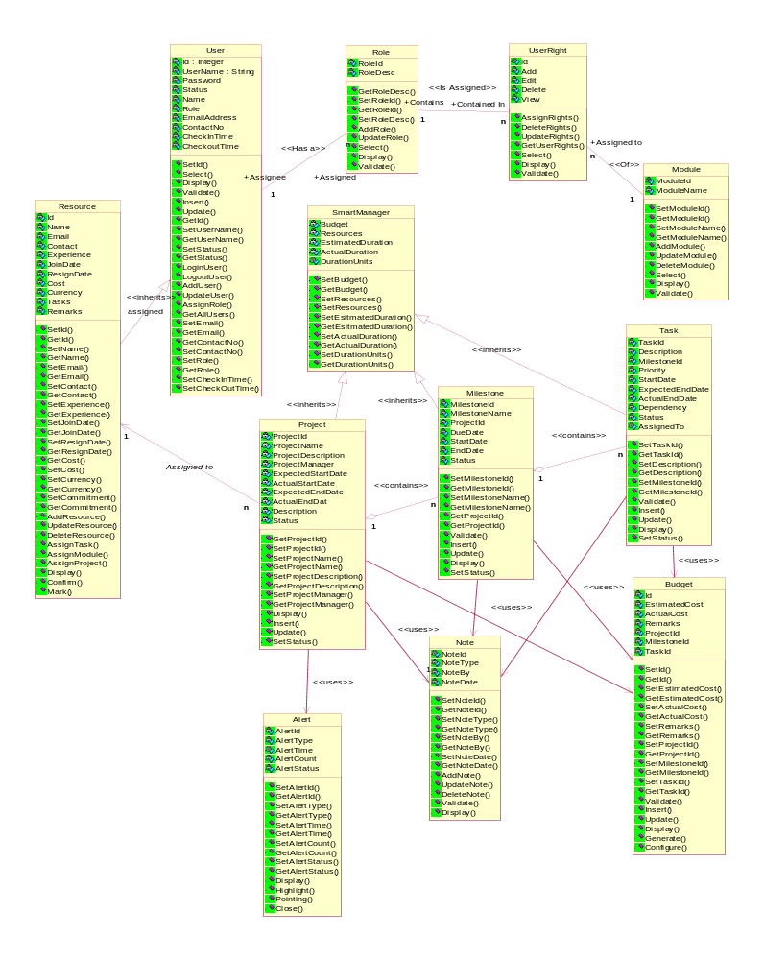

Database Design

Entity Relationship Diagram
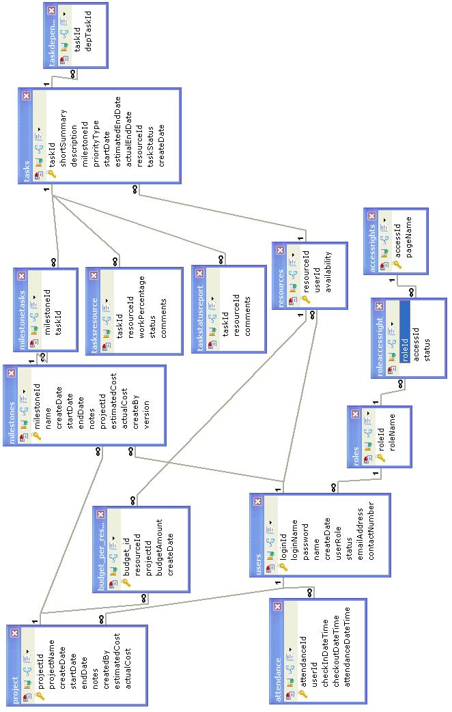

Data Dictionary

Access Rights

Fields

Field | Type | Collation | Null | Key | Default | Extra | Privileges
accessId | int(11) | (NULL) | NO | PRI | (NULL) | auto_increment | select,insert,update,references
pageUrl | varchar(255) | latin1_swedish_ci | NO |  | (NULL) |  | select,insert,update,references
roleId | int(11) | (NULL) | NO |  | (NULL) |  | select,insert,update,references

Indexes

Table | Non  unique | Key  name | Seq  in  index | Column  name | Collation | Cardinality | Sub  part | Packed | Null | Index  type
accessrights | 0 | PRIMARY | 1 | accessId | A | 0 | (NULL) | (NULL) |  | BTREE

Attendance

Fields

Field | Type | Collation | Null | Key | Default | Extra | Privileges
attendanceId | int(11) | (NULL) | NO | PRI | (NULL) | auto_increment | select,insert,update,references
userId | int(11) | (NULL) | NO | MUL | (NULL) |  | select,insert,update,references
checkInDateTime | datetime | (NULL) | NO |  | (NULL) |  | select,insert,update,references
checkoutDateTime | datetime | (NULL) | NO |  | (NULL) |  | select,insert,update,references
attendanceDateTime | datetime | (NULL) | NO |  | (NULL) |  | select,insert,update,references

Indexes

Table | Non  unique | Key  name | Seq  in  index | Column  name | Collation | Cardinality | Sub  part | Packed | Null | Index  type
attendance | 0 | PRIMARY | 1 | attendanceId | A | 0 | (NULL) | (NULL) |  | BTREE
attendance | 1 | FK_attendance | 1 | userId | A | 0 | (NULL) | (NULL) |  | BTREE

Foreign Key Relationships

FK Id | Reference Table | Source Column | Target Column | Extra Info
FK_attendance | Users | `userId` | `loginId` | ON DELETE CASCADE ON UPDATE CASCADE

Budget Per Resource

Fields

Field | Type | Collation | Null | Key | Default | Extra | Privileges
budget_id | int(11) | (NULL) | NO | PRI | (NULL) | auto_increment | select,insert,update,references
resourceId | int(11) | (NULL) | NO | MUL | (NULL) |  | select,insert,update,references
projectId | int(11) | (NULL) | NO | MUL | (NULL) |  | select,insert,update,references
budgetAmount | decimal(10,0) | (NULL) | NO |  | (NULL) |  | select,insert,update,references
createDate | Datetime | (NULL) | NO |  | (NULL) |  | select,insert,update,references

Indexes

Table | Non  unique | Key  name | Seq  in  index | Column  name | Collation | Cardinality | Index  type
budget_per_resource | 0 | PRIMARY | 1 | budget_id | A | 0 | BTREE
budget_per_resource | 1 | FK_budget_per_resource | 1 | projectId | A | 0 | BTREE
budget_per_resource | 1 | FK_budget_per_assigned_resource | 1 | resourceId | A | 0 | BTREE

Foreign Key Relationships

FK Id | Reference Table | Source Column | Target Column | Extra Info
FK_budget_per_assigned_resource | resources | `resourceId` | `resourceId` | ON DELETE CASCADE ON UPDATE CASCADE,
FK_budget_per_resource | Project | `projectId` | `projectId` | ON DELETE CASCADE ON UPDATE CASCADE

Milestone

Fields

Field | Type | Collation | Null | Key | Default | Extra | Privileges
milestoneId | int(11) | (NULL) | NO | PRI | (NULL) | auto_increment | select,insert,update,references
name | varchar(100) | latin1_swedish_ci | NO |  | (NULL) |  | select,insert,update,references
createDate | datetime | (NULL) | NO |  | (NULL) |  | select,insert,update,references
startDate | datetime | (NULL) | NO |  | (NULL) |  | select,insert,update,references
endDate | datetime | (NULL) | NO |  | (NULL) |  | select,insert,update,references
Notes | varchar(255) | latin1_swedish_ci | NO |  | (NULL) |  | select,insert,update,references
projectId | int(11) | (NULL) | NO | MUL | (NULL) |  | select,insert,update,references
estimatedCost | decimal(10,2) | (NULL) | NO |  | (NULL) |  | select,insert,update,references
actualCost | decimal(10,2) | (NULL) | NO |  | (NULL) |  | select,insert,update,references
createBy | int(11) | (NULL) | NO | MUL | (NULL) |  | select,insert,update,references
version | varchar(5) | latin1_swedish_ci | NO |  | (NULL) |  | select,insert,update,references

Indexes

Table | Non  unique | Key  name | Seq  in  index | Column  name | Collation | Cardinality | Sub  part | Packed | Null | Index  type
milestones | 0 | PRIMARY | 1 | milestoneId | A | 0 | (NULL) | (NULL) |  | BTREE
milestones | 1 | FK_milestones | 1 | projectId | A | 0 | (NULL) | (NULL) |  | BTREE
milestones | 1 | FK_milestones_user | 1 | createBy | A | 0 | (NULL) | (NULL) |  | BTREE

Foreign Key Relationships

FK Id | Reference Table | Source Column | Target Column | Extra Info
FK_milestones_user | users | `createBy` | `loginId` | ON DELETE CASCADE ON UPDATE CASCADE,
FK_milestones | project | `projectId` | `projectId` | ON DELETE CASCADE ON UPDATE CASCADE

Milestone Tasks

Fields

Field | Type | Collation | Null | Key | Default | Extra | Privileges
milestoneId | int(11) | (NULL) | NO | MUL | (NULL) |  | select,insert,update,references
taskId | int(11) | (NULL) | NO | MUL | (NULL) |  | select,insert,update,references

Indexes

Table | Non  unique | Key  name | Seq  in  index | Column  name | Collation | Cardinality | Sub  part | Packed | Null | Index  type
milestonetasks | 1 | FK_milestonetasks | 1 | milestoneId | A | 0 | (NULL) | (NULL) |  | BTREE
milestonetasks | 1 | FK_milestonetasks_1 | 1 | taskId | A | 0 | (NULL) | (NULL) |  | BTREE

Foreign Key Relationships

FK Id | Reference Table | Source Column | Target Column | Extra Info
FK_milestonetasks_1 | tasks | `taskId` | `taskId` | ON DELETE CASCADE ON UPDATE CASCADE,
FK_milestonetasks | milestones | `milestoneId` | `milestoneId` | ON DELETE CASCADE ON UPDATE CASCADE

Project

Fields

Field | Type | Collation | Null | Key | Default | Extra | Privileges
projectId | int(11) | (NULL) | NO | PRI | (NULL) | auto_increment | select,insert,update,references
projectName | varchar(150) | latin1_swedish_ci | NO |  | (NULL) |  | select,insert,update,references
createDate | datetime | (NULL) | NO |  | (NULL) |  | select,insert,update,references
startDate | datetime | (NULL) | NO |  | (NULL) |  | select,insert,update,references
endDate | datetime | (NULL) | NO |  | (NULL) |  | select,insert,update,references
notes | varchar(255) | latin1_swedish_ci | NO |  | (NULL) |  | select,insert,update,references
createdBy | int(11) | (NULL) | NO | MUL | (NULL) |  | select,insert,update,references
estimatedCost | decimal(10,0) | (NULL) | NO |  | (NULL) |  | select,insert,update,references
actualCost | decimal(10,0) | (NULL) | NO |  | (NULL) |  | select,insert,update,references

Indexes

Table | Non  unique | Key  name | Seq  in  index | Column  name | Collation | Cardinality | Sub  part | Packed | Null | Index  type
project | 0 | PRIMARY | 1 | projectId | A | 0 | (NULL) | (NULL) |  | BTREE
project | 1 | FK_project | 1 | createdBy | A | 0 | (NULL) | (NULL) |  | BTREE

Foreign Key Relationships

FK Id | Reference Table | Source Column | Target Column | Extra Info
FK_project | users | `createdBy` | `loginId` | ON DELETE CASCADE ON UPDATE CASCADE

Resources

Fields

Field | Type | Collation | Null | Key | Default | Extra | Privileges
resourceId | int(11) | (NULL) | NO | PRI | (NULL) | auto_increment | select,insert,update,references
userId | int(11) | (NULL) | NO | MUL | (NULL) |  | select,insert,update,references
availability | tinyint(1) | (NULL) | NO |  | (NULL) |  | select,insert,update,references

Indexes

Table | Non  unique | Key  name | Seq  in  index | Column  name | Collation | Cardinality | Sub  part | Packed | Null | Index  type
resources | 0 | PRIMARY | 1 | resourceId | A | 0 | (NULL) | (NULL) |  | BTREE
resources | 1 | FK_resources | 1 | userId | A | 0 | (NULL) | (NULL) |  | BTREE

Foreign Key Relationships

FK Id | Reference Table | Source Column | Target Column | Extra Info
FK_resources | users | `userId` | `loginId` | ON DELETE CASCADE ON UPDATE CASCADE

Roles

Fields

Field | Type | Collation | Null | Key | Default | Extra | Privileges
roleId | int(11) | (NULL) | NO | PRI | (NULL) | auto_increment | select,insert,update,references
name | varchar(100) | latin1_swedish_ci | NO |  | (NULL) |  | select,insert,update,references

Indexes

Table | Non  unique | Key  name | Seq  in  index | Column  name | Collation | Cardinality | Sub  part | Packed | Null | Index  type
roles | 0 | PRIMARY | 1 | roleId | A | 0 | (NULL) | (NULL) |  | BTREE

Foreign Key Relationships

FK Id | Reference Table | Source Column | Target Column | Extra Info
FK_roles | users | `roleId` | `loginId` | ON DELETE CASCADE ON UPDATE CASCADE

TaskDependencies

Fields

Field | Type | Collation | Null | Key | Default | Extra | Privileges
taskId | int(11) | (NULL) | NO | MUL | (NULL) |  | select,insert,update,references
depTaskId | int(11) | (NULL) | NO |  | (NULL) |  | select,insert,update,references

Indexes

Table | Non  unique | Key  name | Seq  in  index | Column  name | Collation | Cardinality | Sub  part | Packed | Null | Index  type
taskdependancies | 1 | FK_taskdependancies | 1 | taskId | A | 0 | (NULL) | (NULL) |  | BTREE

Foreign Key Relationships

FK Id | Reference Table | Source Column | Target Column | Extra Info
FK_taskdependancies | Tasks | `taskId` | `taskId` | ON DELETE CASCADE ON UPDATE CASCADE

Tasks

Fields

Field | Type | Collation | Null | Key | Default | Extra | Privileges
Tasked | int(11) | (NULL) | NO | PRI | (NULL) | auto_increment | select,insert,update,references
shortSummary | varchar(255) | latin1_swedish_ci | NO |  | (NULL) |  | select,insert,update,references
Description | text | latin1_swedish_ci | NO |  | (NULL) |  | select,insert,update,references
milestoneId | int(11) | (NULL) | NO | MUL | (NULL) |  | select,insert,update,references
priorityType | varchar(75) | latin1_swedish_ci | NO |  | (NULL) |  | select,insert,update,references
startDate | datetime | (NULL) | NO |  | (NULL) |  | select,insert,update,references
estimatedEndDate | datetime | (NULL) | NO |  | (NULL) |  | select,insert,update,references
actualEndDate | datetime | (NULL) | NO |  | (NULL) |  | select,insert,update,references
resourceId | int(11) | (NULL) | NO | MUL | (NULL) |  | select,insert,update,references
taskStatus | varchar(50) | latin1_swedish_ci | NO |  | (NULL) |  | select,insert,update,references
createDate | datetime | (NULL) | NO |  | (NULL) |  | select,insert,update,references

Indexes

Table | Non  unique | Key  name | Seq  in  index | Column  name | Collation | Cardinality | Sub  part | Packed | Null | Index  type
tasks | 0 | PRIMARY | 1 | taskId | A | 0 | (NULL) | (NULL) |  | BTREE
tasks | 1 | FK_tasks | 1 | milestoneId | A | 0 | (NULL) | (NULL) |  | BTREE
tasks | 1 | FK_tasks_resources | 1 | resourceId | A | 0 | (NULL) | (NULL) |  | BTREE

Foreign Key Relationships

FK Id | Reference Table | Source Column | Target Column | Extra Info
FK_tasks_resources | resources | `resourceId` | `resourceId` | ON DELETE CASCADE ON UPDATE CASCADE

TaskResource

Fields

Field | Type | Collation | Null | Key | Default | Extra | Privileges
tasked | int(11) | (NULL) | NO | MUL | (NULL) |  | select,insert,update,references
resourceId | int(11) | (NULL) | NO |  | (NULL) |  | select,insert,update,references
workPercentage | varchar(25) | latin1_swedish_ci | NO |  | (NULL) |  | select,insert,update,references
Status | varchar(25) | latin1_swedish_ci | NO |  | (NULL) |  | select,insert,update,references
Comments | varchar(255) | latin1_swedish_ci | NO |  | (NULL) |  | select,insert,update,references

Indexes

Table | Non  unique | Key  name | Seq  in  index | Column  name | Collation | Cardinality | Sub  part | Packed | Null | Index  type
tasksresource | 1 | FK_tasksresource | 1 | taskId | A | 0 | (NULL) | (NULL) |  | BTREE

Foreign Key Relationships

FK Id | Reference Table | Source Column | Target Column | Extra Info
FK_tasksresource | tasks | `taskId` | `taskId` | ON DELETE CASCADE ON UPDATE CASCADE

TaskStatusReport

Fields

Field | Type | Collation | Null | Key | Default | Extra | Privileges
taskId | int(11) | (NULL) | NO | MUL | (NULL) |  | select,insert,update,references
resourceId | int(11) | (NULL) | NO |  | (NULL) |  | select,insert,update,references
comments | Text | latin1_swedish_ci | NO |  | (NULL) |  | select,insert,update,references

Indexes

Table | Non  unique | Key  name | Seq  in  index | Column  name | Collation | Cardinality | Sub  part | Packed | Null | Index  type
Taskstatusreport | 1 | FK_taskstatusreport | 1 | taskId | A | 0 | (NULL) | (NULL) |  | BTREE

Foreign Key Relationships

FK Id | Reference Table | Source Column | Target Column | Extra Info
FK_taskstatusreport | tasks | `taskId` | `taskId` | ON DELETE CASCADE ON UPDATE CASCADE

Users

Fields

Field | Type | Collation | Null | Key | Default | Extra | Privileges
loginId | int(11) | (NULL) | NO | PRI | (NULL) | auto_increment | select,insert,update,references
loginName | varchar(150) | latin1_swedish_ci | NO |  | (NULL) |  | select,insert,update,references
password | varchar(150) | latin1_swedish_ci | NO |  | (NULL) |  | select,insert,update,references
name | varchar(100) | latin1_swedish_ci | NO |  | (NULL) |  | select,insert,update,references
createDate | datetime | (NULL) | NO |  | (NULL) |  | select,insert,update,references
userRole | smallint(6) | (NULL) | NO |  | (NULL) |  | select,insert,update,references
status | smallint(6) | (NULL) | NO |  | (NULL) |  | select,insert,update,references
emailAddress | varchar(255) | latin1_swedish_ci | NO |  | (NULL) |  | select,insert,update,references
contactNumber | varchar(30) | latin1_swedish_ci | NO |  | (NULL) |  | select,insert,update,references

Indexes

Table | Non  unique | Key  name | Seq  in  index | Column  name | Collation | Cardinality | Sub  part | Packed | Null | Index  type
Users | 0 | PRIMARY | 1 | loginId | A | 1 | (NULL) | (NULL) |  | BTREE

RoleAccessRights

Fields

Field | Type | Collation | Null | Key | Default | Extra | Privileges
roleId | int(11) | (NULL) | NO | MUL | (NULL) |  | select,insert,update,references
accessId | int(11) | (NULL) | NO | MUL | (NULL) |  | select,insert,update,references
status | int(11) | (NULL) | NO |  | (NULL) |  | select,insert,update,references

Indexes

Table | Non  unique | Key  name | Seq  in  index | Column  name | Collation | Cardinality | Sub  part | Packed | Null | Index  type
roleaccessright | 1 | FK_roleaccessright | 1 | accessId | A | 8 | (NULL) | (NULL) |  | BTREE
roleaccessright | 1 | FK_roleaccessright_roles | 1 | roleId | A | 8 | (NULL) | (NULL) |  | BTREE

Foreign Key Relationships

FK Id | Reference Table | Source Column | Target Column | Extra Info
FK_roleaccessright | accessrights | `accessId` | `accessId` | ,
FK_roleaccessright_roles | roles | `roleId` | `roleId`

Roles

Fields

Field | Type | Collation | Null | Key | Default | Extra | Privileges
roleId | int(11) | (NULL) | NO | PRI | (NULL) |  | select,insert,update,references
roleName | varchar(100) | latin1_swedish_ci | NO |  | (NULL) |  | select,insert,update,references

Indexes

Table | Non  unique | Key  name | Seq  in  index | Column  name | Collation | Cardinality | Sub  part | Packed | Null | Index  type
roles | 0 | PRIMARY | 1 | roleId | A | 6 | (NULL) | (NULL) |  | BTREE

Sequence Diagrams

Assign Rights to Role
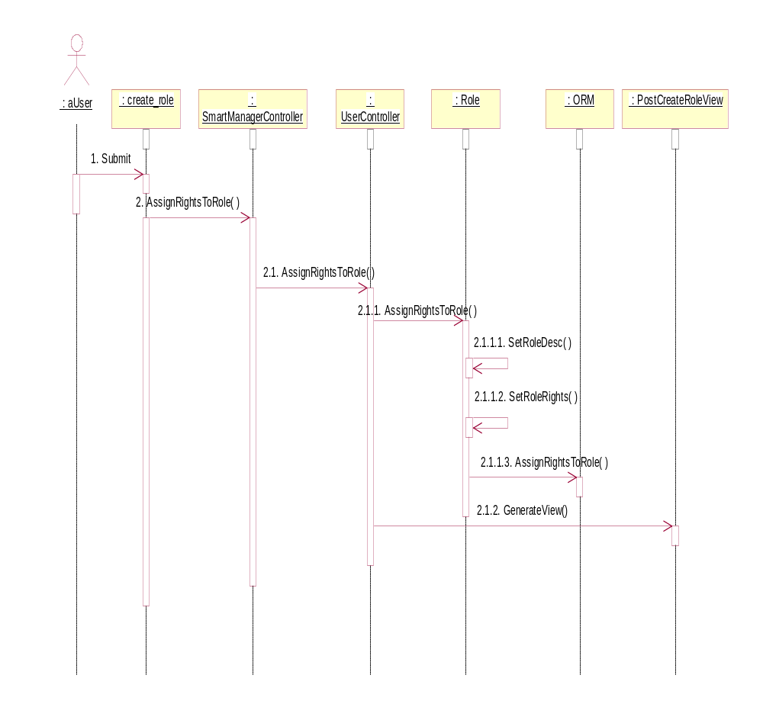

Create User
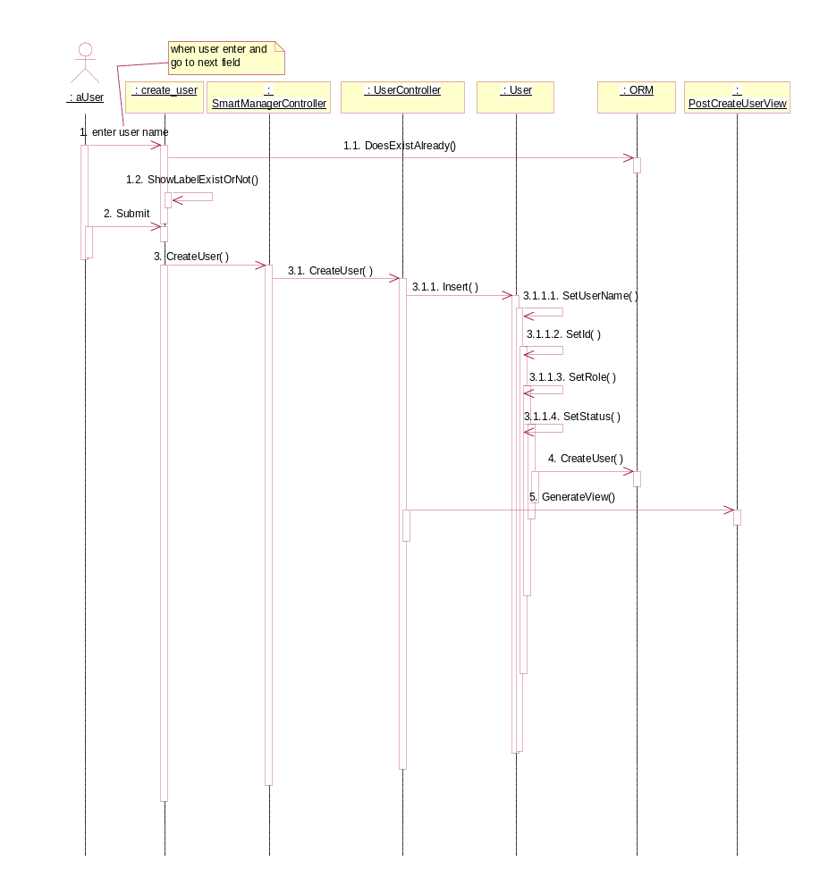

Login User
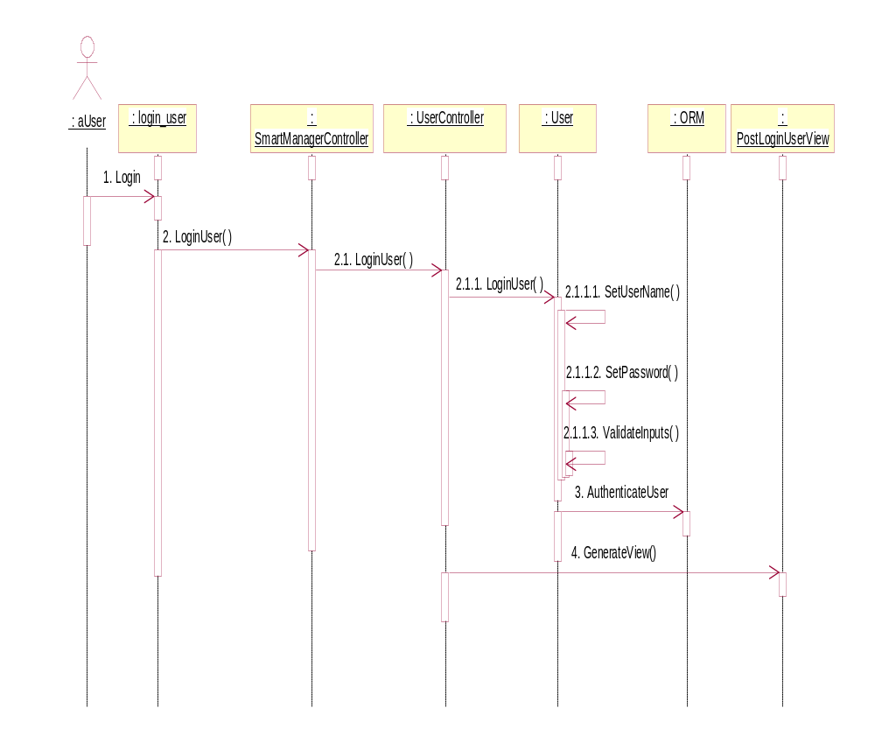

Punch In/Out User
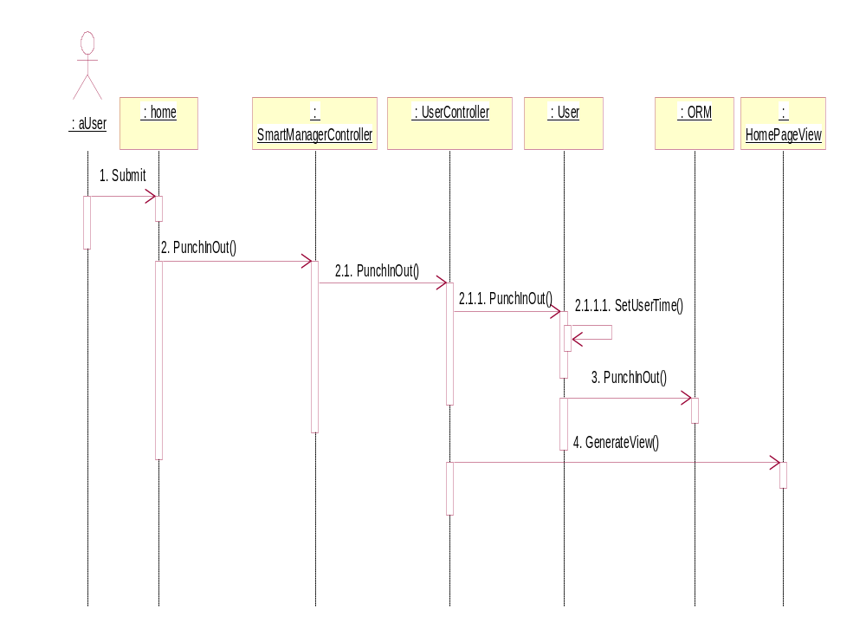

Create Project
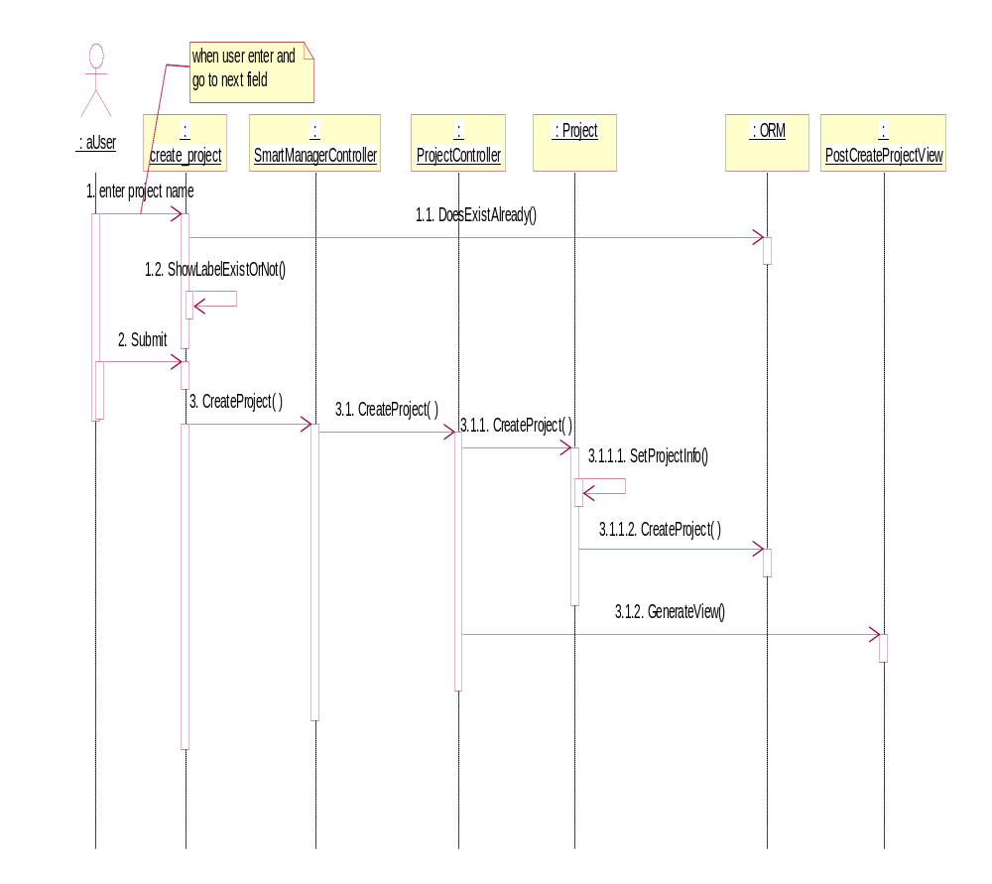

Update Project
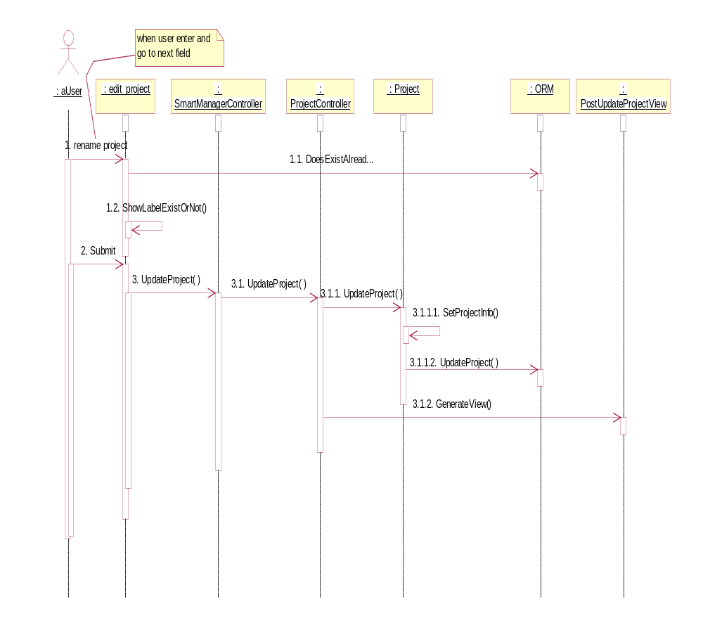

View Projects List Detail
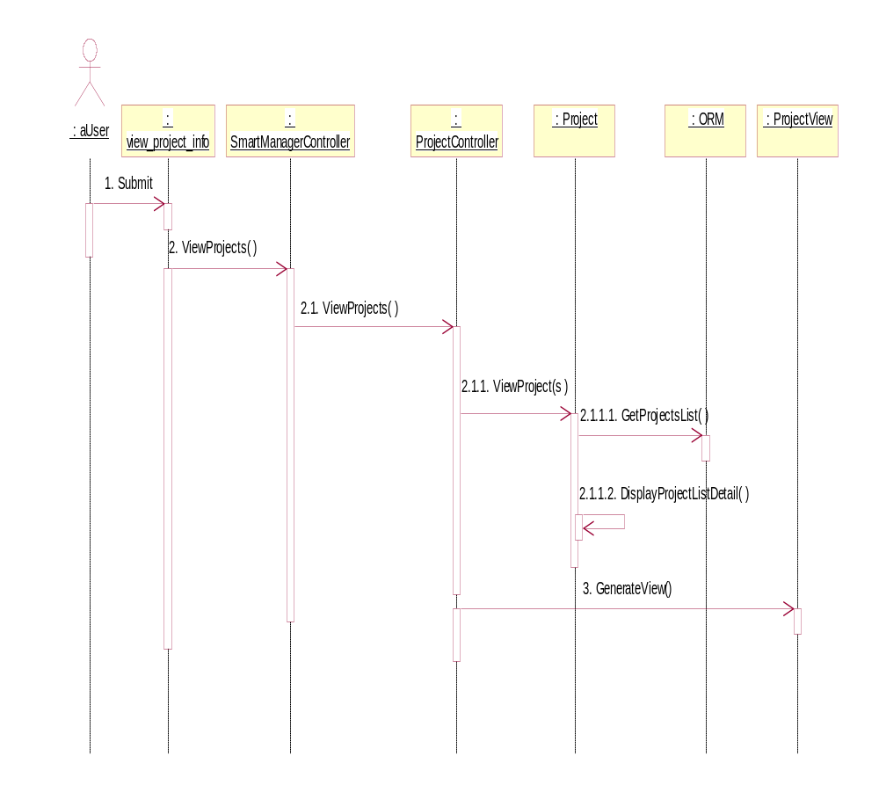

View Project Versions Detail
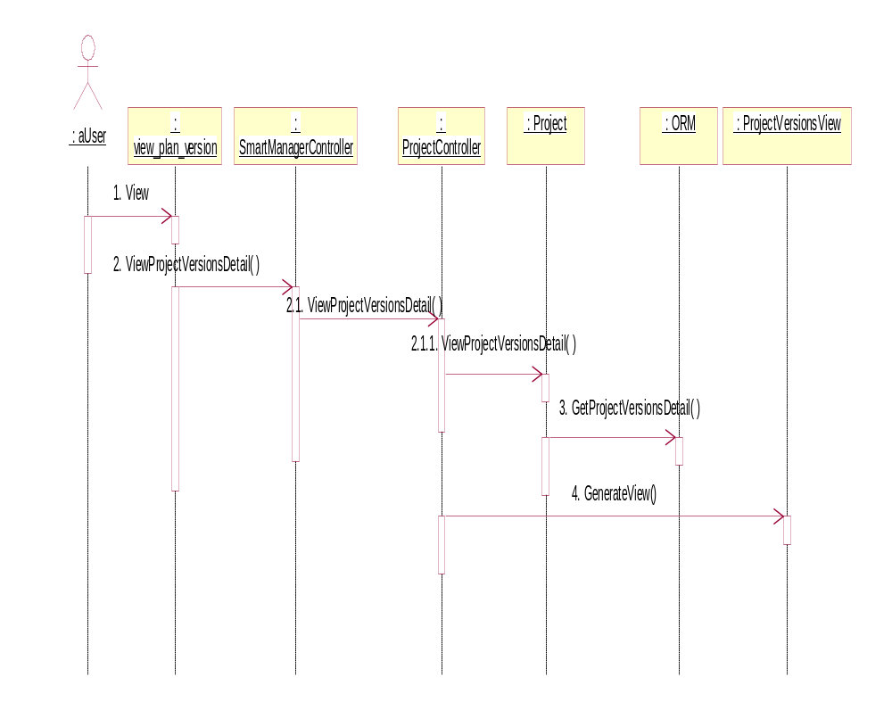

Create Milestone
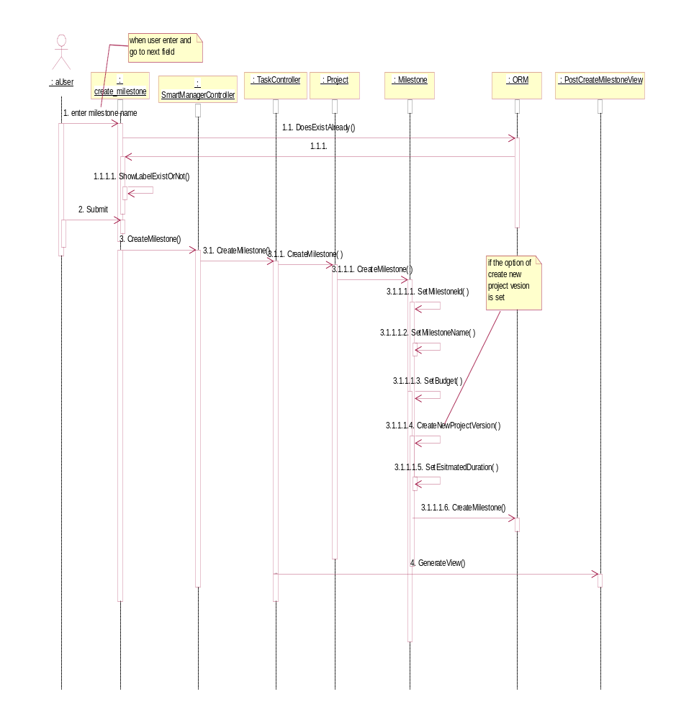

View Milestones Info
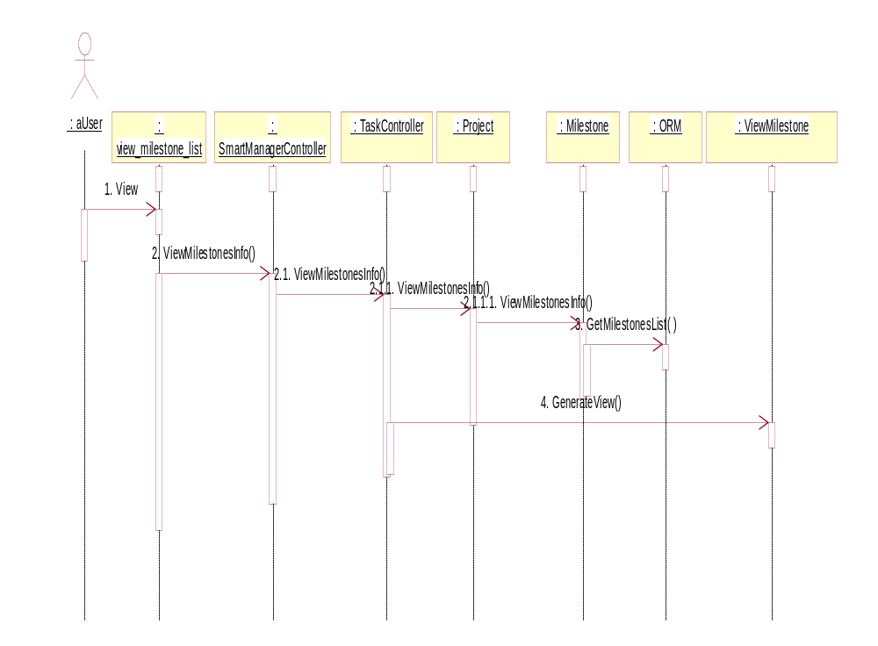

Assign/Update Milestone Budget
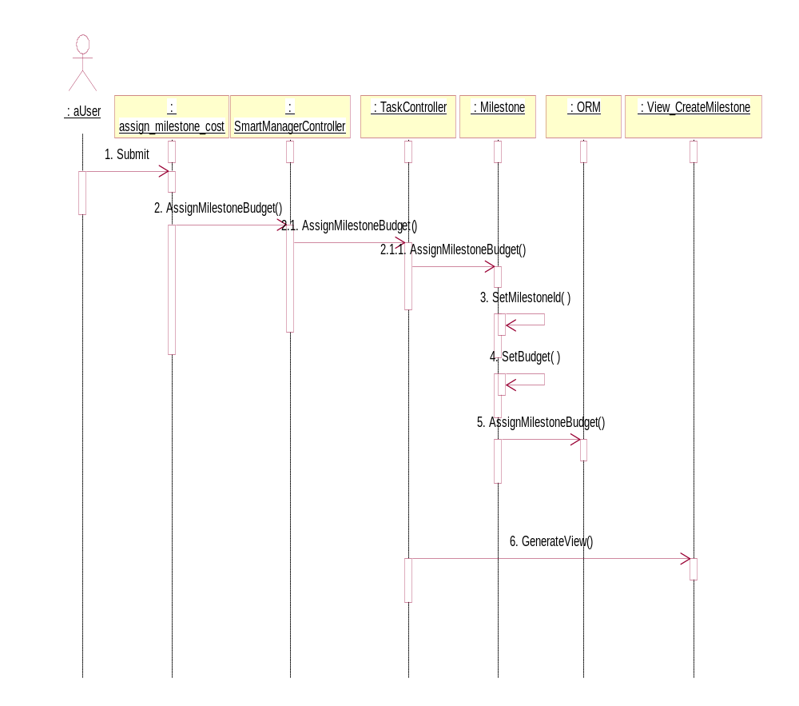

Calculate Budget
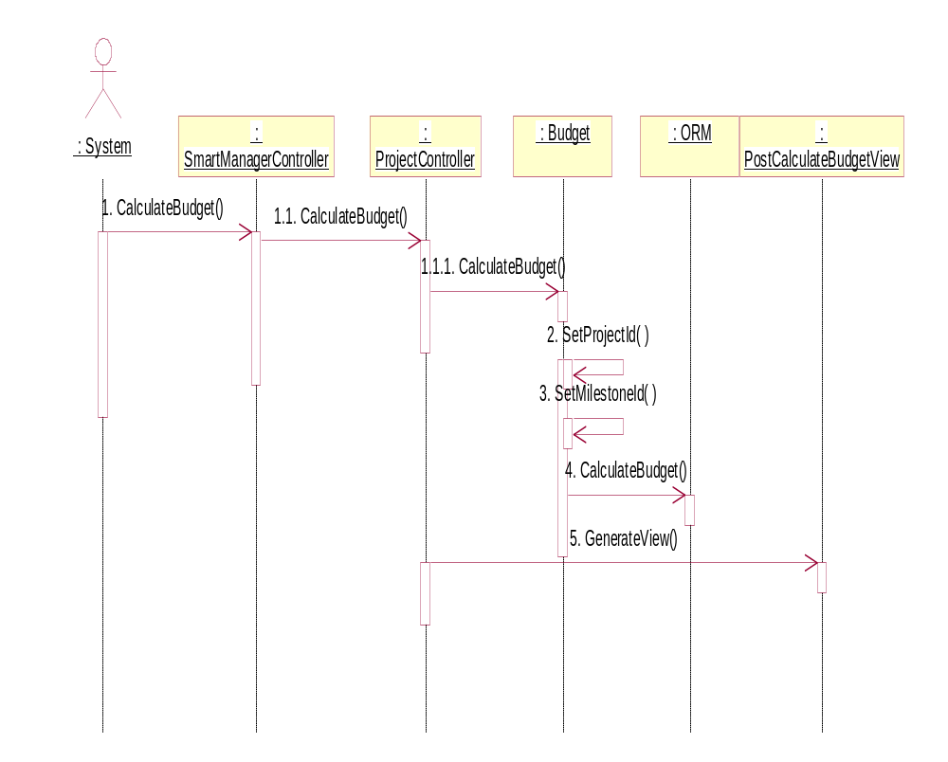

Set Resource Cost
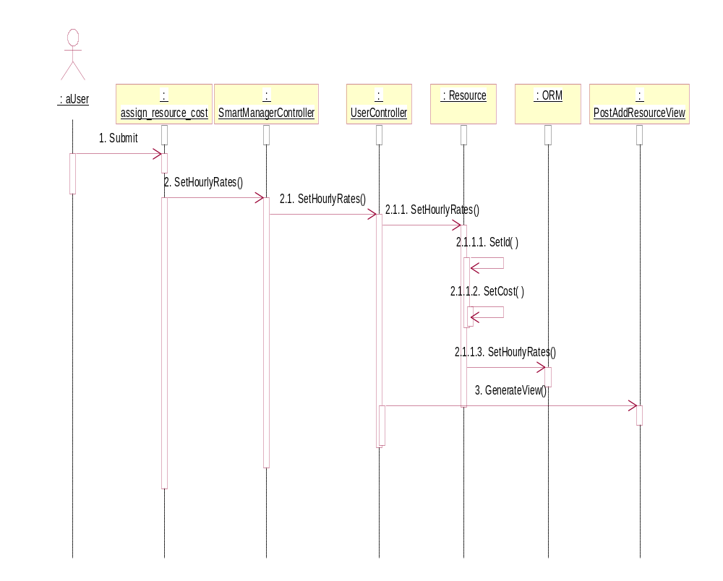

View Resource Info
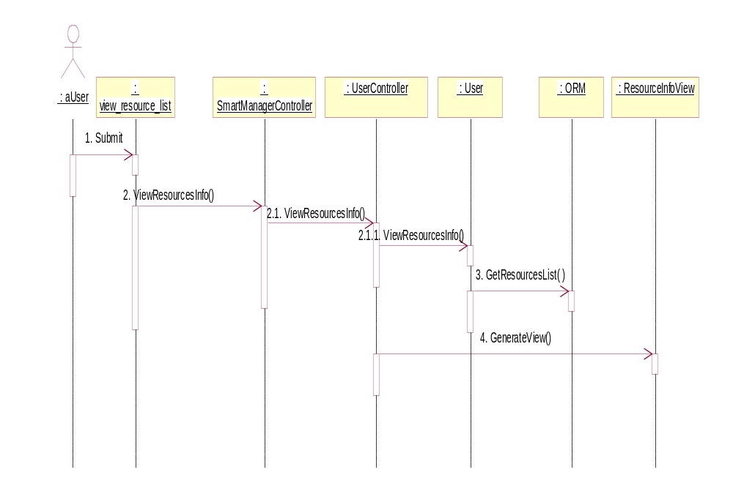

Update Resource Cost
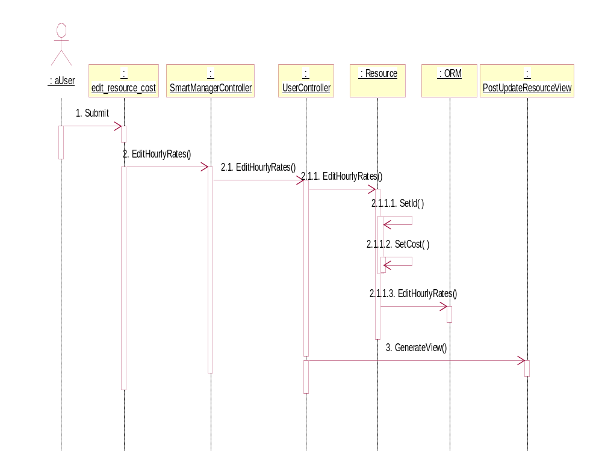

Create Task
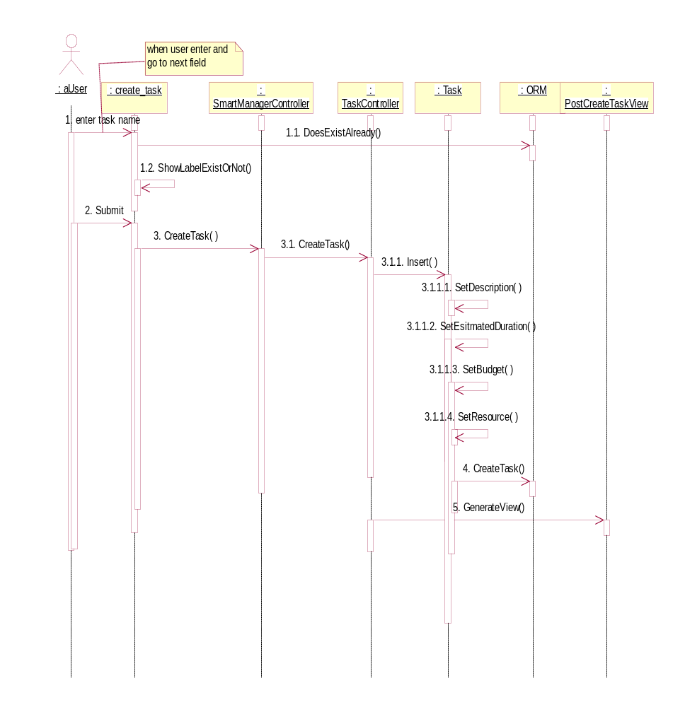

View Project Tasks List
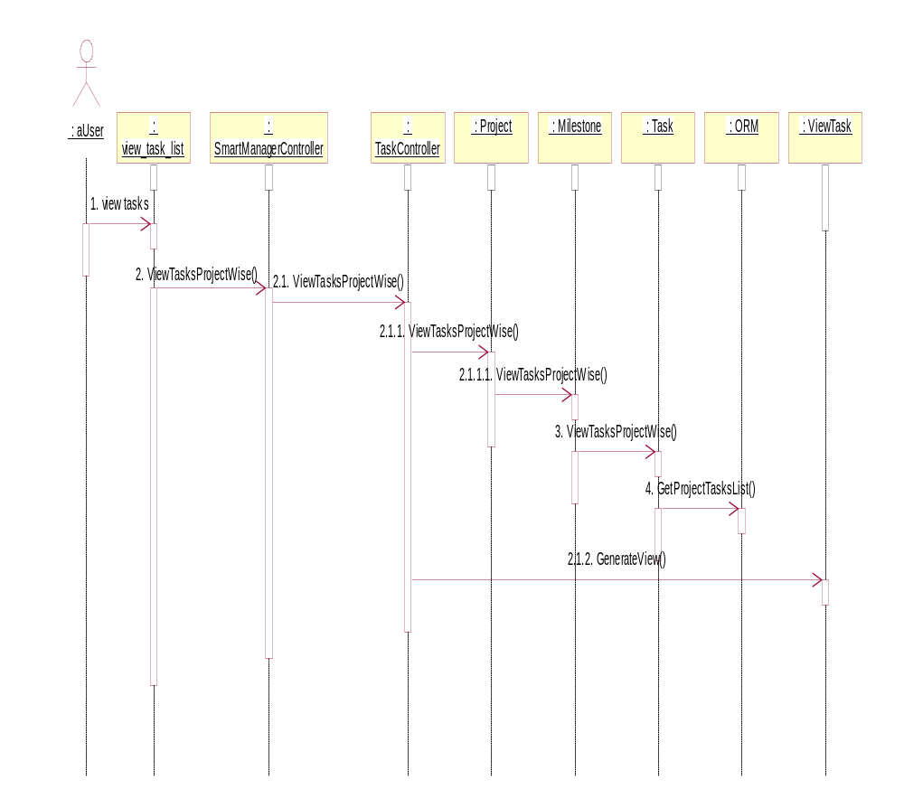

Edit Task
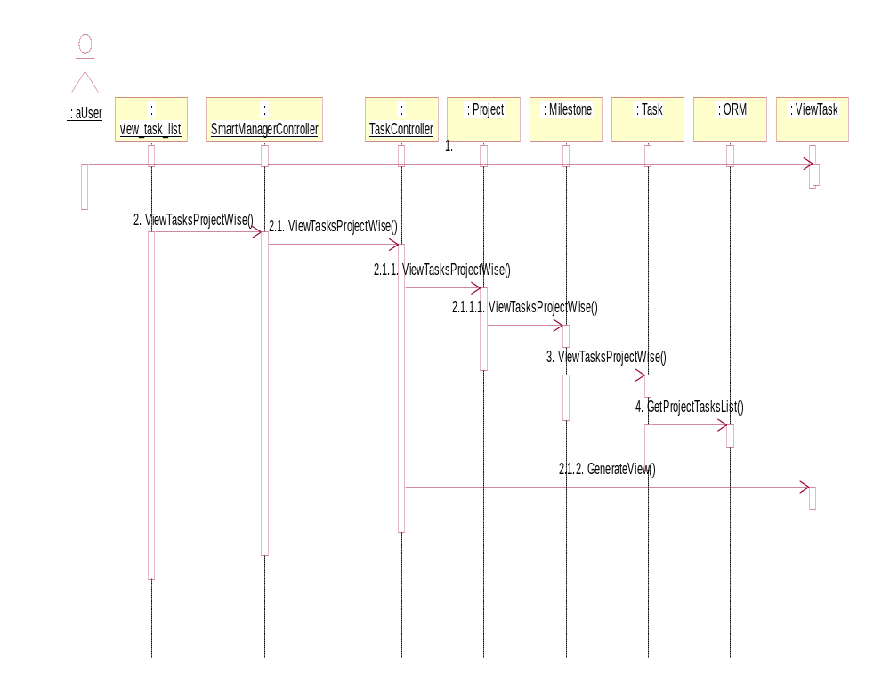

Update Resource
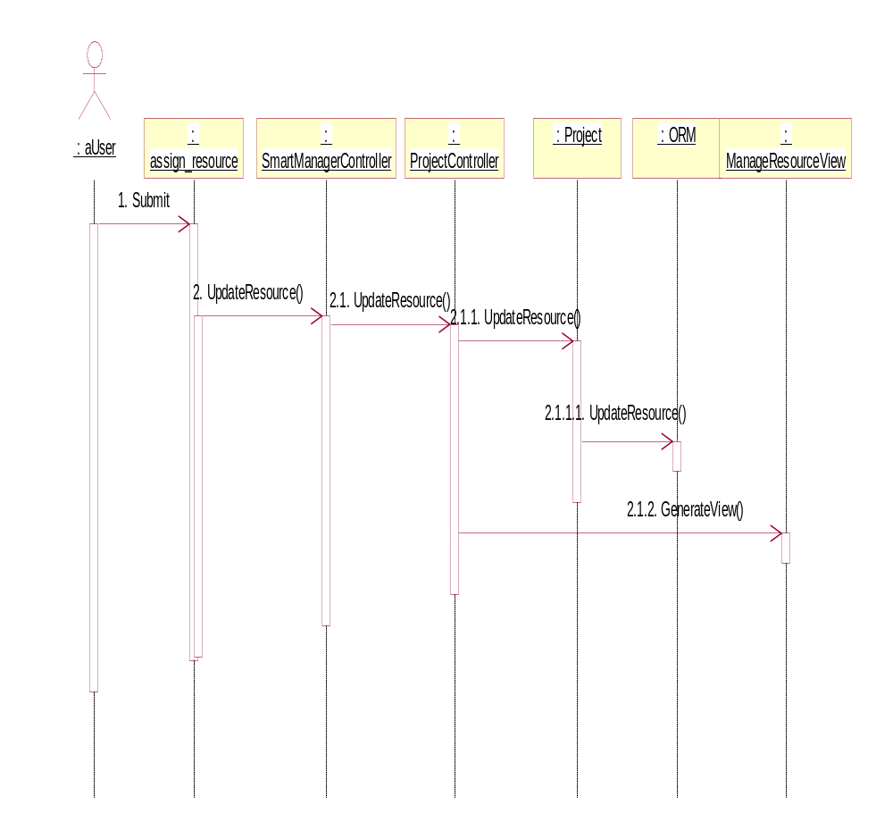

Alert for Delayed Task
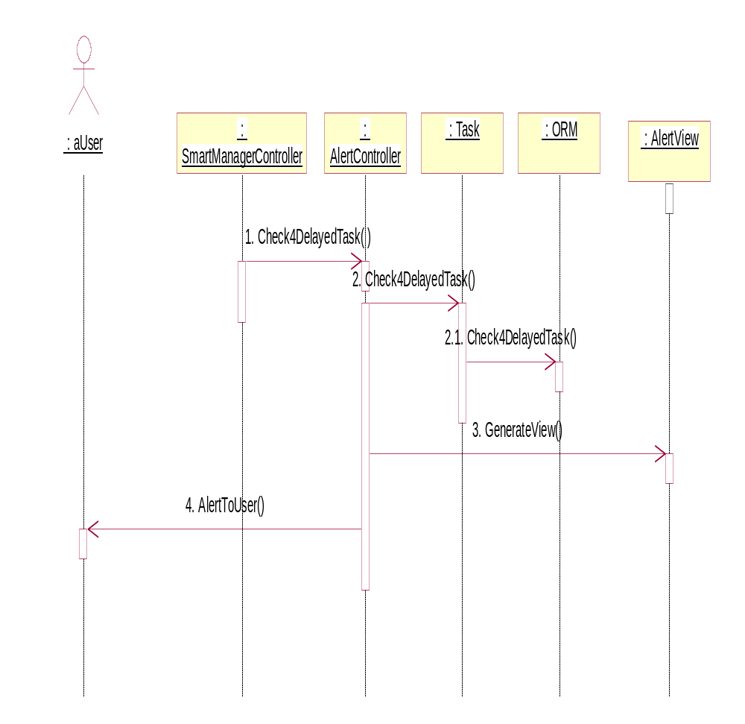

Alert for Budget Over Consumption
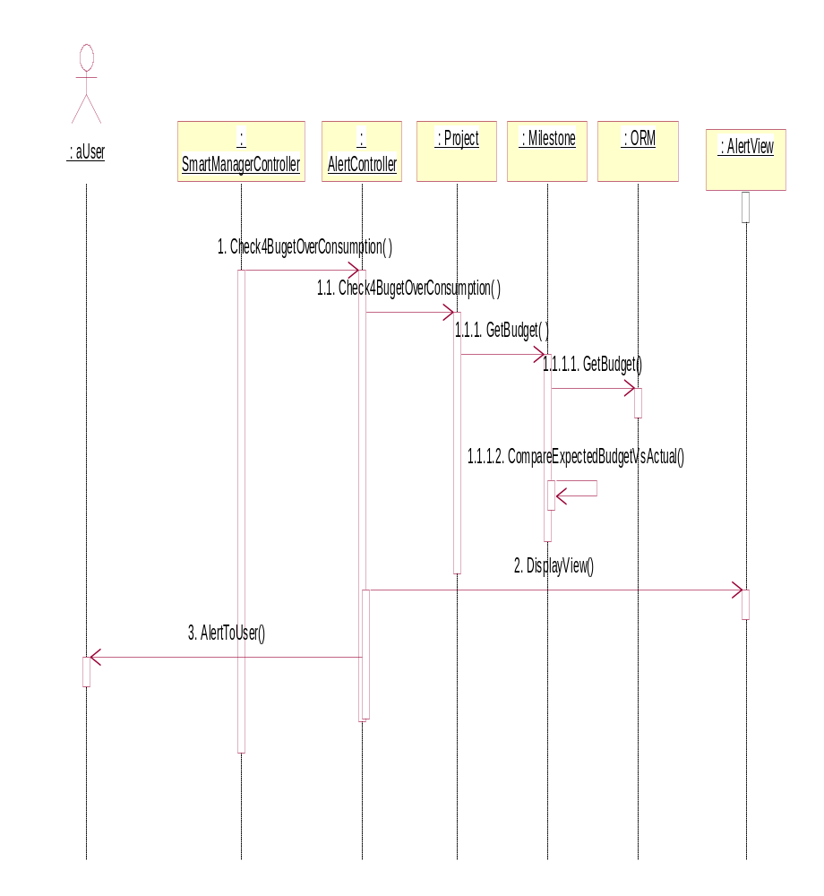

Alert for Milestones Conflict
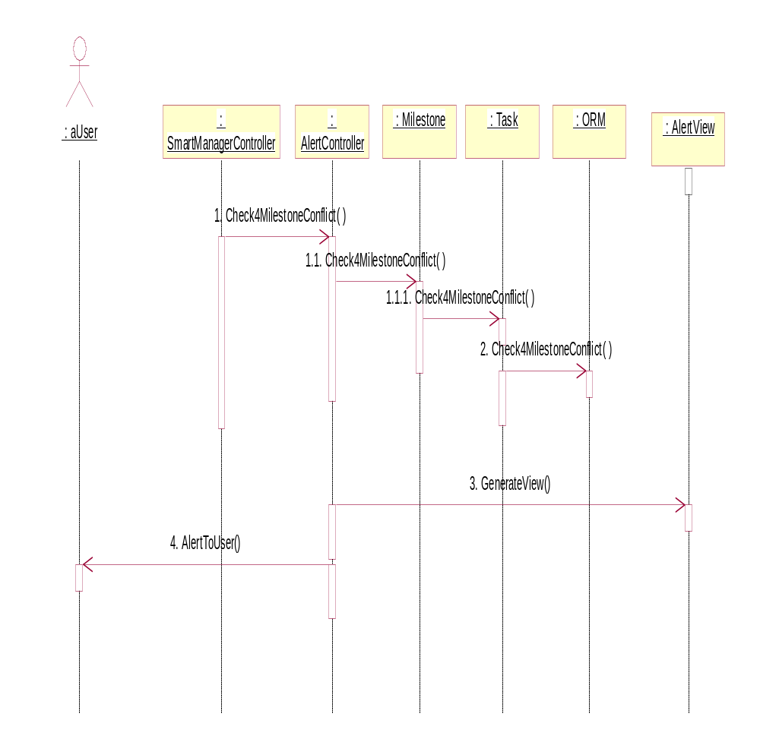

Calendar View
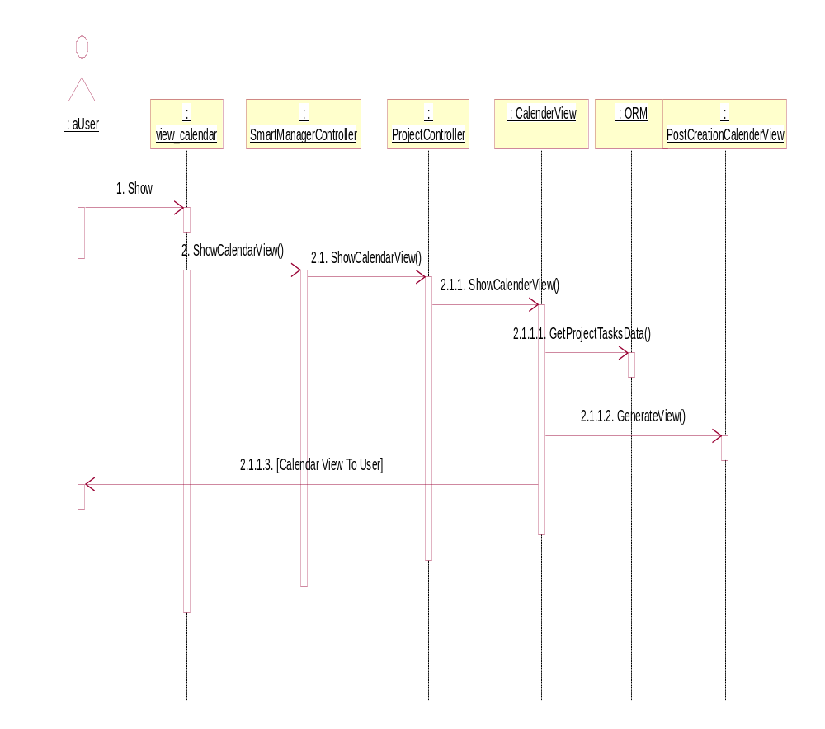

Auto Email Tasks to Resources
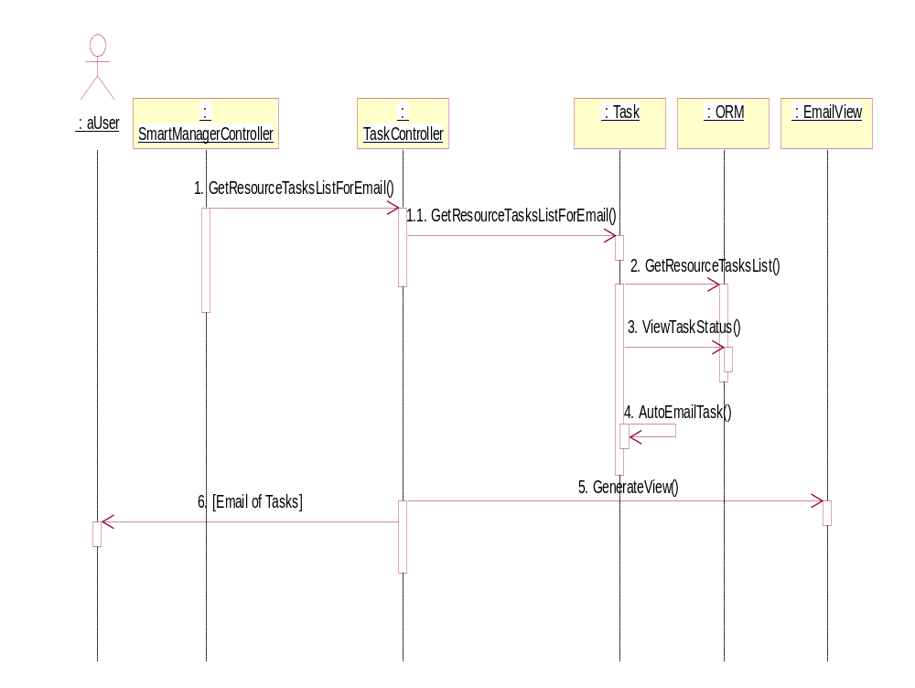

Traceability Matrix

Functional Requirements | Use Case | GUI (SRS) | Sequence Diagrams (Design)
R1 | SMUC-01 | 13.1 | 11.1
R2,R3 | SMUC-02 | 13.2 | 11.2
R2 | SMUC-03 | 13.3 | 11.2
R4 | SMUC-04 | 13.3 | 11.3
R5 | SMUC-05 | 13.5 | 11.4
R6 | SMUC-07 | 13.27 | 11.7
R7 | SMUC-06 | 13.7 | 11.5
R8 | SMUC-08 | 13.6, 13.8 | 11.6
R9 | SMUC-09 | 13.6,13.8,13.24 | 11.9
R10 | SMUC-10 | 13.24 | 11.8
R13 | SMUC-12 | 13.13,13.15 | 11.17
R14 | SMUC-11 | 13.11,13.12 | 11.9
R15 | SMUC-14 | 13.22 | 11.16
R16 | SMUC-15 | 13.24 | 11.18
R17, R18, R19, R20, R21 | SMUC-13 | 13.21,13.22 | 11.17
R20 | SMUC-17 | 13.22 | 11.17
R20 | SMUC-18 | 13.21 | 11.17
R22 | SMUC-16 | 13.22 | 11.18
R23 | SMUC-19 | 13.17 | 11.15
R24 | SMUC-20 | 13.18,13.19 | 11.13
R25 | SMUC-21 | No GUI required | 11.12
R26 | SMUC-22 | 13.25 | 11.19
R27 | SMUC-23 | 13.24 | 11.18
R27 | SMUC-24 | 13.23 | 11.17
R28 | SMUC-25 | 13.28 | 11.20
R29 | SMUC-26 | 13.25 | 11.22
R30 | SMUC-27 | 13.26 | 11.23
R31 | SMUC-28 | 13.28 | 11.21
R32 | SMUC-29 | No GUI required. | 11.24

http://en.wikipedia.org/wiki/Model-view-controller
http://wikipedia.org/wiki/Object-relational_mapping
http://cakephp.org/

