Smart Manager
Software Software Requirements Specification

Version <1.6>

Revision History

Date | Version | Description | Author
<15/Sep/09> | 1.0 | This is the initial version based upon requirement document, may need to be revised with time | Aqib Javed  Burhan Rasool  Muhammad Imran Iqbal  Muhammad Rauf Ayub  Sadia Manzoor
<06/Oct/09> | 1.1 | The SRS is updated after individual team members’ review. | Aqib Javed  Burhan Rasool  Muhammad Imran Iqbal  Muhammad Rauf Ayub  Sadia Manzoor
<09/Oct/09> | 1.2 | The SRS is updated after first group review. | Aqib Javed  Burhan Rasool  Muhammad Imran Iqbal  Muhammad Rauf Ayub  Sadia Manzoor
<09/Nov/09> | 1.3 | The SRS is updated after second group review.  Requirements R11 and R12 have been stroked-out, which means they have been deferred for now. These requirements will not be implemented by us. | Aqib Javed  Burhan Rasool  Muhammad Imran Iqbal  Muhammad Rauf Ayub  Sadia Manzoor
<23/Nov/09> | 1.4 | The SRS is updated after issues identified during nouns identification stage of Design Document | Aqib Javed  Burhan Rasool  Muhammad Imran Iqbal  Muhammad Rauf Ayub  Sadia Manzoor
<25/Dec/09> | 1.5 | The SRS is updated after issues identified during Design Document | Aqib Javed  Burhan Rasool  Muhammad Imran Iqbal  Muhammad Rauf Ayub  Sadia Manzoor
<20/Jan/10> | 1.6 | The SRS is updated after issues identified after Formal Review | Aqib Javed  Muhammad Rauf Ayub  Sadia Manzoor

Table of Contents
1. Introduction 7
1.1 Purpose 7
1.2 Scope 7
2. Overview 7
2.1 Problem Statement 7
2.2 Product Features 7
2.3 User Characteristics 8
3. Process Flow 9
4. Functional Requirements 10
5. Non-Functional Requirements 12
6. Prototyping Scope 12
7. Actors 13
8. Use-Cases 13
8.1 User Management 13
8.1.1 Assign Right(s) to Role 13
8.1.2 Create User 14
8.1.3 Verify Email 14
8.1.4 Login 15
8.1.5 Mark Attendance 15
8.2 Manage Projects 16
8.2.1 Create Project 16
8.2.2 View Project 16
8.2.3 Edit Project 17
8.2.4 Create Project Plan Version 17
8.2.5 View Project Plan Versions 18
8.3 Manage Milestones 18
8.3.1 Create Milestone 18
8.3.2 View Milestone 19
8.4 Manage Tasks 19
8.4.1 View Tasks 19
8.4.2 Create Task 20
8.4.3 Edit Task 21
8.4.4 Enter notes against particular task 21
8.4.5 View task’s status report 22
8.4.6 View project status report 23
8.5 Budget Tracking 23
8.5.1 Assign cost (hourly rates) to resource 23
8.5.2 Edit cost (hourly rates) amount of resource 24
8.5.3 Calculate consumed budget 25
8.6 Resource Management 25
8.6.1 Assign Resource(s) to Project 25
8.6.2 Assign Single Task to Resource(s) 27
8.6.3 Assign Multiple Tasks to Single Resource) 28
8.7 Alert Generation 29
8.7.1 Delayed task Alert 29
8.7.2 Conflicting milestones Alert 30
8.7.3 Calendar view 30
8.7.4 Budget over consumed Alert 31
8.7.5 AutoEmail Daily Task 31
8.8 Common Use Case Exceptions: 32
8.9 Common Alternative Flows: 32
9. Traceability Matrix 34
10. System Architecture Diagram 36
11. Data Model 37
12. Object Model 39
13. GUIs 40
13.1 Create Role Screen 40
13.2 Create User Screen 41
13.3 Login Screen 42
13.4 Home Screen after Successful Login 43
13.5 Login Screen 44
13.6 Home Screen after Successful Login 45
13.7 Mark Attendance Screen 46
13.8 Select Active Project 46
13.9 Create Project Screen 47
13.10 Edit Project Screen 48
13.11 Import Project Schedule Screen 49
13.12 Export Project Schedule Screen 50
13.13 Manage Milestone Menu Screen 51
13.14 Create Milestone Screen 52
13.15 View Milestone Info Screen 53
13.16 Assign Budget to Milestone Screen 55
13.17 View Milestone Info Screen (Edit Budget Cost) 56
13.18 Edit Milestone Budget Screen 57
13.19 Assign Resource Cost Screen 58
13.20 View Resource Info Screen to Edit Resource Cost 59
13.21 Edit Resource Cost Screen 60
13.22 Create task Screen 61
13.23 View Task Info Screen 62
13.24 Edit Task Info Screen 63
13.25 Assign Resource Screen 64
13.26 View Project PlanVersion Screen 65
13.27 View Projects 66
13.28 Alerts’ Screens 67
13.29 Task Alert Calendar View Screen 69
13.30 Budget Over-Consumed by Milestone Alert 69
14. Assumptions 70
15. References 70
16. Glossary 70
17. Appendix 71
17.1 71
17.2 72
17.3 72
17.4 72

Software Requirements Specification

Introduction

Purpose

This is the Software Requirements Specification (SRS) document for a Software Project Management tool called “SMART Manager”. The purpose of this document is to specify system’s requirements, both functional and non-functional and a traceability matrix that displays which functional, non-functional requirement and GUI is intended for a particular use case. Further, this document will present the Process, Dataflow, ER and Object Model Diagrams. Some of the basic GUIs pertaining to the system will also be part of this document.

Scope

The scope of the project management tool is limited to features like User Management, Manage Projects, Manage Milestones & Tasks, Budget Tracking, Resource Management and Alerts Management.
This document details these features along with the characteristics of each user that would be interacting with the system, their roles and responsibilities.

Overview

Problem Statement

Although there are many project management tools available in the market which provides the basic project scheduling and resource allocation mechanism, but our intended tool will provide the following features, in addition to these basic project management tools’ functionalities:
- A mechanism to estimate the cost of the Project
- A mechanism to define milestones and tasks for a project
- Maintain attendance records of resources working on projects
- Generate alerts for major milestones and deadline delays

Product Features

The purpose of our proposed project management tool is to provide a mean for effective project management from inception of a project to finalization. The tool would comprise of the features/modules that are required by project manager during the entire life cycle of the project.

This project would take into account the following features/requirements for managing projects:
- User Management
- Manage Projects (including project versioning)
- Manage Milestones & Tasks
- Budget Tracking
- Resource Management

User Characteristics

Type of User | User Characteristic | User Technical Expertise | Effect on System functionality
Administrator | 1-Create users  2- Assign roles and permissions  3- Interface content management[17.3] | 1. Average in technical proficiency  2. Able to use web application | 1. User interface with less input steps.  2. Easy to learn
CEO | 1- View all project reports  2- Comment on any activity or project | 1. Average in technical proficiency  2. Able to use web application | 1- User interface with less input steps.  2- Easy to learn
Project Manager | - Create project  - Create milestones  - Add tasks  - Assign task  - Project estimations  - Allocate resources  - Budget tracking  - View status reports  - Update his/her’s project/task status  - Comment on all activities of the project | 1.Excellent in technical proficiency  2. Able to use web application | 1- User interface with less input steps.  2- Easy to learn
Team Lead | - Assign task  - Allocate resources  - View status reports  - Update his/her assigned task  - Comment on her/his team’s activities | 1. Excellent in technical proficiency  2. Able to use web application | 1- User interface with less input steps.  2- Easy to learn
Developer | - View status reports of his/her assigned activities  - Update his/her assigned task  - Comment on his/her project activities | 1. Good in technical proficiency  2. Able to use web application | 1- User interface with less input steps.  2- Easy to learn
Tester | - View status reports of his/her assigned activities  - Update his/her assigned task  - Comment on his/her project activities | 1.Good in technical proficiency  2. Able to use web application | 1- User interface with less input steps.  2- Easy to learn
Quality Assurance Officer | - View all project reports  - Update project/task status  - Comment on all activities of the project  - Review all project activities | 1. Good in technical proficiency  2. Able to use web application | 1- User interface with less input steps.  2- Easy to learn

Process Flow

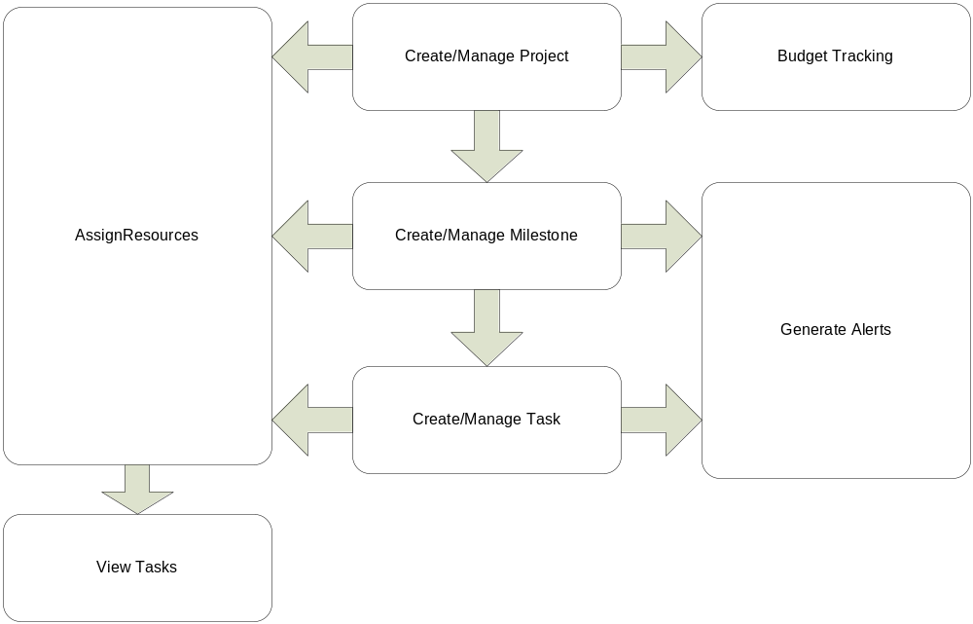

Functional Requirements

Ref # | Explanation
User Account Management
 | System shall allow the administrator to create following roles CEO, project manager, team lead, developer, quality assurance officer, developer and tester.
 | System shall allow the administrator to create users by entering name, password, role, status, email address and contact number.
 | System shall allow the administrator to assign created role(s) to specific user(s)
 | System shall allow the user (CEO, administrator, project manager, team lead, developer and tester) to log in by entering username and password in input box via keyboard.
 | System shall allow the logged in user to mark his/her attendance by entering Check-In and Check-Out his/her time, in the corresponding input boxes through the keyboard.
Manage Projects
 | System shall allow the project manager to view the list of existing projects.
 | System shall allow the project manager to create a new project by entering project name, description, expected start date, actual start date(optional), expected end date, actual end date(optional), status and expected cost and actual cost (optional).
 | System shall allow the project manager to edit an existing project by entering project name, description, expected start date, actual start date, expected end date, actual end date, status and cost.
 | System shall allow the project manager to create the versions of project plan in order to reflect the changes.
 | System shall allow the project manager to view the different versions of project plan which shall reflect the changes of milestones, time estimation and cost estimation in red color.
 | System shall allow the project manager to upload the project schedule by importing CSV file.
 | System shall allow the project manager to export the project schedule into CSV file
Manage Milestones/Tasks
 | System shall allow the users (CEO, administrator, project manager, team lead, developer and tester) to view list of his/her assigned tasks details task id, description, millstone ,start date, end date, states notes and assignee.
 | System shall allow the project manager to create milestones under each project.
 | System shall allow the project manager/team lead to create tasks by entering description, start date, expected end date, actual end date, dependency, cost and status against each milestone.
 | System shall allow the project manager to edit task description, start date, expected end date, actual end date, dependency, cost and status against each milestone.
 | System shall allow the CEO, project manager, team lead, developer, and tester and QA officer to view task’s status report of new, incomplete, complete, in progress or delayed tasks specific to their roles.
 | System shall allow the CEO and project manager to view list of tasks for a particular project or projects.
 | System shall allow the CEO and project manager to view list of tasks for a particular resource or resources.
 | System shall allow the CEO and project manager to view list of new, incomplete, complete, in progress and delayed tasks.
 | System shall allow the CEO and project manager to view list of new tasks which have not been assigned during a given period.
 | System shall allow the project manager, team lead, developer, tester and QA officer to enter notes against their assigned /created tasks.
Budget Tracking
 | System shall allow the project manager to assign the hourly rates to each resource (project manager, developer, tester, QA officer) working on the project.
 | System shall allow the Project Manager to Edit the hourly rates to each resource (project manager, developer, tester, QA officer) working on the project.
System shall automatically calculate the budget consumed
- per day
- per milestone
- per project
at the end of each working day through a scheduled routine.
Resource Management
 | System shall allow the project manager to add resources for a particular project.
 | System shall allow the project manage/team lead to assign tasks to a resource.
Alert Generation
 | System shall automatically generate alerts in case of delayed tasks.
 | System shall automatically generate alerts in case of conflicts between different milestones.
 | System shall provide a calendar view showing scheduled millstones/tasks due in selected dates.
 | System shall generate alerts in case of budget over consumed by slippage of any milestone.
 | System shall communicate daily tasks to each project resources through auto-emails and Cc to PM at the end of the day (i.e. 12 Mid Night).

Non-Functional Requirements

Ref # | Explanation
Usability
 | System shall allow the user to navigate using both the key board and mouse.
 | System shall provide an extensive user manual, elaborating all the features of the product, so that the user takes around a week’s (Average time defined is 7.25 days [Appendix 17.1]) time to be familiar with the features and working of the tool.
Performance
 | System shall perform on average one transaction in 5 seconds (Average time defined is 5.33 seconds [Appendix 17.2])
Security
 | System shall provide access to authorized users only that have valid login
 | System shall allow the users to view only their own data.
Software
 | The required software for server (Windows/Linux Operating System, PHP framework, Apache Server, MySQL Database Server, and Licensed Anti-Virus) shall be available for system implementation.
 | The application is platform independent and shall be accessed by using Microsoft Internet Explorer Versions 8.0+ or Fire fox versions 3.0+) browsers from client machine.
Hardware
 | The required hardware for servers (Server for Database & Application Server, Backup Server & UPS for power backup) shall be available for system implementation.
The required hardware for client machine (CPU: 3.4 GHz Pentium 4, RAM: 500 MB,
HDD: 10GB,Network adapter appropriate for the type of local-area or wireless,
Keyboard, Mouse and UPS for power backup) shall be available for system implementation.
System Availability
 | System shall not be down more than 1 hour.

Prototyping Scope

The scope of prototyping would be as follow

- Navigation of All modules
- Development of User Management module (All requirements)
- Development of Manages Project Module (Create & Edit project requirements (R6,R7,R8))

Actors

Actors | Responsibilities
CEO | - Assigning Projects to Project Managers  - Maintaining a Record of all Projects
Project Manager | - Maintain data regarding all the projects Assigned  - Create and manage Milestones of assigned projects  - Assign resources to projects  - Track budget of projects  - Ensure timely delivery of project deliverables  - Update project plan  - Manage budget and resource requirements for a project
Team Leader | - Divide the milestone into tasks  - Assign tasks to resources allocated for a project  - Ensure timely achievement of all Milestones in project
Quality assurance officer | - Maintain quality of all the deliverables  - Assign tasks to testers assigned to the project
Developer | - Ensure timely completion of all the development tasks assigned.
Tester | - Ensure timely completion of all the QA tasks assigned.

Use-Cases

User Management

Assign Right(s) to Role

Use Case ID
Use Case Name | Assign Right(s) to Role
Actors | Administrator
Description | The purpose of this use case is to define the steps for successful Role creation in the system.
Preconditions | - The user has logged in as Administrator of the System.
Post Conditions | - A new Role has been defined in the System
Main Flow | - The Administrator selects the Add Role option (like Project Manager, etc.)  - The system displays the define Role interface  - The Administrator selects the Role  - The system displays the Assign Rights interface  - The Administrator assigns rights to the defined Role.  - The system validates the input (add, view, edit, delete).[E-2]  - The system displays confirmation message to the Administrator.  - The system asks the user if he/she wants to add another Role. [A-1]
Alternate Flow | A1-1 Repeat Steps 1to 8 of the Main Flow.
Exceptions | E1-1 The Role already exists in the system and the System displays message: “The role is already defined. Please define some new role interface”.  E 1-2 The user has not assigned any rights to the defined Role and the system prompts the user to assign rights.

Create User

Use Case ID
Use Case Name | Create User
Actors | Administrator
Description | The purpose of this use case is to define the steps for successful User creation in the system.
Preconditions | - The user has logged in as Administrator of the System.  - Manage User menu is displayed.
Post Conditions | - A new User has been created in the System
Main Flow | - The Administrator selects the Add User option from the Manage User Menu.  - The system displays the add User interface  - The Administrator inputs  - name,  - password,  - role,  - status (Active/Inactive/Pending)  - email address  - contact number of the User  - The system will validate the input format of each field.[E1-1]  - The system verifies that the User being created do not already exist in the system. [E1-2]  - The system generates an email and sends it to the user’s address with the login information.  - The system marks the user’s status as unverified.  - The system displays confirmation message to the Administrator.  - The system asks the user if he wants to add another User. [A-1]
Alternate Flow | A1-1 Repeat Steps 1to 8 of the Main Flow.
Exceptions | E 1-1 The user has not input the data in the correct format and the system displays error message on the create user interface.  E1-2 The User already exists in the system and the System displays the message: “User already exist. Please define new user” message on the create user interface.

Verify Email

Use Case ID
Use Case Name | Verify Email
Actors | CEO, project manager, team lead, developer and testers
Description | The purpose of this use case is to verify the email address entered when creating a new user.
Preconditions | - The user has received the system generated email.
Post Conditions | - The user has successfully logged in to the system
Main Flow | - The user goes to the link provided in the email  - The system displays the login interface.  - The user inputs the username and password provided in the email  - The system validates the entered information [E-1]  - The system updates the user’s status to verified.  - The system displays the homepage of the user.
Alternate Flow | Not Applicable
Exceptions | E1-1 The system is unable to validate the username and password supplied by the user.  E 1-2 The system displays the login page to the user with error message.

Login

Use Case ID
Use Case Name | Login
Actors | CEO, administrator, project manager, team lead, developer and testers
Description | The purpose of this use case is to define the steps required for the user to successfully log in to the system
Preconditions | - The user has been assigned a username and password by the admin  - The user has access to the system URL.
Post Conditions | - The user has successfully logged in to the system.
Main Flow | - The user inputs the username.  - The user input the password  - User presses the login button.  - The system validates the username and password from database [E-1]  - The system checks for the rights assigned to the user  - The system displays the homepage of the user.
Alternate Flow | Not Applicable
Exceptions | E1-1-1 In case of invalid username, System displays this error message “Unrecognized User”  E1-1-2 In case of invalid password, System displays this error message “Invalid password”

Mark Attendance

Use Case ID
Use Case Name | Mark Attendance
Actors | project manager, team lead, developer and testers
Description | The purpose of this use case is to maintain the attendance record and the work hours put in by each user.
Preconditions | - The user (PM/TL/Developer/Tester) has logged in to the System.  - The attendance screen is displayed in the left corner of the screen.  - If the user has not entered check-in time then only the check-in option will be enabled while the check-out option will be disabled.  - If the user has entered check-in time then only the check-out option will be enabled while the check-in option will be disabled.
Post Conditions | - The user has successfully marked attendance.
Main Flow | - The system displays the time in textbox  - The user confirms the time displayed by the system.[E-1]  - The system marks current system time as the attendance the user.
Alternate Flow | A1-1 The user selects the mark Time out option  A1-2 The system displays the Mark time out Interface  A1-3 The user confirms the time-out displayed by the system.[E-2]  A1-4 The system marks current system time as the time-out for the user.
Exceptions | E1-1 The User submits the request without confirming the time-in option and the system prompts the user to confirm the same.  E2-1 The User submits the request without confirming the time-out option and the system prompts the user to confirm the same.

Manage Projects

Create Project

Use Case ID
Use Case Name | Create Project
Actors | Project Manager
Description | The purpose of this use case is to create/add new Project
Preconditions | - The user (PM) must be logged in.  - The user must possess relevant rights.  - User must be in view project screen.
Post Conditions | - A new project will create in to the system.  - System will show the confirmation message “Project is created successfully”
Main Flow | - User clicks on the “add new Project” button provided in the view screen of manage project.  - System displays the following fields to enter:  - Name of the Project  - Expected Start date  - Actual Start date  - Expected end date  - Actual end date  - Description  - Status (Active/Inactive)  - User must enter data in all mandatory fields whose labels marked with asterisk.  - User press the submit button to save the fields. [A1,A2,A3] [E1,E2,E3,E4]  - System saves data in database.
Alternate Flow | Refer to common alternative flows ()
Exceptions | Refer to common exception flows (UC-CEF)

View Project

Use Case ID
Use Case Name | View Project
Actors | Project Manager
Description | The purpose of this use case is to View the list of existing projects
Preconditions | - The user must be logged in.  - The user must possess relevant rights.
Post Conditions | - The list of existing projects will be displayed to the Project Manager
Main Flow | - The user clicks on the Link View Projects.  - The system displays a list of the existing projects that are assigned to/ created by the project manager.
Alternate Flow | Not Applicable
Exceptions | Not Applicable

Edit Project

Use Case ID
Use Case Name | Edit Project
Actors | Project Manager
Description | The purpose of this use case is to edit an existing Project
Preconditions | - The user must be logged in.  - The user must possess relevant rights.  - User must be in view project screen.[SMUC-7]
Post Conditions | - An existing project will update in the system.  - System will show the confirmation message “Project is updated successfully”
Main Flow | - User select the project by clicking on the radio button [E5]  - User clicks on the “edit Project” button provided on the view project screen.  - System displays the following fields to edit:  - Name of the Project  - Expected Start date  - Actual Start date  - Expected end date  - Actual end date  - Description  - Status (Active/Inactive)  - Expected Cost  - Actual Cost  - User must enter data in all mandatory fields whose labels marked with asterisk.  - User press the submit button to save the fields. [A1,A2,A3] [E1,E2,E3,E4]  - System will update the data in database
Alternate Flow | Refer to common alternative flows (UC-CAF)
Exceptions | Refer to common exception flows (UC-CEF)

Create Project Plan Version

Use Case ID
Use Case Name | Create Project Plan Versions
Actors | Project Manager
Description | The purpose of this use case is to allow the PM to create versions of a project plan.
Preconditions | - The user (i.e. PM) must be logged in.  - The user must possess relevant rights.  - The user is in the create milestone interface
Post Conditions | - System will show the confirmation message, “Project plan version is created successfully”.
Main Flow | - System will provide an option (check box) labeled with “Create Version” on Add Milestone (R8) interface.  - Project manager shall select the option (check box) labeled with “Create Version” in order to create a new version of Project Plan after providing the Milestone information.  - System shall ask the Project Manager to create the task under that Milestone.  - System shall automatically validate the New Milestone’s tasks schedule conflict with the existing Milestone’s tasks schedule.[E6]  - System saves the data in the database.
Alternate Flow | Refer to common alternative flows (UC-CAF)
Exceptions | Refer to common alternative flows (UC-CEF)  E6. System shall generate error message “Provide schedule date are already assigned to Milestone Name. Please modify the schedule dates”.

View Project Plan Versions

Use Case ID
Use Case Name | View Project Plan versions
Actors | Project Manager
Description | The purpose of this use case is to allow the PM to view latest versions of a Project Plan
Preconditions | - The user (i.e. PM) must be logged in.  - The user must possess relevant rights.
Post Conditions | - The system highlights the latest records.
Main Flow | - User will open View Project Plan Versions’ interface from the Manage Project Menu  - System shall provide list of all the versions of a Project Plan which includes, plan version, milestone name, tasks, start date, end date, cost and creator.  - Changes (New added Milestones & Tasks) shall be highlighted in red color [E6]
Alternate Flow | Not Applicable
Exceptions | E6. There is not Project Plan available and system will display the message “No Project Plan Available”

Manage Milestones

Create Milestone

Use Case ID
Use Case Name | Create Milestone
Actors | Project Manager
Description | The purpose of this use case is to allow the PM to create/add new milestone
Preconditions | - The user (i.e. PM) must be logged in.  - The user must possess relevant rights.  - User must be in view project screen.
Post Conditions | - A new milestone will create in the system  - System will show the confirmation message, “Milestone is created successfully”.
Main Flow | - User clicks on the “add new milestone” button provided on the view screen of the manage milestone.  - System will prompt the user to enter the following fields:  - Name of the milestone  - Due date  - End date  - Description  - User must enter data in all mandatory fields whose label marked with asterisk (*)  - User press the submit button to save the fields. [A1,A2,A3] [E1,E2,E3,E4]  - System saves data in database
Alternate Flow | Refer to common alternative flows (UC-CAF)
Exceptions | Refer to common exception flows (UC-CEF)

View Milestone

Use Case ID
Use Case Name | View Milestone
Actors | Project Manager, team lead
Description | The purpose of this use case is to allow the PM/TL to view the list of milestones related to a specific project
Preconditions | - The user (i.e. PM/TL) must be logged in.  - The user must possess relevant rights.
Post Conditions | - System shows the view milestone screen.
Main Flow | - User clicks on the “Manage Milestone” link provided on the main screen of the system. [E3,E4]  - System displays the list of milestones (name, start date, end date, status) that are created, add button, edit button, view button, active/inactive button.  - User presses the add/ edit/ view/ active/inactive button. [E3,E4]
Alternate Flow | Refer to common alternative flows (UC-CAF)
Exceptions | Refer to common exception flows (UC-CEF)

Manage Tasks

View Tasks

Use Case ID
Use Case Name | View Tasks
Actors | CEO, administrator, project manager, team lead, developer and testers
Description | The purpose of this use case is to define the steps for the User to be able to view any tasks assigned to him
Preconditions | - The user (CEO/administrator/PM/TL/Developer/Tester) has logged in to the System.
Post Conditions | - The user has viewed the assigned tasks
Main Flow | - The system extract the assigned tasks for the user  - The system displays the tasks assigned to the user on the user homepage [E1-1]  - The user selects any task to view the details of the task.  - The system displays the task details.
Alternate Flow | Not Applicable
Exceptions | E1-1 The user is not assigned any task and the system will generate the error message “You are not assigned any task.”

Create Task

Use Case ID
Use Case Name | Create Task
Actors | Project Manager
Description | The purpose of this use case is to allow the PM to create/add new task against milestone
Preconditions | - The user (i.e. PM) must be logged in.  - The user must possess relevant rights.  - User select the project by clicking on the radio button [E5]
Post Conditions | - A new task will create in the system  - System will show the confirmation message, “Task is created successfully”.
Main Flow | - User clicks on the “add new task” button provided on the view screen of the task link.  - System will prompt the user to enter the following fields:  - Short Summary  - Description  - Associated milestone (list of milestones for a particular project)  - Priority  - Start date  - Expected end date  - Actual end date  - Assign to (list of team member)  - Dependency  - Status against each task  - User must enter data in all mandatory fields whose label marked with asterisk (*).  - User press the submit button to save the fields. [A1,A2,A3] [E1,E2,E3,E4]  - System shall automatically calculate the budget of milestone based on the cost assigned to resources.  - System saves data in database
Alternate Flow | Refer to common alternative flows (UC-CAF)
Exceptions | Refer to common exception flows (UC-CEF)

Edit Task

Use Case ID
Use Case Name | Edit Task
Actors | Project Manager
Description | The purpose of this use case is to allow the PM to edit existing task against milestone
Preconditions | - The user (i.e. PM) must be logged in.  - The user must possess relevant rights.  - User must be in View task screen
Post Conditions | - An existing task will update in the system  - System will show the confirmation message, “Task is updated successfully”.
Main Flow | - User select the existing task by clicking on the radio button associated with particular task [E5]  - User click on the “Edit task” button.  - System will display the following fields with existing data:  - Short Summary  - Description  - Associated milestone (list of milestones for a particular project)  - Priority  - Start date  - Expected end date  - Actual end date  - Assign to (list of team members)  - Dependency  - Status against each task  - User must enter data in all mandatory fields whose label marked with asterisk (*).[A1,A2,A3] [E1,E2,E3,E4]  - User press the submit button to save the fields.[A1,A2,A3] [E1,E2,E3,E4]  - System saves data in database
Alternate Flow | Refer to common alternative flows (UC-CAF)
Exceptions | Refer to common exception flows (UC-CAF)

Enter notes against particular task

Use Case ID
Use Case Name | Enter notes against particular task
Actors | Project manager, team lead, developer, tester, QA officer
Description | The purpose of this use case is to allow the users to write notes against a particular task
Preconditions | - The user (i.e. PM/TL/Developer/Tester/QA officer) must be logged in.  - The user must possess relevant rights.  - User must be in View task screen
Post Conditions | - A new notes is save in the system  - System will show the confirmation message, “Notes are saved successfully”.
Main Flow | - User select the existing task by clicking on the radio button associated with particular task [E5]  - User click on the “Edit task” button.  - System will display the following read-only fields with existing data:  - Short Summary  - Description  - Associated milestone (list of milestones for a projects)  - Priority  - Start date  - Expected end date  - Actual end date  - Assign to (list of team members)  - Dependency  - Status against each task  - List of previously entered notes in sequential form with owner name  - User must enter note  - User press the submit button to save the note. [A1, A2, A3] [E1,E2,E3,E4]  - System saves data in database
Alternate Flow | Refer to common alternative flows (UC-CAF)
Exceptions | Refer to common exception flows (UC-CEF)

View task’s status report

Use Case ID
Use Case Name | View task’s status report
Actors | CEO, project manager, team lead, developer, tester and QA officer
Description | The purpose of this use case is to allow the user to view the status of each task associated with a particular milestone and specific to their roles.
Preconditions | - The user (i.e. PM/TL/Developer/Tester/QA officer) must be logged in.  - The user must possess relevant rights.  - User must be in View task screen
Post Conditions | - System will show status report
Main Flow | - User select the existing task by clicking on the radio button associated with particular task [E5]  - User click on the “View task status report” button. [E6]  - System will display the following task status:  - new,  - incomplete  - complete  - in progress or delayed tasks
Alternate Flow | Refer to common alternative flows (UC-CAF)
Exceptions | Refer to common exception flows (UC-CEF)

View project status report

Use Case ID
Use Case Name | View project status report
Actors | CEO, project manager
Description | The purpose of this use case is to allow the user to view the status report of each task.
Preconditions | - The user (i.e. CEO/PM) must be logged in.  - The user must possess relevant rights.
Post Conditions | - System will show status report
Main Flow | - User click on the Manage Report link [E6]  - System will display the following type of reports:  - list of tasks for a particular project or projects  - list of tasks for a particular resource or resources  - list of new, incomplete, complete, in progress and delayed tasks  - list of new tasks which have not been assigned during a given period
Alternate Flow | Refer to common alternative flows (UC-CAF)
Exceptions | Refer to common exception flows (UC-CEF)

Budget Tracking

Assign cost (hourly rates) to resource

Use Case ID
Use Case Name | Assign cost (hourly rates) to resource
Actors | Project Manager
Description | The purpose of this use case is to assign the cost (hourly rates) amount to each resource (project manager, developers, testers, SQA manager) working on the project.
Preconditions | 1. The user (PM) must be logged in.  2. The resource information must exist in the system.  3. The resource must already assign to the project.  4. The user must have access to the resource information.
Post Conditions | 1. The user has successfully assigned the cost (hourly rates) amount to resource.  2. System will display the confirmation message “Cost assigned to resource successfully”
Main Flow | 1. The user selects the resource. [E5]  2. The project manager inputs the cost (hourly rates) amount in numeric format against the selected resource.  3. System shall not allow the user to provide alpha numeric or special characters (a-z!-, $ etc) input [E7].  4. System shall validate the correctness of the provided cost (hourly rates) amount by comparing it with the milestone’s budget and project’s overall cost from the database. [E8]  5. System shall store the provided cost (hourly rates) amount to the database.
Alternate Flow | A4. Repeat Steps 1 to 5 of the Main Flow in order to assign cost (hourly rates) to each resource.
Exceptions | Refer to common exception flows (UC-CEF)  E7. Only numeric values (0-99999) are allowed.  E8. The provided amount is greater than the actual budgeted amount and system will display the message” Please provide valid input”.

Edit cost (hourly rates) amount of resource

Use Case ID
Use Case Name | Edit cost (hourly rates)amount of resource
Actors | Project Manager
Description | The purpose of this use case is to edit the cost (hourly rates) amount that was assigned previously to a particular resource (project manager, developers, testers, SQA manager) working on the project.
Preconditions | 1. The user (PM) must be logged in.  2. The resource information is already exists into the system.  3. The user must have access to the resource information.
Post Conditions | - The user has successfully edited the cost (hourly rates) amount against that particular resource.  - System will display the confirmation message “Cost assigned to resource updated successfully”
Main Flow | 1. The user selects the resource from the list. [E5]  2. The user inputs the new cost (hourly rates) amount in numeric format against the selected resource.  3. System shall not allow the user to provide alpha numeric or special characters (a-z!-,$ etc) input [E7].  4. System shall validate the correctness of the newly provided cost (hourly rates) amount by comparing it with the milestone’s budget amount and project’s overall cost from the database. [E8]  5. System shall update the newly provided cost (hourly rates) to the database against the selected resource.
Alternate Flow | Not Applicable
Exceptions | Refer to common exception flows (UC-CEF)  E7. Only numeric values (0-99999) are allowed.  E8. The provided amount is greater than the actual budgeted amount and system will display the message” Please provide valid input”

Calculate consumed budget

Use Case ID
Use Case Name | Calculate consumed budget
Actors | CEO, Project Manager
Description | The purpose of this use case is to calculate the budget that has been consumed by each milestone of project at the time on which the project manager or administrator shall scheduled it by using Operating System schedule service.
Preconditions | 1. The project manager has already assigned the cost (hourly rates) amount to each resource.
Post Conditions | 1. The database shall be updated daily with the consumed budget (cost) amount against active milestone.
Main Flow | 1. The user (CEO, project manager) shall configure the alert application to his/her system (personal computer) by running the setup (exe) file by double clicking on the setup file (exe) name.  2. Application shall perform the calculation by subtracting the consumed budget (SMUC-05) from milestone assigned budget (SMUC-03) E3.  3. The application shall generate an alert at the desktop of the project manager’s system (pc). If difference that has been calculated in Main Flow 2 is less than the total salary of the resources required for next task of same milestone.  4. The application shall allow the user (CEO, project manger) to postponed or block the alerts for a specific time period.  5. The application shall allow the user (CEO, project manger) to exist the application by clicking
Alternate Flow | Not applicable
Exceptions | Refer to common exception flow (UC-CEF)

Resource Management

Assign Resource(s) to Project

Use Case ID
Use Case Name | Assign Resource(s) to Project
Actors | Project Manager
Description | System shall allow the user with PM role to assign/select resources for a particular project
Preconditions | - The user (i.e. PM) must be logged in.  - The user must possess relevant rights.  - The user must be in View Project screen  - Resources must have been added into the system through the User Management module
Post Conditions | - System shall show the confirmation message, “Record has been saved”.  - System shall redirect to the manage resources page after 3 seconds delay
Main Flow | - User clicks on the “manage resources” button provided in the view project screen  - System displays the manage resources page with two list boxes side by side. The list box on the left side with title “Available Resources” displays list of all the resources (with their percentage of available time in small brackets) that are NOT assigned to the current project. The other list box on the right side with title “Committed Resources” displays list of all the resources assigned to the current project (with their percentage of committed time in small brackets).  - System displays the following in between the list boxes, all inactive initially:  - 3 buttons, one with title “add”, second with title “drop” and third with the title “update”,  - A text box with title “commitment (%)”.  - User selects resource(s) in the list box titled “Available Resources” (with CTRL key pressed while clicking multiple resources) and the “add” button gets active, along with the text box for “commitment %” with default value of 100.  - User either enters the commitment percent of the selected resource(s) or simply leaves the default value (i.e. 100) and clicks the “add” button.  - The system adds the selected resource(s) into the “Committed Resources” list box and drops the same from the “Available Resources” list box.  - User clicks the submit button to save the fields.  - System saves data in database and shows confirmation message
Alternate Flow | Refer to common alternative flow (UC-CAF)  A4: User changes commitment percentage of assigned/committed resources  - User selects resource(s) in the list box titled “Committed Resources” (with CTRL key pressed while clicking multiple resources), the “drop” button and the update button get active, along with the text box for “commitment %” with default value of 100.  - User selects the “commitment %” text box (by clicking it or through tab focus), the “drop” button gets inactive, and user makes appropriate changes in the “commitment %” text box.  - User clicks the submit button to save the fields.  - System updates the database and shows confirmation message.  A5: User drops assigned resource(s)  - User selects resource(s) in the list box titled “Committed Resources” (with CTRL key pressed while clicking multiple resources), the “drop” button and the update button get active, along with the text box for “commitment %” with default value of 100.  - User clicks the “drop” button.  - The system drops the selected resource(s) from the “Committed Resources” list box and adds the same into the “Available Resources” list box.  - User clicks the submit button to save the fields.  - System updates the database and shows confirmation message.
Exceptions | Refer to common exception flow (UC-CEF)  E7. If user does not enter data in text box for “commitment %” when it is active, system will prompt user to enter data in this fields.

Assign Single Task to Resource(s)

Use Case ID
Use Case Name | Assign Single Task to Resource(s)
Actors | Project Manager, Team Lead
Description | The System shall allow the user with PM/TL role to assign a task to one/multiple resources for a particular project.
Preconditions | - The user (i.e. PM or TL) must be logged in.  - The user must possess relevant rights.  - The user must be in View Task List screen, having the option to select multiple tasks and dropdown list of resources, along with a button titled “assign resources”  - Task(s) must have been added into the related project through the Manage Milestones/tasks module
Post Conditions | - System shall show the confirmation message, “Record has been saved”.  - System shall redirect to the manage resources page after 3 seconds delay.
Main Flow | - User clicks the task ID of a particular tasks  - User clicks the “assign resources” button  - System displays the assign multiple resources page with two list boxes side by side. The list box on the left side with title “Available Resources” displays list of all the resources (with their percentage of available time in small brackets) that are assigned to the current project but NOT assigned to the current task. The other list box on the right side with title “Committed Resources” displays list of all the resources assigned to the current task of the current project (with their percentage of committed time in small brackets).  - System displays the following in between the list boxes, all inactive initially:  - 3 buttons, one with title “add”, second with title “drop” and third with the title “update”,  - A text box with title “commitment (%)”.  - User selects a resource in the list box titled “Available Resources” (with no option to select multiple resources) and the “add” button gets active, along with the text box for “commitment %” with default value equal to the percentage of the available time of the resource for the current tasks, which shall be less than or equal to the resource’s time committed to the current project depending upon allocation of time on other tasks of the same project.  - User either enters the commitment percent, not greater than the resource’s time committed to the current project as a whole, for the current task OR simply leaves the default value (as mentioned in point 5) and clicks the “add” button.  - The system adds the selected resource(s) into the “Committed Resources” list box and drops the same from the “Available Resources” list box.  - User clicks the submit button to save the fields.  - System saves data in database and shows confirmation message
Alternate Flow | Refer to common alternative flow (UC-CAF)  A4: User changes commitment percentage of assigned/committed resource  - User selects a resource in the list box titled “Committed Resources” (with no option of selecting multiple resources), the “drop” button and the update button get active, along with the text box for “commitment %” with default value (as mentioned in point 5 of main flow).  - User selects the “commitment %” text box (by clicking it or through tab focus), the “drop” button gets inactive, and user makes appropriate changes in the “commitment %” text box, not greater than the resource’s time committed to the current project as a whole, for the current task OR simply leaves the default value (as mentioned in point 5 of main flow).  - User clicks the submit button to save the fields.  - System updates the database and shows confirmation message.  A5: User drops assigned resource  - User selects a resource in the list box titled “Committed Resources” (with no option of selecting multiple resources), the “drop” button and the update button get active, along with the text box for “commitment %” with default value (as mentioned in point 5 of main flow).  - User clicks the “drop” button.  - The system drops the selected resource from the “Committed Resources” list box and adds the same into the “Available Resources” list box.  - User clicks the submit button to save the fields.  - System updates the database and shows confirmation message.
Exceptions | Refer to common exception flow (UC-CEF)  E7. If user leaves text box blank for “commitment %” or enter a value greater than the percentage allocated to the current project, when it is active, system will prompt user to enter data in this fields.

Assign Multiple Tasks to Single Resource

Use Case ID
Use Case Name | Assign Multiple Tasks to Single Resource
Actors | Project Manager, Team Lead
Description | System shall allow the user with PM/TL role to assign multiple tasks to a particular resource for a particular project.
Preconditions | - The user (i.e. PM or TL) must be logged in.  - The user must possess relevant rights.  - The user must be in View Task List screen, having the option to select multiple tasks and dropdown list of resources, along with a button titled “assign resources”  - Task(s) must have been added into the related project through the Manage Milestones/tasks module
Post Conditions | - System shall show the confirmation message, “Record has been saved”.  - System shall redirect to the assign multiple resources page after 3 seconds delay.
Main Flow | - User selects the relevant task(s) by clicking on the related checkbox of the task(s).  - User clicks the dropdown list of resources, titled “assignee” provided at the bottom of the View Task List screen.  - User selects a particular resource and it shows up or gets displayed as the selected assignee.  - User clicks the submit button to save the changes.  - System saves data in database and shows confirmation message.
Alternate Flow | Refer to common alternative flow (UC-CAF)
Exceptions | Refer to common exception flow (UC-CEF)  E7. If user does not select a resource as assignee to the selected tasks and clicks the submit button, the system shall prompt user to assign a resource.

Alert Generation

Delayed task Alert
Use Case ID
Use Case Name | Delayed task Alert
Actors | project manager, team lead, developer and testers
Description | The purpose of this use case is to generate alert to user if a task/milestone is behind schedule
Preconditions | - The PC must be logged in  - Alert Generator service must be running [‘Auto Start’ set to enabled, for windows startup]  - User has concerned rights for Alert Generation System.
Post Conditions | - An alert shown to the user.
Main Flow | - An automatic alert (PopUp) is shown in case of a delayed task with information as listed below: [A1] [E3,E7]  - Short Summary  - Description  - Associated Project  - Priority  - Start date  - Expected end date  - Assigned to  - Dependency  - Today’s Date  - User presses the ok button.[A2]  - Alert window closes.
Alternate Flow | A1-1 Alert Generator service not configured or not set as Start Up  A1-2 Alerts will not be generated/shown  A2-1 User don’t click the Ok button  A2-2 Alert window will remain open.
Exceptions | Refer to common exception flow (UC-CEF)  E7. Alerts not being generated

Conflicting milestones Alert

Use Case ID
Use Case Name | Conflicting milestones Alert
Actors | Project manager, team lead
Description | The purpose of this use case is to generate alert to user in case of conflicts between different milestones.
Preconditions | - The PC must be logged in  - Alert Generator service must be running [‘Auto Start’ set to enabled, for windows startup]  - User has concerned rights for Alert Generation System.
Post Conditions | - An alert shown to the user.
Main Flow | - An automatic alert (PopUp) is shown in case of conflicting milestones as listed below: [A1] [E3,E7]  - Description  - Associated Project  - Milestone1 name  - Milestone2 name  - Milestones expected completion dates  - Today’s Date  - User presses the ok button.[A2]  - Alert window closes.
Alternate Flow | A1-1 Alert Generator service not configured or not set as Start Up  A1-2 Alerts will not be generated/shown  A2-1 User don’t click the Ok button  A2-2 Alert window will remain open.
Exceptions | Refer to common exception flow (UC-CEF)  E7. Alerts not being generated

Calendar view

Use Case ID
Use Case Name | Calendar view
Actors | CEO, administrator, project manager, team lead, developer and testers
Description | The purpose of this use case is to provide an independent interface for calendar view showing scheduled milestones/tasks due in selected dates.
Preconditions | - The PC must be logged in  - User has concerned rights for Calendar View.
Post Conditions | - A calendar view with milestones/tasks highlighted, shown to the user.
Main Flow | - User opens calendar view interface  - Calendar view is shown to the user. [E3]  - Dates having start, end date of a task/milestone are highlighted with different colors, green for start date, red for end date, orange for start of one & end of second task  - On pointing the mouse over a date, calendar shows the task[s] information as tool tip text.  - On clicking a specific date, a window showing the details of the task[s] opens.  - User Press the Ok button  - System closes the task detail window.  - User closes the calendar view by close button[A1]
Alternate Flow | A1-1 User don’t close the calendar view  A1-2 Calendar View window will remain open.
Exceptions | Refer to common exception flow (UC-CEF)

Budget over consumed Alert

Use Case ID
Use Case Name | Budget over consumed Alert
Actors | CEO, project manager
Description | The purpose of this use case is to generate alert to user in case of budget over consumed, by slippage of any milestone.
Preconditions | - The PC must be logged in  - Alert Generator service must be running [‘Auto Start’ set to enabled, for windows startup]  - User has appropriate rights for Alert Generation System.
Post Conditions | - An alert shown to the user.
Main Flow | - An automatic alert (PopUp) is shown in case budget is over consumed for a milestone with details as below: [E3,E7]  - Description  - Associated Project  - Milestone name  - Expected milestone cost  - Consumed milestone cost  - Milestones expected completion date  - Today’s Date  - User presses the ok button.[A1]  3. Alert window closes.
Alternate Flow | A1-1 User does not click the Ok button  A1-2 Alert window will remain open.
Exceptions | Refer to common exception flow (UC-CEF)  E7. Alerts not being generated

AutoEmail Daily Task

Use Case ID
Use Case Name | AutoEmail Daily Task
Actors | project manager, team lead, developer and testers
Description | The purpose of this use case is to communicate daily tasks to each project resources through auto-emails and Cc to PM at the end of the day (i.e. 12 Mid Night)..
Preconditions | - Auto email service must be running [‘Auto Start’ set to enabled, for windows startup]  - User has appropriate rights for Auto Email Generation System.
Post Conditions | - An email sent to the user.
Main Flow | 1. Email Service shall run after 12am (mid night) [E3,E7]  2. System shall check the assigned tasks to a user on today’s date (or incomplete tasks which shall be complete by today)  3. System emails the user with the task information. [E8,E9]  4. System Repeat Step 1-3 for all users to email task to each concerned user.
Alternate Flow | Not applicable.
Exceptions | Refer to common exception flow (UC-CEF)  E7. Auto Email service not started successfully  E8. Email service not running  E9. Email not sent

Common Use Case Exceptions:

E1 | If user does not enter data in mandatory fields, system will prompt user to enter data in mandatory fields.
E2 | If input format is not ok, user is prompted to enter data in correct format.
E3 | The database is not connected and system displays the following message:  “The Database server is down. Please retry after a few seconds. The problem persists, contact the network administrator”
E4 | The web server is not up and system displays the following message:  “The web server is down. Please retry after a few seconds. The problem persists, contact the network administrator”
E5 | If the user does not select the radio button, system will prompt the user to select the radio button.
E6 | The system is unable to process the logic to display the status and display the message “System is unable to process the display data”

Common Alternative Flows:

A1 | User click’s Reset button  A1-1 System ask confirmation by displaying a message “Are you sure you want reset all the fields?”(Yes/No)  A1-2 On pressing Yes, System will reset all fields.  A1-3 On pressing No, System will remain on the current screen.
A2 | User click’s Cancel button  A2-1 System ask confirmation by displaying a message “Are you sure you want to move back to the previous screen?” (Yes/No)  A2-2 On pressing Yes, System will redirect to previous or parent page from which it was launched without saving data.  A2-3 On pressing No, System will remain on the current screen.
A3 | User click’s Save button  A3-1 System ask confirmation by displaying a message “Are you sure you want to save the data?” (Yes/No)  A3-2 On pressing Yes, System will redirect to previous or parent page from which it was launched without saving data.  A3-3 On pressing No, System will remain on the current screen.

Traceability Matrix

Functional Requirements | Use Case | Actor | Non-Functional Requirements | GUI
R1 | SMUC-01 | - Administrator | R1,R2,R3,R4,R5 | 13.1
R2,R3 | SMUC-02 | - Administrator | R1, R3,R4,R5 | 13.2
R2 | SMUC-03 | - CEO,  - Administrator  - Project Manager  - Team Lead  - Developer  - Tester | R1,R3,R4,R5 | 13.3
R4 | SMUC-04 | - CEO,  - Administrator  - Project Manager  - Team Lead  - Developer  - Tester | R1,R2,R3,R4,R5 | 13.3
R5 | SMUC-05 | - Project Manager  - Team Lead  - Developer  - Tester | R1,R2,R3,R4,R5 | 13.5
R6 | SMUC-07 | - Project Manager | R1,R2,R3,R4,R5 | 13.27
R7 | SMUC-06 | - Project Manager | R1,R2,R3,R4,R5 | 13.7
R8 | SMUC-08 | - Project Manager | R1,R2,R3,R4,R5 | 13.6, 13.8
R9 | SMUC-09 | - Project Manager | R1,R2,R3,R4,R5 | 13.6,13.8,13.24
R10 | SMUC-10 | - Project Manager | R1,R2,R3,R4,R5 | 13.24
R13 | SMUC-12 | - Project Manager  - Team Lead | R1,R2,R3,R4,R5 | 13.13,13.15
R14 | SMUC-11 | - Project Manager | R1,R2,R3,R4,R5 | 13.11,13.12
R15 | SMUC-14 | - Project Manager | R1,R2,R3,R4,R5 | 13.22
R16 | SMUC-15 | - Project Manager | R1,R2,R3,R4,R5 | 13.24
R17, R18, R19, R20, R21 | SMUC-13 | - CEO,  - Project Manager  - Team Lead  - Developer  - Tester | R1,R2,R3,R4,R5 | 13.21,13.22
R20 | SMUC-17 | - CEO,  - Project Manager  - Team Lead  - Developer  - Tester | R1,R2,R3,R4,R5 | 13.22
R20 | SMUC-18 | - CEO  - Project Manager | R1,R2,R3,R4,R5 | 13.21
R22 | SMUC-16 | - Project Manager  - Team Lead  - Developer  - Tester | R1,R2,R3,R4,R5 | 13.22
R23 | SMUC-19 | - Project Manager | R1,R2,R3,R4,R5 | 13.17
R24 | SMUC-20 | - Project Manager | R1,R2,R3,R4,R5 | 13.18,13.19
R25 | SMUC-21 | - CEO  - Project Manager | R1,R2,R3,R4,R5 | No GUI required
R26 | SMUC-22 | - Project Manager | R1,R2,R3,R4,R5 | 13.25
R27 | SMUC-23 | - Project Manager  - Team Lead | R1,R2,R3,R4,R5 | 13.24
R27 | SMUC-24 | - Project Manager  - Team Lead | R1,R2,R3,R4,R5 | 13.23
R28 | SMUC-25 | - Project Manager  - Team Lead  - Developer  - Tester | R1,R2,R3,R4,R5 | 13.28
R29 | SMUC-26 | - Project Manager  - Team Lead | R1,R2,R3,R4,R5 | 13.25
R30 | SMUC-27 | - CEO  - Project Manager  - Team Lead  - Developer  - Tester | R1,R2,R3,R4,R5 | 13.26
R31 | SMUC-28 | - CEO  - Project Manager | R1,R2,R3,R4,R5 | 13.28
R32 | SMUC-29 | - Project Manager  - Team Lead  - Developer  - Tester | R1,R2,R3,R4,R5 | No GUI required.

System Architecture Diagram

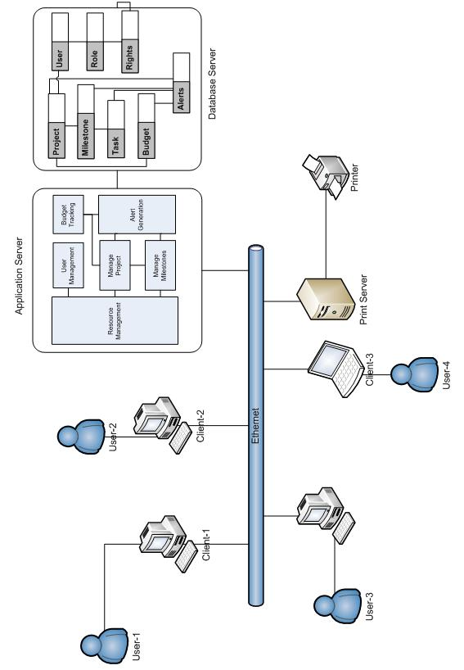

Data Model
- E-R Diagram

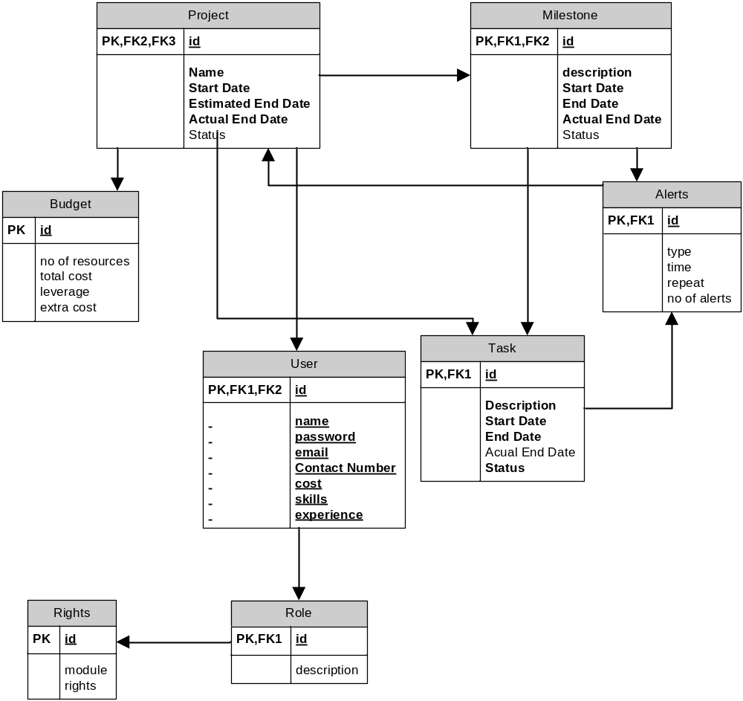

- Data Flow Diagram

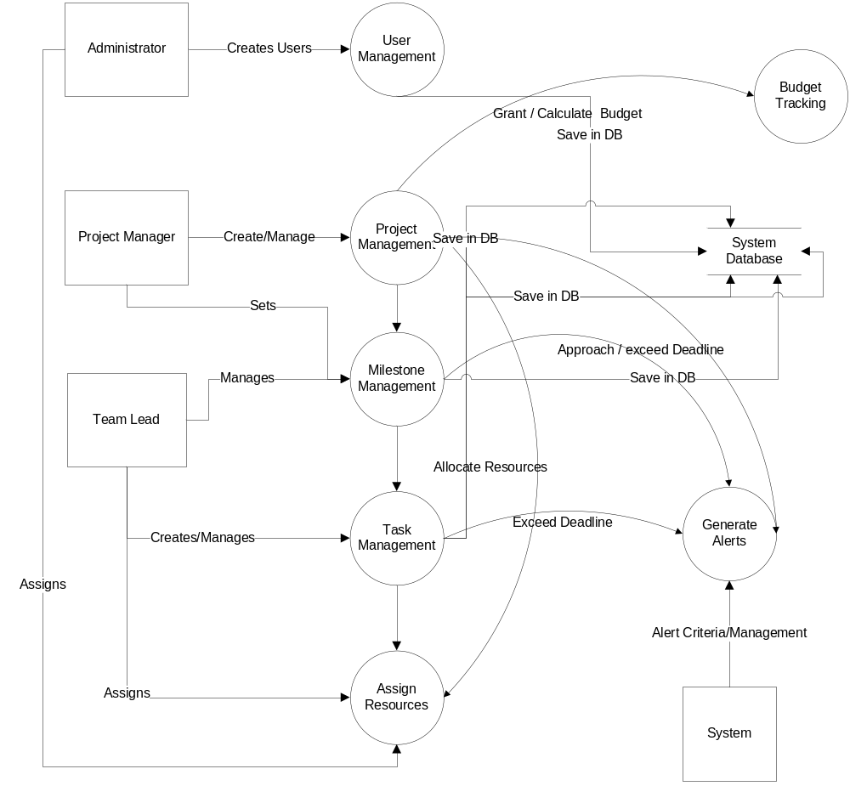

Object Model
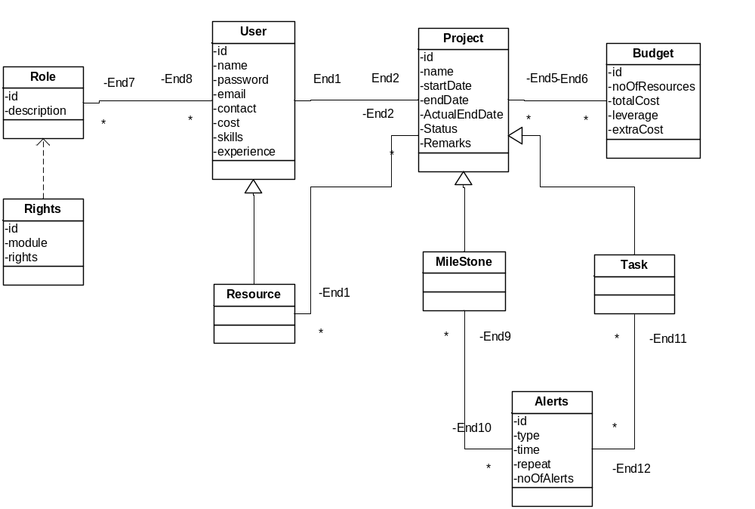

GUIs

Please refer to conceptual design (appendix 17.5). The GUIS are based on the matrix shown in the appendix.
We have also provided you with an HTML presentation of the GUIS.

Create Role Screen
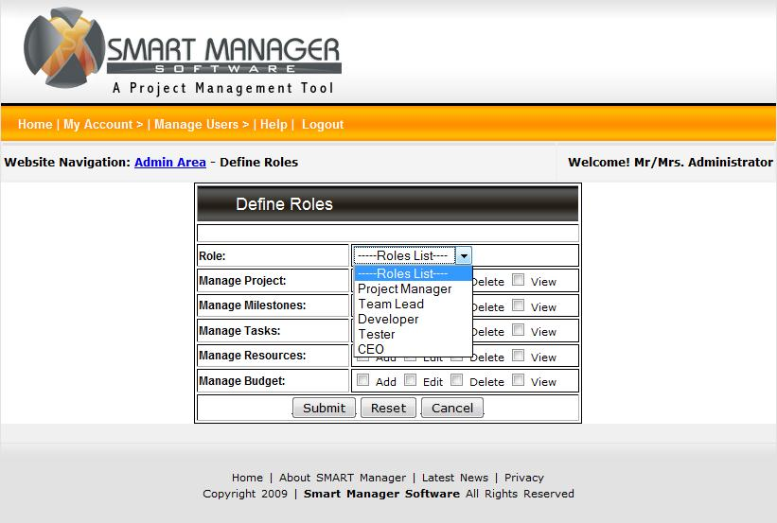

Create User Screen
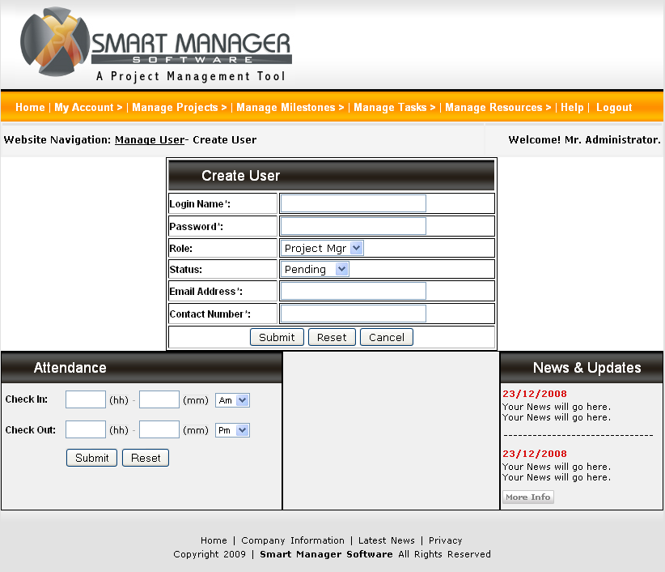

Login Screen
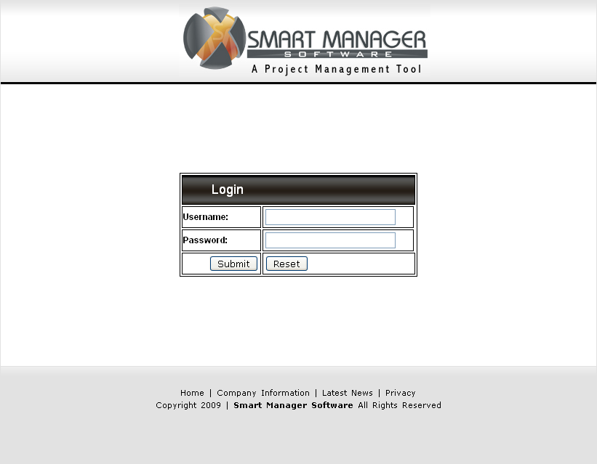

Home Screen after Successful Login
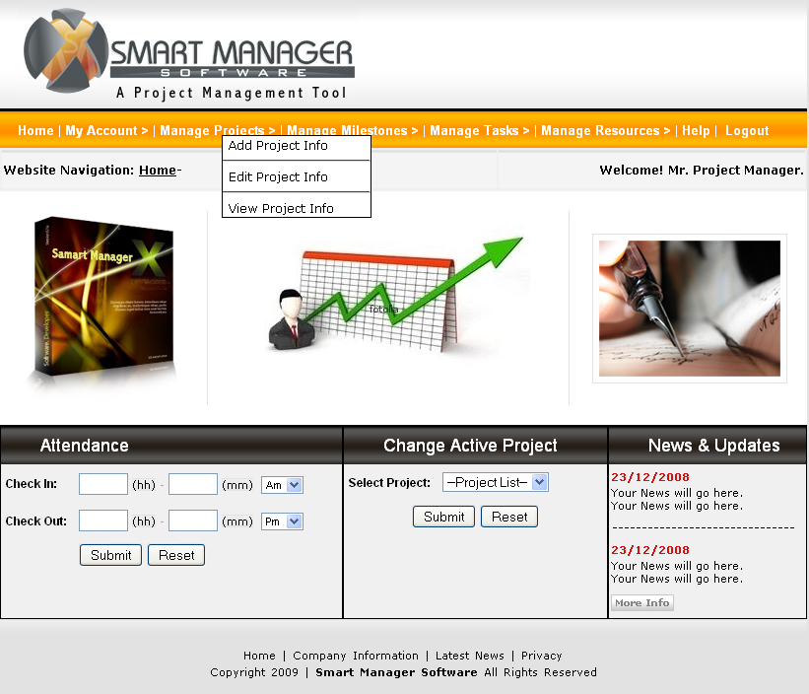

Login Screen

Home Screen after Successful Login

Mark Attendance Screen
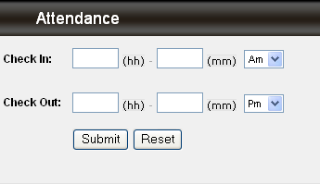

Select Active Project
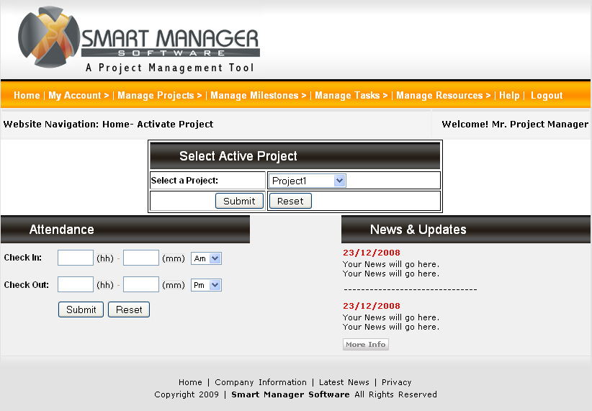

Create Project Screen
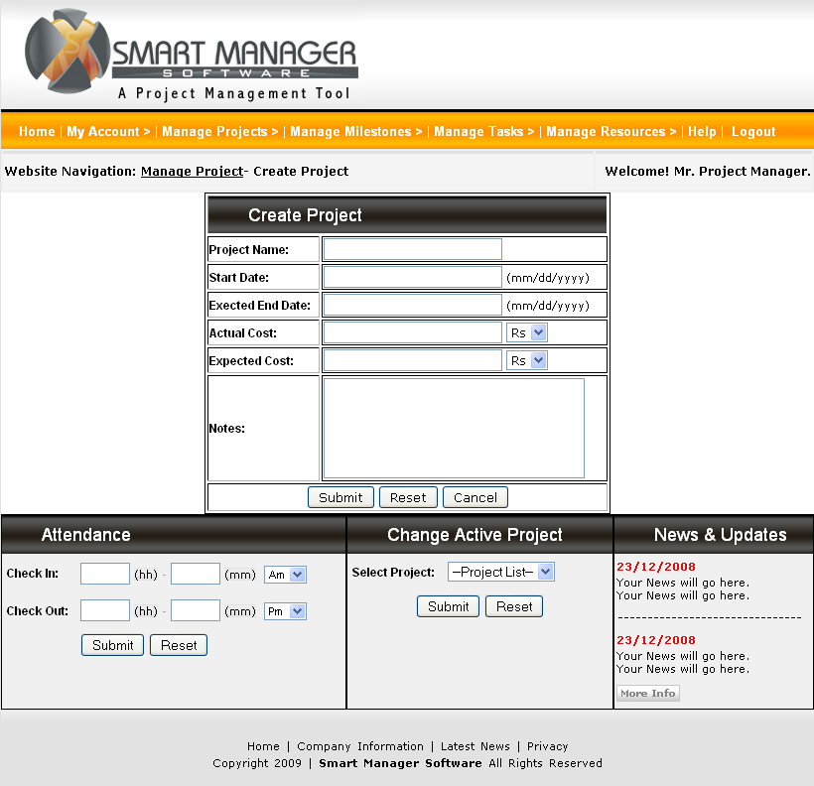

Edit Project Screen

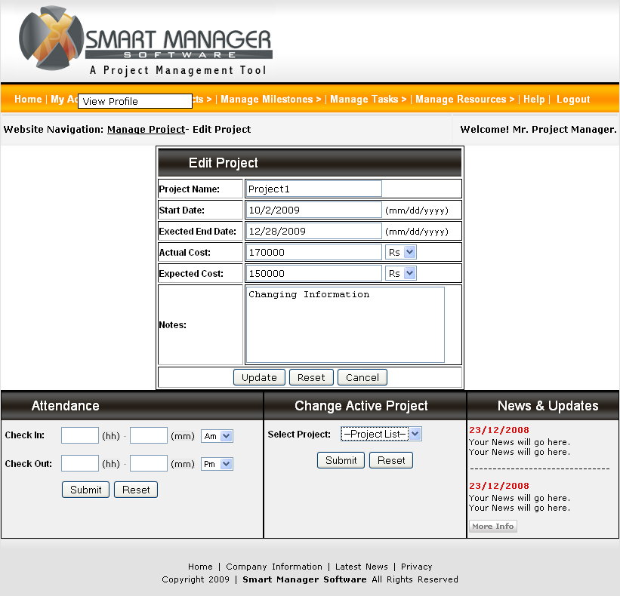

Import Project Schedule Screen

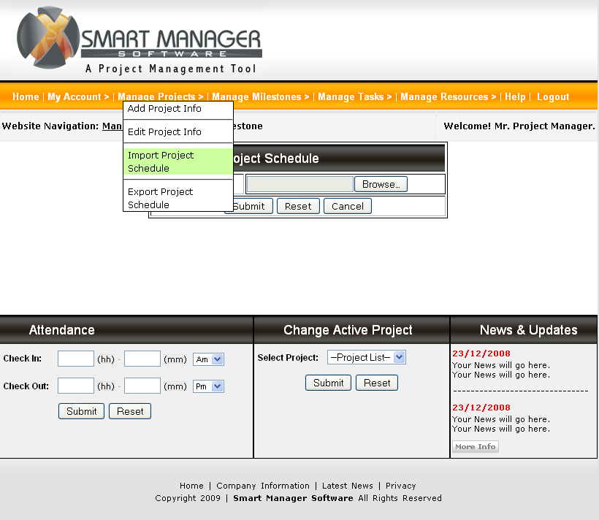

Export Project Schedule Screen

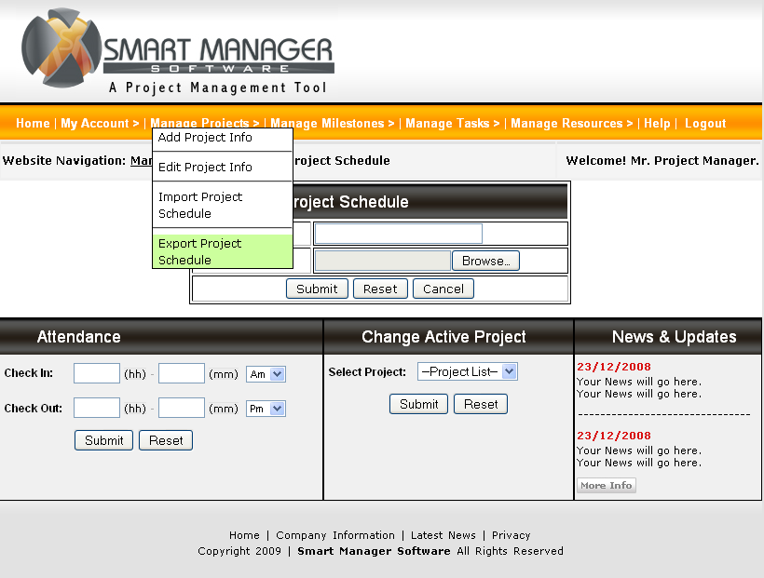

Manage Milestone Menu Screen

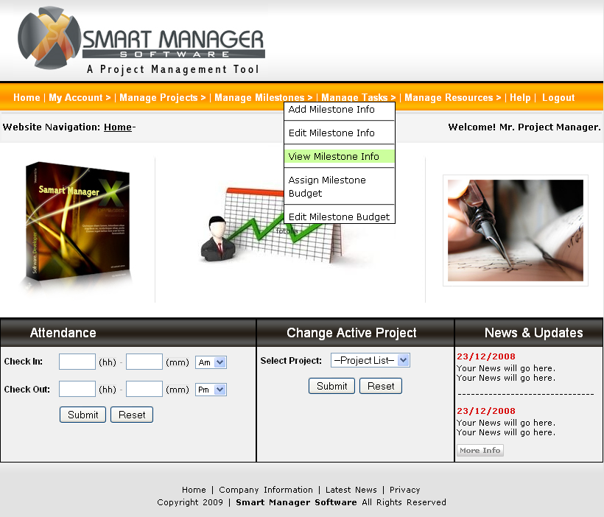

Create Milestone Screen

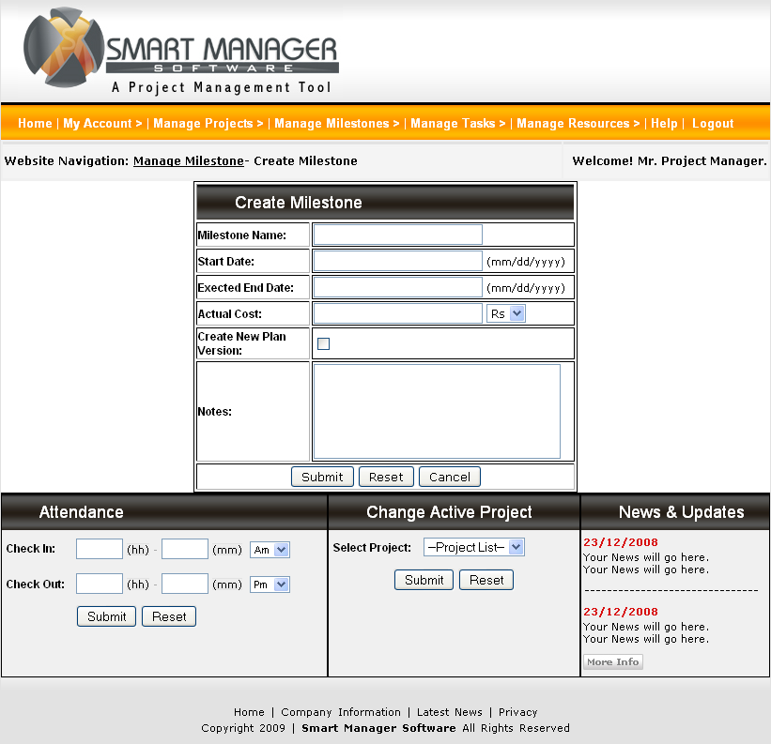

View Milestone Info Screen

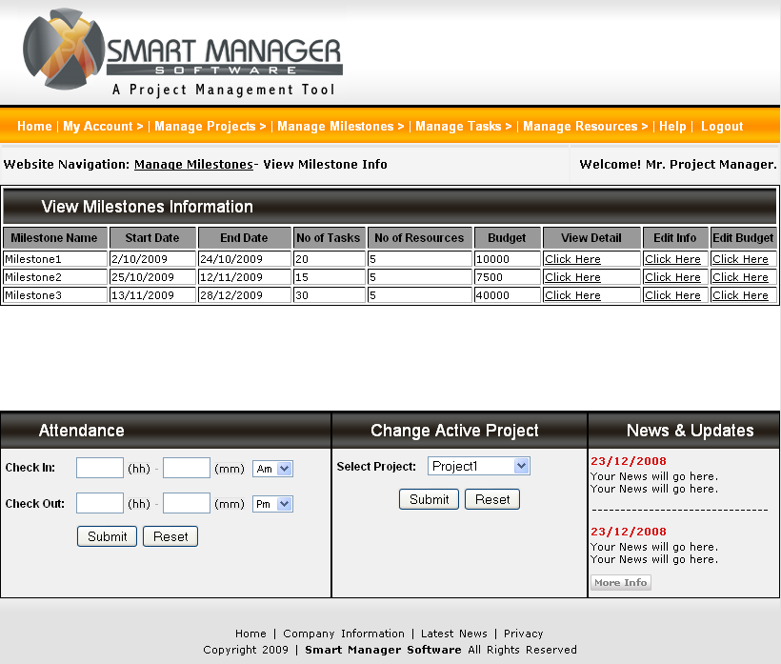

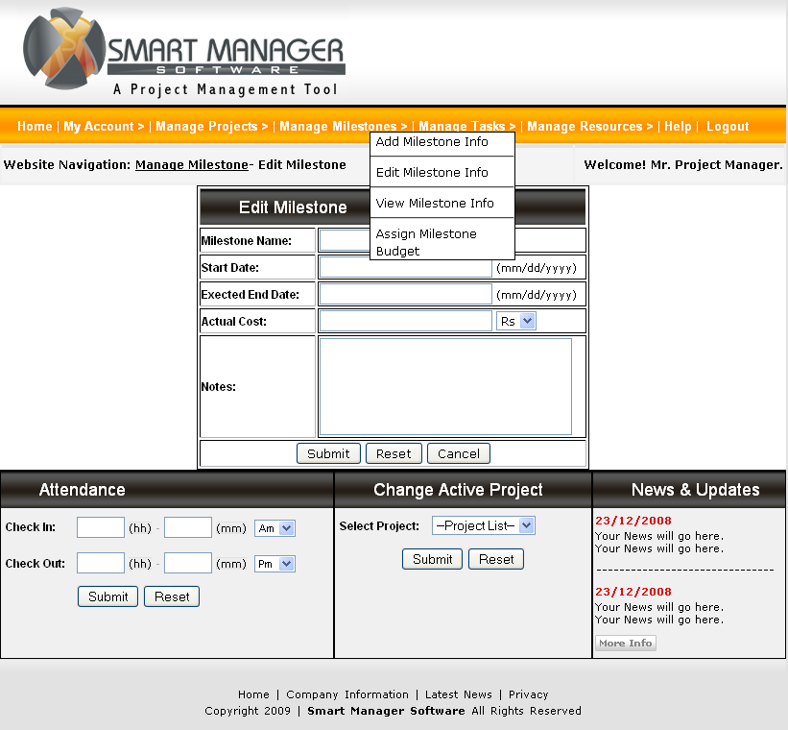

Assign Budget to Milestone Screen

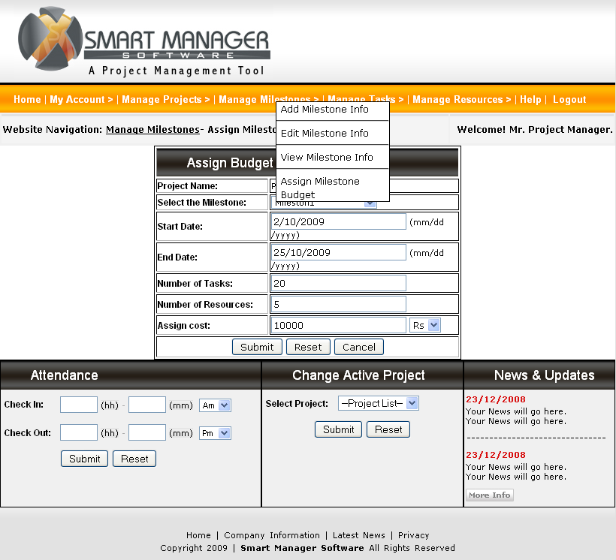

View Milestone Info Screen (Edit Budget Cost)

Edit Milestone Budget Screen

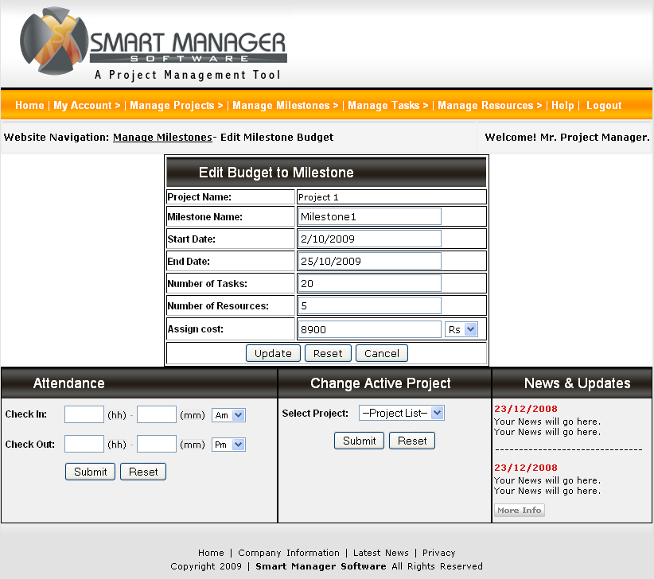

Assign Resource Cost Screen

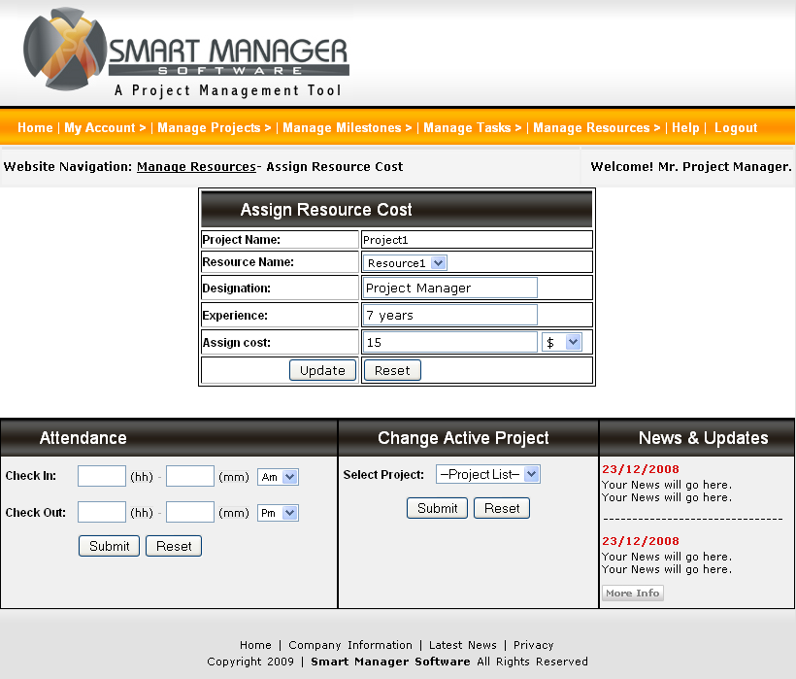

View Resource Info Screen to Edit Resource Cost
User shall Edit Resource Code from View Resources Information Screen
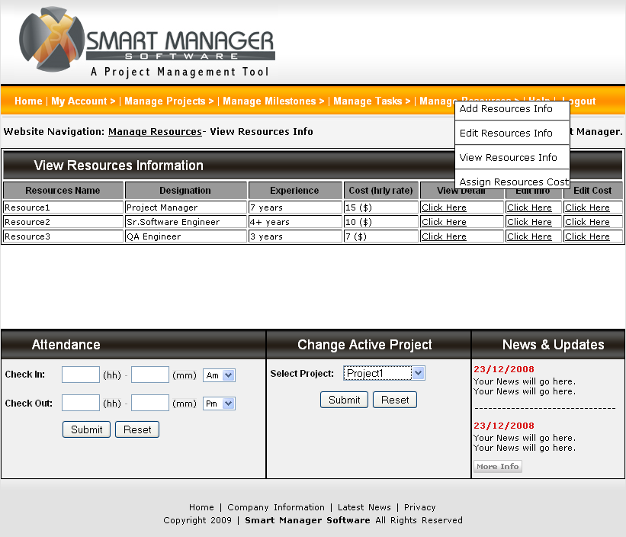

Edit Resource Cost Screen

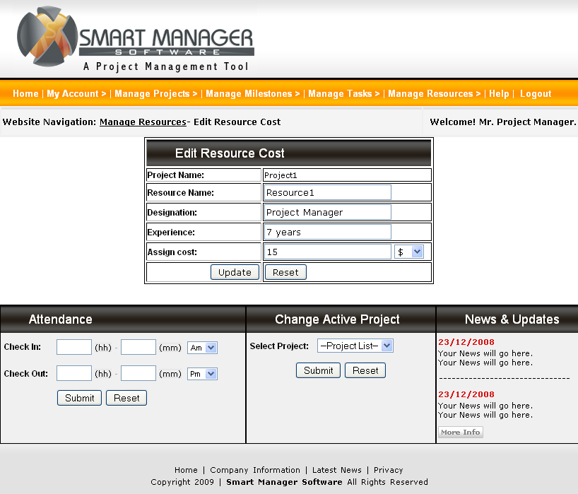

Create task Screen

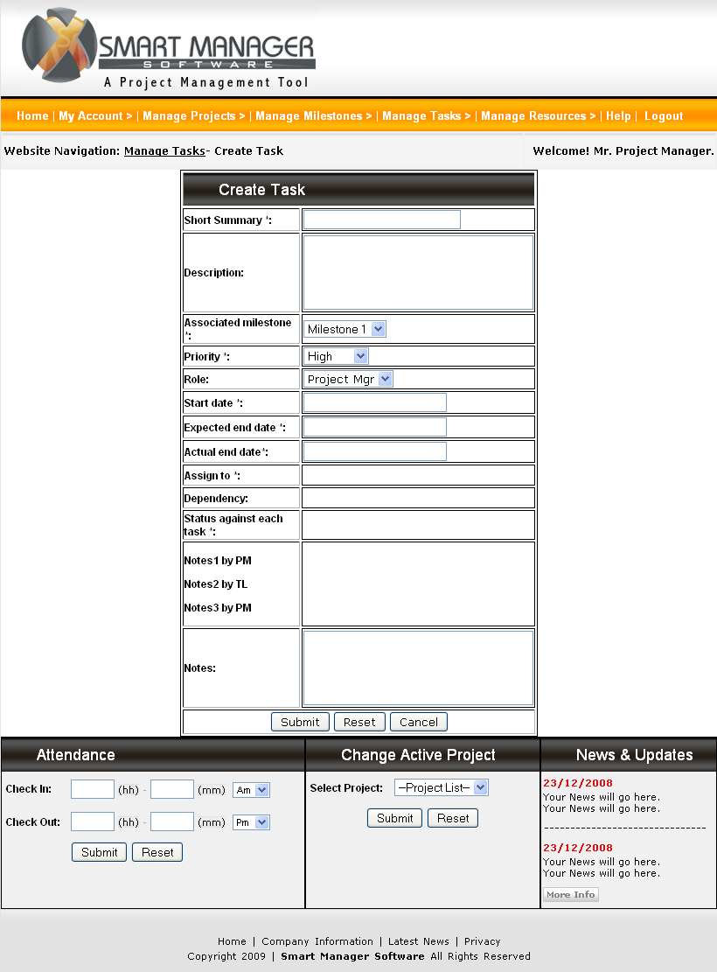

View Task Info Screen

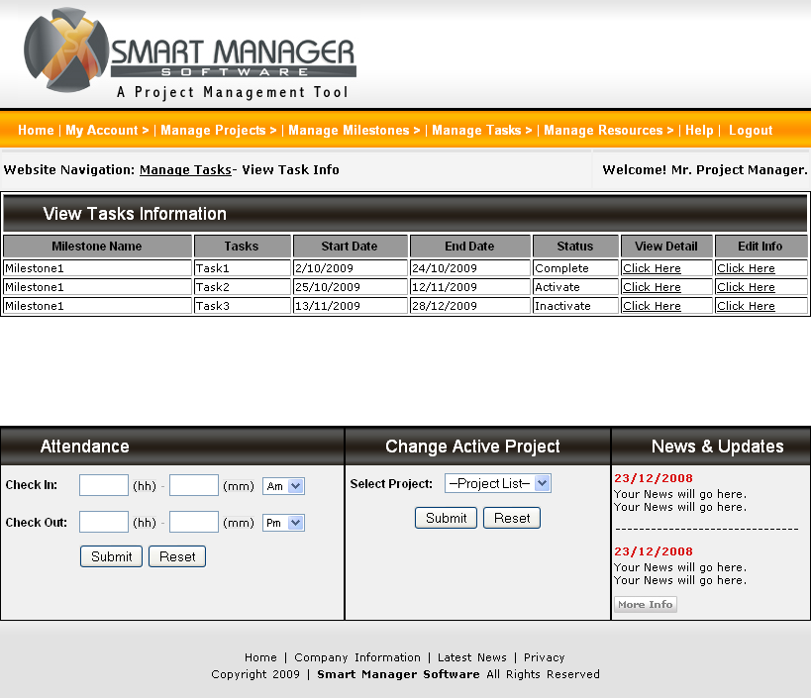

Edit Task Info Screen
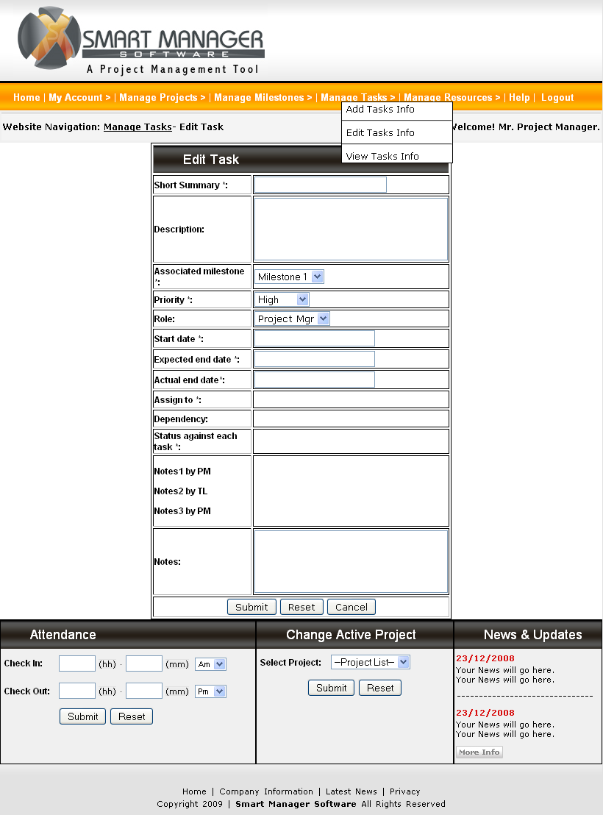

Assign Resource Screen

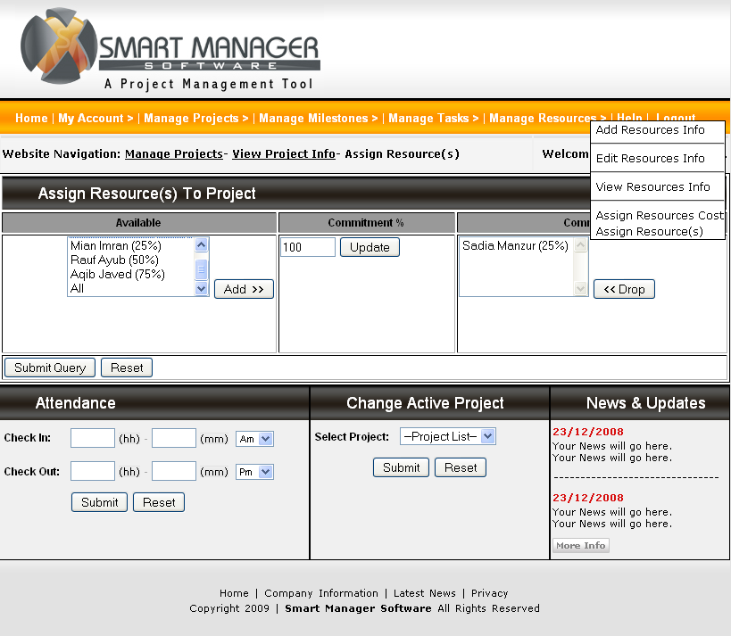

View Project PlanVersion Screen

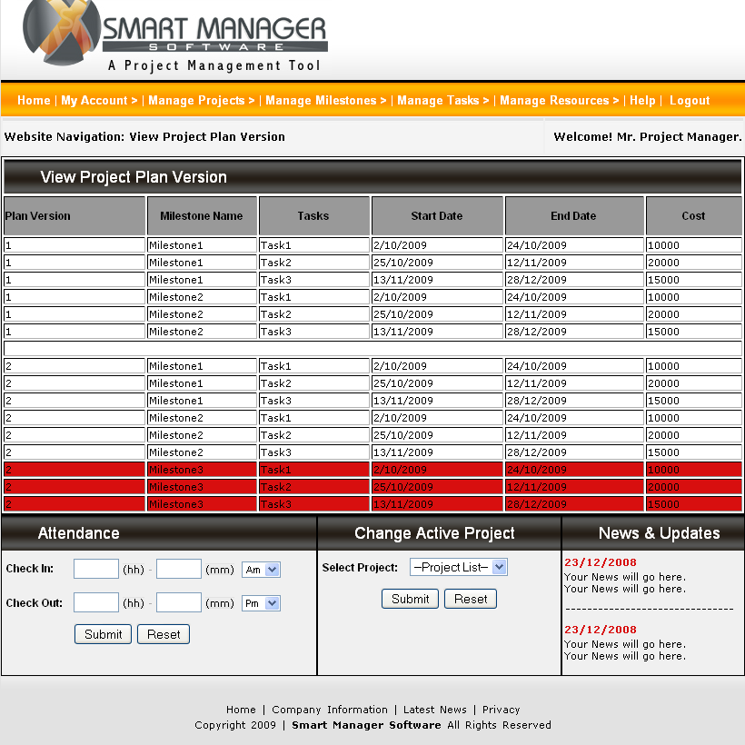

View Projects
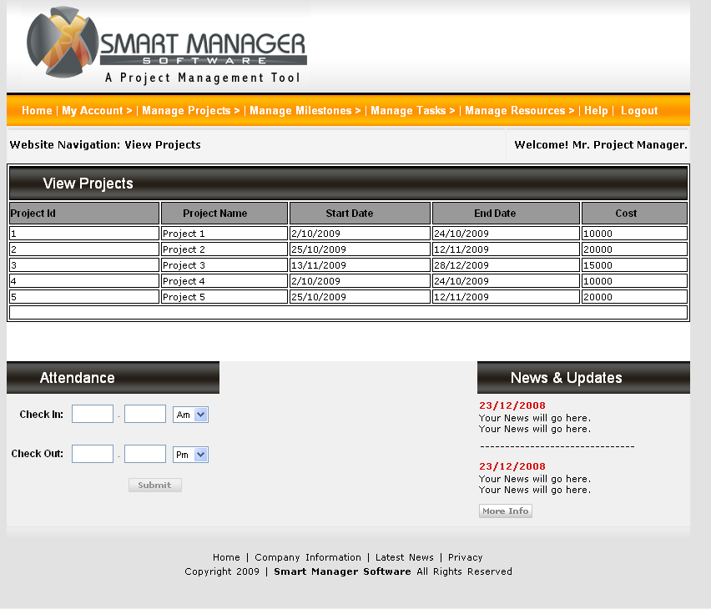

Alerts’ Screens

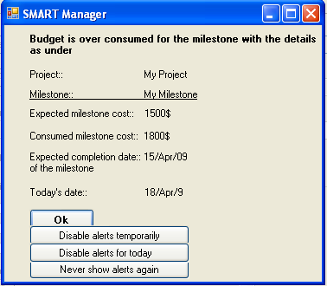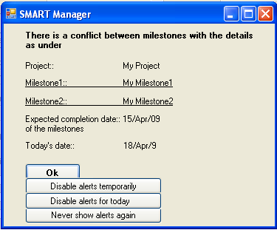
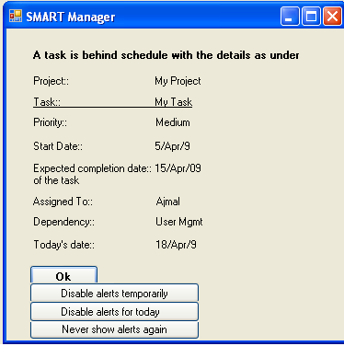

Task Alert Calendar View Screen
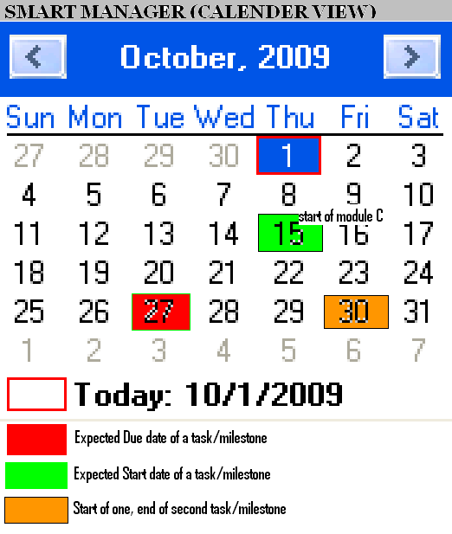

Budget Over-Consumed by Milestone Alert

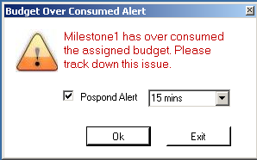

Assumptions

- All the users of the system are computer literate.
- The client is fully aware of the actual project management practices being followed.
- The information provided by the perspective end-users of the system will be correct.
- There would be no social and behavioral issues, which would motivate the end-user to fail the system.
- Local Area Network (LAN) will be available by the time this system would be developed and ready for deployment

References

- www. Ittoolkit.com
- www.Projectsmart.co.uk/project-planning-step-by-step.html
- www.Myteamworkpm.com
- www.App.clarizen.com

Glossary

Term | Definition
Project Management | The application of knowledge, skills, tools, and techniques to project activities in order to meet or exceed stakeholder needs and expectations.
Milestone | A milestone is the point at which one project phase ends and another begins. It is the target date for the completion or start of a phase
Activity | An element of work performed during the course of a project. An activity normally has an expected duration, an expected cost, and expected resource requirements. Activities are often subdivided into tasks.
Task | A subdivision of an activity.
Sub task | An element of work performed during the course of a project. An activity normally has an expected duration, an expected cost, and expected resource requirements. Activities are often subdivided into tasks.
System | A group of interacting, interrelated, or interdependent elements forming a complex whole.
CEO | Chief Executive Officer
Project Manager | Person Managing a Project as a whole
Team Leader | Person responsible for managing a stage team
Quality assurance officer | Person responsible for checking the system for quality issues
Developer | The person developing the system
LAN | Local Area Network
Tester | The person that tests the systems for any bugs/issues
Cc | Carbon Copy

Appendix

This non functional requirement is implied on Project Manger only as he is the critical user of the application. The risk of the failure of this application would be high if this user will not be able to use this project management tool.

The project managers can be categorized in the following four types based on their experience.

Expert
A user who has 8-12 months experience of using any project management tool.
Good
A user who has 4-8 months experience of using any project management tool.
Average
A user who has 1-4 months experience of using any project management tool.
Beginner
A user who has the basic knowledge of computer applications, but has never used a project management tool.

The following table is used to calculate average time to learn this application based on user type and time to learn.

User type | Time to Learn * (Days)
Expert | 2
Good | 5
Average | 7
Beginner | 15
Average Time | 7.25

- The time to learn is based on experience

This non functional requirement is implied on transactions of the developing project management tool. It is critical to manage the transaction time from performance perspective. The risk of the failure of this application would be high if the transaction could not be performed in a reasonable time. The complexity of transactions can be can be categorized in the following three types based on their database operation.

Complex
A transaction, which is used to edit record in the project management tool
Medium
A transaction, which is used to insert record in the project management tool
Simple
A transaction, which is used to view record in the project management tool

The following table is used to calculate average time to perform a transaction based on transaction type and time to perform.

Transaction type | Time to Perform * (Seconds)
Complex | 9
Medium | 5
Simple | 2
Average Time | 5.33

* The time to perform is based on experience

Interface content management: All the links that would appear on the interface can be manage (add/edit) e.g. Add the link, Change the label etc.

Punching-In: User would mark his attendance (office start time) by clicking on button.
Punching-Out: User would mark his attendance (office end time) by clicking on button.

17.5
The following figure displays the conceptual design and traceability matrix for the user interfaces.
