**Migration of Database to MongoDB and Development of Analytics Application**

**Overview**

A leading live content provider is using different databases for different services and over the period of time it became a big challenge to build the analytics on the available data as it has to insert nearly 0.3 million records per second into the database. It is difficult to improve the performance of the existing database as it reached the bottleneck level and to upgrade to latest versions will incur a huge cost. Client has engaged Nexgile to find out a best suitable solution. We have analysed and implemented MongoDB to store the required information for the analysis and analytics along with custom reports has been developed.

**Challenge**

Critical challenges of the project are

* Storing 0.3 million records per second from various sources and streamlining the data for the analysis without compromising on the speed
* Implementing a database which can be scaled to any level to store the data with less cost

**Solution**

Nexgile has analysed the existing architecture of the database and suggested to implement MongoDB which will support the current as well as future needs of the client. The reason behind the MongoDB as an ultimate product is due to the less investment and more output. The implementation cost of MongoDB is very less when compared to other databases like Oracle or MS SQL. Insertion data mostly in JSON style and MongoDB is built using JSON style structure, so this will eliminate any bottlenecks in scaling the application without compromising on the speed. Few of the activities which are carried as part of the project are:

* Pull the data from various sources and insert them into the database
* Developed analytics application to identify the trends and meaningful information about the performance of content
* Created automated reporting structure and workflow to generate ad-hoc reports
* Gathered data in the JSON structure and embedded directly to MongoDB

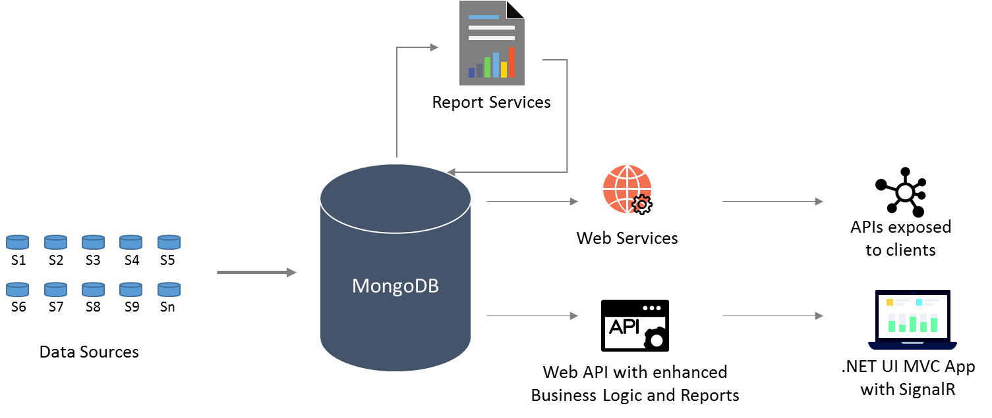

**Key Benefits**

* Implemented MongoDB with the scalability to handle 2million insertions per second and this can be increased in future as per the business requirement
* MongoDB JSON style structure has helped to reduce the issues to insert the huge number of records
* Ad-hoc report generation has helped to take instant decisions
* Total cost of project has been reduced by 50%