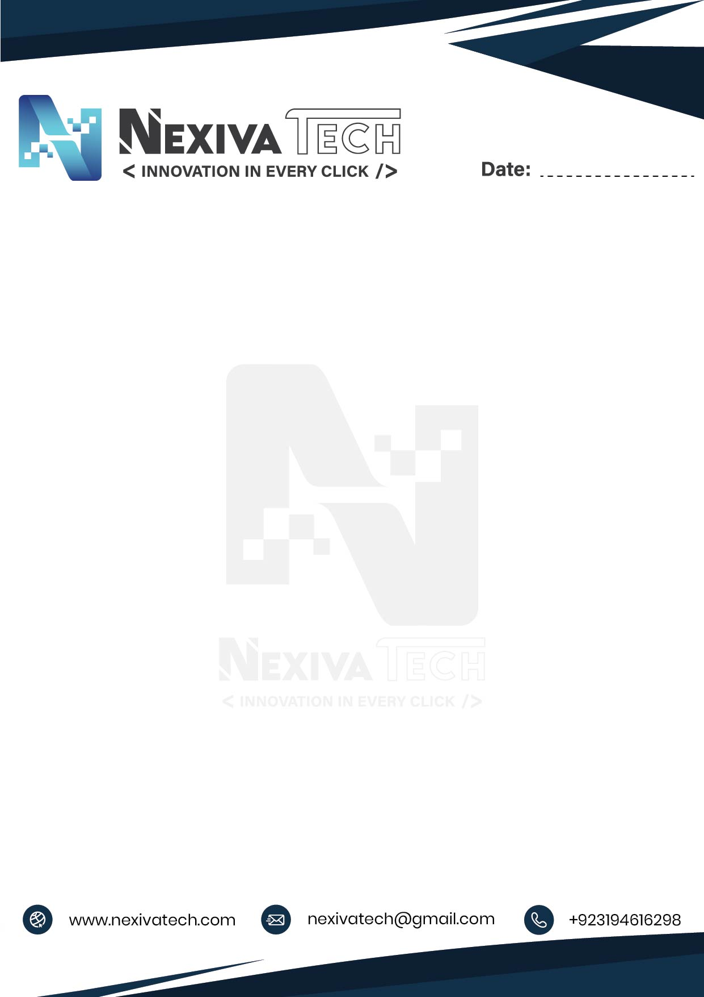

**12/08/2025**

**Offer Letter | Business Development Officer (BDO)**

Dear Mr. Moazam Ali,

Congratulations! We are pleased to extend to you an offer to collaborate with **Nexiva Tech** as a **Bidder / Business Development Executive** on a **commission-based** model.

Based on our discussions and review of your profile, you will be responsible for acquiring projects for Nexiva Tech through freelancing platforms and other direct client channels.

**[Terms of Engagement]**

**Position:** Bidder / Business Development Executive (Commission-Based)

**Start Date: ASAP**

**Compensation:** You will be entitled to **15% commission** on the net value of each project you successfully bring in and which is accepted and executed by Nexiva Tech.

**Scope of Work Includes (but is not limited to):**

* Identifying and bidding on relevant projects.
* Generating and converting leads.
* Communicating effectively with potential clients.
* Collaborating with our technical team to ensure timely and quality delivery.

Please note that this is a commission-based collaboration and does not constitute an employment relationship. Taxes, if applicable, shall be your sole responsibility. Payouts will be processed once the payment is received from the client.

Kindly confirm your acceptance of this offer by replying to this email. Should you have any questions, feel free to get in touch.

Sincerely,

**Syed Muhammad Hassan Kazmi**

Founder & CEO

Nexiva Tech