RF
RESEARCHFLOW HUB
Integrated Research Management Workspace
UNIVERSITY | Not provided
DEPARTMENT | Not provided
COURSE | Web and Internet Programming
STUDENT NAME | Not provided
STUDENT ID | Not provided
GITHUB REPOSITORY | Not configured
LIVE WEBSITE URL | Not deployed

VERSION 1 • 25 SEPTEMBER 2026

02 INTRODUCTION
━
  - The problem, motivation, and purpose of the system
The research-management problem
Research work is often fragmented across browser bookmarks, reference files, spreadsheets, notebooks, and experiment logs. This makes it difficult for a student researcher to connect a project with its supporting papers, datasets, literature findings, research gaps, tasks, notes, and model results.
Motivation
ResearchFlow Hub was created as a focused, beginner-friendly web application for a university Web and Internet Programming course. It demonstrates a complete database-backed workflow without adding collaboration, payment, scraping, AI chatbot, or large-file storage complexity.
Purpose
The application gives one Researcher / User a secure workspace in which all stored records are private to that account. The user can move from a research question to evidence review, gap identification, experiment tracking, task completion, note taking, and citation output in one consistent interface.
1  USER ROLE | 9  CRUD MODULES | 3  CITATION STYLES | 267  E2E CHECKS

Design principles
- Simple enough to build, explain, and demonstrate during a viva.
- Database driven: dashboards, lists, comparisons, and statistics use stored records.
- Secure by default: authentication, ownership checks, prepared statements, CSRF tokens, and output escaping.
- Responsive on desktop, tablet, and mobile with clear empty, success, and error states.

03 OBJECTIVES AND SCOPE
━
  - Version 1 delivers a complete single-user research workflow
Project objectives
- Provide secure registration, login, logout, protected sessions, profile editing, and password change.
- Organize projects and their related resources, papers, datasets, reviews, gaps, experiments, tasks, and notes.
- Support decision making through a literature matrix, gap statistics, experiment comparison, and dashboard summaries.
- Improve retrieval through global search, filters, sorting, and pagination.
- Generate citation text in IEEE, APA, and Harvard formats.
Version 1 module scope
FOUNDATION & DISCOVERY | RESEARCH RECORDS | ANALYSIS & OUTPUT
Authentication  Dashboard  Profile & password | Projects  Resources  Research papers | Literature review matrix  Research gap statistics
Global search  Filters & sorting  Pagination | Datasets  Literature reviews  Research gaps | Experiment comparison  Citation generator
Responsive layout  Security controls  Error handling | Experiments  Research tasks  Research notes | IEEE · APA · Harvard  Flash and empty states
Boundaries
Version 1 intentionally excludes chat, multi-user collaboration, subscriptions or payments, a complex admin panel, AI chatbot features, web scraping, and large dataset/file storage. Dataset records store metadata rather than large uploaded datasets.
High-level success criteria
- A user can complete the full authenticated CRUD workflow using only owned records.
- Search, matrices, statistics, comparison, and citation output work from saved data.
- The interface remains usable at desktop, tablet, and mobile widths.
- Friendly 403, 404, and 500 handling is present and normal flows complete without unresolved defects.

04 SYSTEM ARCHITECTURE
━
  - A conventional three-tier design keeps the project easy to understand and maintain
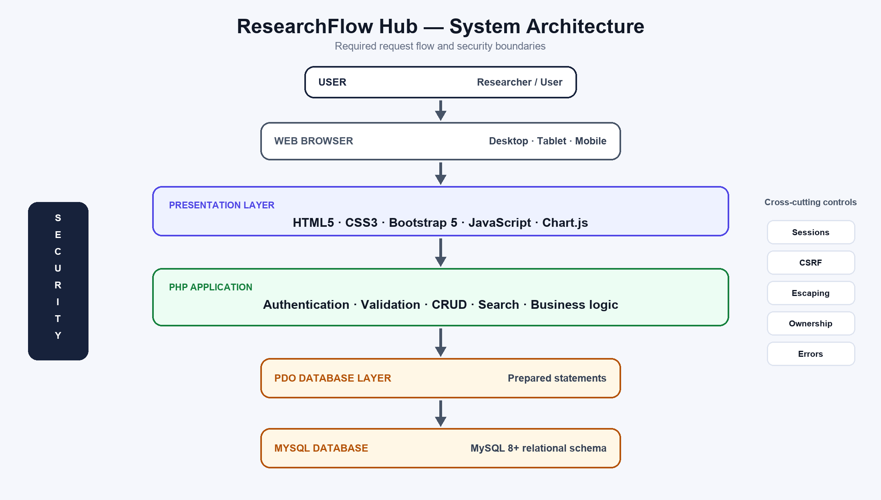
Figure 1. Presentation, application, and data layers with cross-cutting security controls.
Request flow
STEP | RESPONSIBILITY
1. Browser request | Responsive forms and navigation send GET requests for views and POST requests for state changes.
2. PHP bootstrap | Shared configuration, secure session settings, database connection, error handling, authentication, and helpers load.
3. Module logic | Server-side validation, ownership checks, CRUD operations, filters, search, statistics, or comparison are applied.
4. PDO / MySQL | Prepared statements read or update relational records; no user input is concatenated into SQL.
5. Response | Escaped output, flash feedback, empty states, confirmation dialogs, and friendly error pages are returned.
The design uses PHP 8+, MySQL 8+, PDO, HTML5, CSS3, Bootstrap 5, JavaScript, and Chart.js. It requires no framework build process and stays appropriate for a course demonstration.

05 DATABASE DESIGN
━
  - Relational ownership connects each research record to the authenticated user
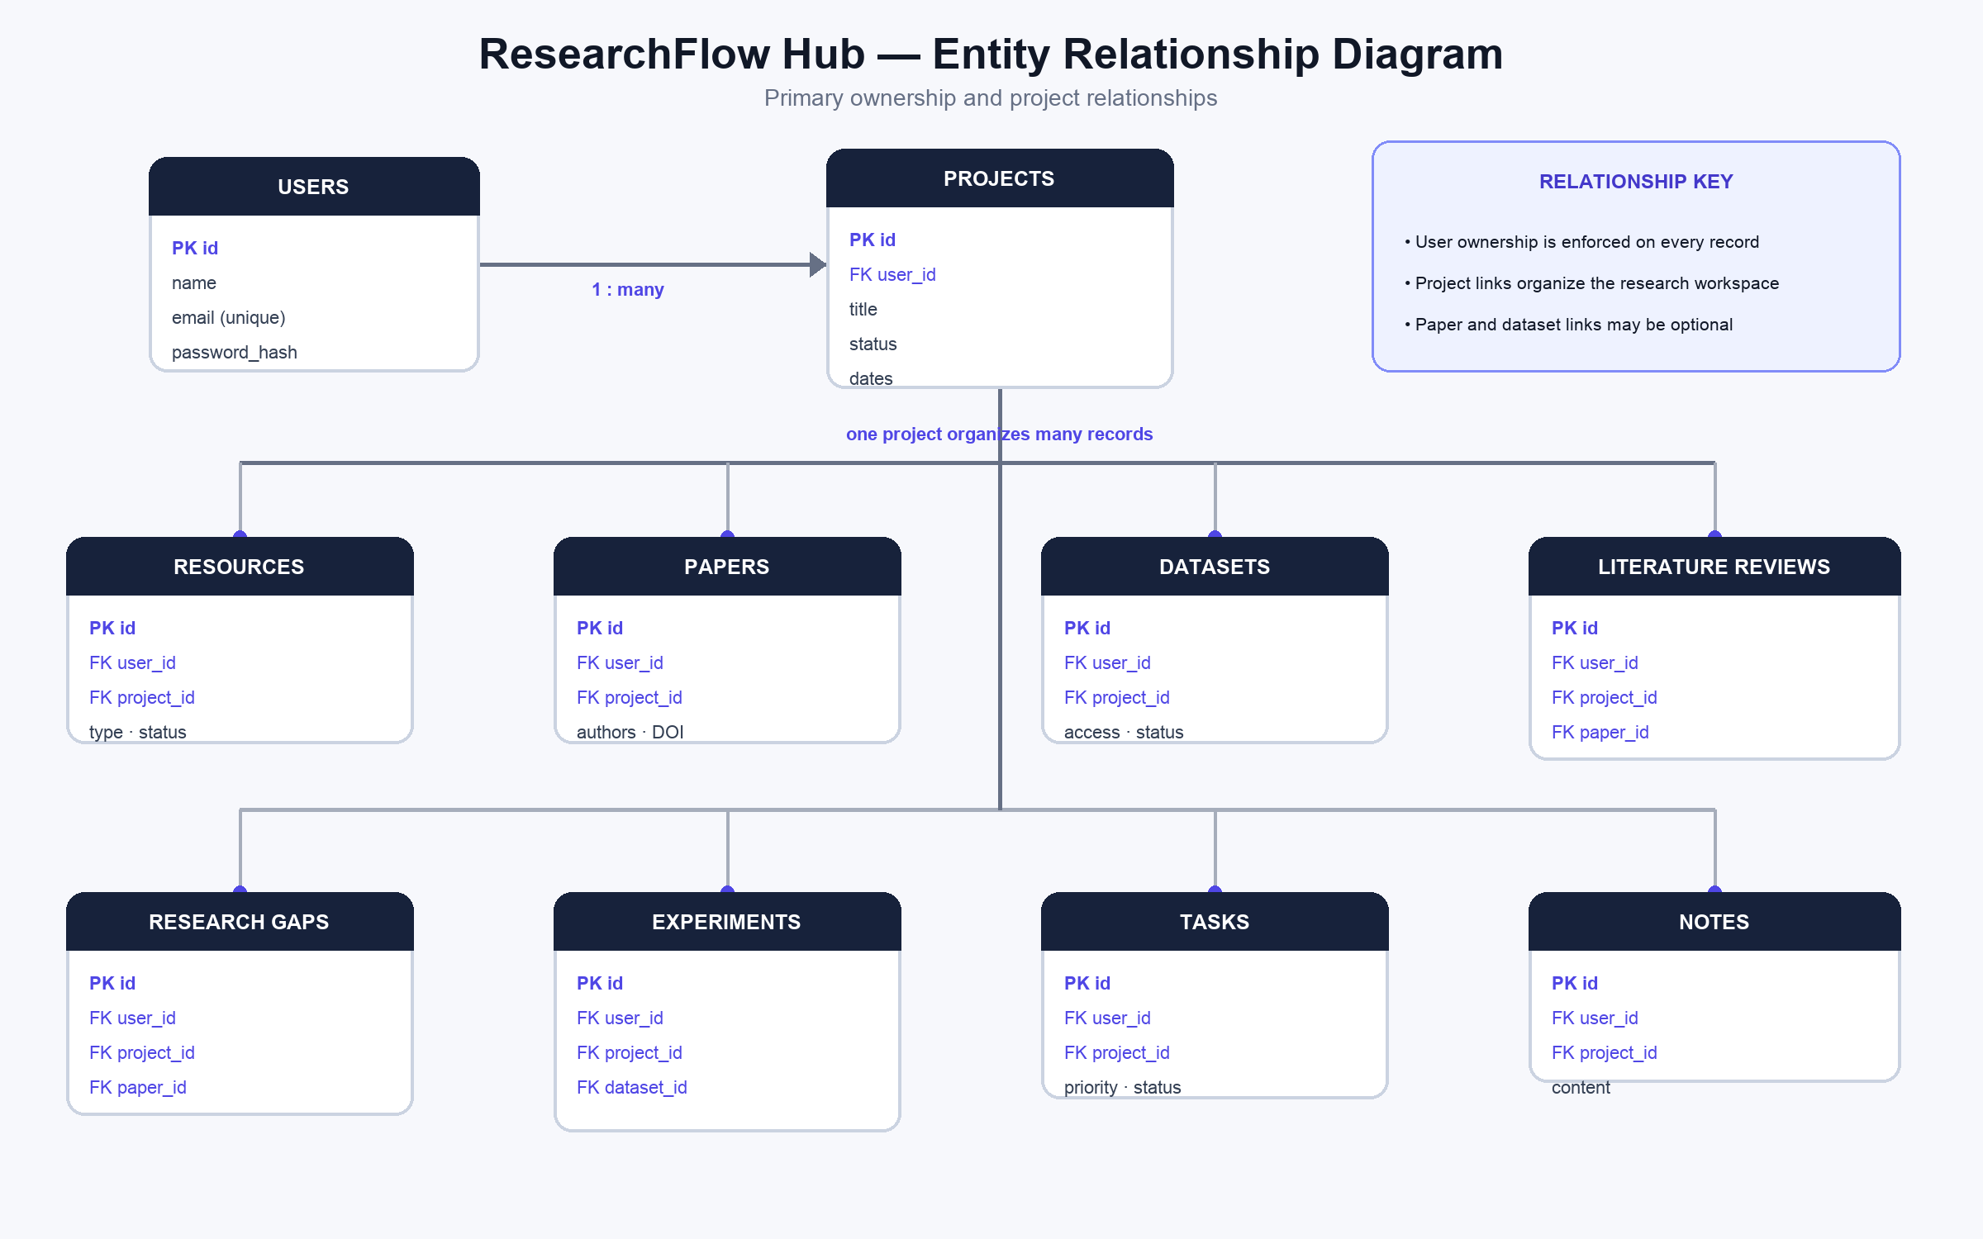
Figure 2. Major tables and primary foreign-key relationships.
Relationship summary
PARENT | CHILD RECORDS | RULE
users | projects and every module record | A user owns many records; account ownership is checked server-side.
projects | resources, papers, datasets, reviews, gaps, experiments, tasks, notes | One project organizes many research records.
papers | literature_reviews, research_gaps | Reviews require a paper; a gap may optionally cite one.
datasets | experiments | An experiment may optionally reference a saved dataset.

06 CORE FEATURES
━
  - Selected screenshots show the most important Version 1 workflows
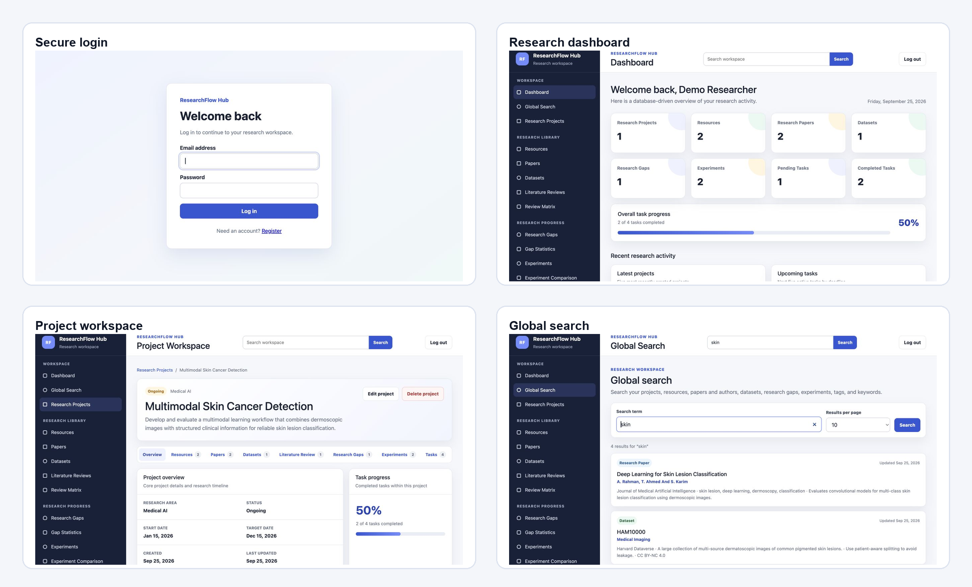
Figure 3. Login, dashboard, project workspace, and global search.
FEATURE | DEMONSTRATED BEHAVIOUR
Authentication | Secure access to an account-specific workspace.
Dashboard | Live totals, task progress, and recent records from the database.
Project workspace | A project connects resources, papers, datasets, reviews, gaps, experiments, and tasks.
CRUD lists | Create, read, update, and delete with filters, sorting, pagination, feedback, and confirmations.
Global search | One query searches projects, resources, papers/authors, datasets, gaps, experiments, tags, and keywords.
The complete screenshot set is stored in the project’s screenshots directory, including registration, forms, lists, dataset manager, mobile view, and the ER diagram.

07 ADVANCED FEATURES
━
  - Structured evidence can be compared without unnecessary system complexity
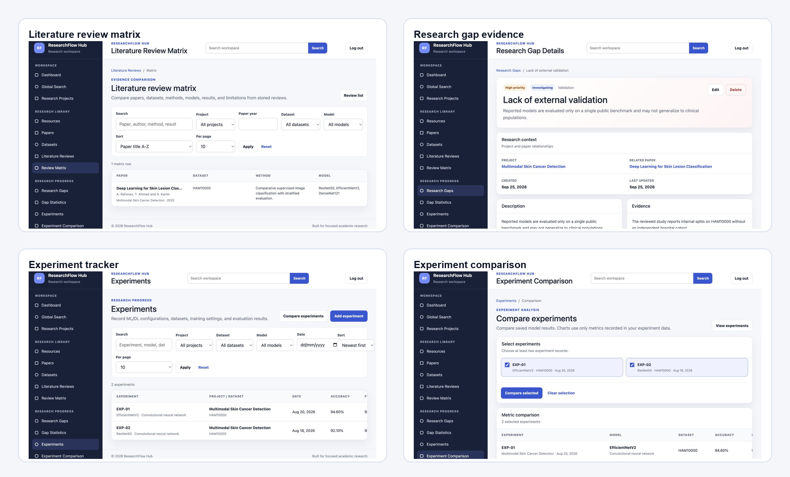
Figure 4. Literature comparison, research-gap evidence, experiment tracking, and metric comparison.
FEATURE | VALUE TO THE RESEARCHER
Literature Review Matrix | Places paper, dataset, method, model, results, and limitations side by side.
Research Gaps | Links a gap to evidence, type, priority, status, and a potential solution.
Gap Dashboard / Statistics | Summarizes gaps by status, priority, type, project, and progress.
Experiment Tracker | Stores model configuration, dataset, training settings, and evaluation metrics.
Experiment Comparison | Compares at least two saved experiments through a metrics table and charts.
Citation Generator | Formats stored paper metadata in IEEE, APA, or Harvard style.

08 VALIDATION AND SECURITY
━
  - Controls are applied at shared helpers and every state-changing endpoint
Implemented controls
CONTROL | IMPLEMENTATION | VERIFICATION
Passwords | password_hash() and password_verify(); session ID rotates after login and password change. | Live authentication and hash checks passed.
SQL injection | PDO prepared statements; dynamic sort fields and helper table names use allowlists. | Static scan and live malformed-input tests passed.
CSRF | Session token on every create, update, delete, profile, password, and logout form. | All 30 state-changing handlers verified.
XSS | Shared output-escaping helper for dynamic HTML. | Stored script payload rendered as text.
Authentication | Protected pages require a valid signed-in session. | Guest redirects and post-logout protection passed.
Ownership | Queries are scoped by record ID and authenticated user ID; relations are ownership checked. | Cross-user read/update/delete attempts denied.
Validation | Required fields, lengths, types, enums, dates, numbers, URLs, and relations checked on server. | Invalid and array-shaped inputs rejected safely.
Destructive actions | Delete and logout handlers accept POST only and require valid CSRF tokens. | All nine delete endpoints rejected GET.
Error and feedback behaviour
- 403 for forbidden access, 404 for missing or unowned records, and a safe 500 page for unexpected failures.
- One-time flash messages confirm successful or failed actions without exposing sensitive implementation details.
- Empty states guide first-time users; browser confirmation dialogs protect destructive actions.
- Real credentials remain outside tracked files; `.env` and local database configuration are ignored.
Security design follows the PHP PDO guidance and OWASP recommendations for CSRF tokens and context-aware output encoding (PHP Documentation Group, n.d.; OWASP Foundation, n.d.).

09 TESTING AND TIMELINE
━
  - The completed Version 1 workflow was verified in an isolated local environment
267 / 267  E2E CHECKS | 78  PHP FILES LINTED | 45  SECURITY CHECKS | 0  UNRESOLVED DEFECTS

Testing summary
AREA | EXAMPLES | RESULT
Access | Registration, login, sessions, profile, password, logout | PASS
CRUD | Nine modules; create, read, update, delete, validation, cleanup | PASS
Analysis | Matrix, gap statistics, experiment comparison, citations | PASS
Discovery | Global search, filters, sorting, multi-page pagination | PASS
Quality | Responsive views, assets, empty states, flash and error pages | PASS
Security | CSRF, XSS, SQL injection, ownership, POST-only deletion | PASS
Development timeline
PHASE | DELIVERABLES | STATUS
1. Scope & setup | Requirements, repository, environment, database | Complete
2. Foundation | PDO, shared bootstrap, authentication, layout | Complete
3. Core modules | Projects, resources, papers, datasets | Complete
4. Research analysis | Reviews, matrix, gaps, experiments, comparisons | Complete
5. Productivity | Tasks, notes, citations, global search | Complete
6. Quality | Profile, responsive UI, security, errors, end-to-end QA | Complete
7. Delivery | Report and screenshot evidence | This report
The test run used PHP 8.0.28 and a temporary MariaDB instance compatible with the MySQL 8+ target. No real user data or saved local database configuration was modified.

10 REFLECTION AND REFERENCES
━
  - What was learned, what remains intentionally limited, and the sources used
Challenges
- Keeping nine CRUD modules consistent while preserving module-specific validation and relationships.
- Enforcing ownership not only on primary records but also on selected related projects, papers, and datasets.
- Presenting wide comparison tables and dashboard content clearly at smaller viewport sizes.
- Testing deletion and error paths without leaving temporary data or sessions behind.
Lessons learned
- Shared helpers reduce duplication and make security controls easier to audit.
- A carefully normalized schema enables dashboards, matrices, statistics, and search without duplicate data entry.
- Small, end-to-end checkpoints are easier to demonstrate and diagnose than one large implementation pass.
Future improvements
Future versions may add optional collaboration, richer exports, accessibility audits, automated browser regression tests, and deployment automation. These are not part of Version 1 and should be considered only after the current single-user workflow is maintained reliably.
References — Harvard style
Bootstrap Team (n.d.) ‘Breakpoints’, Bootstrap 5.3 documentation. Available at: https://getbootstrap.com/docs/5.3/layout/breakpoints/ (Accessed: 25 September 2026).
Chart.js Contributors (n.d.) ‘Getting Started’, Chart.js documentation. Available at: https://www.chartjs.org/docs/latest/getting-started/ (Accessed: 25 September 2026).
OWASP Foundation (n.d.) ‘Cross-Site Request Forgery Prevention Cheat Sheet’. Available at: https://cheatsheetseries.owasp.org/cheatsheets/Cross-Site_Request_Forgery_Prevention_Cheat_Sheet.html (Accessed: 25 September 2026).
OWASP Foundation (n.d.) ‘Cross Site Scripting Prevention Cheat Sheet’. Available at: https://cheatsheetseries.owasp.org/cheatsheets/Cross_Site_Scripting_Prevention_Cheat_Sheet.html (Accessed: 25 September 2026).
PHP Documentation Group (n.d.) ‘PDO::prepare’, PHP Manual. Available at: https://www.php.net/manual/en/pdo.prepare.php (Accessed: 25 September 2026).

