PRODUCT REQUIREMENT DOCUMENT (PRD) & TECHNICAL SYSTEM ARCHITECTURE

PROJECT TITLE: FURNI. – Hybrid Omni-Channel Furniture Platform
1. Project Overview

1.1 Objective
FURNI. is a hybrid, omni-channel e-commerce and retail showroom platform engineered to digitize Indian furniture brick-and-mortar stores. The platform bridges the gap between digital consumer traffic and in-person showroom visits by creating a unified point-of-sale and online catalog system. Customers can either browse and buy directly from home or visit a physical showroom to evaluate items in person, where store sales representatives can create bookings and process transactions for them on-site. Operating natively in Indian Rupees (INR) with integrated calculations for an 18% GST framework, the platform standardizes order fulfillment across both walk-in and online sales channels.

1.2 Target Audience
- End-Customer: Online shoppers and physical showroom visitors who browse products, configure custom collections, review items, and track orders.
- In-Store Sales Executive / Shop Person: Showroom staff who assist walk-in customers, look up live stock levels, apply dynamic discounts, and log orders directly into the system on behalf of clients.
- Store Owner / Admin: Executive managers who oversee nationwide stock, track cross-channel sales analytics, manage discount campaigns, and monitor dispatch logistics.

2. Requirement Analysis & Discovery

Requirement Specification Questions
- Why build a hybrid showroom-digital model instead of a pure e-commerce store? Furniture is a high-touch, high-investment purchase. Many Indian consumers prefer to physically test timber quality, fabric comfort, and dimensions before buying. A hybrid framework ensures that walk-in experiences and online traffic feed into the same database ledger, preventing inventory errors and giving customers a seamless multi-channel experience.
- Why allow store personnel to book orders for the customer inside the platform? To eliminate manual paperwork, order errors, and billing delays at the showroom floor. Giving sales reps the ability to check out on behalf of an unauthenticated or walk-in customer ensures that physical sales are immediately tied to warehouse stock tracking, automated GST accounting, and logistical delivery pipelines.
- Why restrict certain e-commerce catalog items from being physically displayed in-store?
Physical showrooms face structural square-footage and floor-space constraints. An e-commerce catalog can support an infinite aisle of extended product variations, experimental colorways, or warehouse-direct clearances that cannot physically fit on the showroom floor. The platform must explicitly track floor visibility so customers browsing online know what to expect before visiting, and in-store staff can transparently sell non-displayed inventory directly from the central warehouse.
- Why transition data states from client-side localStorage to a Relational Database at checkout? Online users save items to their local browsers via localStorage for convenience while browsing. However, once a checkout handshake begins—whether by an online customer or an in-store sales rep—this data must move to an atomic relational database. This locks down inventory levels, verifies active promo codes, and ensures transaction safety before payment confirmation.
- Why split catalog offerings into named collections tied to specific category slugs? Furniture consumers frequently shop by design themes (e.g., pairing a bed with matching side tables from the Mid-Century Luxe collection). Tying named design collections directly to static category slugs simplifies the frontend presentation while keeping database relationships highly clean and query-efficient.

3. Core Functional Requirements & Prototype Mapping

3.1 Key Features Matrix (Online vs. In-Store Showroom Capabilities)
Feature Pillar | Customer Self-Service (Online View) | Staff-Assisted Booking (Showroom View)
Catalog Access | Browses the standard catalog via 6 public category paths: living-room, bedroom, dining-room, office, outdoor, kids. | Uses the same responsive interface to showcase detailed item pages, technical features, and physical dimensions to floor walk-ins.
Asymmetrical Display Visibility | Views all items, but items restricted from the physical floor are clearly designated with an "Online Exclusive / Not Available for In-Store Viewing" badge. | Views the entire master catalog with explicit stock indicators detailing whether a floor sample is present or if the item must be ordered directly from the warehouse.
Cart & Ordering | Saves configurations locally via browser localStorage and processes their own checkouts. | Overrides or initializes a customer cart directly on a store terminal, inputting shipping addresses for the buyer.
Promo Engine | Enters the coupon code SAVE10 during digital checkout to receive a 10% discount on subtotals. | Applies authorization codes manually to match running in-store sales promotions or clearance events.
Fulfillment Select | Defaults to direct-to-home courier delivery tracking options. | Toggles between home delivery distribution networks or direct showroom floor customer pickup.
Payment Verification | Submits mock digital transaction tokens via online gateway interfaces. | Processes Cash on Delivery (COD), UPI, or physical credit/debit card clearances at the showroom billing desk.

3.2 Out of Scope
- Real-time spatial projection or AR visualization overlays via consumer smartphone cameras.
- Dynamic regional shipping calculators based on live third-party courier APIs.
- Multi-warehouse complex routing logistics (all fulfillment is assumed to originate from a centralized hub).

4. System Logic & Engineering

4.1 Hybrid Process Flows

A. In-Store Assisted Customer Booking Flow (Showroom Walk-In)
- Showroom Evaluation: A customer physically visits an Indian showroom location and selects a solid wood dining table set. They express interest in a matching sideboard they saw online but notice it is not displayed on the floor.
- Staff Login: The In-Store Sales Executive logs into the platform terminal. The Express backend verifies their role as authorized staff (ADMIN or STORE_STAFF).
- Cart Compilation: The executive opens the /shop/dining-room path and adds the floor dining table. For the sideboard, they locate the item, point out the "Online Exclusive" attribute to the client to explain its lack of floor presence, verify that its warehouse stock_count is positive, and append it to the active cart.
- Discount & Info Entry: The staff member captures the customer's delivery details (phone, address, pincode) and applies the active promo code SAVE10.
- Order Finalization: The staff member sets the payment method to CASH or UPI based on the store terminal transaction, submits the checkout, and the system prints out an invoice showing the base price, the discount, and the 18% GST calculation.

B. Direct Customer Digital Checkout Flow
- Digital Discovery: An online consumer browses the store homepage, filters by category, notes whether preferred items are floor-accessible or online-only, and saves their selections via browser localStorage.
- Checkout Launch: The customer navigates to /checkout, logs into their personal account, and inputs their domestic delivery address indicators.
- Server Validation: The system reads the payload data, checks stock counts, calculates the 10% SAVE10 markdown, and appends the 18% GST layer.
- Settlement Handshake: The system processes the payment, updates the order status to CONFIRMED, and generates a delivery record for logistics visibility.

4.2 System Architecture Layer
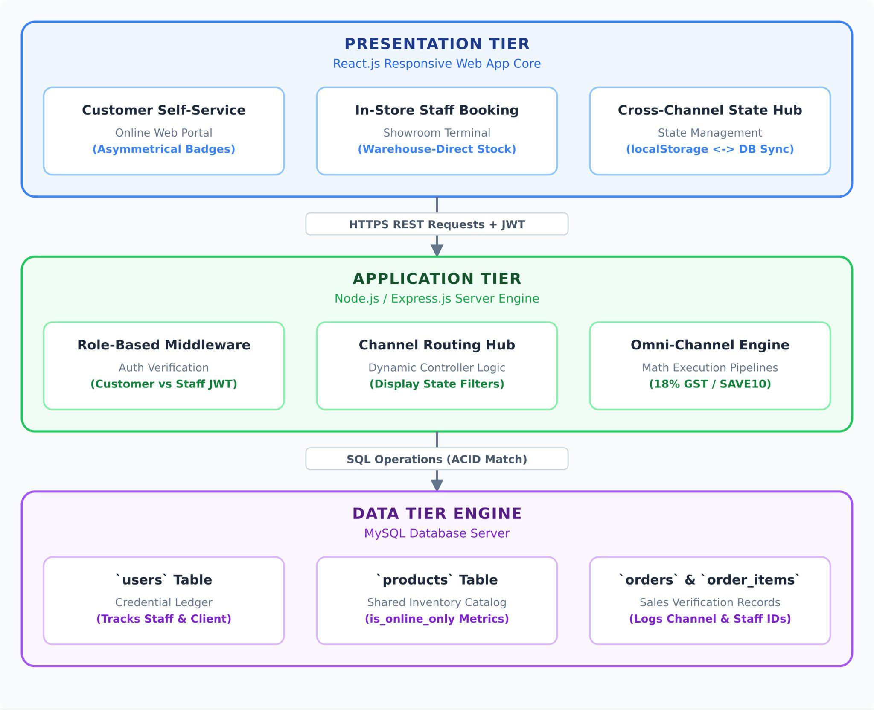

5. Data Architecture (Schema Requirements)
Financial summaries are calculated on the backend using this formula (applying the 10% SAVE10 code followed by the mandatory 18% Indian retail GST calculation):



5.1 Table: users
Tracks system actors, internal showroom staff records, and customer profiles.
Column Name | Data Type | Constraints
user_id | INT | PRIMARY KEY, AUTO_INCREMENT
full_name | VARCHAR(100) | NOT NULL
email | VARCHAR(150) | UNIQUE, NOT NULL
password_hash | VARCHAR(255) | NOT NULL
role | ENUM | NOT NULL, DEFAULT 'CUSTOMER'
phone | VARCHAR(15) | NOT NULL
delivery_address | VARCHAR(255) | NULL
landmark | VARCHAR(100) | NULL
pin_code | VARCHAR(10) | NULL
profile_image_url | VARCHAR(255) | NULL
is_active | BOOLEAN | NOT NULL, DEFAULT FALSE
created_at | TIMESTAMP | DEFAULT CURRENT_TIMESTAMP
updated_at | TIMESTAMP | DEFAULT CURRENT_TIMESTAMP ON UPDATE

5.2 Table: products
Stores product attributes, stock volumes, catalog display constraints, and frontend metadata fields.
Column Name | Data Type | Constraints
product_id | INT | PRIMARY KEY, AUTO_INCREMENT
product_name | VARCHAR(150) | NOT NULL
description | TEXT | NOT NULL
price | DECIMAL(10,2) | NOT NULL
original_price | DECIMAL(10,2) | NOT NULL
category | ENUM | NOT NULL
is_new | BOOLEAN | NOT NULL, DEFAULT TRUE
is_online_only | BOOLEAN | NOT NULL, DEFAULT FALSE
specifications | JSON | NULL
colors | JSON | NULL
available_sizes | JSON | NULL
floor_sample_present | BOOLEAN | NOT NULL, DEFAULT FALSE
showroom_location_bay | VARCHAR(50) | NULL
features | TEXT | NULL
dimensions | VARCHAR(100) | NULL
stock_count | INT | NOT NULL, DEFAULT 0
rating | DECIMAL(3,2) | NOT NULL
is_active | BOOLEAN | NOT NULL, DEFAULT TRUE
image_url | VARCHAR(255) | NOT NULL
created_at | TIMESTAMP | DEFAULT CURRENT_TIMESTAMP
updated_at | TIMESTAMP | DEFAULT CURRENT_TIMESTAMP ON UPDATE

5.3 Table: collections
Manages curated groups created by the Store Owner (e.g., "Oak & Earth", "Mid-Century Luxe").
Column Name | Data Type | Constraints
collection_id | INT | PRIMARY KEY, AUTO_INCREMENT
collection_name | VARCHAR(100) | UNIQUE, NOT NULL
associated_category | ENUM | NOT NULL

5.4 Table: product_collection_mapping
Junction table managing many-to-many configurations between products and design trends.
Column Name | Data Type | Constraints
product_id | INT | FOREIGN KEY, COMPOSITE KEY
collection_id | INT | FOREIGN KEY, COMPOSITE KEY

5.5 Table: cart_items
Tracks live database-backed shopping cart states when synced from client browser localStorage.
Column Name | Data Type | Constraints
cart_item_id | INT | PRIMARY KEY, AUTO_INCREMENT
user_id | INT | FOREIGN KEY, NOT NULL
product_id | INT | FOREIGN KEY, NOT NULL
quantity | INT | NOT NULL DEFAULT 1

5.6 Table: orders
Master ledger tracking transaction channel origins and total financial metrics.
Column Name | Data Type | Constraints
order_id | INT | PRIMARY KEY, AUTO_INCREMENT
user_id | INT | FOREIGN KEY, NOT NULL
booked_by_staff_id | INT | FOREIGN KEY, NULL
order_placement_channel | ENUM | NOT NULL, DEFAULT 'ONLINE' - ONLINE, IN STORE
subtotal_amount | DECIMAL(10,2) | NOT NULL
discount_applied | DECIMAL(10,2) | NOT NULL DEFAULT 0.00
gst_tax_amount | DECIMAL(10,2) | NOT NULL
grand_total | DECIMAL(10,2) | NOT NULL
order_status | ENUM | NOT NULL, DEFAULT 'PENDING' - PENDING, CONFIRMED , CANCELLED
created_at | TIMESTAMP | DEFAULT CURRENT_TIMESTAMP
delivery_mode | ENUM | NOT NULL, DEFAULT 'HOME_DELIVERY' — HOME_DELIVERY, SHOWROOM_PICKUP
delivery_address | VARCHAR(255) | NULL — snapshot at order time
landmark | VARCHAR(100) | NULL
pin_code | VARCHAR(10) | NULL
refund_status | ENUM | NOT NULL, DEFAULT 'NOT_APPLICABLE'
refund_amount | DECIMAL(10,2) | NULL

5.7 Table: order_items
Granular line item entries capturing immutable snapshots of purchased products.
Column Name | Data Type | Constraints
order_item_id | INT | PRIMARY KEY, AUTO_INCREMENT
order_id | INT | FOREIGN KEY, NOT NULL
product_id | INT | FOREIGN KEY, NOT NULL
quantity | INT | NOT NULL, CHECK > 0
price_snapshot | DECIMAL(10,2) | NOT NULL

5.8 Table: payments
Tracks financial auditing data across online systems and manual in-store checkouts.
Column Name | Data Type | Constraints
payment_id | INT | PRIMARY KEY, AUTO_INCREMENT
order_id | INT | UNIQUE, FOREIGN KEY, NOT NULL
amount | DECIMAL(10,2) | NOT NULL — mirrors orders.grand_total at payment time
payment_method | ENUM | NOT NULL
payment_status | ENUM | NOT NULL, DEFAULT 'PENDING'
gateway_transaction_token | VARCHAR(100) | NULL
transaction_id | VARCHAR(50) | UNIQUE, NULL
updated_at | TIMESTAMP | DEFAULT CURRENT_TIMESTAMP ON UPDATE

5.9 Table: deliveries
Fulfillment logistics tracker managing courier states and pickup modes.
Column Name | Data Type | Constraints
delivery_id | INT | PRIMARY KEY, AUTO_INCREMENT
order_id | INT | UNIQUE, FOREIGN KEY, NOT NULL
delivery_status | ENUM | NOT NULL, DEFAULT 'UNASSIGNED' - UNASSIGNED, SHIPPED, DELIVERED
actual_delivery | TIMESTAMP | NULL
delivery_tracking_id | VARCHAR(50) | UNIQUE, NOT NULL
assigned_driver_user_id | INT | FK → users(user_id), NULL
delivery_mode | ENUM | NOT NULL — HOME_DELIVERY, SHOWROOM_PICKUP
destination_address | VARCHAR(255) | NOT NULL
last_updated_timestamp | TIMESTAMP | DEFAULT CURRENT_TIMESTAMP ON UPDATE

5.10 Table: reviews
Captures post-purchase customer feedback and item satisfaction metrics.
Column Name | Data Type | Constraints
review_id | INT | PRIMARY KEY, AUTO_INCREMENT
user_id | INT | FOREIGN KEY, NOT NULL, UNIQUE
product_id | INT | FOREIGN KEY, NOT NULL, UNIQUE
rating | DECIMAL(3,2) | NOT NULL, CHECK (1-5)
feedback | TEXT | NULL
created_at | TIMESTAMP | DEFAULT CURRENT_TIMESTAMP

5.11 Table: wishlist_items

Tracks products saved by customers for later purchase.
Column Name | Data Type | Constraints
wishlist_item_id | INT | PRIMARY KEY, AUTO_INCREMENT
user_id | INT | FOREIGN KEY → users(user_id), NOT NULL
product_id | INT | FOREIGN KEY → products(product_id), NOT NULL
created_at | TIMESTAMP | DEFAULT CURRENT_TIMESTAMP

5.12 Table: contact_messages

Stores inbound contact form submissions and support requests.
Column Name | Data Type | Constraints
contact_id | INT | PRIMARY KEY, AUTO_INCREMENT
full_name | VARCHAR(100) | NOT NULL
email | VARCHAR(150) | NOT NULL
phone | VARCHAR(15) | NOT NULL
message | TEXT | NOT NULL
status | ENUM | NOT NULL, DEFAULT 'OPEN' — values: OPEN, IN_PROGRESS, RESOLVED
created_at | TIMESTAMP | DEFAULT CURRENT_TIMESTAMP

5.13 Table: password_reset_sessions

Stores OTP-based password reset transactions for customer accounts only.
Column Name | Data Type | Constraints
session_id | INT | PRIMARY KEY, AUTO_INCREMENT
session_transaction_id | VARCHAR(50) | UNIQUE, NOT NULL
user_id | INT | FOREIGN KEY → users(user_id), NOT NULL
otp_hash | VARCHAR(255) | NOT NULL
expires_at | TIMESTAMP | NOT NULL
is_verified | BOOLEAN | NOT NULL, DEFAULT FALSE
is_used | BOOLEAN | NOT NULL, DEFAULT FALSE
created_at | TIMESTAMP | DEFAULT CURRENT_TIMESTAMP

5.14 Table: coupons

Manages promotional discount codes (e.g. SAVE10) created by the Store Owner.
Column Name | Data Type | Constraints
coupon_id | INT | PRIMARY KEY, AUTO_INCREMENT
coupon_code | VARCHAR(50) | UNIQUE, NOT NULL
discount_percentage | DECIMAL(5,2) | NOT NULL
is_active | BOOLEAN | NOT NULL, DEFAULT TRUE
valid_from | TIMESTAMP | NOT NULL
valid_until | TIMESTAMP | NOT NULL
created_by | INT | FOREIGN KEY → users(user_id), NULL
created_at | TIMESTAMP | DEFAULT CURRENT_TIMESTAMP
updated_at | TIMESTAMP | DEFAULT CURRENT_TIMESTAMP ON UPDATE

5.15 Table: order_coupon_usage

Links which coupon was applied to an order (audit trail).

Column Name | Data Type | Constraints
order_id | INT | FOREIGN KEY → orders(order_id), PRIMARY KEY
coupon_id | INT | FOREIGN KEY → coupons(coupon_id), NOT NULL
discount_amount | DECIMAL(10,2) | NOT NULL
applied_at | TIMESTAMP | DEFAULT CURRENT_TIMESTAMP

5.16 Table: product_images

Column Name | Data Type | Constraints
image_id | INT | PRIMARY KEY, AUTO_INCREMENT
product_id | INT | FOREIGN KEY → products(product_id), NOT NULL
image_url | VARCHAR(255) | NOT NULL
is_primary | BOOLEAN | NOT NULL, DEFAULT FALSE
sort_order | INT | NOT NULL, DEFAULT 0

5.17 Table: review_images

Column Name | Data Type | Constraints
review_image_id | INT | PRIMARY KEY, AUTO_INCREMENT
review_id | INT | FOREIGN KEY → reviews(review_id), NOT NULL
image_url | VARCHAR(255) | NOT NULL

6.1 Walk-in / staff-assisted checkout

Walk-in customer → orders.user_id (lookup/create)

When staff completes assisted checkout (order_placement_channel = IN_STORE):

Accept customer_details: full_name, phone, email (email or phone required).

Lookup existing CUSTOMER by email (preferred) or phone.

If not found, auto-create a CUSTOMER row (is_active = TRUE).

Set orders.user_id to that customer.

Set orders.booked_by_staff_id to logged-in staff user_id.

Copy delivery address fields onto orders (snapshot — do not rely on profile later).

Payment may complete immediately (showroom COD/UPI/card).

6.4 Reviews & ratings

Review eligibility (CONFIRMED order with product)

Rule | Detail
Eligibility | User may review product_id only if they have at least one CONFIRMED order containing that product in order_items.
Uniqueness | One review per (user_id, product_id) — enforce UNIQUE (user_id, product_id).
Rating | Integer 1–5 stars.
Moderation | Admin may delete reviews; products.rating recalculated as AVG of remaining reviews.
Edit/delete | Author may PATCH/DELETE own review only.

