University of Engineering & Technology, Peshawar

Abbottabad Campus



OPEN ENDED LAB

LAB TITTLE:
DESIGN, FABRICATION, AND ETCHING OF A 5V REGULATED POWER SUPPLY PCB

COURSE TITLE:
Computer Aided Engineering Design (CAED)

SUBMITTED BY:

•Amina Bibi | 24ABELT10988
• Iqra Noor | 24ABELT1001
• Maryam Shahzad | 24ABELT1003

SUBMITTED TO:

Ma’am Sania

SEMESTER:
4th

DEPARTMENT:
Electronics Engineering

TABLE OF CONTENTS
1. ........................... Project Objectives
2. ........................... Circuit Description and Schematic Design
2.1 ........................... Circuit Operation
2.2 ........................... Step-by-Step Design in KiCad
2.3 ........................... Step-by-Step Design in EAGLE CAD
3. ........................... KiCad Layout to Print Conversion and Hardware Fabrication
3.1 ........................... Converting the KiCad Layout to a Black-and-White Print View
3.2........................... Hardware Fabrication Process
4. ........................... Theory and Questions
5. ........................... PCB Fabrication Process Flow and Step Discussions
6. ........................... Conclusion and Observations

LIST OF FIGURES
Figure 1........................... 5V Regulated Power Supply Schematic Designed in KiCad
Figure 2........................... PCB Layout and Multi-Layer Routing in KiCad
Figure 3........................... 5V Regulated Power Supply Schematic in EAGLE CAD
Figure 4 ........................... PCB Layout in EAGLE CAD
Figure 5........................... Black-and-White PCB Mask Print for Toner Transfer
Figure 6 ........................... Print on Butter Paper
Figure 7 ........................... Copper-Clad Board Preparation
Figure 8 ........................... Toner Transfer Process
Figure 9........................... Final Fabricated 5V Regulated Power Supply PCB

1. Project Objectives
Capture the schematic diagram of a 5V regulated power supply circuit using both KiCad and Autodesk EAGLE CAD.
Design and route a multi-layer PCB layout using color-coded copper layers: Red for the Top Copper Layer and Blue for the Bottom Copper Layer.
Convert the PCB layout into a black-and-white mask print view using KiCad layout settings and print the design onto butter paper with a laser printer.
Fabricate the physical PCB using the toner-transfer method, followed by chemical etching, cleaning, drilling, and final inspection.
Study and answer theoretical questions related to PCB fabrication, chemical etching, safety precautions, and the overall PCB manufacturing process.

2. Circuit Description and Schematic Design

2.1 Circuit Operation
The circuit accepts an AC or DC input through a 2-pin screw terminal (J1 / X1). When an AC input is used, the diode bridge rectifier (D2 / B1) converts the AC voltage into pulsating DC. The capacitors (C1, C2, and C3) provide filtering and decoupling to reduce voltage fluctuations and unwanted noise. The filtered voltage is then applied to the LM7805 linear voltage regulator (U1), which regulates the input to a stable +5 V DC output. The regulated output is delivered through the output terminal (J2 / X2).

2.2 Step-by-Step Design in KiCad

KiCade Schematic:
Placed the required components, including Screw_Terminal_01x02, Bridge Rectifier D_Bridge_+-AA, capacitors (C_Polarized and C), and the LM7805_TO220 voltage regulator.
Connected the power nets and added a global GND symbol to establish a common ground reference.
Performed an Electrical Rules Check (ERC) to identify and correct invalid or incomplete electrical connections.
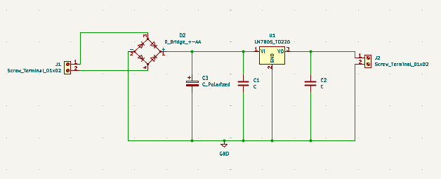
Figure 1:5V Regulated Power Supply Schematic Designed in Ki-Cad

Footprint Assignment and PCB Layout
Assigned appropriate footprints to all schematic components.
Transferred the netlist to the PCB Editor and arranged the components logically to obtain short, clean, and practical signal paths.
Routed the PCB using multiple copper layers.
Used the Top Copper Layer (Red) for top-side traces and the Bottom Copper Layer (Blue) for bottom-size traces.
Performed a Design Rules Check (DRC) to verify trace clearances, spacing, and drill-hole requirements.
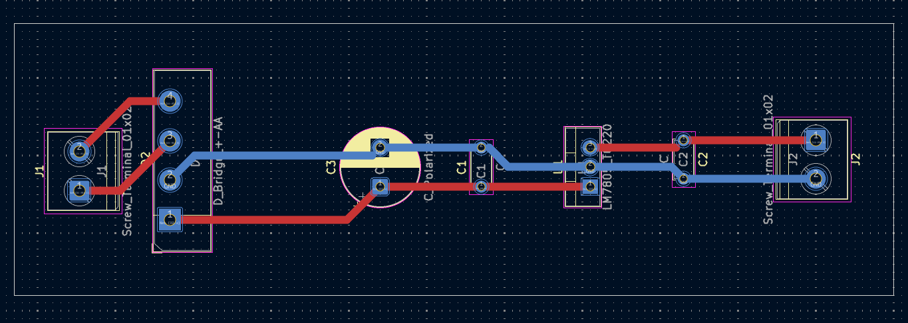
Figure 2:PCB Layout and Multi-Layer Routing in KiCad

2.3 Step-by-Step Design in EAGLE CAD

Schematic Editor
Added the 7805T voltage regulator, DB101G diode bridge, capacitors, and input/output connectors (X1 and X2).
Connected the components using the NET tool and established the required ground references.

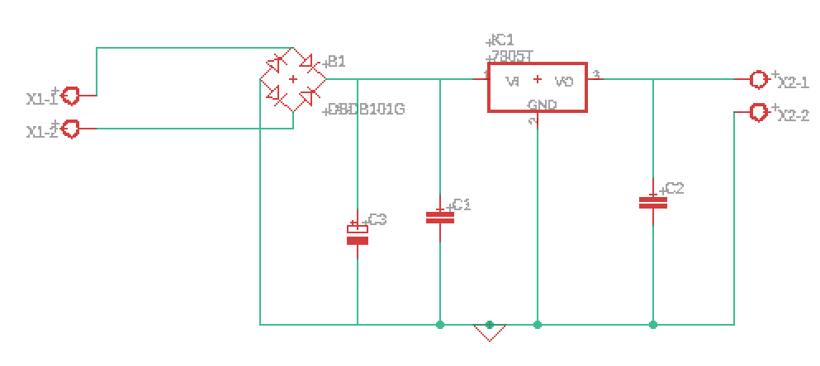
Figure 3:5V Regulated Power Supply Schematic in EAGLE CAD

Board Layout Editor
Opened the Board View using the Switch to Board option.
Defined the PCB outline and positioned the components within the board boundary.
Used the Route tool to create the required copper traces.
Displayed Top Copper Layer traces in Red and Bottom Copper Layer traces in Blue.
Executed the Design Rule Check (DRC) to verify that the layout had no overlapping traces or major constraint violations.

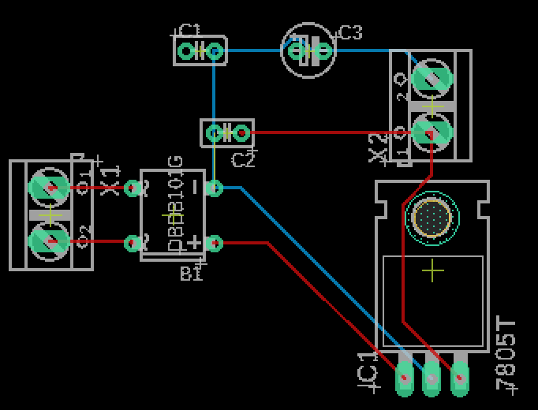
Figure 4:PCB Layout in EAGLE CAD

3. KiCad Layout to Print Conversion and Hardware Fabrication

3.1 Converting the KiCad Layout to a Black-and-White Print View
While the CAD layout explored double-sided multi-layer routing, the physical prototype was convertedto a single-sided bottom-layer layout for standard toner transfer fabrication.
- Opened the PCB layout in KiCad PCB Editor and selected the Print option, or exported the required layer as an SVG/PDF file.
- Enabled Black and White or monochrome printing so that copper traces, pads, and drill locations were represented clearly in solid black.
- Hidden unnecessary silkscreen text, graphics, and borders to reduce toner usage and prevent unwanted marks on the transfer mask.
- Set the print scale to 1:1 (100% actual size) to ensure that the physical PCB dimensions matched the original CAD design.
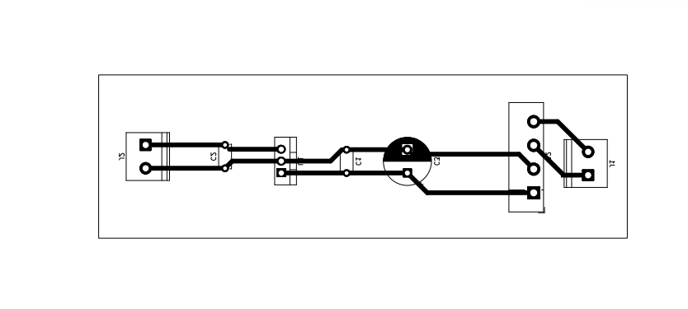
Figure 5:Black-and-White PCB Mask Print for Toner Transfer

- Mirrored the bottom-layer artwork when required for toner transfer and printed the layout onto high-density butter paper using a laser printer.

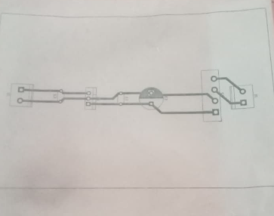
Figure 6: Print on butter paper

3.2 Hardware Fabrication Process
Board Preparation: Cut the copper-clad board to the required dimensions. Clean and lightly scuff the copper surface using fine steel wool or an appropriate abrasive pad to remove oxidation, dirt, and grease.
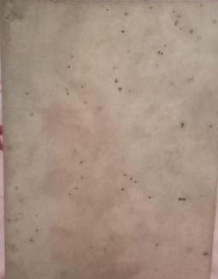
Figure 7:Copper-Clad Board Preparation
Toner Transfer: Place the printed butter paper face down on the cleaned copper surface. Apply heat and pressure using a hot iron for approximately 3–5 minutes so that the toner transfers onto the copper.
Soaking and Paper Removal: Immerse the board in warm water to soften the paper. Carefully peel away the paper while ensuring that the transferred toner mask remains intact on the copper surface.
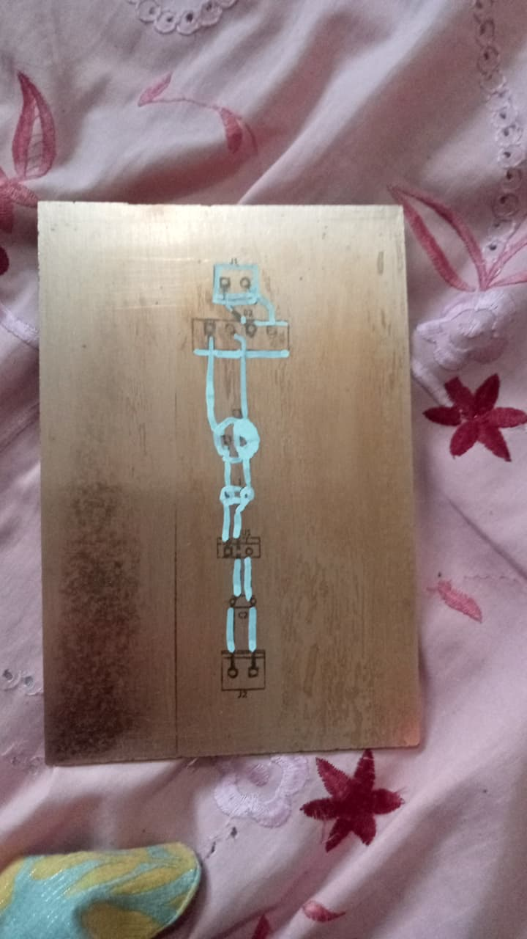
Figure 8:Toner Transfer
Chemical Etching: Place the board in a Ferric Chloride (FeCl₃) etching bath. Gently agitate the solution for approximately 15–20 minutes, or until all exposed copper has been removed.
Cleaning and Inspection: Remove and thoroughly rinse the board with water. Strip the remaining toner using acetone or a suitable solvent. Inspect the PCB for damaged tracks, incomplete etching, or unwanted copper bridges, and verify electrical continuity using a multimeter.
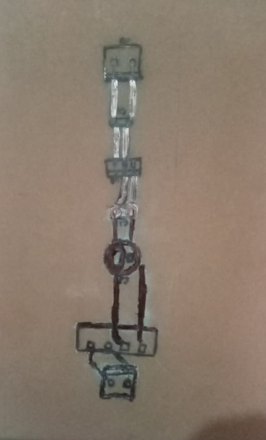
Figure 9: Final Fabricated 5V Regulated Power Supply PCB

4. Theory and Questions

Q1: What is PCB etching? Explain its purpose in the fabrication of printed circuit boards.
- PCB Etching is the chemical removal of unwanted, unprotected copper from a copper-clad laminate board.
Purpose:
Its purpose is to isolate specific copper trace paths, pads, and planes corresponding to the schematic design. By dissolving raw copper everywhere except beneath the protective mask (toner), etching forms conductive pathways that interconnect electronic components without risk of short circuits.

Q2: List the steps involved in the PCB etching process.
- Design and Mirror Printing: Prepare the PCB layout and print the required copper layer in monochrome on suitable transfer paper.
- Surface Cleaning: Clean, scuff, and degrease the copper-clad laminate to improve toner adhesion.
- Thermal Transfer: Transfer the printed toner pattern onto the copper surface using controlled heat and pressure.
- Paper Peeling: Soak the board in water and carefully remove the paper while preserving the toner mask.
- Chemical Etching Bath: Immerse the board in an appropriate etchant, such as Ferric Chloride, to dissolve exposed copper.
- Mask Stripping and Final Inspection: Remove the toner mask, inspect the copper tracks, drill component holes, and test electrical continuity.

Q3: Name two chemicals commonly used for PCB etching and briefly explain their functions.
- Ferric Chloride (FeCl₃): A commonly used and cost-effective etchant that reacts with copper and dissolves the exposed copper areas of the PCB.
Ammonium Persulfate or Sodium Persulfate: Alternative oxidizing etchants that dissolve exposed copper and provide a relatively clean etching process, making the progress easier to observe.

Q4: What safety precautions should be followed while performing PCB etching?
- Wear Personal Protective Equipment (PPE): Use safety glasses, chemical-resistant gloves, and protective clothing to reduce the risk of chemical exposure.
Ensure Proper Ventilation: Perform etching in a well-ventilated area or under suitable local exhaust ventilation to minimize exposure to chemical vapors or fumes.
Use Non-Metallic Containers: Use plastic, glass, or ceramic containers that are compatible with the etchant. Avoid metal containers because the chemicals may react with them.
Handle Chemicals Carefully: Avoid direct skin or eye contact and follow the safety instructions provided for the specific etchant being used.
Dispose of Waste Responsibly: Do not pour used etchant directly into household drains. Collect and dispose of chemical waste according to applicable local laboratory or hazardous-waste procedures.

5. PCB Fabrication Process Flow and Step Discussions
1. Design Schematic and PCB Layout in KiCad / EAGLE CAD
↓
2. Export and Print the Monochrome Black and White PCB Mask
↓
3. Clean the Copper Clad Board (Scuffing and Degreasing)
↓
4. Perform Thermal Toner Transfer (Ironing Process)
↓
5. Soak the Board in Water and Carefully Remove the Paper
↓
6. Submerge the Board in the Chemical Etchant Bath (FeCl₃)
↓
7. Strip the Toner Drill Component Holes and Test Electrical Continuity

Role of Each Step
1 & 2. CAD Design and Printing: Converts the theoretical circuit into an accurate PCB geometry and produces a high-resolution, etch-resistant mask for transferring the copper pattern.
3. Board Cleaning: Removes oxidation, dirt, and grease from the copper surface, allowing the toner to adhere properly during the thermal transfer process.
4 & 5. Toner Transfer and Paper Removal: Transfers the protective etch-resist pattern onto the copper and removes the paper without damaging fine traces or pads.
6. Chemical Etching: Removes unwanted exposed copper while preserving the copper protected by the toner mask, producing isolated conductive tracks.
7. Toner Stripping, Drilling, and Testing: Exposes the final copper tracks, creates component mounting holes, and confirms track continuity and the absence of unintended shorts before assembly.

6. Conclusion and Observations
Software Design: The schematic and PCB layout of the 5V regulated power supply were successfully designed and completed using both KiCad and EAGLE CAD. The multi-layer routing was verified using standard color conventions, with Red representing the Top Copper Layer and Blue representing the Bottom Copper Layer.
Hardware Fabrication: The KiCad monochrome PCB layout was successfully printed onto butter paper, transferred to a copper-clad board using the toner-transfer method, and chemically etched using Ferric Chloride.
Final Result: The fabricated PCB produced clean and well-defined copper tracks. Final inspection and multimeter testing confirmed proper electrical continuity with no observed open tracks or unintended short circuits. The completed work demonstrates the complete process of converting a circuit design into a functional PCB through CAD design, toner transfer, chemical etching, drilling, and inspection.

