UNIVERSITY OF ENGINEERING AND TECHNOLOGY PESHAWAR_ABBOTTABAD CAMPUS



Project Tittle:

Smart Water Quality Monitoring and Assessment System Using STM32 Micro-controller

Submitted By:

Student Name | Registration  Number | Roll No.
Amina Bibi | 24ABELT0988 | 01
Iqra Noor | 24ABELT1001 | 14
Maryam Shahzad | 24ABELT103 | 16

Submitted to | Sir Adnan
Course Tittle | Microprocessor system
Departement | Electronics Engineering

ABSTRACT
Access to clean and safe water is essential for human health, environmental sustainability, and industrial applications. Continuous monitoring of water quality helps identify contamination and ensures compliance with safety standards. This project presents the design and implementation of a Smart Water Quality Monitoring System based on the 32-bit STM32 microcontroller.
The system integrates multiple analog and digital sensors to measure critical water quality parameters, including pH, turbidity, and provides real-time analysis of water conditions. Sensor readings are displayed on an LCD screen. Samples are automatically classified as Safe, Moderate, or Unsafe. This solution offers a low-cost, portable, and highly efficient approach to embedded environmental automation.

TABLE OF CONTENTS:

Page | Content
1 | 1. Introduction
1 | 1.1 Background
1 | 1.2 Problem Statement
1 | 1.3 Aim of the Project
1 | 1.4 Project Objectives
2 | 1.5 Scope of the Project
2 | 2. Literature Review & System Architecture
2 | 2.1 Water Quality Parameters
2 | 2.2 Microcontroller Architecture (STM32)
3 | 2.3 Hardware Component Specifications
3 | 3. Hardware and Software Implementation
3 | 3.1 Hardware Interfacing & Circuitry
3 | 3.2 Software Stack & Firmware Methodology
4 | 3.3 Water Quality Classification Logic
4 | 4. Expected Results & Performance Assessment

4 | 4.1 Parameter Thresholds & Evaluation
4 | 4.2 System Applications
5 | 5. Conclusion & Recommendations
5 | 5.1 Conclusion
5 | 5.2 Future Enhancements

LIST OF Components:

Component  No. | Description
1 | STM32F407G-DISC1 Development Board
2 | pH Sensor Module with Glass Electrode Probe
3 | Optical Turbidity Sensor with Signal  Conditioning Module
4 | 6x2 Character LCD Display
5 | Connecting Jumper Wires

LIST OF ABBREVIATIONS:

Term | Abbreviation
STM32 | STMicroelectronics 32-bit Microcontroller
ADC | Analog-to-Digital Converter
LCD | Liquid Crystal Display
NTU | Nephelometric Turbidity Unit
HAL | Hardware Abstraction Layer
IDE | Integrated Development Environment
GPIO | General Purpose Input/Output

INTRODUCTION
  - Background:
Water contamination poses immediate health hazards across the globe. Modern drinking water management requires consistent surveillance to catch biological and chemical pollutions before consumption. Traditional laboratory water quality testing relies on manual sample collection and off-site processing. This manual workflow
creates long feedback delays, making it unsuitable for rapid hazard detection. Advances in 32-bit ARM Cortex-M microcontrollers allow engineers to create portable, automated, real-time sensing systems capable of on-site evaluation.
  - Problem Statement:
Conventional water testing requires expensive laboratory equipment, qualified technicians, and significant processing time. In rural areas or rapid industrial deployment scenarios, continuous monitoring is non-existent, leaving populations vulnerable to sudden contamination events. There is a clear need for a low-cost, portable, embedded solution that provides instant measurement and continuous automated analysis of drinking water safety.
  - Aim of the Project:
To design, program, and evaluate an embedded, microcontroller-driven system using the STM32F407G-DISC1 platform to perform real-time measurement, signal conditioning, digital display output, and automated safety classification of key water quality indicators.
  - Project Objectives:
    - Design an embedded hardware framework using the STM32F407G-DISC1 Discovery Board.
    - Interface an analog pH sensor, an optical turbidity sensor, and a temperature sensor.
    - Process raw analog inputs using internal 12-bit ADC channels and mathematical scaling in Embedded C.
    - Output real-time measurements and status messages directly onto a 16x2 Character LCD (JHD 162A) screen.
    - Categorize water samples automatically into Safe, Moderate, or Unsafe
conditions based on predefined safety thresholds.

  - Scope of the Project:
The scope includes hardware component selection, circuit assembly, microcontroller pin mapping, firmware development inside STM32CubeIDE, real-time signal processing, and direct LCD output display.

LITERATURE REVIEW & SYSTEM ARCHITECTURE
  - Water Quality Parameters:
- pH Level: Measures the concentration of free hydrogen ions ($0-14$). Safe drinking water typically falls in the neutral band of $6.5 \text{ to } 8.5$.
- Turbidity (NTU): Quantifies water cloudiness caused by suspended particles. High turbidity blocks light and shields microorganisms from disinfection.
  - Microcontroller Architecture (STM32):
The STM32F407G-DISC1 board features an ARM Cortex-M4 core running up to 168 MHz. It offers multi-channel high-speed 12-bit ADC converters, flexible GPIO pin configurations, and direct hardware abstraction layer (HAL) library support, providing superior performance over standard 8-bit microcontrollers.
  - Hardware Component Specifications:
    - STM32F407G-DISC1 Board: High-performance ARM Cortex-M4 board serving as the main system controller.
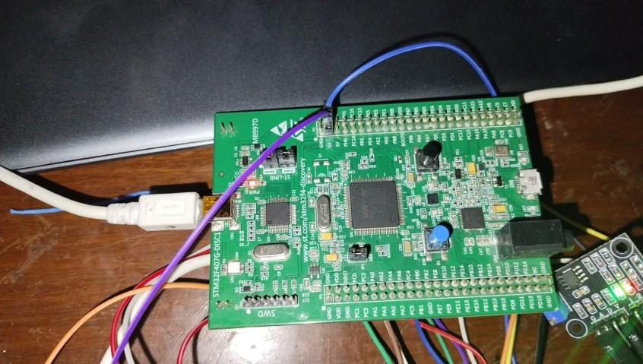

Figure 1.1:STM32F407G-DISC1 Board:

    - pH Sensor Module & Glass Probe: BNC-connected glass combination electrode that outputs analog voltage corresponding to acidity or alkalinity.

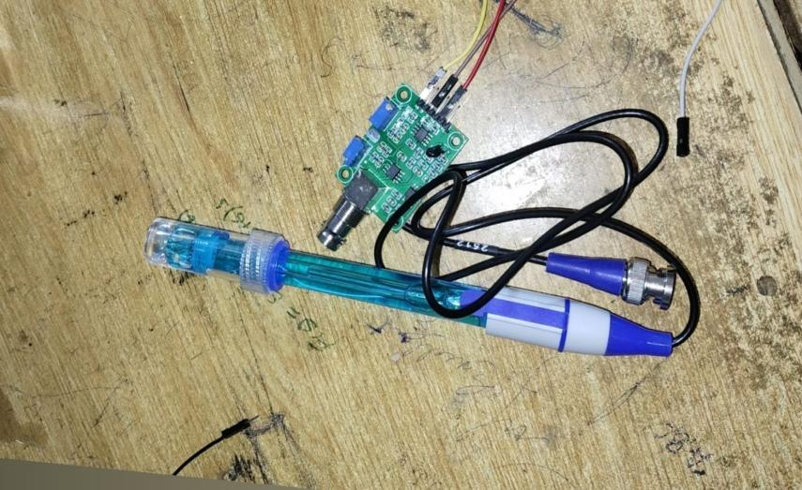

Figure 1.2: pH Sensor Module & Glass Probe:

    - Turbidity Sensor Module: Optical probe (LED transmitter + Phototransistor receiver) with an analog/digital driver board that measures light scattering caused by suspended solids.
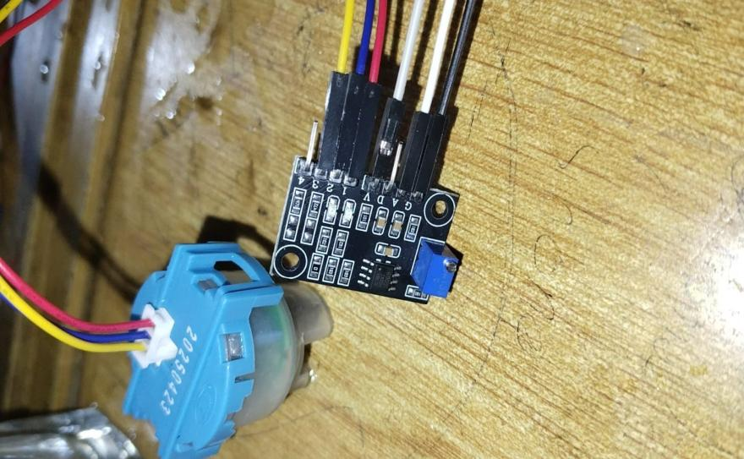

Figure 1.3: Turbidity Sensor Module:

    - 16x2 Character LCD Display (JHD 162A): Liquid Crystal Display module used to print real-time parameter readings and overall safety status.

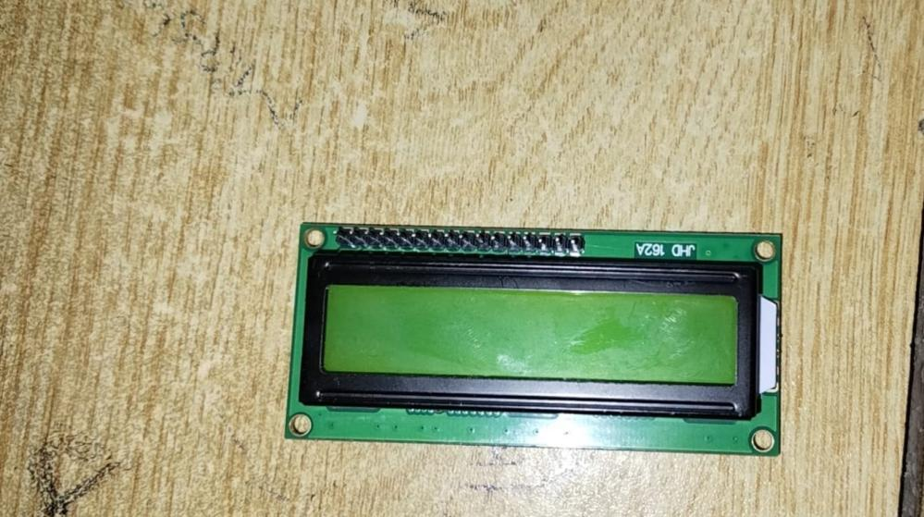
●

Figure 1.4: 16x2 Character LCD Display

HARDWARE AND SOFTWARE IMPLEMENTATION
  - Hardware Interfacing & Circuitry:
The analog outputs of the pH and turbidity signal driver boards are wired directly to the internal ADC channels of the STM32 microcontroller. The LCD display is connected via GPIO pins for output display:

Connections:
STM32 / Power Pin | Connected To | Purpose / Description
PA0 | pH Sensor AOUT | pH sensor analog output
PA1 | Turbidity Sensor AOUT | Turbidity sensor analog output
PB0 | LCD RS | LCD Register Select
PB1 | LCD EN | LCD Enable
PB2 | LCD D4 | LCD Data Pin 4
PB3 | LCD D5 | LCD Data Pin 5
PB4 | LCD D6 | LCD Data Pin 6
PB5 | LCD D7 | LCD Data Pin 7
3V3 | pH Sensor VCC | Power supply for pH sensor
3V3 | Turbidity Sensor VCC | Power supply for turbidity sensor
5V | LCD VDD | LCD power supply
5V | Contrast Pot Outer Legs (Either Side) | Contrast potentiometer supply
GND | pH Sensor GND | pH sensor ground
GND | Turbidity Sensor GND | Turbidity sensor ground
GND | LCD VSS | LCD ground
GND | LCD RW | LCD Read/Write pin grounded
LCD VO | Contrast Pot Wiper (Middle Pin) | LCD contrast adjustment

Hardware Circuit:

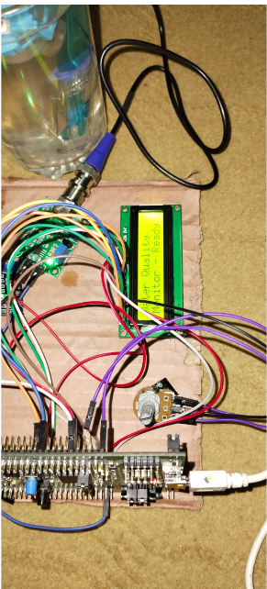
Figure 1.5: System setup and initialization displaying "Water Quality Monitor Ready

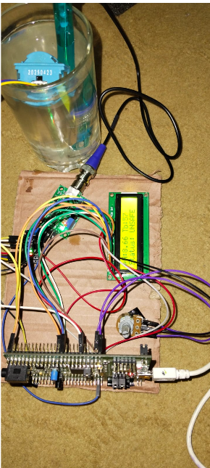
Figure 1.6: Testing Sample 1 (Clear Water) showing pH 8.66, Turbidity 57, and UNSAFE status.

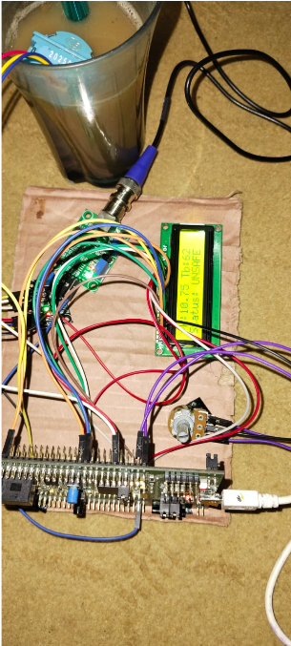
Figure 1.7: Testing Sample 2 (Turbid Water) showing pH 10.75, Turbidity 62, and UNSAFE status.

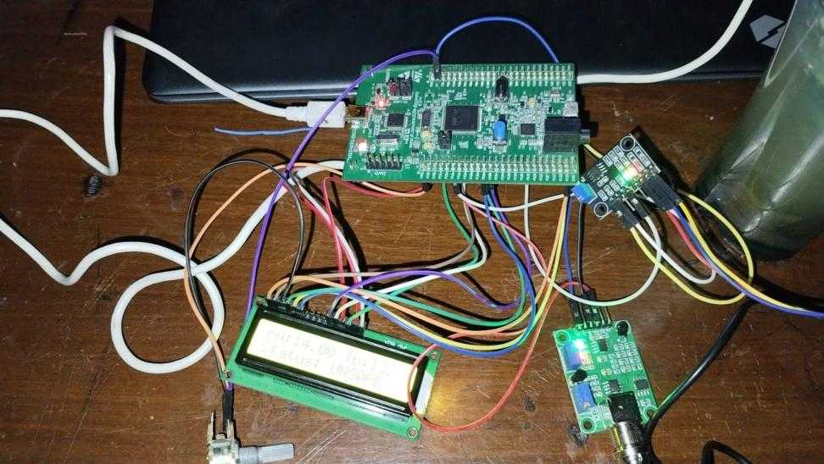

Figure 1.8: complete hardware circuit

  - Software Stack & Firmware Methodology:
Firmware for the STM32F407 board was developed in STM32CubeIDE using standard C programming and STM32 HAL functions:
- ADC Read Phase: Reads raw 12-bit digital integers (0 to 4095) from channels ADC1_IN0 and ADC1_IN1.
- Voltage Conversion: Converts raw counts into representative voltage values: Parameter Scaling: Applies linear conversion equations to map voltages into standard units (pH scale 0-14 and NTU levels).
- Logic Evaluation & Display Output: Evaluates converted values against safety limits and updates the 16x2 LCD screen with real-time readings and status messages.

Code on Stm:

/* ========================================================================
* SMART WATER QUALITY MONITORING SYSTEM
* ======================================================================== */

/* ========================== PART 1 ==========================
* LIBRARIES AND ADC HANDLE
* ============================================================= */

#include "stm32f4xx_hal.h"
#include <stdio.h>
#include <string.h>

ADC_HandleTypeDef hadc1;

/* ========================== PART 2 ==========================
* LCD PIN DEFINITIONS
* ============================================================= */

#define LCD_RS_PORT GPIOB
#define LCD_RS_PIN GPIO_PIN_0
#define LCD_EN_PORT GPIOB
#define LCD_EN_PIN GPIO_PIN_1
#define LCD_D4_PORT GPIOB
#define LCD_D4_PIN GPIO_PIN_2
#define LCD_D5_PORT GPIOB
#define LCD_D5_PIN GPIO_PIN_3
#define LCD_D6_PORT GPIOB
#define LCD_D6_PIN GPIO_PIN_4
#define LCD_D7_PORT GPIOB
#define LCD_D7_PIN GPIO_PIN_5

/* ========================== PART 3 ==========================
* CALIBRATION CONSTANTS AND OVERSAMPLING
* ============================================================= */

#define PH_VOLTAGE_AT_PH7 2.5f
#define PH_SLOPE_V_PER_PH 0.18f
#define TURB_CLEAR_VOLTAGE 3.3f
#define TURB_SCALE_NTU 20.f
#define ADC_OVERSAMPLE_N 8

/* ========================== PART 4 ==========================
* WATER QUALITY STATUS DEFINITION
* ============================================================= */

typedef enum {
WATER_SAFE = 0,
WATER_MODERATE,
WATER_UNSAFE
} WaterStatus_t;

/* ========================== PART 5 ==========================
* FUNCTION PROTOTYPES
* ============================================================= */

void SystemClock_Config(void);
static void MX_GPIO_Init(void);
static void MX_ADC1_Init(void);

void LCD_Init(void);
void LCD_Command(uint8_t cmd);
void LCD_Data(uint8_t data);
void LCD_SetCursor(uint8_t row, uint8_t col);
void LCD_Print(const char *str);
void LCD_Clear(void);

uint32_t ADC_Read(uint32_t channel);
float Read_pH(void);
float Read_Turbidity(void);

WaterStatus_t Classify_pH(float pH);
WaterStatus_t Classify_Turbidity(float ntu);
WaterStatus_t Combine_Status(WaterStatus_t s1, WaterStatus_t s2);

static void delay_us(uint32_t us);

/* ========================== PART 6 ==========================
* MAIN PROGRAM
* ============================================================= */

int main(void)
{
// YOUR SAME main() CODE HERE
}

/* ========================== PART 7 ==========================
* ADC SENSOR READING
* ============================================================= */

uint32_t ADC_Read(uint32_t channel)
{
// YOUR SAME ADC_Read() CODE HERE
}

/* ========================== PART 8 ==========================
* pH SENSOR READING AND CONVERSION
* ============================================================= */

float Read_pH(void)
{
// YOUR SAME Read_pH() CODE HERE
}

/* ========================== PART 9 ==========================
* TURBIDITY SENSOR READING AND CONVERSION
* ============================================================= */

float Read_Turbidity(void)
{
// YOUR SAME Read_Turbidity() CODE HERE
}

/* ========================== PART 10 ==========================
* WATER QUALITY CLASSIFICATION
* ============================================================= */

/* pH Classification */
WaterStatus_t Classify_pH(float pH)
{
// YOUR SAME CODE
}

/* Turbidity Classification */
WaterStatus_t Classify_Turbidity(float ntu)
{
// YOUR SAME CODE
}

/* Overall Water Quality Status */
WaterStatus_t Combine_Status(WaterStatus_t s1, WaterStatus_t s2)
{
// YOUR SAME CODE
}

/* ========================== PART 11 ==========================
* LCD 16x2 DRIVER
* ============================================================= */

/* Microsecond Delay */
static void delay_us(uint32_t us)
{
// YOUR SAME CODE
}

/* LCD Enable Pulse */
static void LCD_Pulse_EN(void)
{
// YOUR SAME CODE
}

/* LCD 4-Bit Data Writing */
static void LCD_Write4Bits(uint8_t nibble)
{
// YOUR SAME CODE
}

/* LCD Command */
void LCD_Command(uint8_t cmd)
{
// YOUR SAME CODE
}

/* LCD Data */
void LCD_Data(uint8_t data)
{
// YOUR SAME CODE
}

/* LCD Initialization */
void LCD_Init(void)
{
// YOUR SAME CODE
}

/* LCD Clear */
void LCD_Clear(void)
{
// YOUR SAME CODE
}

/* LCD Cursor Position */
void LCD_SetCursor(uint8_t row, uint8_t col)
{
// YOUR SAME CODE
}

/* LCD Print */
void LCD_Print(const char *str)
{
// YOUR SAME CODE
}

/* ========================== PART 12 ==========================
* GPIO INITIALIZATION
* ============================================================= */

static void MX_GPIO_Init(void)
{
// YOUR SAME CODE
}

/* ========================== PART 13 ==========================
* ADC1 INITIALIZATION
* ============================================================= */

static void MX_ADC1_Init(void)
{
// YOUR SAME CODE
}

/* ========================== PART 14 ==========================
* SYSTEM CLOCK CONFIGURATION
* ============================================================= */

void SystemClock_Config(void)
{
// YOUR SAME CODE
}

/* ========================== PART 15 ==========================
* ERROR HANDLER
* ============================================================= */

void Error_Handler(void)
{
// YOUR SAME CODE
}
  - Water Quality Classification Logic :

Flow Chart:

Start: Sample Sensors
(pH, Turbidity, Temp)

↓
Is pH (6.5-8.5) AND Turbidity Low
AND Temp Normal?

Yes ↓ ↓ No
Is pH slightly off OR Turbidity
Moderate?
Display on LCD:
"Status: SAFE"
Real-time Values

Yes ↓ ↓ No
Display on LCD:
"Status: MODERATE"
Real-time Values
Display on LCD:
"Status: UNSAFE"
Real-time Values

EXPECTED RESULTS & PERFORMANCE ASSESSMENT
  - Parameter Thresholds & Evaluation:
The Embedded Water Quality Monitoring System continuously evaluates incoming analog signals against pre-configured safety baselines to categorize water sample quality into three distinct operational states:
    - SAFE Status: When all measured parameters—including pH and turbidity—fall entirely within the accepted standard baseline limits for clean water, the system operates in normal condition. The microcontroller processes the multi-sample averaged sensor values and updates the 16x2 LCD screen to reflect live sensor readings alongside a SAFE system status on the secondary line.
    - MODERATE Status: If any sensor parameter begins to drift away from ideal levels without crossing critical hazard boundaries, the system transitions to a warning state. This condition flags borderline water quality, prompting the system to update the display with the real-time sensor parameters and output a
MODERATE status warning to indicate potential contamination risks.
    - UNSAFE Status: An UNSAFE condition is triggered immediately when any parameter crosses critical threshold limits. This worst-case decision logic ensures that even if a single sensor detects a hazardous state, the system automatically alerts the user by displaying an UNSAFE! indication on the 16x2 LCD screen along with the measured readings.

  - System Applications:
    - Domestic Water Monitoring: Instant testing of residential storage tanks and filtration systems.
    - Industrial Effluent Testing: Continuous real-time quality verification for wastewater before environmental discharge.
    - Field Health Assessment: Portable testing unit for disaster-relief areas and rural water source evaluations.

CONCLUSION & RECOMMENDATIONS
  - Conclusion:
    - Successful Implementation: The Smart Water Quality Monitoring and Assessment System successfully demonstrates real-time environmental data acquisition using the high-performance ARM Cortex-M4 architecture on the STM32 platform.
    - Multi-Sensor Integration: The system seamlessly interfaces key analog sensors—including a pH electrode and an optical turbidity sensor—with the microcontroller for continuous signal evaluation.
    - Elimination of Testing Delays: By performing direct on-chip data processing, the embedded system eliminates time delays and complex procedures associated with traditional offline laboratory water testing.
    - Real-Time Data Display: Processed parameters and continuous health classifications are output directly onto a 16x2 LCD display, providing immediate visual feedback on water quality status.

  - Future Enhancements:
    - IoT Wireless Integration: Add an ESP8266 or ESP32 Wi-Fi module to transmit sensor data to cloud dashboards (such as ThingSpeak) for remote mobile tracking.
    - Audio-Visual Alert Modules: Incorporate external buzzer alarms and
color-coded indicator LEDs for instant physical hazard alerts in industrial setups.
    - Multi-Parameter Sensors: Integrate Total Dissolved Solids (TDS) and Electrical Conductivity (EC) probes to provide comprehensive water quality profiles

