WEDGE ANTENNA DESIGN AND SIMULATION
14 GHz Single Element and 1×4 Array Configuration
CST Studio Suite — Simulation Report

Abstract
This project presents the design and electromagnetic simulation of a wedge antenna operating at 14 GHz using CST Studio Suite. A single wedge-shaped radiating element was first developed on a dielectric substrate and subsequently extended to a 1×4 linear array. The design uses a substrate relative permittivity of 2.2 and a thickness of 0.508 mm. The simulated S-parameter response shows a resonance at approximately 14 GHz with a minimum S11 of about −13.8 dB. The far-field results at 14 GHz show a main-lobe directivity of 7.61 dBi and a main-lobe direction of 1°. The realized-gain result shows a maximum value of −3.34 dBi in the displayed cut. These results provide a clear assessment of the antenna's impedance matching and radiation characteristics.

1. Introduction
Wedge antennas are printed radiating structures that can be investigated at microwave frequencies using full-wave electromagnetic simulation. In this project, the design frequency is 14 GHz. CST Studio Suite is used to construct the antenna geometry, define the substrate and excitation, form a four-element linear array, and evaluate the resulting S-parameters and far-field radiation.
The study focuses on two main aspects: impedance matching around the 14 GHz operating frequency and the radiation behavior of the antenna at the same frequency. The supplied CST models include both a single wedge element and a 1×4 array configuration.

2. Objectives
- Design a wedge antenna for an operating frequency of 14 GHz.
- Model the antenna on a substrate with relative permittivity εr = 2.2 and thickness of 0.508 mm.
- Develop a single radiating element and extend it to a 1×4 linear array.
- Evaluate the reflection coefficient (S11) around the design frequency.
- Analyze far-field directivity and realized-gain patterns at 14 GHz.
- Compare the simulated performance with the specified design targets.

3. Design Specifications
Parameter | Specification
Operating Frequency | 14 GHz
Antenna Type | Wedge antenna
Array Configuration | 1×4 linear array
Relative Permittivity, εr | 2.2
Substrate Thickness | 0.508 mm
Target Reflection Coefficient | S11 < −20 dB
Target Gain | > 5 dBi
Simulation Software | CST Studio Suite

4. Design Methodology

4.1 Substrate Definition
A dielectric substrate is defined with a relative permittivity of 2.2 and a thickness of 0.508 mm.

4.2 Single Wedge Element
A wedge-shaped metallic radiator is constructed on the substrate. The CST model includes a feed point at the lower section of the radiator for electromagnetic excitation.

4.3 1×4 Array Configuration
The single wedge element is replicated four times along a common axis to form a 1×4 linear array. The four elements are individually indicated by feed/reference markers 1, 2, 3, and 4 in the CST model.

4.4 Electromagnetic Simulation
The model is simulated over the displayed frequency range, with particular attention given to the 14 GHz design frequency. S11 is used to assess input matching, while far-field plots are used to evaluate directivity and realized gain.

4.5 Performance Evaluation
The simulated results are compared with the specified targets of S11 < −20 dB and gain > 5 dBi.

5. Antenna Model in CST
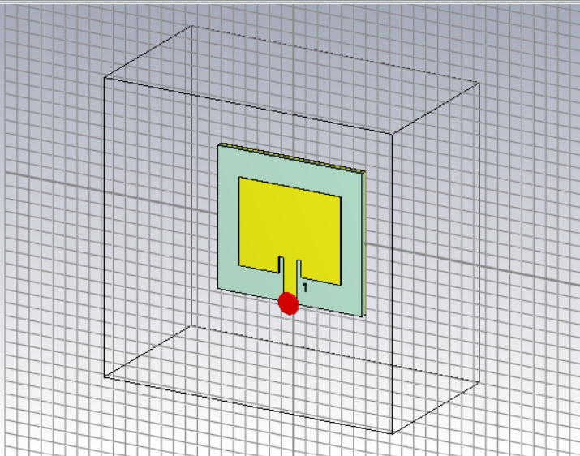
Figure 1. CST model of the 14 GHz wedge antenna single element.
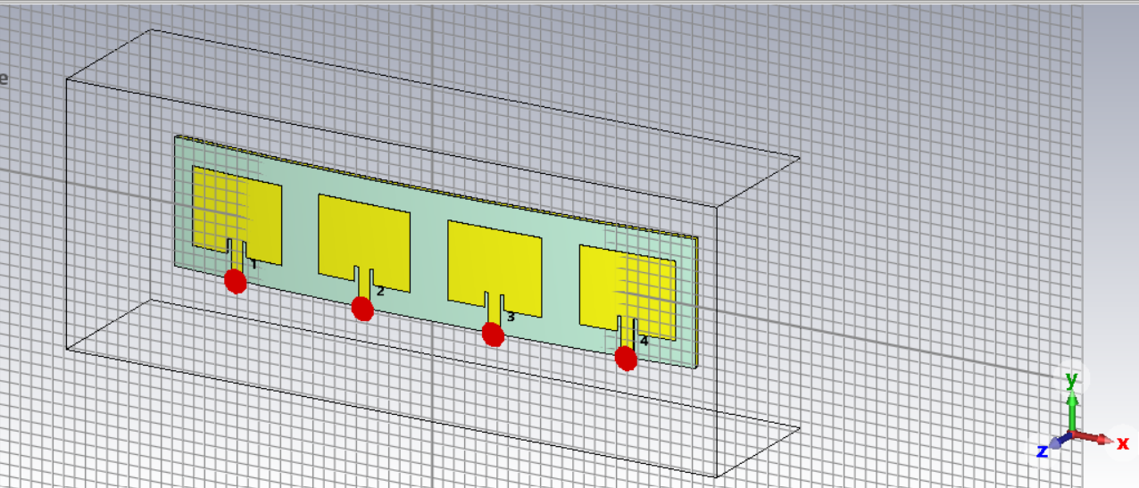
Figure 2. CST model of the 1×4 wedge antenna array with four feed locations.

6. Simulation Results

6.1 S-Parameter / Reflection Coefficient
Observed result: The S-parameter plot shows a pronounced resonance centered at approximately 14 GHz. The minimum displayed S11 is approximately −13.8 dB at 14 GHz.
Target comparison: The specified target is S11 < −20 dB. Therefore, the displayed simulation result does not reach the −20 dB target; the minimum value is approximately 6.2 dB above the target level.
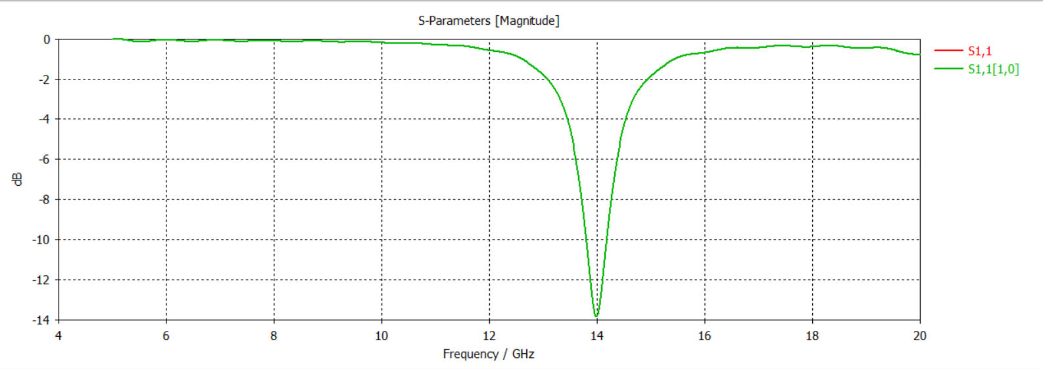
Figure 3. Simulated S-parameter magnitude showing resonance near 14 GHz.

6.2 Far-Field Directivity
At 14 GHz, the displayed far-field directivity plot reports a main-lobe magnitude of 7.61 dBi. The main-lobe direction is 1°, the angular width at the 3 dB level is 80.0°, and the side-lobe level is −20.8 dB.
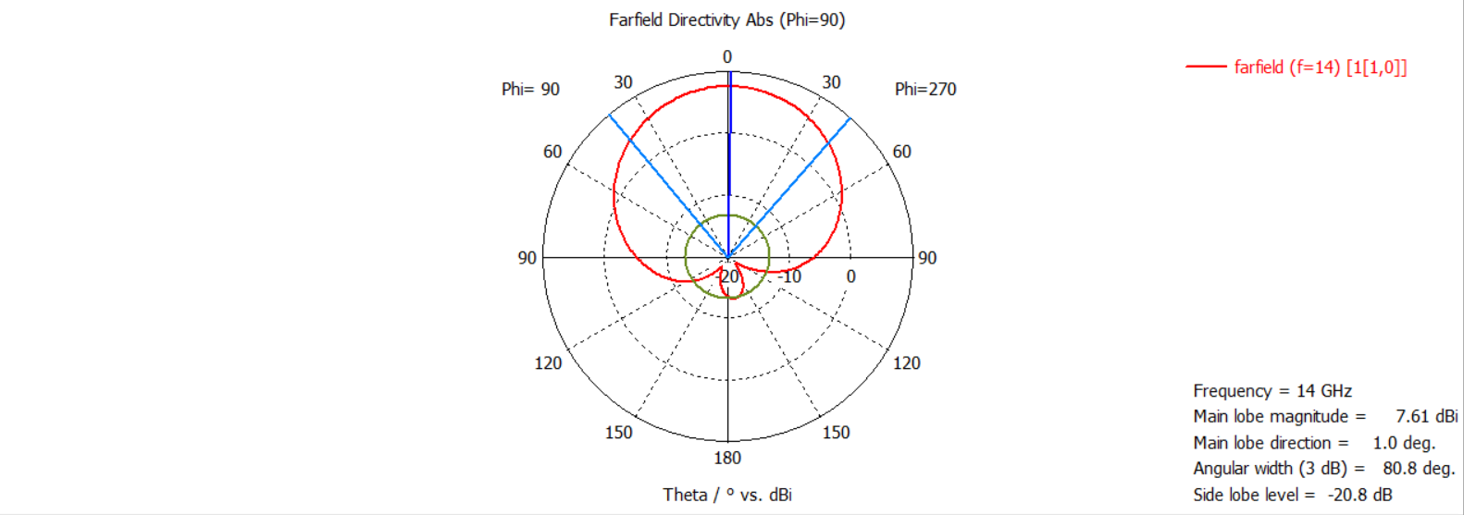
Figure 4. Far-field directivity pattern at 14 GHz (Phi = 90°).

6.3 Far-Field Realized Gain
The displayed realized-gain pattern at 14 GHz reports a main-lobe magnitude of −3.34 dBi. The main-lobe direction is 0°, the 3 dB angular width is 43.0°, and the side-lobe level is −15.6 dB.
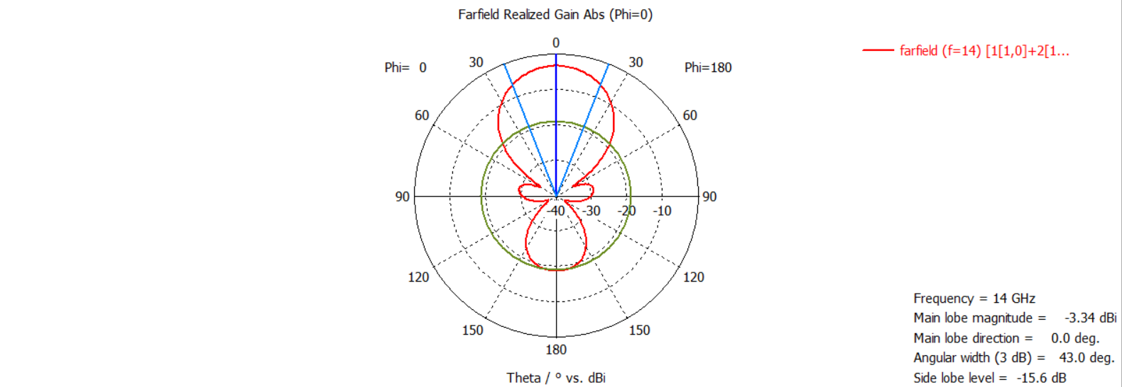
Figure 5. Far-field realized-gain pattern at 14 GHz (Phi = 0°).

7. Results Summary
Performance Parameter | Target | Simulated Result | Assessment
Operating Frequency | 14 GHz | ≈ 14 GHz resonance | Achieved
Minimum S11 | < −20 dB | ≈ −13.8 dB | Target not achieved
Main-Lobe Directivity | > 5 dBi* | 7.61 dBi | Strong directivity
Main-Lobe Direction (Directivity) | — | 1.0° | Observed
3 dB Angular Width (Directivity) | — | 80.0° | Observed
Side-Lobe Level (Directivity) | — | −20.8 dB | Observed
Realized Gain | > 5 dBi | −3.34 dBi | Target not achieved
Main-Lobe Direction (Gain) | — | 0.0° | Observed
3 dB Angular Width (Gain) | — | 43.0° | Observed
Side-Lobe Level (Gain) | — | −15.6 dB | Observed
* The project specification states a gain target greater than 5 dBi. The 7.61 dBi value shown in Figure 4 is explicitly labelled as main-lobe directivity, not realized gain, so it should not be treated as the realized-gain requirement.

8. Discussion
The antenna exhibits its strongest impedance resonance at the intended 14 GHz frequency, confirming that the model is resonating in the desired frequency region. However, the minimum S11 of approximately −13.8 dB is higher than the specified −20 dB threshold, indicating that additional impedance matching or geometric optimization would be required to satisfy the stated matching criterion.
The far-field directivity result is comparatively strong, with a reported main-lobe magnitude of 7.61 dBi and a low side-lobe level of −20.8 dB in the displayed cut. The realized-gain plot, however, shows a main-lobe magnitude of −3.34 dBi. Since realized gain includes radiation and efficiency effects, the directivity and realized-gain values should be reported separately.
Overall, the simulation demonstrates that the antenna structure is correctly resonant near 14 GHz, while the displayed matching and realized-gain results indicate that further optimization is needed before the design can be considered to meet all stated performance targets.

9. Conclusion
A 14 GHz wedge antenna was successfully modelled in CST Studio Suite in both single-element and 1×4 array configurations. The CST results show resonance at approximately 14 GHz with a minimum S11 of about −13.8 dB. At 14 GHz, the far-field directivity reaches 7.61 dBi with a main-lobe direction of 1°, while the displayed realized-gain pattern has a main-lobe magnitude of −3.34 dBi at 0°. The specified S11 < −20 dB and gain > 5 dBi targets are therefore not fully satisfied by the displayed results.

10. Future Optimization
- Optimize the feed position and matching region to reduce S11 below −20 dB.
- Adjust the wedge dimensions and array element spacing to improve impedance matching and radiation efficiency.
- Investigate the effect of substrate and geometric parameters on realized gain.
- Perform a systematic parameter sweep around 14 GHz to identify the optimum configuration.
- Re-simulate the optimized design and verify S11, realized gain, bandwidth, and radiation pattern against the project requirements.

11. Software Used
CST Studio Suite was used for three-dimensional electromagnetic modelling and simulation of the wedge antenna and its 1×4 array configuration.

