# Exercise: Doc4u.com

## Introduction

Doctor Appointment Booking: A place where patients can search and book appointment from preferred doctor/hospital.

* Build few screens for Doctor Appointment Booking system.
* System needs to store all the details being displayed.
* Customer can search & book an appointment

(Self-Learning: you can take inspiration from Practo website).

## Functional Requirements

### List of Screens

* Screen 1(Home Page)
* Screen 2(Hospital List)
* Screen 3(Doctor List)
* Screen 4(Doctor Info)
* Screen 5(User Details Screen)
* Screen 6(Booking Summary Screen)
* Screen 7(Report Screen)
* Screen 8(Customer/Admin Registration Screen)
* Screen 9(Customer/Admin Login Screen)

### Screen Details

#### #1 Home Page

##### Customer Flow

* Should contain Sign-Up & Login buttons.

Sign-Up re-directs user to “User/Admin Registration Screen”

Login re-directs user to “User/Admin Login Screen”

* Should contain a drop-down where user can select a location.

Should contain a search box where-in user can enter either search for a Hospital, Specialization or Doctor.

Searching only with Hospital name re-directs user to “Hospital List Screen”

Searching only with Specialization name or with Doctor Name re-directs user to “Doctor List Screen”

Clicking on Search with no input re-directs user to “Hospital List Screen” with list of Hospitals provided.

##### Screenshots

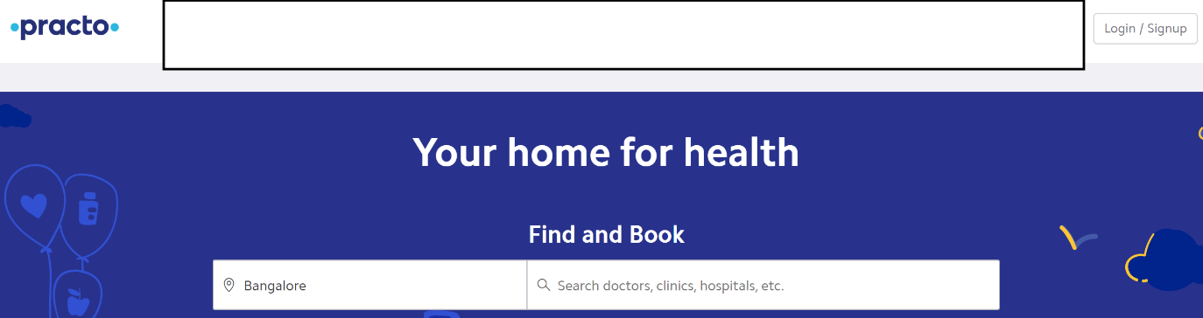

#### #2 Hospital List Screen

##### Customer Flow

* This screen should display Hospital list with some basic Hospital info along with specializations provided in the hospital.
* Clicking on any specialization will again take the user to Doctor List screen.

##### Screenshots

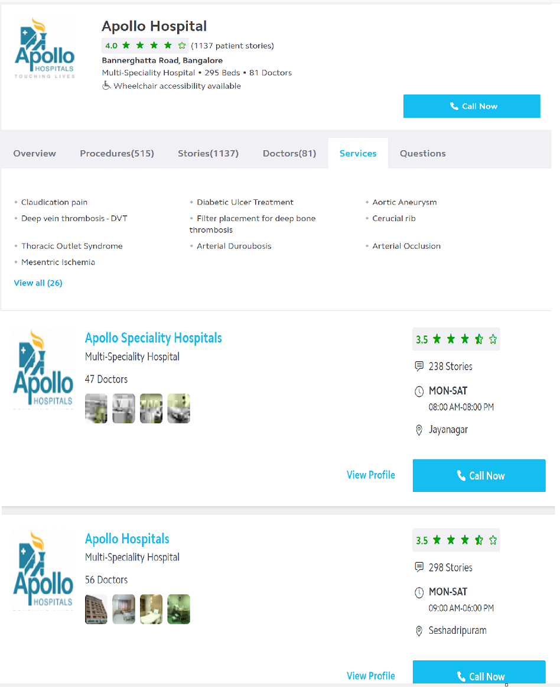

#### #3 Doctor List Screen

##### Customer Flow

* User can be navigated to this screen in 2 ways.
* By searching for any specialization from Home page.
* By clicking on any Specialization in Hospital List Screen.
* This screen should display Doctors available for those specializations.
* Clicking on any doctor will again take the user to Doctor Info screen.

##### Screenshots

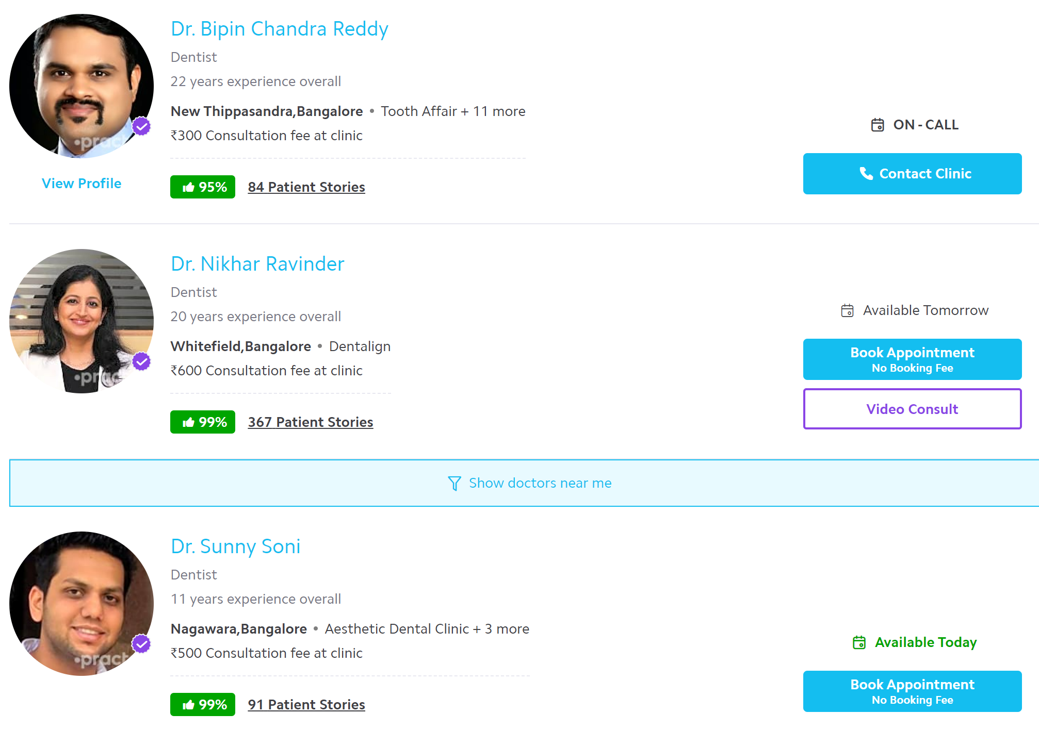

#### #4 Doctor Info Screen

##### Customer Flow

* User can be navigated to this screen in 2 ways.
* By searching for any doctor from Home page.
* By clicking on any doctor in Doctor List Screen.
* Doctor screen with Doctor Info (along with his hospital & specialization) and appointment availability options to book appointment.
* This screen should display doctor info like his experience, hospital & specialization.
* A list of available time slots needs to be displayed so that customer can click on any of the slots to proceed with appointment booking process.

##### Screenshots

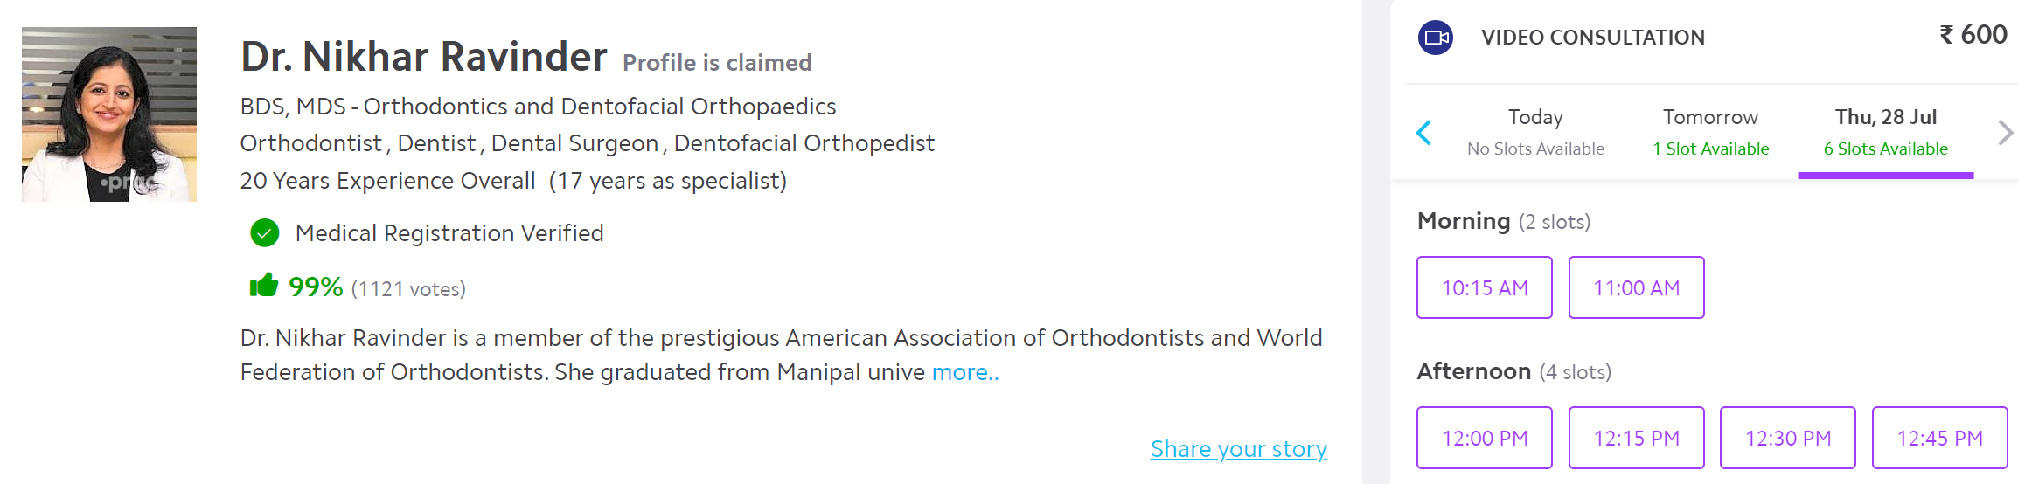

#### #5 User Details Screen

##### Customer Flow

* Clicking on any Time slot on Doctor Info screen will navigate the user to this screen.
* User should have an option to provide some personal info in this screen. Info like Patient Name, Age, Comments on his complaint, mobile number, mail ID can be captured.
* If a user is logged-in, his info should automatically be captured.
* Once all the required info is entered, user will click on “Book Appointment” button.

##### Screenshots

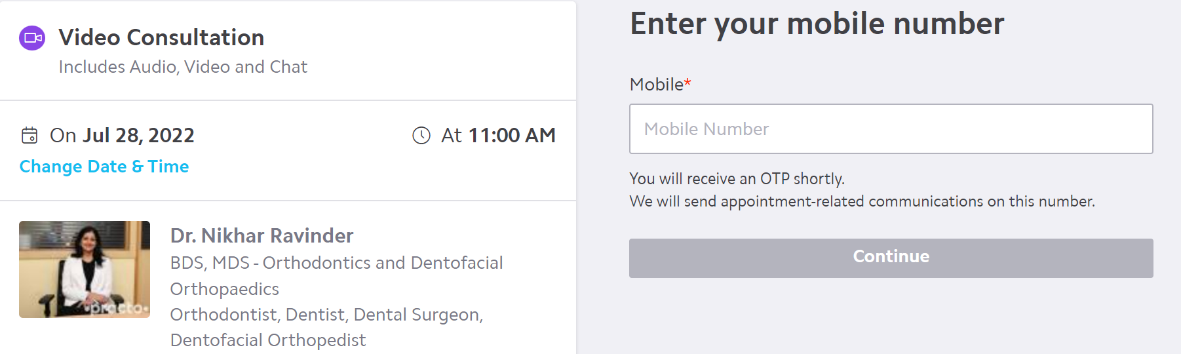

#### #6 Booking Summary Screen

##### Customer Flow

* This is a confirmation page which informs user that booking has been made.
* Booking Summary should be displayed.

Booking summary includes the appointment date & time, hospital address, relevant contact info and a unique reference number.

* An assistant doctor & a nurse who are available in the same hospital should be assigned to this case. This information should also be displayed on this screen.
* Print to PDF option should be provided.

##### Screenshots

None

#### #7 Report Screen

##### Customer Flow

* A screen to display Report which provides info on the following:
* No: of appointments taken up by a doctor on a given day.
* Hospital occupancy info on a given day.
* No: of patients who have taken appointments on a certain specialization on a given day.
* No: of patients who visited the hospital on a given day in the given time frame.
* Displays the Doctor, Assistant Doctor & Nurse names for any given patient.

##### Screenshots

None

#### #8 User/Admin Registration screen

##### Customer Flow

* Customer/Admin Registration screen needs to be built which captures some basic personal info about the user.

##### Screenshots

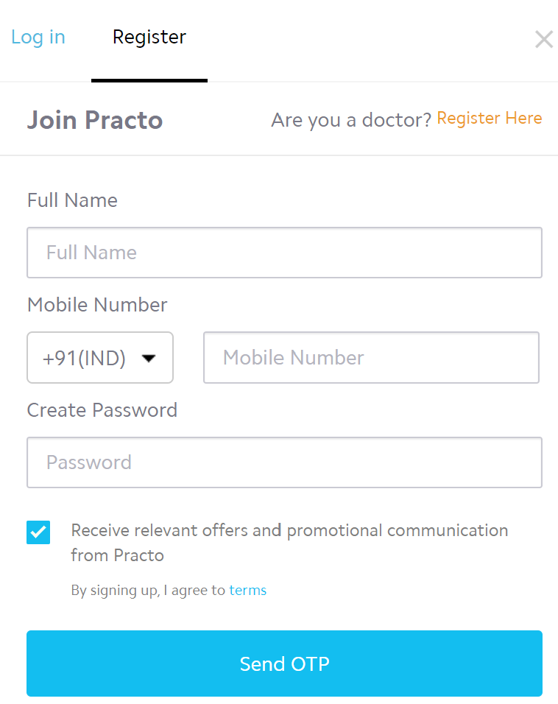

#### #9 User/Admin Login Screen

##### Customer Flow

* Login screen with regular User ID & Password info.
* Password should be encrypted while saving in database.

##### Screenshots

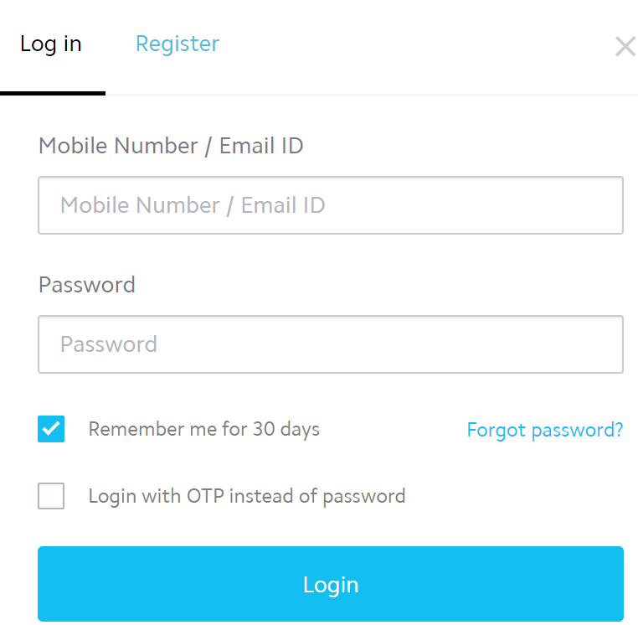

## Team Split: 5 people in a team

### Requirements Phase

* You need to interact with each other about the functionality in detail, the error scenarios.
* Check the Practo website thoroughly and note down the requirements for each screen.
* Provide a description not exceeding 10 lines about the functionality present/being built, call out error scenarios.

### Design Phase

* Create an ERD
* Determine what values need to be stored for each entity and determine suitable

1. primary keys
2. foreign keys
3. indexes

* Decide what entities we need to consider in a data model
* List down the assumptions does your model make?
* List down the information in the text was irrelevant to your design?
* List down any further restrictions might you want to apply to the data?
* Identify Business Functions
* List down all the queries that you need for queries/stored procedures etc., as per your need.

### Coding

* You need to make the 4 pages mentioned in Functional requirements section.
* You need to build all services required to handle the functionality and error scenarios.
* Write search, add, edit, delete Stored Procedures for each of the business function.

### Testing

* Set-up Test Data (manual or script or bulk upload thru excel)
* Perform full end to end testing with different scenarios.
* We will do Acceptance Testing based on this document.
* Discuss among yourselves on the requirements and prepare manual Test cases.

## Solution submission

1. Project Code Folder (entire .Net code + SQL Code)
2. Functional Requirements Document
3. ER Diagram
4. A screen share/video to show the working prototype

Note – all the deliverables can be uploaded (without zipping) to their personal github and can share the links with us.