# **Assignment: Property Management System**

## Introduction

Property management System: It’s a Property Management portal site where Users (Owners or Customers) can search for sale/rent/buy the Property (House) based on their preferred location without external brokerage people.

* Owners (Sellers) can register and post their House Property details into this portal in order to Sale/Rent their House Property to the Customers.
* Customers (Buyers) can register and search for Buy/Rent a House/Property based on their preferred location
* Admin User of this site who have access to manage the Users (Customers or Owners).
* Reference sites:
  + - <https://property.sulekha.com/>
    - <https://www.magicbricks.com/>
    - <https://www.nobroker.in/>
    - <https://www.99acres.com/>

## Functional Requirements by Module wise:

### Register/Signup Page

* + User Type: To Create one DropDownlist or Radio button to keep the User Type static values as “Owners” & “Customers”.
    - Note: You can feed the Admin credentials into database through backend directly.
  + User Name: Customers/Owners can enter their User Name in order to signup this site.
  + MobileNo / Email ID:  Customers/Owners can enter their mobile/Email in order to communicate further between Customers & Owners.
  + Password:
    - It should meet strong password constraint such as minimum 8 chars which contains at least one Uppercase Letter, one number and one Special Characters. (Ex: Nexturn@2022$ )
    - It should be encrypted when store it into database
  + Terms & Conditions:
    - It should be Checkbox
    - SignUp button should be enabled only when Checkbox is Checked
  + Signup Screenshot for reference: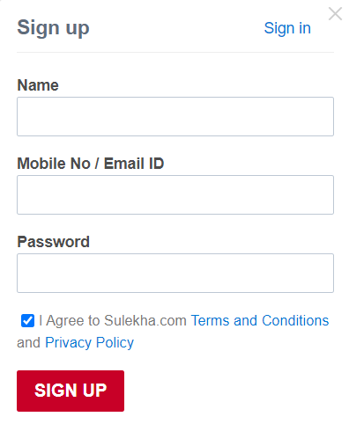

### Login/SignIn Page

* + User Name: Admin/Owners/Customers can enter their User Name in order to Sign In this site.
  + Password:
    - Admin/Owners/Customers can enter their password in order to Sign In this site.
  + Note:
    - Based on the logged-in User Type (Admin/Owners/Customers), respective home page has to be displayed

### Home Page:

* + Owners/Customers can manage their profile details such as they can edit their Contact_No or email address.
  + Profile:
    - Owners/Customers can manage their own profile only like they can edit their Contact_No or email address.
  + Dashboards:
    - If you are the Owner, then you can see the list of your property details as well as the customer details who booked your property.
    - If you are the Customer, then you can see the property details which booked earlier.
    - If you are the admin, then you can see the both Owner & customer buy/sell details and able to pull the Periodic Reports of overall Property Sale & Rent and can export such reports in pdf format as well.

### Post your Property:

User Type (Owners) only can access this module and post their property with below details.

#### 4.1. Property Details:

* + Apartment Type:
    - Independent House/Villa
    - Gated community/Villa
  + BHK Type:
    - 1 RK
    - 1 BHK
    - 2 BHK
    - 3 BHK
    - 4+ BHK
  + Floor:
    - Ground,1,2,3,4,5,6
  + Total Floor:
    - Ground Only,1,2,3,4,5,6
  + Property Age:
    - Less than a year
    - 1 to 3 year
    - 3 to 5 year
    - 5 to 10 year
    - More than 10 year
  + Facing:
    - North,South,East,West,North-East,North-West,South-East,South-West
  + Build Up Area:
    - Mention overall property size in sqft.

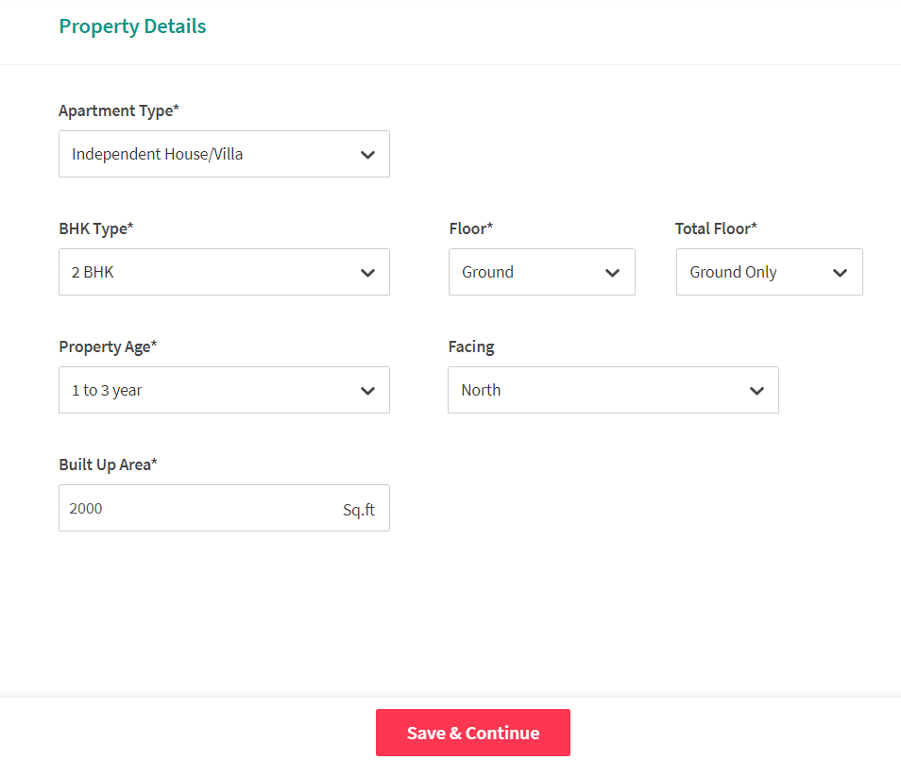

#### Locality Details:

* + City
  + Location
  + Landmark/Street

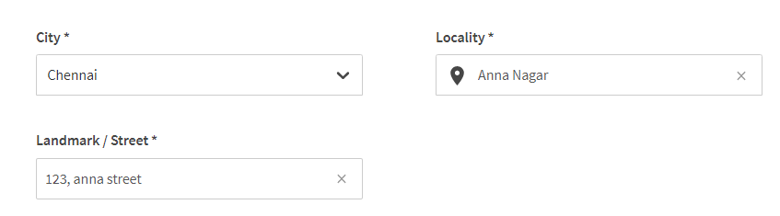

#### Property price Details:

* + Below screenshot is for rental the property.

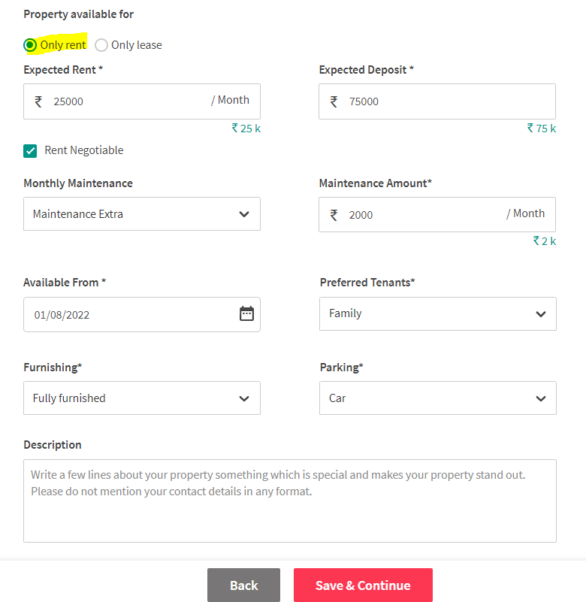

* + Similarly, you can design for sale the property with below fields:

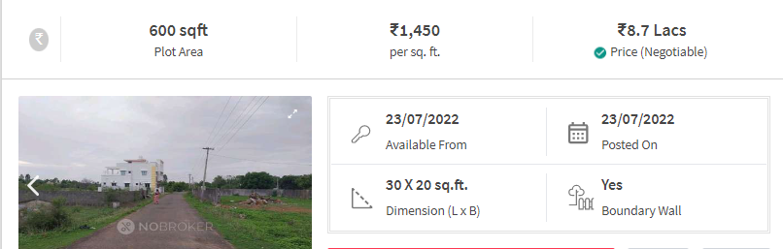

#### Property Status:

* + Property Availability:
    - Immediate
    - Within 15 days
    - Within 30 days
    - After 30 days
  + Property Status:
    - Under Construction
    - Ready
    - Booked

### Buy/Rent the Property:

User Type (Customers) only can access this module in order to book for **Buy** or **Rent** the House based on House availability & customer’s preferred location.

#### 5.1. Buy Property Details:

Customers can search to book for **buy** the property by using below fields

* + City:
    - City field should be dropdownlist & values should be populated from Property locality table dynamically.
  + Location:
    - <Optional>
  + Apartment Type (BHK Type ):
    - 1 RK
    - 1 BHK
    - 2 BHK
    - 3 BHK
    - 4+BHK
  + Property Status:
    - Under Construction
    - Ready

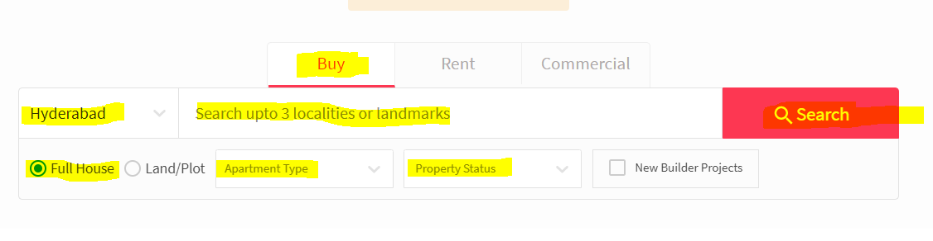

#### 5.2. Rent Property Details:

Customers can search to book for **Rent** the property by using below fields

* + City:
    - City field should be dropdownlist & values should be populated from Property locality table dynamically.
  + Location:
    - <Optional>
  + Apartment Type (BHK Type ):
    - 1 RK
    - 1 BHK
    - 2 BHK
    - 3 BHK
    - 4+BHK
  + Property Availability:
    - Immediate
    - Within 15 days
    - Within 30 days
    - After 30 days

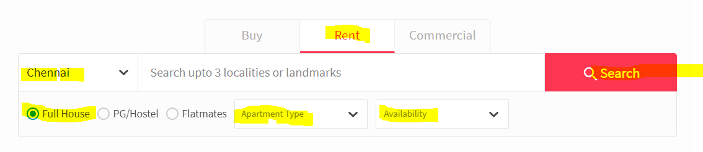

### Booking History of Property:

User Type (Owners/Customers) can access this module which they can see their own history of the respective property.

* + If you are the Owner, then you can see the list of your property details as well as the customer details who booked your property.
  + If you are the Customer, then you can see the property details which booked earlier.
  + If you are the admin, then you can see the both Owner & customer buy/sell details.

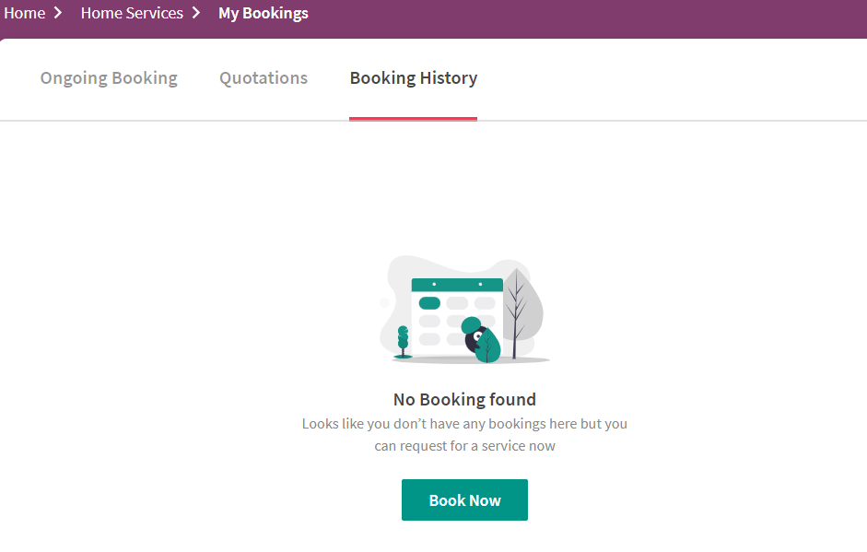

### Reports:

User Type (Portal Admin user) can access this module in order to pull the Periodic Reports and can export it in **pdf format** of overall Property Sale & Rent by using below filter conditions.

* + Overall Property Sale report
  + Overall Property Rent report
  + Filter conditions:
    - From Date & To Date
    - City
    - Sale or Rent
    - Property Status
    - Property Availability

## Team Split: 5 people in a team Note: The screens designed in assignment need not depict the screenshots provided in document. These are just provided for reference. You can use your own creativity in screen designing.

### Requirements Phase

* You need to interact with each other about the functionality in detail, the error scenarios.
* Please go through the above given reference website thoroughly and note down the requirements for each screen.
* Provide a description not exceeding 10 lines about the functionality present/being built, call out error scenarios.

### Design Phase

* Create an ERD
* Determine what values need to be stored for each entity and determine suitable

1. primary keys
2. foreign keys
3. indexes

* Decide what entities we need to consider in a data model
* List down the assumptions does your model make?
* List down the information in the text was irrelevant to your design?
* List down any further restrictions might you want to apply to the data?
* Identify Business Functions
* List down all the queries that you need for queries/stored procedures etc., as per your need.

### Coding

* You need to make the pages which mentioned in above Functional requirements section.
* You need to build all services required to handle the functionality and error scenarios.
* Write search, add, edit, delete Stored Procedures for each of the business function.

### Testing

* Set-up Test Data (manual or script or bulk upload thru excel)
* Perform full end to end testing with different scenarios.
* We will do Acceptance Testing based on this document.
* Discuss among yourselves on the requirements and prepare manual Test cases.

### Solution submission

1. Project Code Folder (entire Development code along with SQL Code)
2. Functional Requirements Document
3. ER Diagram
4. A screen share/video to show the working prototype

Note – all the deliverables can be uploaded (without zipping) to their personal github and can share the links with us.