# Exercise: Vehicle Rental

## Introduction

Vehicle Rental System: Website where customers can search and rent the bikes/cars of their choice.

* Build few screens for Vehicle rental system.
* System needs to store all the details being displayed.
* Doctors can be added, updated, and removed by Admin.
* Customer can search & rent a car/bike for a defined time period.

(Self-Learning: you can take inspiration from ZoomCar website).

## Functional Requirements

### List of Screens

* Screen 1(Home Page)
* Screen 2(Add-on Info)
* Screen 3(Cars List)
* Screen 4(Bikes List)
* Screen 5(User Details Screen)
* Screen 6(Booking Summary Screen)
* Screen 7(Report Screen)
* Screen 8(Customer/Admin Registration Screen)
* Screen 9(Customer/Admin Login Screen)

### Screen Details

#### #1 Home Page

##### Customer Flow

* Should contain Sign-Up & Login buttons.

Sign-Up re-directs user to “Customer/Admin Registration Screen”

Login re-directs user to “Customer/Admin Login Screen”

* Should contain a drop-down where user can select a location.

Should also contain calendar options to let the user input start date & return date.

Time should also be captured.

Should contain a radio button where-in user can select either Bike or a Car. (not available in screenshot)

##### Screenshots

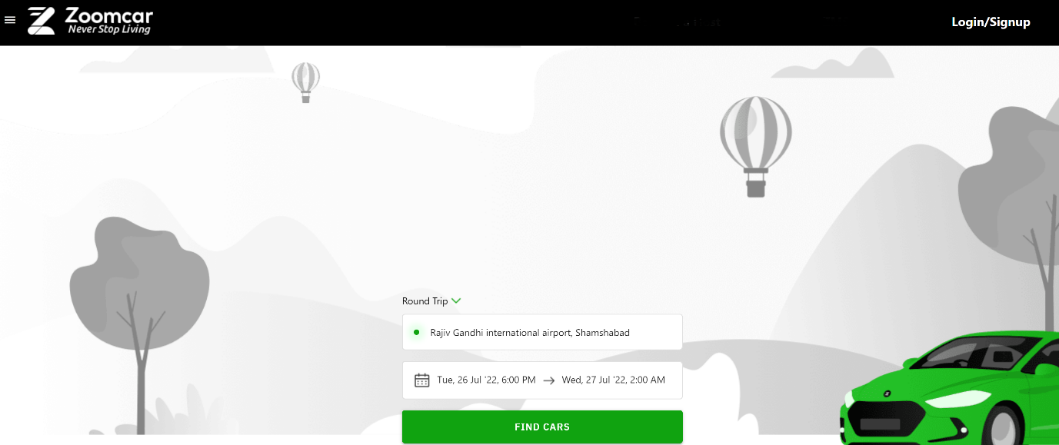

#### #2 Add-on Info

##### Customer Flow

* This screen should display few options based on which the data can be displayed.
* Insurance – Required/Not Required 🡪 if required is selected, the fare should be increased by Rs.150 per day in next screen
* Driver Facility – Required/Not Required 🡪 if required is selected, the fare should be increased by Rs.1500 per day in next screen. (This option should be displayed only for Car selection in Screen 1)
* Locality – Within State/Outside State 🡪 if outside state is selected, the fare should be increased by Rs.200 per day in next screen.

##### Screenshots

None

#### #3 Cars List

##### Customer Flow

* User will be displayed with all the cars based on availability.
* The fare should also be auto-calculated and displayed for each car (the conditions that were mentioned in previous screens should be considered and included in the fare)
* Filtering based on criteria mentioned in the screenshot should be provided. The display of filters can be similar to the ones displayed in screenshot.

##### Screenshots

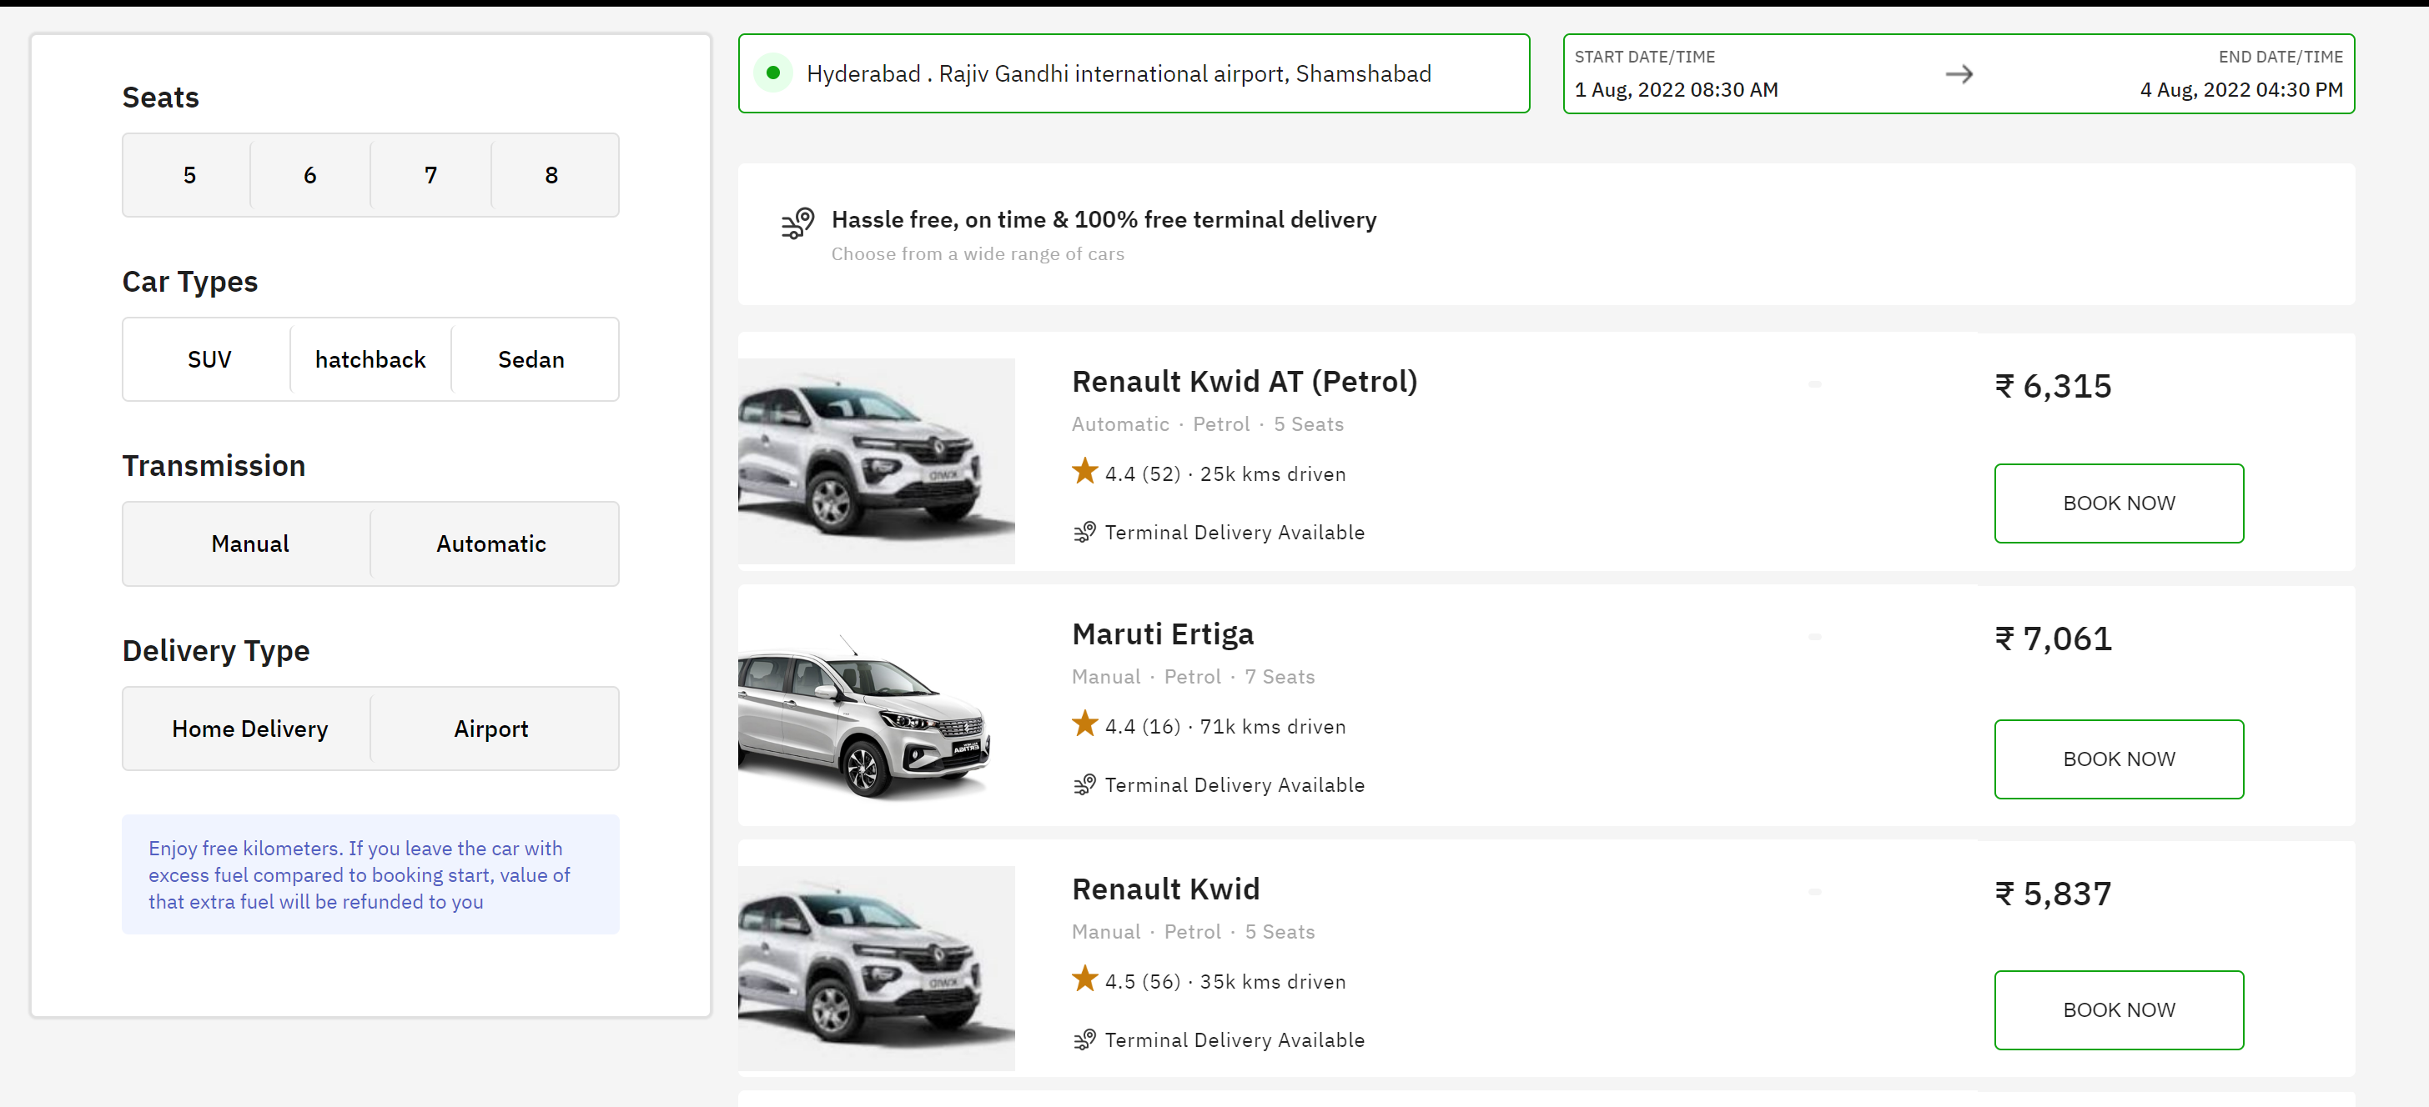

#### #4 Bikes List

##### Customer Flow

* User will be displayed with all the bikes based on availability.
* The fare should also be auto-calculated and displayed for each car (the conditions that were mentioned in previous screens should be considered and included in the fare)
* Filtering should be provided based on parameters like bike model, milage, engine capacity etc. The display of filters can be similar to the ones displayed in Cars List screenshot.

##### Screenshots

None

#### #5 User Details Screen

##### Customer Flow

* Clicking on any Price on Cars List or Bikes List screen will re-direct the user to this screen.
* User should have an option to provide some personal info in this screen. Info like Driving Licence No, Aadhaar No, Name, Age, mobile number, mail ID can be captured.
* If a user is logged-in, his info should automatically be captured.
* Once all the required info is entered, user will click on “Book Now” button.

##### Screenshots

None

#### #6 Booking Summary Screen

##### Customer Flow

* This is a confirmation page which informs user that booking has been made.
* Booking Summary should be displayed.

Booking summary includes the booking date & time, rental start date time & end date time, customer address, relevant contact info and a unique reference number.

* Print to PDF option should be provided.

##### Screenshots

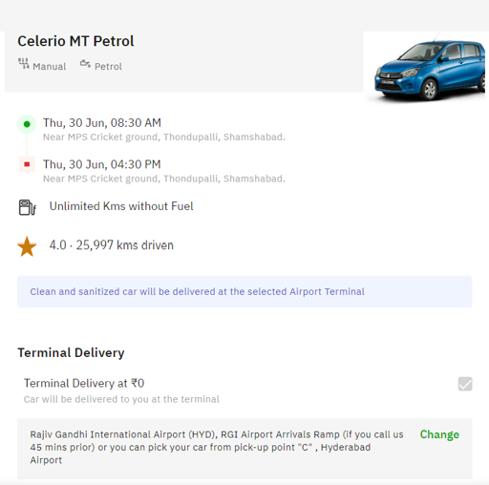

#### #7 Report Screen

##### Customer Flow

* A screen to display Report which provides info on the following:
* No: of bikes booked in a specific location on a given day separated by models.
* No: of cars booked in a specific location on a given day separated by models.
* Revenue generated on a given day for a given location.
* List of customers to whom vehicle are currently rented out.

##### Screenshots

None

#### #8 Customer/Admin Registration screen

##### Customer Flow

* Customer/Admin Registration screen needs to be built which captures some basic personal info about the user.

##### Screenshots

None

#### #9 Customer/Admin Login Screen

##### Customer Flow

* Login screen with regular User ID & Password info.
* Password should be encrypted while saving in database.

##### Screenshots

None

## Team Split: 5 people in a team

### Requirements Phase

* You need to interact with each other about the functionality in detail, the error scenarios.
* Check the Zoom Car website thoroughly and note down the requirements for each screen.
* Provide a description not exceeding 10 lines about the functionality present/being built, call out error scenarios.

### Design Phase

* Create an ERD
* Determine what values need to be stored for each entity and determine suitable

1. primary keys
2. foreign keys
3. indexes

* Decide what entities we need to consider in a data model
* List down the assumptions does your model make?
* List down the information in the text was irrelevant to your design?
* List down any further restrictions might you want to apply to the data?
* Identify Business Functions
* List down all the queries that you need for queries/stored procedures etc., as per your need.

### Coding

* You need to make the 4 pages mentioned in Functional requirements section.
* You need to build all services required to handle the functionality and error scenarios.
* Write search, add, edit, delete Stored Procedures for each of the business function.

### Testing

* Set-up Test Data (manual or script or bulk upload thru excel)
* Perform full end to end testing with different scenarios.
* We will do Acceptance Testing based on this document.
* Discuss among yourselves on the requirements and prepare manual Test cases.

## Solution submission

1. Project Code Folder (entire .Net code + SQL Code)
2. Functional Requirements Document
3. ER Diagram
4. A screen share/video to show the working prototype

Note – all the deliverables can be uploaded (without zipping) to their personal github and can share the links with us.