|  |  |  |  |
| --- | --- | --- | --- |
| DI | 数字隔离输入检测口 | 1 | 1 |
| DO | 数字隔离继电器输出控制口 | 1 | 1 |
| AI | 数字量输入检测口 | 1 | 1 |

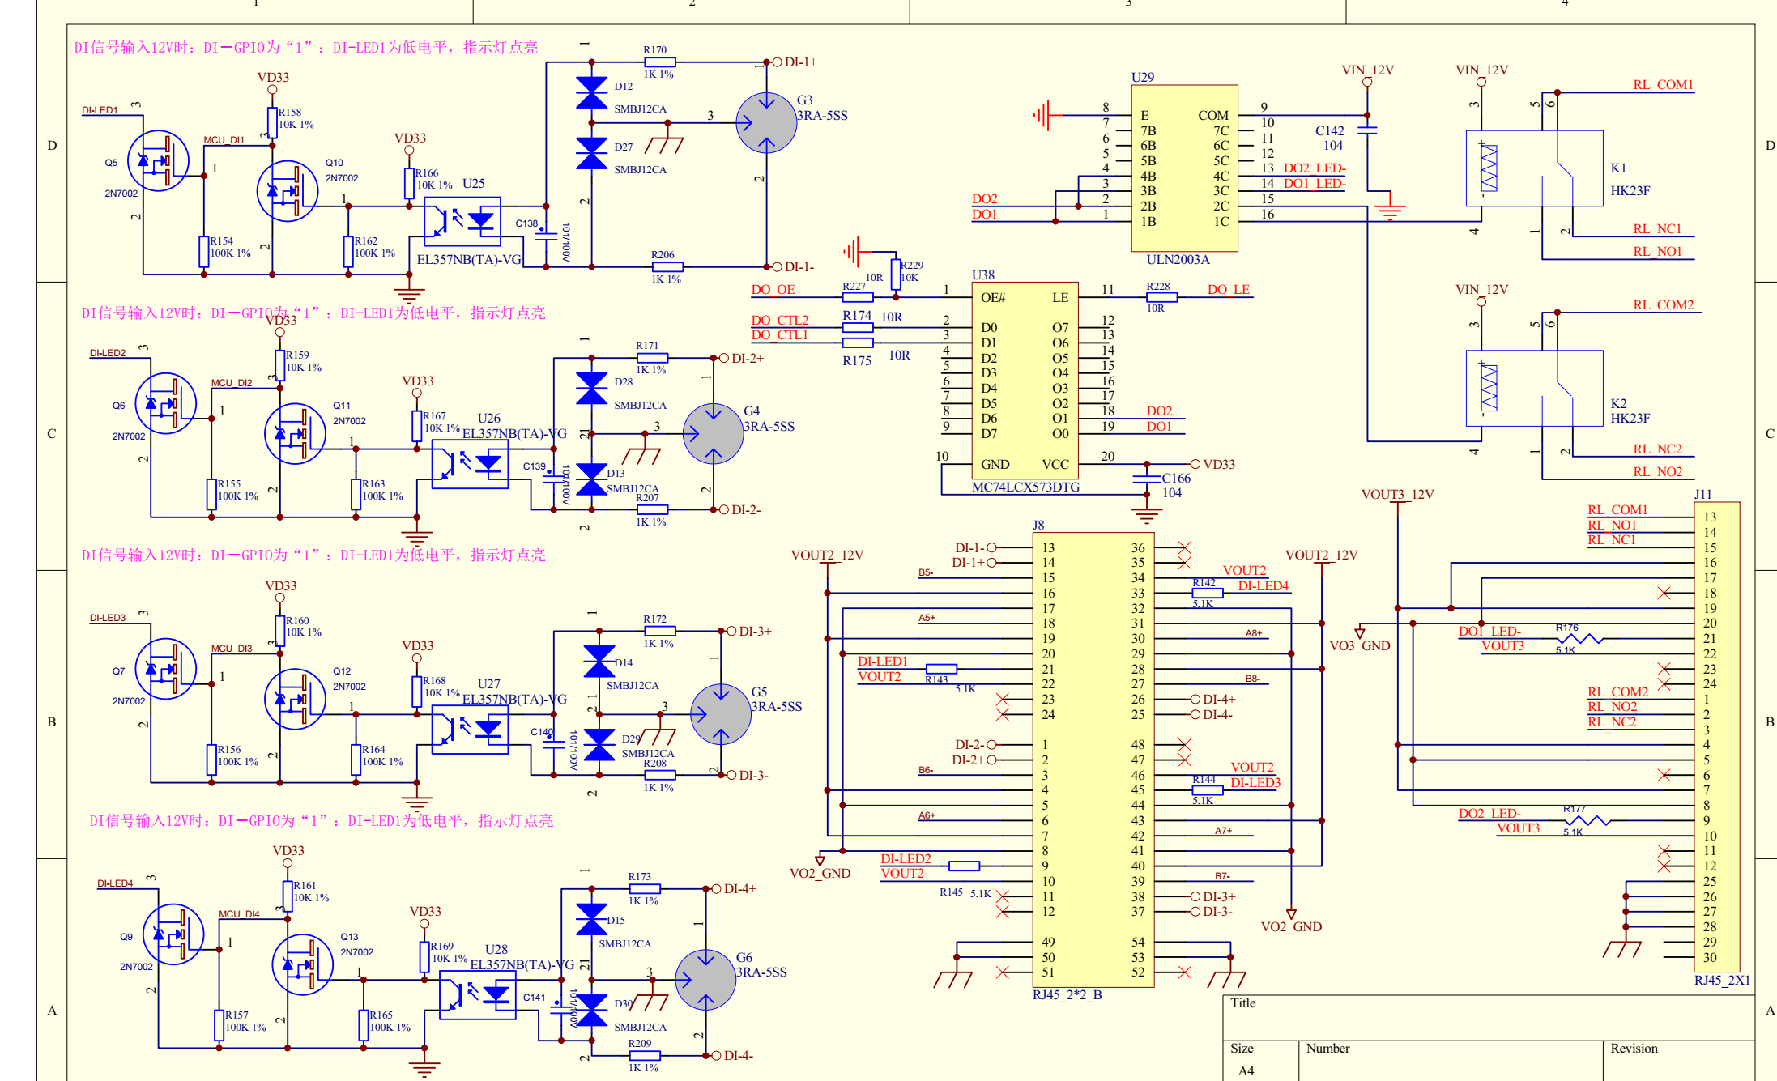

1. DI功能要求
2. 看看芯片手册是否支持中断（电平触发）uevent
3. 支持滤波去掉误触发
4. /sys/devices/platform/nuc970-gpio.x/可以查询
5. 设置功能关闭

2.管脚分配图

|  |  |  |
| --- | --- | --- |
| PIN | INPUT SIGNAL |  |
| PB.4 | DI1 |  |
| PB.5 | DI2 |  |
| PB.6 | DI3 |  |
| PB.7 | DI3 |  |

代码修改部分：

1.driver/gpio/gpio-nuc970.c

|  |  |
| --- | --- |
| DO | 数字隔离继电器输出控制口 |

分配图

|  |  |  |
| --- | --- | --- |
| PIN | OUTPUT SIGNAL |  |
| PD.11 | DI1 |  |
| PD.12 | DI2 |  |
|  |  |  |
|  |  |  |

1. /sys/devices/platform/nuc970-gpio.x/可以查询和设置

内核

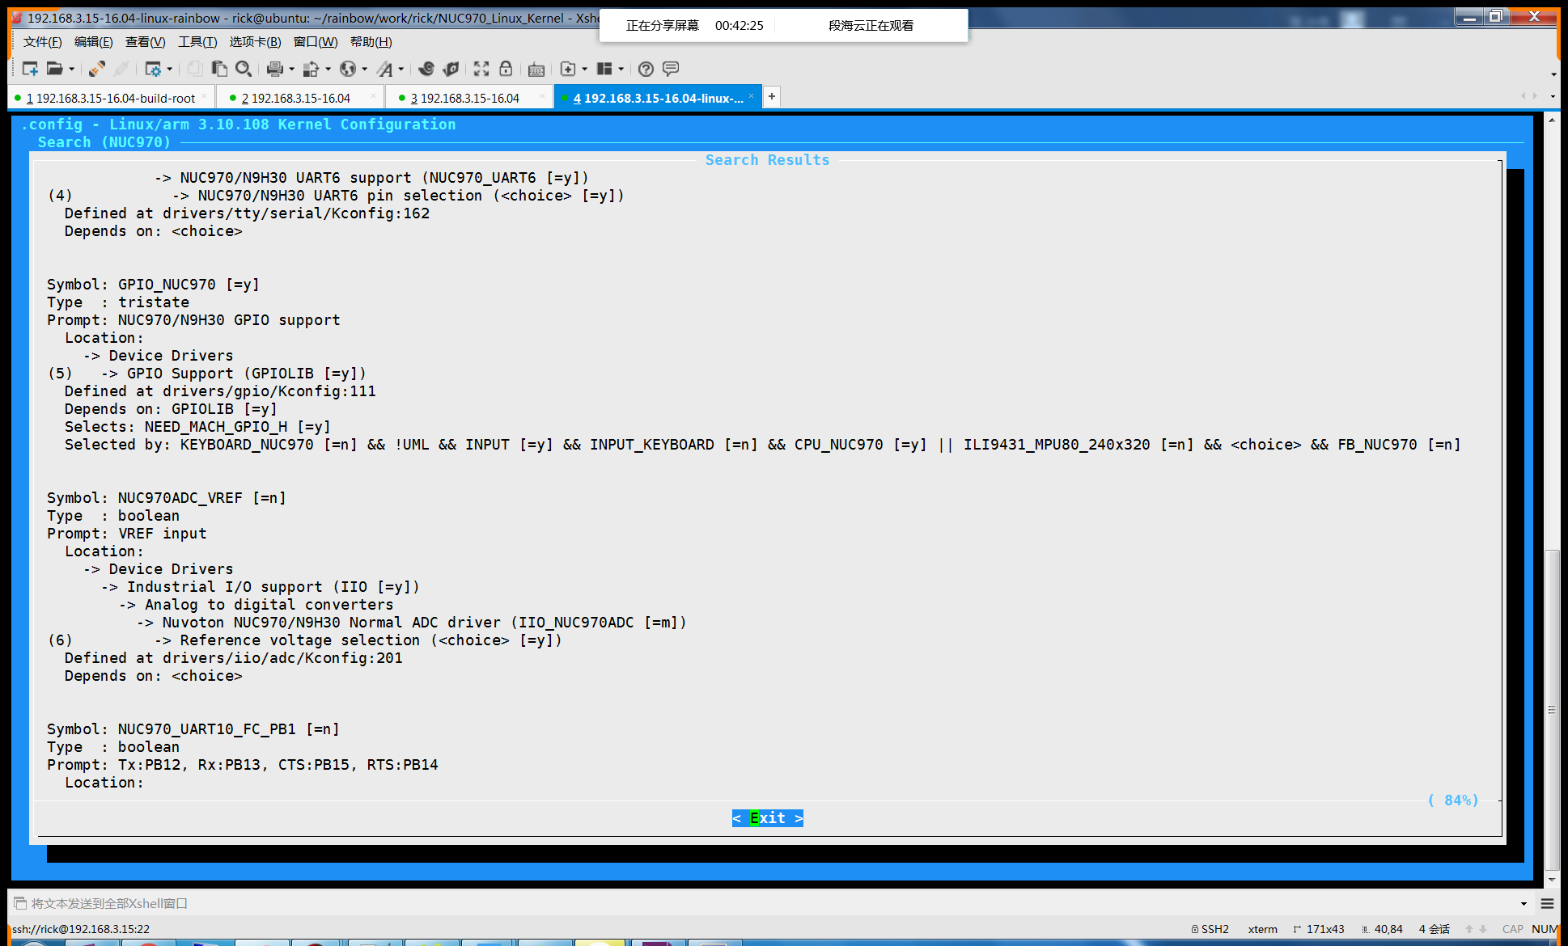

485

4个485

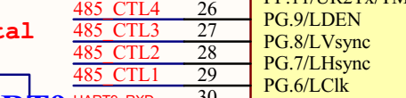

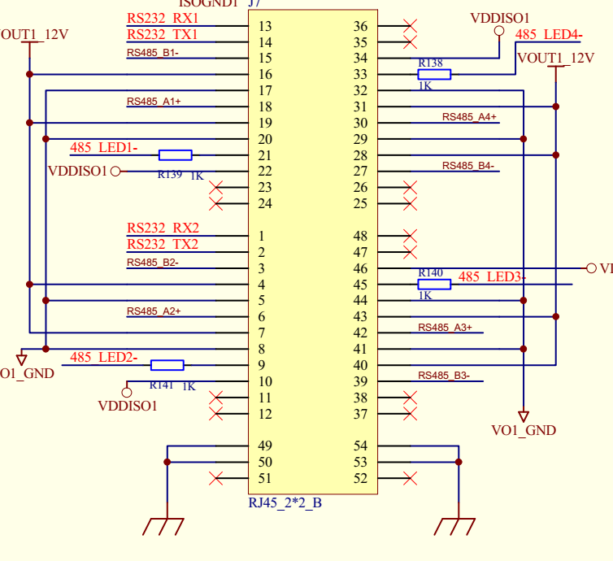

J7端子位置关系

|  |  |  |
| --- | --- | --- |
| J7 |  |  |
| ttyS1 | ttyS3 |  |
| ttyS2 | TtyS4 |  |

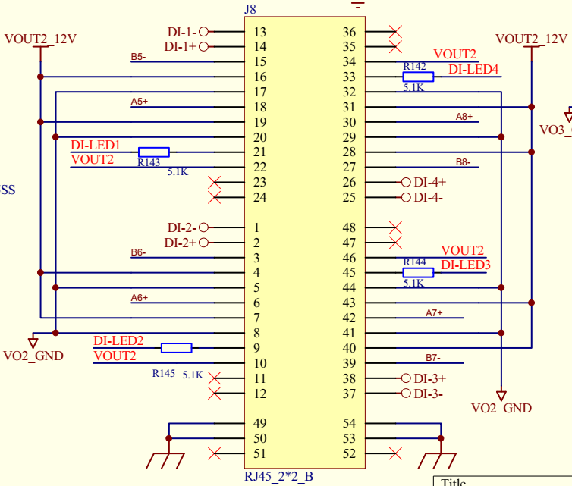

J7端子位置关系

|  |  |  |
| --- | --- | --- |
| J8 |  |  |
| ttyS5 | ttyS7 |  |
| ttyS6 | TtyS8 |  |