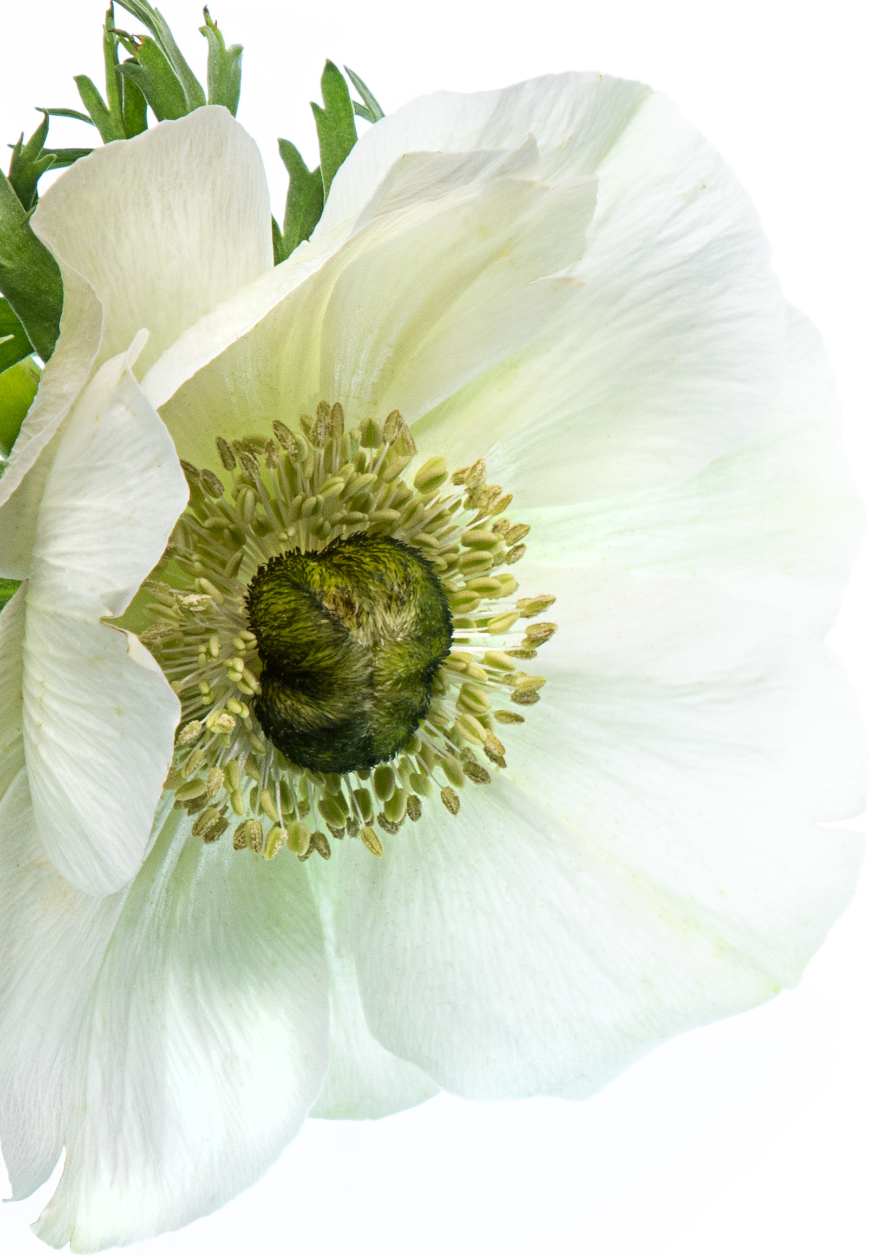

You are invited to my

Birthday party
5. Mai 2023 in the park

Hi Alex,

it’s been another year and I’d love to celebrate with all my dear friends. We will have a picnic in the park so bring your favorite finger food.
I’ll bring drinks and music!

See you there,
Sam



