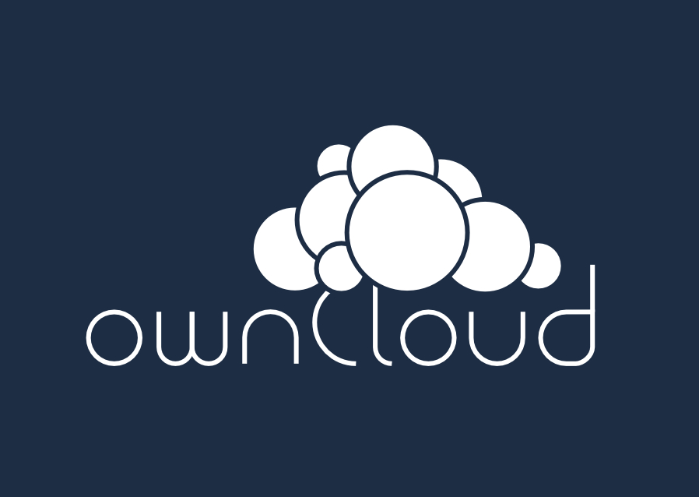

ownCloud Example Document

Welcome to ownCloud, your self-hosted file sync and share solution.
OwnCloud is open source file sync and share software for everyone from individuals operating the free Community Edition, to large enterprises and service providers operating ownCloud Enterprise Edition. ownCloud provides a safe, secure and compliant file sync and share solution on servers you control.
With ownCloud you can share one or more folders on your PC, and sync them with your ownCloud server. Place files in your local shared directories, and those files are immediately synced to the server, and then to other PCs via the desktop client. Not near a desktop client? No problem, simply log in with the web client and manage your files there. The Android and iOS mobile apps allow you to browse, download and upload photos and videos. On Android, you may also create, download, edit and upload any other files, with the correct software installed.
Whether using a mobile device, a workstation, or a web client, ownCloud provides the ability to put the right files in the right hands at the right time on any device in one simple-to-use, secure, private and controlled solution.
After all, with ownCloud, it’s Your Cloud, Your Data, Your Way.

