Practical:03
Prac:3.1: Understanding Activity Life Cycle
Problem Statement: Develop an Android application to demonstrate the Activity Life Cycle by observing life cycle method calls during different user interactions.
Procedure:
Language: Java
Template: Empty Views Activity
STEP 1: Create a New Android Project
Open Android Studio
- Launch Android Studio
- Click New Project
Select Project Template
- Choose Empty Views Activity
- Click Next
Project Configuration (VERY IMPORTANT)
Fill the details exactly like this (you may change the name slightly if needed):
- Name:
ActivityLifeCycleDemo
- Package name:
com.example.activitylifecycle
- Save location:
(Keep default)
- Language:
Java
- Minimum SDK:
API 21: Android 5.0 (Lollipop)
- Build configuration language:
Groovy (default)
Click Finish
STEP 2: Designing the UI (TextView for Life Cycle messages)
Replace the Entire XML Code
<?xml version="1.0" encoding="utf-8"?>
<LinearLayout xmlns:android="http://schemas.android.com/apk/res/android"
android:layout_width="match_parent"
android:layout_height="match_parent"
android:orientation="vertical"
android:gravity="center"
android:padding="20dp">
<TextView
android:id="@+id/tvLifecycle"
android:layout_width="wrap_content"
android:layout_height="wrap_content"
android:text="Activity Life Cycle Status"
android:textSize="20sp"
android:textStyle="bold" />
</LinearLayout>
Why This UI? (Understand Concept)
- LinearLayout → arranges items vertically
- TextView → shows which life cycle method is currently running
- tvLifecycle → will be updated from Java code
MainActivity.java
SourceCode
package com.example.activitylifecycledemo;
import android.os.Bundle;
import android.util.Log;
import android.widget.TextView;
import androidx.appcompat.app.AppCompatActivity;
public class MainActivity extends AppCompatActivity {
TextView tvLifecycle;
String TAG = "ActivityLifeCycle";
@Override
protected void onCreate(Bundle savedInstanceState) {
super.onCreate(savedInstanceState);
setContentView(R.layout.activity_main);
tvLifecycle = findViewById(R.id.tvLifecycle);
tvLifecycle.setText("onCreate() called");
Log.d(TAG, "onCreate() executed");
}
@Override
protected void onStart() {
super.onStart();
tvLifecycle.setText("onStart() called");
Log.d(TAG, "onStart() executed");
}
@Override
protected void onResume() {
super.onResume();
tvLifecycle.setText("onResume() called");
Log.d(TAG, "onResume() executed");
}
@Override
protected void onPause() {
super.onPause();
Log.d(TAG, "onPause() executed");
}
@Override
protected void onStop() {
super.onStop();
Log.d(TAG, "onStop() executed");
}
@Override
protected void onDestroy() {
super.onDestroy();
Log.d(TAG, "onDestroy() executed");
}
}
Understand What We Did
- onCreate() → app starts
- onStart() → activity becomes visible
- onResume() → user interacts
- onPause() → app goes to background
- onStop() → app not visible
- onDestroy() → activity closed
We used:
- TextView → to show state on screen
- Log.d() → to track life cycle in Logcat

STEP 4: Run the App and Observe Activity Life Cycle
Run the Application
- Click the ▶ Run button in Android Studio
- Select:
Observe Output on Mobile Screen
When the app opens, you will see:
onResume() called
(You may briefly see onCreate → onStart → onResume internally.)
Open Logcat
- Bottom panel → Logcat
- Select:
Device: your emulator/phone
App: your application
- In search box, type:
ActivityLifeCycle
Perform User Actions & Observe Life Cycle
User Action | Life Cycle Methods Called
Launch app | onCreate → onStart → onResume
Press Home | onPause → onStop
Return to app | onRestart → onStart → onResume
Press Back | onPause → onStop → onDestroy
(Logcat will clearly show these messages.)
What to Capture for Output
For practical submission, take:
- Screenshot of app screen
- Screenshot of Logcat showing life cycle logs

Practical–3.2: Exploring Multiple Activities
Aim
To develop an Android application that demonstrates interaction between multiple activities by navigating between screens and presenting user-specific content dynamically.
Problem Statement
Design an Android application consisting of two activities where the first activity acts as a welcome screen to collect basic user input, and the second activity displays a personalized message based on the input received, demonstrating activity-to-activity communication.
STEP 1: Create a New Android Project
Open Android Studio
- Click New Project
Select Template
- Choose Empty Views Activity
- Click Next
Project Configuration
- Name:
WelcomeMessageApp
- Language:
Java
- Minimum SDK:
API 21 (Android 5.0)
- Build configuration language:
Groovy (default)
Click Finish
Wait for Gradle sync to complete.
activity_mainXML: SOURCECODE:
<?xml version="1.0" encoding="utf-8"?>
<LinearLayout xmlns:android="http://schemas.android.com/apk/res/android"
android:layout_width="match_parent"
android:layout_height="match_parent"
android:orientation="vertical"
android:gravity="center"
android:padding="24dp">
<TextView
android:layout_width="wrap_content"
android:layout_height="wrap_content"
android:text="Welcome!"
android:textSize="26sp"
android:textStyle="bold"
android:layout_marginBottom="20dp" />
<EditText
android:id="@+id/etName"
android:layout_width="match_parent"
android:layout_height="wrap_content"
android:hint="Enter your name"
android:inputType="textPersonName"
android:layout_marginBottom="16dp" />
<Button
android:id="@+id/btnNext"
android:layout_width="wrap_content"
android:layout_height="wrap_content"
android:text="Continue" />
</LinearLayout>
Concept & Logic
- TextView → welcomes the user
- EditText → takes user input (name)
- Button → moves to second activity
STEP 3: Create Second Activity (Display Screen)
Create New Activity
- Right-click on java → com.example.multipleactivities
- Select New → Activity → Empty Views Activity
Activity Configuration
Fill details exactly:
- Activity Name:
SecondActivity
- Layout Name:
activity_second
- Language:
Java
Click Finish
Wait for Gradle to sync.
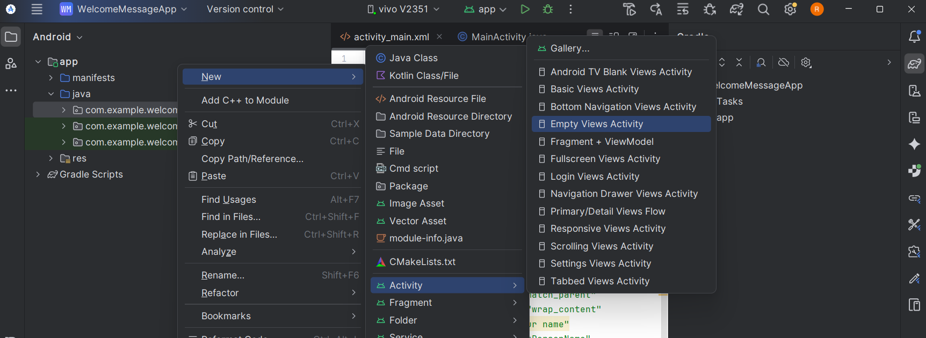

Activity_second.xml:code
<?xml version="1.0" encoding="utf-8"?>
<LinearLayout xmlns:android="http://schemas.android.com/apk/res/android"
android:layout_width="match_parent"
android:layout_height="match_parent"
android:orientation="vertical"
android:gravity="center"
android:padding="24dp">
<TextView
android:id="@+id/tvMessage"
android:layout_width="wrap_content"
android:layout_height="wrap_content"
android:text="Hello User!"
android:textSize="24sp"
android:textStyle="bold" />
</LinearLayout>
Second_activity.java
package com.example.welcomemessageapp;
import android.os.Bundle;
import android.widget.TextView;
import androidx.appcompat.app.AppCompatActivity;
public class SecondActivity extends AppCompatActivity {
TextView tvMessage;
@Override
protected void onCreate(Bundle savedInstanceState) {
super.onCreate(savedInstanceState);
setContentView(R.layout.activity_second);
// Link TextView
tvMessage = findViewById(R.id.tvMessage);
// Get data sent from MainActivity
String name = getIntent().getStringExtra("username");
// Display personalized message
tvMessage.setText("Hello, " + name + "! Welcome to the App.");
}
}
MainActivity.java
package com.example.welcomemessageapp;
import android.content.Intent;
import android.os.Bundle;
import android.view.View;
import android.widget.Button;
import android.widget.EditText;
import androidx.appcompat.app.AppCompatActivity;
public class MainActivity extends AppCompatActivity {
EditText etName;
Button btnNext;
@Override
protected void onCreate(Bundle savedInstanceState) {
super.onCreate(savedInstanceState);
setContentView(R.layout.activity_main);
// Linking UI components with Java
etName = findViewById(R.id.etName);
btnNext = findViewById(R.id.btnNext);
// Button click event
btnNext.setOnClickListener(new View.OnClickListener() {
@Override
public void onClick(View view) {
// Get user input
String name = etName.getText().toString();
// Create Intent to move to SecondActivity
Intent intent = new Intent(MainActivity.this, com.example.welcomemessageapp.SecondActivity.class);
// Pass data using Intent
intent.putExtra("username", name);
// Start second activity
startActivity(intent);
}
});
}
}
Run the application

Practical:3.3
Aim
To create an interactive Android application that uses fragments to divide the screen into multiple sections, allowing users to input data in one fragment and display it in another fragment dynamically.
Problem Statement
Develop an Android application containing two fragments inside one activity:
- Input Fragment: Accepts user input (e.g., name, message)
- Display Fragment: Shows the entered input in real-time when a button is clicked.
This demonstrates fragment interaction, dynamic UI updates, and fragment lifecycle understanding.
Open Android Studio → New Project
Select Empty Views Activity
Project Configuration:
Name: FragmentCommunicationApp
Package: com.example.fragmentsapp
Language: Java
Minimum SDK: API 21
Finish and wait for Gradle sync.
STEP 2: Create Two Fragments
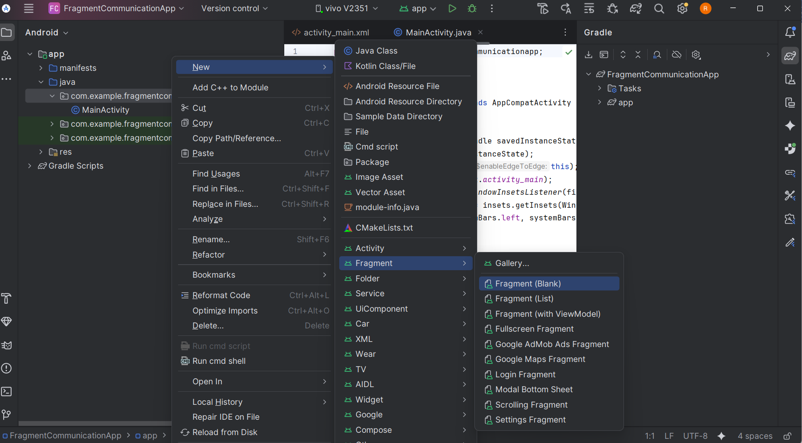

Fragment A (Input Fragment)
- Right-click java → New → Fragment → Fragment (Blank)
- Name: InputFragment
- Layout: fragment_input.xml
- Finish
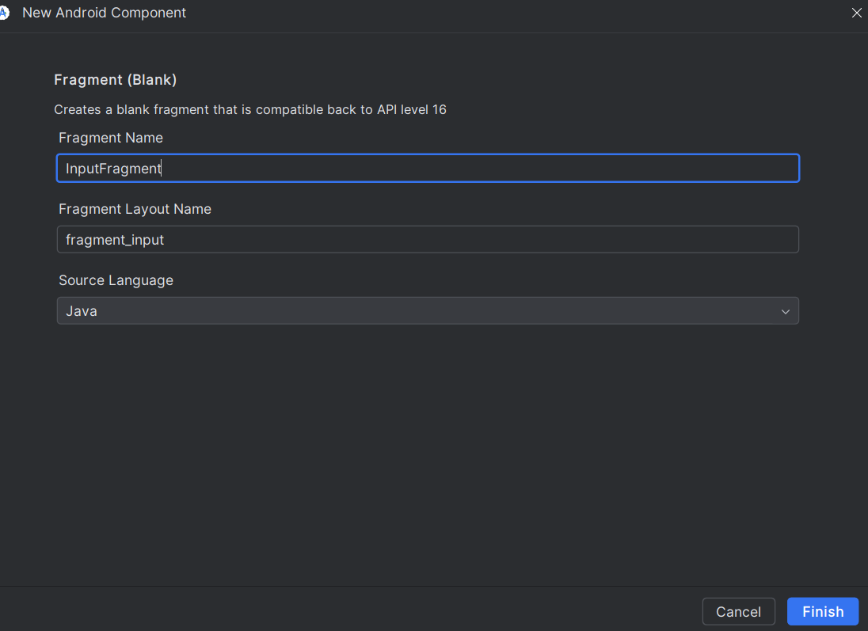
Fragment B (Display Fragment)
- Right-click java → New → Fragment → Fragment (Blank)
- Name: DisplayFragment
- Layout: fragment_display.xml
- Finish
STEP 3: Design Fragment Layouts
3A: fragment_input.xml (User Input)
<LinearLayout xmlns:android="http://schemas.android.com/apk/res/android"
android:layout_width="match_parent"
android:layout_height="match_parent"
android:orientation="vertical"
android:padding="24dp"
android:gravity="center">
<EditText
android:id="@+id/etMessage"
android:layout_width="match_parent"
android:layout_height="wrap_content"
android:hint="Enter your message" />
<Button
android:id="@+id/btnSend"
android:layout_width="wrap_content"
android:layout_height="wrap_content"
android:text="Send"
android:layout_marginTop="16dp" />
</LinearLayout>
3B: fragment_display.xml (Display Output)
<LinearLayout xmlns:android="http://schemas.android.com/apk/res/android"
android:layout_width="match_parent"
android:layout_height="match_parent"
android:gravity="center"
android:padding="24dp">
<TextView
android:id="@+id/tvDisplay"
android:layout_width="wrap_content"
android:layout_height="wrap_content"
android:text="Your message will appear here"
android:textSize="20sp"
android:textStyle="bold" />
</LinearLayout>
STEP 4: Add Fragments to MainActivity Layout
Open activity_main.xml and replace with:
<LinearLayout xmlns:android="http://schemas.android.com/apk/res/android"
android:orientation="horizontal"
android:layout_width="match_parent"
android:layout_height="match_parent">
<FrameLayout
android:id="@+id/fragment_container_input"
android:layout_width="0dp"
android:layout_weight="1"
android:layout_height="match_parent"/>
<FrameLayout
android:id="@+id/fragment_container_display"
android:layout_width="0dp"
android:layout_weight="1"
android:layout_height="match_parent"/>
</LinearLayout>
Logic:
- Two FrameLayouts divide the screen into left (input) and right (display).
- Fragments will be loaded dynamically into these containers.
STEP 5: Write Java Code for Fragments
5A: InputFragment.java
package com.example.fragmentcommunicationapp;
import android.content.Context;
import android.os.Bundle;
import android.view.LayoutInflater;
import android.view.View;
import android.view.ViewGroup;
import android.widget.Button;
import android.widget.EditText;
import androidx.fragment.app.Fragment;
public class InputFragment extends Fragment {
EditText etMessage;
Button btnSend;
OnMessageSendListener listener;
public interface OnMessageSendListener {
void onMessageSend(String message);
}
@Override
public void onAttach(Context context) {
super.onAttach(context);
if(context instanceof OnMessageSendListener){
listener = (OnMessageSendListener) context;
} else {
throw new RuntimeException(context.toString() + " must implement OnMessageSendListener");
}
}
@Override
public View onCreateView(LayoutInflater inflater, ViewGroup container,
Bundle savedInstanceState) {
View view = inflater.inflate(R.layout.fragment_input, container, false);
etMessage = view.findViewById(R.id.etMessage);
btnSend = view.findViewById(R.id.btnSend);
btnSend.setOnClickListener(new View.OnClickListener() {
@Override
public void onClick(View v) {
String message = etMessage.getText().toString();
listener.onMessageSend(message);
}
});
return view;
}
}
5B: DisplayFragment.java
package com.example.fragmentcommunicationapp;
import android.os.Bundle;
import android.view.LayoutInflater;
import android.view.View;
import android.view.ViewGroup;
import android.widget.TextView;
import androidx.fragment.app.Fragment;
public class DisplayFragment extends Fragment {
TextView tvDisplay;
@Override
public View onCreateView(LayoutInflater inflater, ViewGroup container,
Bundle savedInstanceState) {
View view = inflater.inflate(R.layout.fragment_display, container, false);
tvDisplay = view.findViewById(R.id.tvDisplay);
return view;
}
public void updateMessage(String message){
tvDisplay.setText(message);
}
}
STEP 6: MainActivity.java (Handles Fragment Communication)
package com.example.fragmentcommunicationapp;
import android.os.Bundle;
import androidx.appcompat.app.AppCompatActivity;
import androidx.fragment.app.FragmentManager;
import androidx.fragment.app.FragmentTransaction;
public class MainActivity extends AppCompatActivity implements InputFragment.OnMessageSendListener {
DisplayFragment displayFragment;
@Override
protected void onCreate(Bundle savedInstanceState) {
super.onCreate(savedInstanceState);
setContentView(R.layout.activity_main);
InputFragment inputFragment = new InputFragment();
displayFragment = new DisplayFragment();
FragmentManager fm = getSupportFragmentManager();
FragmentTransaction ft = fm.beginTransaction();
ft.replace(R.id.fragment_container_input, inputFragment);
ft.replace(R.id.fragment_container_display, displayFragment);
ft.commit();
}
@Override
public void onMessageSend(String message) {
displayFragment.updateMessage(message);
}
}
run

