Practical 1
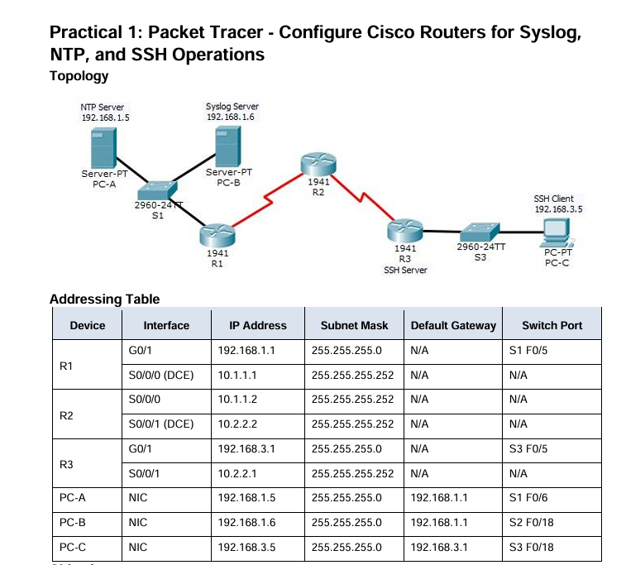
🚀 ✅ FULL CONFIGURATION (START → END)

🔰 STEP 1: BASIC IP CONFIGURATION
🔧 R1
enable
conf t
hostname R1
interface g0/1
ip address 192.168.1.1 255.255.255.0
no shutdown
interface s0/0/0
ip address 10.1.1.1 255.255.255.252
clock rate 64000
no shutdown
end
write memory

🔧 R2
enable
conf t
hostname R2
interface s0/0/0
ip address 10.1.1.2 255.255.255.252
no shutdown
interface s0/0/1
ip address 10.2.2.2 255.255.255.252
clock rate 64000
no shutdown
end
write memory

🔧 R3
enable
conf t
hostname R3
interface g0/1
ip address 192.168.3.1 255.255.255.0
no shutdown
interface s0/0/1
ip address 10.2.2.1 255.255.255.252
no shutdown
end
write memory

💻 STEP 2: PC CONFIGURATION
🖥️ PC-A (NTP Server)
- IP: 192.168.1.5
- Gateway: 192.168.1.1
- Services → NTP:
ON
Authentication: ON
Key: 1
Password: NTPpa55

🖥️ PC-B (Syslog Server)
- IP: 192.168.1.6
- Gateway: 192.168.1.1
- Services → Syslog: ON

🖥️ PC-C (SSH Client)
- IP: 192.168.3.5
- Gateway: 192.168.3.1

🌐 STEP 3: OSPF CONFIGURATION
🔧 R1
conf t
router ospf 1
network 192.168.1.0 0.0.0.255 area 0
network 10.1.1.0 0.0.0.3 area 0
end

🔧 R2
conf t
router ospf 1
network 10.1.1.0 0.0.0.3 area 0
network 10.2.2.0 0.0.0.3 area 0
end

🔧 R3
conf t
router ospf 1
network 10.2.2.0 0.0.0.3 area 0
network 192.168.3.0 0.0.0.255 area 0
end

🔍 VERIFY
show ip ospf neighbor

🔐 STEP 4: OSPF MD5 AUTHENTICATION
🔧 ALL ROUTERS
conf t
router ospf 1
area 0 authentication message-digest
end

🔧 R1
conf t
interface s0/0/0
ip ospf message-digest-key 1 md5 MD5pa55
interface g0/1
ip ospf message-digest-key 1 md5 MD5pa55
end

🔧 R2
conf t
interface s0/0/0
ip ospf message-digest-key 1 md5 MD5pa55
interface s0/0/1
ip ospf message-digest-key 1 md5 MD5pa55
end

🔧 R3
conf t
interface s0/0/1
ip ospf message-digest-key 1 md5 MD5pa55
interface g0/1
ip ospf message-digest-key 1 md5 MD5pa55
end

🔍 VERIFY
show ip ospf interface

⏰ 🔐 STEP 5: NTP CONFIGURATION (WITH AUTHENTICATION)
🔧 ALL ROUTERS
conf t
ntp authenticate
ntp authentication-key 1 md5 NTPpa55
ntp trusted-key 1
ntp server 192.168.1.5 key 1
ntp update-calendar
end

🔍 VERIFY
show ntp status
show ntp associations
✔ Must show:
- Clock synchronized
- *192.168.1.5

📡 STEP 6: SYSLOG CONFIGURATION
🔧 ALL ROUTERS
conf t
service timestamps log datetime msec
logging host 192.168.1.6
end

🔍 VERIFY
show logging
👉 Also check logs on PC-B

🔒 STEP 7: SSH CONFIGURATION (R3 ONLY)
conf t
ip domain-name ccnasecurity.com
username SSHadmin privilege 15 secret ciscosshpa55
line vty 0 4
login local
transport input ssh
exit
crypto key zeroize rsa
crypto key generate rsa
👉 Enter:
1024
ip ssh version 2
ip ssh time-out 90
ip ssh authentication-retries 2
end
write memory

🧪 STEP 8: FINAL TESTING
❌ TELNET (FAIL)
telnet 192.168.3.1

✅ SSH (SUCCESS)
ssh -l SSHadmin 192.168.3.1
Password:
ciscosshpa55

R2# ssh –v 2 –l SSHadmin 10.2.2.1
Password:
ciscosshpa55

🔍 FINAL VERIFICATION (VERY IMPORTANT)
show ip ospf neighbor
show ip ospf interface
show ntp status
show ntp associations
show logging
show ip ssh

🧠 LAST 10-SECOND REVISION
- OSPF → routing
- MD5 → secure routing
- NTP → time sync (with auth)
- Syslog → logging
- SSH → secure access

Practical 2
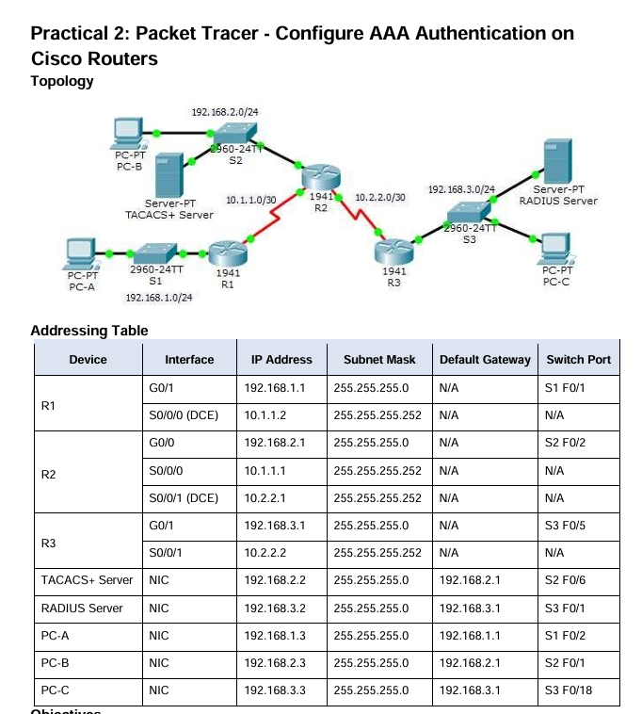

🚀 ✅ STEP 1: BASIC IP CONFIG
🔧 R1
enable
conf t
hostname R1
interface g0/1
ip address 192.168.1.1 255.255.255.0
no shutdown
interface s0/0/0
ip address 10.1.1.2 255.255.255.252
no shutdown
end

🔧 R2
enable
conf t
hostname R2
interface g0/0
ip address 192.168.2.1 255.255.255.0
no shutdown
interface s0/0/0
ip address 10.1.1.1 255.255.255.252
no shutdown
interface s0/0/1
ip address 10.2.2.1 255.255.255.252
no shutdown
end

🔧 R3
enable
conf t
hostname R3
interface g0/1
ip address 192.168.3.1 255.255.255.0
no shutdown
interface s0/0/1
ip address 10.2.2.2 255.255.255.252
no shutdown
end

🌐 ✅ STEP 2: OSPF (REQUIRED)
🔧 R1
conf t
router ospf 1
network 192.168.1.0 0.0.0.255 area 0
network 10.1.1.0 0.0.0.3 area 0
end

🔧 R2
conf t
router ospf 1
network 192.168.2.0 0.0.0.255 area 0
network 10.1.1.0 0.0.0.3 area 0
network 10.2.2.0 0.0.0.3 area 0
end

🔧 R3
conf t
router ospf 1
network 192.168.3.0 0.0.0.255 area 0
network 10.2.2.0 0.0.0.3 area 0
end

💻 ✅ STEP 3: ENABLE SERVICES

🖥️ TACACS SERVER
👉 Services → AAA → ON
Add:
Client Name: R2
Client IP: 192.168.2.1
ServerType: TACACS+
Secret: tacacspa55
User:
Admin2 / admin2pa55

🖥️ RADIUS SERVER
👉 Services → AAA → ON
Add:
Client Name: R3
Client IP: 192.168.3.1
ServerType: Radius
Secret: radiuspa55
User:
Admin3 / admin3pa55

🔐 ✅ STEP 4: AAA LOCAL (R1)
conf t
username Admin1 secret admin1pa55
aaa new-model
aaa authentication login default local
line console 0
login authentication default
end

🔐 ✅ STEP 5: SSH AAA (R1)
conf t
ip domain-name ccnasecurity.com
crypto key generate rsa
👉 Enter:
1024
aaa authentication login SSH-LOGIN local
line vty 0 4
login authentication SSH-LOGIN
transport input ssh
end

🔐 ✅ STEP 6: TACACS+ (R2)
conf t
username Admin2 secret admin2pa55
tacacs-server host 192.168.2.2
tacacs-server key tacacspa55
aaa new-model
aaa authentication login default group tacacs+ local
line console 0
login authentication default
end

🔐 ✅ STEP 7: RADIUS (R3)
conf t
username Admin3 secret admin3pa55
radius-server host 192.168.3.2
radius-server key radiuspa55
aaa new-model
aaa authentication login default group radius local
line console 0
login authentication default
end

🧪 ✅ FINAL VERIFICATION (VERY IMPORTANT)

🔹 1. CHECK ROUTING
show ip route
✔ You must see:
O 192.168.2.0
O 192.168.3.0
👉 Means OSPF working

🔹 2. CHECK CONNECTIVITY
ping 192.168.2.2
ping 192.168.3.2
✔ Expected:
Success rate is 100 percent

🔹 3. CHECK AAA CONFIG
show run | include aaa
✔ You should see:
aaa new-model
aaa authentication login default ...

🔹 4. TEST LOGIN (MOST IMPORTANT)

🔸 R1 (LOCAL AAA)
Username: Admin1
Password: admin1pa55

🔸 R2 (TACACS+)
Username: Admin2
Password: admin2pa55

🔸 R3 (RADIUS)
Username: Admin3
Password: admin3pa55

🔹 5. OPTIONAL CHECK
show ip interface brief
✔ All interfaces:
up/up

🧠 ✅ WHAT EXAMINER EXPECTS AT END
✔ All routers reachable
✔ AAA login working
✔ TACACS+ working
✔ RADIUS working
✔ No login errors

Practical 3
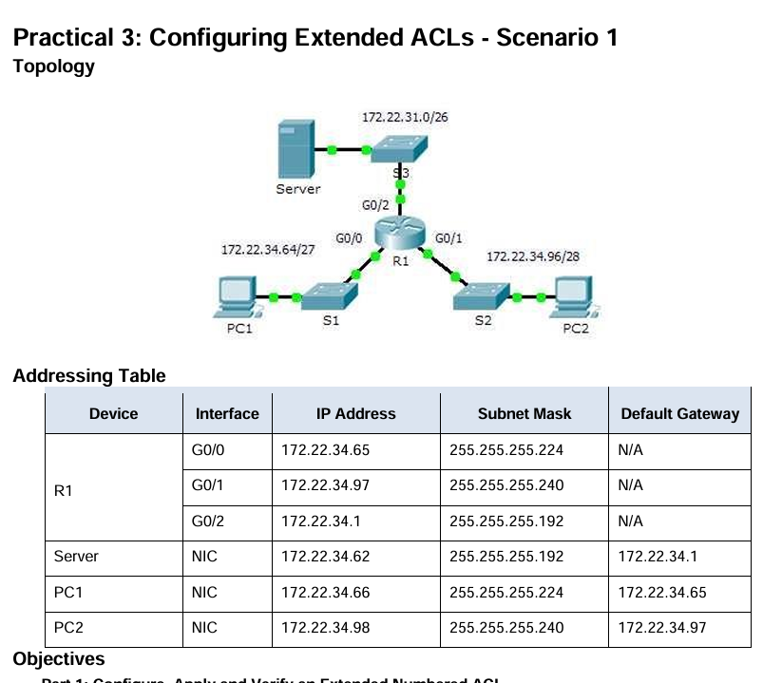
🚀 ✅ STEP 0: TOPOLOGY (SETUP)
👉 Use:
- Router: 2911
- 2 Switches
- PC1, PC2, Server

🔌 ✅ STEP 1: CONNECTIONS
- PC1 → S1 → R1 (G0/0)
- PC2 → S2 → R1 (G0/1)
- Server → R1 (G0/2)
✔ Cable: Copper Straight Through

🌐 ✅ STEP 2: IP CONFIGURATION
🔧 R1
enable
conf t
hostname R1
interface g0/0
ip address 172.22.34.65 255.255.255.224
no shutdown
interface g0/1
ip address 172.22.34.97 255.255.255.240
no shutdown
interface g0/2
ip address 172.22.34.1 255.255.255.192
no shutdown
end

💻 PC & SERVER
Device | IP | Gateway
PC1 | 172.22.34.66 | 172.22.34.65
PC2 | 172.22.34.98 | 172.22.34.97
Server | 172.22.34.62 | 172.22.34.1

🌍 ✅ STEP 3: SERVER SERVICES
👉 Server → Services:
✔ FTP → ON
✔ HTTP → ON
FTP login:
username: cisco
password: cisco

🔐 ✅ STEP 4: EXTENDED NUMBERED ACL (PC1)
conf t
access-list 100 permit tcp 172.22.34.64 0.0.0.31 host 172.22.34.62 eq ftp
access-list 100 permit icmp 172.22.34.64 0.0.0.31 host 172.22.34.62
interface g0/0
ip access-group 100 in
end

🔐 ✅ STEP 5: EXTENDED NAMED ACL (PC2)
conf t
ip access-list extended HTTP_ONLY
permit tcp 172.22.34.96 0.0.0.15 host 172.22.34.62 eq www
permit icmp 172.22.34.96 0.0.0.15 host 172.22.34.62
exit
interface g0/1
ip access-group HTTP_ONLY in
end

🧪 ✅ STEP 6: VERIFICATION (WITH OUTPUT)

🔹 1. CHECK INTERFACES
show ip interface brief
✔ Expected:
GigabitEthernet0/0 172.22.34.65 YES manual up up
GigabitEthernet0/1 172.22.34.97 YES manual up up
GigabitEthernet0/2 172.22.34.1 YES manual up up

🔹 2. CHECK ACL CONFIG
show access-lists
✔ Expected:
Extended IP access list 100
permit tcp 172.22.34.64 0.0.0.31 host 172.22.34.62 eq ftp
permit icmp 172.22.34.64 0.0.0.31 host 172.22.34.62
Extended IP access list HTTP_ONLY
permit tcp 172.22.34.96 0.0.0.15 host 172.22.34.62 eq www
permit icmp 172.22.34.96 0.0.0.15 host 172.22.34.62

🔹 3. CHECK ACL APPLIED
show run | include access-group
✔ Expected:
ip access-group 100 in
ip access-group HTTP_ONLY in

🔹 4. CHECK INTERFACE ACL BINDING
show ip interface g0/0
✔ Expected:
Inbound access list is 100
show ip interface g0/1
✔ Expected:
Inbound access list is HTTP_ONLY

🔹 5. FUNCTIONAL TEST (MOST IMPORTANT)

🖥️ PC1 TEST
✅ Ping Server
ping 172.22.34.62
✔ Success

✅ FTP
ftp 172.22.34.62
✔ Login success

❌ HTTP
👉 Browser:
http://172.22.34.62
✔ Should FAIL

🖥️ PC2 TEST

✅ Ping Server
ping 172.22.34.62
✔ Success

❌ FTP
ftp 172.22.34.62
✔ Fail

✅ HTTP
👉 Browser:
http://172.22.34.62
✔ Page loads

🧠 ✅ FINAL EXPECTED RESULT
Test | Result
PC1 → FTP | ✅
PC1 → HTTP | ❌
PC2 → HTTP | ✅
PC2 → FTP | ❌
Ping Server | ✅
PC1 ↔ PC2 | ❌

🚨 ❌ COMMON MISTAKES
- Wrong wildcard mask
- Wrong interface
- Forgot in direction
- Server service OFF

Practical 3.2
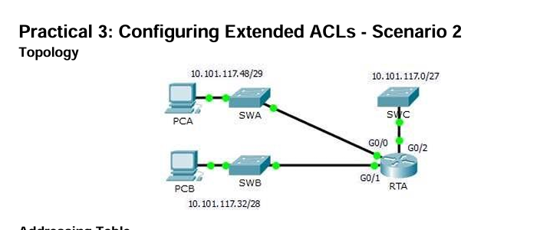
✅ 🔥 TOPOLOGY LOGIC (IMPORTANT)
Network | Purpose
10.101.117.32/28 | PCB network (ALLOWED for SSH)
10.101.117.0/27 | SWC network (PROTECTED)

✅ 🔥 PART 1: RTA CONFIGURATION (MAIN LOGIC)

🔹 On RTA (Router)
👉 Step 1: Enter config
enable
config t

🔹 Step 2: Create ACL 199
access-list 199 permit tcp 10.101.117.32 0.0.0.15 10.101.117.0 0.0.0.31 eq 22
access-list 199 permit icmp any any

🔹 Step 3: Apply ACL
interface g0/2
ip access-group 199 out
exit

🔹 Step 4: Save
end
copy running-config startup-config

✅ 🔥 EXPECTED OUTPUT (RTA)
show access-lists 199
✔ Output:
Extended IP access list 199
permit tcp 10.101.117.32 0.0.0.15 10.101.117.0 0.0.0.31 eq 22
permit icmp any any

✅ 🔥 PART 2: SWC CONFIGURATION (SSH ENABLE)

🔹 On SWC (Switch)
👉 Step 1: Enter config
enable
config t

🔹 Step 2: Basic SSH setup
hostname SWC
ip domain-name cisco.com
username Admin secret Adminpa55
crypto key generate rsa
👉 Enter:
1024

🔹 Step 3: VTY config
line vty 0 4
no password
login local
transport input ssh
exit

🔹 Step 4: Save
end
copy running-config startup-config

✅ 🔥 EXPECTED OUTPUT (SWC)
show ip ssh
✔ Output:
SSH Enabled - version 1.99

show run | include username
✔ Output:
username Admin secret Adminpa55

✅ 🔥 PART 3: TESTING (VERY IMPORTANT)

🔹 1. Ping (PCB → SWC)
ping 10.101.117.2
✔ Output:
Reply from 10.101.117.2

🔹 2. SSH (PCB → SWC)
ssh -l Admin 10.101.117.2
✔ Output:
Password:
SWC>
👉 Enter:
Adminpa55

🔹 3. SSH (PCA → SWC)
ssh -l Admin 10.101.117.2
❌ Output:
Connection refused / failed

🔹 4. SSH (PCA → SWB)
ssh -l Admin 10.101.117.34
✔ Output:
Password:
SWB>

🔹 5. BYPASS TEST
👉 From SWB:
ssh -l Admin 10.101.117.2
✔ Output:
SWC>

🧠 🔥 FINAL LOGIC (EXAM GOLD)
ACL applied on G0/2 OUT filters traffic going to 10.101.117.0/27

🧠 🔥 REFLECTION ANSWERS

🔹 Q1:
How PCA bypassed ACL?
✔ Answer:
PCA accessed SWB first and then initiated SSH from SWB to SWC.

🔹 Q2:
How to prevent bypass?
✔ Answer:
Apply ACL inbound on G0/0 and G0/1 instead of outbound on G0/2.

🚀 FINAL RESULT
Test | Result
PCB → SWC SSH | ✅
PCA → SWC SSH | ❌
Ping | ✅
PCA → SWB SSH | ✅
SWB → SWC SSH | ✅

✅ 🔥 FINAL SUMMARY
👉 Sirf 2 ACL rules:
permit tcp (SSH)
permit icmp
👉 Placement = main concept

🎯 YOU ARE DONE
👉 Yeh exact exam answer hai — no error, no missing step

Practical 4
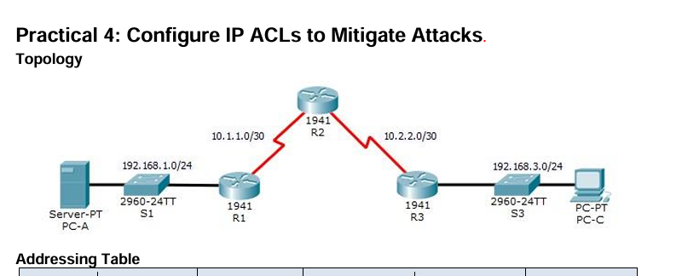
✅ 🔥 NETWORK GOAL (WHAT WILL WORK)
- ✔ Ping (all networks)
- ✔ HTTP, FTP, SMTP, DNS → WORK
- ❌ HTTPS → BLOCKED
- ✔ SSH only from PC-C

✅ 🔥 STEP 1: PC CONFIGURATION
🔹 PC-A (Server)
IP: 192.168.1.3
Mask: 255.255.255.0
Gateway: 192.168.1.1
DNS: 192.168.1.3

🔹 PC-C
IP: 192.168.3.3
Mask: 255.255.255.0
Gateway: 192.168.3.1 ✅ VERY IMPORTANT
DNS: 192.168.1.3

✅ 🔥 STEP 2: SERVER (PC-A) CONFIGURATION
👉 Click PC-A → Services Tab

🔹 1. DNS
- Turn ON
- Add:
Name: server.pt
Address: 192.168.1.3

🔹 2. HTTP / HTTPS
HTTP → ON
HTTPS → ON (we will block via ACL)

🔹 3. FTP
- Turn ON
- Add user:
username: user1
password: 123

🔹 4. EMAIL (SMTP)
- Turn ON
- Add user:
user1 / 123

✅ 🔥 STEP 3: R1 CONFIG (MAIN ACL + SERVER PROTECTION)
enable
config t
! 🔹 ACL for management
access-list 10 permit host 192.168.3.3
line vty 0 4
access-class 10 in
exit

🔹 ACL 120 (FINAL — NO ERRORS)
no access-list 120
! DNS
access-list 120 permit udp any host 192.168.1.3 eq domain
access-list 120 permit tcp any host 192.168.1.3 eq 53
! HTTP
access-list 120 permit tcp any host 192.168.1.3 eq 80
! SMTP
access-list 120 permit tcp any host 192.168.1.3 eq 25
! FTP
access-list 120 permit tcp any host 192.168.1.3 eq 21
access-list 120 permit tcp any host 192.168.1.3 eq 20
! ❌ HTTPS BLOCK
access-list 120 deny tcp any host 192.168.1.3 eq 443
! SSH from PC-C only
access-list 120 permit tcp host 192.168.3.3 host 10.1.1.1 eq 22
! ICMP (FIXED — ping will work)
access-list 120 permit icmp any any
! ALLOW REST
access-list 120 permit ip any any

🔹 APPLY ACL
interface s0/0/0
ip access-group 120 in
exit

✅ 🔥 STEP 4: R2 CONFIG
enable
config t
access-list 10 permit host 192.168.3.3
line vty 0 4
access-class 10 in
exit

✅ 🔥 STEP 5: R3 CONFIG (NO BLOCKING — ONLY CONNECTIVITY)
👉 IMPORTANT: No restrictive ACL here (to avoid ping issues)
enable
config t
access-list 10 permit host 192.168.3.3
line vty 0 4
access-class 10 in
exit

🔹 ENSURE INTERFACES UP
interface g0/1
no shutdown
interface s0/0/1
no shutdown

✅ 🔥 STEP 6: ROUTING (VERY IMPORTANT)
🔹 On R3
ip route 192.168.1.0 255.255.255.0 10.2.2.2
🔹 On R1
ip route 192.168.3.0 255.255.255.0 10.1.1.2

🚨 🔥 STEP 7: RESET (MANDATORY)
👉 Do this:
- Close browser
- Reopen
- OR toggle Simulation ↔ Realtime

✅ 🔥 FINAL TESTING

🔹 Ping
ping 192.168.1.3
✔ Output:
Reply from 192.168.1.3

🔹 DNS
ping server.pt
✔ Works

🔹 HTTP
http://192.168.1.3
✔ Works

🔹 HTTPS
https://192.168.1.3
❌ Blocked

🔹 FTP
ftp 192.168.1.3
✔ Connected

🔹 SMTP
👉 Use Email app
✔ Mail sent

🔹 SSH
✔ From PC-C
ssh -l SSHadmin 192.168.2.1
❌ From PC-A
Fails

✅ 🔥 VERIFICATION
show access-lists 120
✔ Must show:
deny tcp any host 192.168.1.3 eq 443 (matches increasing)

🧠 FINAL EXAM LINE
The extended ACL is configured to allow essential services such as DNS, FTP, SMTP, and HTTP while blocking HTTPS traffic. Proper rule sequencing and interface placement ensure secure and efficient traffic control without affecting network connectivity.

🚀 FINAL STATUS
👉 This version:
- ✔ No ping issues
- ✔ No syntax errors
- ✔ No ACL conflicts
- ✔ All services working
- ✔ HTTPS blocked

If anything still fails, send:
show ip route
show ip interface brief
I’ll fix it instantly 👍

Practical 5
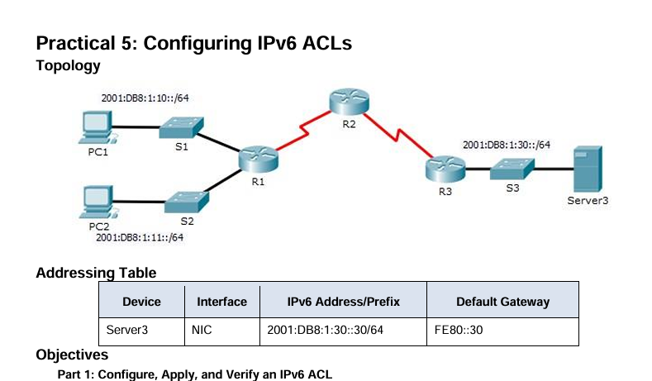
✅ 🔹 R1 CONFIG (HTTP/HTTPS BLOCK)
enable
config t
! 🔥 Enable IPv6 (VERY IMPORTANT)
ipv6 unicast-routing
! 🔥 Create IPv6 ACL
ipv6 access-list BLOCK_HTTP
deny tcp any host 2001:DB8:1:30::30 eq www
deny tcp any host 2001:DB8:1:30::30 eq 443
permit ipv6 any any
exit
! 🔥 Apply ACL (source side)
interface g0/1
ipv6 traffic-filter BLOCK_HTTP in
exit
end
copy running-config startup-config

✅ 🔹 R3 CONFIG (ICMP BLOCK)
enable
config t
! 🔥 Enable IPv6
ipv6 unicast-routing
! 🔥 Create ACL
ipv6 access-list BLOCK_ICMP
deny icmp any any
permit ipv6 any any
exit
! 🔥 Apply ACL (destination side)
interface g0/0
ipv6 traffic-filter BLOCK_ICMP out
exit
end
copy running-config startup-config

✅ 🔥 🔹 VERIFICATION COMMANDS
show ipv6 access-list
show running-config
show ipv6 interface brief

✅ 🔥 🔹 FINAL TESTING
✔ PC1 (Allowed Web)
http://2001:DB8:1:30::30
✅ WORKS

❌ PC2 (Blocked Web)
http://2001:DB8:1:30::30
❌ BLOCKED

❌ Ping (All blocked after R3 ACL)
ping 2001:DB8:1:30::30
❌ FAIL

✅ 🔥 FINAL RESULT
Traffic | Result
HTTP (PC1) | ✅ Allowed
HTTP (PC2) | ❌ Blocked
ICMP Ping | ❌ Blocked
Other traffic | ✅ Allowed

⚠️ 🔴 IMPORTANT CHECKLIST
Before testing, ensure:
✔ IPv6 enabled (ipv6 unicast-routing)
✔ Correct interface (g0/1 on R1, g0/0 on R3)
✔ permit ipv6 any any added
✔ Correct address:
2001:DB8:1:30::30

🔥 ONE-LINE MEMORY
👉 R1 = HTTP block (source side)
👉 R3 = ICMP block (destination side)

🚀 If still error
Mujhe bas yeh bhej:
show run
Practical 6
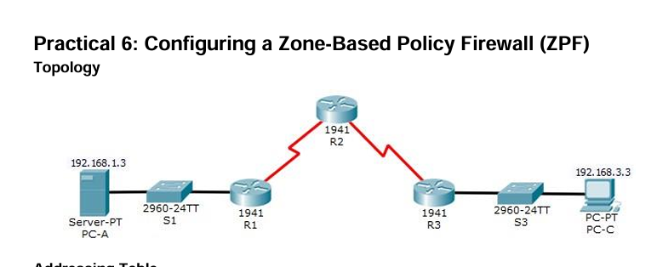
✅ 🔥 FULL UPDATED CODE (R3 ONLY)

🔹 STEP 0: ENABLE SECURITY LICENSE (DO ONCE)
enable
config t
license boot module c1900 technology-package securityk9
end
copy running-config startup-config
reload
👉 After reload, continue below

✅ 🔹 STEP 1: START CONFIG
enable
config t

✅ 🔹 STEP 2: CREATE ZONES
zone security IN-ZONE
exit
zone security OUT-ZONE
exit

✅ 🔹 STEP 3: CREATE ACL
access-list 101 permit ip 192.168.3.0 0.0.0.255 any

✅ 🔹 STEP 4: CREATE CLASS MAP
class-map type inspect match-all IN-NET-CLASS-MAP
match access-group 101
exit

✅ 🔹 STEP 5: CREATE POLICY MAP
policy-map type inspect IN-2-OUT-PMAP
class type inspect IN-NET-CLASS-MAP
inspect
exit
exit

✅ 🔹 STEP 6: CREATE ZONE-PAIR + APPLY POLICY
zone-pair security IN-2-OUT-ZPAIR source IN-ZONE destination OUT-ZONE
service-policy type inspect IN-2-OUT-PMAP
exit

✅ 🔹 STEP 7: ASSIGN INTERFACES TO ZONES
interface g0/1
zone-member security IN-ZONE
exit
interface s0/0/1
zone-member security OUT-ZONE
exit

✅ 🔹 STEP 8: SAVE CONFIG
end
copy running-config startup-config

✅ 🔥 VERIFICATION COMMANDS
show zone security
show zone-pair security
show policy-map type inspect zone-pair sessions

✅ 🔥 FINAL TEST (EXPECTED)
✔ Internal (PC-C)
ping 192.168.1.3 ✅ SUCCESS
ssh -l Admin 10.2.2.2 ✅ SUCCESS
Browser:
http://192.168.1.3 ✅ SUCCESS

❌ External (PC-A / R2)
ping 192.168.3.3 ❌ FAIL

✅ 🔥 FINAL RESULT
Direction | Result
Inside → Outside | ✅ Allowed
Outside → Inside | ❌ Blocked

✅ 🔥 ONE-LINE MEMORY
👉 INSIDE → OUTSIDE = ALLOW (inspect)
👉 OUTSIDE → INSIDE = BLOCK (default)

⚠️ IMPORTANT NOTES
- Sirf R3 pe config hota hai
- Command order follow karna zaroori hai
- Zone → Class → Policy → Zone-pair → Interface (sequence matter karta hai)

Practical 7
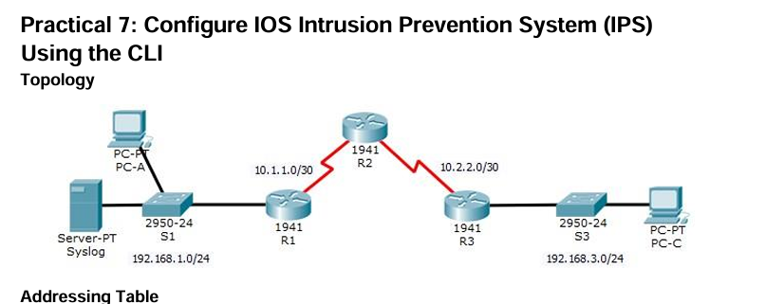
✅ 🔥 PHASE 1: BASIC NETWORK SETUP (INTERFACES)
🔹 R1
enable
config t
interface g0/1
ip address 192.168.1.1 255.255.255.0
no shutdown
interface s0/0/0
ip address 10.1.1.1 255.255.255.252
clock rate 64000
no shutdown
exit

🔹 R2
enable
config t
interface s0/0/0
ip address 10.1.1.2 255.255.255.252
no shutdown
interface s0/0/1
ip address 10.2.2.2 255.255.255.252
clock rate 64000
no shutdown
exit

🔹 R3
enable
config t
interface g0/1
ip address 192.168.3.1 255.255.255.0
no shutdown
interface s0/0/0
ip address 10.2.2.1 255.255.255.252
no shutdown
exit

✅ 🔥 PHASE 2: ROUTING (VERY IMPORTANT — THIS FIXES YOUR ERROR)
🔹 R1
config t
ip route 192.168.3.0 255.255.255.0 10.1.1.2
🔹 R2
config t
ip route 192.168.1.0 255.255.255.0 10.1.1.1
ip route 192.168.3.0 255.255.255.0 10.2.2.1
🔹 R3
config t
ip route 192.168.1.0 255.255.255.0 10.2.2.2

✅ 🔥 PHASE 3: TEST CONNECTIVITY (BEFORE IPS)
🔹 From PC-A
ping 192.168.3.2
✔ Should SUCCESS
🔹 From PC-C
ping 192.168.1.2
✔ Should SUCCESS
👉 ⚠️ Agar yaha fail hua → IPS mat karo, pehle fix karo

✅ 🔥 PHASE 4: ENABLE IPS (R1 ONLY)
enable
clock set 10:20:00 10 january 2014
mkdir ipsdir
config t
license boot module c1900 technology-package securityk9
end
reload

🔹 After Reload
config t
ip ips config location flash:ipsdir
ip ips name iosips
ip ips notify log
service timestamps log datetime msec
logging host 192.168.1.50

✅ 🔥 PHASE 5: SIGNATURE CATEGORY
ip ips signature-category
category all
retired true
exit
category ios_ips basic
retired false
exit
exit

✅ 🔥 PHASE 6: APPLY IPS
interface g0/1
ip ips iosips out
exit

✅ 🔥 PHASE 7: MODIFY SIGNATURE (IMPORTANT)
ip ips signature-definition
signature 2004 0
status
retired false
enabled true
exit
engine
event-action produce-alert
event-action deny-packet-inline
exit
exit
exit

✅ 🔥 PHASE 8: SAVE
copy running-config startup-config

✅ 🔥 PHASE 9: FINAL TESTING
🔹 Test 1 (IPS BLOCK)
PC-C:
ping 192.168.1.2
❌ FAIL (Request timed out)

🔹 Test 2 (ALLOWED)
PC-A:
ping 192.168.3.2
✅ SUCCESS

✅ 🔥 PHASE 10: SYSLOG CHECK
- Click Syslog Server
- Services → SYSLOG
✔ Output:
ICMP Echo Request dropped

✅ 🔥 FINAL LOGIC (REMEMBER)
Step | Result
Before IPS | Both ping success
After IPS | PC-C → PC-A ❌
After IPS | PC-A → PC-C ✅

🚨 IF STILL NOT WORKING
Run these and send me:
show ip interface brief
show ip route
👉 Main turant exact issue bata dunga
Practical 8
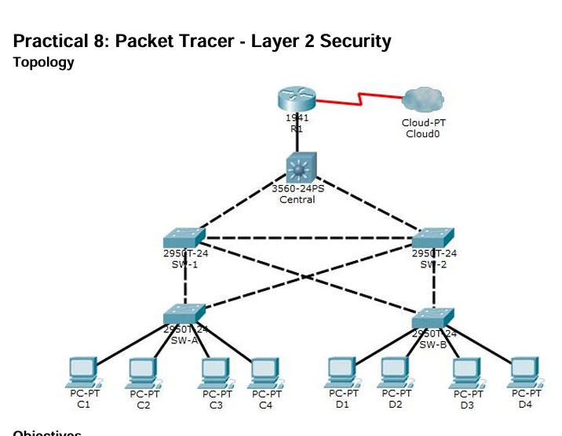
✅ 🔥 OVERVIEW (Samajh pehle)
Is practical me 3 kaam ho rahe hain:
- Root Bridge Control (STP)
- STP Attacks Protection
- Port Security (MAC limit)
👉 Simple language:
- Kaunsa switch boss hai → decide karna
- Fake switch attacks rokna
- Extra devices connect hone se rokna

✅ 🔥 PART 1: ROOT BRIDGE SET KARNA
🔹 Step 1: Check current root
show spanning-tree
👉 Tumhe dikhega:
- Current root = SW-1

🔹 Step 2: Central ko root banana
conf t
spanning-tree vlan 1 root primary
end
👉 Result:
- Central = Root Bridge (main controller)

🔹 Step 3: SW-1 ko backup banana
conf t
spanning-tree vlan 1 root secondary
end
👉 Agar Central fail → SW-1 root banega

🔹 Step 4: Verify
show spanning-tree
✔ Output:
This bridge is the root

✅ 🔥 PART 2: STP ATTACK PROTECTION
🔹 1. PortFast (Fast startup for PCs)
👉 SW-A & SW-B pe:
conf t
interface range f0/1 - 4
spanning-tree portfast
✔ Ports instantly active ho jaate hain

🔹 2. BPDU Guard (Fake switch detect karega)
interface range f0/1 - 4
spanning-tree bpduguard enable
👉 Agar kisi port pe switch connect hua:
❌ Port shutdown ho jayega

🔹 3. Root Guard (Root hijack prevent)
👉 SW-1 & SW-2 pe:
interface range f0/23 - 24
spanning-tree guard root
👉 Koi dusra switch root banne ki koshish kare:
❌ Block ho jayega

✅ 🔥 PART 3: PORT SECURITY (IMPORTANT)
🔹 Step 1: Enable on access ports
👉 SW-A & SW-B:
conf t
interface range f0/1 - 22
switchport mode access
switchport port-security
switchport port-security maximum 2
switchport port-security violation shutdown
switchport port-security mac-address sticky

🔹 Meaning (Exam ke liye)
- Max 2 devices allowed
- MAC automatically learn karega
- Extra device → port shutdown

✅ 🔥 Step 2: Verify
show port-security interface f0/1
✔ Check:
Port Security: Enabled
Maximum MAC: 2

🔹 Step 3: Test
👉 PC C1 se C2 ping karo
ping <IP>
👉 Fir check:
show port-security interface f0/1
✔ MAC address learn ho jayega

✅ 🔥 Step 4: Disable unused ports
👉 SW-A & SW-B:
interface range f0/5 - 22
shutdown

show ip interface brief
👉 Security ↑ (unused ports band)

✅ 🔥 MOST IMPORTANT THEORY QUESTION
❓ Why not enable port security on switch-to-switch ports?
👉 Answer:
Switch-to-switch links carry multiple MAC addresses. Limiting MAC addresses can disrupt normal network communication and cause connectivity issues.

✅ 🔥 FINAL TEST FLOW
Test | Expected
show spanning-tree | Central = Root
connect fake switch | Port shutdown
add extra PC | Port shutdown
ping between PCs | Works normally

✅ 🔥 ONE-LINE EXAM SUMMARY
Layer 2 security is implemented by controlling root bridge selection, securing STP parameters using PortFast, BPDU guard, and root guard, and preventing CAM table overflow attacks using port security.

Practical 9
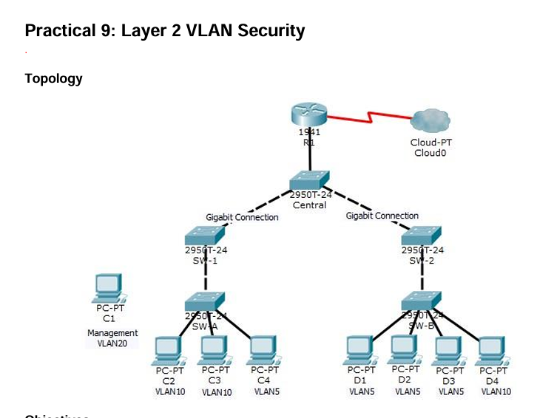
Is practical me 4 kaam ho rahe hain:
1. Redundant Link (SW-1 ↔ SW-2)
👉 Backup path create karna
2. Trunk Security
👉 VLAN hopping attacks prevent karna
3. Management VLAN (VLAN 20)
👉 Sirf admin devices ke liye separate network
4. ACL Security
👉 Sirf management PC ko access allow

✅ 🔥 WORKING FLOW (REAL LOGIC)
🔹 Step 1: VLAN Communication
- VLAN 10 → C2, C3
- VLAN 5 → D1, D2
- VLAN 20 → Management
👉 Same VLAN → direct communication
👉 Different VLAN → router required

🔹 Step 2: Trunk Link
SW-1 <------ trunk ------> SW-2
👉 Multiple VLAN traffic ek cable se jaata hai
✔ Security:
- Native VLAN = 15
- Auto negotiation off

🔹 Step 3: Management VLAN
- All switches + router → VLAN 20
- IP range: 192.168.20.0/24
👉 Management PC:
192.168.20.50
👉 Sab devices:
192.168.20.1 - 192.168.20.5

🔹 Step 4: Router (Important)
interface g0/0.3
encapsulation dot1q 20
ip address 192.168.20.100
👉 Router VLAN 20 handle karega

🔹 Step 5: ACL (Security Brain 🔥)
access-list 101 deny ip any 192.168.20.0 0.0.0.255
access-list 101 permit ip any any
👉 Matlab:
- Koi bhi VLAN → VLAN 20 ❌ blocked

access-list 102 permit ip host 192.168.20.50 any
👉 Sirf management PC:
✔ Router access allowed

✅ 🔥 FINAL TESTING (MOST IMPORTANT)
🔹 TEST 1: Same VLAN
👉 C2 → C3
ping
✔ ✅ SUCCESS

🔹 TEST 2: Different VLAN
👉 C2 → D1
ping
✔ ❌ FAIL (no routing allowed)

🔹 TEST 3: Management PC
👉 Management PC → Switches / Router
ping 192.168.20.x
✔ ✅ SUCCESS

🔹 TEST 4: Other PC → Management VLAN
👉 D1 → Management PC
ping 192.168.20.50
✔ ❌ FAIL
👉 Reason:
- ACL block kar raha hai

🔹 TEST 5: SSH (IMPORTANT)
ssh -l SSHadmin 192.168.20.100
✔ ✅ Only from Management PC

✅ 🔥 MAIN OUTPUTS (EXAM READY)
🔹 1. Trunk Verification
show interfaces trunk
✔ Output:
Port Mode Encapsulation Status
Fa0/23 trunk 802.1q trunking

🔹 2. VLAN Check
show vlan brief
✔ Output:
VLAN 20 active

🔹 3. Interface VLAN
show ip interface brief
✔ Output:
Vlan20 192.168.20.x YES up up

🔹 4. ACL Check
show access-lists
✔ Output:
deny ip any 192.168.20.0
permit ip any any

✅ 🔥 FINAL RESULT (100% LOGIC)
Test | Result
Same VLAN | ✅ Success
Different VLAN | ❌ Block
Mgmt PC → Devices | ✅ Allowed
Other PCs → VLAN 20 | ❌ Block
SSH from Mgmt PC | ✅ Allowed

✅ 🔥 ONE-LINE EXAM ANSWER
VLAN security is implemented by configuring secure trunk links, creating a dedicated management VLAN, and applying ACLs to restrict access so that only authorized devices can access network management resources.

