Security In Computing Practical

Practical 3: Configuring Extended ACLs

A]

Topology:

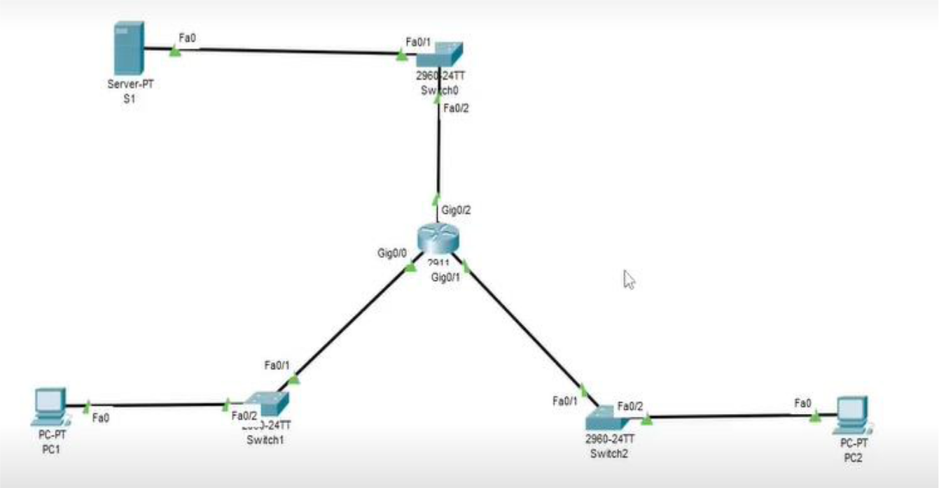

Addressing Table:

Device | Interface | IP Address | Subnet Mask | Default Gateway
 | gig0/0 | 172.22.34.65 | 255.255.255.224 | N/A
R1
R1 | gig0/1 | 172.22.34.97 | 255.255.255.240 | N/A
 | gig0/2 | 172.22.34.1 | 255.255.255.192 | N/A
Server | NIC | 172.22.34.62 | 255.255.255.192 | 172.22.34.1
PC1 | NIC | 172.22.34.66 | 255.255.255.224 | 172.22.34.65
PC2 | NIC | 172.22.34.98 | 255.255.255.240 | 172.22.34.97

Objectives:
- Configure, Apply and Verify an Extended Numbered ACL

- Configure, Apply and Verify an Extended Named ACL

Scenario:

o PC1 Should be allowed only FTP access o PC2 Should be allowed only web access

o Both PCs must ping server but not each other’s

Configure Router:

Step 1: Configure password for vty lines

R1(config) # line vty 0 4

R1(config-line) #password vtypa55

R1(config-line) #login

Step 2: Configure secret on router

R1(config) # enable secret enpa55

Part 1: Configure, Apply and Verify an Extended Numbered ACL

Step 1: Configure an ACL to permit FTP and ICMP. (Use Router 2911)

R1(config)# access-list 100 permit tcp 172.22.34.64 0.0.0.31 host

172.22.34.62 eq ftp

R1(config)# access-list 100 permit icmp 172.22.34.64 0.0.0.31 host

172.22.34.62

Step 2: Apply the ACL on the correct interface to filter traffic.

R1(config)# int gig 0/0

R1(config-if)# ip access-group 100 in

Step 3: Verify the ACL implementation. a. Ping from PC1 to Server. PC1> ping 172.22.34.62 (Successful)

b. FTP from PC1 to Server. The username and password are both cisco. PC1> ftp 172.22.34.62

c. Exit the FTP service of the Server.

ftp> quit

d. Ping from PC1 to PC2.

PC1> ping 172.22.34.98

(Unsuccessful) destination host unreachable

Part 2: Configure, Apply and Verify an Extended Named ACL

Step 1: Configure an ACL to permit HTTP access and ICMP. R1(config)# ip access-list extended HTTP_ONLY

R1(config-ext-nacl)# permit tcp 172.22.34.96 0.0.0.15 host 172.22.34.62 eq www

R1(config-ext-nacl)# permit icmp 172.22.34.96 0.0.0.15 host 172.22.34.62

Step 2: Apply the ACL on the correct interface to filter traffic.

R1(config)# int gig0/1

R1(config-if)# ip access-group HTTP_ONLY in

Step 3: Verify the ACL implementation. a. Ping from PC2 to Server. PC2> ping 172.22.34.62 (Successful)

b. FTP from PC2 to Server

PC2> ftp 172.22.34.62

(Unsuccessful)

c. Open the web browser on PC2.

URL -> http://172.22.34.62

(Successful)

d. Ping from PC2 to PC1.

PC> ping 172.22.34.66

(Unsuccessful)

B]

Topology:

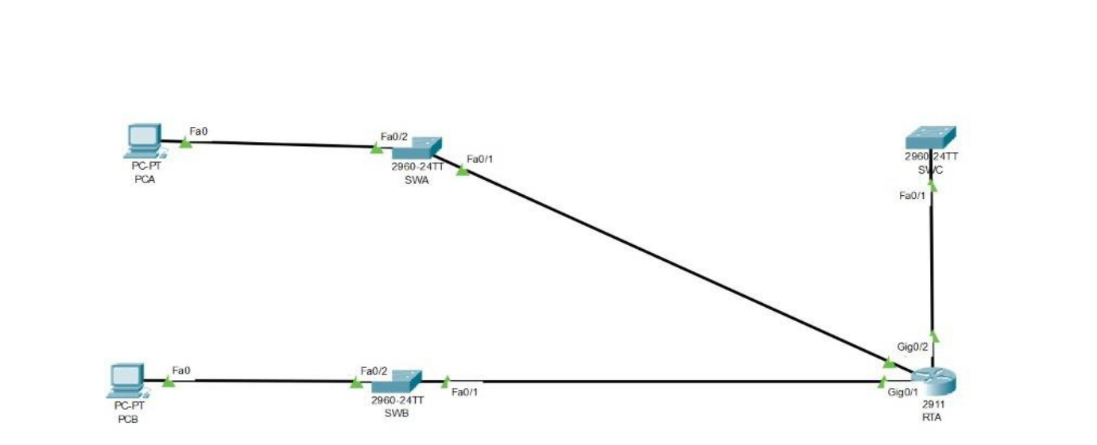

Addressing Table:

Device | Interface | IP Address | Subnet Mask | Default Gateway
 | gig0/0 | 10.101.117.49 | 255.255.255.248 | N/A
RTA | gig0/1 | 10.101.117.33 | 255.255.255.240 | N/A
 | gig0/2 | 10.101.117.1 | 255.255.255.224 | N/A
PCA | NIC | 10.101.117.51 | 255.255.255.248 | 10.101.117.49
PCB | NIC | 10.101.117.35 | 255.255.255.240 | 10.101.117.33
SWA | VLAN 1 | 10.101.117.50 | 255.255.255.248 | 10.101.117.49
SWB | VLAN 1 | 10.101.117.34 | 255.255.255.240 | 10.101.117.33
SWC | VLAN 1 | 10.101.117.2 | 255.255.255.224 | 10.101.117.1

Objectives:
- Configure, Apply and Verify an Extended Numbered ACL

Scenario:

- Device on one LAN are allowed to remotely access device in

another LAN using SSH protocol

- Besides ICMP all traffic from other network is denied

Configure Switch and Router:

Step 1: Configure the IP address on switch SWA(config)# int vlan 1

SWA(config-if)# ip address 10.101.117.50 255.255.255.248

SWA(config-if)# no shut

SWA(config-if)# ip default-gateway 10.101.117.49

SWB(config)# int vlan 1

SWB(config-if)# ip address 10.101.117.34 255.255.255.240

SWB(config-if)# no shut

SWB(config-if)# ip default-gateway 10.101.117.33

SWC(config)# int vlan 1

SWC(config-if)# ip address 10.101.117.2 255.255.255.224

SWC(config-if)# no shut

SWC(config-if)# ip default-gateway 10.101.117.1

Step 2: Configure the secret on router and switch RTA/SW(config)# enable secret enpa55

Step 3: Configure the console password on router and switch

RTA/SW(config)# line console 0

RTA/SW(config)# password tyit

RTA/SW(config)# login

Step 4: Test connectivity

Ping from PCA to PC-B.

PCA>ping 10.101.117.35

(Successful)

Ping from PCA to SWC.

PCA>ping 10.101.117.2

(Successful)

Ping from PCB to SWC.

PCB>ping 10.101.117.2

(Successful)

Part 1: Configure Switch and Router to support SSH Connection

Step 1: Configure domain name and crypto key for use with SSH. RTA/SW(config)# ip domain-name ccnasecurity.com

Step 2: Configure users to login to SSH RTA/SW(config)# username admin secret adminpa55

Step 3: Configure incoming vty lines RTA/SW(config)# line vty 0 4 RTA/SW(config-line)# login local RTA/SW(config)# crypto key generate rsa How many bits in the modulus [512]: 1024 Step 4: Verify the SSH Connection PCA> ssh -l Admin 10.101.117.34 Password: adminpa55

SWB>

PCA> ssh -l Admin 10.101.117.2

Password: adminpa55

SWC>

PCB> ssh -l Admin 10.101.117.50

Password: adminpa55

SWA>

PCB> ssh -l Admin 10.101.117.2

Password: adminpa55

SWC>

SWC> ssh -l Admin 10.101.117.50

Password: adminpa55

SWA>

SWC> ssh -l Admin 10.101.117.34

Password: adminpa55

SWB>

SWB> exit

Part 2: Configure, Apply and Verify an Extended Numbered ACL

Step 1: Configure the extended ACL.

RTA(config)# access-list 199 permit tcp 10.101.117.32 0.0.0.15 10.101.117.0 0.0.0.31 eq 22

RTA(config)# access-list 199 permit icmp any any

Step 2: Apply the extended ACL. RTA(config)# int gig0/2 RTA(config-if)# ip access-group 199 out

Step 3: Verify the extended ACL implementation.

a. Ping from PCB to all of the other IP addresses in the network.

PCB> ping 10.101.117.51

(Successful)

PCB> ping 10.101.117.2

(Successful)

b. SSH from PCB to SWC.

PCB> ssh -l Admin 10.101.117.2

Password:adminpa55

SWC>

c. Exit the SSH session to SWC.

SWC>exit

d. Ping from PCA to all of the other IP addresses in the network.

PCA> ping 10.101.117.35

(Successful)

PCA> ping 10.101.117.2

(Successful)

e. SSH from PCA to SWC

PCA> ssh -l Admin 10.101.117.2

Connection timed out. Remote host not responding

f. SSH from PCA to SWB.

PCA> ssh -l Admin 10.101.117.34

Password: adminpa55

SWB>

g. After logging into SWB, do not log out. SSH to SWC in privileged EXEC mode.

SWB# ssh -l Admin 10.101.117.2

Password: adminpa55

SWC>

