Practical 6:- Configuring a Zone-Based Policy Firewall (ZPF)

Topology:
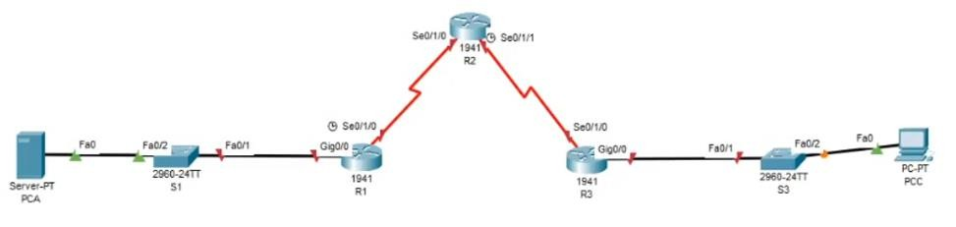

Addressing Table:

Device | Interface | IP Address | Subnet Mask | Default Gateway
R1 | gig0/0 | 192.168.1.1 | 255.255.255.0 | N/A
 | Se0/1/0 (DCE) | 10.1.1.1 | 255.255.255.252 | N/A
R2 | Se0/1/0 | 10.1.1.2 | 255.255.255.252 | N/A
 | Se0/1/1 (DCE) | 10.2.2.2 | 255.255.255.252 | N/A
R3 | gig0/0 | 192.168.3.1 | 255.255.255.0 | N/A
 | Se0/1/0 | 10.2.2.1 | 255.255.255.252 | N/A
PC-A | NIC | 192.168.1.3 | 255.255.255.0 | 192.168.1.1
PC-C | NIC | 192.168.3.3 | 255.255.255.0 | 192.168.3.1

Objectives:
- Verify connectivity among devices before firewall configuration.
- Configure a zone-based policy (ZPF) firewall on R3.
- Verify ZPF firewall functionality using ping, SSH, and a web browser.

Configure Router:

Step 1: Configure console password on router
Execute command on all routers R(config) # line console 0 R(config-line) #password conpa55 R(config-line) #login

Step 2: Configure password for vty lines Execute command on all routers R(config)# line vty 0 4
R(config-line)# password vtypa55 R(config-line)# login

Step 3: Configure secret on router
R(config) # enable secret enpa55

Step 4: Configure SSH login on router
Execute command on all routers
R(config)# ip domain-name ccnasecurity.com R(config)# username admin secret adminpa55 R(config)# line vty 0 4
R(config-line)# login local
R(config-line)# crypto key generate rsa How many bits in the modulus [512]: 1024

Step 5: Configure static routing on routers
Execute command on all routers
R(config)#ip route destination-network-address subnetmask next-hop- destination-address

Part 2: Verify Basic Network Connectivity Step 1: Check connectivity from PCA to PCC PCA>ping 192.168.3.3
(Successful)
Step 2: Access R2 using SSH. PCC>ssh –l admin 10.2.2.2 Password:adminpa55
R2>exit

Step 3: From PC-C, open a web browser to the PC-A server.
Desktop -> Web Browser URL: http://192.168.1.3
(Successful)

Part 3: Create the Firewall Zones on R3

Step 1: Verify that the Security Technology package
R3# show version

Step 2: Enable the Security Technology package
R3(config)# license boot module c1900 technology-package securityk9

Step 3: Save the running-config and reload the router
R3#copy run start R3# reload

Step 4: Verify that the Security Technology package
R3# show version

Step 5: Create an internal zone. R3(config)# zone security IN-ZONE R3(config-sec-zone)# exit

Step 6: Create an external zone. R3(config)# zone security OUT-ZONE R3(config-sec-zone)# exit

Part 4: Identify Traffic Using a Class-Map

Step 1: Create an ACL that defines internal traffic.
R3(config)# access-list 101 permit ip 192.168.3.0 0.0.0.255 any

Step 2: Create a class map referencing the internal traffic ACL R3(config)# class-map type inspect match-all IN-NET-CLASS-MAP R3(config-cmap)# match access-group 101
R3(config-cmap)# exit

Part 5: Specify Firewall Policies

Step 1: Create a policy map to determine what to do with matched traffic.
R3(config)# policy-map type inspect IN-2-OUT-PMAP

Step 2: Specify a class type of inspect and reference class map IN-NET- CLASS-MAP.
R3(config-pmap)# class type inspect IN-NET-CLASS-MAP

Step 3: Specify the action of inspect for this policy map.
R3(config-pmap-c)# inspect R3(config-pmap-c)# exit R3(config-pmap)# exit

Part 6: Apply Firewall Policies

Step 1: Create a pair of zones.
R3(config)# zone-pair security IN-2-OUT-ZPAIR source IN-ZONE destination OUTZONE

Step 2: Specify the policy map for handling the traffic between the two zones.
R3(config-sec-zone-pair)# service-policy type inspect IN-2-OUT-PMAP R3(config-sec-zone-pair)# exit
R3(config)#

Step 3: Assign interfaces to the appropriate security zones.
R3(config)# int g0/0
R3(config-if)# zone-member security IN-ZONE R3(config-if)# exit
R3(config)# int s0/1/0
R3(config-if)# zone-member security OUT-ZONE R3(config-if)# exit

Step 4: Copy the running configuration to the startup configuration.
R3# copy run start R3# reload

Part 7: Test Firewall Functionality from IN-ZONE to OUT ZONE

Step 1: From internal PC-C, ping the external PC-A server.
PCC>ping 192.168.1.3
(Successful)

Step 2: Access R2 using SSH. PCC>ssh –l admin 10.2.2.2 Password:
R2>

Step 3: View established sessions
R3# show policy-map type inspect zone-pair sessions
Session 175216232 (192.168.3.3:1028)=>(10.2.2.2:22) tcp SIS_OPEN/TCP_ESTAB

Step 4: From PC-C, exit the SSH session on R2 and close the command prompt window.
R2>exit

Step 5: From internal PC-C, open a web browser to the PC-A server web page.
Desktop -> Web Browser URL: http://192.168.1.3
(Successful)

Step 6: View established sessions
R3# show policy-map type inspect zone-pair sessions

Session 565266624 (192.168.3.3:1031)=>(192.168.1.3:80) tcp SIS_OPEN/TCP_ESTAB

Part 8: Test Firewall Functionality from OUT-ZONE to IN- ZONE

Step 1: From internal PC-A, ping the external PC-C server.
PCA>ping 192.168.3.3
(Unsuccessful – Request timed out)

Step 2: From R2, ping PC-C.
R2# ping 192.168.3.3
(Unsuccessful – Request timed out)

