Security In Computing Practical
Practical 7: Layer 2 Security

Topology:

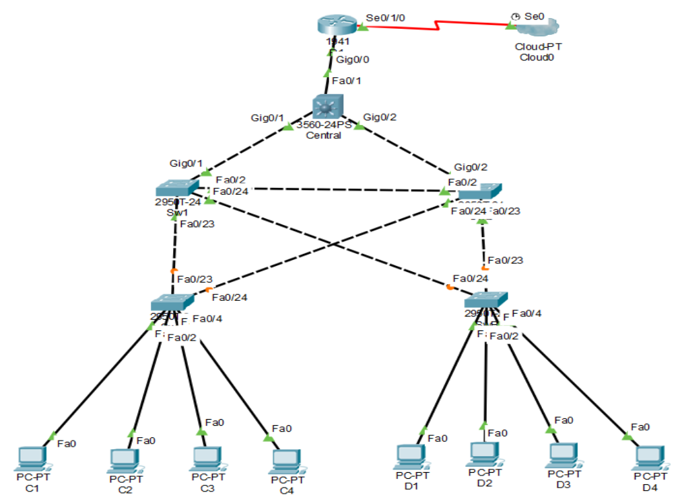

Addressing Table:

Device | Interface | IP Address | Subnet Mask | Default Gateway
 | gig0/0 | 192.168.1.1 | 255.255.255.0 | N/A
R1
R1 | Se0/1/0 | 209.165.200.1 | 255.255.255.0 | N/A
C1 | NIC | 10.1.1.10 | 255.255.255.0 | 10.1.1.1
C2 | NIC | 10.1.1.11 | 255.255.255.0 | 10.1.1.1
C3 | NIC | 10.1.1.12 | 255.255.255.0 | 10.1.1.1
C4 | NIC | 10.1.1.13 | 255.255.255.0 | 10.1.1.1
D1 | NIC | 10.1.1.14 | 255.255.255.0 | 10.1.1.1
D2 | NIC | 10.1.1.15 | 255.255.255.0 | 10.1.1.1
D3 | NIC | 10.1.1.16 | 255.255.255.0 | 10.1.1.1
D4 | NIC | 10.1.1.17 | 255.255.255.0 | 10.1.1.1

Objectives:

- Assign the Central switch as the root bridge.

- Secure spanning-tree parameters to prevent STP manipulation attacks.

- Enable port security to prevent CAM table overflow attacks.

Part 1: Configure Switch / Router

Step 1: Configure secret

Execute command on all switches and router

R1/SW(config) # enable secret enpa55

Step 2: Configure console password

Execute command on all switches and router

R1/SW(config)# line console 0

R1/SW(config-line)# password conpa55

R1/SW(config-line)# login

Step 3: Configure SSH login

Execute command on all switches and router

R1/SW(config)# ip domain-name ccnasecurity.com

R1/SW(config)# username admin secret adminpa55

R1/SW(config)# line vty 0 4

R1/SW(config-line)# login local

R1/SW(config-line)# crypto key generate rsa

How many bits in the modulus [512]: 1024

Part 2: Configure Root Bridge

Step 1: Determine the current root bridge.

Central# show spanning-tree

SW1# show spanning-tree

Step 2: Assign Central as the primary root bridge.

Central(config)# spanning-tree vlan 1 root primary

Central# show spanning-tree

Step 3: Assign SW-1 as a secondary root bridge.

SW1(config)# spanning-tree vlan 1 root secondary

SW1# show spanning-tree

Part 3: Protect Against STP Attacks

Step 1: Enable PortFast on all access ports.

SWA/B(config)# int range fa0/1 - 4

SWA/B(config-if-range)# spanning-tree portfast

Step 2: Enable BPDU guard on all access ports.

SWA/B(config)# int range fa0/1 - 4

SWA/B(config-if-range)# spanning-tree bpduguard enable

Step 3: Enable root guard.

SW-1/2(config)# int range fa0/23 - 24

SW-1/2(config-if-range)# spanning-tree guard root

Part 4: Configure Port Security and Disable Unused Ports

Step 1: Configure basic port security on all ports connected to host devices.

SW-A/B(config)# int range fa0/1 - 22

SW-A/B(config-if-range)# switchport mode access

SW-A/B(config-if-range)# switchport port-security

SW-A/B(config-if-range)# switchport port-security maximum 2

SW-A/B(config-if-range)# switchport port-security violation shutdown

SW-A/B(config-if-range)# switchport port-security mac-address sticky

Step 2: Verify port security.

SW-A/B# show port-security int fa0/1

Step 3: Disable unused ports.

SW-A/B(config)# int range fa0/5 - 22

SW-A/B(config-if-range)# shutdown

Step 4: Verify Connectivity

Ping C1->C2 (Successful)

Ping C1->D1 (Successful)

Step 5: Verify port security.

SW-A/B# show port-security int fa0/1

