Pyramid Strategy
High-Level System Architecture & Execution Blueprint
This document provides a comprehensive blueprint of the Pyramid Strategy automated options trading system. It is designed to serve as a reference for understanding the overall component layout, data routing, state machine logic, and user authentication lifecycle.

1. High-Level Component Architecture
The system is split into a React Frontend, a FastAPI Backend, a Redis cache feed, and various third-party execution/alert channels:
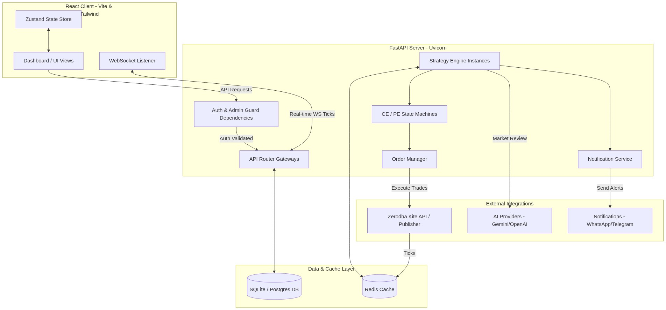
Figure 1: System Diagram 1

2. Real-Time Tick & Order Processing Flow
The core strategy engine operates on NIFTY spot tick updates. Below is the sequence detailing how ticks trigger crossover detections, strike locks, state updates, and order placements:
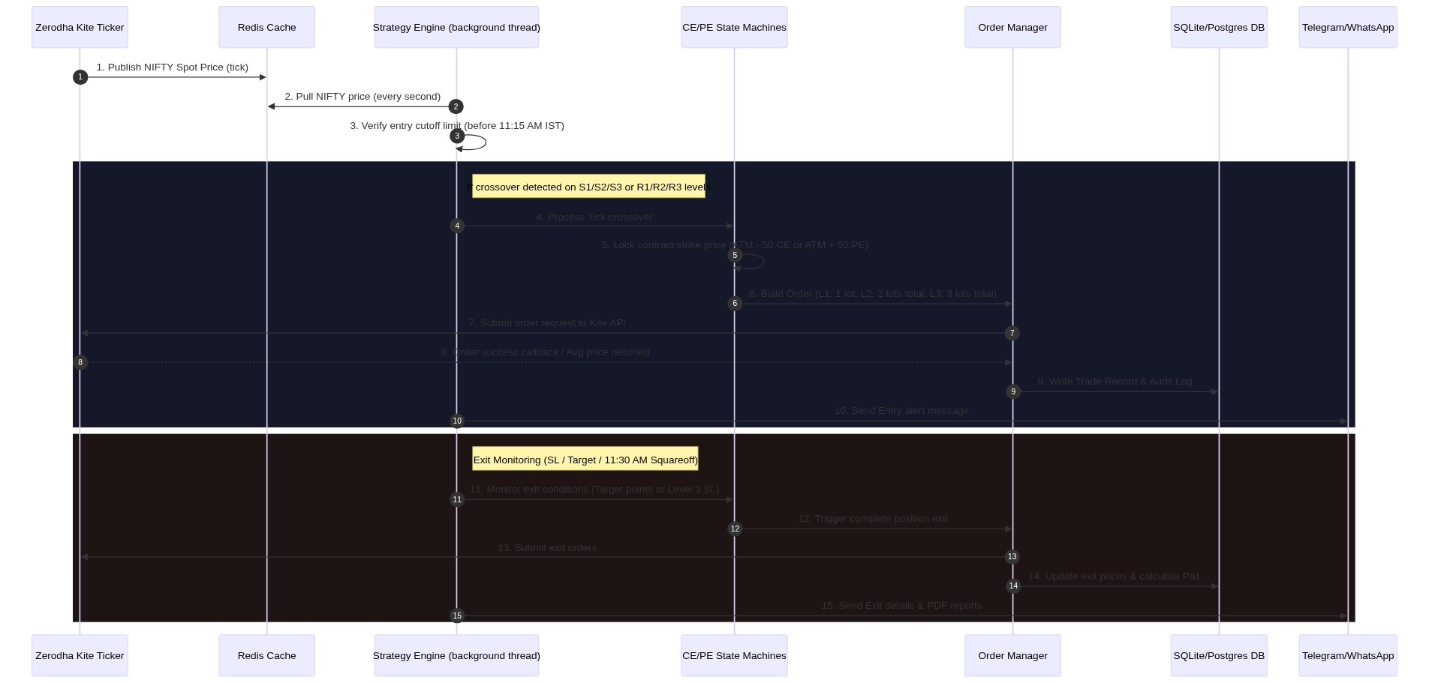
Figure 2: System Diagram 2

3. Component Details & Design Specifications

A. Frontend Client (Vite React + Tailwind CSS)
- Design Aesthetic: Midnight dark background (`bg-navy-950`), custom amethyst highlights, glassmorphism containers (`backdrop-blur-xl`), and animated layout updates.
- Navigation: Collapsible sidebar navigation. Dynamically renders a `👑 Admin` badge and reveals the **Admin Panel** link only if `user.is_admin === true`.
- State Management: Zustand-powered strategy store synchronizes the real-time WebSocket state, ticking option LTPs, live levels, and AI suggestions.

B. FastAPI Backend Server
- Authentication Guard: JWT-based session security. The `require_auth` dependency blocks requests with a `403 Forbidden` status if the user account has `is_approved = False`.
- Database Models (SQLAlchemy):
- `User`: Credentials, approval status, and admin role flags.
- `StrategyConfig`: Target/SL parameters, lot sizing configs, and custom S/R points.
- `Trade`: Record of exact entry and exit times, transaction prices, and net P&L.
- Auto-Bootstrap System: If the user registers matching the `SUPER_ADMIN_USERNAME` configured in `.env`, the server automatically marks the user as approved and flags them as an admin on database creation.

C. Multi-User Strategy Engine
- Isolation: Instantiated uniquely per active user. Evaluates state machines (`StateMachine`) independently for CE and PE legs.
- State Lifecycles:
- `IDLE`: Awaiting S/R crossover.
- `L1`: Locked strike contract, entered 1 lot.
- `L2`: Averaged down, added 1 lot (total 2 lots).
- `L3`: Maximum position depth reached, added 1 lot (total 3 lots). Stop Loss activated (10 points below avg price).
- Safety Guards: Prevents re-entries on the same leg if a target exit has occurred during the session. Triggers forced squareoff at exactly 11:30 AM.

4. Moderated Registration Lifecycle Flow
The user approval and activation sequence details how signups are moderated by administrators:
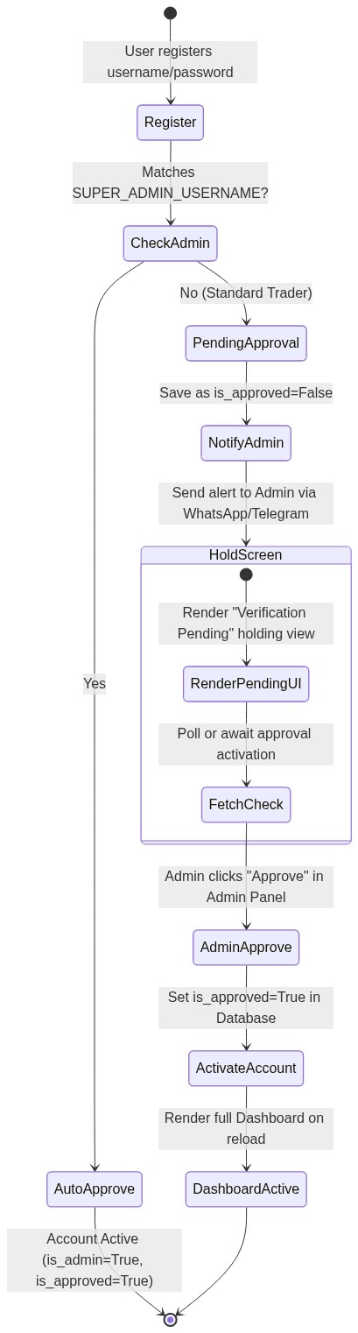
Figure 3: System Diagram 3

5. Code Execution Flow Diagram
This diagram charts the logical execution flow of the backend python code when handling market data ticks:
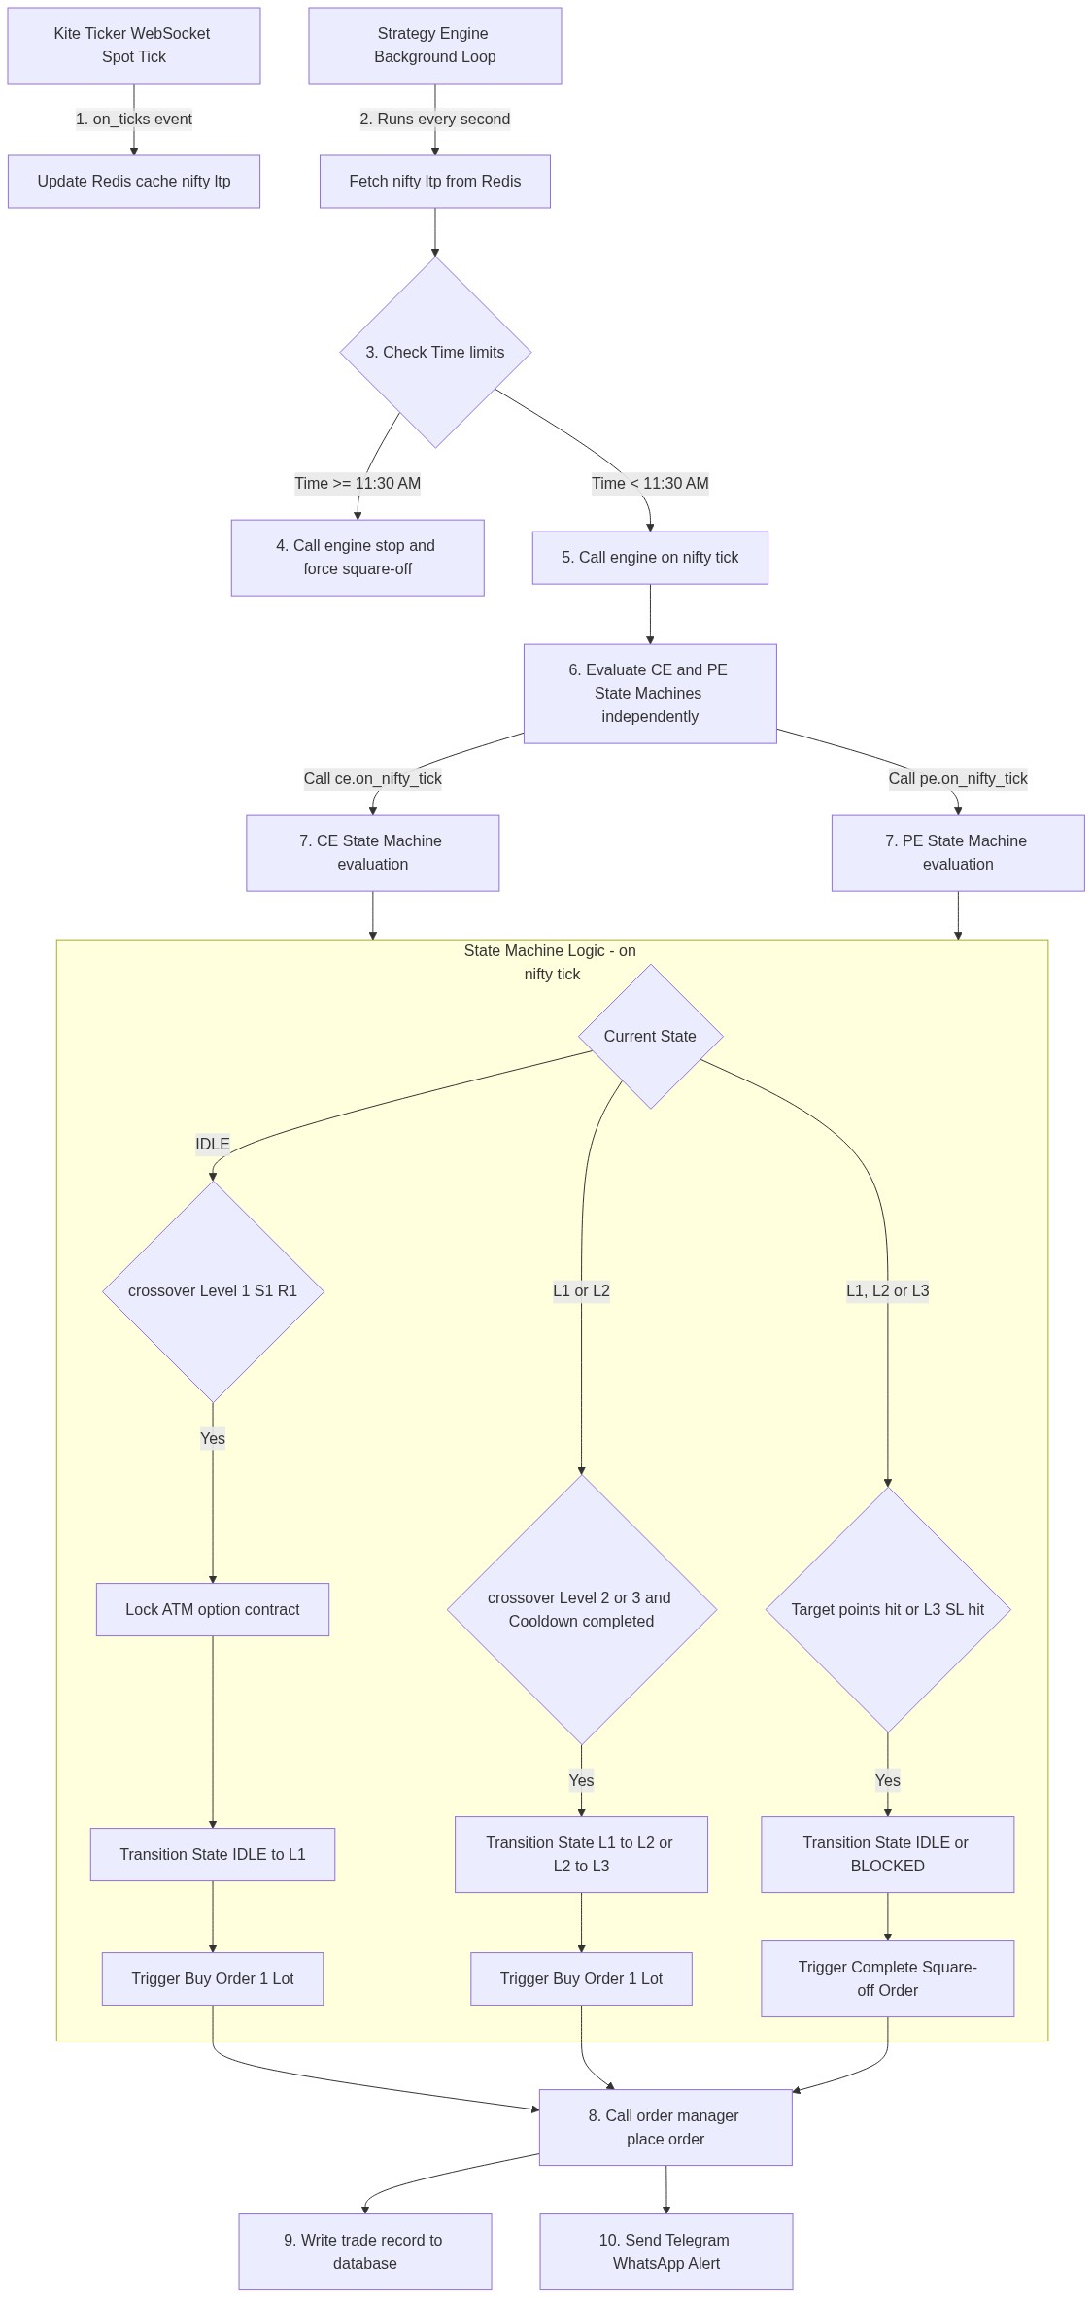
Figure 4: System Diagram 4

