Content Analysis Service Design Document

Version | Date | Author | Comments
0 | 11/11/08 | Heidi Nolan | Draft

Program Manager
Development Engineer
QA Engineer
Customer Support

Introduction
Content analysis enforcement requires scanning the content of the documents, email body or clipboard to search for the sensitive information. This scanning process can be expensive in terms of CPU time and memory. Additionally, for some certain formats documents, the searching depends on some third-party software to extract information. In order to exclude any side-effects of those software from the policy controller and policy adaptors, content scanning will be done by a separated service process called “NLCA_service”. In this way, the policy controller and policy adaptors will be also isolated from content scanning’s consumptions on CPU time and memory in some degrees.

External Documents
Context Analysis Design Document

High Level Design

Overview
Content analysis service is a multi-threading server application that handles the content analysis requests from service clients via a thin socket layer. The service is launched by the policy controller through policy controller’s plug-in services at the run beginning of the policy controller. When the policy engine does evaluation on content against content analysis policy, it sends the content analysis request in the form of RPC to the service. Before the policy controller stops running, it sends STOP RPC to NLCA service to gracefully shut down the service.
The following is the overall architect of NLCA service.

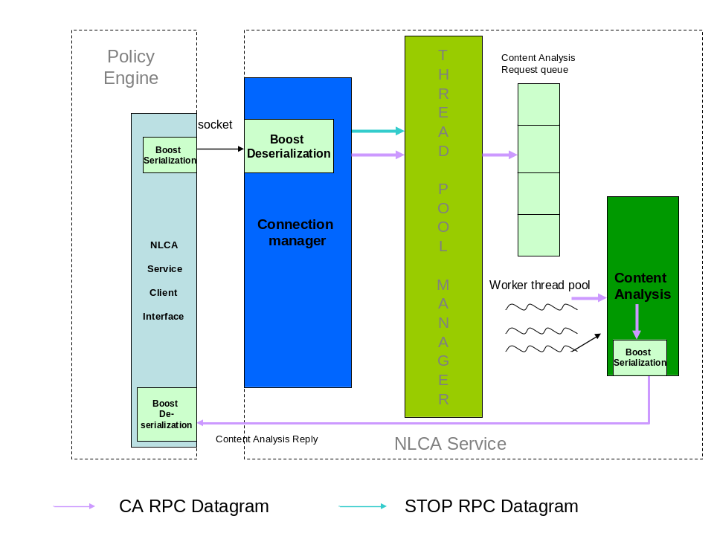

Decisions and Tradeoffs
- Boost serialization library provides a flexible, easy-to-use way to serialize/de-serialize C/C++ data structure. Therefore, it is used here to package and un-package NLCA RPC data.
- Comparing with IPC or other forms of RPC, socket provides cross-platform communications. Also, it is more graceful to tear down socket layer when the system is shutting down. Therefore, content analysis RPC is based on socket.

Low Level Design

NLCA Service Server
On the server side of NLCA service, there are connection manager module, framework module and general content analysis module. The framework module includes the general thread pool module and NLCA RPC module.
The document, Content Analysis Design, gives detailed description about content analysis module. This module will be used by the individual worker of the thread pool to analysis on an individual document.

Connection Manager
The connection manager will first initialize the thread pool and then setup the listening socket at port 27019 (This will be reconsidered.). If these steps are successful, the connection manager will wait for the new connection or the data coming in via an existing connected socket.
The following is the execution flow of connection manager.
Waiting for status change(s) on socket(s)
De-serialize Packet
Add to the list of connected clients
New Connection?
Data packet comes in via an existing socket
no
yes
yes
no
Stop RPC
yes
No
Dispatch this request to a worker thread of thread pool by calling function NLCA_ThreadPool_AddTask
Socket error or fail to read
yes
1. Inform thread pool to cancel the task of the client’s, who own this socket
2. Free the client object
3. Remove the client from the list of connected clients
Exit:
1. Shutdown thread pool by calling function NLCA_ThreadPool_Shutdown,
2. Close sockets

When a new connection is accepted, an object of class Client will be generated and it will be added to a list maintained by the connection manager. When any date packet comes in over an existing socket, it will be de-serialized to the object of class ContentAnalysisRPCTask; then the connection manager looks for the client using the same socket ID from its client list; after then the connection manger will assign the data in ContentAnalysisRPCTask type as the client task and ask thread pool manager to assign this client with its task to a worker thread. This is done by calling function NLCA_ThreadPool_AddTask.
The class Client is defined as,
class Client : public boost::noncopyable
{
private:
TASK *task; /* client task */
SOCKET s; /* client socket */
LPVOID event; /* event to client; optional (can be null) */
bool bAbort; /* flag to abort if true */
CRITICAL_SECTION _cs; /*client mutex*/

friend class ThreadPool;
friend class ContentAnalysisRPCTask;
Public:
Client();
~Client();

//access member functions
TASK *GetTask() {return task;}
void SetTask(TASK *t) {task=t;}
SOCKET GetSocket() {return s;}
void SetSocket(SOCKET s_in) {s=s_in;}
LPVOID GetEvent() {return event;}
void SetEvent(LPVOID e) {event=e;}
bool IsAbort() {return bAbort;}
void SetAbort(bool a) {bAbort=a;}
CRITICAL_SECTION *GetLock() {return &_cs;}

//This is not an equal operator, it only checks if the client is from the same socket
bool IsSameClient(Client &c);
}; /* Client */
For each client, there is an optional “event” member to handle an event (e.g. cancel) while the task is running. For general purpose, the member “event” is in the type of LPVOID.
For the task of content analysis RPC (i.e. in the type of ContentAnalysisRPCTask), the event is in the type of class ContentCracker. When the content analysis task needs to be cancelled while the task is running, the member function “Cancel” of ContentCracker will be called to stop fetching the content for analyzing.
The class ContentAnalysisRPCTask is a derived class of class TASK. The TASK class is defined as,
class TASK {
public:
virtual ~TASK(){};
TASK(){};
virtual bool Run(void * pParam)=0;
virtual bool Cancel(void *pParam)=0;
virtual TASK *CloneTask()=0;

//Only the drived class knows the type of its event in order to call the corresponding destructor
virtual void DeleteTaskEvent(LPVOID event)=0;
};
For general purpose, the functions to be inherited take the input parameter in the type of LPVOID. The corresponding functions in derived class will cast (i.e. reinterpreter_cast) those parameters to the proper type.
The class ContentAnalysisRPCTask is defined as,
class ContentAnalysisRPCTask : public TASK
{
private:
NLCA::ContentAnalysisRPC *_rpc;

bool HandleCommand(Client *client);
bool SendResponse(SOCKET &s);
ContentCracker *CreateContentCracker(Client *client);
bool ImpersonateCARPCCaller();
public:
ContentAnalysisRPCTask():_rpc(NULL){};
~ContentAnalysisRPCTask(){if(_rpc) delete _rpc;};

//access member function
void SetRPC(NLCA::ContentAnalysisRPC *r) {_rpc=r;}
NLCA::ContentAnalysisRPC *GetRPC(){return _rpc;}

//Inherited functions from base class TASK
bool Run(void * pParam);
bool Cancel(void * pParam);
TASK *CloneTask();
void DeleteTaskEvent(LPVOID event);
}; //ContentAnalysisRPCTask
The class ContentAnalysisRPC is defined as,
class ContentAnalysisRPC
{
public:
typedef enum{NotSpecified, DoContentAnalysis, StopService} Type;
private:
friend class ContentAnalysisRPCTask;
friend class boost::serialization::access;
// When the class Archive corresponds to an output archive, the
// & operator is defined similar to <<. Likewise, when the class Archive
// is a type of input archive the & operator is defined similar to >>.
template<class Archive>
void serialize(Archive & ar, const unsigned int version) {
ar & _ca;
ar & pid;
ar & type;
}
NLCA::ContentAnalysis _ca;
int pid; // Process ID of client
Type type;
public:
ContentAnalysisRPC():type(NotSpecified), pid(0){};
ContentAnalysisRPC(Type t):type(t), pid(0) { }
ContentAnalysisRPC(NLCA::ContentAnalysis &ca,
int in_pid, Type t):_ca(ca), pid(in_pid), type(t){ }
~ContentAnalysisRPC(){};

//Access member function
Type GetRPCType() {return type;}
NLCA::ContentAnalysis & GetContentAnalysis() {return _ca;}
void SetContent(NLCA::ContentAnalysis &ca) {_ca=ca;}
void SetType(Type t) {type=t;}
void SetPID( int in_pid ) {pid=in_pid;}
}; //ContentAnalysisRPC
The instance of class ContentAnalysis is transferred over the socket between NLCA service server and client. From client, it represents the request of RPC; from server back to client, it is the reply to RPC. See the appendix about the definition of class ContentAnalysis and the type of its member.
The details of inherited functions in class ContentAnalysisRPCTask will be described in the section “NLCA RPC Module”.
The code of connection manager resides at content/service and is mainly the function “nlca_service_worker”.

Thread Pool Manager
The general thread pool manages a pool of threads that execute clients’ tasks. The definition of thread pool class is,
class ThreadPool : public boost::noncopyable
{
private:
std::vector<NLCAThread *> _pool; //pool of threads in NLCAThread type
std::vector<Client *> _tasks; //pending tasks queue
CRITICAL_SECTION _cs; //mutex to synchronize thread pool’s pool and pending task queue
unsigned int _poolSize; //size of pool
HANDLE _taskCountSema; //the number of pending tasks
HANDLE _abortSignal; //When it is signaled, all workers thread should exit

Client *FetchTask(NLCAThread *pWorker); //worker thread fetch task
public:
friend class NLCAThread;
ThreadPool();
~ThreadPool();

bool Initialize(int numThreads);
bool Shutdown();
void AddTask(Client *c);
bool CancelTask(Client *c);

static unsigned int __stdcall WorkerProc(void *pParam); //worker thread function
};
For each thread in the pool, its class is defined as,
class NLCAThread : public boost::noncopyable
{
private:
HANDLE _t; //handle of thread
Client *_client; //client running in this thread; NULL if this thread is idle
ThreadPool *_myThreadPool;//The pool that this thread belongs to
public:
//friend static unsigned int __stdcall ThreadPool::WorkerProc(void *pParam);
friend class ThreadPool;

NLCAThread():_t(NULL), _client(NULL), _myThreadPool(NULL){}
~NLCAThread() {if(_t) CloseHandle(_t);}

inline void SetThread(HANDLE t){_t=t;}
inline void SetMyThreadPool(ThreadPool *p){_myThreadPool=p;}
};
The general thread pool provides the following functions to mange the thread pool. They are,
- NLCA::ThreadPool * NLCA_ThreadPool_Initialize( int numThreads ) or bool NLCA::ThreadPool::Initialize(int numThreads)
This function initializes the thread pool. The caller specifies the number of worker threads that the thread pool needs to create. In C style, the function will return NULL if it failed; otherwise it will return the pointer to the object of class NLCA::ThreadPool. In C++ style, this function will return true if the operation is successful.
- bool NLCA_ThreadPool_Shutdown(NLCA::ThreadPool *) or bool NLCA::ThreadPool::Shutdown()
This function shutdowns the pool (pointed by the input pointer of NLCA::ThreadPool in C style). It removes all the tasks that are in the pending task queue. For the running task, it will call the task’s Cancel function to abort from the running. In C style, it will free the object pointed by the input pointer.
- void NLCA_ThreadPool_AddTask(NLCA::ThreadPool *, NLCA::Client *c) or NLCA::ThreadPool::AddTask(NLCA::Client *c)
This function assigns a client (with its task), pointed by the input pointer of NLCA::Client, to the thread pool (pointed by the input pointer of NLCA::ThreadPool in C style).
When this function is called, the client with its task will be added to the pending tasks queue of the thread pool. Then, the count semaphore “_taskCountSema” is increased. One of the threads who are waiting for the task to execute will be waken up by the count semaphore. It will fetch the task from the queue and execute it. After complete the task,
The following is the running flow when this function is called and afterwards. (See the appendix about the definition of NLCA::Client and NLCA::TASK.)
- bool NLCA_ThreadPool_CancelTask(NLCA::ThreadPool *tp, NLCA::Client *c) or NLCA::ThreadPool::CancelTask(NLCA::Client *c)
This function will cancel the task of a client pointed by the input pointer of NLCA::Client. If the task is still listed in the pending task queue, it will be removed from the queue. If the task is running, the task’s Cancel function will be called to abort from running.

Worker Thread
The function of worker thread of thread pool is defined as,
unsigned int __stdcall ThreadPool::WorkerProc(void *pParam)
Its running flow is as the following diagram.
Waiting for abort signal or task count semaphore
Call NLCA::ThreadPool::FectchTask to
Fetch a clinet’s task from pending queue
Abort Connection?
Pending task > 0
no
yes
yes
no
Run the client’s task
Clean up:
1. Hold the mutext of thread pool’s
2. Hold the mutext of client’s
3. Delete task’s event by calling TASK::DeleteTaskEvent
4. Delete task
5. Un-assign worker thread’s client
6. Release the mutext of client’s
7. Delete the client
8. Release the mutex of thread pool’s
Exit

NLCA RPC Module
NLCA RPC module is the implementation of the member functions of class ContentAnalysisRPCTask.
The followings describe its inheriting member functions from the base class TASK.
- bool ContentAnalysisRPCTask::Run(void * pParam)
This function will execute the content analysis. The input parameter need to be casted into the pointer of class Client. In this way, the socket ID will be available to send the reply to the NLCA service client. Also, the mutex of client’s is available for synchronization on client’s event, abort Boolean and socket information, etc.
Its running flow is,
  - Impersonate the RPC client to get full grant on document of any type
  - Create the instance of ContentCracker class. If the abort signal is signaled, the instance won’t be created and the function returns without execution. The client’s member “event” will be pointed to the instance of ContentCracker so that it is possible to stop file searching if it needs to be. Also, the instance of ContentCracker is not transferred to between NLCA servicer server and client; therefore it is not part of class ContentAnalysisRPC.
  - Call the function “NLCA::SearchFile” of Content Analysis module with the instance of ContentCracker and the regular expressions to be matched.
  - Revert back to NLCA service server.
  - If the abort signal is not signaled, pack, de-serialize the reply and send it back to client.
- bool ContentAnalysisRPC::Cancel(void * pParam)
This function stops the execution of content analysis. The input parameter needs to be casted to the pointer of class Client. Thus, the client’s information will be available for cancellation. Its running flow is,
- Hold the mutex “_cs” of client
- Set the client’s “bAbort” Boolean to true.
- If the client event object (i.e. instance of ContentCracker) has been created, the client is in the stage of running content analysis. Call the cancel function of ContentCracker to stop the task.
- Invalidate client’s socket ID to avoid duplicated socket ID in the thread pool. (In some case, when a connected socket is closed, the system will use this same ID for the next new connection socket.)
- Release the mutex “_cs” of client
- TASK *CloneTask()
This function will make a copy of itself and return the pointer to the copy to the caller. When the connection manager asks thread pool manager to execute a task by its worker thread, the thread pool manger clones the client’s task first. This way will reduce the synchronization management between connection manager and thread pool manager. For example, when a client’s task is running and its connection is dropped, the connection manager only needs to tell the thread pool manager to stop the task and then free its own record of this client. It doesn’t need to wait the client’s task to be dropped by thread manger in order to free the client and remove it from its client list. On the side of thread pool manager, when the task is completed by a worker thread, the client and its task will be freed within the thread pool module only. It saves the management on the heap memory cross module.
- void DeleteTaskEvent(LPVOID event)
This function will free the client task’s event object. Only the task (i.e. ContentAnalysisRPCTask here) knows what the type of the event object is in order to cast the input parameter to the proper type to invoke the correct destructor. The client doesn’t know the type of event object because the client can have a different task from the previous one, and then the corresponding event can be different. The DeleteTaskEvent of ContentAnalysisRPCTask class casts the input parameter to the pointer of ContentCracker.

NLCA Service Client Interface
The interface provides the following functions for NLCA service client to send content analysis request or stop service request.
- bool NLCAService_SearchFile(const wchar_t* file , int pid , std::list<NLCA::Expression *> &exps, int timeout_ms = 0 )
The running flow of this function is,
  - Connects with the server at port 27019
  - Construct request package in the form of class ContentAnalysisRPC with type DoContentAnalysis
  - Serialize the package and send it out
  - Wait for the result with timeout. If timed out, this function will return false.
  - Read the reply from the socket and de-serialize it. Get the match result, if there is match, return true; otherwise return false.
Before this function returns, the connected socket will be closed.
The input parameters are,
  - const wchar_t *file: content to be analyzed.
  - int pid: ID of process that operate on the content
  - std::list<NLCA::Expresion*>&exps: the list of expressions that analysis is based on. When the function returns, this list includes the real match count for each expression.
  - Int timedout_ms: timeout in millisecond.
- bool NLCAService_Stop(void)
This function will send STOP RPC to ask NLCA service server to stop. It won’t get reply from server that if the server really stops or not. If the RPC failed to send out over the socket, this function will return false. Otherwise, it returns true.
The running flow of this function is,
  - Connects with the server at port 27019
  - Construct request package in the form of class ContentAnalysisRPC with type StopService
  - Serialize the package and send it out. If the sending fails, the function close the socket and returns false.
  - Disconnect and return true.

Dependencies

Configuration

Testing
The NLCA service server can run as a standalone application. A test NLCA service multi-threading client can test this server. The testing client resides at content/service/client.

Regression Impacts

Performance, Scalability, Reliability

Appendix
namespace NLCA
{
/** SerializableExpression
*
* Serializable regular expression object.
* It is same as class expression but allow boost serialization library
* to access its members.
*/
class SerializableExpression
{
public:
SerializableExpression(Expression &e) ;
SerializableExpression& operator=(const Expression &e) ;

//Access member functions
const char* GetExpTypeName() {return expTypeName.c_str();}
const std::wstring& RegexString(void) const throw() {
return rx_string;
}/* RegexString */
size_t RequiredMatchCount(void) const throw() {
return required_match_count;
}/* RequiredMatchCount */
size_t MatchCount(void) const throw() {
return match_count;
}/* MatchCount */
void SetMatch(size_t s) {match_count=s;}
void display(CELog &calog);
}

/** CreateExpression
*
* \brief Generate non-serializable Expression object
*/
void CreateExpressionObject(Expression *e);

private:
std::string expTypeName; /* expression type name, e.g. SSN */
std::wstring rx_string; /* Regular expression - string */
size_t match_count; /* Running match count */
size_t required_match_count; /* Required match count */

//boost data structure serialization
friend class boost::serialization::access;
// When the class Archive corresponds to an output archive, the
// & operator is defined similar to <<. Likewise, when the class Archive
// is a type of input archive the & operator is defined similar to >>.
template<class Archive>
void serialize(Archive & ar, const unsigned int version) ;

SerializableExpression(void) :
rx_string(), /* expression string */
match_count(0), /* running match count */
required_match_count(1) /* one required matche */
{
//no default constructor
//expression type name must be specified
//in order to generate non-serializable Expression object
}/* SerializableExpression */
};/* class NLCA::SerializableExpression */

/** Content
*
* Object of content to be analized.
*/
class Content
{
public:
typedef enum {FILE, DATA} ContentType;
private:
friend class boost::serialization::access;
// When the class Archive corresponds to an output archive, the
// & operator is defined similar to <<. Likewise, when the class Archive
// is a type of input archive the & operator is defined similar to >>.
template<class Archive>
void serialize(Archive & ar, const unsigned int version) ;

std::wstring details; //content details (e.g. location or data)
ContentType type; //content type
public:
Content():type(DATA) {};// content by default is DATA type
Content(std::wstring &d, ContentType t):details(d), type(t) {}
Content(const wchar_t* d, ContentType t):type(t) {
if(d) details=d;
else details=L"";
}

void display(CELog &calog);

ContentType GetType() {return type;}
void GetDetails(std::wstring &d) {d=details;}
}; //class NLCA::Content

/** ContentAnalysis
*
* A wrapper of content to be analized and the expressions to
* be serarched against.
*/
class ContentAnalysis
{
private:
friend class boost::serialization::access;
// When the class Archive corresponds to an output archive, the
// & operator is defined similar to <<. Likewise, when the class Archive
// is a type of input archive the & operator is defined similar to >>.
template<class Archive>
void serialize(Archive & ar, const unsigned int version) ;

NLCA::Content _content; //content to be analized
std::list<NLCA::SerializableExpression> _expressions; //expressions
bool bHasMatch; //true, content matches one or more of expressions
public:
ContentAnalysis():bHasMatch(false){};
ContentAnalysis(Content &c,
std::list<NLCA::SerializableExpression> &expression_list)
:_content(c), _expressions(expression_list), bHasMatch(false){}

ContentAnalysis &operator=(ContentAnalysis &rhs) ;

void display(CELog &calog);

//Access Functions
Content &GetContent() {return _content;}
std::list<NLCA::SerializableExpression> &GetExpressions() {
return _expressions;}
bool HasMatch() {return bHasMatch;}

void SetMatchResult(bool m) {bHasMatch=m;}
}; //ContentAnalysis
}; /* NLCA */

