Content Analysis Functional Specification

Date | Author | Comments
9/22/2008 | Matt Lewis | Initial draft
9/30/2008 | Wasi | Draft changes  - Email and clipboard resources  - Modified screen shots
10/8/2008 | Matt Lewis | Review revisions
10/13/2008 | Matt Lewis | Use of raw scanning mode when a known scanning method cannot be determined. Footnotes regarding file type scanning.  Match count specified at 10000.  Clean up meaning of match summation for Keyword(s).
10/14/2008 | Matt Lewis | Changes to document resources for email and clipboard content.
10/15/2008 | Matt Lewis | Update screen shots for attributes
10/20/2008 | Matt Lewis | Draft changes  - Default criteria for SSN, IP, etc.  - File types and raw mode description revised.  - Implied supported actions made explicit.  - Enforcers which may use CA.  - User notification (screenshot added)  - Obligations to match default criteria (screenshot update)  - Document resource attribute screenshot changes for attribute structure.  - Update Appendix A,B for Policy Server configuration (still TBD)  - PDF performance numbers for word counts
10/21/2008 | Matt Lewis | Draft changes  - Policy Studio 4.0 (affected product)  - Redaction exceptions for SSN and CCN  - PCI, PII, PHI default components
10/22/2008 | Matt Lewis | Draft changes  - Document resource screenshot to include “With Content” panel  - Correct Non-Goals to remove unsupported actions (PRD Section 1.2)  - Add default Content Analysis attribute for Address  - Correct redaction policy for Currency Values, SSN, Phone Number  - Refresh default components
10/24/2008 | Matt Lewis | Draft changes  - Keyword(s) added again  - Screen shot updates for Keyword(s) addition  - Stability notes
10/29/2008 | Matt Lewis | Draft changes  - Correct validation to CCN and SSN only.  - Update ‘With Match Count >=” screen shot to new control.
10/30/2008 | Matt Lewis | Draft changes  - Added FAQ  - Update CCN valid/invalid account numbers  - Update SSN valid/invalid account numbers.
11/2/2008 | Matt Lewis | Qualify example use of document resource for Deny policy
11/3/2008 | Matt Lewis | Draft changes  - Clarify redaction of email subject and body.  - Update redaction obligation structure.  - Clarify failure behavior for redaction in Error Handling section.
11/4/2008 | Matt Lewis | Error Handling for timeout. Acrobat Reader version specified to 7.0.5.
11/7/2008 | Matt Lewis | Match criteria is always case insensitive.
11/10/2008 | Matt Lewis | Minor revisions/typo corrections.
11/19/2008 | Matt Lewis | Changes:  (1) Update description of match count [1,10000]  (2) CCN delimiter of hyphen/space
11/23/2008 | Matt Lewis | Notification behavior for file names greater than 32-35 characters.
11/24/2008 | Matt Lewis | Changes:  - Policy decision cache and user search notifications.  - Update screenshot for non-zero count consistency.  - Update CCN format accepted.

Program Manager | Bobby Ng
Development Engineer | Matt Lewis
QA Engineer | Tetyana Psyarevska
Customer Support | Bill Dillon

Table of Contents
Table of Contents 2
1 Introduction 3
2 Overview 3
3 Stories – Document Resource Matching 14
3.1 Accessing/Using Documents (PRD Use Case 1) 14
3.2 Sending Email and Attachments (PRD Use Case 2) 14
4 Stories – Content Redaction 15
4.1 Clipboard Copy-Paste (PRD Use Case 2) 15
4.2 Sending Email (PRD Use Case 2) 15
5 Installation Specifications 16
5.1.1 Initial Install 16
5.1.2 Upgrade Specifications 16
5.2 Version Compatibility 16
5.3 Performance, Scalability, Reliability 16
5.4 System Requirements 18
6 Non-Goals 18
7 Frequently Asked Questions (FAQ) 18

Introduction
This document describes the functional specification for the Content Analysis feature described by the Content-based Policy Enforcement document (September 2008, Version 0.2, 8/15/08).

Overview
The Content Enforcer acts on match criteria described in the document resource of a policy. For example, the document resource may indicate that a credit card sequence may occur 10 times for that resource attribute to evaluate to true and cause a deny result from a policy query.

There are two ways Content Analysis can be used. First, match criteria can be described as part of a document resource using a set of attributes. For example, a document resource can be described as matching content containing a specific count of credit card numbers. The minimum and maximum match count is 1 and 10,000, respectively. A match count that exceeds 10,000 is considered satisfied for policy evaluation. A match count that is set in a policy which is larger than 10,000 means 10,000. Although the larger value may persist its meaning is 10,000, the maximum value. Content is always matched without regard to case. That is, matches are never case sensitive.

Second, an obligation can be selected to perform content redaction when content such as the above matches a pattern specified by the obligation. For example, the body of an email may redact matches of credit card numbers. Match criteria for redaction includes match count, but the match count is used only to determine if redaction should occur. If redaction should occur (based on match count being satisfied) all occurs are redacted.

There is a set of default match criteria which are provided and described within this document. The set of match criteria available to policy authors may also be extended by addition of Content Analysis attributes in the Policy Server such that new match criteria may be added without a change to software. The method to perform this addition is defined in Appendix A.

The content of this document is separated into these two general uses cases. Match criteria is described below.

Affected Products (Directly)
The below products are affected by Content Analysis since they are required to change in order to support content redaction.

EDLP Windows Desktop Enforcer (WDE) 4.0
EDLP Outlook Enforcer (OE) 4.0

EDLP Policy Studio 4.0 must change to support Content Analysis document resource attributes.

Affected Products (Availability)
Content Analysis is a feature available to any product for which document resource attributes (i.e. file size) can be determined. For example, the Office Communicator Enforcer (OCE) may rely on Content Analysis attributes without modification when a policy’s document resource uses a Content Analysis attribute.

User Interface (Notification)
When a file will be scanned for content based on a policy, there will be a notification to inform the user that scanning is being performed. The document name is supplied in the notification.

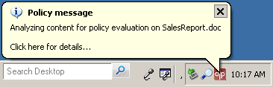
Figure 1: User notification for document scanning of SalesReport.doc

Notification occurs using the Obligation Manager, so notifications behave the same as do notify obligations. Notifications differ from Notify obligations since they are not controlled explicitly by the written policy. That is, they cannot be enabled or disabled as Notify obligations can. In addition, notification will only occur when a file is going to be searched for content with respect to a set of policies that apply to that resource. If a content search for that file has already occurred and the result is cached, then there will not be a notification.

The probability that a policy decision is cached is highly determined by the user’s activity. For example, it is very likely that two consecutive copies (COPY action) by a user for a single file result in the first action causing a notification and the second issuing no notification. If these same to events occur a day or week apart it is unlikely that the policy decision exists in the cache.

Supported File Types & Text Extraction for Document Object Model
Content search requires text extraction from a variety of file types (i.e. doc, pdf, etc.). If a policy requires that the contents of a file be searched the Content Analysis feature will attempt to extract text of the file with respect to the type of file and its document object model. When this cannot occur the scanning method will revert to raw. The raw scanning method will extract strings of printable characters while scanning the file in a raw (non-interpretive) mode.

The selection of text extraction method is based on the document object model which is indicated by file extension. Extraction will occur based on the below supported object model types.

Supported File Types
Native Document Object Model
Microsoft Office 2003/2007
Adobe PDF
Autodesk DWG
ZIP
HTML (.htm/.html)
XML and XML Schema (.xml and .xsd)
Rich Text Format (.rtf)
Plain Text (.txt)

Raw / Plain Text
All other file types (i.e. Extensible HTML (.xhtml))

The method used for native document object modules is the Microsoft IFilter. If an IFilter for an additional file type (DOM) is installed, then Content Analysis feature will use it. For example, if an IFilter for DWG is installed after the installation of a NextLabs product using Content Analysis, then scanning of DWG files will be scanned for content.

Default Content Enforcement Match Criteria
There are several default match criteria options. They are outline below and a summary is provided. Examples are not complete with respect to possible valid values. These are demonstrative only.

Credit Card Number
Basic credit card types and lengths are specified in the PRD under validation (1.1.5). Valid delimiters for 2-digit and 4-digit segments are space, hyphen, or empty (none).

To accept account numbers the structure of the account number must match 1234Z5678Z90Z12Z3456 where Z is {empty,hyphen,space}. This covers major card account numbers for Visa, MasterCard, Discover, etc.

Validation
Validation is performed using “mod 10” (Luhn) algorithm.

Examples:
- 4111-1111-1111-1111 (valid)
- 5111111111111118 (valid)
- 6111 1111 1111 1116 (valid)
- 1234-5678-8765-4321 (invalid)

Reaction
Redaction will omit striking of non-numeric hyphen and space only.

Currency Values
Values of major currency units in a variety of formats. For example, $9.99, $10,000 and $.99 are valid currency matches. Currency units are limited to the following: US $, EU €, UK £, JP ¥.

Examples:
- ¥100 (valid)
- €7.000,87 (valid)
- $X.99 (invalid)
- 700 billion (invalid)
- 100USD (invalid)

Summary: Required currency unit (i.e. $), followed by a space and string of digits which composes a valid value (i.e. there may not be two “.” in a U.S. dollar denominated value).

Phone Number
Domestic and Canadian phone number. Domestic number may not include a three digit area code. Delimiters may include dot, hyphen, left or right parenthesis, or space.

Examples:
- (650)555-6789 (valid)
- 650.555.6789 (valid)
- 555-6789 (valid)
- 000-6789 (invalid)

Reaction
Redaction will omit striking of numeric delimiters such as hyphen, parenthesis, dot, and space.

Social Security Number
Account number for Social Security Administration. In the format of XXX-XX-XXXX with optional delimiters of hyphen or space.

Validation
Social Security numbers are structured by region, so account numbers that do not match a known region are invalid.

Examples:
- 567-54-9872 (valid)
- 899-00-8238 (invalid)

Reaction
Redaction will omit striking of numeric delimiters such as hyphen and space.

Internet Protocol (IP) v4 Address
Numeric IP address such as the 4-byte base-10 address 192.168.1.1

Validation
IP address validation is required since not all [1,3] digit numeric strings are valid. Only numeric values of [0,255] are permitted.

Examples:
- 10.10.10.1 (valid)
- 10.100.10.200 (valid)
- 10.20.298.7 (invalid)

Email Address
Email address defined by RFC 4952.

Examples:
- helpdesk@nextlabs.com
- joe_the_plumber@heartland.america.com

Date of Birth (DOB)
Date of birth is calendar date in several common formats. Three letter month abbreviations are always equivalent to full month name. For example, “Sep” is equivalent to “September”.

Examples:
- 02/03/1990 (valid)
- Feb 3rd, 1990 (valid)
- February 3, 1990 (valid)
- 30th Jan 1990 (valid)
- 1st Jan 1990 (valid)

Mailing Address (State and ZIP)
Mailing address is an well structured, but highly variable, piece of personal information. For this attribute it is assumed that all addresses are terminated by a State and ZIP code with an optional mail stop. The presents of a state abbreviation and ZIP with optional stop is interpreted as an address match.

Examples:
- CA 94403-0001
- NY 21013

Validation
A state and zip will be match only when the state is valid. For example, the two letters XY followed by a valid ZIP with optional stop is not a valid Address match.

Keyword(s)
A set of Keywords may be specified in a freeform text box when this attribute is selected. Keywords are a set of words or phrase which represent literal (exact) matches.

A string which is quoted is treated as a phrase. This may consist of one or more words such as “This is a phrase”. When a phrase is specified the entire string, without quotes, must match for there to be a content match. An unquoted set of words are treated as literals only for those words. That is without quotes each word becomes a separate match criteria.

Examples:
- “This is a phrase” (literal phrase)
- This is not a phrase (literal set of words)
- foo bar (literal set of words)
- “foo bar” foobar (literal phrase and literal word)

Since there may be a set of phrases and/or keywords the match count is sum of the individual objects match counts. That is, a phrase is an object and a word is an object. Each may match content of a file, email subject/body, or clipboard and the sum of those matches is the match count for the attribute.

For example, if the text box contained [“foo bar” foobar] there are two objects: (1) “foo bar” and “foobar”. Each object may exist in content any number of times and their sum is the total match count.

Total Match Count = Match Count(Object 1) + Match Count(Object 2) + …

The below summarizes the above options.

Attribute | Match Description | Validation
Credit Card Number | Credit Card Number | Yes
Currency Value | Currency values | N/A
Phone Number | Domestic or international phone number with or without area code. | No
Social Security Number | SSN Number | Yes
Internet Protocol (IP) v4 Address | IPv4 Address | No
Email Address | Email address | No
Date of Birth (DOB) | Calendar date | No
Mailing Address (State and ZIP) | Mailing address | No
Keyword(s) | Set of phrases and/or words | N/A
Table 1: Summary of Default Match Criteria Options

Document Resource
The above match criteria must be specified as a document resource attribute. This is similar to file size, modified time, and the like. Attribute configuration changes to the Policy Server must be made to add these attributes. These changes are defined in Appendix A.

When all of the match criterion has been met the content analysis will complete. For example, if there are 1000 credit card numbers in a document and a document resource specifies a match criterion of 10, the document analysis will complete after 10 credit card numbers have been matched. This is also true for multiple resource attributes. If all of them satisfy the match criteria the scanning of a document is complete.

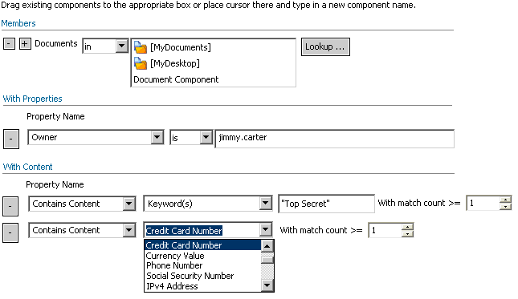
Figure 2: Document Resource Attributes

Content Analysis attributes do not work with the Preview option in Policy Studio.

Email Resource
Content Analysis can also be used on email content. In this case, the match criteria will run against the email subject, body, and attachment. To run content analysis against the email subject and/or body, the document resource is defined as shown below. The resource represents content of a document resource and an attribute which indicates the type of email content it is. There are two types of email contents: (1) subject and (2) body. Figure 3 shows Content Type attribute with a value of Email Body. If the attribute is not present to select one of the preceding two content types, then the resource is considered as an attachment.

If a document resource is present for the email content such as subject and/or body and the content search results in a match, then the Email action is denied for a Deny policy. The interpretation of this is that the content represented by the document resource may not be emailed as part of the body or subject.

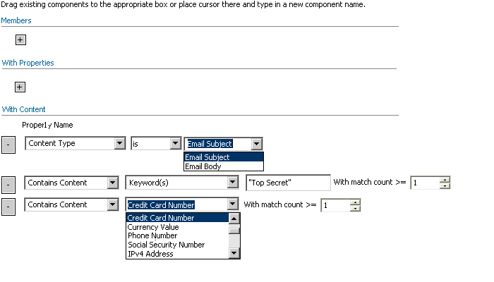
Figure 3: Defining an Email Body resource

Figure 3 shows an empty email body definition. The Members (names) is always empty and there should be a set of content analysis attributes defined (see the Document Resource section).

Email Content within Communication Policy
The content of an email is represented by the document resource box previously used only for Attachment. Figure 3.1 shows how the content of an email and an attachment storage location can be used with the “content” resources to describe a policy which restricts emailing any containing confidential information. The Document Resource panel will be moved between Recipient and Channel in the Communication Policy.

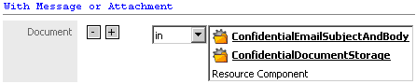
Figure 3.1: Email Content – Document Resources

Content analysis can be performed on attachment, email subject and body by defining an empty document resource with Content Analysis attributes.

Table 2 shows the types of content which can be selected using the Content Type attribute. The benefit of this attribute is that its absence can be used, along with an empty name, to describe content which may not be sent in an Email. That is, a single document resource may represent a set of match criteria that is applied to both the email content (body and subject) and the any attached files.

Content Type | Content Description
Email Subject | Content is the subject of the Email
Email Body | Content is the body of the Email
Table 2: Summary of Document Resource Attributes for Email

Clipboard Content
Content Analysis may be used to control content allowed to enter the clipboard. The Copy Content action is used and the clipboard is the destination of the policy. To specify this, you can define the document resource as shown below in Figure 4 as the destination document resource of a Deny Copy Content policy.

Deny of Copy Content for a clipboard resource will occur if the Copy Content action is denied based on the document resource attributes vs. the content being placed in the clipboard. The interpretation of this is that the content represented by the document resource may not be placed in the clipboard. The Members (name) must always be empty.

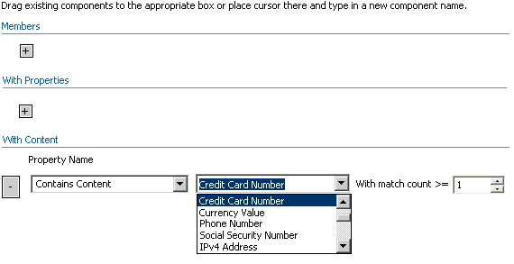
Figure 4: Defining the Clipboard content for destination resource

Figure 4 shows an empty clipboard content definition. The Members (names) is always empty and there should be a set of content analysis attributes defined (see the Document Resource section).

Pre-Built Components
There are several default Content Analysis attributes and those attributes will be combined to form three default document components which represent general confidential data concepts. For all of the attributes below the match count is specified as one.

- Contains PCI Data
  - Credit Card Number

- Contains PII Data
  - Social Security Number
  - Credit Card Number
  - Phone Number
  - Email Address
  - IPv4 Address

- Contains PHI Data
  - Social Security Number
  - Phone Number
  - Date of Birth (DOB)
  - Email Address
  - IPv4 Address

Content Analysis document attributes are logical AND when combined within a single document resource, so it is necessary to define a document component for each Content Analysis attribute and crease a composite document resource such as Contains PCI Data, Contains PII Data, and Contains PHI Data. The default component names and meaning are provided in the below table.

Component Name | Content Analysis Attribute
ContainsCreditCardNumber | Credit Card Number
ContainsCurrencyValue | Currency Value
ContainsPhoneNumber | Phone Number
ContainsSSN | Social Security Number
ContainsIPAddress | IPv4 Address
ContainsEmailAddress | Email Address
ContainsDOB | Date of Birth (DOB)
ContainsMailingAddress | Mailing Address
Default Components and their Content Analysis Attributes

Redaction Obligation
The redaction obligation specifies content which should be redacted in the clipboard, email subject, or email body content. All the of the default match criteria attributes defined in previous sections are available as redaction obligations. The obligation structure is described in the Appendix B.

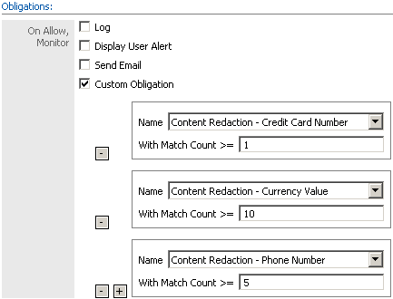
Figure 5.1: Content Redaction Obligations

The above are examples obligations for redaction of clipboard and email content. When possible, content that has matched will be redacted to remove matched content. This includes clipboard, email subject, or email body content that contains the match. File content is never modified. Only the text of the clipboard, email subject, or email body is changed. Use of any of the Content Analysis obligations on any action other than Email or Copy Content has no effect.

All redacted content is replaced with the character X except for Credit Card Number delimiters. For example, the source below is redacted per a match to a credit card number.

“The card number is 7656-4572-3467-2345. Please charge it.”
“The card number is XXXX-XXXX-XXXX-XXXX. Please charge it!”

Content of this type may be modified either in the clipboard or an email body before send of message. Redaction of credit card numbers does not include hyphens “-“ or spaces “ “. This redaction policy applies only to the default option of Credit Card Number and Social Security Number. This is intended to indicate the type of data that has been modified. It should be clear that a credit card number was removed.

Reporting
Reporter should capture if content analysis or the redaction obligation has been executed. In addition to the currently reported information, reporter should report the following information:
- Match Criteria (Type & Description)
- These are determined by the document resource attributes.
- Content Type (Email Subject/Body or Clipboard)
- Document resources that contain Email Subject/Body content type attribute must be specified as Email Subject/Body in reporting.
- Clipboard content is specified as such in the reporter. The destination indicates the clipboard.
- Redaction obligation is reported using the Policy Assistant Logging interface available in the CE SDK.

Stories – Document Resource Matching
Content match criteria is specified using document resource attributes. Because of this representation any action which uses document resource attributes may specify Content Analysis match criteria. However, the most meaningful actions are those which duplicate data and/or permit its transfer outside of the desktop (i.e. via email, copy to removable device, etc.).

We address the following use-cases in this spec:
- Use Case 1: Accessing/Using Documents
- Use Case 2: Sending email/attachments
- Content Redaction: Clipboard/Email body

The file being accessed is searched for content matching the any specified policies. When a match is found the obligation of the matched policies are performed. In the case of a deny policy the action is denied.

The following use-cases are non-goals:
- Use Case 3: Accessing Portal Resources

In some cases, content analysis using keywords and regular expression may result in finding content that does not match the original intent of the data rule. In this case, it's called a false positive match. In order to address this, a monitor policy can be used to trigger a Tagging Obligation and allow the user to select the appropriate class of data. Deny policy can apply to the tag property rather than the content property.

Accessing/Using Documents (PRD Use Case 1)

For example, a user attempts to copy a file to removable media. A policy matching this action and document resource (i.e. source path) results in the source document being analyzed for content specified in the attribute. The action is allowed or denied based on the match criteria described in the document resource.

Summary: Action is Copy / Embed File. Source document resource specifies content match criteria.

Sending Email and Attachments (PRD Use Case 2)

For example, a user attaches a document to an email message which matches a policy. The document being attached is analyzed per the document resource attribute for content analysis.

Summary: Action is EMail. Document resource specifies content match criteria.

Stories – Content Redaction
Content redaction is performed for clipboard content and email body. These two cases are determined only by an obligation. The obligation may be used with any monitor policy that may affect the clipboard and/or email. The actions supported Copy Content and Email. Their behavior is described below.

Clipboard
Content is redacted when it is placed into the clipboard. The clipboard content is modified when an allow occurs, there is matched content. The use of a deny policy with the redaction obligation has no effect.

Email Subject/Body
When an email is sent, the body of that email is searched when a policy specifies the redaction obligation. The email body is modified when an allow occurs, there is matched content.

When the redact obligation is selected the number of matches only specifies whether the redaction should occur. It does not indicate how many matches will be redacted. For example, a document containing 100 credit card numbers will result in 100 redactions if the redact obligation specifies less than or equal to 100 matches. This is intended to avoid partial redaction.

Content redaction obligations need not be combined with document resource attributes for content analysis. That is, there is no requirement that a policy describe both deny/monitor and redaction of content. The two Content Analysis features are independent.

Clipboard Copy-Paste (PRD Use Case 2)
For example, a user attempts to copy document content into the clipboard using the copy-paste action. A policy for this action matches due to (1) a monitor policy or (2) deny policy due to the content of the copied content. The redaction obligation results in some content in the copy-paste being redacted. Content in the clipboard has been redacted.

Summary: Action is Copy Content. Document resource specifies content match criteria.

Sending Email (PRD Use Case 2)
For example, a user attempts to send an email. A policy for this action matches due to (1) a monitor policy or (2) deny policy due to the content of the email body content. The redaction obligation results in some content in the email body being redacted. Content in the email body has been redacted before the email is sent.

Summary: Action is EMail. Document resource specifies content match criteria and specifies that the document is the body of an email.

Installation Specifications

Initial Install
Installation requirements are those of the Windows Desktop Enforcer (WDE) and Outlook Enforcer (OE). There is no change that Content Analysis makes to their requirements.

Upgrade Specifications
This is the first version of the Content Analysis. There are no upgrade requirements

Version Compatibility
Policy Server: EDLP 4.0
Policy Controller and SDK: EDLP 4.0
Policy Studio: EDLP 4.0

Performance, Scalability, Reliability

Performance
Performance findings for text extraction as a function of document [random] word count. Both IFilter and Raw scanning scale well and differences are largely visible due to document object model. For example, Microsoft Doc format forms worst compared to plain text, RTF, and Microsoft DocX formats.

Figure 5.1: IFilter Performance as a Function of [Random] Word Count

With the inclusion of PDF the performance differential is large. Searching PDF is at least an order of magnitude slower than all other formats.
Figure 5.1: IFilter Performance as a Function of [Random] Word Count w/PDF

Figure 5.3: Raw Performance as a Function of [Random] Word Count

Error Handling

Document Resource Attributes
It is possible that a file or class of files cannot be scanned or that the scanning of those files in some way produces a fault in the Content Analysis content searcher. In any case of failure, the a policy must not evaluate to cause a deny on false criteria. For example, if the scanning of a particular PDF document causes the Content Analysis service to crash, the evaluation for that file must not evaluate to false as a result of the crash.

If a fault occurs in the Content Analysis process it will restart immediately. This will prevent a fault from disabling the Content Analysis feature.

If the evaluation of a document exceeds the timeout specified by the PEP in it’s policy query via CE SDK, then the CE SDK timeout mechanism will trigger and result in a timeout result. This case is commonly handled as an allow case and it is the decision for the PEP to make.

Content Redaction
When redaction cannot be completed for any reason the Enforcer should not deny the action for which the redaction was triggered. For example, if the body of an email cannot be redacted the email should not be denied. Likewise, the clipboard should not prevent copy when redaction fails.

System Requirements
There are no specific system requires other than those already defined the EDLP Policy Controller 4.0.

Non-Goals

Content-base Policy Enforcement
- Watermark (1.1.7)
- Structure Data Fingerprints (1.1.8)
- Response Time (1.6)
See Policy Assistant (PA) (1.7). A PA is required for this option. A Display notification obligation can be used to inform the user that a content scan is in progress. Only basic notification is issued at the beginning of a document search.
- Policy Assistant (1.7)
- Content Aware Portal Component (P2) p.8

Frequently Asked Questions (FAQ)

- Why are document resource attributes and obligations not the same? Why can the match counts be different?

The match counts may be difference because the features of search and redaction are independent. That is, a policy may specify match criteria for document resources that do not match a redaction obligation of that same policy. This provides some flexibility for the policy author if redaction criteria must be stricter than search policy.

Appendix A – Document Resource Attributes
The Content Analysis document resource attribute definition is defined as the template below. The type is REGEX and the value is the match expression used for content search. Credit Card Number is REGEX type and the match expression is 16 consecutive digits, \d{16}.

<ResourceAttribute>
<DisplayName>Credit Card Number</DisplayName>
<Name>NLCA_CCN</Name>
<Type>REGEX</Type>
<Value>\d{16}</Value>
</ResourceAttribute>

Appendix B - Obligations
<Obligation>
<DisplayName>Content Redaction - Credit Card</DisplayName>
<RunAt>PEP</RunAt>
<Name>NLCA_REDACT</Name>
<Arguments>
<Argument usereditable="true">
<Name>With Match Count >=</Name>
</Argument>
<Argument usereditable="false" hidden="false"> <!-- Regular expression type -->
<Name>RegexType</Name>
<Value>CCN</Value>
</Argument>
<Argument hidden="true"> <!-- Regular expression -->
<Name>Regex</Name>
<Value>\d{16}</Value>
</Argument>
</Arguments>
</Obligation>

There must be a deny policy for there to be a deny in this case.
When the file name exceeds a specified length (about 32) characters it will the center of the name will be replaced with “…” such that the resulting file name is about 32 characters.
The EDLP/CE Policy Controller uses policy decision caching to improve decision [elapsed] time performance. The policy decision cache is persistent meaning that a stop and start of the Policy Controller retains the cache.
Raw file scanning is similar to the UNIX strings utility.
When Adobe Acrobat or Acrobat Reader 7.0.5 or later is installed.
DWG support is TBD based on licensing discussion with 3rd party vendor. If a DWG IFilter is installed after NextLabs Enforcer scanning of DWG files will begin to work.
Well known document types contained in a ZIP file will also be scanned for match criteria. This does not include document types which require Raw extraction.
Valid account numbers are provided by Microsoft as test numbers from Visa, MasterCard, and Discover. Microsoft site is http://support.microsoft.com/kb/258255.
Validation policy supplied by U.S. Social Security Administration at www.ssa.org in FAQ Answer ID 425.
Multiple document resource attributes are conditional as logical AND. That is, all attributes must be true for the evaluation result to be true. This is a restatement of current policy evaluation behavior.
Structure of attributes is TBD.
It is often the case that a searched document will not satisfy all of the match criteria, so this optimization applies only to complete matches.
A document resource representing email subject and/or body must never specify a member (name). It is not meaningful to the user and/or policy administrator.
The Content Type attribute will be an enumerated attribute that may take the value only of Email Subject or Email Body as outlined in Table 2.
The attribute Content Type will be an enumerated attribute with only two options. The screenshots show standard “string” attributes and will be updated when possible.
The name is never meaningful for the user and/or policy administrator.

