

Compliant Enterprise Enforcer for
SendTo from application
Version0.1

High-Level Design Document
November 2008

Overview
Introduction
Because user can SendTo file or folder by right click file or folder so that the sensitive data were mailed under unconsciousness condition, we need enforce user’s SendTo action.
Purpose
This document describes how to do policy to user right-click and SendTo mail.

Terms
Policy Enforcer – A policy enforcer is a product shipped by Nextlabs to provide policy enforcement for particular system, application, or protocol. It includes a Policy Controller and Policy Adapter. Policy Enforcers for Windows Desktop, Windows Server, SharePoint Server, Linux Server, and MS Outlook application are available from NextLabs.
Policy Adapter – A policy adapter specifically created to integrate policy enforcement for a particular application. It detects application events, interacts with the Policy Controller, and blocks or automates actions.
Policy Controller – Provides common services and obligations to native policy adapters that integrate at the system, protocol, or application level. At its core, a Policy Engine enables real-time, distributed policy evaluation across control points.

Reference
《Live_Meeting_2007_Getting_Started_Guide_Service.doc》
《PRD - Office Communicator Enforcer.doc》

System overview

Service

Explorer

Word

…….

Service Client API
Outlook

Service Client API
。。。。。。
  - System Overview
Note：
Applications write sensitive data into Service by ServiceClientAPI, and then the other applications concern the sensitive data get the data from Service by ServiceClientAPI

Detail description
- Component
  - Explorer: Windows shell process
  - Explorer Plug-In: it’s a standard COM, it implement the IShellExtInit interface in order to inject hook into explorer to catch SendTo Event
  - Word: windows office word 2003
  - Word Plug-in: it’s a standard COM, it implement the IDTExtensibility2 interface for set hook into word2003 to catch SendTo event
  - Outlook: Microsoft outlook process
  - Outlook Plug-In
  - Agent: Service access API client. All of user access Service by include it and use it’s API.
  - Service: Windows service, It responsibility for get the source file into memory and responsibility for set file to outlook plugin for use

- Sequence diagram
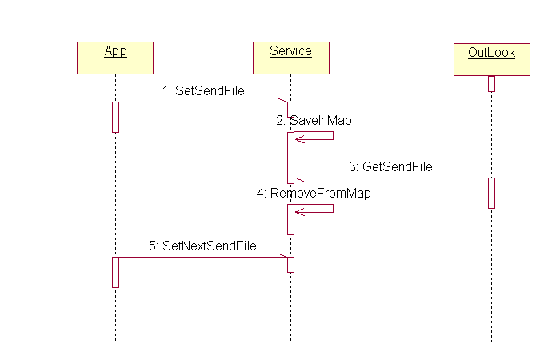
Once app catch sendmail event, app should setsendfile to service,service save the files into map,
- App activity diagram
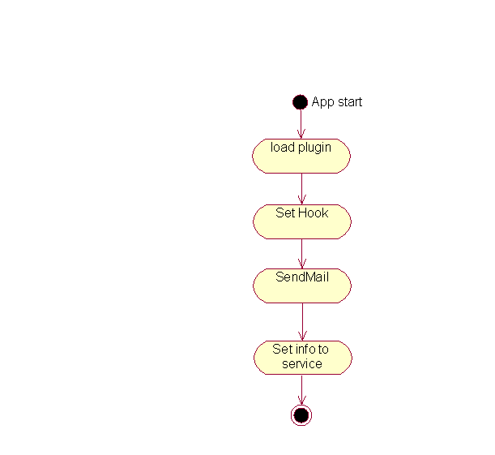

- Service communicate protocol
  - Packet header
Name | Length | Note | Type | default
Packet Len | 4Byte | All Packet length | unsigned long
Msg Type | 2Byte | Packet Type | unsigned short | Start from 0x100
Verify code | 1Byte |  | ..
Parameter number | 1Byte | This msg’s parameter’s number | Unsigned char

  - Packet Body
Name | Type | Length | Note
Parameter Type | String & binary | 2 | If string ,the parameters value end by \0  The length is strlen+1
Parameter Len | Unsigned long | 4 | Just the value’s length not include type and len
Parameter value

  - SetFilesMsg type is 0x101
Parameter number is 3
The first one is:Files
Second is Len

