**EM for Azure SQL/File Web App Guide**

**Signup**

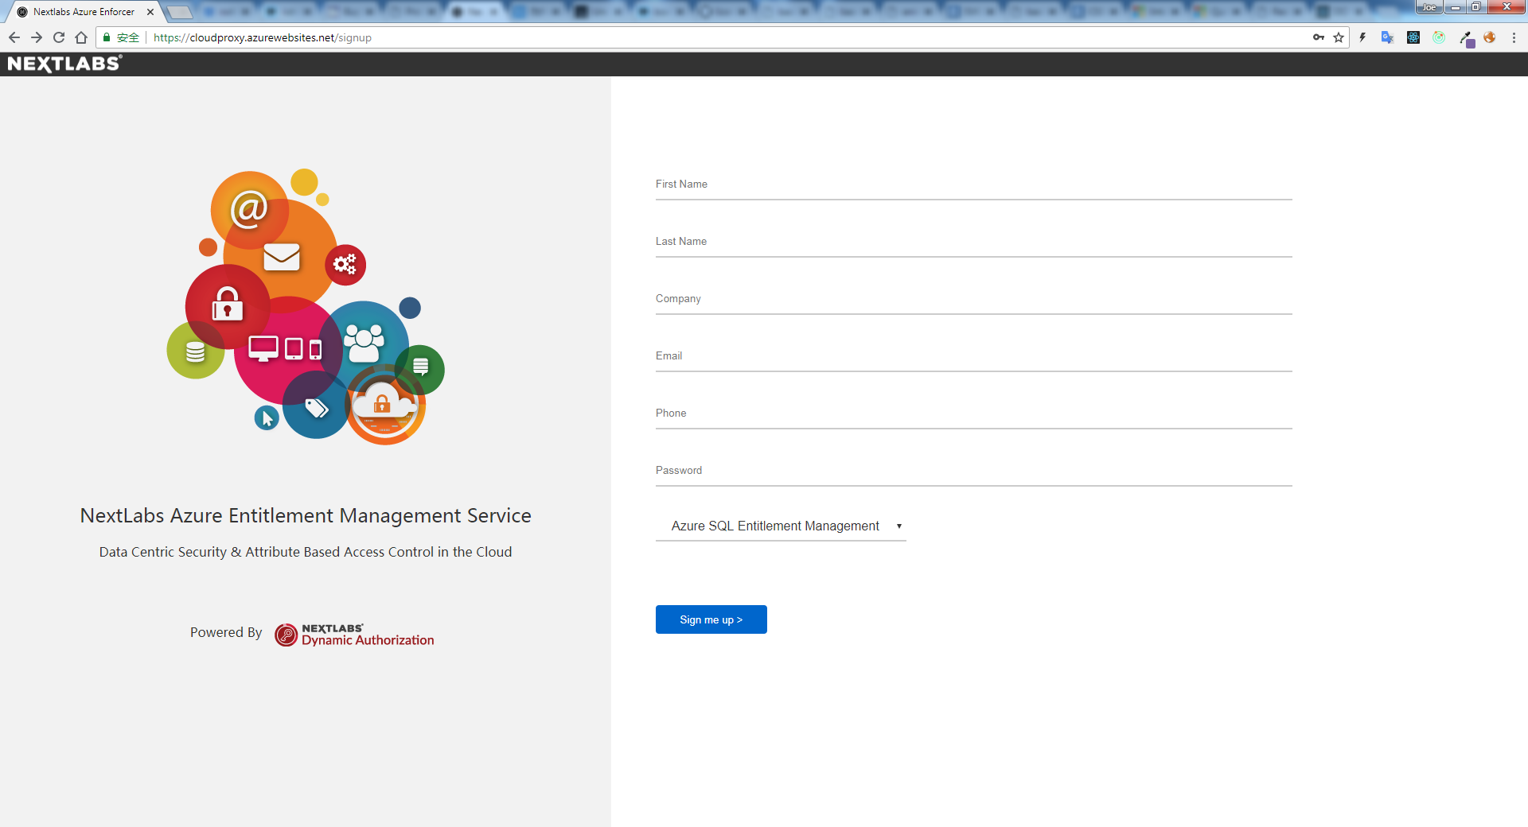

1. open [signup](https://cloudproxy.azurewebsites.net/signup) page in browser
2. fill the informations
3. choose the product

**Note**:

EM for Azure SQL/File can be signed up with the same email, but the same type product can only be signed up once with the same email.

1. After signup completion, we’ll send an email with login url.(**It has not implemented yet, the web will redirect the user to the login page in about 5s for the time being**)

**Login**

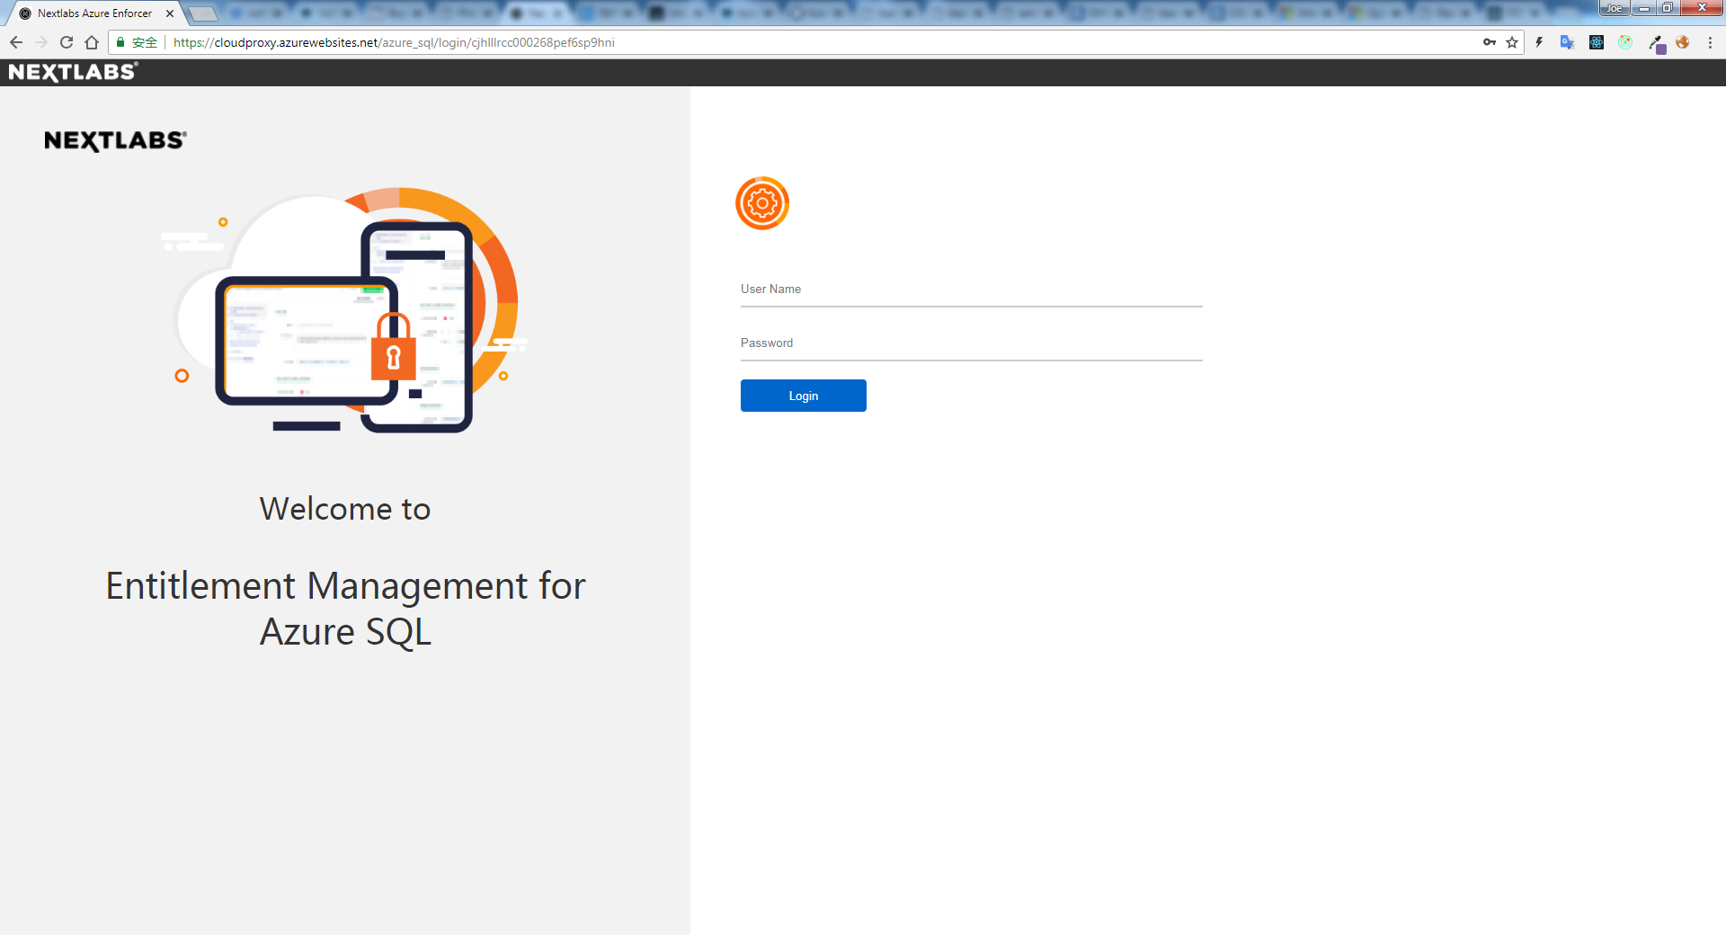

1. confirm that the product are the one you signed up before
2. login in the console with email & password

**Config Proxy**

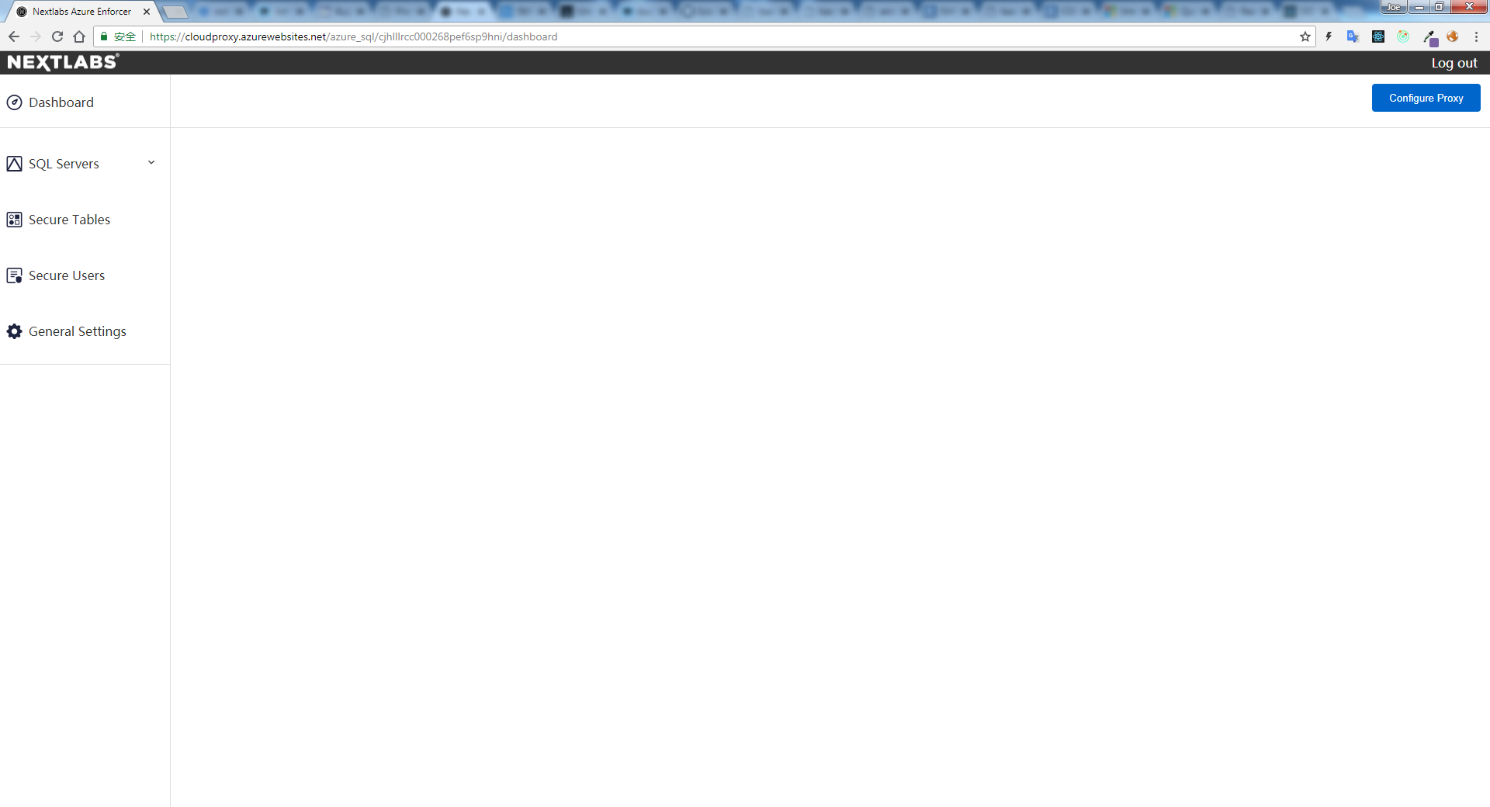

1. After login, you’ll be directed to the dashboard.
2. Click the **Configure Proxy** on the topright, fill the sql server with port(if not specified, please use 1433) to be proxied in the blank.
3. Click **Deploy**. Proxy server will be set up for the server.
4. After deployment, the proxy ip will be displayed in the popup.

**Connect to the server**

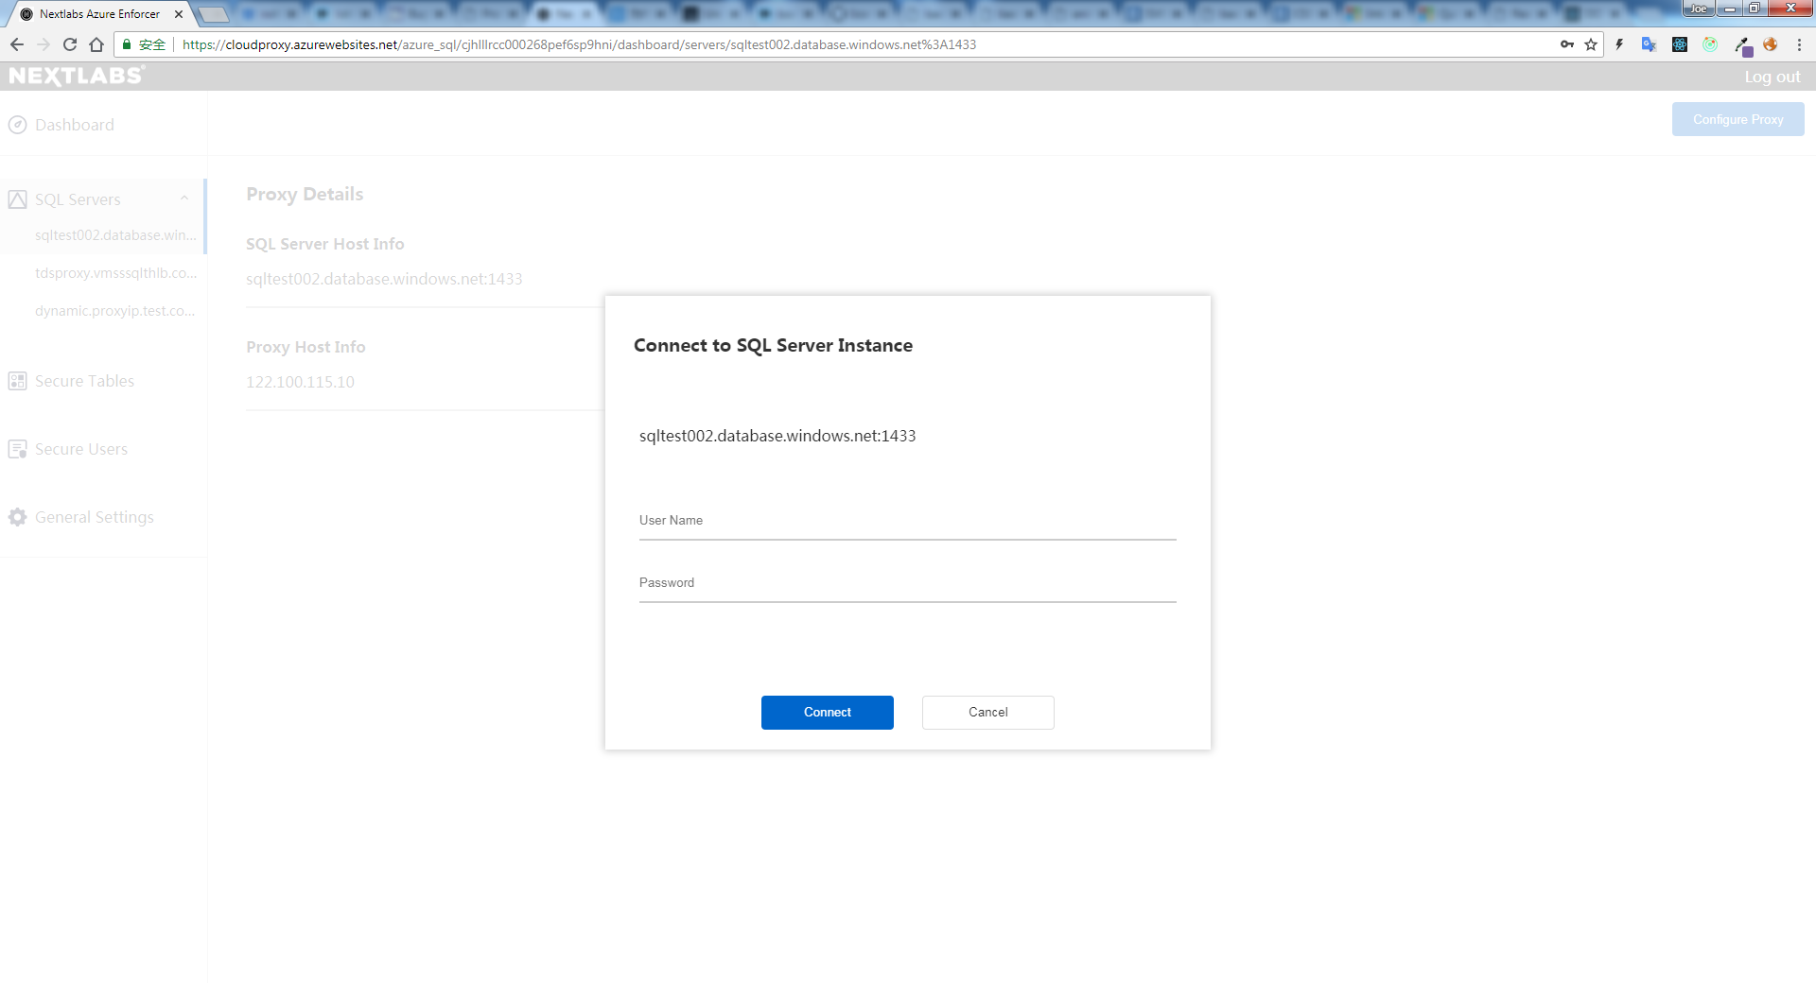

1. Navigate to the panel on the left-hand, unfold the SQL Server dropdown menu, and tab the server you configured before.
2. You’ll be asked to connect to the server using database admin account & password. The reasons are as follows:

* An table named ‘nxl_users’ will be created for holding Active Directory users informations
* A user named ‘nxluser’ will be created with only access to the table ‘nxl_users’ for user attributes & table information queries.

**Note:**

database admin account & password only stay in our server session memory, the data will be erased as long as you log out or the session expires.

**Import AD Users**

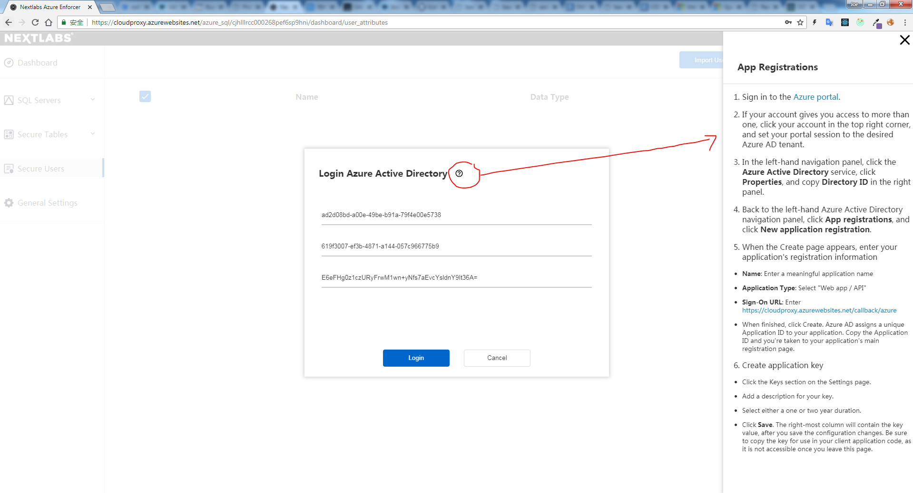

1. After connection, navigate to the panel on the left-hand, and click **Secure Users**.
2. You’ll be asked to fill the app id, app key & tenant id.
3. If you have no idea what it is, please click the help icon beside the title and refer to the tutorial on the right.
4. After completion, click **Login**. Our web app will direct you to the microsoft oauth login page.

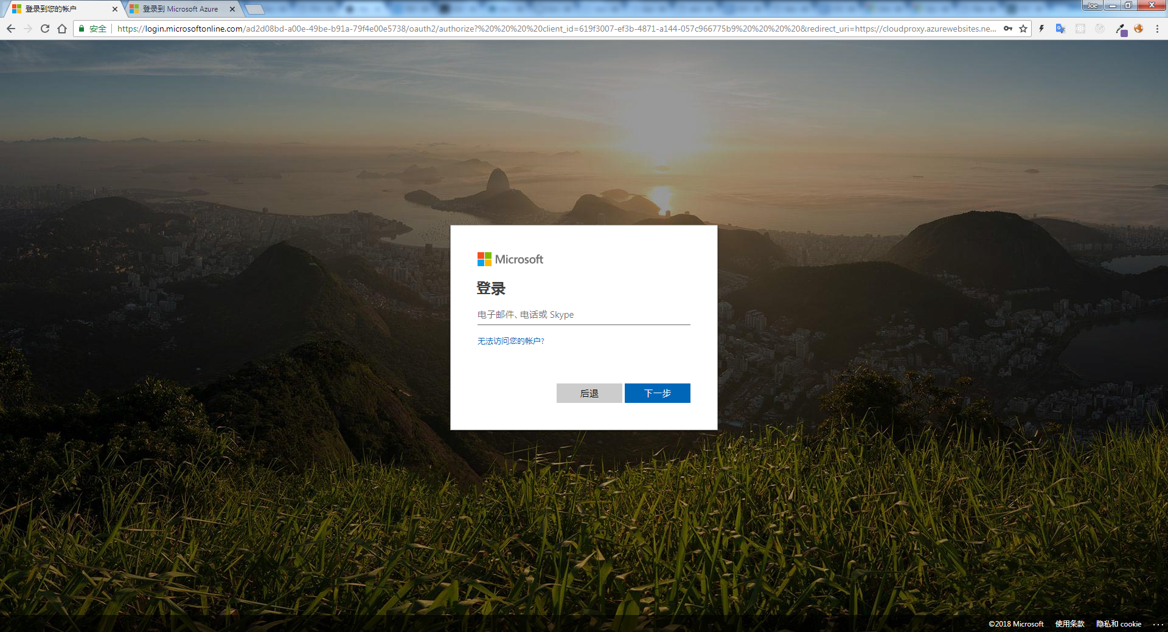

1. login in with an account that has the permission to access Active Directory user informations(graph api).
2. After completion, the microsoft will redirect you back to the web console.

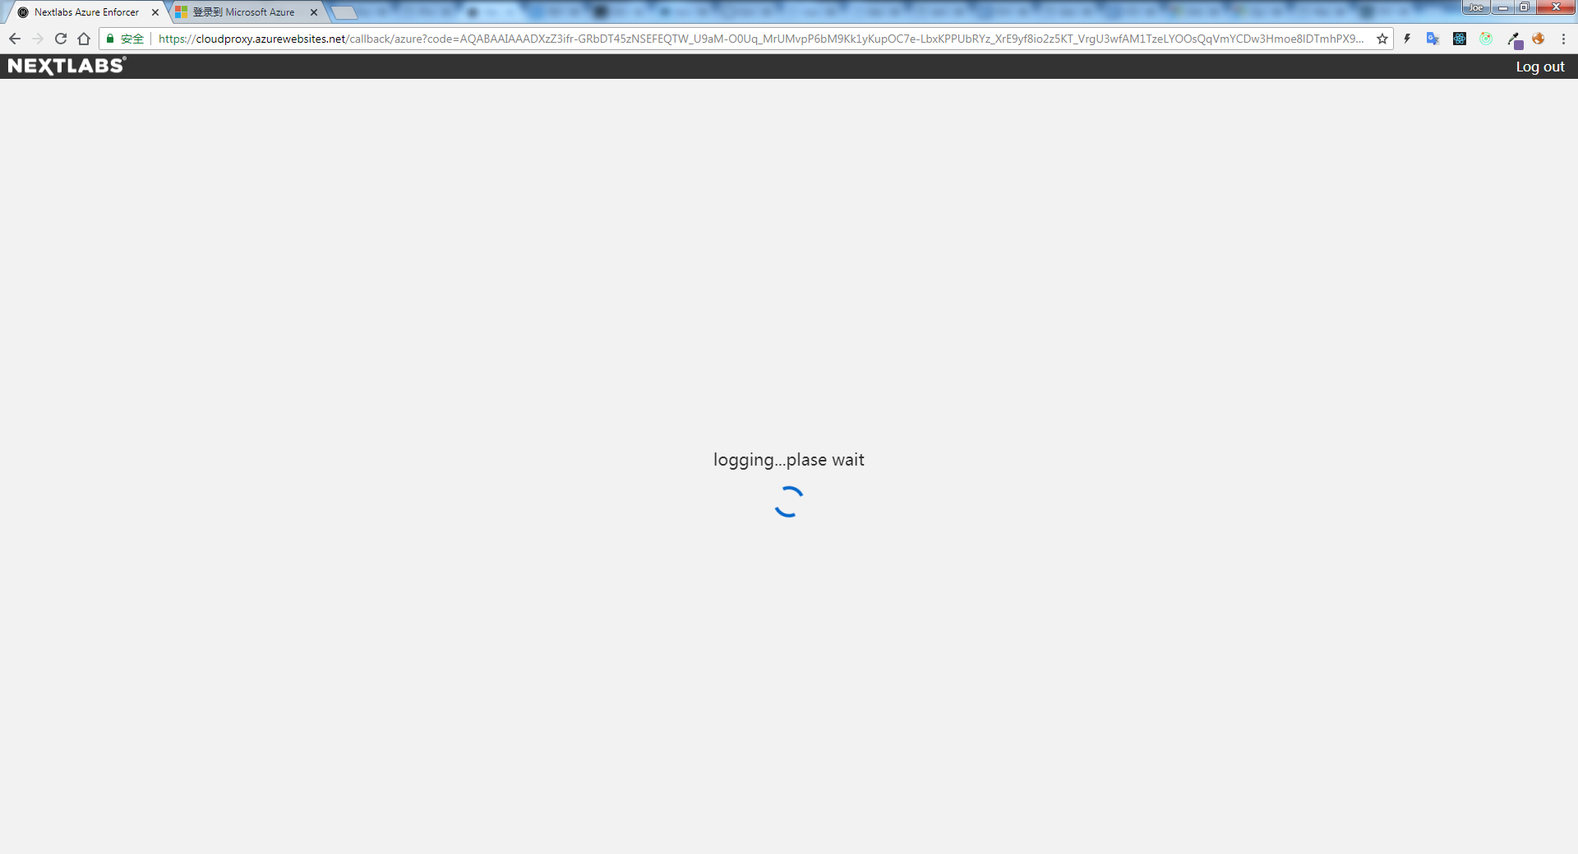

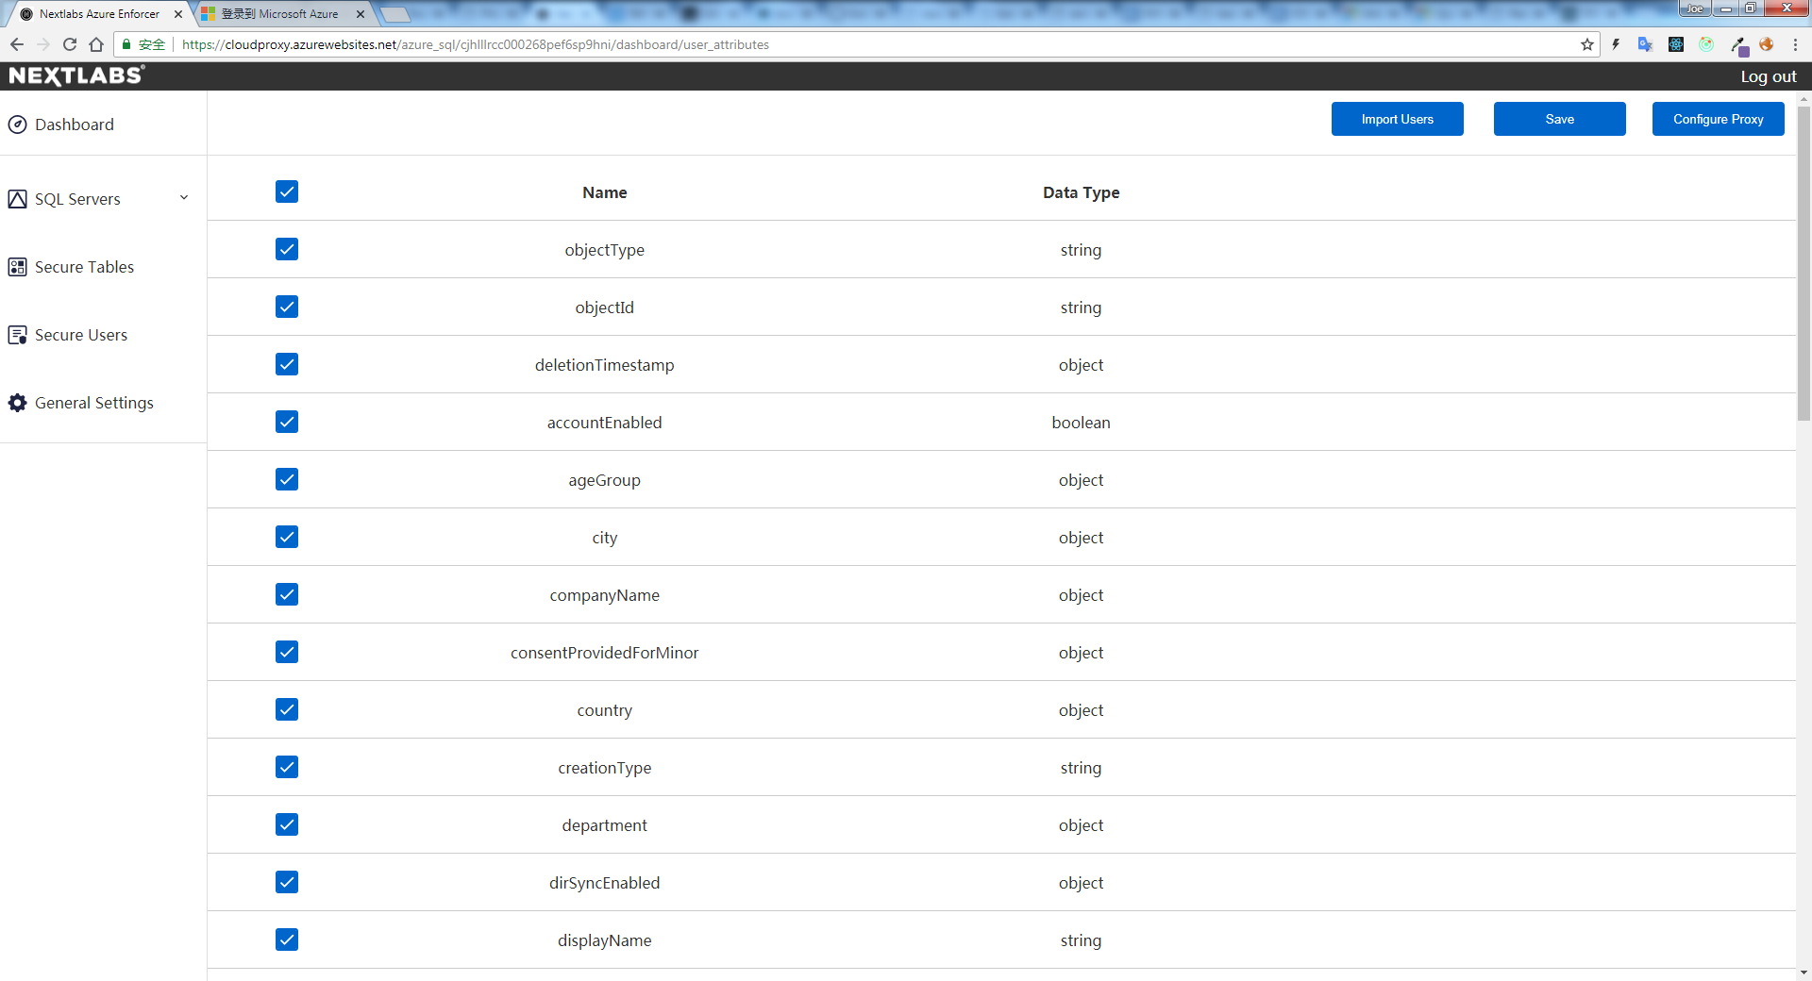

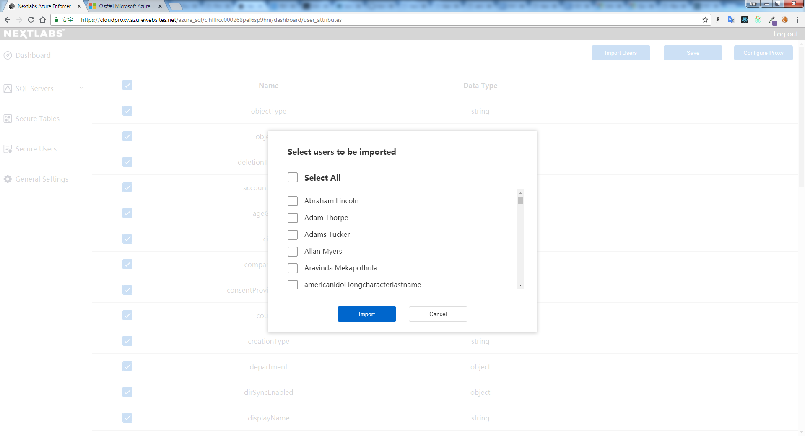

1. user attributes & users in active directory will be retrieved.
2. Click **Import Users** on the topright, a modal filled with users will pop up.
3. check the user you want to import & click **Import**.

**Note**:

SQL users registered in master database will be imported along with the ad users every time**.**

**Enforce User Attributes**

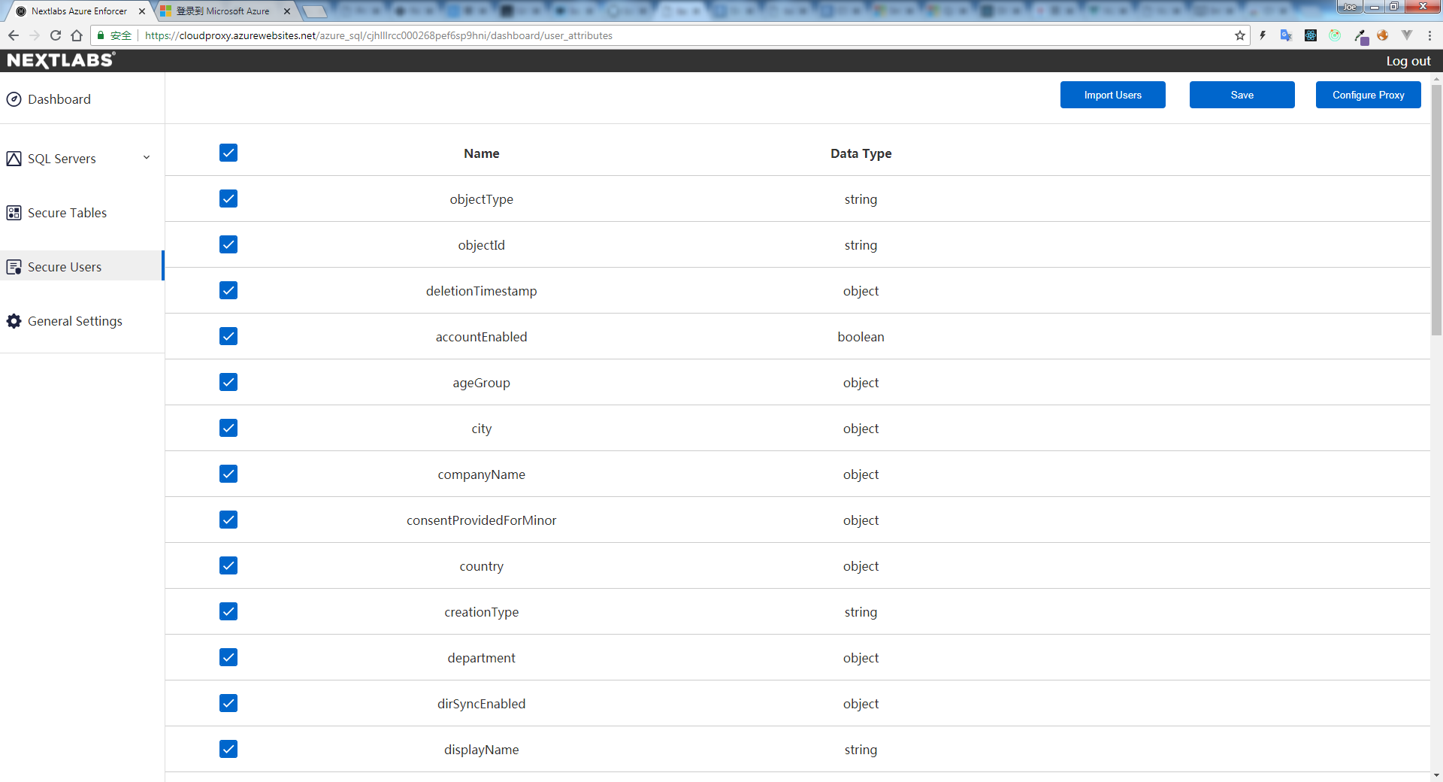

1. Check the user attributes in Secure Users, and click **Save** on the topright to save the change

**Note**:

Policy model export is not supported in user attributes because it is included in the policy model exported by the **Secure Tables** as an **obligation.**

**Enforce Secure Tables**

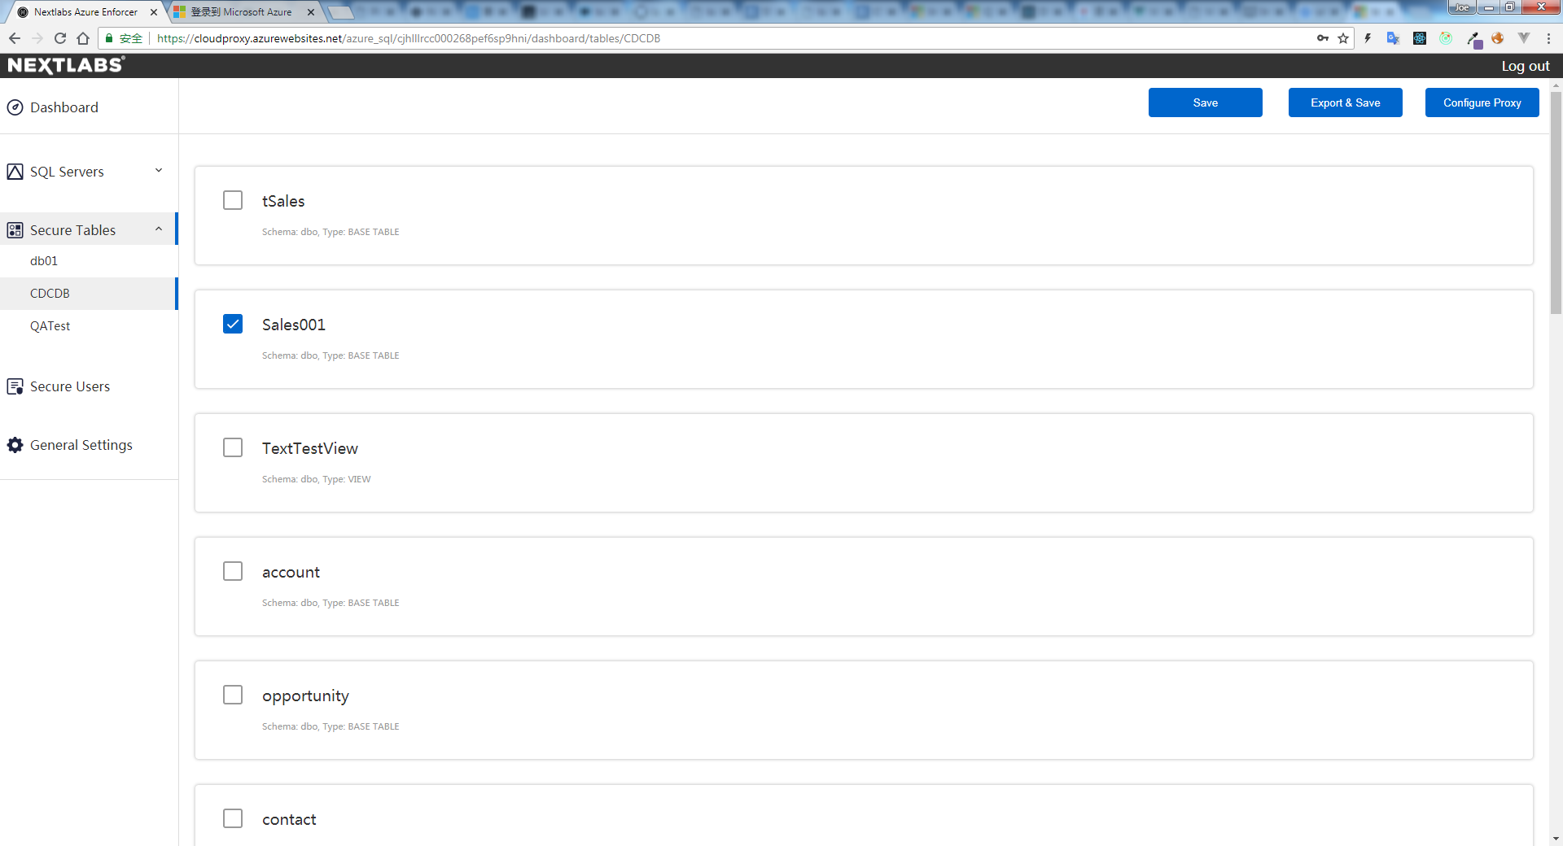

1. After enforcing user attributes, navigate to the panel on the left-hand, unfold the **Secure Tables** dropdown menu, all the databases of the server will be listed.
2. click the database you’d like to enforce, and all the tables of the database will be listed on the right-hand.
3. click the table you’d like to enforce, and click the **Export & Save** on the topright, the table enforcement will be saved to the backend and policy model will be exported including tables & user attributes.

**Note**:

By default, all fields of enforced tables excluding reference fields are exported in the policy model.

**General Settings**

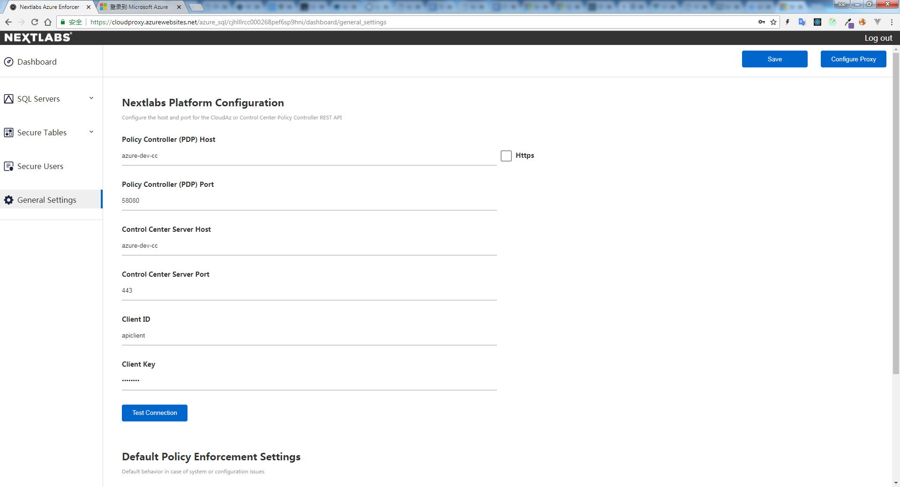

1. Navigate to the panel on the left-hand, click **General Settings**.
2. Fill the blanks with jpc & cc informations. Click **Test Connection** to test the accessibility of the remote server.
3. After filling the blanks, click **Save** on the topright.

**Logout**

1. All done, click the **Log out** on the topright to log out.
2. By default, session stays 30min in server.
3. If session expires, please logout and login again.