L6
# Step 1: Import sqlite3
import sqlite3
import pandas as pd

# Step 2: Connect to a SQLite database (it will create it in Colab environment)
conn = sqlite3.connect('example.db') # 'example.db' is the database file
cursor = conn.cursor()

# Step 3: Create a table
cursor.execute('''
CREATE TABLE IF NOT EXISTS students (
id INTEGER PRIMARY KEY,
name TEXT NOT NULL,
age INTEGER,
grade TEXT
)
''')

# Step 4: Insert some data
students_data = [
(1, 'Alice', 20, 'A'),
(2, 'Bob', 22, 'B'),
(3, 'Charlie', 21, 'A'),
(4, 'David', 23, 'C')
]

cursor.executemany('INSERT OR REPLACE INTO students VALUES (?, ?, ?, ?)', students_data)

# Commit changes
conn.commit()

# Step 5: Query the table
cursor.execute('SELECT * FROM students')
rows = cursor.fetchall()

# Display the results using pandas for better readability
df = pd.DataFrame(rows, columns=['ID', 'Name', 'Age', 'Grade'])
print("All students in the database:")
print(df)

# Step 6: Example: Filter students with grade 'A'
cursor.execute("SELECT * FROM students WHERE grade='A'")
grade_a_students = cursor.fetchall()
df_a = pd.DataFrame(grade_a_students, columns=['ID', 'Name', 'Age', 'Grade'])
print("\nStudents with Grade A:")
print(df_a)

# Step 7: Close the connection
conn.close()

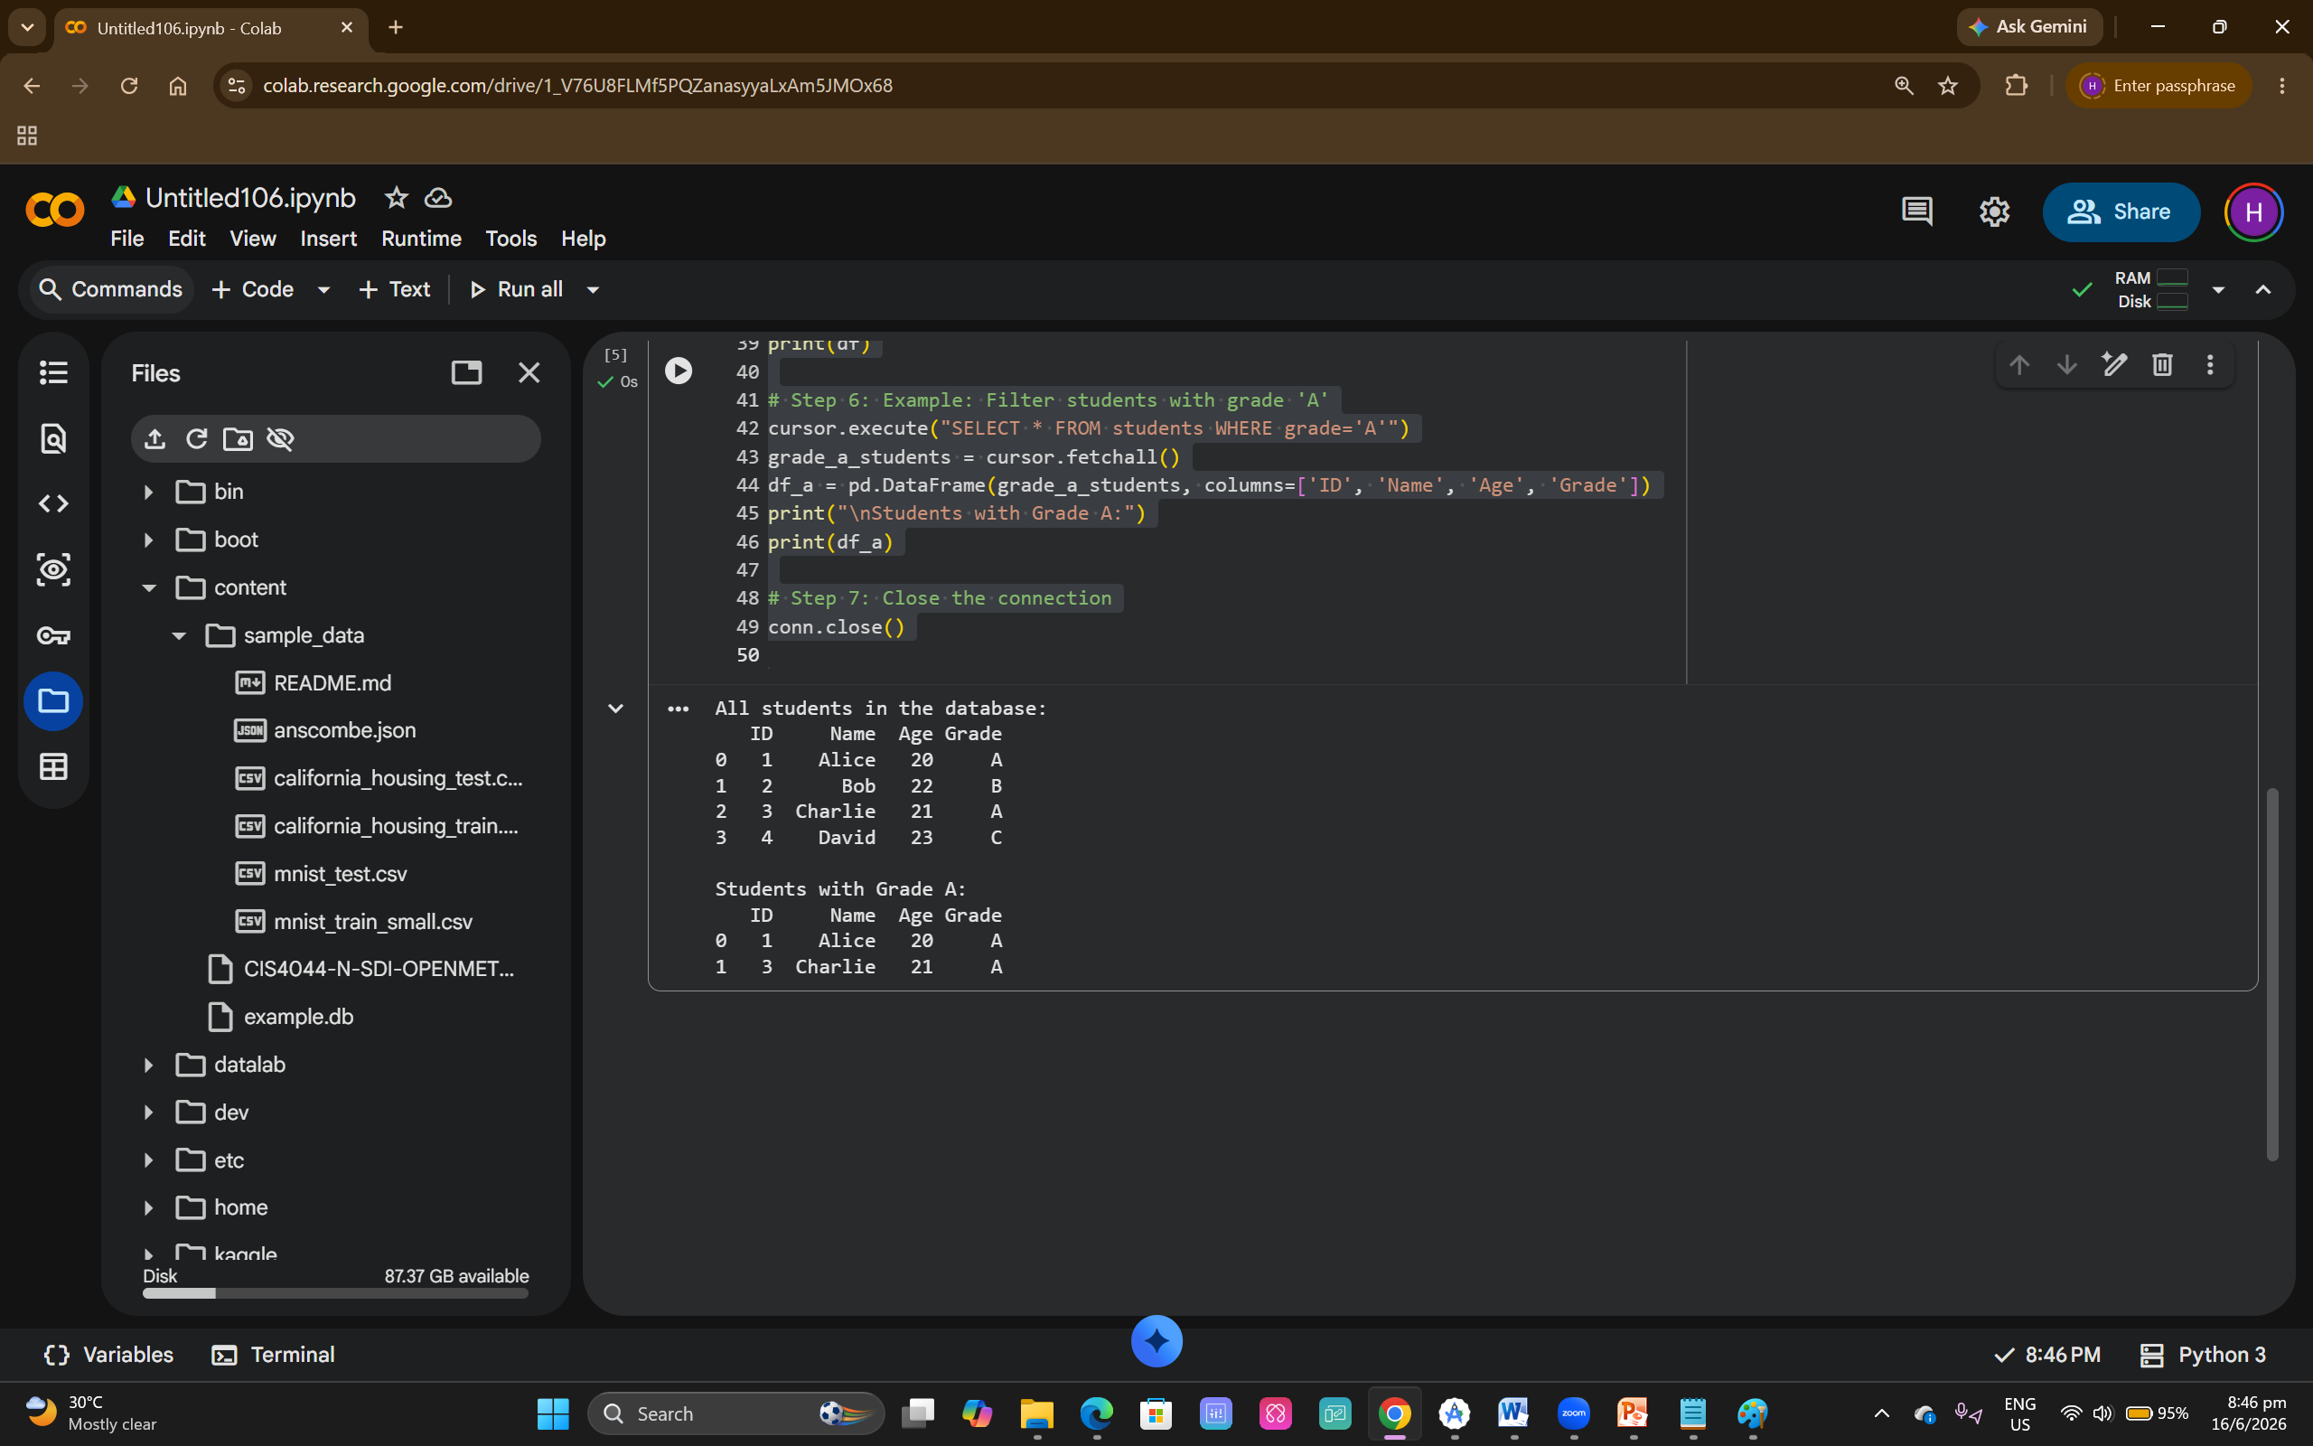

Phase 1 | # Author: <Your name here>  # Student ID: <Your Student ID>  import sqlite3  # Phase 1 - Starter  #  # Note: Display all real/float numbers to 2 decimal places.  '''  Satisfactory 50-59  '''  def select_all_countries(connection):  # Queries the database and selects all the countries  # stored in the countries table of the database.  # The returned results are then printed to the  # console.  try:  # Define the query  query = "SELECT * from [countries]"  # Get a cursor object from the database connection  # that will be used to execute database query.  cursor = connection.cursor()  # Execute the query via the cursor object.  results = cursor.execute(query)  # Iterate over the results and display the results.  for row in results:  print(f"Country Id: {row['id']} -- Country Name: {row['name']} -- Country Timezone: {row['timezone']}")  except sqlite3.OperationalError as ex:  print(ex)  def select_all_cities(connection):  # TODO: Implement this function  pass  '''  Good  In additional to successfully completing *all* the "Satisfactory" queries,  implement the queries that satisfy the each query requirements indicated by the name  of the function and any parameters to achieve a potential mark in the range 60-69.  '''  def average_annual_temperature(connection, city_id, year):  # TODO: Implement this function  pass  def average_seven_day_precipitation(connection, city_id, start_date):  # TODO: Implement this function  pass  '''  Very good  In additional to successfully completing *all* the "Satisfactory" and "Good" queries,  implement the queries that satisfy the each query requirements indicated by the name  of the function and any parameters to achieve a potential mark in the range 70-79.  '''  def average_mean_temp_by_city(connection, date_from, date_to):  # TODO: Implement this function  pass  def average_annual_precipitation_by_country(connection, year):  # TODO: Implement this function  pass  '''  Excellent  To achieve 80+ you will identify several suitable queries of your own that go beyond  basic requirements for this phase.  '''  if __name__ == "__main__":  # Create a SQLite3 connection and call the various functions  # above, printing the results to the terminal.  pass
# Author: <Your name here>
# Student ID: <Your Student ID>

import sqlite3

db_path = "/content/CIS4044-N-SDI-OPENMETEO-PARTIAL.db"
conn = sqlite3.connect(db_path)

# Allow dictionary-style row access
conn.row_factory = sqlite3.Row

# -----------------------------------------------------------
# Phase 1 - Starter
# -----------------------------------------------------------

'''
Satisfactory 50-59
'''

def select_all_countries(connection):
# Queries the database and selects all the countries
# stored in the countries table of the database.
# The returned results are then printed to the console.
try:
query = "SELECT * FROM countries"
cursor = connection.cursor()
results = cursor.execute(query)

# Display rows
for row in results:
print(
f"Country Id: {row['id']} -- "
f"Country Name: {row['name']} -- "
f"Country Timezone: {row['timezone']}"
)

except sqlite3.OperationalError as ex:
print(ex)

def select_all_cities(connection):
# TODO: Implement this function
pass

'''
Good (60–69)
'''

def average_annual_temperature(connection, city_id, year):
# TODO: Implement this function
pass

def average_seven_day_precipitation(connection, city_id, start_date):
# TODO: Implement this function
pass

'''
Very Good (70–79)
'''

def average_mean_temp_by_city(connection, date_from, date_to):
# TODO: Implement this function
pass

def average_annual_precipitation_by_country(connection, year):
# TODO: Implement this function
pass

'''
Excellent (80+)
'''

if __name__ == "__main__":
# Call starter functions here
print("=== All Countries ===")
select_all_countries(conn)

output
import sqlite3
import pandas as pd

# --- Load your DB file ---
db_path = "/content/CIS4044-N-SDI-OPENMETEO-PARTIAL.db"
conn = sqlite3.connect(db_path)

# --- Get list of all tables in the DB ---
tables = pd.read_sql_query(
"SELECT name FROM sqlite_master WHERE type='table';", conn
)
table_names = tables["name"].tolist()

print("Tables detected:")
display(tables)

# --- Loop through each table and display ALL records ---
for table in table_names:
print(f"\n=== TABLE: {table} ===")
df = pd.read_sql_query(f"SELECT * FROM {table};", conn)
display(df)

conn.close()

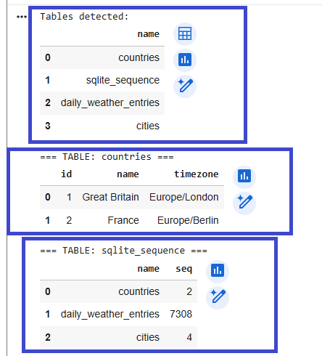
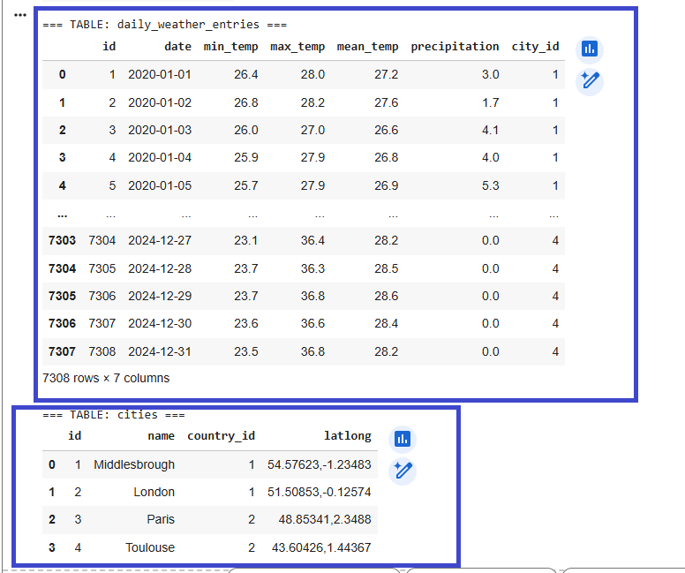
Phase 2  Using Matplotlib | import sqlite3  import pandas as pd  import matplotlib.pyplot as plt  # --- Load DB ---  db_path = "/content/CIS4044-N-SDI-OPENMETEO-PARTIAL.db"  conn = sqlite3.connect(db_path)  # --- Fetch table list ---  tables = pd.read_sql_query(  "SELECT name FROM sqlite_master WHERE type='table';", conn  )  table_names = tables["name"].tolist()  print("Tables detected:")  display(tables)  # --- Loop through each table ---  for table in table_names:  print(f"\n==============================")  print(f"TABLE: {table}")  print(f"==============================")  # Load table  df = pd.read_sql_query(f"SELECT * FROM {table};", conn)  # Display all records  display(df)  # Make bar chart for this table  plt.figure(figsize=(8, 4))  # Count non-null values per column (universal bar chart)  col_counts = df.count()  plt.bar(col_counts.index, col_counts.values)  plt.title(f"Bar Chart – Column Value Count for Table '{table}'")  plt.xlabel("Columns")  plt.ylabel("Non-null Values")  plt.xticks(rotation=45)  plt.tight_layout()  plt.show()  conn.close()
 | 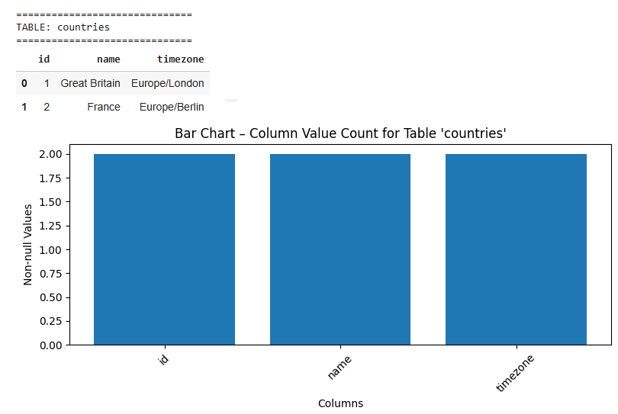
Phase 3 | https://open-meteo.com/en/docs/historical-weather-api  https://open-meteo.com/en/docs/climate-api  https://open-meteo.com/en/docs/historical-forecast-api  https://open-meteo.com/  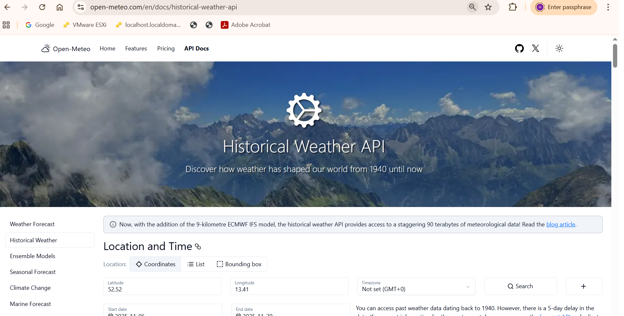
# ===============================

# Install required packages
# ===============================
!pip install openmeteo-requests requests-cache retry-requests pandas matplotlib

# ===============================
# Import libraries
# ===============================
import openmeteo_requests
import requests_cache
from retry_requests import retry
import pandas as pd
import matplotlib.pyplot as plt

# ===============================
# Open-Meteo Client Setup
# ===============================
cache_session = requests_cache.CachedSession('.cache', expire_after=3600)
retry_session = retry(cache_session, retries=5, backoff_factor=0.2)
client = openmeteo_requests.Client(session=retry_session)

# ===============================
# API Endpoint (working alternative)
# ===============================
url = "https://historical-forecast-api.open-meteo.com/v1/forecast"

params = {
"latitude": 1.2897, # Singapore
"longitude": 103.8501,
"start_date": "2024-01-01",
"end_date": "2024-01-07",
"hourly": ["temperature_2m", "windspeed_10m", "precipitation"]
}

# ===============================
# Fetch Data
# ===============================
response = client.weather_api(url, params=params)[0]
hourly = response.Hourly()

# ===============================
# Convert to DataFrame
# ===============================
df = pd.DataFrame({
"time": pd.date_range(
start=pd.to_datetime(hourly.Time(), unit="s"),
end=pd.to_datetime(hourly.TimeEnd(), unit="s"),
freq=pd.Timedelta(seconds=hourly.Interval()),
inclusive="left"
),
"temperature_2m": hourly.Variables(0).ValuesAsNumpy(),
"windspeed_10m": hourly.Variables(1).ValuesAsNumpy(),
"precipitation": hourly.Variables(2).ValuesAsNumpy()
})

# Show full data
display(df)

# ===============================
# Plot charts
# ===============================

# Temperature
plt.figure(figsize=(12,4))
plt.plot(df["time"], df["temperature_2m"])
plt.title("Temperature Over Time (°C)")
plt.xlabel("Time")
plt.ylabel("Temperature (°C)")
plt.xticks(rotation=30)
plt.tight_layout()
plt.show()

# Wind speed
plt.figure(figsize=(12,4))
plt.plot(df["time"], df["windspeed_10m"])
plt.title("Wind Speed Over Time (m/s)")
plt.xlabel("Time")
plt.ylabel("Wind Speed (m/s)")
plt.xticks(rotation=30)
plt.tight_layout()
plt.show()

# Precipitation
plt.figure(figsize=(12,4))
plt.plot(df["time"], df["precipitation"])
plt.title("Precipitation Over Time (mm)")
plt.xlabel("Time")
plt.ylabel("Precipitation (mm)")
plt.xticks(rotation=30)
plt.tight_layout()
plt.show()

 | 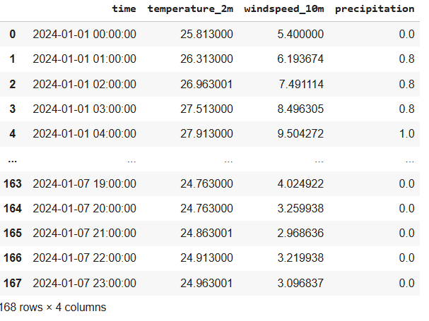
 | 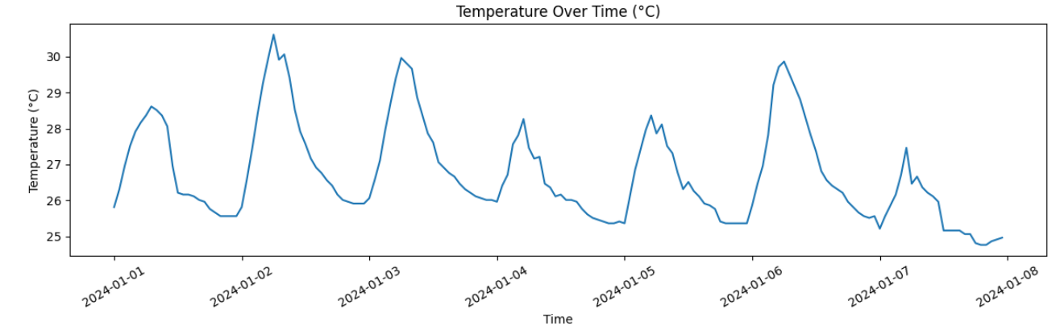
!pip install SQLAlchemy --quiet

import os
from sqlalchemy import create_engine, MetaData, select
from sqlalchemy.orm import sessionmaker

# -------------------------------------------------
# 1. Locate the SQLite DB file in Colab
# -------------------------------------------------
db_filename = "CIS4044-N-SDI-OPENMETEO-PARTIAL.db"
db_path = f"/content/{db_filename}"

if not os.path.exists(db_path):
raise FileNotFoundError(f"Database file not found at: {db_path}")

print(f"Using database at: {db_path}")

# -------------------------------------------------
# 2. Connect to the SQLite database
# -------------------------------------------------
engine = create_engine(f"sqlite:///{db_path}")

# -------------------------------------------------
# 3. Reflect tables inside the DB
# -------------------------------------------------
metadata = MetaData()
metadata.reflect(bind=engine)

print("\nTables found in database:")
for table_name in metadata.tables:
print(" -", table_name)

# -------------------------------------------------
# 4. Start ORM session
# -------------------------------------------------
Session = sessionmaker(bind=engine)
session = Session()

# -------------------------------------------------
# 5. Query & display up to 10 records per table
# -------------------------------------------------
for table_name, table in metadata.tables.items():
print("\n==============================")
print(f"TABLE: {table_name} (up to 10 records)")
print("==============================")

stmt = select(table).limit(10)
rows = session.execute(stmt).fetchall()

if len(rows) == 0:
print("(No records)")
else:
for row in rows:
print(dict(row._mapping)) # Use _mapping to convert SQLAlchemy Row to dict

 | 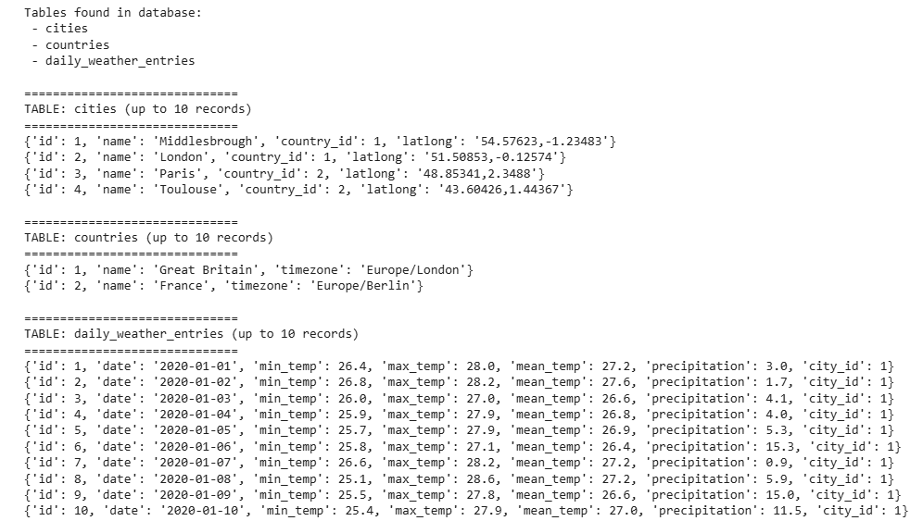
Report Table of Contents- 4044

1. Introduction and Literature Review
1.1 SQLite Database
1.2 Graphs using Matplotlib
1.3 Data Retrieval using OpenMeteo API (free and publicly available weather-related web-services)
1. Phase 1 - Database Queries
1.1 SQLite Database (CIS4044-N-OPENMETEO-PARTIAL.db)
1.2 select_all_countries
1.2.1 Python Code Explanaion
1.2.2 Black Box Testing
1.3 select_all_cities
...
1.4 average_annual_temperature
...
1.5 average_seven_day_precipitation
1.6 average_mean_temp_by_city
1.7 average_annual_precipitation_by_country

2. Phase 2 - Database Queries and Basic Graphs using Matplotlib
2.1 Bar chart to show the 7-day precipitation for a specific town/city
2.1.1 Python Code Explanation
2.1.2 Black Box Testing
2.2 Bar chart for a specified period for a specified set of towns/cities
...
2.6 ...
3. Phase 3 - Data Retrieval and Storage
3.1 Retrieve data from the API (daily_weather_entries)
3.1.1 Python Code Explanaion
3.1.2 Black Box Testing
3.2 Insert data into the sqlite3 database table (CIS4044-N-OPENMETEO-PARTIAL.db)
3.2.1 Python Code Explanaion
3.2.2 Black Box Testing
4. Further enhancements
4.1 Sqlalchemy to provide an abstracted way of querying and updating the database
5. References
6. Appendices
6.1 Program 1 (with name, id, comments)
6.2 Program 2 (with name, id, comments)

L5
# Python Programming - Lecture Sample
# Modified MK 2021
#

def del_lines_containing(file, term):
""" Deletes all lines in a file containing a term.
Args:
file (str): The path of the file to modify.
term (str): The term to search for.
"""

# Read whole file into list of the lines, that we want
lines = []
with open(file, mode="r") as my_file: # Open file in read mode.
for line in my_file:
if not term in line: # Don't store any lines that contain `term`.
lines.append(line)

# Write file back out, without excluded lines.
with open(file, mode="w") as my_file: # Open file in write mode.
for line in lines:
my_file.write(line)
return

# invoke the function
del_lines_containing('cars_exercise.txt', 'ford')

## Count-Words-in-File.py
##
## Using file Handling and loops
##
# Notes:
# + This file is for demonstration purposes only.
# + You must use this example to guide your own solution.
# **DO NOT SUBMIT THIS FILE FOR ASSESSMENT**

name = input('Enter Filename: ')
handle = open(name, 'r')
text = handle.read()
words = text.split()
counts = dict()

for word in words:
counts[word] = counts.get(word,0) + 1

big_count = None
big_word = None

for word,count in counts.items():
if big_count is None or count > big_count:
big_count = count
big_word = word

print("Most common - '{}': {} times".format( big_word, big_count))

def read_names():
with open("names.txt", mode="r") as my_file:
for line in my_file:
print(line)
read_names() # Don't forget this line!

names.txt
Hyundai
Tucson
2006
Mitsubishi
Outlander
2015
Ford
Focus
1998

Report Table of Contents- 4044

1. Introduction and Literature Review
1.1 SQLite Database
1.2 Graphs using Matplotlib
1.3 Data Retrieval using OpenMeteo API (free and publicly available weather-related web-services)
1. Phase 1 - Database Queries
1.1 SQLite Database (CIS4044-N-OPENMETEO-PARTIAL.db)
1.2 select_all_countries
1.2.1 Python Code Explanation
1.2.2 Black Box Testing
1.3 select_all_cities
...
1.4 average_annual_temperature
...
1.5 average_seven_day_precipitation
1.6 average_mean_temp_by_city
1.7 average_annual_precipitation_by_country
1.8 ….
1.9 ….

2. Phase 2 - Database Queries and Basic Graphs using Matplotlib
2.1 Bar chart to show the 7-day precipitation for a specific town/city
2.1.1 Python Code Explanation
2.1.2 Black Box Testing
2.2 Bar chart for a specified period for a specified set of towns/cities
...
2.6 ...
3. Phase 3 - Data Retrieval and Storage
3.1 Retrieve data from the API (daily_weather_entries)
3.1.1 Python Code Explanaion
3.1.2 Black Box Testing
3.2 Insert data into the sqlite3 database table (CIS4044-N-OPENMETEO-PARTIAL.db)
3.2.1 Python Code Explanaion
3.2.2 Black Box Testing
4. Further enhancements
4.1 Sqlalchemy to provide an abstracted way of querying and updating the database
5. References
6. Appendices
6.1 Phase 1 - Python Program 1 (with name, id, comments)
6.2 Phase 2 - Python Program 2 (with name, id, comments)
6.3 Phase 3 - Python Program 2 (with name, id, comments)
6.4 Phase 4 – Enhancement (with name, id, comments)

L4

Tips.csv
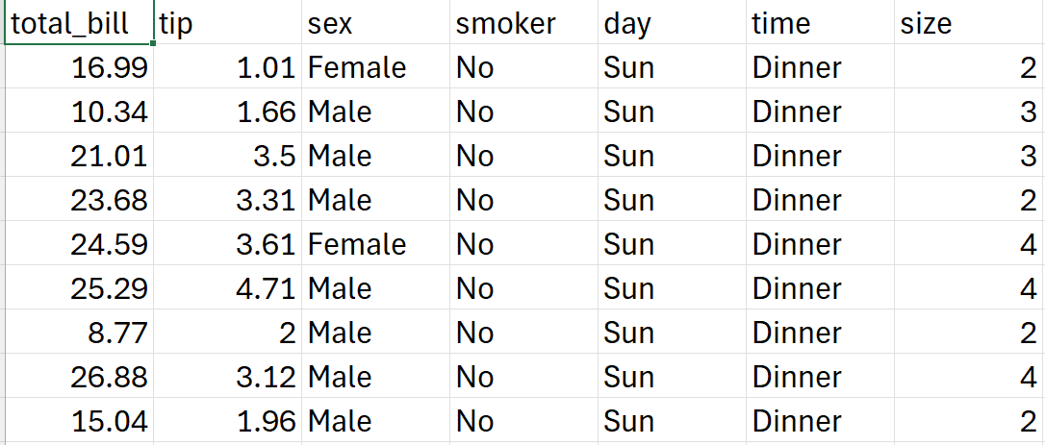
Colab  Prediction using  AI Regression |  | # ---------------------------------------------------------  # Regression in Colab — Numeric Only + Labelled Graph + Prediction Output  # ---------------------------------------------------------  !pip install pandas scikit-learn matplotlib  from google.colab import files  uploaded = files.upload()  import pandas as pd  # Load CSV  file_name = list(uploaded.keys())[0]  df = pd.read_csv(file_name)  print(" Dataset preview:")  display(df.head())  # Choose target column  target_col = input("Enter the target column name for prediction: ")  # Target  y = df[target_col]  # Keep only numeric columns for prediction  numeric_df = df.drop(columns=[target_col]).select_dtypes(include=['int64', 'float64'])  print("\n🔧 Using only numeric columns for training:")  print(list(numeric_df.columns))  X = numeric_df  # Train-test split  from sklearn.model_selection import train_test_split  X_train, X_test, y_train, y_test = train_test_split(  X, y, test_size=0.2, random_state=42  )  # Model  from sklearn.linear_model import LinearRegression  model = LinearRegression()  model.fit(X_train, y_train)  print("\n Model training complete!")  # Predict  y_pred = model.predict(X_test)  # Metrics  from sklearn.metrics import r2_score, mean_squared_error  import numpy as np  r2 = r2_score(y_test, y_pred)  rmse = np.sqrt(mean_squared_error(y_test, y_pred))  print("\nModel Evaluation:")  print(f"R² Score: {r2:.4f}")  print(f"RMSE: {rmse:.4f}")  # ---------------------------------------------------------  # Labelled Graph  # ---------------------------------------------------------  import matplotlib.pyplot as plt  plt.figure(figsize=(7, 5))  plt.scatter(y_test, y_pred)  plt.xlabel("Actual Values", fontsize=12)  plt.ylabel("Predicted Values", fontsize=12)  plt.title("Actual vs Predicted Regression Output", fontsize=14)  plt.grid(True)  plt.show()  # ---------------------------------------------------------  # Show a sample predicted value  # ---------------------------------------------------------  sample_index = 0  print("\n Example Prediction:")  print("Features used:", list(X.columns))  print(f"Actual value: {y_test.iloc[sample_index]}")  print(f"Predicted value: {y_pred[sample_index]}")  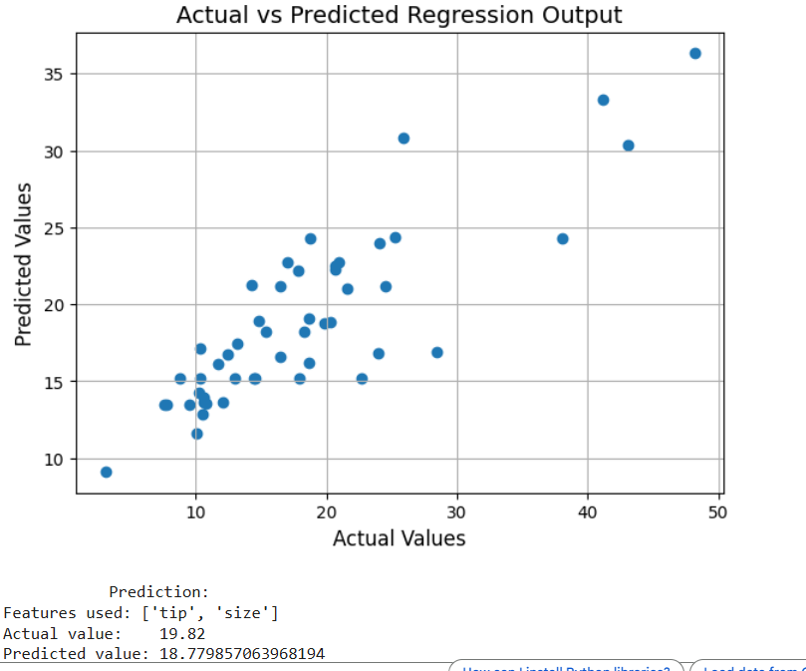
# ---------------------------------------------------------
# Regression in Colab — Numeric Only + Detailed Graphs
# ---------------------------------------------------------

!pip install pandas scikit-learn matplotlib seaborn

from google.colab import files
uploaded = files.upload()

import pandas as pd
import numpy as np

# Load CSV
file_name = list(uploaded.keys())[0]
df = pd.read_csv(file_name)

print("Dataset preview:")
display(df.head())

# Choose target column
target_col = input("Enter the target column name for prediction: ")

# Target
y = df[target_col]

# Keep only numeric columns for prediction
numeric_df = df.drop(columns=[target_col]).select_dtypes(include=['int64', 'float64'])

print("\n Using only numeric columns for training:")
print(list(numeric_df.columns))

X = numeric_df

# Train-test split
from sklearn.model_selection import train_test_split
X_train, X_test, y_train, y_test = train_test_split(
X, y, test_size=0.2, random_state=42
)

# Model
from sklearn.linear_model import LinearRegression
model = LinearRegression()
model.fit(X_train, y_train)

print("\nModel training complete!")

# Predict
y_pred = model.predict(X_test)

# Metrics
from sklearn.metrics import r2_score, mean_squared_error

r2 = r2_score(y_test, y_pred)
rmse = np.sqrt(mean_squared_error(y_test, y_pred))

print("\n Model Evaluation:")
print(f"R² Score: {r2:.4f}")
print(f"RMSE: {rmse:.4f}")

# ---------------------------------------------------------
# GRAPH 1 – Actual vs Predicted Scatter Plot
# ---------------------------------------------------------
import matplotlib.pyplot as plt
import seaborn as sns

plt.figure(figsize=(7, 5))
plt.scatter(y_test, y_pred)
plt.xlabel("Actual Values", fontsize=12)
plt.ylabel("Predicted Values", fontsize=12)
plt.title("Actual vs Predicted Regression Output", fontsize=14)
plt.grid(True)
plt.show()

# ---------------------------------------------------------
# RAPH 2 – Correlation Heatmap (Feature influence)
# ---------------------------------------------------------
plt.figure(figsize=(8, 6))
corr = df.select_dtypes(include=['int64','float64']).corr()

sns.heatmap(corr, annot=True, cmap='coolwarm', fmt=".2f")
plt.title("Correlation Heatmap — Feature Influence on Target", fontsize=14)
plt.show()

# ---------------------------------------------------------
# GRAPH 3 – Feature vs Target scatter for each feature
# ---------------------------------------------------------
for col in X.columns:
plt.figure(figsize=(6,4))
plt.scatter(df[col], y)
plt.xlabel(col, fontsize=12)
plt.ylabel(target_col, fontsize=12)
plt.title(f"{col} vs {target_col}", fontsize=14)
plt.grid(True)
plt.show()

# ---------------------------------------------------------
#GRAPH 4 – Feature Importance (Linear Regression Coefficients)
# ---------------------------------------------------------
coeff_df = pd.DataFrame({
"Feature": X.columns,
"Coefficient": model.coef_
}).sort_values(by="Coefficient", ascending=False)

plt.figure(figsize=(8, 5))
plt.barh(coeff_df["Feature"], coeff_df["Coefficient"])
plt.xlabel("Coefficient Weight", fontsize=12)
plt.title("Feature Importance — Linear Regression Coefficients", fontsize=14)
plt.gca().invert_yaxis()
plt.grid(True)
plt.show()

# ---------------------------------------------------------
# Show a sample predicted value
# ---------------------------------------------------------
sample_index = 0
print("\n Example Prediction:")
print("Features used:", list(X.columns))
print(f"Actual value: {y_test.iloc[sample_index]}")
print(f"Predicted value: {y_pred[sample_index]}")

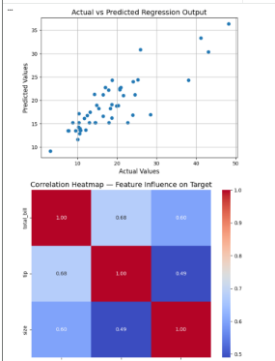
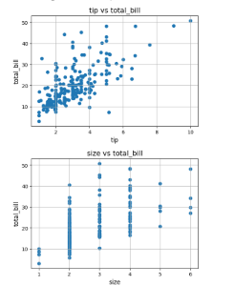
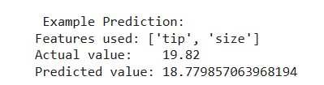
AI  Models  For Prediction | 1. Linear Models (scikit-learn)  These are fast, easy, and used as baseline models.  ✔ Models:  LinearRegression()  Ridge()  Lasso()  ElasticNet()  SGDRegressor()  2. Tree-Based Models  Great for non-linear relationships.  ✔ Decision Trees:  DecisionTreeRegressor()  ✔ Ensemble Models:  RandomForestRegressor()  ExtraTreesRegressor()  GradientBoostingRegressor()  AdaBoostRegressor()  ✔ XGBoost / LightGBM / CatBoost (most accurate for tabular data):  XGBRegressor() (xgboost)  LGBMRegressor() (lightgbm)  CatBoostRegressor() (catboost – works well without preprocessing)  3. SVM Models  Good for medium-sized datasets.  SVR()  LinearSVR()  4. k-Nearest Neighbours  Simple and non-parametric.  KNeighborsRegressor()  5. Neural Network (Deep Learning)  Works well when data is large and complex.  ✔ TensorFlow / Keras:  Sequential model with Dense layers  ✔ PyTorch:  Custom nn.Module regression networks
Python  Data Science | # https://colab.research.google.com/drive/15BMJhmJ0AJdiWWRHs43zivpdGWwAjnK-  # https://www.geeksforgeeks.org/data-visualization/data-visualization-with-python/  from google.colab import files  import pandas as pd  # Step 1: Upload file  uploaded = files.upload()  # Step 2: Check uploaded files  print(uploaded.keys())  # Step 3: Read the CSV  filename = list(uploaded.keys())[0]  df = pd.read_csv(filename)  # Step 4: Show first 5 rows  print(df.head())  ///  import pandas as pd  import matplotlib.pyplot as plt  from google.colab import files  # Upload CSV file  uploaded = files.upload()  # Get the uploaded file name  for filename in uploaded.keys():  print(f"Uploaded file: {filename}")  data = pd.read_csv(filename)  # Scatter plot with day against tip  plt.scatter(data['day'], data['tip'])  # Add title and labels  plt.title("Scatter Plot")  plt.xlabel('Day')  plt.ylabel('Tip')  plt.show()  ////  import pandas as pd  import matplotlib.pyplot as plt  from google.colab import files  # Upload CSV file  uploaded = files.upload()  # Get the uploaded file name dynamically  for filename in uploaded.keys():  print(f"Uploaded file: {filename}")  data = pd.read_csv(filename)  # Bar chart with day against tip  plt.bar(data['day'], data['tip'])  # Add title and labels  plt.title("Bar Chart")  plt.xlabel('Day')  plt.ylabel('Tip')  # Show the chart  plt.show()  ///  # Importing packages  import seaborn as sns  import matplotlib.pyplot as plt  import pandas as pd  from google.colab import files  # Upload CSV file  uploaded = files.upload()  # Get the uploaded file name dynamically  for filename in uploaded.keys():  print(f"Uploaded file: {filename}")  data = pd.read_csv(filename)  # Create bar plot using seaborn  sns.barplot(x='day', y='tip', data=data, hue='sex')  # Show plot  plt.show()  ////  # Importing packages  import seaborn as sns  import matplotlib.pyplot as plt  import pandas as pd  from google.colab import files  # Upload CSV file  uploaded = files.upload()  # Read the uploaded file dynamically  for filename in uploaded.keys():  print(f"Uploaded file: {filename}")  data = pd.read_csv(filename)  # Create histogram plot  sns.histplot(x='total_bill', data=data, kde=True, hue='sex')  # Show plot  plt.show()  ////  # Importing the modules  from bokeh.plotting import figure, output_notebook, show  from bokeh.palettes import magma  import pandas as pd  from google.colab import files  # Enable Bokeh output in Colab  output_notebook()  # Upload CSV file  uploaded = files.upload()  # Read the uploaded file dynamically  for filename in uploaded.keys():  print(f"Uploaded file: {filename}")  data = pd.read_csv(filename)  # Instantiate the figure object  graph = figure(title="Bokeh Scatter Graph", x_axis_label="Total Bill", y_axis_label="Tip")  # Use a color palette  color = magma(256)  # Plot the graph  graph.scatter(data['total_bill'], data['tip'], color=color[100])  # Display the plot  show(graph)  ////  # Importing the modules  from bokeh.plotting import figure, output_notebook, show  import pandas as pd  from google.colab import files  # Enable Bokeh output in Colab  output_notebook()  # Upload CSV file  uploaded = files.upload()  # Read the uploaded file dynamically  for filename in uploaded.keys():  print(f"Uploaded file: {filename}")  data = pd.read_csv(filename)  # Instantiate the figure object  graph = figure(title="Bokeh Bar/Line Chart", x_axis_label="Tip Value", y_axis_label="Count")  # Count of each unique value in 'tip' column  df = data['tip'].value_counts().sort_index()  # Plot the line chart (Bokeh can also do bars)  graph.line(x=df.index, y=df.values, line_width=2)  # Display the plot  show(graph)  ////  # Importing the modules  from bokeh.plotting import figure, output_notebook, show  import pandas as pd  from google.colab import files  # Enable Bokeh output inside Colab  output_notebook()  # Upload CSV file  uploaded = files.upload()  # Read the uploaded file dynamically  for filename in uploaded.keys():  print(f"Uploaded file: {filename}")  data = pd.read_csv(filename)  # Instantiate the figure object  graph = figure(title="Bokeh Bar Chart", x_axis_label="X Values", y_axis_label="Y Values")  # Plot the graphs  graph.vbar(x=data['total_bill'], top=data['tip'],  legend_label="Bill VS Tips", color='green', width=0.4)  graph.vbar(x=data['tip'], top=data['size'],  legend_label="Tips VS Size", color='red', width=0.4)  # Allow legend click-to-hide feature  graph.legend.click_policy = "hide"  # Display the plot  show(graph)  /////  # --- Imports ---  import pandas as pd  import numpy as np  from google.colab import files  from bokeh.io import output_notebook, show  from bokeh.layouts import column  from bokeh.models import Button, ColumnDataSource, CustomJS  from bokeh.plotting import figure  # Enable Bokeh output in Colab  output_notebook()  # --- Upload CSV ---  uploaded = files.upload()  for filename in uploaded.keys():  print(f"Uploaded file: {filename}")  data = pd.read_csv(filename)  # --- Data sources for plots ---  source_scatter = ColumnDataSource(data=dict(x=data['total_bill'], y=data['tip']))  source_bar = ColumnDataSource(data=dict(x=data['tip'], y=data['size']))  hist, edges = np.histogram(data['total_bill'], bins=10)  source_hist = ColumnDataSource(data=dict(top=hist, left=edges[:-1], right=edges[1:]))  # --- Figures ---  p1 = figure(title="Scatter: total_bill vs tip", width=600, height=400)  p1.circle('x', 'y', source=source_scatter, size=8, color="green", alpha=0.6)  p2 = figure(title="Bar: tip vs size", width=600, height=400)  p2.vbar(x='x', top='y', source=source_bar, width=0.4, color="red")  p3 = figure(title="Histogram: total_bill", width=600, height=400)  p3.quad(top='top', bottom=0, left='left', right='right', source=source_hist, fill_color="blue", alpha=0.6)  # --- Initial visibility ---  p2.visible = False  p3.visible = False  # --- Buttons with JS callbacks ---  b1 = Button(label="Show Scatter", button_type="success")  b1.js_on_click(CustomJS(args=dict(p1=p1, p2=p2, p3=p3), code="""  p1.visible = true;  p2.visible = false;  p3.visible = false;  """))  b2 = Button(label="Show Bar", button_type="warning")  b2.js_on_click(CustomJS(args=dict(p1=p1, p2=p2, p3=p3), code="""  p1.visible = false;  p2.visible = true;  p3.visible = false;  """))  b3 = Button(label="Show Histogram", button_type="primary")  b3.js_on_click(CustomJS(args=dict(p1=p1, p2=p2, p3=p3), code="""  p1.visible = false;  p2.visible = false;  p3.visible = true;  """))  # --- Layout ---  layout = column(b1, b2, b3, p1, p2, p3)  show(layout)  ////  # Import packages  import pandas as pd  from google.colab import files  import plotly.graph_objects as go  # --- Upload CSV file ---  uploaded = files.upload()  for filename in uploaded.keys():  print(f"Uploaded file: {filename}")  data = pd.read_csv(filename)  # --- Create Plotly figure ---  plot = go.Figure(data=[go.Scatter(  x=data['day'],  y=data['tip'],  mode='markers',  )])  # --- Add dropdown to switch plot type ---  plot.update_layout(  updatemenus=[  dict(  buttons=list([  dict(  args=["type", "scatter"],  label="Scatter Plot",  method="restyle"  ),  dict(  args=["type", "bar"],  label="Bar Chart",  method="restyle"  )  ]),  direction="down",  ),  ]  )  # --- Show plot ---  plot.show()  ///  # Import packages  import pandas as pd  from google.colab import files  import plotly.graph_objects as go  # --- Upload CSV file ---  uploaded = files.upload()  for filename in uploaded.keys():  print(f"Uploaded file: {filename}")  data = pd.read_csv(filename)  # --- Create Plotly figure with line plot ---  plot = go.Figure(data=[go.Scatter(  y=data['tip'],  mode='lines',  )])  # --- Add range selector and range slider ---  plot.update_layout(  xaxis=dict(  rangeselector=dict(  buttons=list([  dict(count=1,  step="day",  stepmode="backward"),  ])  ),  rangeslider=dict(  visible=True  ),  )  )  # --- Show plot ---  plot.show()
L3

import sqlite3
import pandas as pd

# --- Load your DB file ---
db_path = "/content/CIS4044-N-SDI-OPENMETEO-PARTIAL.db"
conn = sqlite3.connect(db_path)

# --- Get list of all tables in the DB ---
tables = pd.read_sql_query(
"SELECT name FROM sqlite_master WHERE type='table';", conn
)
table_names = tables["name"].tolist()

print("Tables detected:")
display(tables)

# --- Loop through each table and display ALL records ---
for table in table_names:
print(f"\n=== TABLE: {table} ===")
df = pd.read_sql_query(f"SELECT * FROM {table};", conn)
display(df)

conn.close()

/////

# Step 1: Import sqlite3
import sqlite3
import pandas as pd

# Step 2: Connect to a SQLite database (it will create it in Colab environment)
conn = sqlite3.connect('example.db') # 'example.db' is the database file
cursor = conn.cursor()

# Step 3: Create a table
cursor.execute('''
CREATE TABLE IF NOT EXISTS students (
id INTEGER PRIMARY KEY,
name TEXT NOT NULL,
age INTEGER,
grade TEXT
)
''')

# Step 4: Insert some data
students_data = [
(1, 'Alice', 20, 'A'),
(2, 'Bob', 22, 'B'),
(3, 'Charlie', 21, 'A'),
(4, 'David', 23, 'C')
]

cursor.executemany('INSERT OR REPLACE INTO students VALUES (?, ?, ?, ?)', students_data)

# Commit changes
conn.commit()

# Step 5: Query the table
cursor.execute('SELECT * FROM students')
rows = cursor.fetchall()

# Display the results using pandas for better readability
df = pd.DataFrame(rows, columns=['ID', 'Name', 'Age', 'Grade'])
print("All students in the database:")
print(df)

# Step 6: Example: Filter students with grade 'A'
cursor.execute("SELECT * FROM students WHERE grade='A'")
grade_a_students = cursor.fetchall()
df_a = pd.DataFrame(grade_a_students, columns=['ID', 'Name', 'Age', 'Grade'])
print("\nStudents with Grade A:")
print(df_a)

# Step 7: Close the connection
conn.close()

L2
Tutorial 2
Design
Pseudocode (Structured English)
input() = READ/INPUT
print() = DISPLAY

DISPLAY "Enter 3 numbers"
READ A,B,C
Total = A+B+C
DISPLAY Total

Programming

Tutorial 2
2.1

PSEUDOCODE
DISPLAY "Enter 2 numbers"
INPUT A
INPUT B
IF A > B
DISPLAY "The first number is bigger than the Second"

IF B > A
DISPLAY "The second number is bigger than the First"

2.2
PSEUDOCODE
DISPLAY "Enter Your Age"
INPUT Age

DISPLAY "1-UK/Britain 2-Others"
INPUT Citizen

IF Age > 18 AND Citizen = 1
DISPLAY "You can vote"
...

2.3
PSEUDOCODE
DISPLAY "Enter a Number"
INPUT NUM
if (NUM % 3) == 0
DISPLAY "FIZZ"
...

2.4
PSEUDOCODE
DISPLAY "Enter Mark"
INPUT Mark
IF Mark = 0
DISPLAY "N/S"
IF (Mark >= 1) AND (Mark <= 39)
DISPLAY "F"
....

2.5
DISPLAY
"Enter
a. Fire
b. Water
...
"

INPUT TYPE

DISPLAY "Enter First letter"
INPUT FL
IF (TYPE == 'b') AND (FL == 'S')
DISPLAY "Squirtle"

# Python Beginner-Level Multiple Choice Questions

# --------------------------------------------------
# Question 1
x = 15
y = 3
print(x % y)
# What is the output?
# A) 0
# B) 3
# C) 5
# D) 1

# --------------------------------------------------
# Question 2
# Which of the following statements correctly checks if a number `score` is greater than or equal to 60?
# A) if score > 60:
# B) if score = 60:
# C) if score >= 60:
# D) if score => 60:

# --------------------------------------------------
# Question 3
for i in range(2, 10, 3):
print(i)
# What will be printed?
# A) 2 5 8
# B) 2 3 4
# C) 3 6 9
# D) 2 4 6 8

# --------------------------------------------------
# Question 4
n = 4
while n > 0:
print(n)
n -= 1
# What is the last number printed?
# A) 0
# B) 1
# C) 4
# D) 3

# --------------------------------------------------
# Question 5
# Which of the following is an example of integer division in Python?
# A) 7 / 2
# B) 7 * 2
# C) 7 // 2
# D) 7 % 2

# --------------------------------------------------
# Question 6
name = input("Enter your name: ")
print("Hello", name)
# What type of data is stored in `name`?
# A) Integer
# B) String
# C) Boolean
# D) Float

# --------------------------------------------------
# Question 7
def greet(user):
print("Welcome,", user)

greet("Alex")
# What will be printed?
# A) Welcome Alex
# B) Welcome, Alex
# C) Alex Welcome
# D) Welcome user

# --------------------------------------------------
# Question 8
print(bool(0))
print(bool("hello"))
# What is the output?
# A) False True
# B) True False
# C) 0 hello
# D) Error

# --------------------------------------------------
# Question 9
total = 5
total += 3
print(total)
# What will be printed?
# A) 2
# B) 8
# C) 53
# D) 15

# --------------------------------------------------
# Question 10
fruits = ["apple", "banana", "cherry"]
for f in fruits:
print(f)
# How many times will the loop run?
# A) 1
# B) 2
# C) 3
# D) 4

# Question 1
# Consider the following code:
a = 47
print(a)

# What is the data type of variable 'a'?
# A) str
# B) int
# C) float
# D) bool

# Question 2
# Referring to the code in Question 1, which of the following statements is correct?
# A) Variable a is a string
# B) Variable a holds a numeric value
# C) Variable a cannot be printed
# D) Variable a is undefined

# Question 3
# Consider the following code:
for n in range(10, 5, -1):
print(n)

# Expected output:
# 10
# 9
# 8
# 7
# 6
#
# Why does this code output as expected?
# A) The range function decreases because of the negative step
# B) The range function increases from 10 to 5
# C) The code is invalid syntax
# D) The loop never runs

# Question 4
# Consider the following code:
security_level = 8

if security_level >= 7:
print("You have access to the lab")
else:
print("Access denied")

# What will be printed?
# A) You have access to the lab
# B) Access denied
# C) Syntax error
# D) Nothing is printed

# Question 5
# Consider the following code:
number = input("Please enter a number: ")
multiplier = input("Please enter another number: ")

result = number * multiplier
print(result)

# What is wrong with this code?
# A) Inputs are strings and need to be converted to integers
# B) The print statement is incorrect
# C) The multiplication symbol is invalid
# D) Nothing is wrong

# Question 6
half = 3 // 2
my_number = int(input("Enter a number: "))
print("Half my number is", my_number + half)

# What is the value of 'half'?
# A) 1
# B) 1.5
# C) 2
# D) 3

# Question 7
def print_message(message, times=8):
for _ in range(times):
print(message)

print("End of program")

# What will be printed if print_message("Hi", 3) is called before 'End of program'?
# A) Hi printed 8 times followed by 'End of program'
# B) Hi printed 3 times followed by 'End of program'
# C) Only 'End of program'
# D) Syntax error

L1
Assessment will be by two components that will assess all learning outcomes.

Component 1: Lab-based, time-constrained test (20%)
Students will sit a lab-based online test to assess their understanding and application of the fundamentals of programming. This will also include testing their ability to read Python code to interpret what the code does without executing it in Python, identify any syntax or logic errors, and recommend fixes.

Component 2: Application development (80%)
Students will design and implement a solution to a data-orientated problem. The submission will include code with structured code comments, test plan, test results, and short evaluation (up to 1000 words) of the security and other risk implications related to the utilisation of software libraries and tools.


Resources
https://www.programiz.com/python-programming/online-compiler/

https://www.python.org/downloads/
https://colab.research.google.com/

https://docs.python.org/3/tutorial/introduction.html

https://code.visualstudio.com/download
https://www.w3schools.com/python/python_conditions.asp
https://realpython.com/defining-your-own-python-function/
https://www.w3schools.com/python/python_ref_list.asp
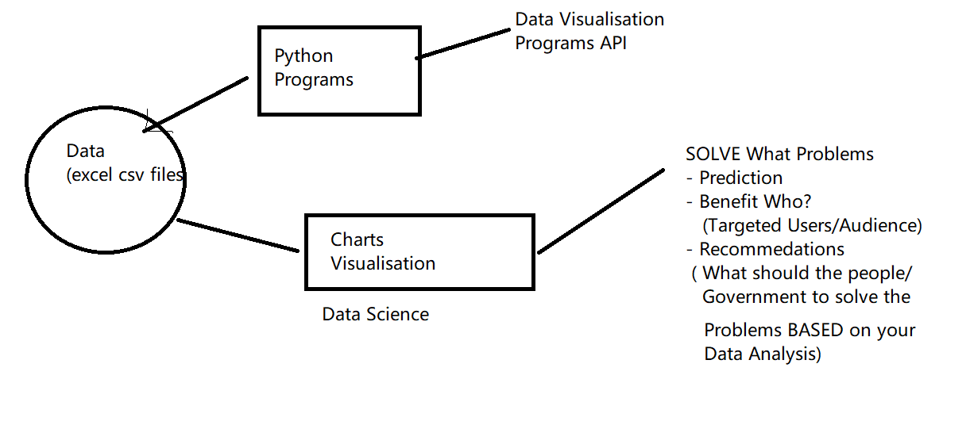

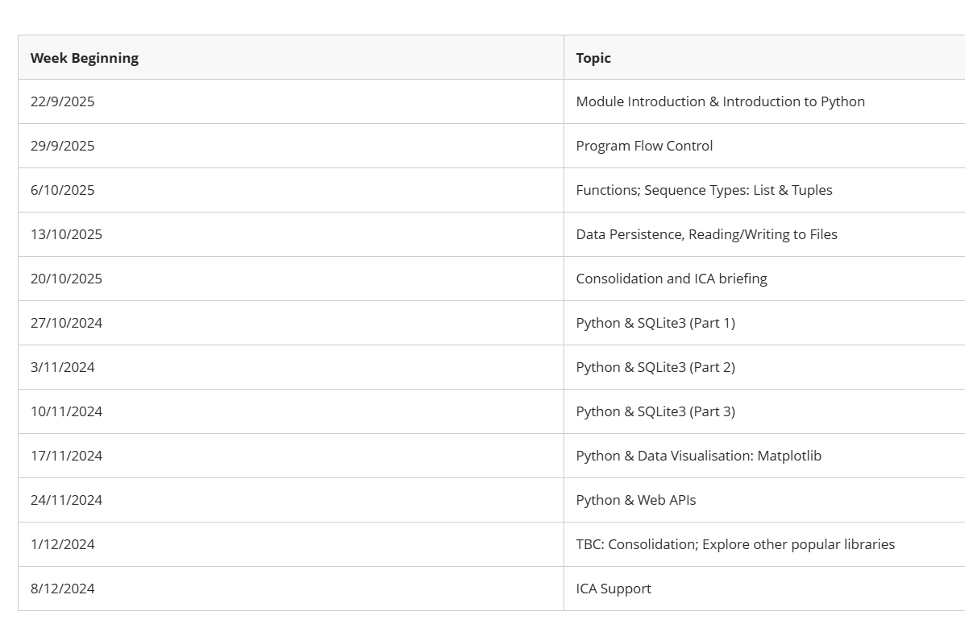
Python Basics
Input  Output | # using input() to take user input  num = input('Enter a number: ')  print('You Entered:', num)  print('Data type of num:', type(num))  # https://www.programiz.com/python-programming/input-output-import
Operators | # https://www.programiz.com/python-programming/operators  a = 7  b = 2  # addition  print ('Sum: ', a + b)  # subtraction  print ('Subtraction: ', a - b)  # multiplication  print ('Multiplication: ', a * b)  # division  print ('Division: ', a / b)  # floor division  print ('Floor Division: ', a // b)  # modulo  print ('Modulo: ', a % b)  # a to the power b  print ('Power: ', a ** b)
IF-ELSE  SELECTION  CHOICES | number = int(input('Enter a number: '))  # check if number is greater than 0  if number > 0:  print(f'{number} is a positive number.')  print('A statement outside the if statement.')  # https://www.programiz.com/python-programming/if-elif-else  ####################################  number = int(input('Enter a number: '))  if number > 0:  print('Positive number')  else:  print('Not a positive number')  print('This statement always executes')
FOR | # https://www.programiz.com/python-programming/for-loop  languages = ['Swift', 'Python', 'Go']  # access elements of the list one by one  for lang in languages:  print(lang)
WHILE | # https://www.programiz.com/python-programming/while-loop  number = 1  while number <= 3:  print(number)  number = number + 1
FUNCTION | # https://www.programiz.com/python-programming/function-argument  def add_numbers(a, b): # define function  sum = a + b  print('Sum:', sum)  add_numbers(2, 3) # call function  # Output: Sum: 5
RECURSION  factorial (3)  factorial (2)  factorial (1) | # https://www.programiz.com/python-programming/recursion  def factorial(x):  """This is a recursive function  to find the factorial of an integer"""  if x == 1: # second : stop case/base case  return 1  else:  return (x * factorial(x-1))  # first : call itself  third : input must approach the stop case  num = 3  print("The factorial of", num, "is", factorial(num))

# https://colab.research.google.com/drive/15BMJhmJ0AJdiWWRHs43zivpdGWwAjnK-
# https://www.geeksforgeeks.org/data-visualization/data-visualization-with-python/

from google.colab import files
import pandas as pd

# Step 1: Upload file
uploaded = files.upload()

# Step 2: Check uploaded files
print(uploaded.keys())

# Step 3: Read the CSV
filename = list(uploaded.keys())[0]
df = pd.read_csv(filename)

# Step 4: Show first 5 rows
print(df.head())

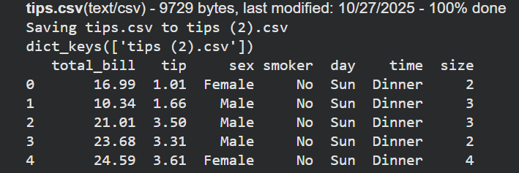
///

import pandas as pd
import matplotlib.pyplot as plt
from google.colab import files

# Upload CSV file
uploaded = files.upload()

# Get the uploaded file name
for filename in uploaded.keys():
print(f"Uploaded file: {filename}")
data = pd.read_csv(filename)

# Scatter plot with day against tip
plt.scatter(data['day'], data['tip'])

# Add title and labels
plt.title("Scatter Plot")
plt.xlabel('Day')
plt.ylabel('Tip')

plt.show()

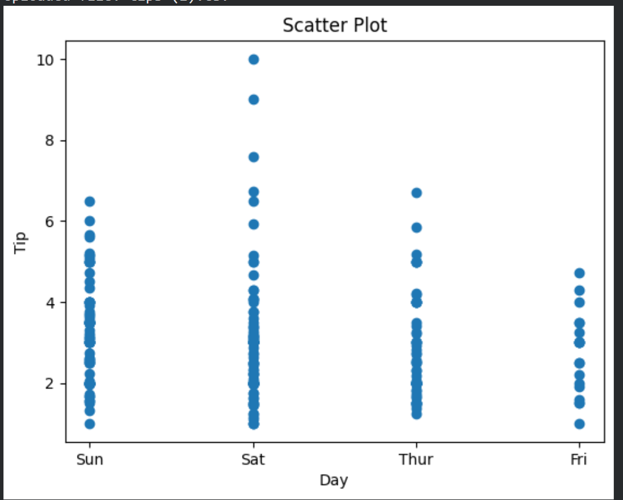
////

import pandas as pd
import matplotlib.pyplot as plt
from google.colab import files

# Upload CSV file
uploaded = files.upload()

# Get the uploaded file name dynamically
for filename in uploaded.keys():
print(f"Uploaded file: {filename}")
data = pd.read_csv(filename)

# Bar chart with day against tip
plt.bar(data['day'], data['tip'])

# Add title and labels
plt.title("Bar Chart")
plt.xlabel('Day')
plt.ylabel('Tip')

# Show the chart
plt.show()

///

# Importing packages
import seaborn as sns
import matplotlib.pyplot as plt
import pandas as pd
from google.colab import files

# Upload CSV file
uploaded = files.upload()

# Get the uploaded file name dynamically
for filename in uploaded.keys():
print(f"Uploaded file: {filename}")
data = pd.read_csv(filename)

# Create bar plot using seaborn
sns.barplot(x='day', y='tip', data=data, hue='sex')

# Show plot
plt.show()

////

# Importing packages
import seaborn as sns
import matplotlib.pyplot as plt
import pandas as pd
from google.colab import files

# Upload CSV file
uploaded = files.upload()

# Read the uploaded file dynamically
for filename in uploaded.keys():
print(f"Uploaded file: {filename}")
data = pd.read_csv(filename)

# Create histogram plot
sns.histplot(x='total_bill', data=data, kde=True, hue='sex')

# Show plot
plt.show()

////

# Importing the modules
from bokeh.plotting import figure, output_notebook, show
from bokeh.palettes import magma
import pandas as pd
from google.colab import files

# Enable Bokeh output in Colab
output_notebook()

# Upload CSV file
uploaded = files.upload()

# Read the uploaded file dynamically
for filename in uploaded.keys():
print(f"Uploaded file: {filename}")
data = pd.read_csv(filename)

# Instantiate the figure object
graph = figure(title="Bokeh Scatter Graph", x_axis_label="Total Bill", y_axis_label="Tip")

# Use a color palette
color = magma(256)

# Plot the graph
graph.scatter(data['total_bill'], data['tip'], color=color[100])

# Display the plot
show(graph)
////

# Importing the modules
from bokeh.plotting import figure, output_notebook, show
import pandas as pd
from google.colab import files

# Enable Bokeh output in Colab
output_notebook()

# Upload CSV file
uploaded = files.upload()

# Read the uploaded file dynamically
for filename in uploaded.keys():
print(f"Uploaded file: {filename}")
data = pd.read_csv(filename)

# Instantiate the figure object
graph = figure(title="Bokeh Bar/Line Chart", x_axis_label="Tip Value", y_axis_label="Count")

# Count of each unique value in 'tip' column
df = data['tip'].value_counts().sort_index()

# Plot the line chart (Bokeh can also do bars)
graph.line(x=df.index, y=df.values, line_width=2)

# Display the plot
show(graph)

////

# Importing the modules
from bokeh.plotting import figure, output_notebook, show
import pandas as pd
from google.colab import files

# Enable Bokeh output inside Colab
output_notebook()

# Upload CSV file
uploaded = files.upload()

# Read the uploaded file dynamically
for filename in uploaded.keys():
print(f"Uploaded file: {filename}")
data = pd.read_csv(filename)

# Instantiate the figure object
graph = figure(title="Bokeh Bar Chart", x_axis_label="X Values", y_axis_label="Y Values")

# Plot the graphs
graph.vbar(x=data['total_bill'], top=data['tip'],
legend_label="Bill VS Tips", color='green', width=0.4)

graph.vbar(x=data['tip'], top=data['size'],
legend_label="Tips VS Size", color='red', width=0.4)

# Allow legend click-to-hide feature
graph.legend.click_policy = "hide"

# Display the plot
show(graph)

/////

# --- Imports ---
import pandas as pd
import numpy as np
from google.colab import files
from bokeh.io import output_notebook, show
from bokeh.layouts import column
from bokeh.models import Button, ColumnDataSource, CustomJS
from bokeh.plotting import figure

# Enable Bokeh output in Colab
output_notebook()

# --- Upload CSV ---
uploaded = files.upload()
for filename in uploaded.keys():
print(f"Uploaded file: {filename}")
data = pd.read_csv(filename)

# --- Data sources for plots ---
source_scatter = ColumnDataSource(data=dict(x=data['total_bill'], y=data['tip']))
source_bar = ColumnDataSource(data=dict(x=data['tip'], y=data['size']))
hist, edges = np.histogram(data['total_bill'], bins=10)
source_hist = ColumnDataSource(data=dict(top=hist, left=edges[:-1], right=edges[1:]))

# --- Figures ---
p1 = figure(title="Scatter: total_bill vs tip", width=600, height=400)
p1.circle('x', 'y', source=source_scatter, size=8, color="green", alpha=0.6)

p2 = figure(title="Bar: tip vs size", width=600, height=400)
p2.vbar(x='x', top='y', source=source_bar, width=0.4, color="red")

p3 = figure(title="Histogram: total_bill", width=600, height=400)
p3.quad(top='top', bottom=0, left='left', right='right', source=source_hist, fill_color="blue", alpha=0.6)

# --- Initial visibility ---
p2.visible = False
p3.visible = False

# --- Buttons with JS callbacks ---
b1 = Button(label="Show Scatter", button_type="success")
b1.js_on_click(CustomJS(args=dict(p1=p1, p2=p2, p3=p3), code="""
p1.visible = true;
p2.visible = false;
p3.visible = false;
"""))

b2 = Button(label="Show Bar", button_type="warning")
b2.js_on_click(CustomJS(args=dict(p1=p1, p2=p2, p3=p3), code="""
p1.visible = false;
p2.visible = true;
p3.visible = false;
"""))

b3 = Button(label="Show Histogram", button_type="primary")
b3.js_on_click(CustomJS(args=dict(p1=p1, p2=p2, p3=p3), code="""
p1.visible = false;
p2.visible = false;
p3.visible = true;
"""))

# --- Layout ---
layout = column(b1, b2, b3, p1, p2, p3)
show(layout)

////

# Import packages
import pandas as pd
from google.colab import files
import plotly.graph_objects as go

# --- Upload CSV file ---
uploaded = files.upload()
for filename in uploaded.keys():
print(f"Uploaded file: {filename}")
data = pd.read_csv(filename)

# --- Create Plotly figure ---
plot = go.Figure(data=[go.Scatter(
x=data['day'],
y=data['tip'],
mode='markers',
)])

# --- Add dropdown to switch plot type ---
plot.update_layout(
updatemenus=[
dict(
buttons=list([
dict(
args=["type", "scatter"],
label="Scatter Plot",
method="restyle"
),
dict(
args=["type", "bar"],
label="Bar Chart",
method="restyle"
)
]),
direction="down",
),
]
)

# --- Show plot ---
plot.show()

///
# Import packages
import pandas as pd
from google.colab import files
import plotly.graph_objects as go

# --- Upload CSV file ---
uploaded = files.upload()
for filename in uploaded.keys():
print(f"Uploaded file: {filename}")
data = pd.read_csv(filename)

# --- Create Plotly figure with line plot ---
plot = go.Figure(data=[go.Scatter(
y=data['tip'],
mode='lines',
)])

# --- Add range selector and range slider ---
plot.update_layout(
xaxis=dict(
rangeselector=dict(
buttons=list([
dict(count=1,
step="day",
stepmode="backward"),
])
),
rangeslider=dict(
visible=True
),
)
)

# --- Show plot ---
plot.show()

import sqlite3
import pandas as pd

# --- Load your DB file ---
db_path = "/content/CIS4044-N-SDI-OPENMETEO-PARTIAL.db"
conn = sqlite3.connect(db_path)

# --- Get list of all tables in the DB ---
tables = pd.read_sql_query(
"SELECT name FROM sqlite_master WHERE type='table';", conn
)
table_names = tables["name"].tolist()

print("Tables detected:")
display(tables)

# --- Loop through each table and display ALL records ---
for table in table_names:
print(f"\n=== TABLE: {table} ===")
df = pd.read_sql_query(f"SELECT * FROM {table};", conn)
display(df)

conn.close()

# Step 1: Import sqlite3
import sqlite3
import pandas as pd

# Step 2: Connect to a SQLite database (it will create it in Colab environment)
conn = sqlite3.connect('example.db') # 'example.db' is the database file
cursor = conn.cursor()

# Step 3: Create a table
cursor.execute('''
CREATE TABLE IF NOT EXISTS students (
id INTEGER PRIMARY KEY,
name TEXT NOT NULL,
age INTEGER,
grade TEXT
)
''')

# Step 4: Insert some data
students_data = [
(1, 'Alice', 20, 'A'),
(2, 'Bob', 22, 'B'),
(3, 'Charlie', 21, 'A'),
(4, 'David', 23, 'C')
]

cursor.executemany('INSERT OR REPLACE INTO students VALUES (?, ?, ?, ?)', students_data)

# Commit changes
conn.commit()

# Step 5: Query the table
cursor.execute('SELECT * FROM students')
rows = cursor.fetchall()

# Display the results using pandas for better readability
df = pd.DataFrame(rows, columns=['ID', 'Name', 'Age', 'Grade'])
print("All students in the database:")
print(df)

# Step 6: Example: Filter students with grade 'A'
cursor.execute("SELECT * FROM students WHERE grade='A'")
grade_a_students = cursor.fetchall()
df_a = pd.DataFrame(grade_a_students, columns=['ID', 'Name', 'Age', 'Grade'])
print("\nStudents with Grade A:")
print(df_a)

# Step 7: Close the connection
conn.close()

