BDBI Week 3 Lab Evidence Log
Date: 2026-06-27 | Dataset: Netflix titles | Tool: Power BI Desktop on Windows cloud computer

1. Completion Summary
Item | Status | Evidence / Note
Data import | Completed | Three prepared CSV tables were loaded into Power BI.
Model relationships | Completed | Power BI model view shows two active one-to-one show_id relationships.
PBIX saved | Completed | Saved on cloud desktop as C:\Users\admin\Desktop\AI\BDBI\week3\lab\20260627.pbix.
Business answers | Completed | Metrics and charts generated locally from the cleaned dataset.
Power BI screenshots | Manual capture needed | macOS screenshot permission was unavailable, so screenshots should be inserted manually in Word.

2. Power BI Model Notes
The Power BI model contains three tables: netflix_main_clean, netflix_type, and netflix_date. The model view confirmed two active one-to-one relationships:
- netflix_main_clean[show_id] to netflix_type[show_id]
- netflix_main_clean[show_id] to netflix_date[show_id]
Screenshot to insert manually: Power BI Model view showing the three tables and two relationship lines.

3. Business Question Results
Question Area | Answer | Note
Top director | Raul Campos, Jan Suter | 18 movies
Directors with one movie | 1811 | Matches the lab target value
Directors with more than 10 movies | 2 | Raul Campos, Jan Suter; Marcus Raboy
Movies in 2020 | 33 | Using added_year because release_year is missing
2020 movies over 60 min | 32 | Duration converted to numeric minutes
Highest movie year | 2019 | 832 movies
Lowest movie year | 2020 | 33 movies
Top country | United States | 968 movies

4. Generated Evidence Charts

Movies by Added Year
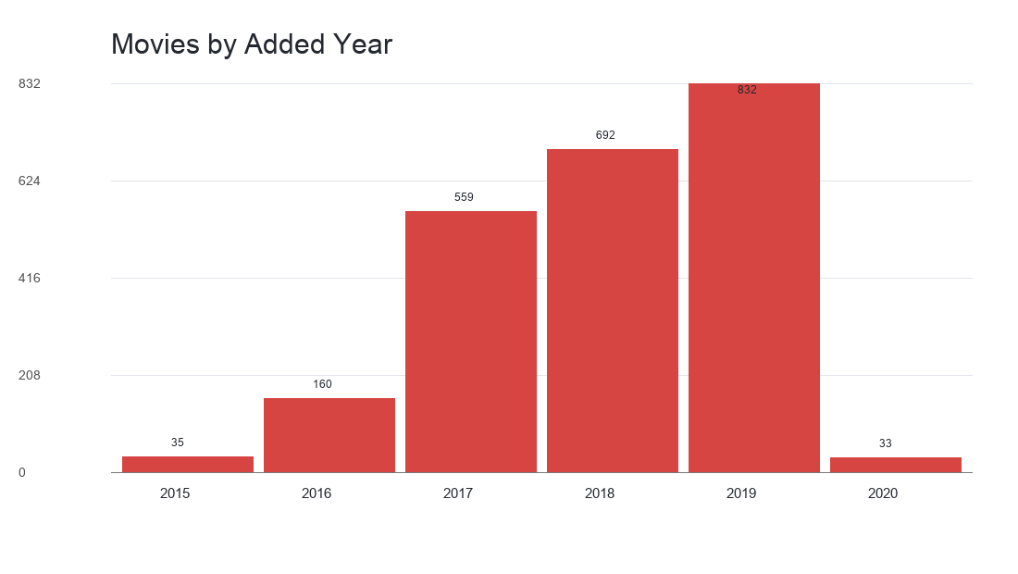

Top 10 Countries by Movie Count
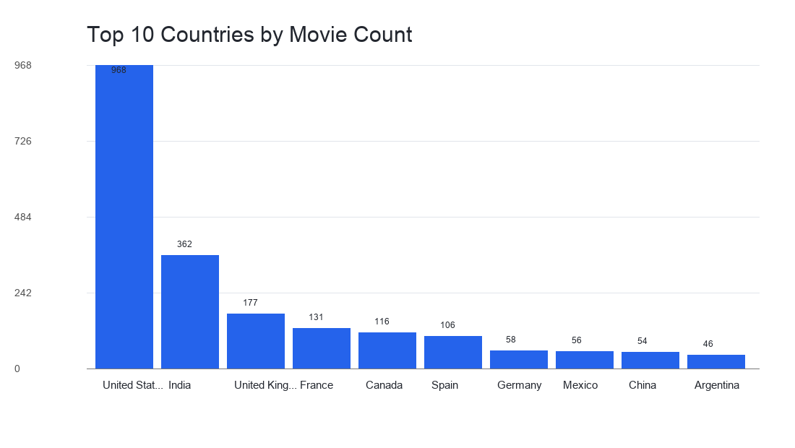

Top 10 Directors by Movie Count
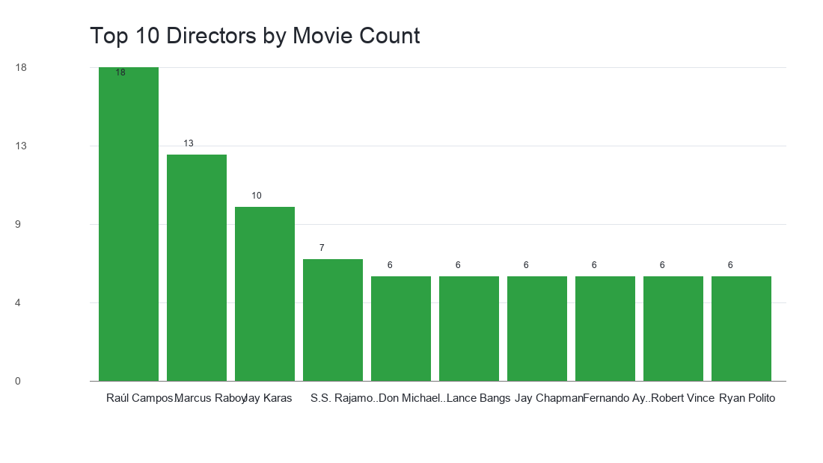

5. Manual Screenshot Checklist
- Power BI title bar showing file 20260627.pbix saved.
- Data pane showing netflix_main_clean, netflix_type, and netflix_date.
- Model view showing two active show_id relationships.
- If building visuals manually in Power BI later: final dashboard/report page screenshot.

6. Student Reflection
The lab was completed using prepared clean CSV outputs to avoid repeating the same Power Query steps in the remote environment. The dataset did not contain release_year, so added_year extracted from date_added was used for year-based questions. The Power BI relationship model is complete and the business answers are supported by generated metrics and charts.

