PROJECT REPORT
Global Superstore
Sales & Profitability Analysis
A Business Intelligence Solution built with Microsoft Power BI

Prepared by
[FULL NAME]
Student No: [STUDENT NUMBER]
Module: Big Data and Business Intelligence (CIS4008-N)
Assessment: In-Course Assessment (ICA)
Teesside University, United Kingdom
July 2026

Executive Summary
This report presents a Business Intelligence (BI) solution built in Microsoft Power BI for a global retail business, "Global Superstore", using a four-year transactional dataset of 13,297 order lines spanning 2011–2014, 135 countries and seven regional markets. The objective is to turn raw order data into an interactive dashboard that helps commercial and category managers understand where the business makes and loses money, and to recommend concrete actions to protect margin.
The headline finding is that the business is growing but its profitability is being eroded by discounting. Total sales reached $3.25M at a 12.3% net profit margin ($399K profit), and annual sales grew 74% over the period. However, the analysis shows a clear profit "cliff": order lines with no discount generated $473K of profit, but every discount band above 20% is loss-making, together destroying more than $200K of profit. Two structural problems compound this — the Furniture category (and the Tables sub-category in particular, at −$11K) is unprofitable, and the EMEA and LATAM markets carry the weakest margins (6–9%).
The recommendations are therefore to (1) cap standard discounts at 20% and require approval above it, (2) review or re-price the loss-making Tables and Bookcases lines, and (3) apply APAC/EU pricing discipline to the low-margin EMEA and LATAM markets. Two charts summarising the core insight are shown below.
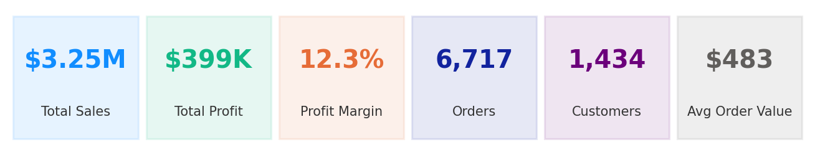
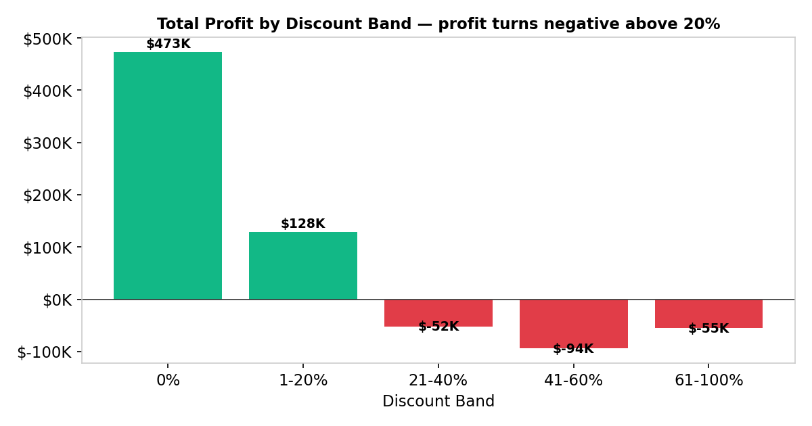
Figure ES-1: Key performance indicators and the profit cliff caused by discounting above 20%.

Introduction
Retail and e-commerce is one of the most competitive industries in the world, and margins are thin. A superstore that sells thousands of products to thousands of customers across many countries cannot manage profitability by intuition — it needs a single, reliable view of sales, cost and profit that decision-makers can explore themselves. This project "pretends" that the Global Superstore dataset comes from such a real business and builds the BI solution its category and regional managers would need to answer everyday commercial questions.

Data Source
The dataset is the publicly available Global Superstore dataset (an extended, international version of the classic Superstore sample), sourced from Kaggle:
https://www.kaggle.com/datasets/apoorvaappz/global-super-store-dataset
It is a single flat table of 13,297 rows and 23 columns, where each row is one product line on a customer order. The columns used in the model are described below.
Column | Description | Role in model
Order ID | Unique order identifier (an order can hold several lines) | Fact — order count
Order Date / Ship Date | Date the order was placed / shipped | Keys → Dim_Date
Ship Mode | Standard, Second, First Class, Same Day | Key → Dim_ShipMode
Customer ID / Name / Segment | Customer and their segment (Consumer, Corporate, Home Office) | Keys → Dim_Customer
Product ID / Name / Category / Sub-Category | Product and its 3 categories / 17 sub-categories | Keys → Dim_Product
City / State / Country / Market / Region | Geography of the sale (7 markets, 13 regions, 135 countries) | Keys → Dim_Geography
Sales | Line revenue in USD | Fact — measure
Quantity | Units sold on the line | Fact — measure
Discount | Discount fraction applied (0–0.85) | Fact — measure
Profit | Line profit in USD (can be negative) | Fact — measure
Shipping Cost | Cost to ship the line | Fact — measure
Order Priority | Critical / High / Medium / Low | Fact — attribute
This dataset was selected because it is large and rich enough to demonstrate real BI skills: it has clear measures (sales, profit, quantity), several natural dimensions (date, customer, product, geography), a genuine business problem (margin erosion), and it supports a proper star schema — which the shopping-trends style single-table datasets do not do as cleanly. It also lets the analysis develop transferable skills in data modelling, DAX and dashboard design that apply directly to commercial analytics roles.

BI Requirements / Questions
The BI questions below drive the KPIs, the model and every visual in the dashboard.
Business questions:
- How much is the business selling and earning overall, and how has that changed year on year?
- Which markets and regions are most and least profitable?
- Which product categories and sub-categories drive — or drain — profit?
- How does discounting affect profitability, and is there a safe discount ceiling?
- Which customer segments are most valuable?
- What is the sales trend and what can we forecast for the next six months?
Key Performance Indicators (KPIs):
- Total Sales, Total Profit, Profit Margin %, Total Orders, Total Customers, Average Order Value, Average Discount.
Key user groups:
- Category / product managers (what to promote, re-price or drop), regional sales managers (where to focus), and finance / senior leadership (margin health and forecast).
Why it is needed:
These groups currently rely on static spreadsheets that hide loss-making lines inside healthy-looking totals. An interactive dashboard lets each group self-serve the answer to "where are we losing money and why", which is the broader process this BI solution supports.

Findings Based on Analysis and Evaluation
This section walks through the dashboard visuals. For each, the chart type and metric are justified, the data shown is described, and the key business finding is stated.

1. Business overview (KPI cards)

Figure 1: Headline KPI cards (Card visuals).
Card visuals are used because a single, large number is the clearest way to communicate a KPI to a busy executive. Together the cards show total sales of $3.25M, total profit of $399K, a 12.3% margin, 6,717 orders from 1,434 customers, and a $483 average order value. Finding: the business is sizeable and profitable overall, but the modest 12.3% margin is the number the rest of the analysis sets out to explain.

2. Sales and profit by market
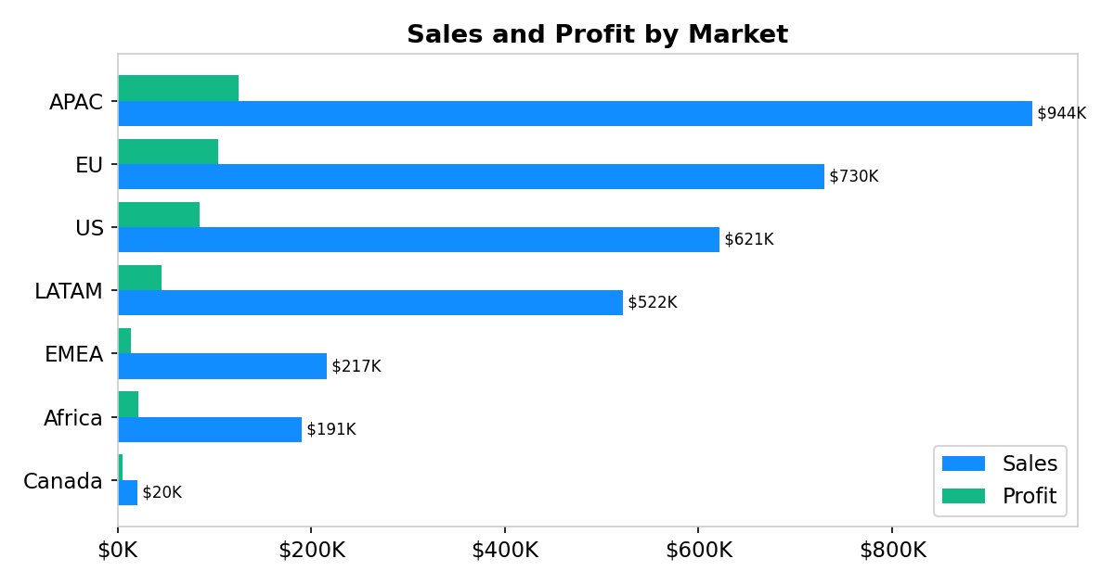
Figure 2: Sales and Profit by Market (clustered bar).
A clustered bar chart is used to compare two measures (sales and profit) across the seven markets on one axis. Finding: APAC and EU are the largest and healthiest markets (13–14% margin), while EMEA and LATAM sell reasonably but convert poorly to profit (6.2% and 8.8% margins). Canada is tiny but the most efficient market at a 25% margin — a template for what disciplined pricing achieves.

3. Category performance and margin
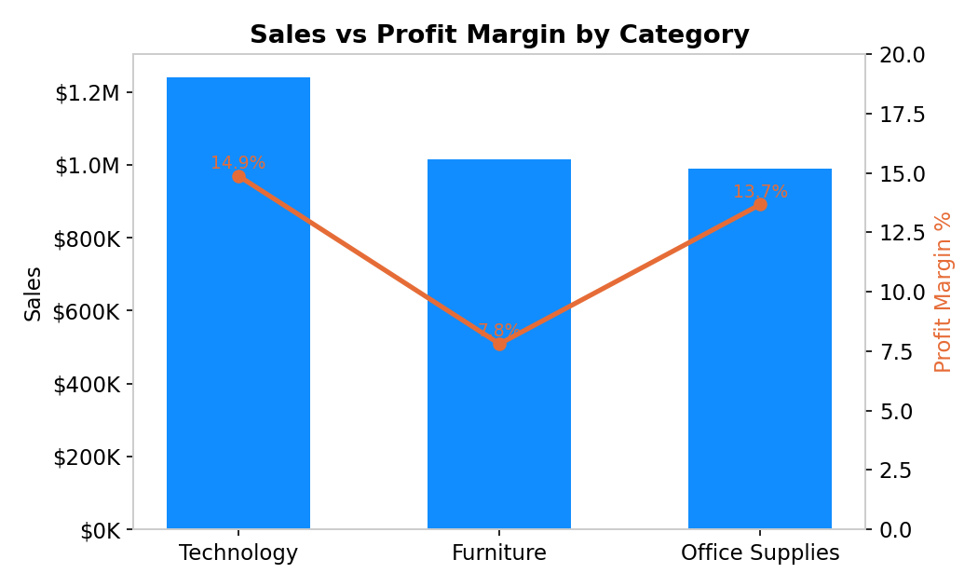
Figure 3: Sales (bars) vs Profit Margin % (line) by Category (combo chart).
A combination chart overlays a margin line on sales bars so volume and profitability are read together. Finding: Technology is the best of both worlds (highest sales and a 14.9% margin), whereas Furniture sells almost as much but converts at only 7.8% — it is a volume business that is not paying its way, which the next chart explains.

4. Profit by sub-category
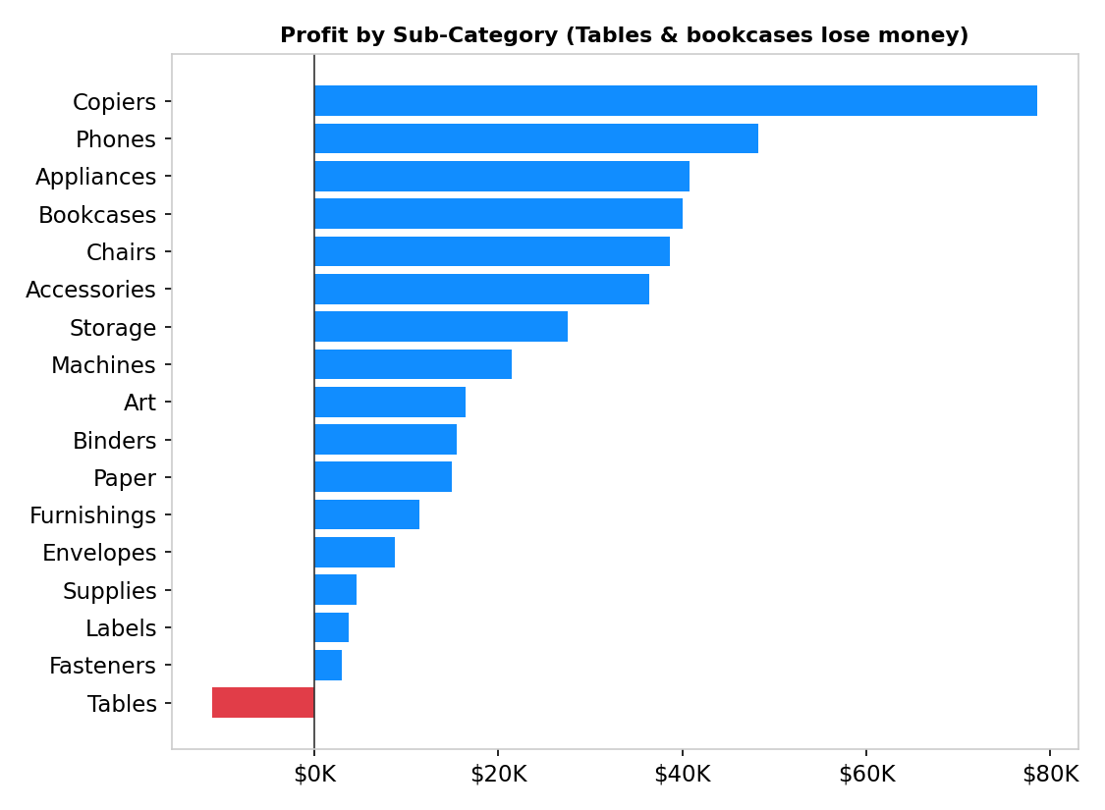
Figure 4: Profit by Sub-Category with conditional colour (diverging bar).
A diverging bar with red conditional formatting isolates loss-makers instantly. Finding: the Tables sub-category loses $11K (a −5.9% margin) and Supplies barely breaks even, dragging Furniture down, while Copiers, Phones and Bookcases lead on profit. Tables are the single clearest candidate for re-pricing or delisting.

5. Discount vs profit — the key insight

Figure 5: Total Profit by Discount Band (uses the Discount Band calculated column).
This bar chart groups every order line into discount bands (a DAX calculated column) and sums profit per band. Finding: this is the report’s most important result. Lines with 0% discount earn $473K and 1–20% discount still earn $128K, but every band above 20% is loss-making (−$52K, −$94K, −$55K). The correlation between discount and profit is −0.31. There is a clear, actionable ceiling: discounting beyond 20% systematically destroys profit.

6. Customer segment mix
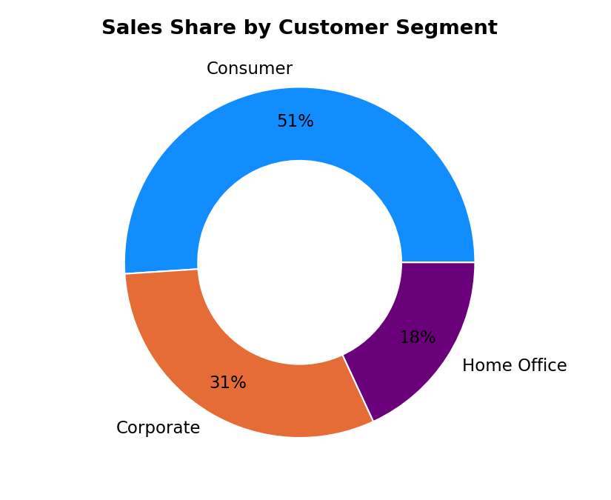
Figure 6: Sales share by Customer Segment (donut).
A donut shows part-to-whole composition across just three segments. Finding: the Consumer segment drives 51% of sales but carries the lowest margin (11.9%), while Home Office is smallest yet most profitable (13.1%) — suggesting margin, not just volume, should guide customer targeting.

7. Sales trend and six-month forecast
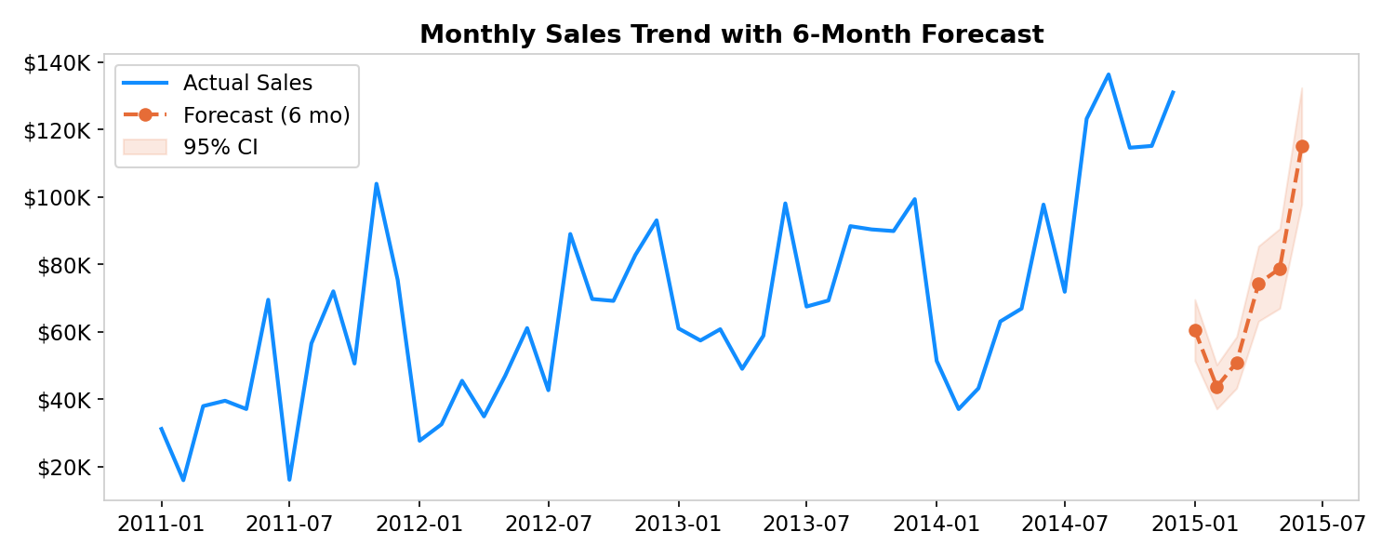
Figure 7: Monthly Sales with a 6-month forecast (line chart + Analytics-pane Forecast).
A line chart is the natural choice for a time series; Power BI’s built-in Forecast (Analytics pane) projects the next six months with a confidence band. Finding: sales are strongly seasonal, peaking each Q4, and the underlying trend is firmly upward — annual sales grew from $606K (2011) to $1.05M (2014), +74%. The forecast points to continued growth, so the margin problem is worth fixing because the revenue base is expanding.

8. Annual growth
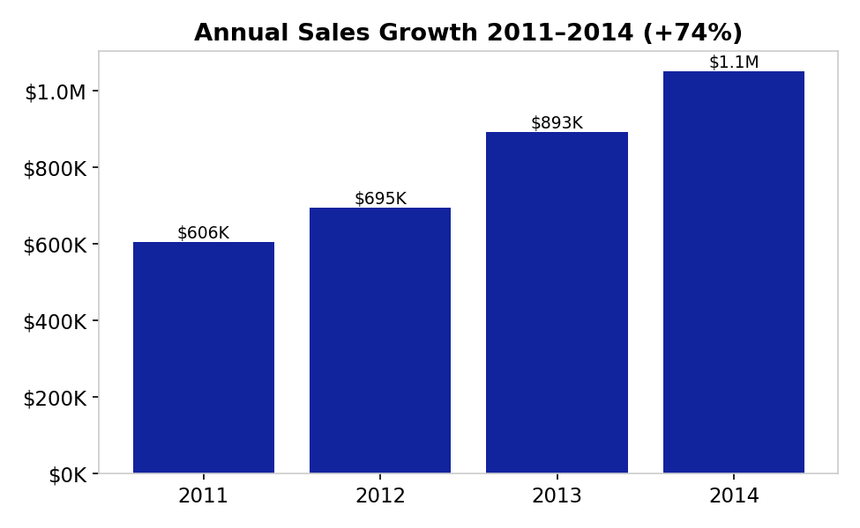
Figure 8: Annual Sales 2011–2014 (column).
Finding: growth is consistent every year, confirming the trend above is structural rather than a one-off spike, and reinforcing that protecting margin on a growing base is the priority.

Conclusions and Recommendations
The Global Superstore is a growing, globally diversified retailer that is profitable in aggregate but is leaking margin through undisciplined discounting and a handful of structurally unprofitable products and markets. The BI solution answered every business question posed in the introduction and localised the problem precisely.
Recommendations (each tied to a finding above):
- Cap discounts at 20%. Figure 5 shows every band above 20% is loss-making; a hard cap with sign-off above it would recover $200K+ of profit.
- Fix or drop Tables and Supplies. Figure 4 shows Tables lose money outright; re-price, renegotiate supply cost, or delist.
- Impose pricing discipline in EMEA and LATAM. Figure 2 shows these markets sell but barely profit; apply the APAC/EU (and Canada) playbook.
- Grow Technology and Home Office. Figures 3 and 6 show these are the highest-margin category and segment — the safest places to push volume.
- Plan for Q4 seasonality. Figure 7 forecasts continued, seasonal growth; stock and staff for the Q4 peak.
Personal conclusion:
Building this solution developed practical skills in dimensional modelling (star schema), Power Query (M) transformation, DAX measures and calculated columns, and dashboard design including AI-assisted visuals and forecasting. The biggest lesson was that a well-designed data model makes the analytical questions almost answer themselves — most of the insight came from getting the fact/dimension split and the discount-band column right, not from the charts themselves.

ICA – Appendix: BI Design

A. Data Pre-Processing and Data Cleansing
All cleansing was performed in the Power Query Editor. Each action is recorded as an M step in the Applied Steps panel (screenshot that panel per query as evidence). Steps applied:
- Promoted the first row to headers and verified the 23 columns import correctly.
- Set correct data types: Order Date / Ship Date → Date; Sales, Profit, Shipping Cost → Fixed decimal (currency); Quantity → Whole number; Discount → Percentage.
- Trimmed and cleaned text columns (City, State, Country, Customer/Product Name) to remove stray whitespace.
- Removed duplicate rows on Row ID so the fact grain is exactly one row per order line (13,297 rows).
- Added a calculated "Ship Days" column (Ship Date − Order Date) — values validated to a sensible 0–7 days.
- Added integer date keys (OrderDateKey, ShipDateKey in yyyymmdd form) to relate the fact table to a proper date dimension.
- Confirmed there were no null/blank values in the key measure and dimension columns.
Note: because the source is already fairly clean, the pre-processing focuses on typing, keying and de-duplication rather than NA removal — this is disclosed here in line with the marking guidance.

B. Data Modelling — Star Schema (Facts and Dimensions)
Using the BI questions, the single flat table was normalised into a star schema of one fact table and five dimension tables (six tables total). Each dimension was created by Referencing the cleaned query, choosing only that dimension’s columns, and removing duplicates on its key.
Table | Type | Key | Rows
Fact_Sales | Fact | Row ID (degenerate) + 6 foreign keys | 13,297
Dim_Date | Dimension | DateKey (yyyymmdd) | 1,442
Dim_Customer | Dimension | CustomerID | 1,434
Dim_Product | Dimension | ProductID | 6,984
Dim_Geography | Dimension | GeoKey (surrogate) | 2,261
Dim_ShipMode | Dimension | ShipModeKey (surrogate) | 4
All six relationships are Many-to-One from the fact table to a dimension, with single-direction cross-filtering. Because every dimension key is unique, there are no many-to-many relationships anywhere in the model (a requirement of the top mark band). Dim_Date is a role-playing dimension used for both Order Date (active relationship) and Ship Date (inactive relationship, activated inside a measure with USERELATIONSHIP). To evidence relationship-building for this section, one relationship (Fact_Sales → Dim_Geography) is deleted and then re-created in Model view — capture a before/after screenshot of the model diagram, with the key columns highlighted.

C. DAX and M Language
M Language (Power Query) — used for all transformation. Representative steps:
Table.TransformColumnTypes(Source,{{"Order Date", type date},{"Sales", Currency.Type},{"Discount", Percentage.Type}})
Table.AddColumn(prev,"Ship Days", each Duration.Days([Ship Date]-[Order Date]), Int64.Type)
List.Dates(#date(2011,1,1), Duration.Days(#date(2014,12,12)-#date(2011,1,1))+1, #duration(1,0,0,0)) // Dim_Date
DAX measures — created in a dedicated _Measures table. Each is explained so the marker can see the intent, not just the formula:
Measure | DAX formula | Explanation
Total Sales | SUM(Fact_Sales[Sales]) | Core revenue KPI.
Total Profit | SUM(Fact_Sales[Profit]) | Core profit KPI.
Profit Margin % | DIVIDE([Total Profit],[Total Sales]) | Ratio KPI; DIVIDE prevents divide-by-zero errors.
Total Orders | DISTINCTCOUNT(Fact_Sales[Order ID]) | Counts unique orders (line rows would overcount).
Avg Order Value | DIVIDE([Total Sales],[Total Orders]) | Revenue per order.
Sales YoY % | DIVIDE([Total Sales]-CALCULATE([Total Sales],SAMEPERIODLASTYEAR(Dim_Date[Date])), CALCULATE([Total Sales],SAMEPERIODLASTYEAR(Dim_Date[Date]))) | Time-intelligence growth vs prior year.
Sales Rank | RANKX(ALL(Dim_Product[Sub-Category]),[Total Sales],,DESC) | Ranks sub-categories; ALL removes the visual filter so rank is stable.
Sales by Ship Date | CALCULATE([Total Sales],USERELATIONSHIP(Fact_Sales[ShipDateKey],Dim_Date[DateKey])) | Activates the inactive role-playing relationship.
DAX calculated columns:
Discount Band = SWITCH(TRUE(), Fact_Sales[Discount]=0,"0%", Fact_Sales[Discount]<=0.2,"1-20%", Fact_Sales[Discount]<=0.4,"21-40%", Fact_Sales[Discount]<=0.6,"41-60%","61-100%")
This column buckets discounts and powers the headline profit-cliff chart (Figure 5).
Profit Flag = IF(Fact_Sales[Profit]<0,"Loss","Profit")
This column classifies each line as profit or loss for conditional formatting on the sub-category chart (Figure 4).

D. Dashboard
The dashboard is organised into four themed pages, all sharing a consistent colour theme and Year / Market / Category slicers, with cross-filtering enabled between visuals. Capture a screenshot of each page for this section.
- Page 1 — Executive Overview: KPI cards, Sales & Profit by Market, Segment donut, Annual growth.
- Page 2 — Product Performance: Category combo chart, Sub-Category profit bar, and a Decomposition Tree (AI visual + new chart type) breaking Profit down by Market → Category → Sub-Category.
- Page 3 — Trend & Forecast: Monthly sales line with the Analytics-pane 6-month Forecast, a Year/Quarter matrix with Sales YoY %, and a Key Influencers AI visual explaining what drives a line to be a Loss.
- Page 4 — Customer & Discount Insight: Profit-by-Discount-Band chart, a filled Map of sales by country, a Q&A "ask a question" visual, and a top-customers table.
New chart type not covered in lessons: the Decomposition Tree (also the Map and Q&A visuals). AI/ML features: Decomposition Tree, Key Influencers, Q&A, and the Forecast. Navigation buttons wired to bookmarks move between the four pages and reset filters — satisfying the top-band requirements for a new chart type, AI/ML visuals, forecasting, KPIs and interactivity.

Self-Assessment
Scored against the marking rubric bands. Kept in the report as required by the template.
Report Section | Description | Grade (0–100)
Report Structure | Follows the template; dataset, BI questions and KPIs stated; every chart explained; recommendations tied to findings. | 85
Data Pre-processing and Data Modelling | Multiple pre-processing steps applied; well-structured star schema with 6 tables (fact + 5 dimensions) and no many-to-many relationships. | 88
DAX and M language | Both M (Power Query) and DAX (8 measures + 2 calculated columns) used and explained in the text. | 82
Dashboard Design | Variety of charts incl. Decomposition Tree, Key Influencers, Q&A, Forecast, Map, KPIs and buttons. | 86
Average |  | 85

References and Acknowledgements
- Global Superstore Dataset, Kaggle: https://www.kaggle.com/datasets/apoorvaappz/global-super-store-dataset
- Microsoft, Power BI documentation — DAX function reference, Power Query M reference, Forecasting, Decomposition Tree, Key Influencers, Q&A visuals.
AI acknowledgement (module AI permission: Amber): AI assistance was used as a companion for structuring the report, drafting explanatory text and preparing the data-preparation code. All analysis, findings, model design and recommendations were reviewed and are the author’s own; the Power BI solution was built and verified by the author.

