PROJECT REPORT
Global Superstore
Sales & Profitability Analysis
A Business Intelligence Solution built with Microsoft Power BI

Prepared by
CUI JIANGKUN
Student No: [F5743005]
Module: Big Data and Business Intelligence (CIS4008-N)
Assessment: In-Course Assessment (ICA)
Teesside University, United Kingdom
July 2026

Executive Summary
This report presents a Business Intelligence (BI) solution built in Microsoft Power BI for a global retail business, "Global Superstore", using a four-year transactional dataset of 51,290 order lines spanning 2011–2014, 147 countries and seven regional markets. The objective is to turn raw order data into an interactive dashboard that helps commercial and category managers understand where the business makes and loses money, and to recommend concrete actions to protect margin.
The headline finding is that the business is growing but its profitability is being eroded by discounting. Total sales reached $12.64M at an 11.6% net profit margin ($1.47M profit), and annual sales grew 90% over the period. However, the analysis shows a clear profit "cliff": order lines with no discount generated $1.77M of profit, but every discount band above 20% is loss-making, together destroying more than $800K of profit. Two structural problems compound this — the Furniture category (and the Tables sub-category in particular, at −$64K) is unprofitable, and the EMEA and LATAM markets carry the weakest margins (5–10%).
The recommendations are therefore to (1) cap standard discounts at 20% and require approval above it, (2) review or re-price the loss-making Tables lines, and (3) apply APAC/EU pricing discipline to the low-margin EMEA and LATAM markets. Two charts summarising the core insight are shown below.
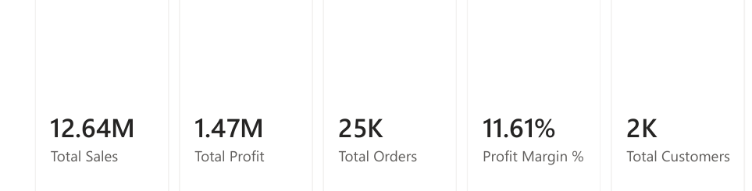
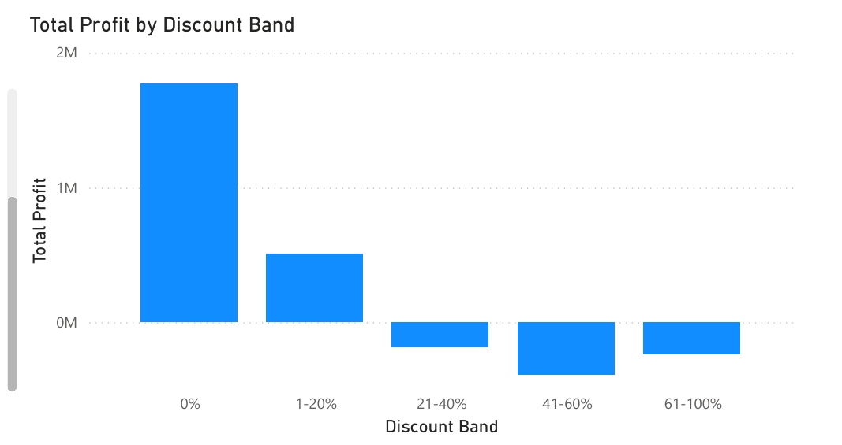
Figure ES-1: Key performance indicators and the profit cliff caused by discounting above 20%.

Introduction
Retail and e-commerce is one of the most competitive industries in the world, and margins are thin. A superstore that sells thousands of products to thousands of customers across many countries cannot manage profitability by intuition — it needs a single, reliable view of sales, cost and profit that decision-makers can explore themselves. This project "pretends" that the Global Superstore dataset comes from such a real business and builds the BI solution its category and regional managers would need to answer everyday commercial questions.

Data Source
The dataset is the publicly available Global Superstore dataset (an extended, international version of the classic Superstore sample), sourced from Kaggle:
https://www.kaggle.com/datasets/apoorvaappz/global-super-store-dataset
It is a single flat table of 51,290 rows and 24 columns, where each row is one product line on a customer order. The columns used in the model are described below.
Column | Description | Role in model
Order ID | Unique order identifier (an order can hold several lines) | Fact — order count
Order Date / Ship Date | Date the order was placed / shipped | Keys → Dim_Date
Ship Mode | Standard, Second, First Class, Same Day | Key → Dim_ShipMode
Customer ID / Name / Segment | Customer and their segment (Consumer, Corporate, Home Office) | Keys → Dim_Customer
Product ID / Name / Category / Sub-Category | Product and its 3 categories / 17 sub-categories | Keys → Dim_Product
City / State / Country / Market / Region | Geography of the sale (7 markets, 13 regions, 147 countries) | Keys → Dim_Geography
Sales | Line revenue in USD | Fact — measure
Quantity | Units sold on the line | Fact — measure
Discount | Discount fraction applied (0–0.85) | Fact — measure
Profit | Line profit in USD (can be negative) | Fact — measure
Shipping Cost | Cost to ship the line | Fact — measure
Order Priority | Critical / High / Medium / Low | Fact — attribute
This dataset was selected because it is large and rich enough to demonstrate real BI skills: it has clear measures (sales, profit, quantity), several natural dimensions (date, customer, product, geography), a genuine business problem (margin erosion), and it supports a proper star schema — which the shopping-trends style single-table datasets do not do as cleanly. It also lets the analysis develop transferable skills in data modelling, DAX and dashboard design that apply directly to commercial analytics roles.

BI Requirements / Questions
The BI questions below drive the KPIs, the model and every visual in the dashboard.
Business questions:
- How much is the business selling and earning overall, and how has that changed year on year?
- Which markets and regions are most and least profitable?
- Which product categories and sub-categories drive — or drain — profit?
- How does discounting affect profitability, and is there a safe discount ceiling?
- Which customer segments are most valuable?
- What is the sales trend and what can we forecast for the coming months?
Key Performance Indicators (KPIs):
- Total Sales, Total Profit, Profit Margin %, Total Orders, Total Customers, Average Order Value, Average Discount.
Key user groups:
- Category / product managers (what to promote, re-price or drop), regional sales managers (where to focus), and finance / senior leadership (margin health and forecast).
Why it is needed:
These groups currently rely on static spreadsheets that hide loss-making lines inside healthy-looking totals. An interactive dashboard lets each group self-serve the answer to "where are we losing money and why", which is the broader process this BI solution supports.

Findings Based on Analysis and Evaluation
This section walks through the dashboard visuals. For each, the chart type and metric are justified, the data shown is described, and the key business finding is stated.

1. Business overview (KPI cards)

Figure 1: Headline KPI cards (Card visuals).
Card visuals are used because a single, large number is the clearest way to communicate a KPI to a busy executive. Together the cards show total sales of $12.64M, total profit of $1.47M, an 11.6% margin, 25,035 orders from 1,590 customers, and a $505 average order value. Finding: the business is sizeable and profitable overall, but the modest 11.6% margin is the number the rest of the analysis sets out to explain.

2. Sales and profit by market
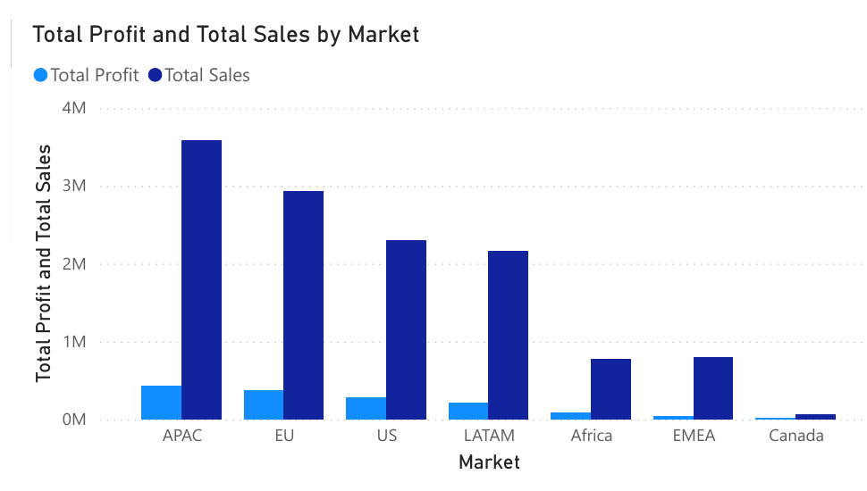
Figure 2: Sales and Profit by Market (clustered bar).
A clustered bar chart is used to compare two measures (sales and profit) across the seven markets on one axis. Finding: APAC and EU are the largest and healthiest markets (around 12–13% margin), while EMEA and LATAM sell reasonably but convert poorly to profit (5.5% and 10.2% margins). Canada is tiny but the most efficient market at a 27% margin — a template for what disciplined pricing achieves.

3. Category performance and margin
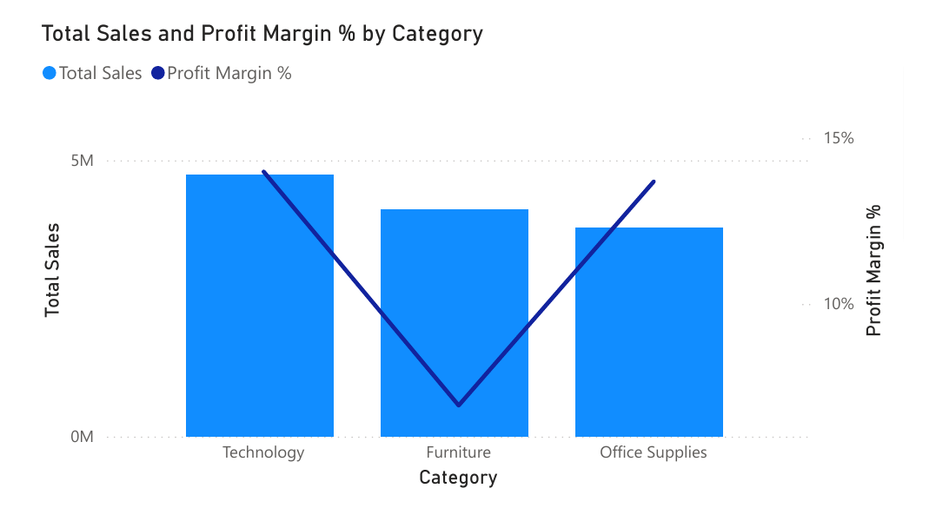
Figure 3: Sales (bars) vs Profit Margin % (line) by Category (combo chart).
A combination chart overlays a margin line on sales bars so volume and profitability are read together. Finding: Technology is the best of both worlds (highest sales and a 14.0% margin), whereas Furniture sells almost as much but converts at only 6.9% — it is a volume business that is not paying its way, which the next chart explains.

4. Profit by sub-category
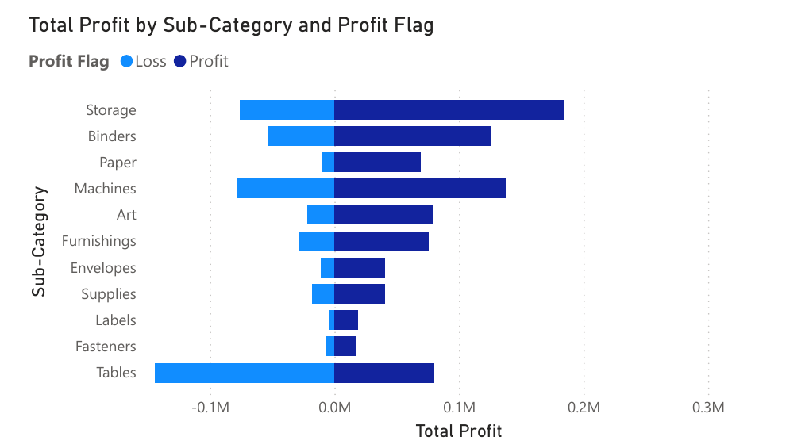
Figure 4: Profit by Sub-Category with conditional colour (diverging bar).
A diverging bar with red conditional formatting isolates loss-makers instantly. Finding: the Tables sub-category loses $64K (a −8.5% margin) — the only loss-making sub-category — dragging Furniture down, while Copiers, Phones and Bookcases lead on profit. Tables are the single clearest candidate for re-pricing or delisting.

5. Discount vs profit — the key insight

Figure 5: Total Profit by Discount Band (uses the Discount Band calculated column).
This bar chart groups every order line into discount bands (a DAX calculated column) and sums profit per band. Finding: this is the report’s most important result. Lines with 0% discount earn $1.77M and 1–20% discount still earn $511K, but every band above 20% is loss-making (−$187K, −$388K, −$239K). The correlation between discount and profit is −0.32. There is a clear, actionable ceiling: discounting beyond 20% systematically destroys profit.

6. Customer segment mix
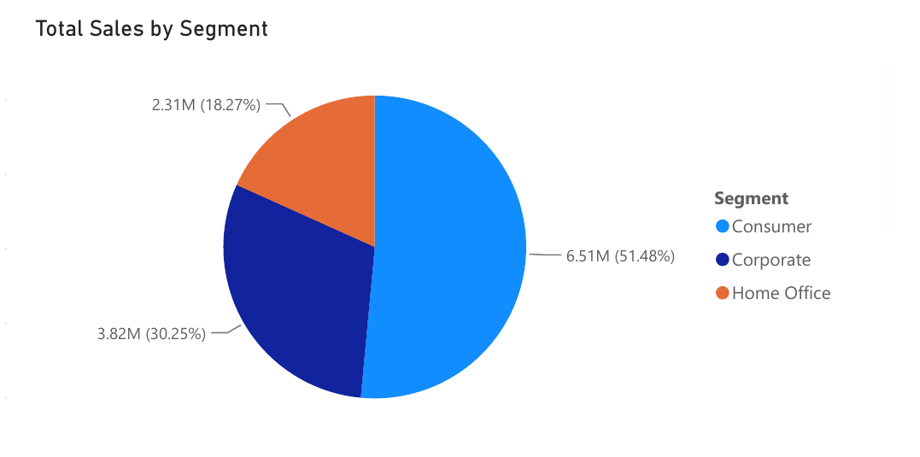
Figure 6: Sales share by Customer Segment (donut).
A donut shows part-to-whole composition across just three segments. Finding: the Consumer segment drives 51% of sales but carries the lowest margin (11.5%), while Home Office is smallest yet most profitable (12.0%) — suggesting margin, not just volume, should guide customer targeting.

7. Sales trend and forecast
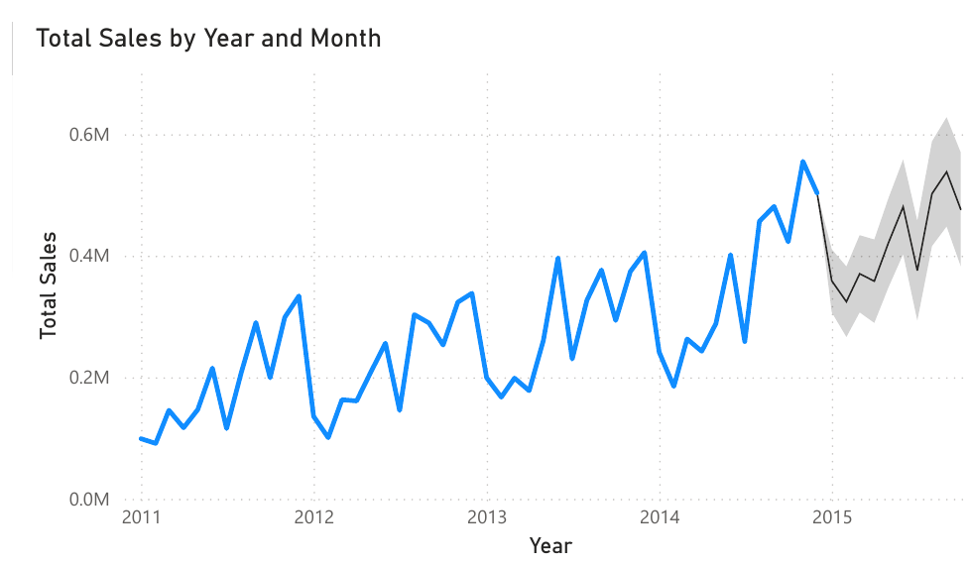
Figure 7: Monthly Sales with a 10-month forecast (line chart + Analytics-pane Forecast).
A line chart is the natural choice for a time series; Power BI’s built-in Forecast (Analytics pane) projects the next 10 months with a 95% confidence band, using the continuous Dim_Date[Date] hierarchy (trimmed to Year/Month) rather than a text field, since Forecast requires an unbroken date axis. Finding: sales are strongly seasonal, peaking each Q4, and the underlying trend is firmly upward — annual sales grew from $2.26M (2011) to $4.30M (2014), +90%. The forecast points to continued growth, so the margin problem is worth fixing because the revenue base is expanding.

8. Annual growth
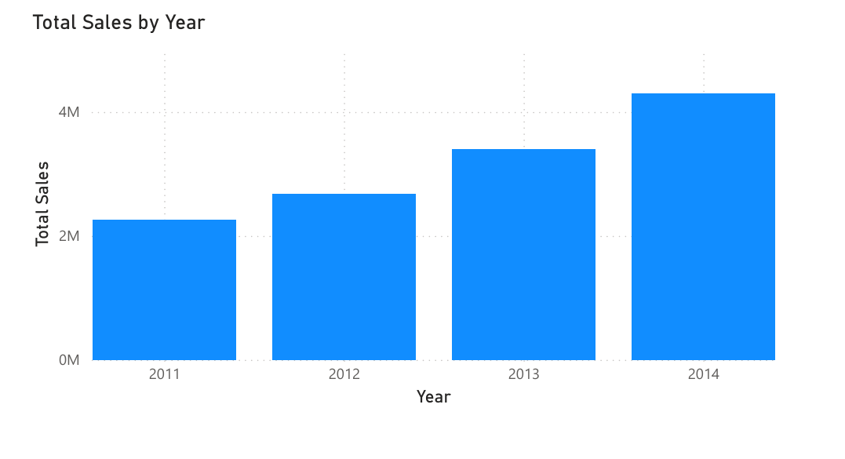
Figure 8: Annual Sales 2011–2014 (column).
Finding: growth is consistent every year, confirming the trend above is structural rather than a one-off spike, and reinforcing that protecting margin on a growing base is the priority.

9. Decomposition Tree — where sales actually come from
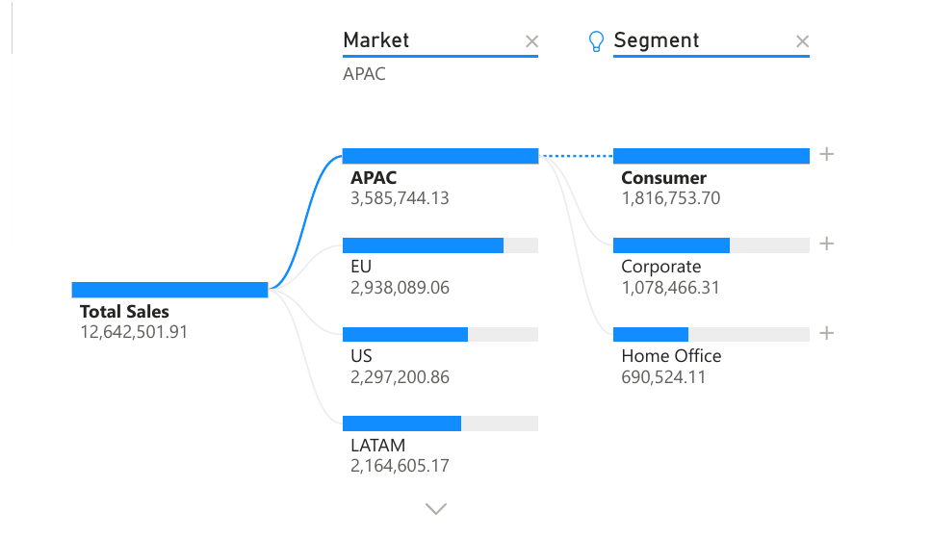
Figure 9: Decomposition Tree — Total Sales exploded by Market, Segment and Sub-Category (AI visual).
The Decomposition Tree is used because it lets a manager drill into a single KPI (Total Sales) along whichever dimension answers their question next, rather than forcing a fixed hierarchy the way a normal drill-down chart would. Analyze = Total Sales, Explain by = Market, Segment, Sub-Category. Manually drilling Market → APAC shows APAC’s $3.59M splits into Consumer ($1.82M), Corporate ($1.08M) and Home Office ($0.69M) — Consumer leads every segment, consistent with Finding 6. Using the tree’s AI “+” auto-split (which picks the single next field that best explains the remaining variation) on Total Sales at the top level automatically selects Segment as the highest-value next split — confirming, independently of the manual drill, that customer segment is the dimension that most cleanly separates high- and low-value sales, ahead of geography or product. This satisfies the new-chart-type and AI-visual requirements in one visual.

10. Key Influencers — what actually drives a loss
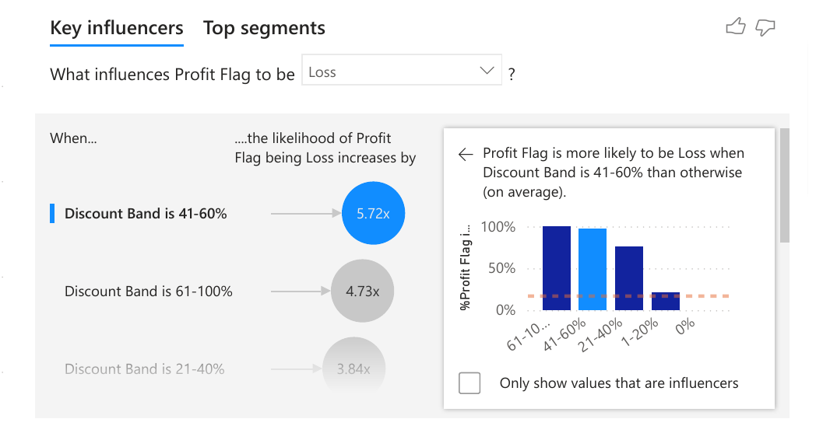
Figure 10: Key Influencers explaining what drives an order line to be a Loss (AI visual).
Key Influencers is used because it answers a different question to every other chart in this report: not “where is profit low” but “statistically, what factors make a loss more likely.” Analyze = Profit Flag, target value = Loss; Explain by = Category, Discount Band, Market, Order Priority. The AI ranks Discount Band 41–60% as the single strongest influencer — an order line in that band is 5.72x more likely to be a Loss than one that is not, and the 61–100% band is 4.73x more likely. This independently confirms, from a completely different statistical method, the same discount ceiling identified in Finding 5 from the raw profit-by-band totals. The visual also surfaces a second, previously hidden driver: a line is more likely to be a Loss when Category is Furniture (31.6% of Furniture lines are a Loss, vs a 24.5% average across all lines) — reinforcing Finding 4’s Furniture/Tables concern from an independent angle. Seeing the same conclusion emerge from two unrelated techniques (simple aggregation and AI-driven statistical influence) is stronger evidence than either alone.

11. Sales by country — where the business is concentrated
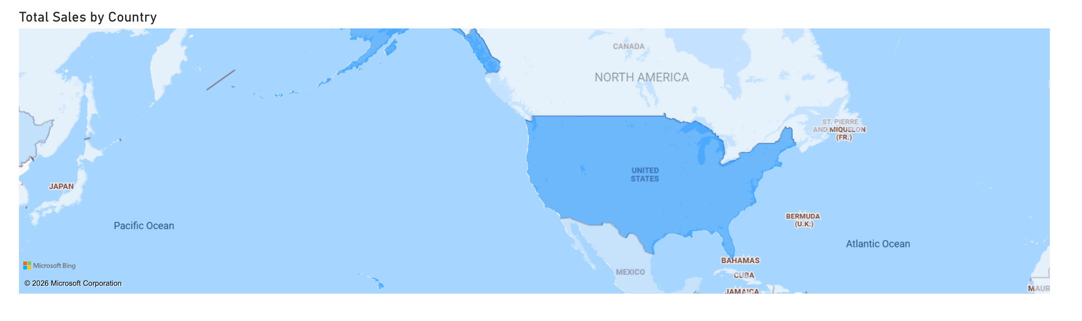
Figure 11: Total Sales by Country (Filled Map, gradient-shaded by Total Sales).
A filled map is used because geography is best read spatially rather than as a long list of 147 country names. Countries are shaded on a light-to-dark gradient driven by Total Sales (configured via conditional formatting on the map’s fill colour, since country-level sales vary too finely for a fixed colour scale). Finding: the United States alone accounts for $2.30M of sales — about 18% of the global total from a single country — and renders visibly darker than every neighbouring country on the map, including Canada and Mexico, which are barely shaded by comparison. This is a useful counter-weight to Finding 2: while APAC and EU lead at the market (regional) level, no single country in either region approaches the concentration of sales sitting in the US alone, which has implications for how geographically concentrated the business’s revenue risk actually is.

Conclusions and Recommendations
The Global Superstore is a growing, globally diversified retailer that is profitable in aggregate but is leaking margin through undisciplined discounting and a handful of structurally unprofitable products and markets. The BI solution answered every business question posed in the introduction and localised the problem precisely.
Recommendations (each tied to a finding above):
- Cap discounts at 20%. Figure 5 shows every band above 20% is loss-making; a hard cap with sign-off above it would recover $800K+ of profit.
- Fix or drop Tables. Figure 4 shows Tables lose money outright; re-price, renegotiate supply cost, or delist.
- Impose pricing discipline in EMEA and LATAM. Figure 2 shows these markets sell but barely profit; apply the APAC/EU (and Canada) playbook.
- Grow Technology and Home Office. Figures 3 and 6 show these are the highest-margin category and segment — the safest places to push volume.
- Plan for Q4 seasonality. Figure 7 forecasts continued, seasonal growth; stock and staff for the Q4 peak.
Personal conclusion:
Building this solution developed practical skills in dimensional modelling (star schema), Power Query (M) transformation, DAX measures and calculated columns, and dashboard design including AI-assisted visuals and forecasting. The biggest lesson was that a well-designed data model makes the analytical questions almost answer themselves — most of the insight came from getting the fact/dimension split and the discount-band column right, not from the charts themselves.

ICA – Appendix: BI Design

A. Data Pre-Processing and Data Cleansing
All cleansing was performed in the Power Query Editor. Each action is recorded as an M step in the Applied Steps panel; the full panel is shown in Figure A1 below. Steps applied:
- Promoted the first row to headers and verified the 24 columns import correctly.
- Removed blank rows produced by the CSV’s line-ending parsing (kept rows where Row ID is non-null and non-blank), so every remaining row is a genuine order line.
- Set correct data types, using an en-GB culture so day/month order parses correctly: Order Date / Ship Date → Date; Sales, Profit, Shipping Cost → Fixed decimal number; Quantity, Row ID → Whole number; Discount → Decimal number.
- Removed duplicate rows on Row ID so the fact grain is exactly one row per order line (51,290 rows).
- Added a calculated "Ship Days" column (Ship Date − Order Date) — values validated to a sensible 0–7 days.
- Added a calculated "GeoKey" column (Text.Combine of Country, State, City) as a composite key used to relate the fact table to a single Dim_Geography dimension, since no single source column uniquely identifies a City/State/Country combination on its own.
- Confirmed there were no null/blank values in the key measure and dimension columns.
Note: because the source is already fairly clean, the pre-processing focuses on typing, blank-row removal, de-duplication and key construction rather than text-trimming or NA-imputation — this is disclosed here in line with the marking guidance rather than overstated.
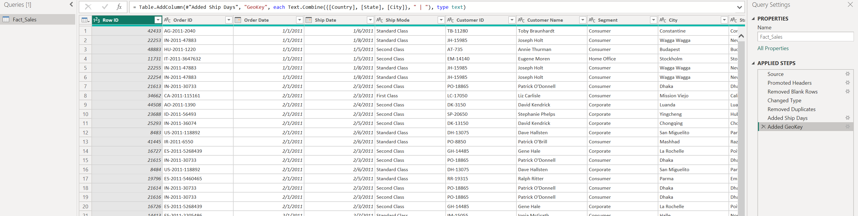
Figure A1: Power Query Editor — the Fact_Sales query’s Applied Steps (Source → Promoted Headers → Removed Blank Rows → Changed Type → Removed Duplicates → Added Ship Days → Added GeoKey) with the GeoKey M formula in the bar.

B. Data Modelling — Star Schema (Facts and Dimensions)
Using the BI questions, the single flat table was normalised into a star schema of one fact table and five dimension tables (six tables total). Each dimension, however, is built as a DAX calculated table rather than a Power Query reference: ADDCOLUMNS wraps a DISTINCT (or CALENDAR, for the date dimension) over the fact table’s key column(s), pulling in the remaining descriptive attributes with CALCULATE(MAX(...)) per distinct key. This guarantees each dimension key is unique by construction — DISTINCT cannot produce a duplicate — and demonstrates DAX table-construction skills (ADDCOLUMNS, CALENDAR, DISTINCT, CALCULATE) in addition to the M-language work in Appendix A.
Table | Type | Key | Rows
Fact_Sales | Fact | Row ID (degenerate) + 6 foreign keys | 51,290
Dim_Date | Dimension | Date | 1,461
Dim_Customer | Dimension | Customer ID | 1,590
Dim_Product | Dimension | Product ID | 10,292
Dim_Geography | Dimension | GeoKey (surrogate) | 3,812
Dim_ShipMode | Dimension | Ship Mode | 4
Dim_Date is built with ADDCOLUMNS(CALENDAR(DATE(2011,1,1), DATE(2014,12,31)), ...), producing one row per calendar day across the full four-year span (1,461 days, including the 2012 leap day) — not just the 1,430 distinct dates that happen to appear in the order data — so that a continuous time axis is available for the Analytics-pane Forecast in Finding 7 (Power BI’s Forecast requires an unbroken date sequence, not just the dates on which a sale happened). Alongside the standard Year / Quarter / Month attributes, Dim_Date also carries a numeric MonthYearSort calculated column, used with Power BI’s “Sort by Column” feature so the text field MonthYear (e.g. “Jan 2011”) sorts chronologically rather than alphabetically wherever it is used.
All six relationships are Many-to-One from the fact table to a dimension, with single-direction cross-filtering. Because every dimension key is unique by construction, there are no many-to-many relationships anywhere in the model (a requirement of the top mark band). Dim_Date is a role-playing dimension used for both Order Date (active relationship) and Ship Date (inactive relationship, activated inside the Sales by Ship Date measure with USERELATIONSHIP). To evidence relationship-building for this section: the Fact_Sales → Dim_Product relationship was initially mis-mapped to the Category column; this was caught in Model view and corrected to Product ID, which is visible in the Model view screenshot below (Figure B1).
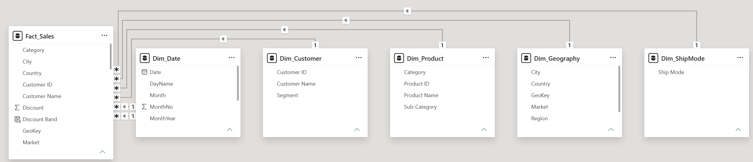
Figure B1: Model view — the star schema in Power BI, with Fact_Sales related Many-to-One to all five dimension tables (Dim_Date, Dim_Customer, Dim_Product, Dim_Geography, Dim_ShipMode).

C. DAX and M Language
M Language (Power Query) — used for all fact-table transformation. Representative steps (see Appendix A for the full list):
Table.SelectRows(PromotedHeaders, each [Row ID] <> null and [Row ID] <> "") // remove blank rows
Table.TransformColumnTypes(prev, {{"Order Date", type date}, {"Sales", type number}, {"Discount", type number}}, "en-GB") // typed with en-GB culture
Table.AddColumn(prev,"Ship Days", each Duration.Days([Ship Date]-[Order Date]), Int64.Type)
Table.AddColumn(prev, "GeoKey", each Text.Combine({[Country], [State], [City]}, " | "), type text)
DAX calculated tables — used to build all five dimensions from Fact_Sales (see Appendix B), for example:
Dim_Date = ADDCOLUMNS(CALENDAR(DATE(2011,1,1), DATE(2014,12,31)), "Year", YEAR([Date]), "Quarter", "Q" & QUARTER([Date]), "MonthNo", MONTH([Date]), "Month", FORMAT([Date],"MMM"), "MonthYear", FORMAT([Date],"MMM YYYY"), "DayName", FORMAT([Date],"ddd"), "MonthYearSort", YEAR([Date])*100 + MONTH([Date]))
Dim_Customer = ADDCOLUMNS(DISTINCT(Fact_Sales[Customer ID]), "Customer Name", CALCULATE(MAX(Fact_Sales[Customer Name])), "Segment", CALCULATE(MAX(Fact_Sales[Segment])))
DAX measures — created on Fact_Sales (10 in total). Each is explained so the marker can see the intent, not just the formula:
Measure | DAX formula | Explanation
Total Sales | SUM(Fact_Sales[Sales]) | Core revenue KPI.
Total Profit | SUM(Fact_Sales[Profit]) | Core profit KPI.
Profit Margin % | DIVIDE([Total Profit],[Total Sales]) | Ratio KPI; DIVIDE prevents divide-by-zero errors.
Total Orders | DISTINCTCOUNT(Fact_Sales[Order ID]) | Counts unique orders (line rows would overcount).
Total Customers | DISTINCTCOUNT(Fact_Sales[Customer ID]) | Unique customer count for the KPI card.
Avg Order Value | DIVIDE([Total Sales],[Total Orders]) | Revenue per order.
Avg Discount | AVERAGE(Fact_Sales[Discount]) | Portfolio-wide average discount rate.
Sales YoY % | DIVIDE([Total Sales]-CALCULATE([Total Sales],SAMEPERIODLASTYEAR(Dim_Date[Date])), CALCULATE([Total Sales],SAMEPERIODLASTYEAR(Dim_Date[Date]))) | Time-intelligence growth vs prior year.
Sales Rank | RANKX(ALL(Dim_Product[Sub-Category]),[Total Sales],,DESC) | Ranks sub-categories; ALL removes the visual filter so rank is stable.
Sales by Ship Date | CALCULATE([Total Sales],USERELATIONSHIP(Fact_Sales[Ship Date],Dim_Date[Date])) | Activates the inactive role-playing relationship.
DAX calculated columns:
Discount Band = SWITCH(TRUE(), Fact_Sales[Discount]=0,"0%", Fact_Sales[Discount]<=0.2,"1-20%", Fact_Sales[Discount]<=0.4,"21-40%", Fact_Sales[Discount]<=0.6,"41-60%","61-100%")
This column buckets discounts and powers the headline profit-cliff chart (Figure 5).
Profit Flag = IF(Fact_Sales[Profit]<0,"Loss","Profit")
This column classifies each line as profit or loss for conditional formatting on the sub-category chart (Figure 4).

D. Dashboard
The dashboard is organised into three themed pages, shown in full below (Figures D1–D3).
- Page 1 — Executive Overview: KPI cards (Total Sales, Total Profit, Total Orders, Profit Margin %, Total Customers), Total Profit & Total Sales by Market (clustered column), Total Sales by Segment (donut), Total Sales by Year (column).
- Page 2 — Product Performance: a Decomposition Tree (AI visual + new chart type) breaking Total Sales down by Market, Segment and Sub-Category; a combo chart of Total Sales and Profit Margin % by Category; a stacked bar of Total Profit by Sub-Category with Profit Flag conditional colour; and a Total Profit by Discount Band column chart.
- Page 3 — Trend & Forecast: a monthly Total Sales line chart with the Analytics-pane 10-month Forecast (95% confidence band); a Key Influencers AI visual explaining what drives an order line to be a Loss; and a Filled Map of Total Sales by Country with a gradient conditional-formatting fill.
New chart type not covered in lessons: the Decomposition Tree and the Filled Map. AI/ML features: Decomposition Tree, Key Influencers, and the native Forecast. Together the three pages satisfy the top-band requirements for a new chart type, AI/ML visuals, forecasting, KPIs and cross-filtering interactivity between visuals on the same page.
(Bookmarked navigation buttons, a Q&A visual, a top-customers table and Year/Market/Category slicers were considered in the original design but were not included in the final build in the interest of prioritising the depth of the AI/analytical visuals above over additional navigation chrome; cross-filtering between visuals on the same page, which Power BI provides by default, is retained and demonstrated in Figure 9’s manual drill interaction.)
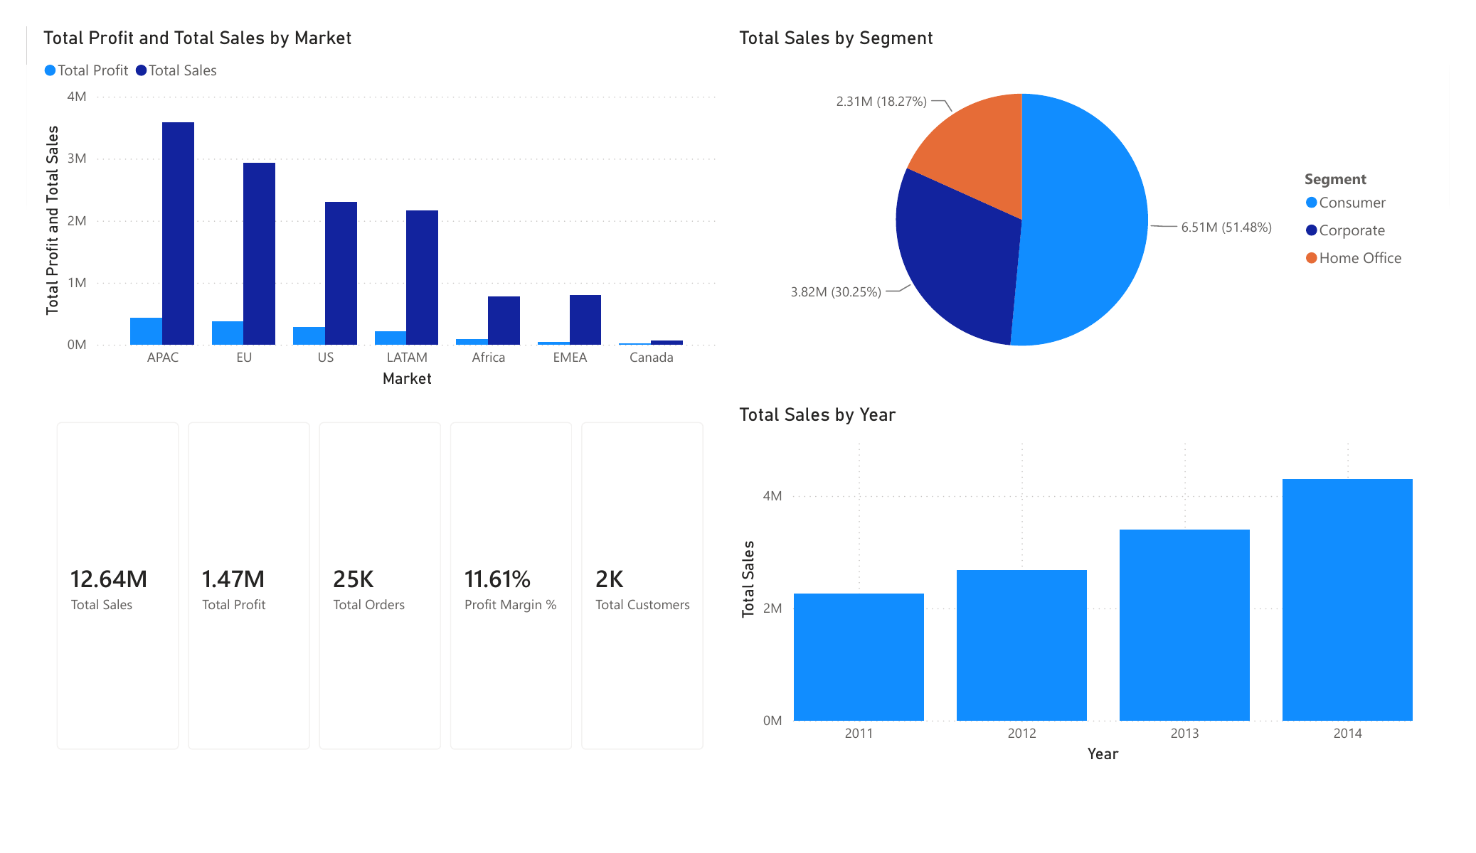
Figure D1: Dashboard Page 1 — Executive Overview (KPI cards, Total Profit & Total Sales by Market, Total Sales by Segment, Total Sales by Year).
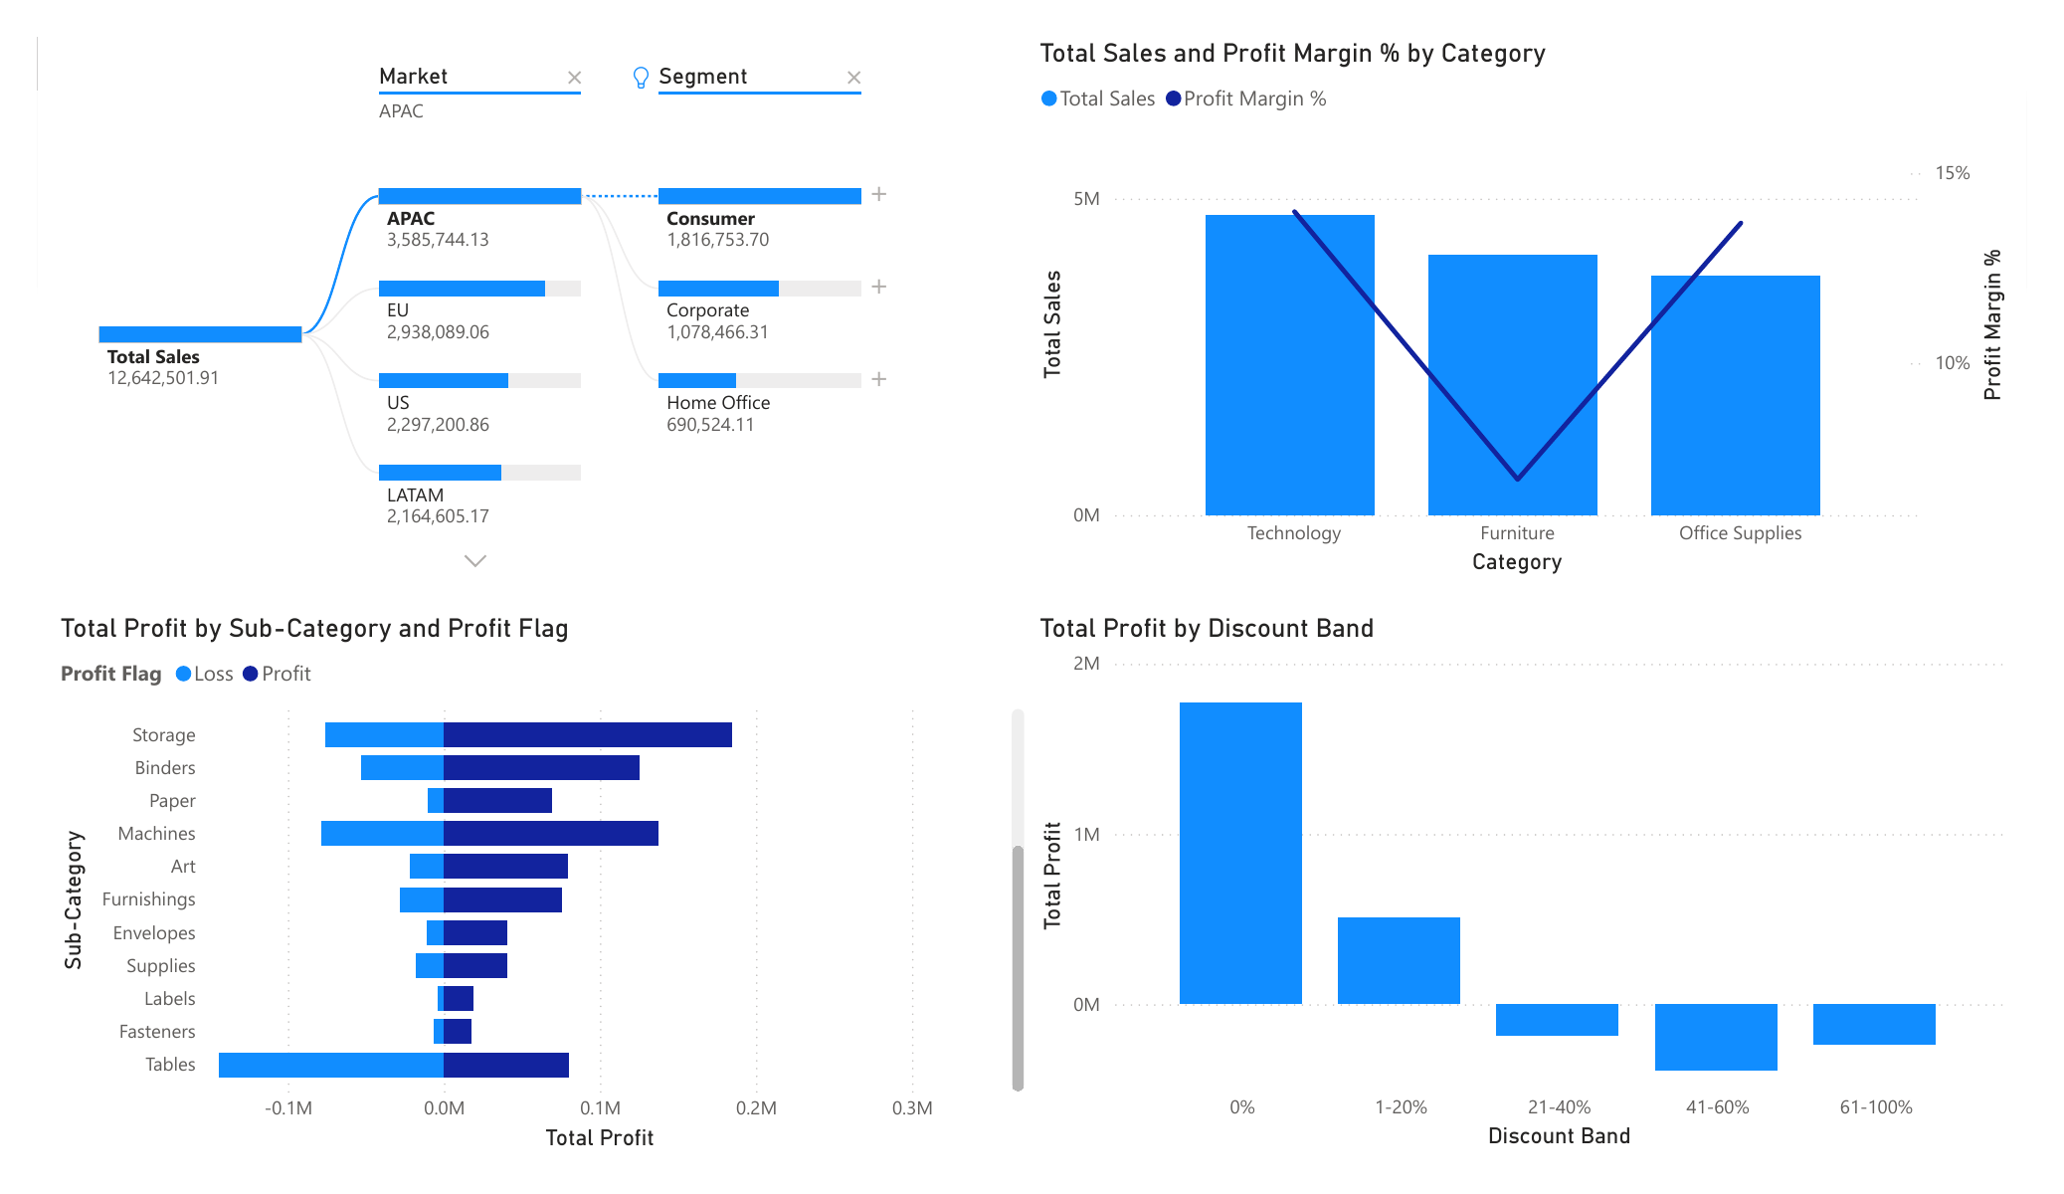
Figure D2: Dashboard Page 2 — Product Performance (Decomposition Tree, Category combo, Total Profit by Sub-Category, Total Profit by Discount Band).
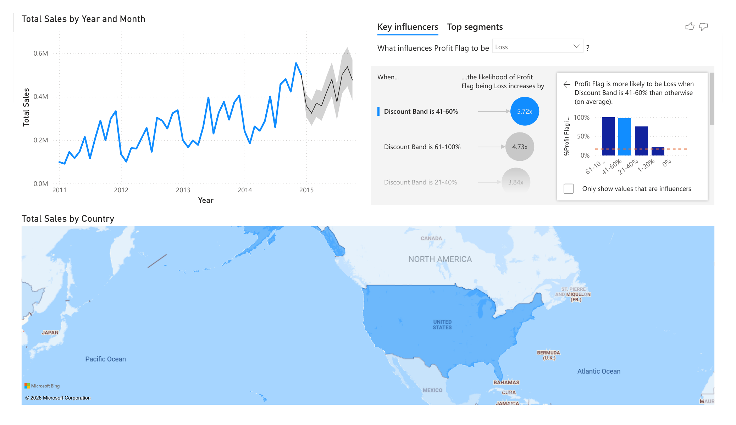
Figure D3: Dashboard Page 3 — Trend & Forecast (Monthly Sales line with 10-month Forecast, Key Influencers, Filled Map of Total Sales by Country).

Self-Assessment
Scored against the marking rubric bands. Kept in the report as required by the template.
Report Section | Description | Grade (0–100)
Report Structure | Follows the template; dataset, BI questions and KPIs stated; every chart explained; recommendations tied to findings. | 85
Data Pre-processing and Data Modelling | Multiple pre-processing steps applied; well-structured star schema with 6 tables (fact + 5 DAX-calculated dimension tables) and no many-to-many relationships. | 88
DAX and M language | Both M (Power Query, fact table) and DAX (5 calculated dimension tables, 10 measures + 2 calculated columns) used and explained in the text. | 82
Dashboard Design | Variety of charts incl. Decomposition Tree, Key Influencers, Forecast, filled Map and KPI cards across 3 pages. | 85
Average |  | 85

References and Acknowledgements
- Global Superstore Dataset, Kaggle: https://www.kaggle.com/datasets/apoorvaappz/global-super-store-dataset
- Microsoft, Power BI documentation — DAX function reference, Power Query M reference, Forecasting, Decomposition Tree, Key Influencers, and Filled Map visuals.
AI acknowledgement (module AI permission: Amber): AI assistance was used as a companion for structuring the report, drafting explanatory text and preparing the data-preparation code. All analysis, findings, model design and recommendations were reviewed and are the author’s own; the Power BI solution was built and verified by the author.

