Software for Digital Innovation (CIS4044-N)
Historical Weather Data
In-Course Assignment Report
Phases 1–3, Further Enhancements, Critical Evaluation and Black-box Testing
Module Code: CIS4044-N | Module Leader: Steven Mead

Table of Contents
1. Phase 1 – Python and SQLite3 Database Queries 3
1.1 List all countries 3
1.2 List all cities 3
1.3 Average annual temperature for a city 3
1.4 Average seven-day precipitation 3
1.5 Average mean temperature by city (date range) 3
1.6 Average annual precipitation by country 4
1.7 Further analytical queries 4
2. Phase 2 – Basic Graphs using Matplotlib 5
2.1 Seven-day precipitation (bar chart) 5
2.2 City precipitation comparison (bar chart) 5
2.3 Average yearly precipitation by country (bar chart) 6
2.4 Grouped weather averages (grouped bar chart) 6
2.5 Daily min/max temperature for a month (line chart) 6
2.6 Temperature vs rainfall (scatter plot) 7
3. Phase 3 – Data Retrieval and Storage 8
4. Further Enhancements 9
5. Critical Evaluation (Report) 10
5.1 Software tools: appropriateness and limitations 10
5.2 Security and other risk implications 10
5.3 Programming fundamentals and data structures 10
6. Testing 11
References 11
Appendix A – Black-box Test Plan 12

1. Phase 1 – Python and SQLite3 Database Queries
Phase 1 completes the supplied phase_1.py template. Each function opens a connection through the shared connect_database helper, runs a parameterised SQL query and prints the result to the console. The queries increase in complexity, from simple table listings to multi-table joins with grouping and aggregation. The database contains weather entries for 2020–2024 for two countries and four cities. All outputs below are the real console output produced by running the queries against the provided database.

1.1 List all countries
Returns every country with its id and timezone using a simple ordered SELECT.
SELECT id, name, timezone FROM countries ORDER BY name
Console output:
Country Id: 2 -- Country Name: France -- Country Timezone: Europe/Berlin
Country Id: 1 -- Country Name: Great Britain -- Country Timezone: Europe/London

1.2 List all cities
Joins cities to countries so each city is shown with its country name and coordinates.
SELECT cities.id, cities.name, countries.name AS country_name, cities.latlong
FROM cities JOIN countries ON countries.id = cities.country_id
ORDER BY country_name, cities.name
Console output:
City Id: 3 -- City Name: Paris -- Country: France -- Latitude/Longitude: 48.85341,2.3488
City Id: 4 -- City Name: Toulouse -- Country: France -- Latitude/Longitude: 43.60426,1.44367
City Id: 2 -- City Name: London -- Country: Great Britain -- Latitude/Longitude: 51.50853,-0.12574
City Id: 1 -- City Name: Middlesbrough -- Country: Great Britain -- Latitude/Longitude: 54.57623,-1.23483

1.3 Average annual temperature for a city
Uses AVG with strftime('%Y', date) to average the daily mean temperature for one city in one year. The year is validated before the query runs.
SELECT AVG(daily_weather_entries.mean_temp) AS average_mean_temp
FROM daily_weather_entries JOIN cities ON cities.id = daily_weather_entries.city_id
WHERE daily_weather_entries.city_id = ?
AND strftime('%Y', daily_weather_entries.date) = ?
Console output (city 1, 2024):
City Id: 1 -- City: Middlesbrough -- Year: 2024 -- Average Mean Temperature: 27.65

1.4 Average seven-day precipitation
Averages precipitation over a seven-day window using date(?, '+6 day') and returns a days_found count so the range can be verified.
WHERE daily_weather_entries.city_id = ?
AND daily_weather_entries.date BETWEEN ? AND date(?, '+6 day')
Console output (city 1, from 2024-01-01):
City Id: 1 -- City: Middlesbrough -- Start Date: 2024-01-01 -- End Date: 2024-01-07
-- Average Precipitation: 3.00 -- Days Found: 7

1.5 Average mean temperature by city (date range)
Joins all three tables and groups by city, ordering the warmest city first, for a chosen date range.
WHERE daily_weather_entries.date BETWEEN ? AND ?
GROUP BY cities.id, cities.name, countries.name
ORDER BY average_mean_temp DESC
Console output (2024-01-01 to 2024-12-31):
City Id: 4 -- City: Toulouse -- Country: France -- Average Mean Temperature: 28.05
City Id: 1 -- City: Middlesbrough -- Country: Great Britain -- Average Mean Temperature: 27.65
City Id: 2 -- City: London -- Country: Great Britain -- Average Mean Temperature: 27.34
City Id: 3 -- City: Paris -- Country: France -- Average Mean Temperature: 27.14

1.6 Average annual precipitation by country
Aggregates to country level, returning both the average and the total precipitation for a year using AVG and SUM.
Console output (2024):
Country Id: 2 -- Country: France -- Year: 2024 -- Average Precipitation: 1.22 -- Total Precipitation: 893.00
Country Id: 1 -- Country: Great Britain -- Year: 2024 -- Average Precipitation: 2.24 -- Total Precipitation: 1637.80

1.7 Further analytical queries
Two additional queries go beyond the basic requirements to demonstrate deeper analysis. The first summarises the average minimum, mean and maximum temperature month-by-month for a city; the second finds the wettest city for every year in the database using a per-year ORDER BY … LIMIT 1 pattern.
Monthly summary (city 1, 2024, abridged):
City: Middlesbrough -- Month: 01 -- Average Min: 27.22 -- Average Mean: 28.21 -- Average Max: 28.81
City: Middlesbrough -- Month: 06 -- Average Min: 26.31 -- Average Mean: 27.11 -- Average Max: 27.70
City: Middlesbrough -- Month: 12 -- Average Min: 26.60 -- Average Mean: 27.46 -- Average Max: 27.97
... (one row per month) ...
Wettest city per year (abridged):
Year: 2020 -- Wettest City: Middlesbrough -- Country: Great Britain -- Total Precipitation: 1260.30
Year: 2023 -- Wettest City: Middlesbrough -- Country: Great Britain -- Total Precipitation: 1829.00
Year: 2024 -- Wettest City: Middlesbrough -- Country: Great Britain -- Total Precipitation: 1085.70

2. Phase 2 – Basic Graphs using Matplotlib
Phase 2 reads data from the same SQLite database and renders charts with Matplotlib using the non-interactive Agg backend, saving each as a PNG in the charts folder. The functions cover all chart types requested in the brief and add grouping and aggregation to surface trends and comparisons. The six charts below are the actual generated output.

2.1 Seven-day precipitation (bar chart)
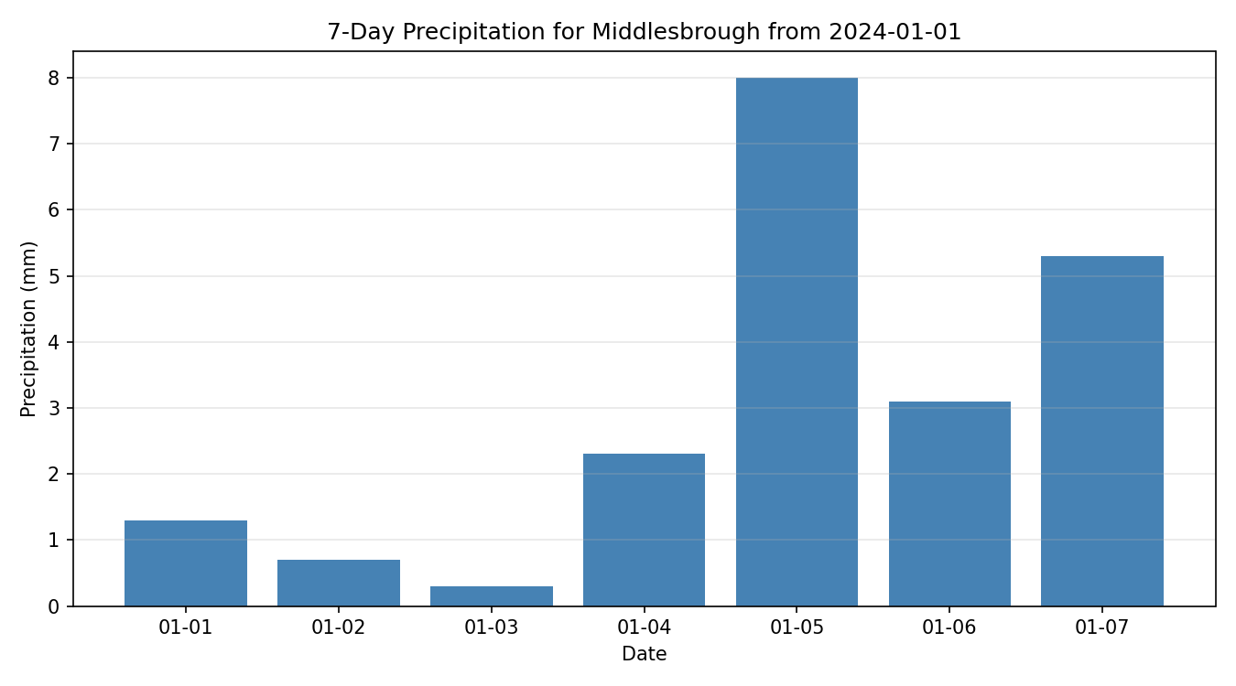
Figure 1: Daily precipitation for Middlesbrough over seven days, peaking on 05 January.

2.2 City precipitation comparison (bar chart)
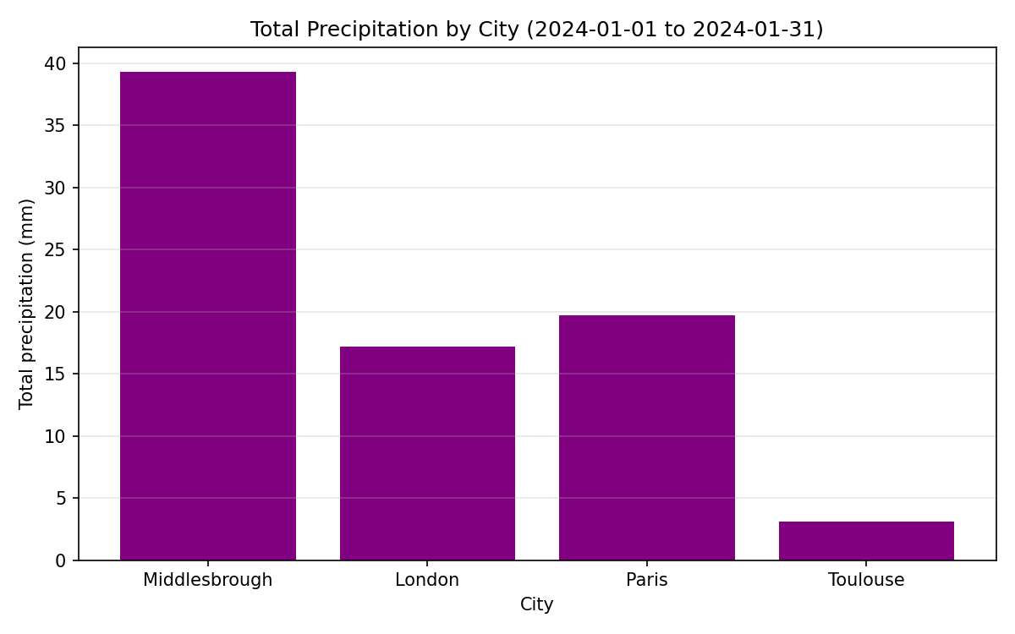
Figure 2: Total January precipitation across the four cities; Middlesbrough wettest, Toulouse driest.

2.3 Average yearly precipitation by country (bar chart)
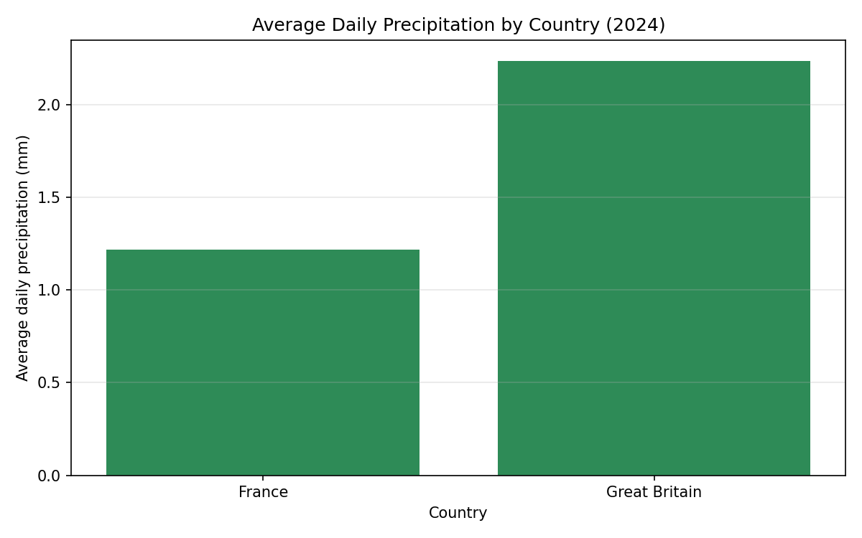
Figure 3: Country-level average daily precipitation for 2024 (Great Britain wetter than France).

2.4 Grouped weather averages (grouped bar chart)
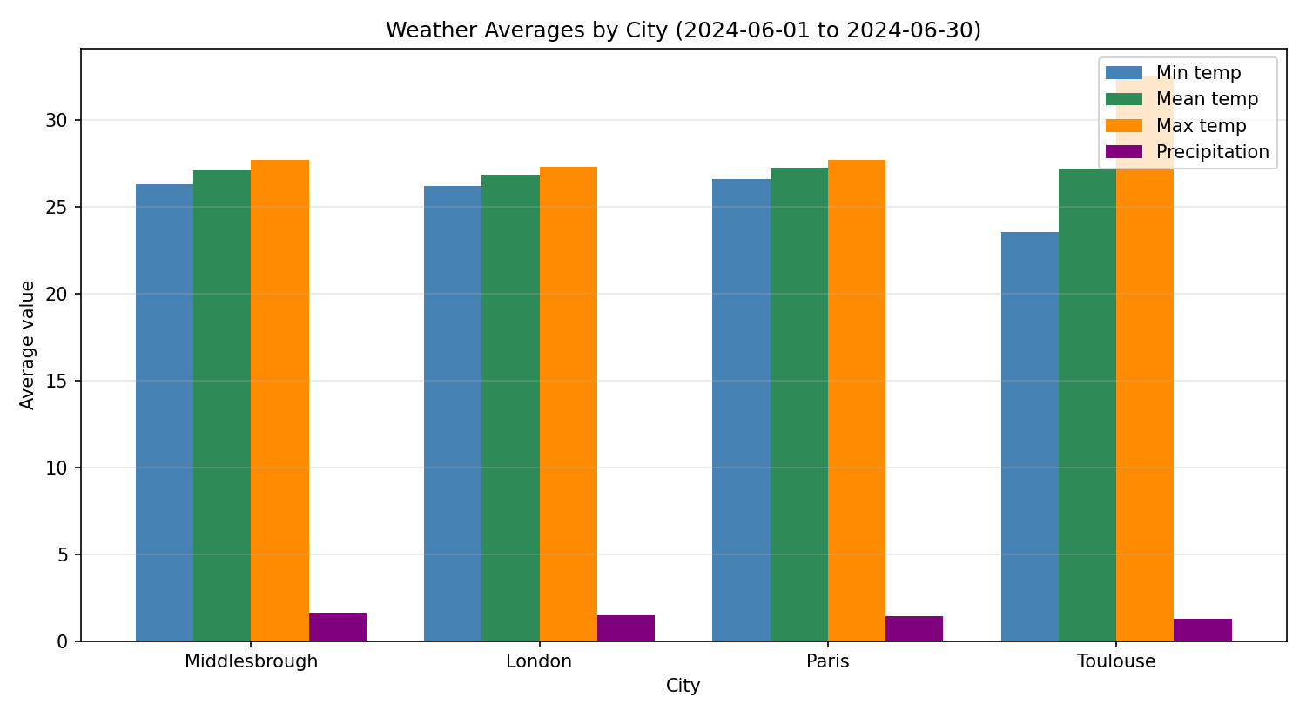
Figure 4: Min, mean and max temperature with precipitation per city on a single grouped plot.

2.5 Daily min/max temperature for a month (line chart)
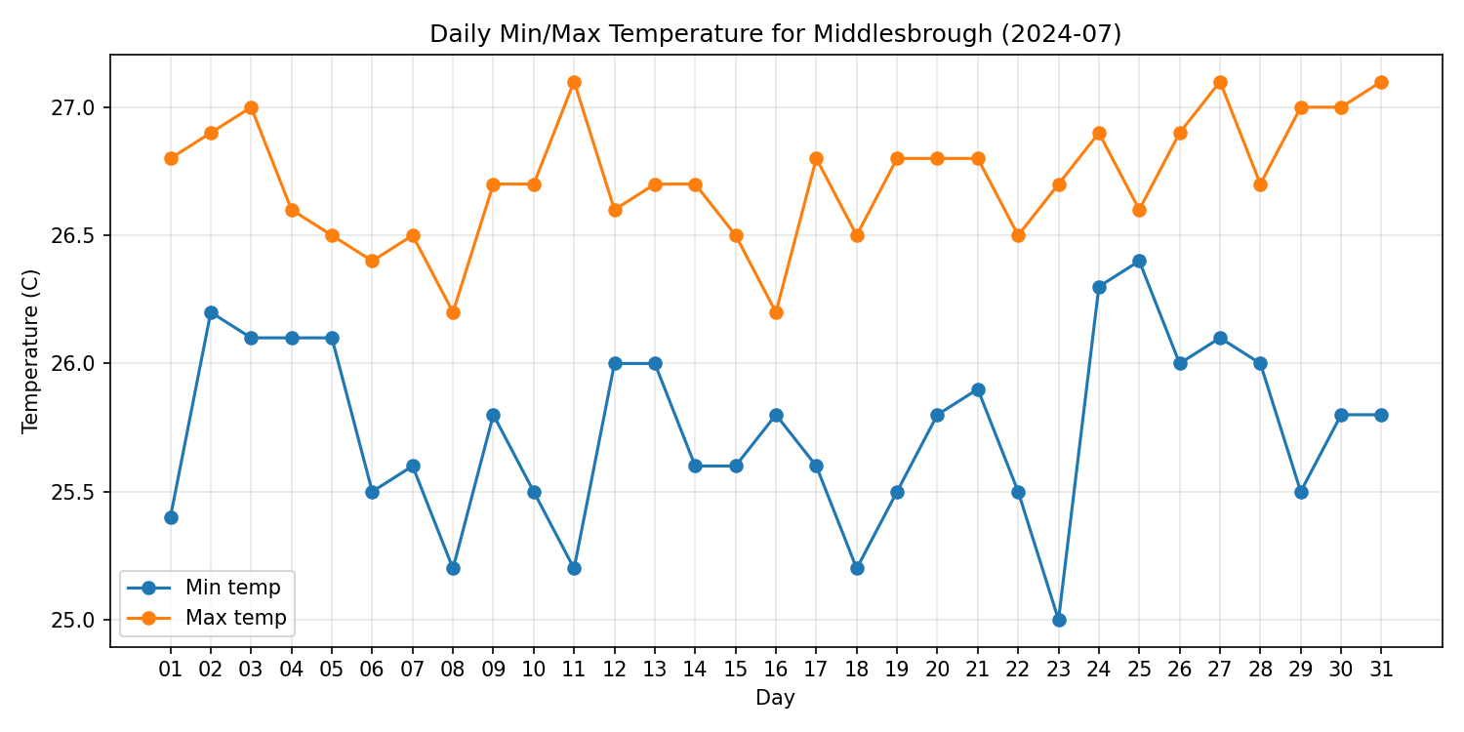
Figure 5: Daily minimum and maximum temperature for Middlesbrough, July 2024.

2.6 Temperature vs rainfall (scatter plot)
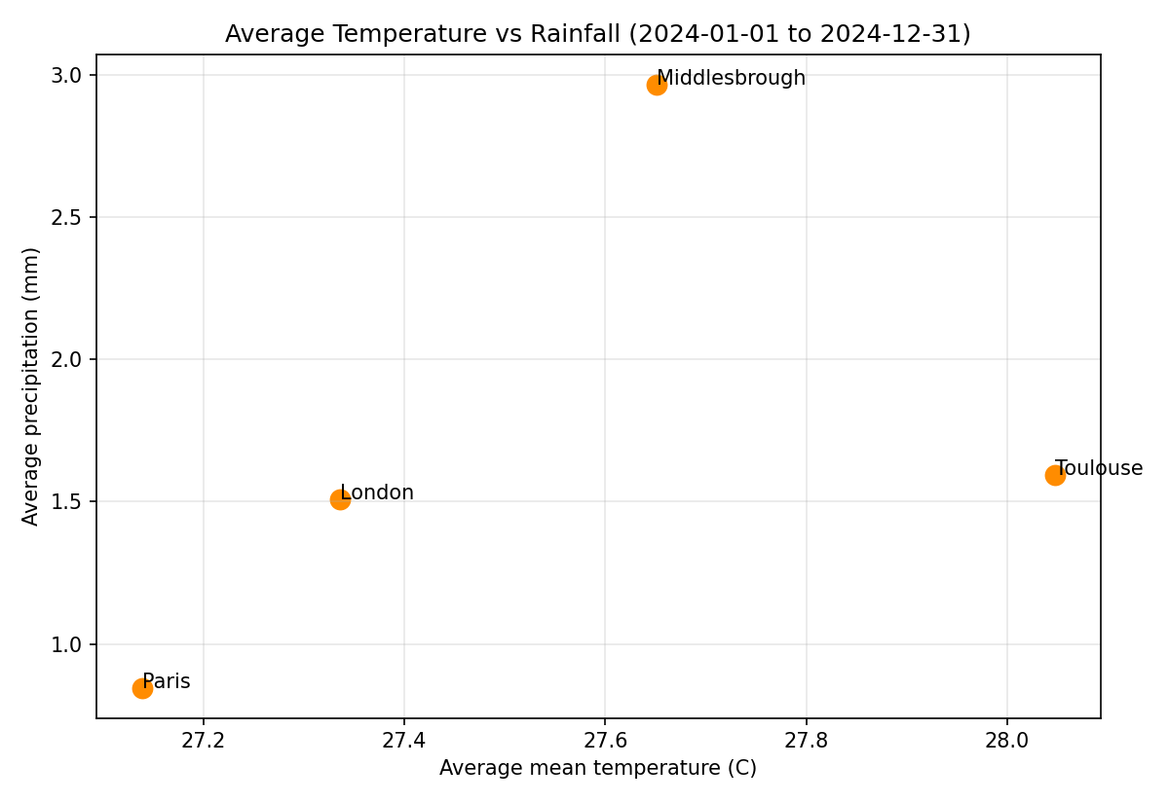
Figure 6: Average temperature against average rainfall per city over 2024, labelled per city.

3. Phase 3 – Data Retrieval and Storage
Phase 3 retrieves fresh data from the Open-Meteo historical weather archive API and stores it in the SQLite database. Rather than using Open-Meteo's helper library, the application writes its own HTTP request code with the requests module (targeting a Merit/Distinction level for this phase). The work is split into four focused functions: get_city looks up the city and its coordinates, download_weather_data builds and sends the request, parse_daily_weather converts the JSON into rows, and store_daily_weather writes them to the database.
The request is built from the city's stored latitude, longitude and timezone, with a timeout and explicit status-code check:
params = {
"latitude": city["latitude"], "longitude": city["longitude"],
"start_date": start_date, "end_date": end_date,
"daily": "temperature_2m_min,temperature_2m_max,temperature_2m_mean,precipitation_sum",
"timezone": city["timezone"],
}
response = requests.get(API_URL, params=params, timeout=20)
if response.status_code != 200:
raise Exception("Open-Meteo request failed with status code " + ...)
Storage is made idempotent: before inserting, the existing row for the same city and date is deleted, so re-running an update never creates duplicate records. Network failures, non-200 responses and missing daily blocks are all caught and converted into clear error messages. Two extra capabilities support the requirement to widen coverage: an add_city helper inserts new cities, and the date range is fully controllable at runtime, so weather for additional places and periods can be fetched.

4. Further Enhancements
Several enhancements were added on top of the three core phases. A single entry point (main.py) provides an interactive text menu so every feature can be driven from one place, satisfying the higher-grade expectation of a single starting point rather than running each module separately.
A lightweight command-line interface is layered over the same menu: python3 main.py demo runs every Phase 1 query and generates all charts offline, and python3 main.py charts regenerates the chart evidence. This makes the evidence reproducible without any manual interaction.
python3 main.py # interactive menu
python3 main.py demo # run all Phase 1 queries + build all charts
python3 main.py charts # regenerate all chart evidence
A modular, reusable structure is used throughout: the database connection and the date/year validation helpers live in one module and are imported by the others, removing duplication. An automated test suite (unittest) provides fourteen tests spanning all three phases and runs entirely offline, using temporary database copies so the supplied data is never modified. A README and requirements.txt document how to install, run and test the application. Together these enhancements improve reliability, reproducibility and maintainability.

5. Critical Evaluation (Report)
This section addresses the assignment's written report requirement: a critical examination of the software tools, an evaluation of the security and risk implications of using software libraries in real-world applications, and a reflection on how programming fundamentals and data structures supported the work.

5.1 Software tools: appropriateness and limitations
SQLite (via the standard-library sqlite3 module) suits a relational, local, modestly-sized dataset and needs no database server (Python Software Foundation, 2024). It supports the joins, grouping and aggregates every query relies on, but offers only file-level write locking, so a concurrent production platform would need a client-server database such as PostgreSQL (Owens, 2006). Matplotlib produces reproducible PNG evidence with fine control over labels and export (Hunter, 2007); its cost is verbosity and a lack of interactivity compared with higher-level libraries. Requests gives a clean interface for building the Open-Meteo calls and satisfies the brief's requirement for custom API code (Reitz, 2024), though it is a synchronous, blocking, external dependency. VS Code accelerated editing, debugging and database inspection, but an editor does not prove correctness, which is why the automated tests and chart evidence matter.

5.2 Security and other risk implications
In Data Science and AI contexts the integrity of the data pipeline matters as much as model accuracy, because corrupted inputs silently degrade every downstream result. SQL injection is mitigated by parameterised queries throughout — values pass through ? placeholders rather than string concatenation, the primary defence recommended by OWASP (OWASP Foundation, 2021). Input validation rejects malformed dates, reversed ranges and non-integer identifiers before any query or API call. Dependency risk is real: Requests and Matplotlib enlarge the attack surface, so a production system should pin versions and monitor advisories, since one compromised transitive package can undermine an application (Ohm et al., 2020). External-service risk is handled defensively with timeouts, status checks and field validation, and duplicate-data risk is reduced by deleting-before-inserting, which a production schema would reinforce with a unique constraint on (city_id, date).

5.3 Programming fundamentals and data structures
Standard-library data structures shaped the design directly. Lists hold query rows and parsed records, and their index-aligned nature is exploited when the Open-Meteo response arrives as parallel arrays that are combined by position. Dictionaries provide named, self-documenting records — one per weather day, and one carrying a city's id, name, coordinates and timezone — which is clearer than passing many positional arguments. Single-responsibility functions and shared modules keep common behaviour written once, while control flow and structured exception handling convert low-level failures into meaningful messages. These fundamentals, combined with unittest running against temporary databases, made the application both testable and robust.

6. Testing
Testing combines an automated unittest suite with a black-box test plan. The fourteen automated tests run offline (Phase 3 tests use hand-made example payloads and temporary database copies) and all pass:
unittest result:
Ran 14 tests in 0.099s
OK
The black-box test plan documents individual test cases covering success, failure and range conditions across all phases. It is provided in full as Appendix A below and also as a separate spreadsheet file (Blackbox_Test_Plan.xlsx) for submission.

References
Hunter, J.D. (2007) ‘Matplotlib: a 2D graphics environment’, Computing in Science & Engineering, 9(3), pp. 90–95.
Ohm, M., Plate, H., Sykosch, A. and Meier, M. (2020) ‘Backstabber’s knife collection: a review of open source software supply chain attacks’, in Detection of Intrusions and Malware, and Vulnerability Assessment (DIMVA 2020). Cham: Springer, pp. 23–43.
Open-Meteo (2024) Historical Weather API documentation. Available at: https://open-meteo.com/en/docs/historical-weather-api (Accessed: 12 July 2026).
OWASP Foundation (2021) SQL injection prevention cheat sheet. Available at: https://cheatsheetseries.owasp.org/cheatsheets/SQL_Injection_Prevention_Cheat_Sheet.html (Accessed: 12 July 2026).
Owens, M. (2006) The definitive guide to SQLite. Berkeley, CA: Apress.
Python Software Foundation (2024) sqlite3 — DB-API 2.0 interface for SQLite databases. Available at: https://docs.python.org/3/library/sqlite3.html (Accessed: 12 July 2026).
Reitz, K. (2024) Requests: HTTP for Humans documentation. Available at: https://requests.readthedocs.io/ (Accessed: 12 July 2026).

Appendix A – Black-box Test Plan
The plan below records black-box test cases run against the finished application. Steps describe the user actions; expected and actual results are compared to give a pass/fail verdict.
Id | Description | Steps | Expected | Actual | Result | Comment
1 | List countries | Choose menu option 1 | 2 countries listed | 2 countries listed | PASS
2 | List cities | Choose menu option 2 | 4 cities listed with country | 4 cities listed | PASS
3 | Annual temperature | Option 3; city 1; year 2024 | One average temperature shown | 27.65 shown | PASS
4 | Seven-day precipitation | Option 4; city 1; 2024-01-01 | 7 days counted | days_found = 7 | PASS
5 | Invalid date | Option 4; enter 2024-99-99 | Validation error, re-prompt | ValueError raised | PASS
6 | Reversed date range | Enter 2024-02-01 to 2024-01-01 | Validation error | ValueError raised | PASS
7 | Non-numeric city id | Option 3; enter 'abc' as id | Handled, no crash | Error shown, menu continues | PASS
8 | Generate all charts | Choose menu option 5 | Six PNG files created | Six PNGs created | PASS
9 | Chart file non-empty | Inspect 01_7_day_precipitation.png | File size > 0 | Non-empty PNG | PASS
10 | Empty city list | Call city chart with [] | Validation error | ValueError raised | PASS
11 | Parse API JSON | Feed example 2-day payload | 2 weather rows parsed | 2 rows parsed | PASS
12 | Missing daily block | Feed payload without 'daily' | Controlled API error | Clear error raised | PASS
13 | Replace existing row | Store same city/date twice | One row remains, value updated | count = 1, updated | PASS
14 | Unknown city id | Update weather for city 999 | Rejected with message | ValueError raised | PASS
15 | Invalid menu option | Enter option 8 | "Invalid option" message | Message shown | PASS

