Ideas for https://nodejs-by-nextsem.web.app
- some part of lessons are not visible like open full lesson
- one urgent thing add node js below nextsem logo and also wrote the nextsem text of header in the same way as the logo is made with white colour
- very nice but keep coor of ns logo in green and text in white
- also write text on header as "Node.js by NextSem"
- also write text on header as "Node.js by NextSem" and add all pages under hamburger
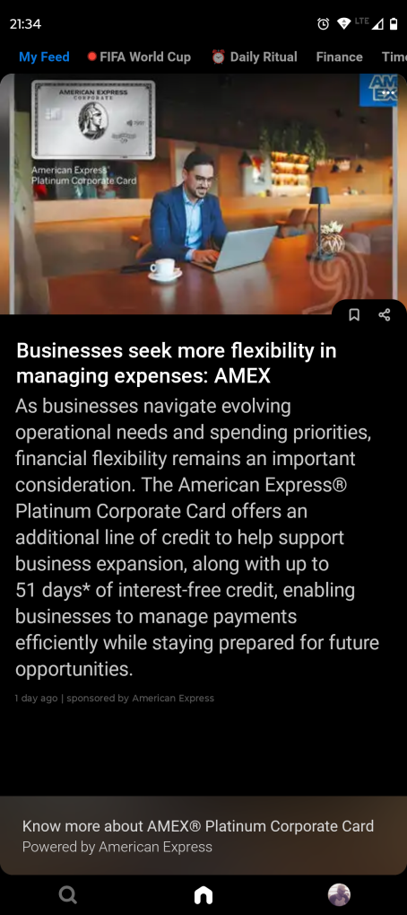
- also put header all parts as in this image

- also put header all parts as in this image that is make a horizontal section below the app as inmost android app like youtube and inside that space add three options searcch nextsem logo icon and profile picture with all hamburger options ansettings accesible from profile part
- also remove now header completely
- like on mos apps there comes an option that lets users login with google on top right sidebar with smooth sign in option please do that and also sign out button is still dead on mobile
- please update pivacy.html page as it is not mobile friendly
- 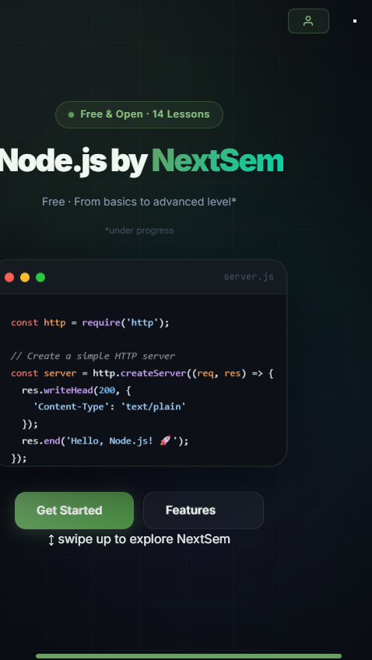
- https://nodejs-by-nextsem.web.app/lessons.html?v=32 this page and all lessons page must follow swipe up and down functionality with pre list and next placed bottom of lesson and horizontal arrow to navigate removed
- add progress bar inside menu too.
- update sign in sign up button whenever user login wherever it is logged
- add pwa inside menu and also offer it as an app to install whenever user opens the site for the first time .
- also add more lessons
- also in each lesson there is lots of free space and in each lesson card explain the relevent topic n detail with some realistic images and screenshots if possible run that script on my system and use it in each lesson with more focus on rich and easy to understnad contetn focused on students of bca b tech m tech job doing persons etc.
- word wrapping
- 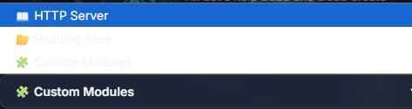
- correct the colour background as it is white and text is not clearly visible
- http://127.0.0.1:5500/lessons.html?v=36 make content on full pageview 