Nexus Core ERP
Client Operations and Maintenance Manual
Apparel manufacturing ERP · PLM · Inventory · Document control
Client | [Client company name]
Client address | [Client address]
Prepared by | [Delivery company name]
Document reference | [NCE-HO-001]
Document version | 1.0
Preparation date | 7 November 2026
Software release | Repository branch erp-dashboard-units-grid-colors, commit 09452f5 plus working-tree changes (to be replaced by the final release tag)
Classification | Confidential — client and delivery team only
Document Control

Revision history
Version | Date | Author | Description
1.0 | 2026-11-07 | [Author name] | First issue, prepared from a source-code audit of the delivered repository and the automated test runs of 7 November 2026.
[ ] | [ ] | [ ] | [ ]

Review and approval
Role | Name | Signature | Date
Prepared by | [ ]
Reviewed by (delivery) | [ ]
Approved by (client) | [ ]

Distribution
Recipient | Organisation / role
[ ] | Client project sponsor
[ ] | Client IT / system owner
[ ] | Client key users

Related documents
Document | Location
Developer documentation (11 Markdown files and an endpoint appendix) | docs/ in the source repository
Production deployment notes | DEPLOYMENT.md
Performance audit report | performance-audit-report.md
Contents
1. Introduction 5
1.1 Purpose of this manual 5
1.2 How this manual was prepared 5
1.3 Conventions 5
2. System Overview 6
2.1 What the system does 6
2.2 Delivered modules 6
2.3 Screens that are not operational 7
2.4 Main business flow 8
2.5 Technical components (summary) 9
3. Getting Started 10
3.1 Signing in 10
3.2 Screen layout 10
3.3 Permissions 10
3.4 Approvals 10
3.5 Companies 11
4. Working with the Modules 12
4.1 Legacy ERP master data 12
4.2 Purchase and subcontract orders 12
4.3 Work orders 12
4.4 Fabric, trim and yarn requirements 13
4.5 Order manufacturing and cutting 13
4.6 Inventory receipts 13
4.7 Receipt invoices 14
4.8 Packing lists 14
4.9 Serial cards and QR labels 14
4.10 Financial receipts and item statement 14
4.11 PLM 15
4.12 Docket management 15
4.13 Reports and Report Builder 15
4.14 BPM 16
5. Administration 17
5.1 First administrator 17
5.2 Users 17
5.3 Roles and permissions 17
5.4 Approval configuration and screen parameters 17
5.5 Companies 17
5.6 Menu 18
5.7 Audit log 18
6. Installation and Start-up 19
6.1 Prerequisites 19
6.2 Installation steps (overview) 19
6.3 Reverse proxy 19
6.4 Configuration settings 20
6.5 Checks after installation 20
7. Operation and Maintenance 21
7.1 Backups 21
7.2 Applying a new release 21
7.3 Monitoring and logs 21
7.4 Routine tasks 21
8. Security and Access 22
8.1 Controls in place 22
8.2 Client responsibilities 22
8.3 Known security limitations 23
9. Testing, Limitations and Open Items 24
9.1 Automated test results (7 November 2026) 24
9.2 Known limitations 24
9.3 Not verified during the audit 25
10. Troubleshooting 26
10.1 For users 26
10.2 For IT 26
11. Support and Maintenance Arrangements 27
12. Handover Checklist 28
12.1 Deliverables 28
12.2 Configuration dependencies (client to provide) 28
12.3 Decisions required 28
12.4 Access handover 29
13. Acceptance and Sign-off 30
13.1 Acceptance tests 30
13.2 Acknowledgement of limitations 30
13.3 Sign-off 31
Appendix A — Technical Summary 32
Appendix B — Glossary 33

1. Introduction

1.1 Purpose of this manual
This manual explains how to operate, administer and maintain the delivered Nexus Core ERP system. It is written for the client's key users, system administrator and IT staff. It does not require knowledge of the source code; detailed database, API and developer material is kept in the developer documentation (docs/ folder of the repository).

1.2 How this manual was prepared
The content was derived from an audit of the delivered source code, configuration, database migrations and automated tests carried out on 7 November 2026. The automated test suites were run during the audit and their results are reported in Section 9.
Important. The screen workflows in Section 4 were documented from the application code and its automated tests. They were not walked through in a browser during the audit, and no production installation, backup restore or e-mail delivery was tested. These items are listed as acceptance checks in Section 12 and must be confirmed on the client's environment.

1.3 Conventions
Convention | Meaning
Menu → Item | A path in the left-hand sidebar menu.
Italic text in quotes | An exact message shown by the system.
code | A command, file name, setting or address to type exactly.
[ ] | Information to be completed by the client or delivery team.
Implemented | Works with real data stored in the database.
Demo / Placeholder | Visible in the application but does not store data (see Section 2.3).

2. System Overview

2.1 What the system does
Nexus Core ERP is a web application for an apparel and textile manufacturing business. Users work in a web browser; no software is installed on their computers. The system brings together:
- Legacy ERP — manufacturing, inventory, purchasing, invoicing and logistics, using the data structures migrated from the client's earlier ERP.
- PLM — product lifecycle management: style, sample, swatch and product cards, costing sheets, PLM orders, tasks and critical path.
- Docket Management — document control for styles, samples, products and orders, with approvals and secure external sharing.
- Reporting — standard reports and a Report Builder with CSV, Excel and PDF export.
- Administration — users, roles and permissions, approvals, audit log, menu and company management.

2.2 Delivered modules
Module | Main screens | Status
Legacy ERP — master data | Warehouses, Current Accounts, Yarn / Fabric / Trim Cards, Trim Inventory Cards, Inventory Card List, Sizes, Unit Sets, code masters | Implemented
Legacy ERP — purchasing | Purchase Orders, Subcontract Orders, Subcontract Receipts, Purchase and Sale Contracts | Implemented
Legacy ERP — manufacturing | Work Orders, Fabric/Trim/Yarn Requirements and Planning, Yarn Recipes, Order Manufacturing Entry, Cutting Card | Implemented, tested
Legacy ERP — inventory | Inventory Receipts (18 types), approvals, Item Allocation, Item Statement | Implemented, tested
Legacy ERP — invoicing | Receipt Invoices (18 types), combined invoices | Implemented, tested
Legacy ERP — logistics | Packing Lists, Serial Cards with QR labels | Implemented, tested
Legacy ERP — finance | Financial Receipts, Receipt & Master Data | Implemented
PLM | Style, Sample, Swatch and Product Cards, Mood Boards, PLM Templates, General Definitions, PLM Orders, Tasks, Critical Path, PLM reports | Implemented
Costing | Costing Sheets, Cost Detail Entry, Profit Breakdown, lock/unlock | Implemented, tested (lock feature pending release — Section 9)
Docket Management | Dockets, Approval Queue, Document Register, Setup, Sharing, Reports | Partial (documents are registered by link)
Cutting Orders and BPM | Cutting orders, BPM Task Queue, Request Types | Implemented
Reports | Standard reports, Report Builder with export | Implemented, tested
Administration | Users (with role assignment), Companies, Menu, Approval Configuration, Screen Parameters, Log Tracking, User-Defined Fields | Implemented, tested (roles: API only — Section 5.3)

2.3 Screens that are not operational
The application was built on a commercial user-interface template. Some screens from that template, and some placeholder screens, are still present. They do not store data:
Area | Behaviour
Finance ERP (General Ledger, Payables, Receivables, Fixed Assets) | Demonstration only. Sample data is held in the browser; all changes are lost when the page is reloaded.
Settings screens: Currencies, Locations, Taxes, Units, SMTP Settings, Email Templates, Pricing Plans, Custom Fields, Access Control, Business Processes, Form Designer, Login History | Placeholder. They show empty lists and saving has no effect.
Apps: Notes, Mail, Todo List; AI Chat, Image Generator, Text to Speech | Placeholder or demonstration responses; no data is stored and no AI service is used.
Template pages (dashboards for other industries, alternative login pages, pricing pages) | Static examples.
Several of these items appear in the default sidebar menu. The client should decide before go-live whether to hide them (decision Q1 in Section 12). Administrators can hide menu items without any software change.

2.4 Main business flow
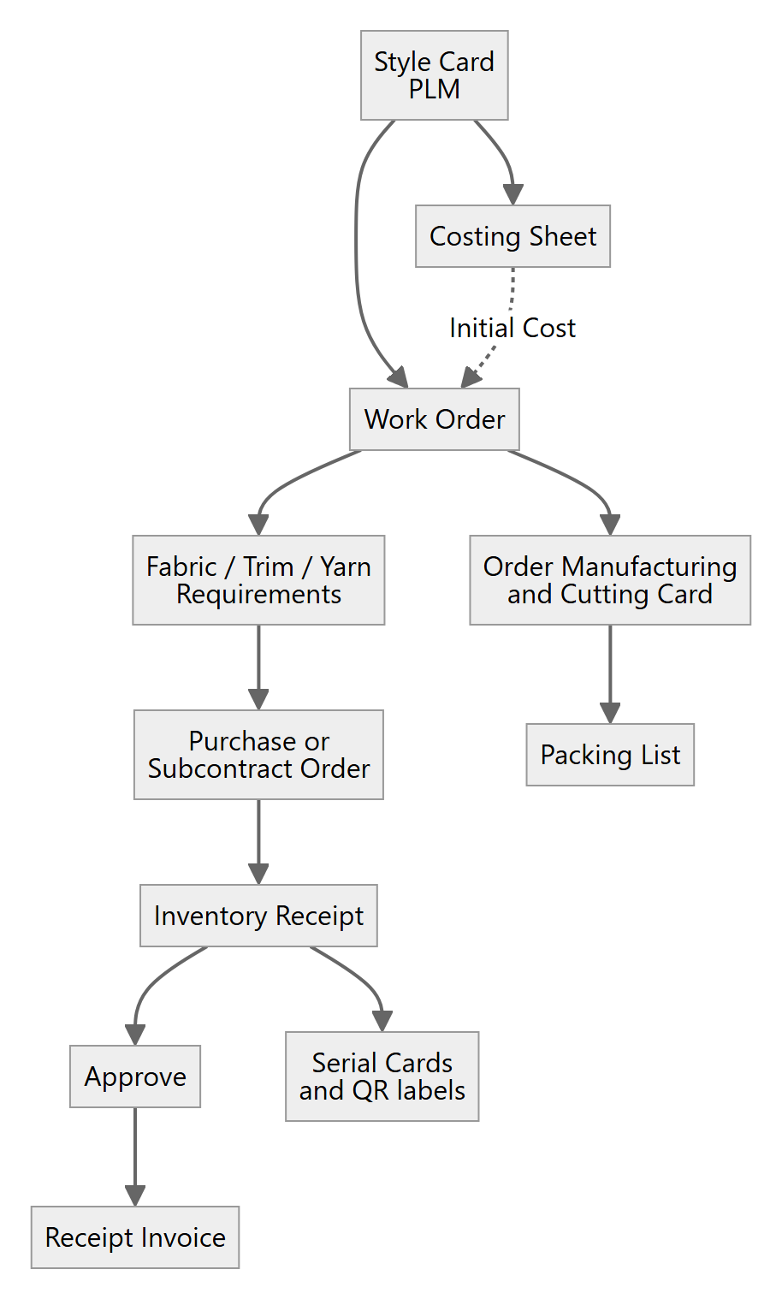
Figure 1 — How the main records connect, from style development to invoicing and packing.

2.5 Technical components (summary)
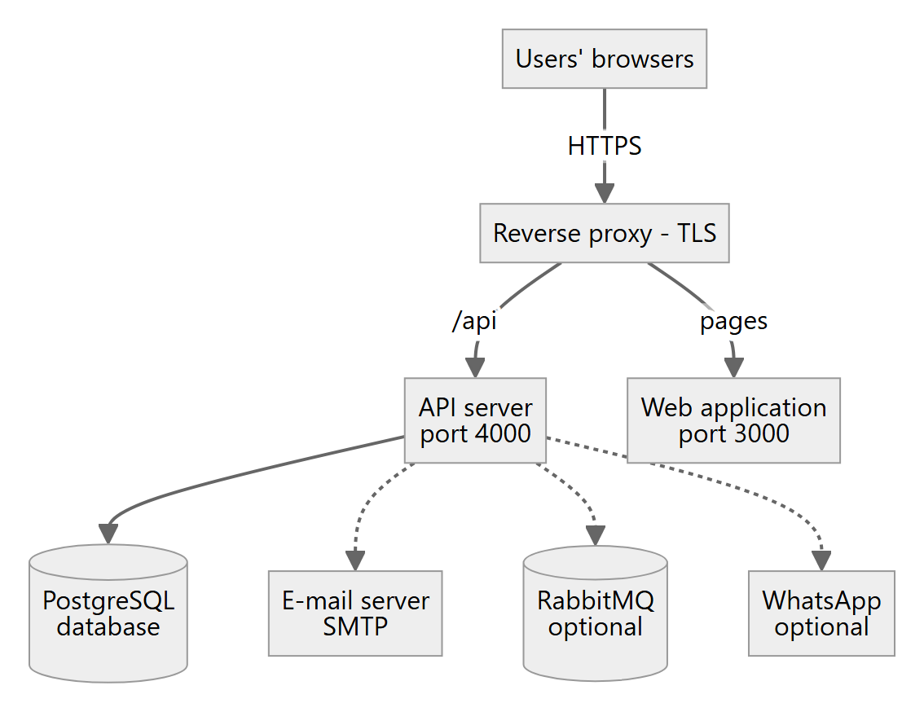
Figure 2 — Components of a production installation.
Component | Role
Web application | Delivers the screens to the browser (Next.js, port 3000).
API server | Business rules, security and data access (NestJS, port 4000, addresses beginning /api/v1).
PostgreSQL database | Stores all business data and uploaded attachments.
Reverse proxy | Provides HTTPS and routes requests to the two servers (IIS or Nginx).
E-mail server (SMTP) | Needed to send password-reset and administrator-invitation e-mails.
RabbitMQ, WhatsApp | Optional; the system works without them.

3. Getting Started

3.1 Signing in
- Open the address provided by your administrator in a current version of Chrome, Edge or Firefox.
- Enter your e-mail address and password and select Sign in.
- On your first sign-in, or after an administrator has set your password, you must choose a new password (at least 6 characters). Until you do, the system answers "Password change required".
- After sign-in, every address contains your company's short name, for example https://erp.example.com/acme/legacy-erp/work-orders-list.
Message | Meaning
"Invalid credentials" | E-mail or password is wrong.
"Account is deactivated" | Your account was switched off by an administrator.
Trial expired | Your company's trial period has ended; contact the system owner.
Too many requests (HTTP 429) | More than 10 sign-in attempts in one minute; wait a minute and try again.

Forgotten password
Select Forgot password, enter your e-mail address and follow the link in the e-mail within 30 minutes. For privacy, the screen gives the same answer whether or not the address exists. This feature only works if the e-mail server has been configured (Section 6.4).

3.2 Screen layout
- Sidebar menu — groups such as Legacy ERP, PLM, Docket Management and BPM. The administrator controls which items appear.
- List screens — a grid of records with search, column filters, paging and, where available, Export and Print. Opening a row opens the record in a tab so several records can be open side by side.
- Record screens — a header and tabs with detail grids. Use New, Save and Delete on the toolbar; add, edit and delete lines in the grids.
- Lookups — fields such as Current Account, Inventory Card, Work Order or Style Card open a search dialog. Lookups show only your own company's records.

3.3 Permissions
What you may change depends on the roles your administrator has given you. Any signed-in user can view most data of their own company; creating, changing, deleting, approving, locking and exporting require specific permissions. If you lack one, the system answers "Insufficient permissions" — ask your administrator.

3.4 Approvals
Documents such as inventory receipts, invoices, packing lists and orders can be approved. For each screen the administrator decides whether a formal approval step is required (Section 5.4).
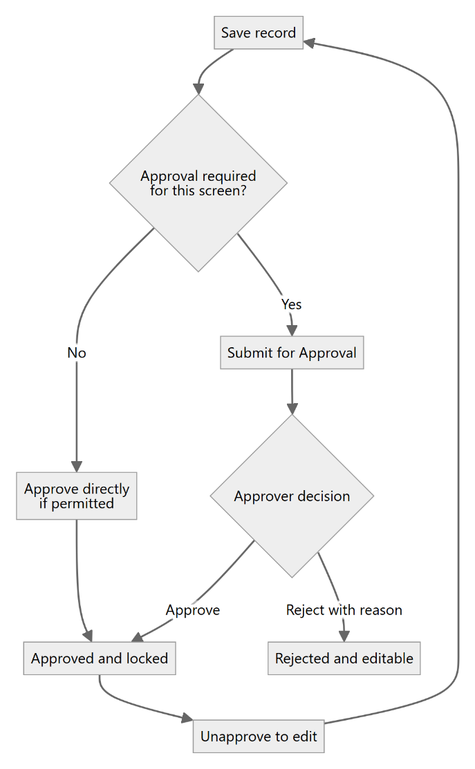
Figure 3 — Approval of a document.
- A rejection always needs a reason ("A rejection reason is required.").
- You cannot approve your own submission unless self-approval is allowed for that screen ("You cannot approve or reject your own submission.").
- An approved document is protected against changes; use Unapprove (with the approval permission) before editing.

3.5 Companies
One installation can serve more than one company. Each company sees only its own Legacy ERP records; records of another company behave as if they do not exist. A few reference lists (processes, quality types, size sets, item groups and unit sets) are deliberately shared by all companies. If you see "This company is not linked to a legacy ERP company", the administrator must complete the company set-up (Section 5.5).

4. Working with the Modules

4.1 Legacy ERP master data
Menu item | Use it to
Warehouses; Warehouse Parameters | Maintain warehouses and their settings.
Current Account | Maintain customers, suppliers and subcontractors, with addresses, contacts, bank accounts, forex rates and attached documents/pictures.
Yarn Cards, Fabric Cards, Customer Define Trims, Trim Inventory Cards | Maintain material cards (fabric cards include their yarn recipe).
Inventory Card List | Find any inventory card and see its stock value.
Fab Type, Group Code, Finish GSM, Dye Type, Composition, Subcontract Type, Subcontract Receipt Masters | Maintain simple code lists.
Sizes, Unit Sets | Maintain size sets and units of measure with conversions (shared by all companies).
Procedure: open the list → New → complete the required fields → Save. A code that already exists is refused ("A record with the same unique value already exists").

4.2 Purchase and subcontract orders
- Open Legacy ERP → 1 - Purchase Order (or 3 - Subcontract Order) and select New.
- Choose the Current Account, warehouse and dates.
- Add lines: an inventory item (or a service), its colour/size variant where applicable, quantity and price. A line can be linked to a Work Order line of your company.
- Save. If the screen requires approval, choose Submit for Approval.
System message | What to do
"An inventory item is required" / "A service is required" / "A variant is required" | Complete the line.
"An order already exists with this number." | Use a different number or let the system propose one.
"This screen requires approval — use the Approve/Reject actions …" | Use Submit for Approval instead of changing the status.
Contracts: 1 - Purchase Contract and 2 - Sale Contract record contract headers, lines and attachments for a Current Account.

4.3 Work orders
- Open Legacy ERP → Work Order and select New. The next number is proposed automatically. A Style Card of your company is mandatory.
- Style Info tab: enter the style lines. Manufacturing Quantities: enter the colour × size quantities.
- BOM tabs (Fabric, Trim, Ornament, Process): use Transfer from Style Card or the Transfer … Details actions to copy the bill of materials from the PLM style, then adjust.
- Optionally link a Costing Sheet as Initial Cost (feature pending release — Section 9).
- Use the Explanation, Activities and Expenses tabs as needed and print the Order Form.

4.4 Fabric, trim and yarn requirements
- Open Fabric/Trim/Yarn Requirements and the required type (Fabric, Trim or Yarn); select the Work Order.
- Select Calculate to build the requirement lines from the bill of materials and quantities; review and save.
- Select Lock to freeze the requirement. While it is locked, recalculating, saving and deleting are refused unless you hold the unlock permission.
- Unlock is available only to users with the unlock permission ("You do not have permission to unlock Requirements.").
Lines marked Fix Quantity take their quantity from the Style Card bill of materials; change them there. The planning screens (Fabric, Yarn and Trim Planning, Yarn Recipe) present the requirements for planning purposes.

4.5 Order manufacturing and cutting
Order Manufacturing Entry records produced quantities for each process on the work order's route and the related price contracts. The processes come from the style's route card. Cutting Card (from a work order) records cutting details and entries by size. A separate Cutting Orders module follows the stages Draft → Pending Approval → Approved → In Progress → Quality Check → Completed (or Cancelled).

4.6 Inventory receipts
Each receipt type has its own menu item under Legacy ERP → Inventory Receipts:
Code | Receipt type | Code | Receipt type
2 | Purchase Receipt | 140 | Manufacture Send Receipt
122 | Purchase Return | 40 | Manufacture Return Receipt
16 | Counting Stock Receipt | 10 | Outside Manufacture Receipt
101 | Counting Stockovers Receipt | 132 | Special Purpose (Outflow) Receipt
17 | Warehouse Transfer Receipt | 18 | Special Purpose (Inflow) Receipt
11 | Outside Process Receive Receipt | 22 | Service Purchase Receipt
12 | Outside Process Return Receipt | 139 | Service Purchase Return Receipt
134 | Outside Process Sent Receipt | 120 | Wholesale Receipt
133 | Outside Process Sent Return Receipt | 3 | Return Wholesale Receipt
- Open the receipt type and select New. Complete the header (Current Account, warehouse(s), date, document number, vehicle/driver where shown).
- Add lines (item, variant, quantity), or import them from an order — or, for returns, from an earlier receipt.
- Save, then Approve. A receipt without lines cannot be approved.
- Optional: Generate Serial Cards for a line; use Item Allocation to allocate stock to work-order requirements.
System message | Meaning
"Cannot receive this quantity — only N still pending (Base Unit) on this order line." | Over-receipt against the order is not allowed.
"Cannot return this quantity — only N still available to return …" | Return exceeds what was received.
"The originating order line belongs to a different Current Account …" | Order and receipt must be for the same account.
"This receipt is on invoice X — delete or relink that invoice first." | Invoiced receipts cannot be deleted.

4.7 Receipt invoices
- From an approved receipt select Create Invoice, or open Legacy ERP → Invoices → (type), select New and choose the receipt.
- Several receipts of the same Current Account can be combined into one invoice when it is created.
- Approve or Unapprove as required. Totals are calculated by the system and cannot be typed.
A receipt can belong to one invoice only ("Inventory Receipt X is already on invoice Y").

4.8 Packing lists
- Open Packing Lists → New and select the Work Order (mandatory).
- Add lines with colour, From (Box), To (Box) and the quantity for each size.
- Approve when complete. An approved packing list must be unapproved before it can be changed.
Rules: box numbers start at 1, To must not be below From, box ranges must not overlap between lines, a size may appear only once per line and quantities cannot be negative.

4.9 Serial cards and QR labels
Serial cards are generated from receipt lines and can be edited individually. Printed labels carry a QR code with the address <ERP address>/s/<serial number>. Scanning it with a phone opens a mobile page after sign-in; the user needs permission to view serial cards. Set the public address of the ERP (QR_PUBLIC_BASE_URL, Section 6.4) before printing labels in production so that the codes remain valid.

4.10 Financial receipts and item statement
Financial Receipts and Receipt & Master Data record financial receipts with their lines and attachments. Item Statement lists the movements of an inventory item.

4.11 PLM
Area | Screens
Definitions | Style Cards, Sample Cards, Mood Boards, Swatch Cards, Product Cards, Costing Sheets, Cost Detail Entry, Costing Profit Breakdown, PLM Templates
General Definitions | Style Sample Types, Design Detail Types, Measurement Definitions and Charts, Department, Process, Employee, Resource, Activity Type, Color, Company, Brand, Season, Gender, Size and Route Cards, Study Templates, Sample Task Types
Utilities | PLM Orders, PLM Tasks, Critical Path Chart
Reports | Delayed, Daily and Cancelled Task Lists, Sample Cost, Sample History, Analyse Cubes, Report Builder
Creating a style: Style Cards → New → style number (must be unique), title, season, customer, merchandisers, sizes and colourways → Save. Further tabs hold the bill of materials, wash care, expenses, measurements and attachments. PLM records belong to your branch.

Costing sheets
- Costing Sheets → New; link a Style or Sample Card; enter currency rates, quoted price, order quantity and percentages (overhead, waste, profit, commission and others).
- Complete the raw-material, labour and other-cost lines. Cost Detail Entry and Profit Breakdown give summarised views.
- Lock freezes a sheet; Unlock needs the unlock permission. A sheet used as a work order's Initial Cost cannot be deleted.

4.12 Docket management
- Setup: define Document Types, Docket Templates (which documents each docket needs) and Approval Workflows.
- Dockets: open the docket of a style, sample, product or order. Each item shows whether its document is missing, uploaded, pending, approved or rejected, and the docket shows its completeness percentage.
- Adding a document: enter the document's file address (URL), file name, type and version notes. The system stores the link, not the file — the file must be stored on a location agreed with IT (decision C6, Section 12).
- Approval Queue and Document Register: review, approve or reject documents.
- Sharing: create a Shared Link (valid for a chosen number of days, 30 by default, optionally protected by a password, can be switched off) or an External Review. Recipients open the link without an account.
- Reports: Completeness, Missing Documents and Document Expiry.
The watermark option of shared links has no effect in this release; recipients receive the original file link.

4.13 Reports and Report Builder
Standard reports are installed in each module's Reports menu. With the Report Builder (PLM, Legacy ERP and Docket Management):
- Open Reports → Manage Reports and create a report: choose the data source, fields and filters.
- Preview, then save.
- Run the report and Export it as CSV, Excel or PDF.
Viewing, exporting and designing reports are separate permissions per module.

4.14 BPM
BPM → Task Queue lists workflow tasks; Request Types defines request categories.

5. Administration

5.1 First administrator
The installation creates one administrator with the Admin role (full access). Its initial password is printed once during set-up (or taken from the installation settings) and must be changed at first sign-in. Keep at least two administrator accounts so that access is never lost.

5.2 Users
Apps → Users: create users (name, e-mail, company branch), set an initial password, assign roles and deactivate leavers. A deactivated user can no longer sign in or use existing sessions. Every new user must change the password at first sign-in.

5.3 Roles and permissions
A role is a named set of permissions of the form module : action (for example work-orders:create, approval:approve, requirements:unlock, costing:lock). Only administrators can create or change roles. No roles other than Admin are delivered; the client should create roles that match its organisation.
No role-management screen. In this release roles can be assigned to users on the Users screen, but creating roles and choosing their permissions is only possible through the system's API (done by IT or the support provider). The Permission settings page in the application manages a different, CRM-level setting and does not change these roles. Building a role screen is decision Q7 in Section 12.
A suggested starting point:
Role | Typical permissions
Viewer | None beyond sign-in (most data can be viewed).
Store keeper | Inventory receipts, serial cards, packing lists, item allocation.
Purchasing | Purchase orders, orders, contracts, current accounts.
Production planner | Work orders, requirements (create, delete, lock), order manufacturing, cutting cards.
Merchandiser / PLM | PLM, costing (create, update, lock), dockets, PLM reports (view, export).
Approver | Approval (approve, reject, view pending, view history), requirements unlock, costing unlock.
Administrator | Admin role.
Roles apply to the whole installation. If several companies share one installation, a change to a role affects users in all of them.

5.4 Approval configuration and screen parameters
Legacy ERP → General Settings: for each screen choose whether approval is required and whether users may approve their own submissions. Screen Parameters holds per-screen settings.

5.5 Companies
The platform-owner company can create client companies on the Companies screen (address /<company>/pages/companies; it is not in the default menu), set trial dates and invite each company's first administrator by e-mail (the invitation link is valid for 72 hours unless configured otherwise). Each company that uses the Legacy ERP must be linked to a legacy ERP company; the installation does this for the first company, and IT can link further companies with the provided maintenance script.

5.6 Menu
Administrators can rename, reorder, hide or add menu items. Use this to hide the demonstration and placeholder screens listed in Section 2.3.

5.7 Audit log
The Log Tracking screen (address /<company>/administration/log-tracking; not in the default menu — an administrator can add it) lists who created, changed, deleted or approved which record, with old and new values. User-Defined Fields (/administration/user-defined-fields) is reached the same way.

6. Installation and Start-up
This section is for IT staff. Full detail is in docs/06-Installation-Guide.md and docs/09-Deployment-and-Maintenance.md.

6.1 Prerequisites
Item | Requirement
Operating system | Windows Server or Linux able to run Node.js
Node.js | Version 22 LTS or 24 LTS, with npm
Database | PostgreSQL 14 or newer
Web server | IIS or Nginx as reverse proxy with a TLS certificate
Process manager | systemd or PM2 (Linux); NSSM, WinSW or PM2 (Windows)
E-mail | An SMTP account for system e-mails
Optional | RabbitMQ 3.12+; Meta (WhatsApp) business account

6.2 Installation steps (overview)
1. Obtain the release and install dependencies (repository root):
npm ci
2. Create the PostgreSQL database and a dedicated database login.
3. Create nexuscore-backend/.env from nexuscore-backend/.env.example and fill in the values (6.4).
4. Build:
npm run build -w nexuscore-backend
NEXT_PUBLIC_NEXUSCORE_API_URL=/api/v1 npm run build -w frontend
5. Create the database structure and initial data:
cd nexuscore-backend
npm run db:deploy
npm run db:setup
6. Start both services under the process manager:
npm run start:prod (in nexuscore-backend, port 4000)
npm run start -- -p 3000 (in frontend)
7. Configure the reverse proxy (6.3) and run the checks in 6.5.
On Windows PowerShell set the build variable first: $env:NEXT_PUBLIC_NEXUSCORE_API_URL="/api/v1".

6.3 Reverse proxy
- Send addresses beginning /api/ to the API server (port 4000) and everything else to the web application (port 3000).
- Allow WebSocket upgrade for /socket.io.
- Allow request bodies of at least 10 MB.
- Terminate HTTPS and add standard security headers here.
- Make ports 3000 and 4000 reachable only from the proxy.

6.4 Configuration settings
Settings are held in nexuscore-backend/.env. Never place real values in documents, e-mails or tickets.
Setting | Purpose
NODE_ENV=production | Production mode (strict security checks, API documentation hidden).
NEXUSCORE_DATABASE_URL | Database connection.
NEXUSCORE_JWT_SECRET, NEXUSCORE_JWT_REFRESH_SECRET | Two different random values of at least 32 characters. The API refuses to start without them.
APP_PUBLIC_URL | Public address used in e-mail links.
QR_PUBLIC_BASE_URL | Public address encoded in serial-card QR labels.
SMTP_HOST, SMTP_PORT, SMTP_SECURE, SMTP_USER, SMTP_PASS, SMTP_FROM | E-mail server. The SMTP Settings screen in the application is a placeholder; configure e-mail here. npm run smtp:verify -w nexuscore-backend tests the connection without sending.
CORS_ORIGINS | Only needed when the API is served from a different address than the screens.
SEED_ADMIN_EMAIL, SEED_ADMIN_PASSWORD, SEED_COMPANY_NAME, SEED_BRANCH_NAME | Used once by db:setup to create the first company and administrator.
COMPANY_TRIAL_DAYS, FIRST_ADMIN_INVITE_TTL_HOURS | Optional: default trial length; validity of administrator invitations (default 72 h).
NEXUSCORE_RABBITMQ_URL, META_* | Optional integrations.
Generate a random secret with: node -e "console.log(require('crypto').randomBytes(48).toString('base64url'))"

6.5 Checks after installation
Check | Expected result
https://<host>/api/v1/health | Status ok
https://<host>/api/v1/health/ready | Status ready; an error means the database cannot be reached
Administrator sign-in | Asked to change the password
Open Legacy ERP → Warehouses | List opens without a company-link message
https://<host>/api/docs | Not available in production

7. Operation and Maintenance

7.1 Backups
- Take a nightly pg_dump of the database. Uploaded attachments are stored inside the database and are included.
- Docket documents are stored only as links: back up the location where those files are kept.
- Use WAL archiving or managed point-in-time recovery if finer recovery points are required.
- Copy backups off the server; keep the .env file in a separate secure backup.
- Test a restore at least quarterly. No restore test was performed during the handover audit.
pg_dump --format=custom --file=nexuscore_YYYYMMDD.dump "<connection-string>"
pg_restore --clean --if-exists --dbname="<restore-target>" nexuscore_YYYYMMDD.dump

7.2 Applying a new release
- Back up the database and .env.
- Stop the services, deploy the new release and run npm ci.
- Rebuild both parts (Section 6.2, step 4).
- Run npm run db:deploy then npm run db:setup in nexuscore-backend; both are safe to repeat.
- Start the services and repeat the checks in Section 6.5.
Database changes cannot be rolled back automatically. To return to the previous release, restore the backup taken in step 1 and redeploy the previous release.

7.3 Monitoring and logs
Source | Use
Health addresses | Monitor /api/v1/health/ready every minute and alert on failure.
Service logs | Captured by the process manager. Unexpected errors carry an error ID that also appears in the user's error message — use it to find the log entry.
Log Tracking (audit) | Business changes and approvals by user.

7.4 Routine tasks
When | Task
Daily | Confirm backups completed and the health monitor is green.
Weekly | Review error logs and disk space.
Monthly | Review users and roles; deactivate leavers; apply operating-system and database updates.
Quarterly | Restore test on a separate server; review software dependency security advisories in a test environment.
Each release | Follow Section 7.2 on a test server first and run the automated tests.

8. Security and Access

8.1 Controls in place
Control | Description
Passwords | Stored only as secure hashes; forced change at first sign-in; reset links valid 30 minutes.
Sign-in protection | Rate limits on sign-in and password-reset requests.
Sessions | Signed tokens; deactivated users are refused immediately.
Permissions | Every change, approval, lock and export is checked on the server against the user's roles.
Company separation | Legacy ERP data is separated per company and tested by automated tests.
Error handling | Users never see technical details; they receive an error ID instead.
Uploads | File types and sizes are checked; downloads are served safely.
Audit | Changes and approvals are recorded with the user and old/new values.

8.2 Client responsibilities
- Use HTTPS only; keep the server, database and Node.js patched.
- Protect the .env file; replace the token secrets after handover and whenever they may have leaked.
- Create roles on the principle of least privilege; review them monthly.
- Restrict database access to the application server and administrators.
- Do not store proxy logs containing full download addresses longer than necessary.

8.3 Known security limitations
The following points were identified by code review during the audit. They were not exploited or penetration-tested. Their priority is decision Q6 in Section 12.
# | Finding | Recommendation
S1 | The sign-in token is kept in browser storage readable by scripts. | Move to secure HTTP-only cookies.
S2 | Signing out does not invalidate tokens; tokens are valid for up to 7 days (refresh 30 days). | Shorter lifetimes and server-side revocation.
S3 | The sign-in response contains the company's WhatsApp/Meta credentials. | Remove secret fields from the response; do not configure WhatsApp until fixed.
S4 | Real-time notification channel accepts connections from any web origin (sign-in still required). | Restrict to the ERP address.
S5 | Roles are shared by all companies of one installation. | One company per installation, or company-specific roles.
S6 | Shared-link passwords are stored unencrypted. | Store them hashed.
S7 | Some PLM records can be opened by ID without a branch check. | Add branch/company checks.
S8 | Most data can be read by any signed-in user of the company. | Add view permissions for sensitive areas (costing, users, audit).
S9 | Minimum password length is 6; no lockout or two-factor sign-in. | Stronger password policy; consider MFA.
S10 | File downloads can carry the sign-in token in the address. | Use short-lived download tokens; limit log retention.
S11 | The user list can be requested for all companies of the installation. | Restrict to the user's own company.

9. Testing, Limitations and Open Items

9.1 Automated test results (7 November 2026)
Test group | Suites | Tests | Result
Type checks (API and web application) | 2 | — | Passed, 0 errors
API tests without database | 8 | 68 | All passed
API tests with test database | 16 | 420 | All passed
Web application unit tests | 18 | 336 | 335 passed, 1 skipped (needs a sample label file)
Development launcher tests | 1 | 8 | All passed
The tests cover, among others: company separation (including a real sign-in test), receipt approval, invoices and combined invoices, packing-list box rules, serial cards, stock value, work-order bill-of-materials transfer, order manufacturing routes, costing, cutting, user management, company provisioning and user-defined fields.
Not run: seven browser-based tests (they need a running system), production build, code-style checks, load and security tests.

9.2 Known limitations
# | Limitation | Impact / action
L1 | Finance ERP screens are a demonstration. | Do not use for accounting.
L2 | Placeholder settings and app screens (Section 2.3). | Hide from the menu.
L3 | Docket documents are stored as links; no file upload; watermark option has no effect. | Agree a file storage location.
L4 | Opening or downloading Current Account attachments is expected to fail with an access error (found by code review, not confirmed on a running system). | Test during acceptance; fix if confirmed.
L5 | Costing lock, manual amounts and the work-order Initial Cost link were not yet part of a committed release at the time of the audit. | Decide to release or exclude (Q3).
L6 | Legacy ERP document numbers are shared across companies. | Decide on per-company numbering (Q4).
L7 | Database server and application server must use the same time zone, otherwise legacy dates can shift by a day. | Align time zones at installation.
L8 | No screen to create roles or set their permissions (API only). | Decide on Q7.
L9 | Companies, Log Tracking and User-Defined Fields screens are not in the default menu. | Add menu items or use the addresses in Section 5.

9.3 Not verified during the audit
- Browser walkthrough of every screen; printing on real label printers; QR scanning on phones.
- A production installation, upgrade and backup restore.
- E-mail delivery through a real e-mail server; RabbitMQ and WhatsApp integrations.
- Report exports opened in Excel and PDF readers.

10. Troubleshooting

10.1 For users
Symptom or message | Action
"Insufficient permissions" | Ask the administrator for the required permission.
"Password change required" | Change your password.
"This company is not linked to a legacy ERP company …" | Administrator / IT completes the company link.
A record is "not found" although a colleague can see it | It belongs to another company or was deleted.
"A record with the same unique value already exists" | Use a different code or number.
Too many requests | Wait one minute.
An error with an error ID | Send the error ID, time and screen to support.
A saved setting disappears (Currencies, Taxes, SMTP Settings …) | The screen is a placeholder (Section 2.3).

10.2 For IT
Symptom | Cause and fix
API stops at start-up with a message about NEXUSCORE_JWT_SECRET | Secret missing, too short, a placeholder, or both secrets equal. Set two different random values of 32+ characters.
Web build fails mentioning NEXT_PUBLIC_NEXUSCORE_API_URL | Set the variable (normally /api/v1) before building.
/api/v1/health/ready reports the database unavailable | Check PostgreSQL, the connection string and the firewall.
Password-reset e-mails do not arrive | Configure SMTP_* settings; run npm run smtp:verify -w nexuscore-backend.
Warnings about RabbitMQ in the log | Harmless if RabbitMQ is not used.
Port already in use when starting | Another instance is running; stop it first.
Uploads fail for large files | Proxy body-size limit below 10 MB; raise it.

11. Support and Maintenance Arrangements
Item | Details
Support provider | [Company name]
Support contact | [Name, e-mail, telephone]
Support hours | [ ]
Response targets | [Critical / High / Normal]
Warranty period | [ ]
Client system owner | [Name]

How to report a problem
- Screen name and menu path.
- Exact message, including the error ID if shown.
- Date and time, user name and company.
- Steps to reproduce and the record number involved.
Never send passwords or token secrets in a support request.

12. Handover Checklist

12.1 Deliverables
✓ | Item
☐ | Source code repository access and release tag [ ]
☐ | Developer documentation (docs/)
☐ | This manual (Word and PDF)
☐ | Configuration templates without secrets

12.2 Configuration dependencies (client to provide)
✓ | # | Item
☐ | C1 | Production server(s)
☐ | C2 | Domain name and TLS certificate
☐ | C3 | PostgreSQL instance and backup storage
☐ | C4 | SMTP account
☐ | C5 | Public ERP address for e-mail links and QR labels
☐ | C6 | File storage location for docket documents
☐ | C7–C9 | Optional: RabbitMQ; WhatsApp account; label printers and phones

12.3 Decisions required
# | Decision | Outcome / owner
Q1 | Hide demonstration and placeholder screens before go-live? | [ ]
Q2 | Is a real finance/accounting module required? | [ ]
Q3 | Release or exclude the costing lock / Initial Cost features. | [ ]
Q4 | Per-company document numbering. | [ ]
Q5 | Ownership of a few records created before company separation. | [ ]
Q6 | Priority of security items S1–S11. | [ ]
Q7 | Role design, user administration responsibility, and whether a role-management screen is needed. | [ ]
Q8 | One or several companies per installation. | [ ]
Q9 | Password policy. | [ ]
Q10 | Hosting, support model and backup retention. | [ ]
Q11 | Fix of the Current Account attachment issue (L4). | [ ]

12.4 Access handover
Hand over credentials through a password manager or sealed envelope — never by e-mail or in this document.
✓ | Access | Received by
☐ | Source code repository (owner rights) | [ ]
☐ | Servers / hosting account | [ ]
☐ | Database administrator and application logins | [ ]
☐ | Application administrator account | [ ]
☐ | Configuration secrets (token secrets regenerated after handover) | [ ]
☐ | E-mail, WhatsApp, RabbitMQ accounts (if used) | [ ]
☐ | Domain, DNS and certificate | [ ]
☐ | Developer access no longer required has been removed | [ ]

13. Acceptance and Sign-off

13.1 Acceptance tests
# | Test | Expected result | Pass / tester
T1 | Health check /api/v1/health/ready | ready
T2 | Administrator first sign-in | Password change forced, then dashboard
T3 | Create a role (by IT, via the API) and a user with it; user tries a non-permitted change | Refused with "Insufficient permissions"
T4 | Forgot password | E-mail received; reset works within 30 min
T5 | Create warehouse, current account and inventory card; repeat a code | Saved; duplicate refused
T6 | Create a Style Card | Saved and listed
T7 | Work order from the style; transfer BOM; calculate, lock, unlock requirements | Locked requirement refuses changes
T8 | Purchase order and purchase receipt; try to over-receive | Over-receipt refused; receipt approves
T9 | Invoice from the receipt; try a second invoice | Second refused
T10 | Packing list with overlapping boxes | Refused; valid list approves
T11 | Generate serial cards, print label, scan QR | Card shown on phone after sign-in
T12 | Costing sheet lock (if released) | Edit refused while locked
T13 | Docket document link, approval, shared link with password | Link needs password; expires
T14 | Report Builder export CSV / Excel / PDF | Files open correctly
T15 | Approval required for a screen; try self-approval | Refused unless allowed
T16 | Second company cannot see first company's data (if used) | Records not found
T17 | Backup and restore to a separate database | Restored system works
T18 | Audit log shows the above actions | Entries present

13.2 Acknowledgement of limitations
☐ The client has read Sections 2.3, 8.3 and 9 and acknowledges the listed limitations and open items.

13.3 Sign-off
Acceptance: ☐ Full ☐ Conditional on items: ______________________ ☐ Not accepted
Role | Name | Organisation | Signature | Date
Client project sponsor | [ ] | [ ]
Client IT / system owner | [ ] | [ ]
Delivery project manager | [ ] | [ ]
Lead developer | [ ] | [ ]

Appendix A — Technical Summary
Item | Value
Web application | Next.js 16, React 19 (336 page routes, including template pages)
API server | NestJS 10 modular application; 82 controllers; 1,461 API routes, of which 264 are placeholders
Database | PostgreSQL; 196 application tables managed by Prisma plus 532 legacy ERP tables; 48 database migrations
Reports | CSV, Excel (exceljs) and PDF (pdfmake) exports
Real-time | Socket.IO notifications
Developer documentation | docs/README.md (index), database design, API reference with full endpoint list, testing details

Appendix B — Glossary
Term | Meaning
Current Account | A business partner: customer, supplier or subcontractor.
BOM | Bill of materials — the fabrics, trims, ornaments and processes needed for a style.
Requirement | Calculated material quantity needed for a work order.
Receipt | Any stock movement document (purchase, return, transfer, manufacture, counting …).
Docket | The set of documents required for a style, sample, product or order.
PLM | Product Lifecycle Management — design and development of styles and samples.
Legacy ERP | The manufacturing and inventory part of the system based on data structures migrated from the previous ERP.
Role / permission | A permission allows one action in one module; a role groups permissions and is given to users.
Reverse proxy | The web server that receives HTTPS traffic and passes it to the application.
Error ID | A reference shown with unexpected errors that lets IT find the matching log entry.

