MENU

Giswater
- New project - db connection & schema name

- copy project as - db schema name & qgis file name

- project configuration - snapping tolerance
- node tolerance

- project management - table wizard (actua Java)
- undo wizard (actua Java)

- analysis - epa results - result catalog (actua Java)
- result selector (actua Java)

- flow trace - from node (actua Java)
- from arc (actua Java)

- go2epa - Giswater interface (actua Java)
- Run simulation (actua Java)

INSERT FEATURES BAR (URBAN DRAINAGE PROJECTS)

Insert junction
Insert outfall
Insert divider
Insert storage
Insert conduit
Insert pump
Insert orifice
Insert weir
Insert outlet

INSERT FEATURES BAR (WATER SUPPLY PROJECTS)

Insert junction
Insert reservoir
Insert tank
Insert pipe
Insert pump
Insert valve

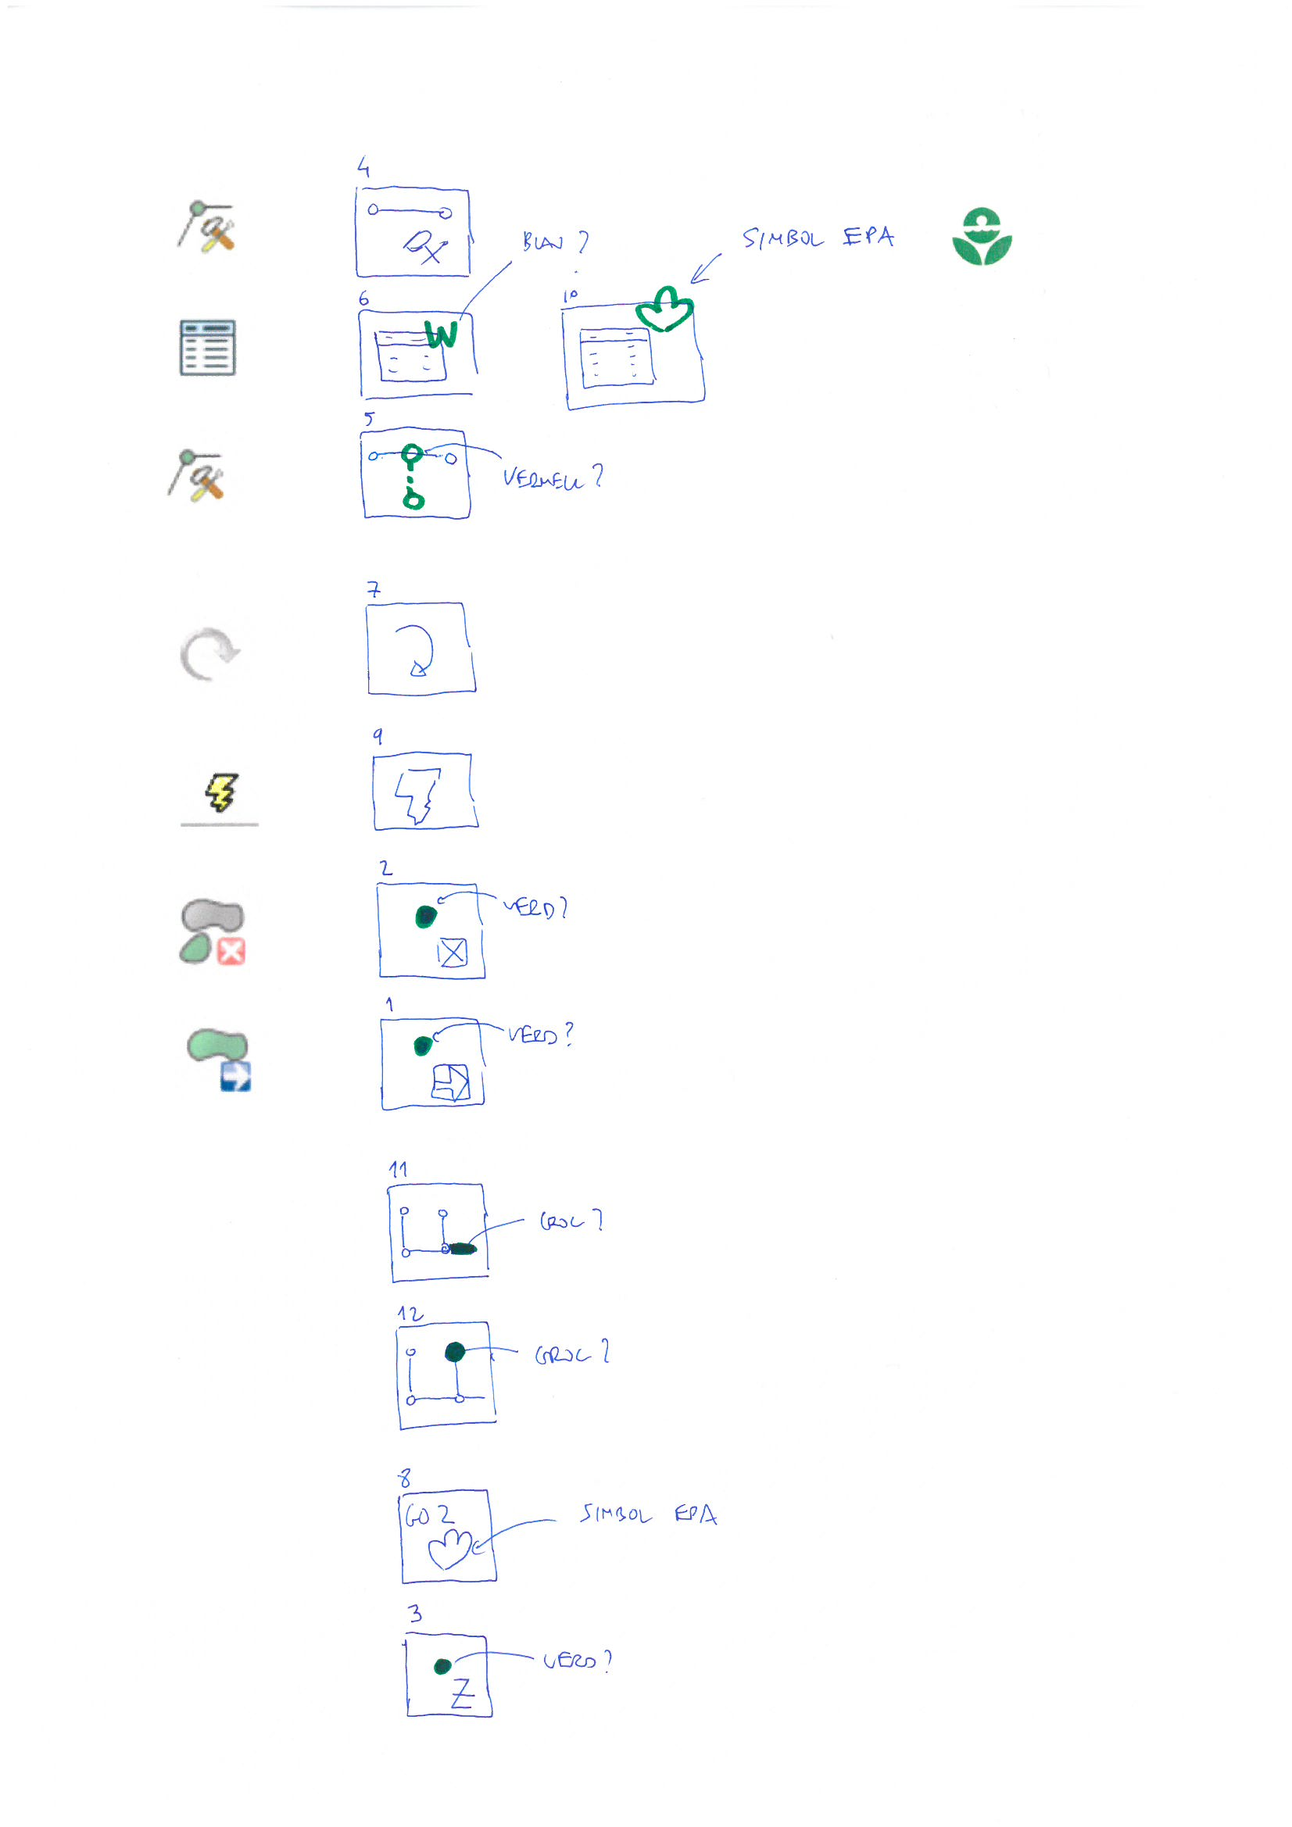
EDIT & ANALYSIS BAR

1. Move node
2. Delete node
3. Capture raster elevation
4. Edit arc
5. Connec tool
6. Table wizard
7. Undo wizard
8. Go2epa
9. Go2epa express
10. Result selector
11. Flow trace (from arc)
12. Flow trace (from node)

