

|  |
| --- |
| User Manual |
| SITMUN 3 ADMINISTRATOR |

1. Introduction 5

1.1. Document content 5

2. Application description 5

2.1. Generic components 5

2.1.1. Application Menu 5

2.1.2. Data Tables 7

2.1.2.1. Edited fields 7

2.1.2.2. Filters 8

2.1.2.2.1. Column Filter 8

2.1.2.2.2. Column Sorting 8

2.1.2.2.3. General Filter 8

2.1.2.3. Buttons 9

2.1.2.3.1. Edit buttons 9

2.1.2.3.2. Action buttons 9

2.1.3. Forms 10

2.1.3.1. Buttons 10

2.1.3.2. Fields 10

2.1.3.2.1. Translation fields 11

2.1.3.3. Internal tables 12

2.1.3.4 Status column 12

2.1.3.4. Dialogs 13

2.2. Sections 14

2.2.1. Connections 14

2.2.1.1. Generic table 14

2.2.1.2. Form 14

2.2.1.3. Tasks internal table 15

2.2.2. Services 15

2.2.2.1. Generic table 15

2.2.2.2. Form 16

2.2.2.3. Parameters configuration internal table 17

2.2.2.4. Layers to register internal table 18

2.2.3. Layers 18

2.2.3.1. Generic table 18

2.2.3.2. Form 19

2.2.3.3. Spatial selection internal table 20

2.2.3.4. Parameter configuration internal table 21

2.2.3.5. Territorial filter internal table 22

2.2.3.6. Territory internal table 23

2.2.3.7. Layer permissions configuration internal table 23

2.2.3.8. Nodes internal table 23

2.2.4. Trees 24

2.2.4.1. Generic table 24

2.2.4.2. Form 24

2.2.4.3. Folders and nodes 25

2.2.4.3.1. Buttons 25

2.2.4.3.2. Folder form 26

2.2.4.3.3. Node form 26

2.2.4.3.4. Drag and drop 26

2.2.5. Background Layers 27

2.2.5.1. Generic table 27

2.2.5.2. Form 27

2.2.5.3. Cartography configuration internal table 28

2.2.5.4. Roles internal table 28

2.2.6. Permissions on layers 29

2.2.6.1. Generic table 29

2.2.6.2. Form 29

2.2.6.3. Cartography configuration internal table 29

2.2.6.4. Roles internal table 30

2.2.7. Territories 30

2.2.7.1. Generic table 30

2.2.7.2. Form 31

2.2.7.3. Permissions internal table 31

2.2.7.4. Children permissions internal table 32

2.2.7.5. Child territories internal table 32

2.2.7.6. Child territories internal table 33

2.2.7.7. Cartography internal table 33

2.2.7.8. Tasks internal table 33

2.2.8. Roles 34

2.2.8.1. Generic table 34

2.2.8.2. Form 34

2.2.8.3. Permission group layers configuration internal table 34

2.2.8.4. Tasks internal table 35

2.2.8.5. Applications internal table 35

2.2.9. Users 36

2.2.9.1. Generic table 36

2.2.9.2. Form 36

2.2.9.3. Permissions internal table 37

2.2.9.4. Data associated to territory table 38

2.2.10. Task groups 39

2.2.10.1. Generic table 39

2.2.10.2. Form 39

2.2.11. Basic Tasks 40

2.2.11.1. Generic table 40

2.2.11.2. Form 40

2.2.11.3. Parameters internal table 41

2.2.11.4. Territory internal table 42

2.2.11.5. Roles internal table 42

2.2.12. Download tasks 43

2.2.12.1. Generic table 43

2.2.12.2. Form 43

2.2.12.3. Parameters internal table 44

2.2.12.4. Territory internal table 44

2.2.12.5. Roles internal table 45

2.2.13. Document tasks 45

2.2.13.1. Generic table 45

2.2.13.2. Form 46

2.2.13.3. Territory internal table 46

2.2.13.4. Roles internal table 46

2.2.14. Query tasks 47

2.2.14.1. Generic table 47

2.2.14.2. Form 47

2.2.14.3. Territory internal table 48

2.2.14.4. Roles internal table 48

2.2.14.5. Parameter internal table 48

2.2.15. More information tasks 49

2.2.15.1. Generic table 49

2.2.16.2 Form 49

2.2.15.2. Territory internal table 50

2.2.15.3. Roles internal table 50

2.2.15.4. Parameter internal table 51

2.2.16. Locator tasks 52

2.2.16.1. Generic table 52

2.2.16.2. Form 52

2.2.16.3. Territory internal table 53

2.2.16.4. Roles internal table 53

2.2.16.5. Parameter internal table 53

2.2.17. Report tasks 54

2.2.17.1. Generic table 54

2.2.17.2. Form 55

2.2.17.3. Territory internal table 55

2.2.17.4. Roles internal table 55

2.2.18. Thematic tasks 56

2.2.18.1. Generic table 56

2.2.18.2. Form 56

2.2.18.3. Territory internal table 56

2.2.18.4. Roles internal table 57

2.2.19. FME Extraction tasks 57

2.2.19.1. Generic table 57

2.2.19.2. Form 58

2.2.19.3. Territory internal table 58

2.2.19.4. Roles internal table 58

2.2.20. Applications 59

2.2.20.1. Generic table 59

2.2.20.2. Form 59

2.2.20.3. Parameter configuration internal table 60

2.2.20.4. Template configuration internal table 60

2.2.20.5. Roles internal table 61

2.2.20.6. Background internal table 61

2.2.20.7. Tree internal table 61

1. Introduction

This document has been prepared as help for Sitmun3 users.

* 1. Document content

This document gives a short description of how the application works and introduce the application to the users that have access to Sitmun3.

1. Application description
   1. Generic components

This section describes the generic components that can be found throughout the application.

* + 1. Application Menu

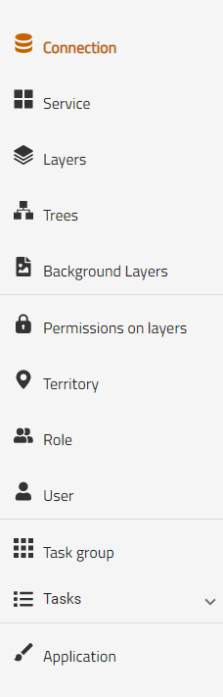

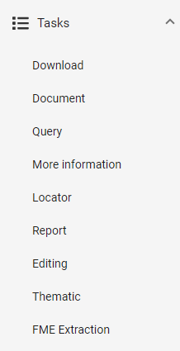

The menu is common to the entire application and is located on the left side of the screen. It is formed by the section name and its icon. When we select one of the sections it will take you to the corresponding screen.

Clicking on the "Tasks" drop-down will open the drop-down with all available task screens (right image).

The selection we are currently in will be its name marked orange.

* + 1. Data Tables

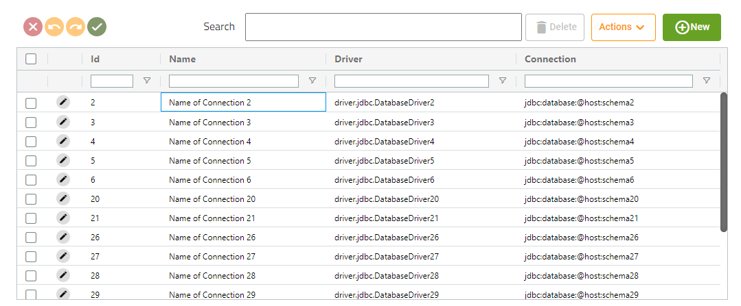

To show data from different sections we will have a table like this.

* + - 1. Edited fields

Clicking on a field will allow you to edit the cell value (if the field clicked can be modified), once the new value is written, pressing the intro key will change the value in the table and highlight the modified green cell.

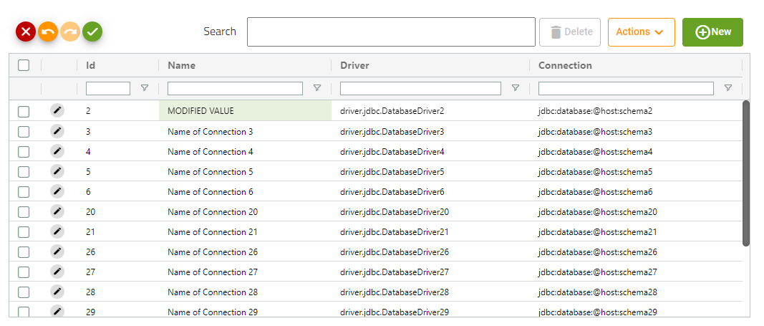

(IMPORTANT: Modifying a value does not mean that it has already been saved, we will see how to do it in other sections)

* + - 1. Filters
         1. Column Filter



Below each column we see a text field that will allow us to filter by the values of that column.

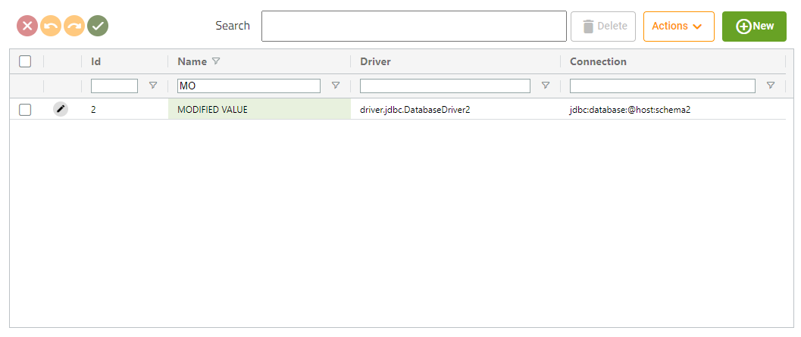

To the right of the text field we will see a button that allow us to select how the filter is been applied

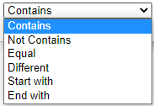

* + - * 1. Column Sorting

  

Clicking on the column name will allow us to order the table ascending or descending by that column.

* + - * 1. General Filter

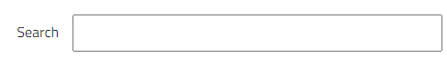

This text field will allow you to filter by a value over all columns.

* + - 1. Buttons
         1. Edit buttons

 

The edit buttons will be displayed at the top-left of the table, if we have not edited any field, it will be disabled (left image), otherwise they will be enabled (the undo and redo buttons may not be the two activated according to the edits)

|  |  |
| --- | --- |
|  | Discard changes button: Pressing that button will discard all edit changes. |
|  | Undo button: Pressing that button will undo the last change. |
|  | Redo button: Pressing that button will redo the last undo action (only available if you have pressed the undo button before. |
|  | Save changes button: This button will save all the changes we have made on the table. (**IMPORTANT**: That button will only be available in external tables, in form’s tables it won’t be available) |

* + - * 1. Action buttons

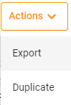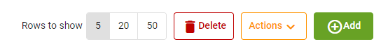

The action buttons will be displayed at the top-right of the table.

|  |  |
| --- | --- |
|  | The delete button will delete the selected rows. If we are in a generic table, the element will be deleted immediately. If we are in a form table, it will be marked as pending delete and will be deleted later. (We will deepen in other sections). The delete button will only be available if we have any column selected by the checkbox of the first column. |
|  | The new button only will be available on a generic tables (where it will redirect us to a form to create a new element) and in a few form tables (where it will open a dialog to create the new element. |
|  | The add button only will be available on the tables that there isn’t the new button. This button will open a dialog to select a new elements of the same type as the table entity to introduce it on the table |
|  | Export button will start a download of a csv file where there will be the columns of the table and the selected rows. |

Example:

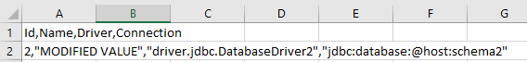



Duplicate button will duplicate the selected rows, introducing the new elements to the table (on generic tables will be created immediately). This button only will be available on a generic tables and in a few form tables.

Rows to show button will only be available on form tables, allow the user to modify the number of values displayed in the table.

* + 1. Forms
       1. Buttons



The form buttons will be displayed on the top-right of the screen.

|  |  |
| --- | --- |
|  | The return button will redirect us to the generic table of the element type that we are editing. |
|  | The save button will save create or save all the changes of the element, form changes will be saved first, and if it goes correctly, it will save all the changed made on the element tables. |

* + - 1. Fields

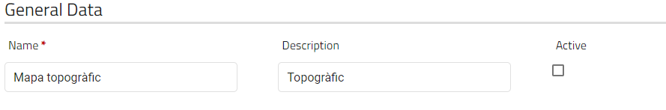

Every form will have their own fields to edit/create the element.

If a field has a red star at the end of its name, it will indicate that you must fill that field before send the form.

* + - * 1. Translation fields

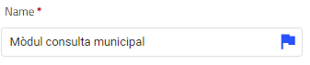

The blue flag at the end of the entrance means that that field is translatable, if you click on it a dialog will be shown

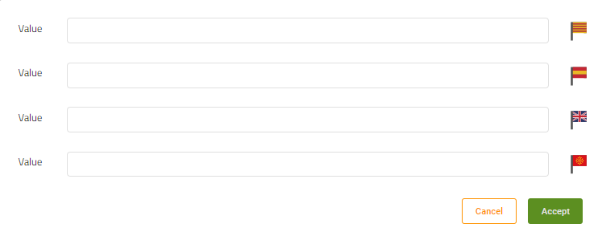

This dialog allows the user to define a translation for the selected field in 4 different languages (Catalan-Spanish-English-Aranese).

If a field already has a translation for any language, it will be shown when the dialog opens

**Important: Accept button does not save the translations, they will be saved when the user clicks on the save button**

* + - 1. Internal tables

Forms can have their own internal tables that will allow the user to manage relations of the edited/new element.

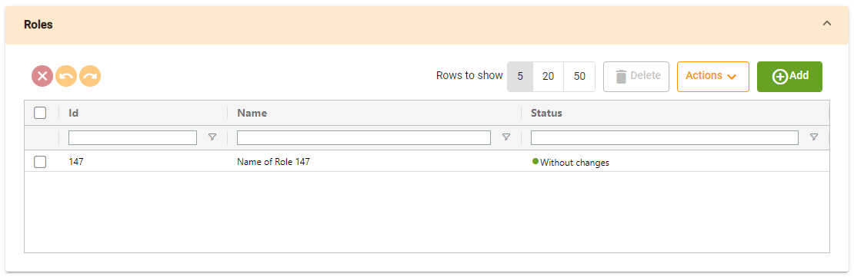

Pressing on the drop-down button, will allow the user to hide the table, but all the tables will be opened by default.

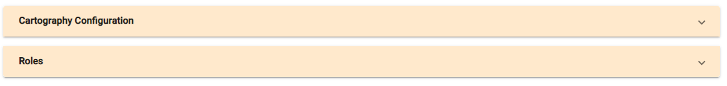

#### 2.1.3.4 Status column

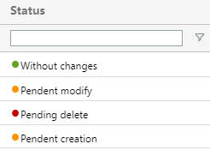

Almost all internal tables will have a status column, that will show the user the status of the row.

|  |  |
| --- | --- |
|  | This status indicates that the rows has not been changed and it is not a new element. The row is in its original status. |
|  | This row has been edited by the user, but the changes are not saved yet. |
|  | This row has been marked by the user to be deleted, but the element is not deleted yet. |

* + - 1. Dialogs

Clicking on the add/new button will open a dialog that allows the user to select the elements that will be added to the table

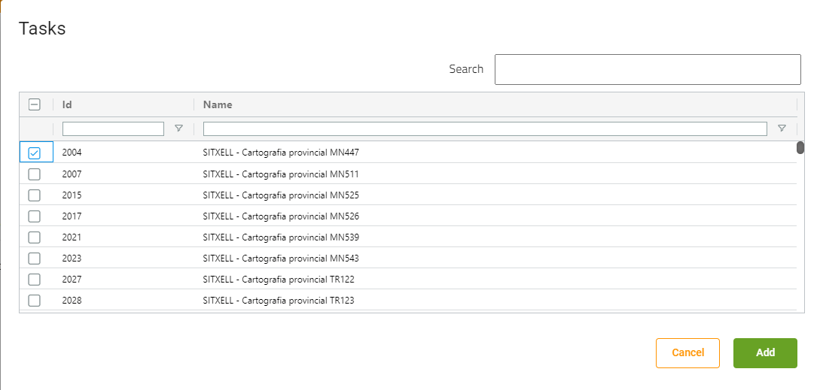

(Some tables only allow the user to select one element)

If the internal button has the “new button”, it will open a dialog with a internal form to create the element:

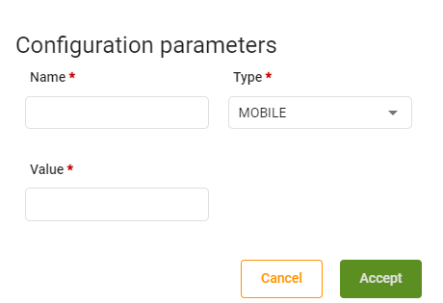

* 1. Sections
     1. Connections
        1. Generic table

This screen will show us all the connections that the application has.

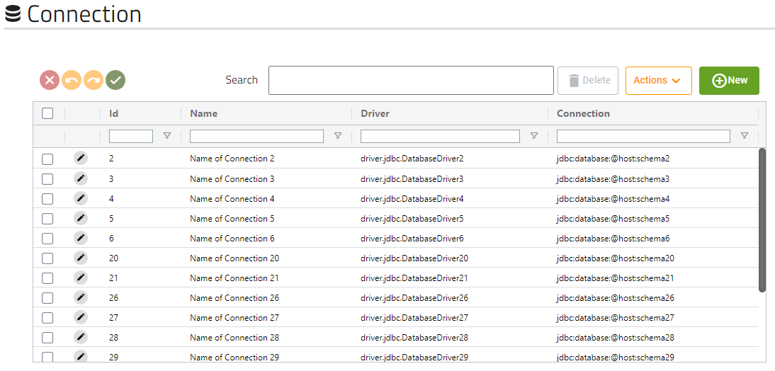

* + - 1. Form

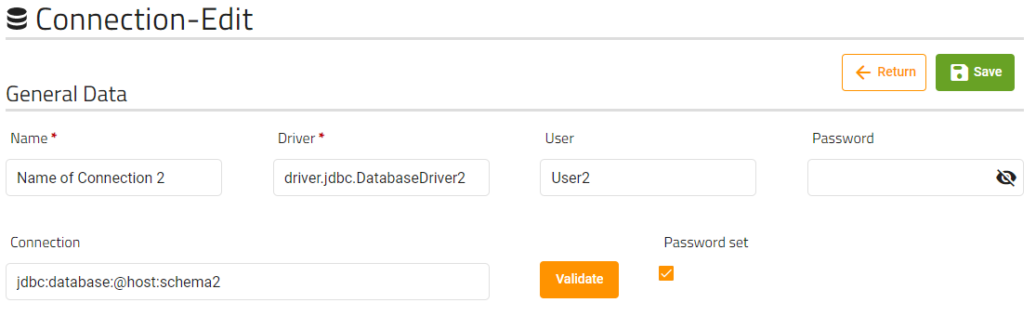

These are the fields that the user can modify of a connection. The validate button will validate that de connection introduced is correct.

The password field will never show the password of the user, but if “Password set” checkbox is selected will mean the password is already stored, so if you put any password on the field, it will modify the connection password. If checkbox is unmarked will mean that the connection has not a password saved.

* + - 1. Tasks internal table

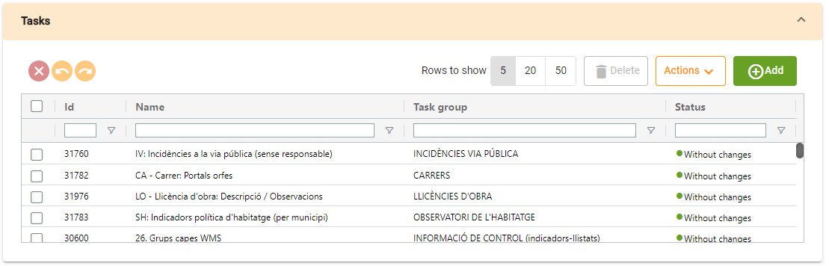

Tasks table will show us the tasks that are related to the connection.

* + 1. Services
       1. Generic table

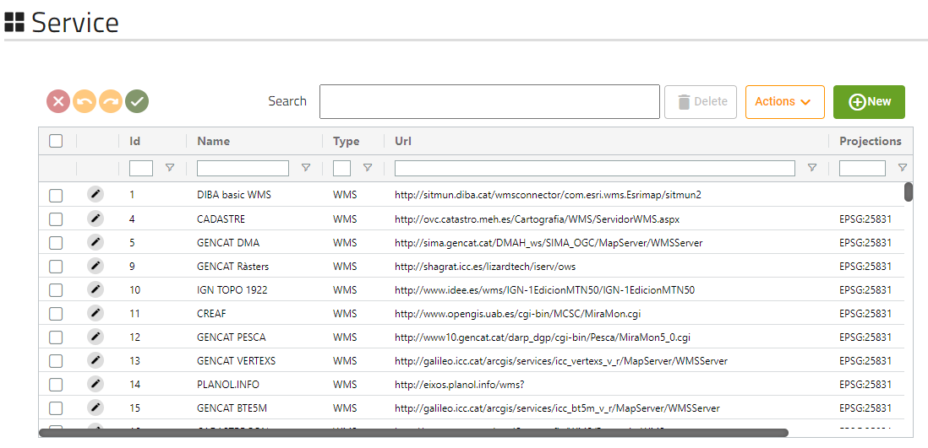

This screen will show us all the services that the application has.

* + - 1. Form

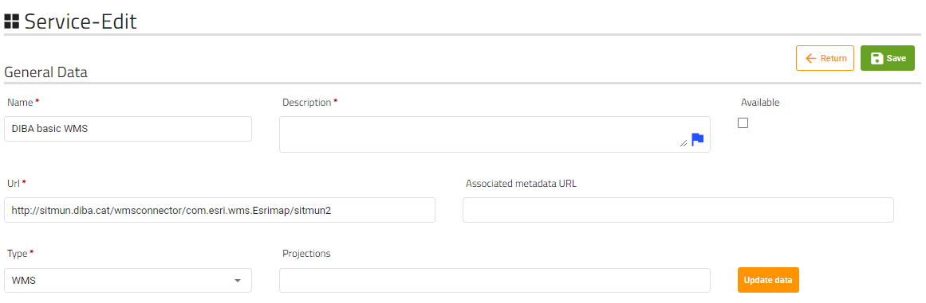

These are the fields that the user can modify of a service. The update data will update the the service data with the data retrieved from the Url field

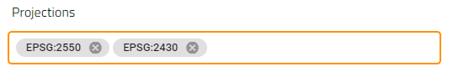

The projections field must be filled by elements made by EPSG:code of the projection.

* + - 1. Parameters configuration internal table

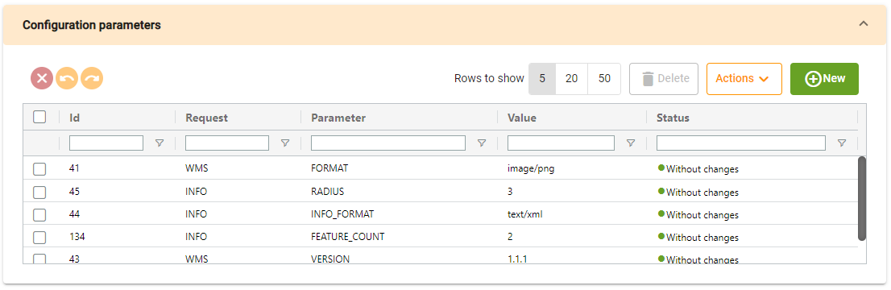

Tasks table will show us the parameters configuration that are related to the service.

Clicking on new will show us the dialog with the form to create a new parameter:

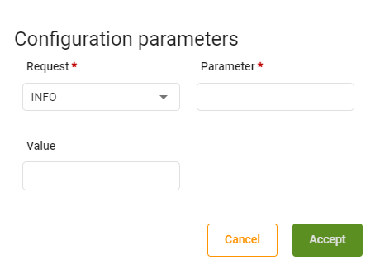

* + - 1. Layers to register internal table

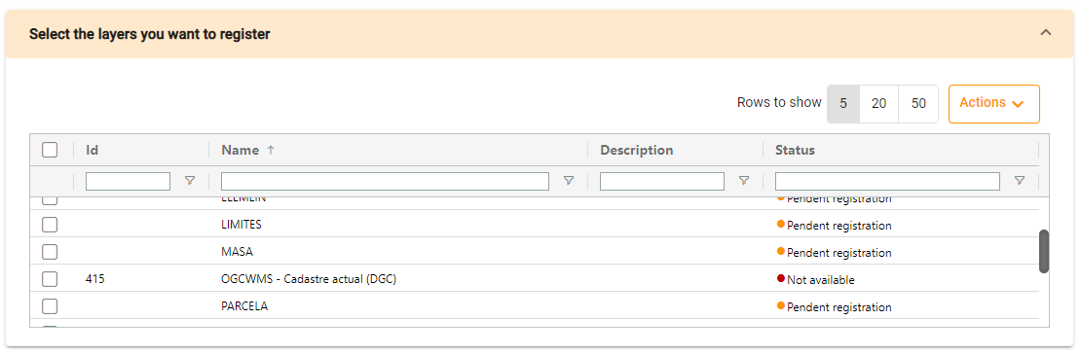

This table relates to the “Update data” button, the layers appearing on the table are the layers received from the request to the url field. This table has two status different from other tables:

- **Pending registration**: The layer is on the url field data retrieved but not on the service, when we click on save the layer will be created.

- **Not available**: The layers is saved on the service but not appears on the data retrieved from the url field.

* + 1. Layers
       1. Generic table

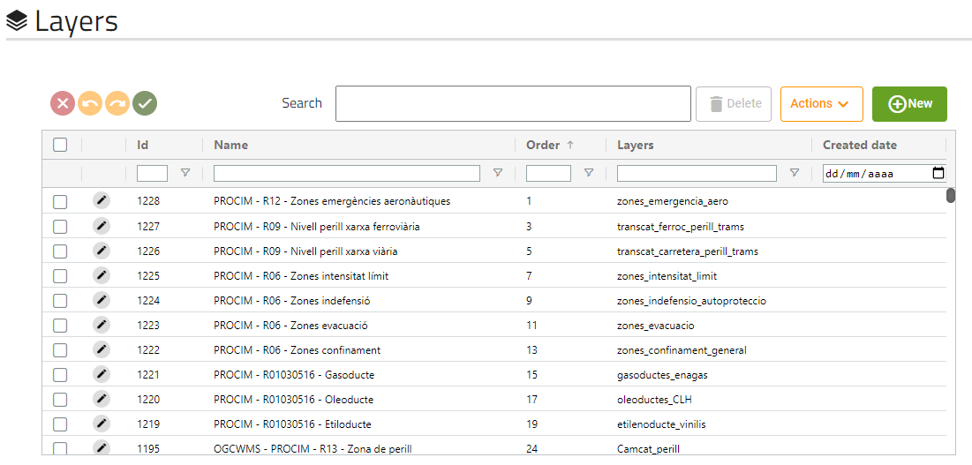

This screen will show us all the layers that the application has.

* + - 1. Form

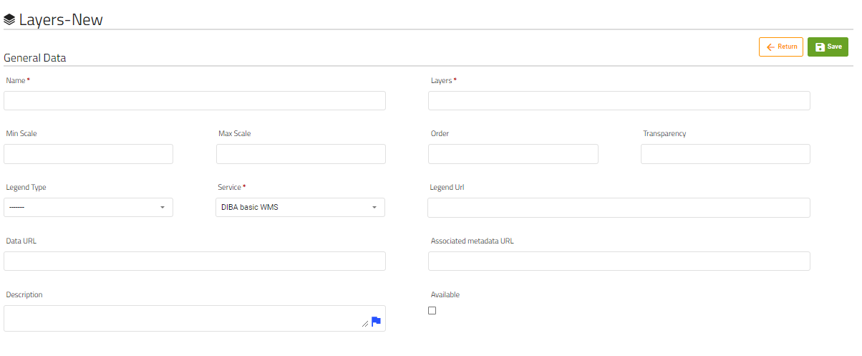

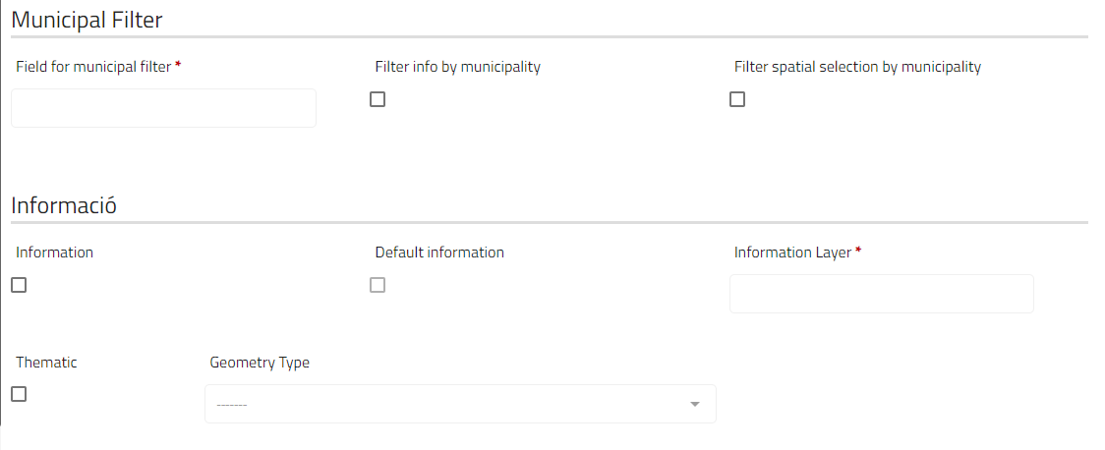

These are the fields that the user can modify of a layer.

The field “Field for municipal filter” will only be available and required if the field “filter info by municipality” or the field “Filter spatial selection by municipality” are marked.

The field “Geometry Type” will only be available if the field “thematic” is marked.

* + - 1. Spatial selection internal table

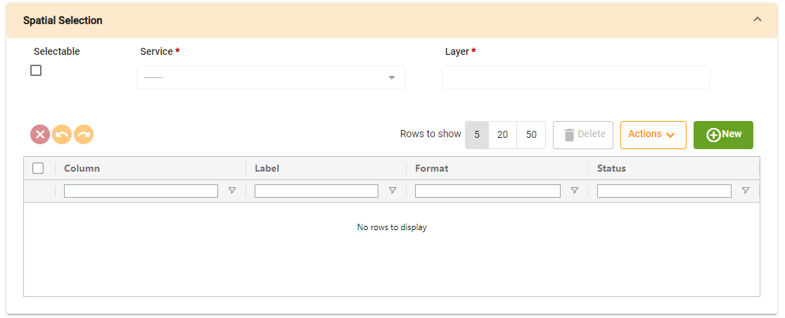

Spatial selection table will show us the spatial selection parameters that are related to the layer.

Clicking on new will show us the dialog with the form to create a spatial selection parameter:

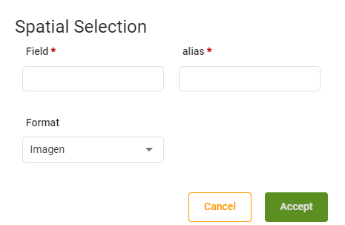

* + - 1. Parameter configuration internal table

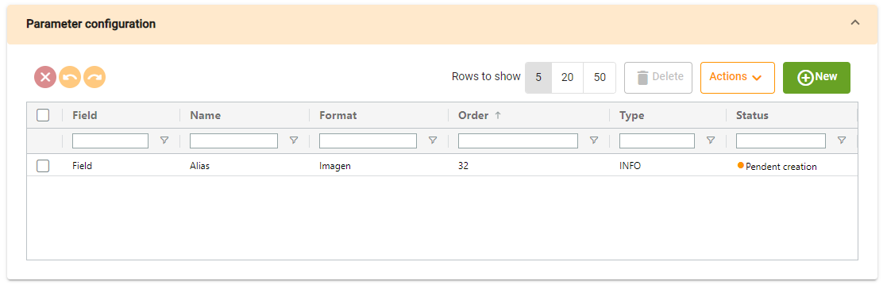

Parameter configuration table will show us the configuration parameters that are related to the layer.

Clicking on new will show us the dialog with the form to create a new parameter:

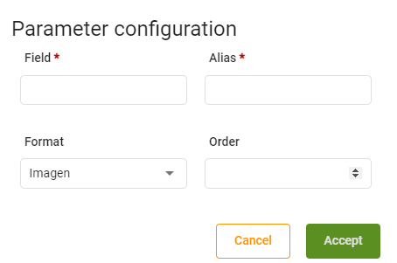

* + - 1. Territorial filter internal table

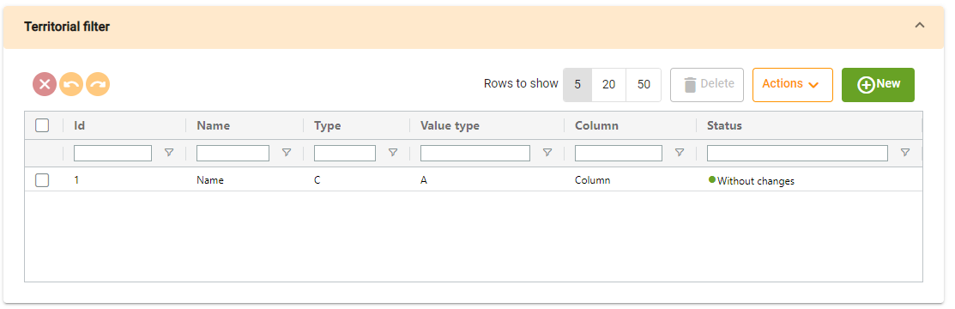

Territorial filter table will show us the territorial filters that are related to the layer.

Clicking on new will show us the dialog with the form to create a new parameter:

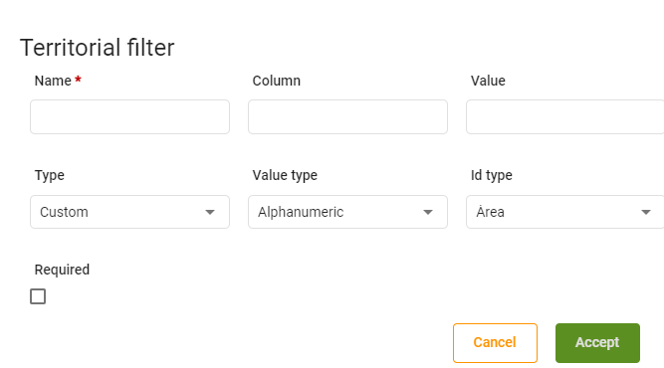

* + - 1. Territory internal table

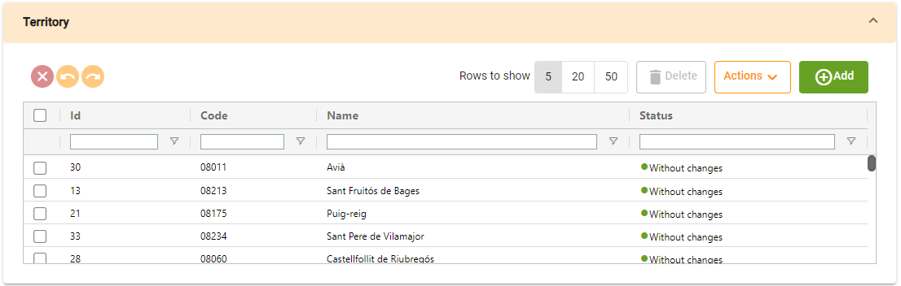

Territory table will show us the territories that are related to the layer.

* + - 1. Layer permissions configuration internal table

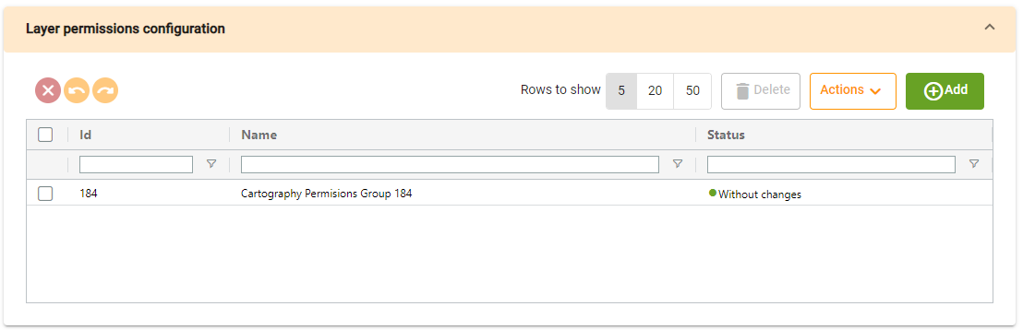

Layer permissions configuration table will show us the layer permissions configurations that are related to the layer.

* + - 1. Nodes internal table

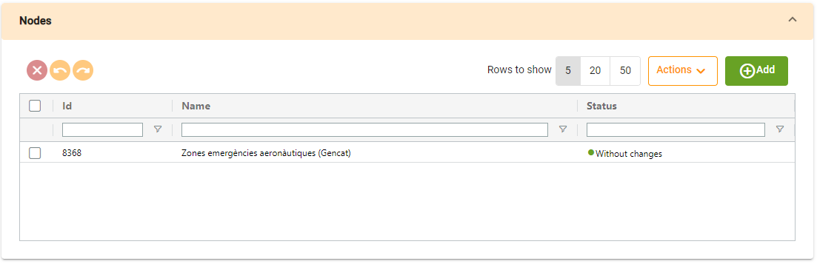

Nodes table will show us the nodes that are related to the layer.

* + 1. Trees
       1. Generic table

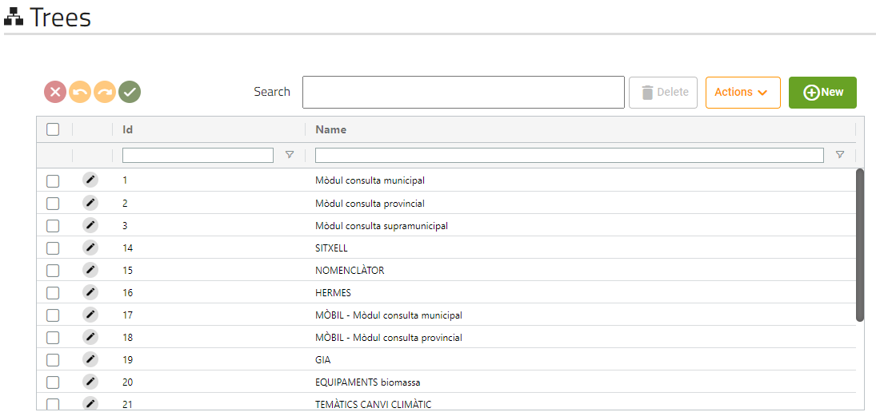

This screen will show us all the trees that the application has.

* + - 1. Form

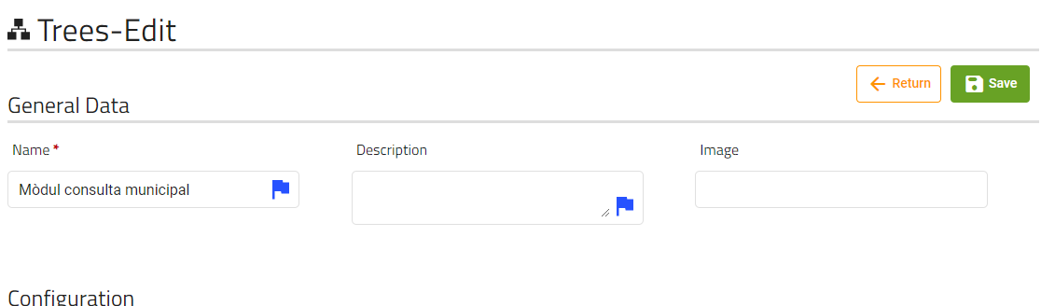

These are the fields that the user can modify of a layer.

* + - 1. Folders and nodes

A tree is composed of folders and nodes.

|  |  |
| --- | --- |
|  | This icon will appear if a node is a folder, if is not a folder no icon will be displayed. |

The different folders and nodes will be displayed as follows:

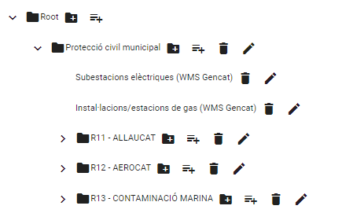

* + - * 1. Buttons

|  |  |
| --- | --- |
|  | This icon will appear if the node is a folder and has children nodes, clicking on it will show them |
|  | This icon will open the form to add a folder to the node selected, only will be displayed if the node is a folder. |
|  | This icon will open the form to add a node that is not a folder to the node selected, only will be displayed if the node is a folder. |
|  | This button will mark the node and its children as deleted; the nodes deleted will be displayed as follows: |
|  | This button will open the corresponding form (depending on the node if is folder or not) to edit the item. |

* + - * 1. Folder form

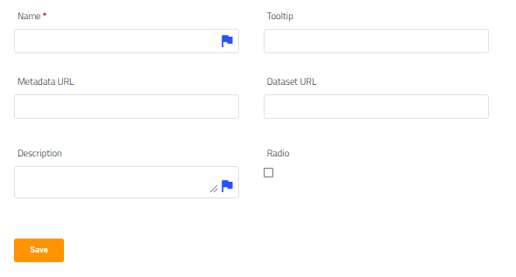

These are the field that a folder has and the user can modify, clicking on save we will mark the folder as pending to save/pending to create

* + - * 1. Node form

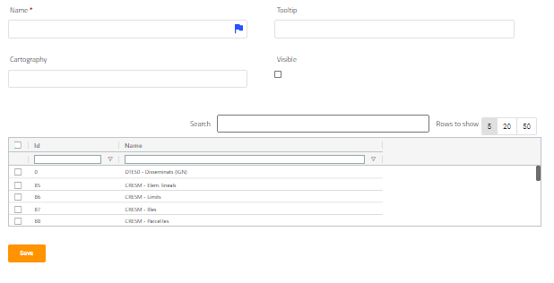

These are the field that a folder has and the user can modify. Cartography is a read-only field, it shows the cartography name of the node’s cartography, we must select 1 cartography on the above table (only 1 selection is allowed).

Clicking on save we will mark the node as pending to save/pending to create.

* + - * 1. Drag and drop

The folders tree has available the drag and drop function, you can press on any node/folder and drag to another, as all internal changes, it will only be saved when the user press the save button.

* + 1. Background Layers
       1. Generic table

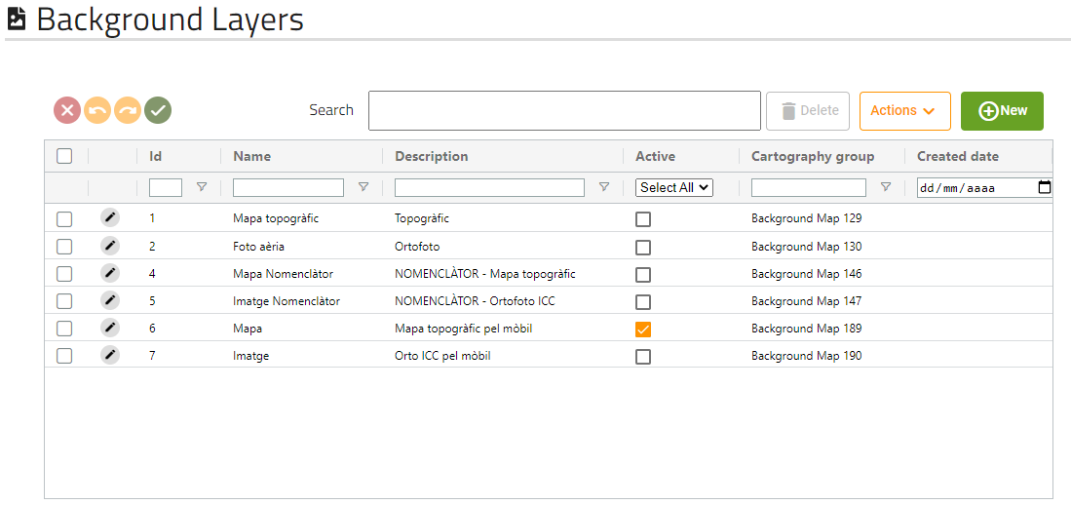

This screen will show us all the background layers that the application has.

* + - 1. Form

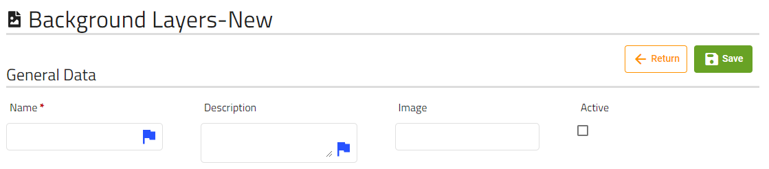

These are the fields that the user can modify of a background map.

When we click on save button, a permission on layer will be created with the same name as name field if it does not already exist, then will create the background layers and will associate the permission on layer created with the new background layers.

**Important: The internal tables showed above the form, refers to the internal tables of the permission on layer created, not to the background layer.**

* + - 1. Cartography configuration internal table

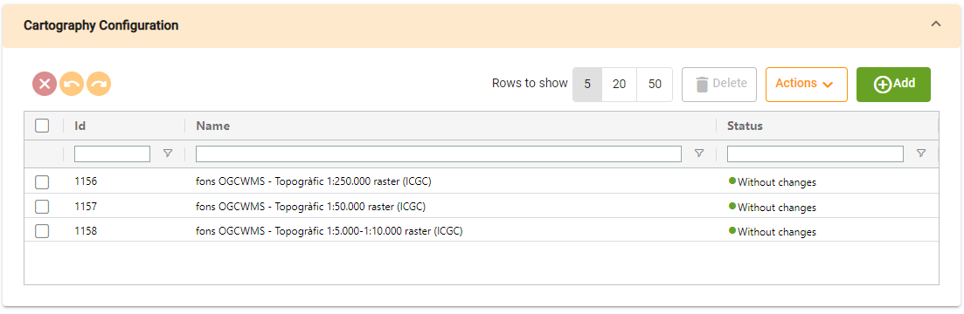

Cartography configuration table will show us the cartography configurations that are related to the permission on layer.

* + - 1. Roles internal table

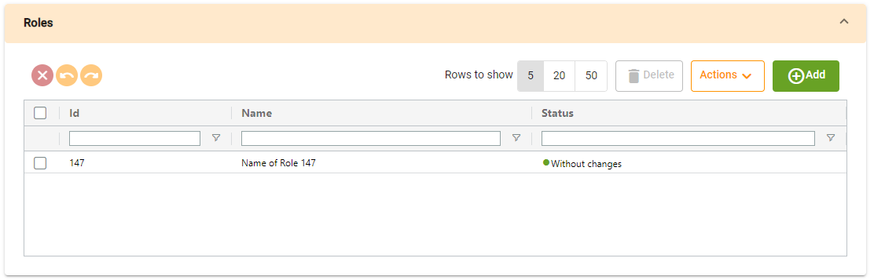

Roles table will show us the roles that are related to the permission on layer.

* + 1. Permissions on layers
       1. Generic table

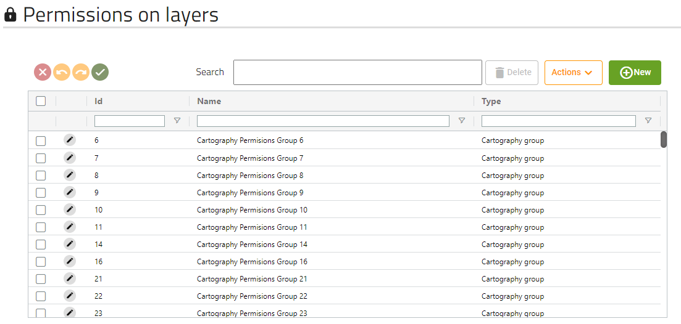

This screen will show us all the Permissions on layers that the application has.

* + - 1. Form

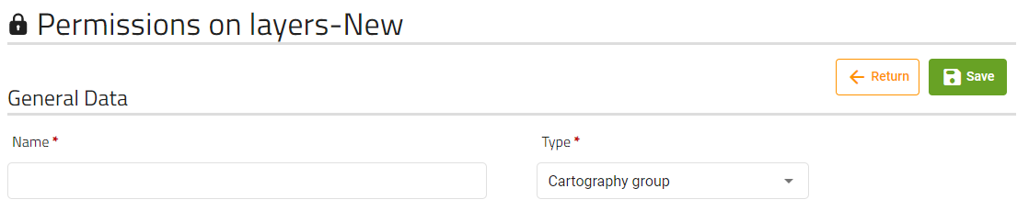

These are the fields that the user can modify of a permission on a layer.

* + - 1. Cartography configuration internal table



Cartography configuration table will show us the cartography configuration that are related to the permission on layer.

* + - 1. Roles internal table



Roles table will show us the roles that are related to the permission on layer.

* + 1. Territories
       1. Generic table

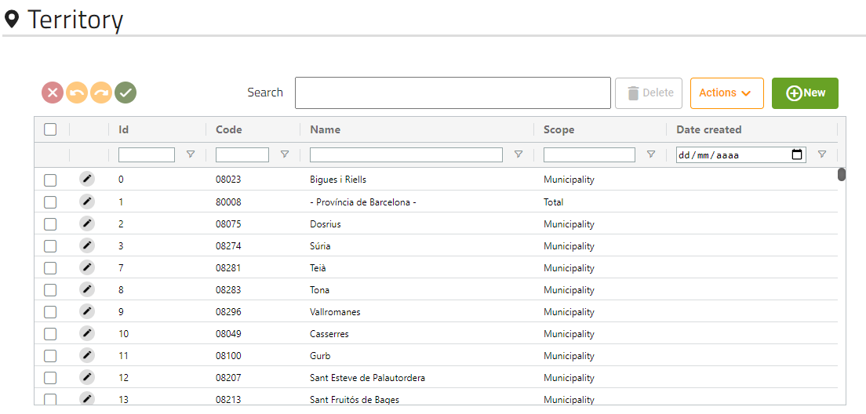

This screen will show us all the territories that the application has.

* + - 1. Form

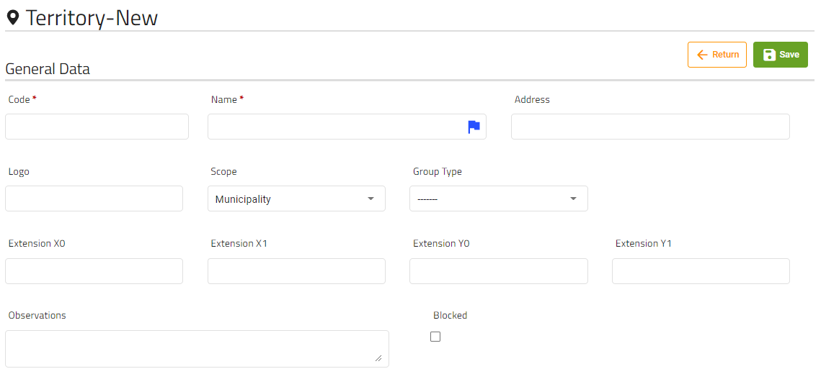

These are the fields that the user can modify of a territory.

Logo must be a url.

* + - 1. Permissions internal table

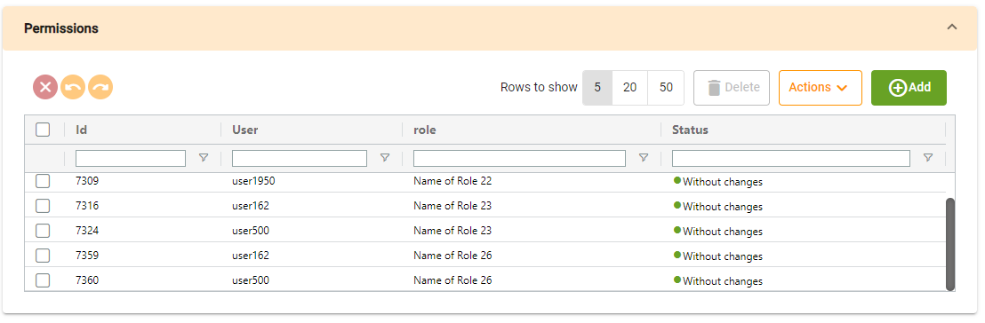

Permissions table will show us the permissions that are related to the territory.

Clicking on add, will open a dialog with two tables (users and roles), where you must select at least one of them to create a new permission:

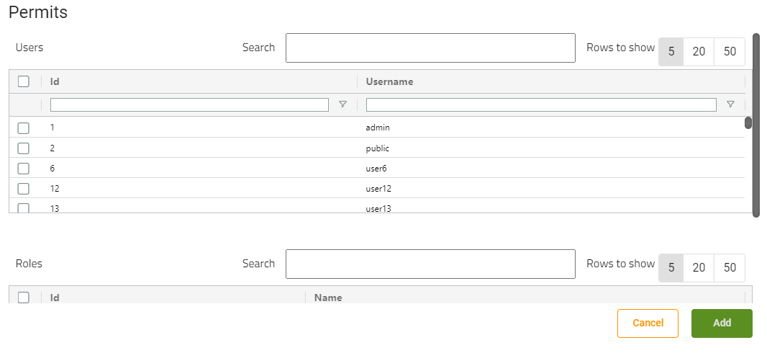

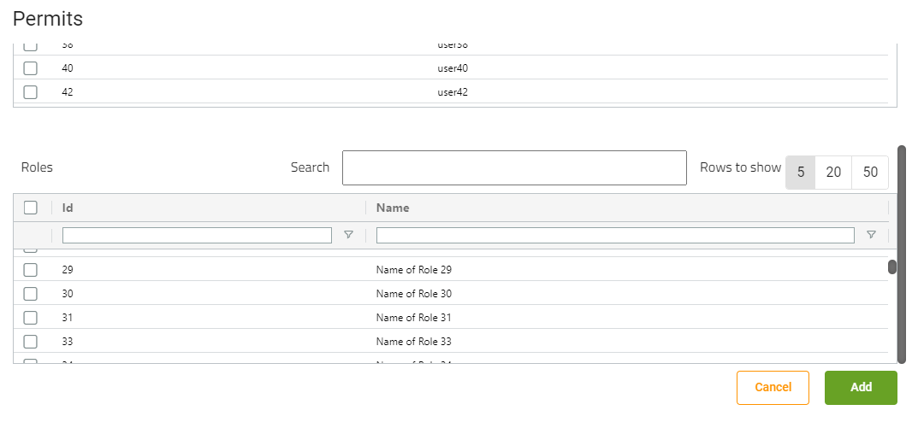

* + - 1. Children permissions internal table

Important: This table only appear if the scope of the territory we are editing is “Regional”

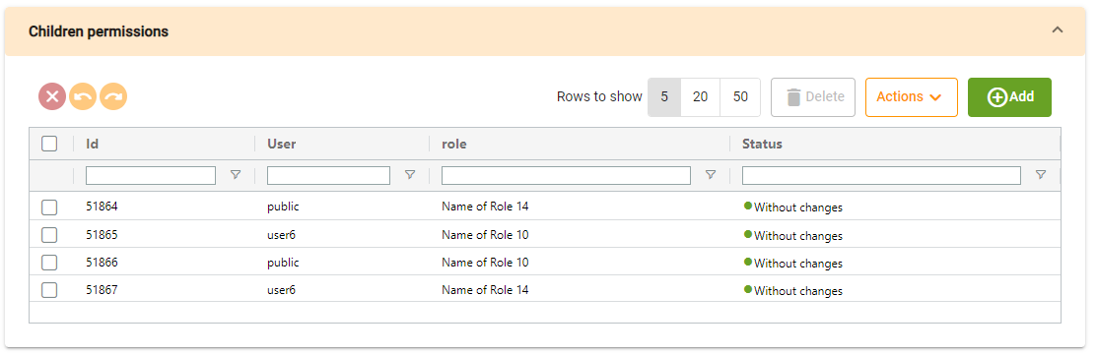

Children permissions table will show the permissions that the territory’s children territories have. If we want to add a children permission, clicking on add button will display the same dialog as the children table.

* + - 1. Child territories internal table

Important: This table only appear if the scope of the territory we are editing is “Regional”

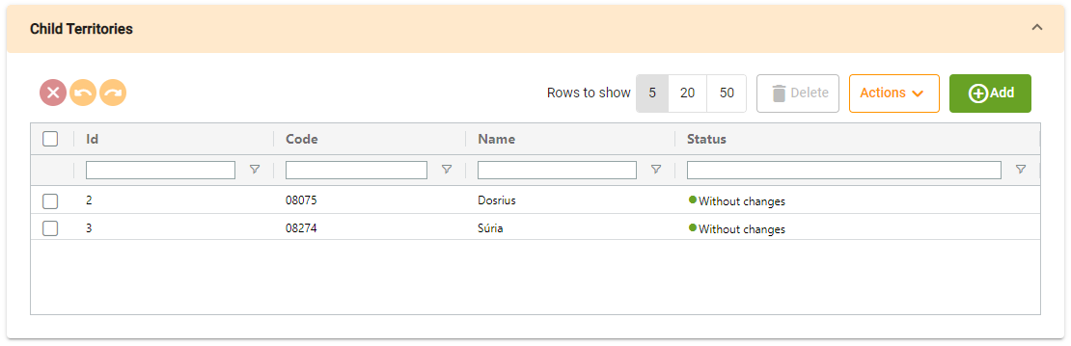

This table shows the territory’s children.

* + - 1. Child territories internal table

Important: This table only appear if the scope of the territory we are editing is “Municipality”

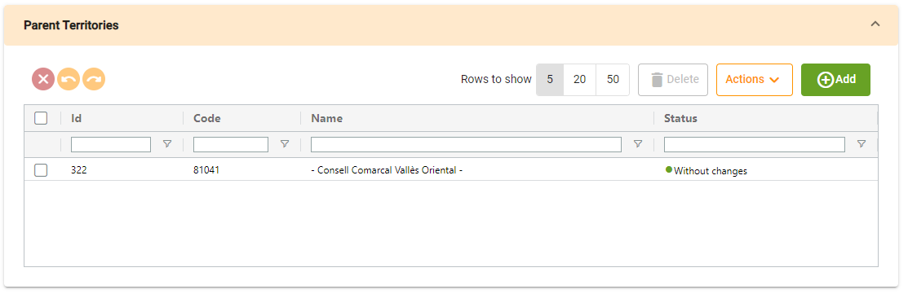

This table shows the territory’s parent.

* + - 1. Cartography internal table

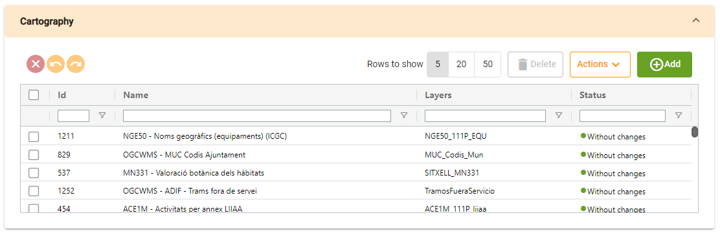

Cartography table will show us the cartographies that are related to the territory.

* + - 1. Tasks internal table

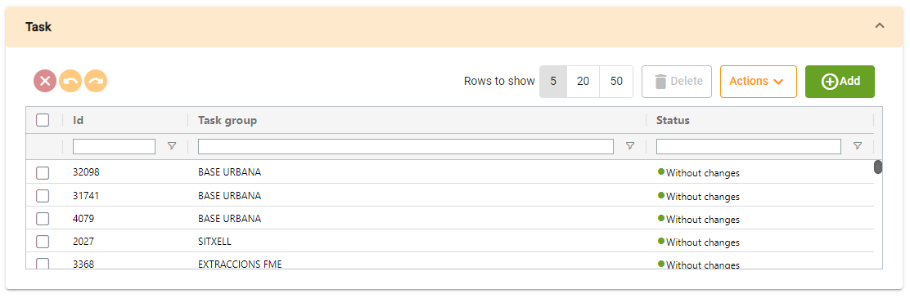

Task table will show us the tasks that are related to the territory.

* + 1. Roles
       1. Generic table

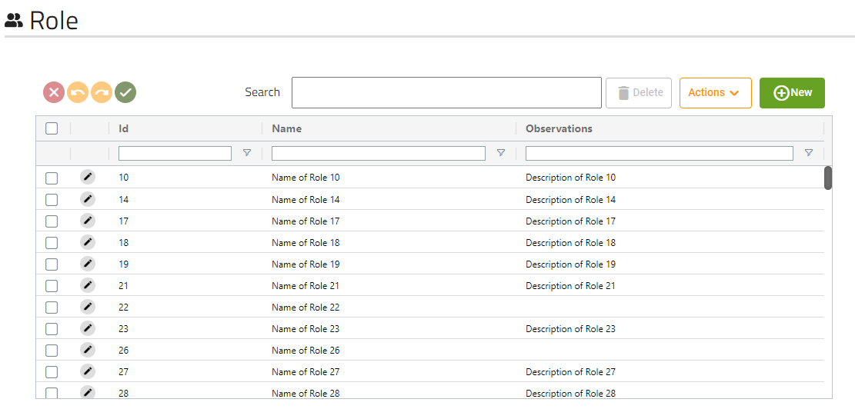

This screen will show us all the roles that the application has.

* + - 1. Form

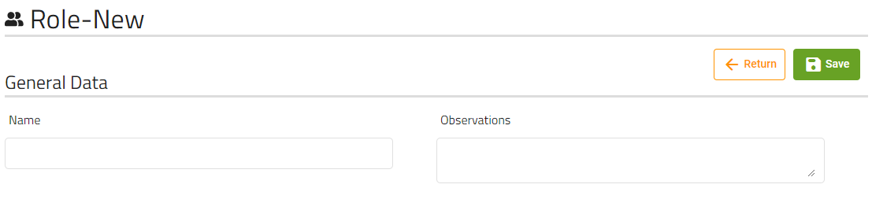

These are the fields that the user can modify of a role.

* + - 1. Permission group layers configuration internal table

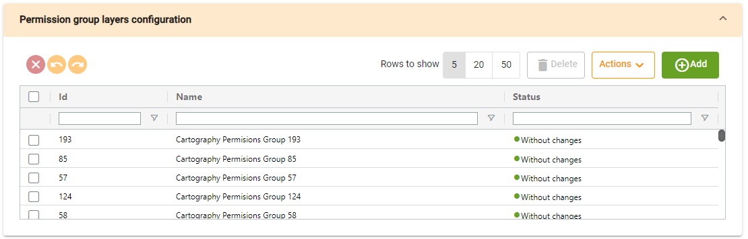

Permission group layers configuration table will show us the permission groups that are related to the role.

* + - 1. Tasks internal table

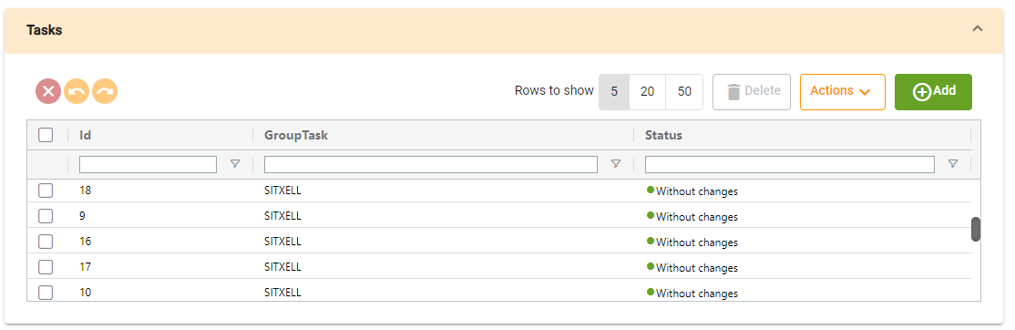

Tasks table will show us the tasks that are related to the role.

* + - 1. Applications internal table

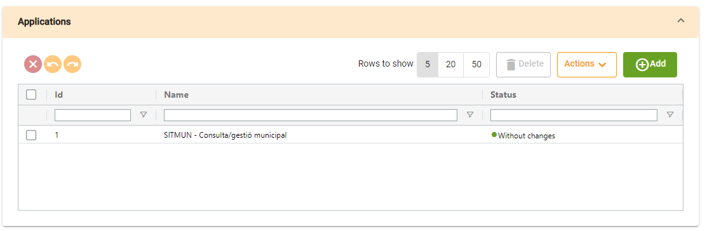

Applications table will show us the applications that are related to the role.

* + 1. Users
       1. Generic table

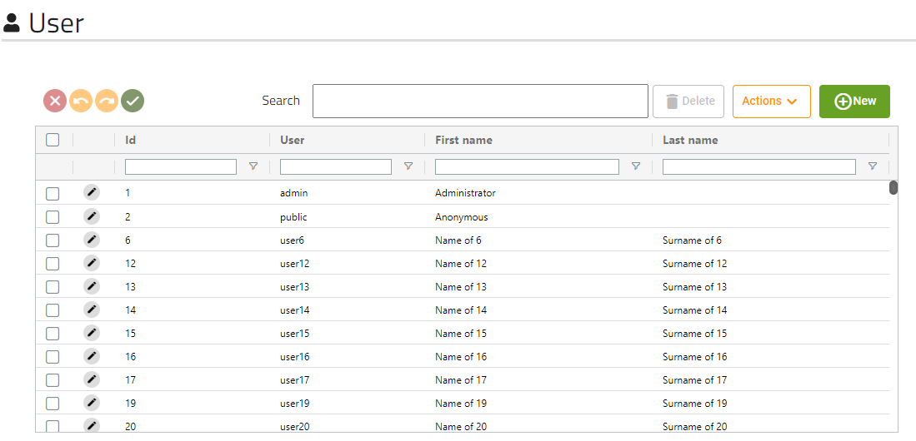

This screen will show us all users that the application has.

* + - 1. Form

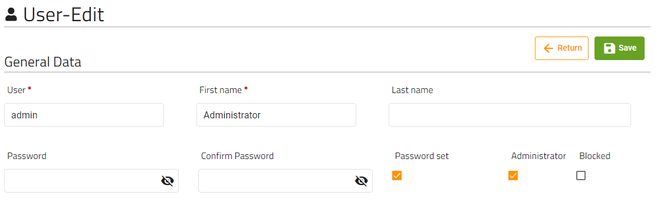

These are the fields that the user can modify of a user.

The password and confirm password fields will never show the password of the user, but if “Password set” checkbox is selected will mean the password is already stored, so if you put any password on the field, it will modify the user password. If checkbox is unmarked will mean that the user has not a password saved.

* + - 1. Permissions internal table



Permissions table will show us the permissions that are related to the user.

Clicking on add, will open a dialog with two tables (territories and roles), where you must select one territory and at least one role:

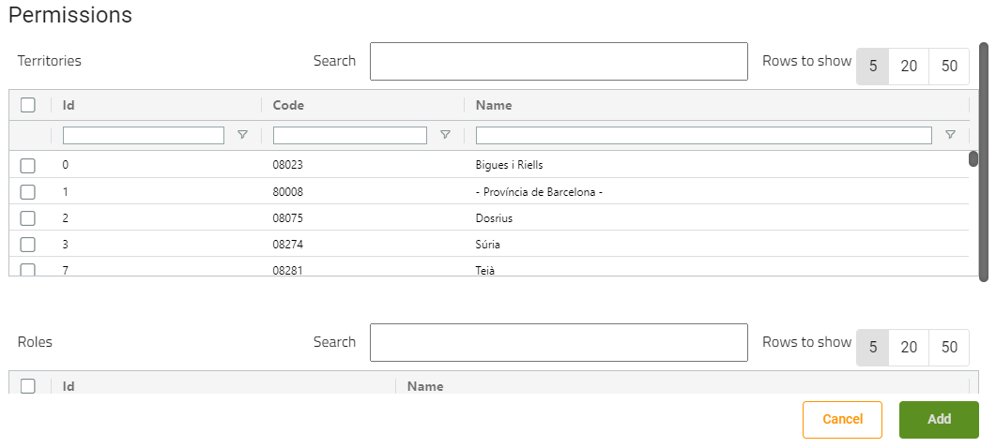

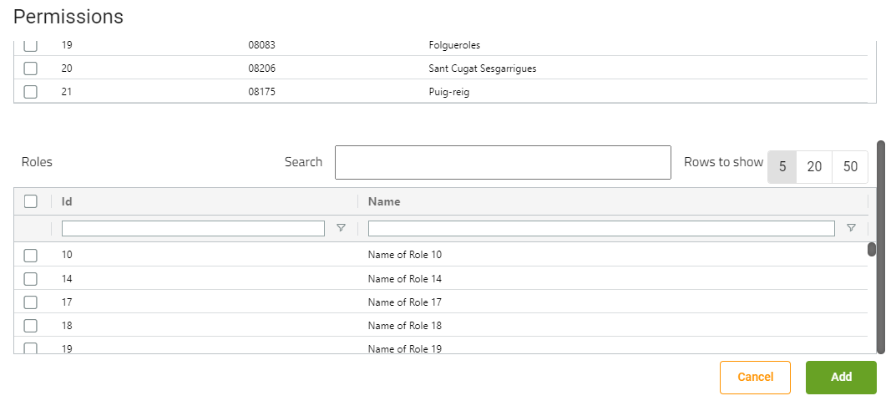

If the selected territory’s scope is “Regional, a dialog will be shown asking us if we want to add roles to territory’s children:

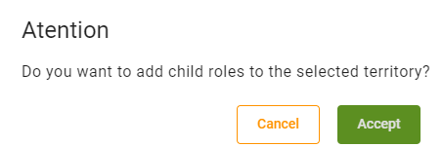

If we click on “Accept”, another dialog will be opened with the roles we want to add

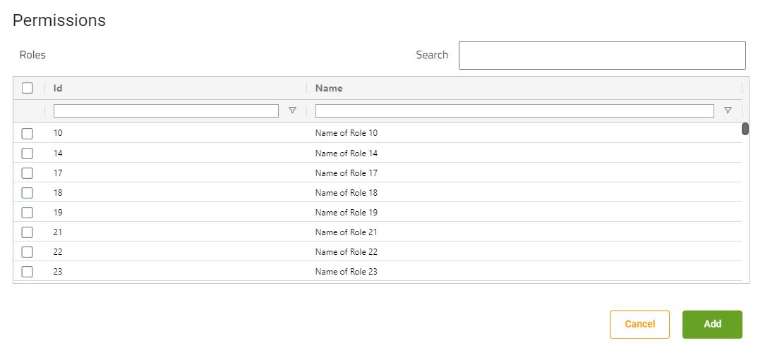

* + - 1. Data associated to territory table

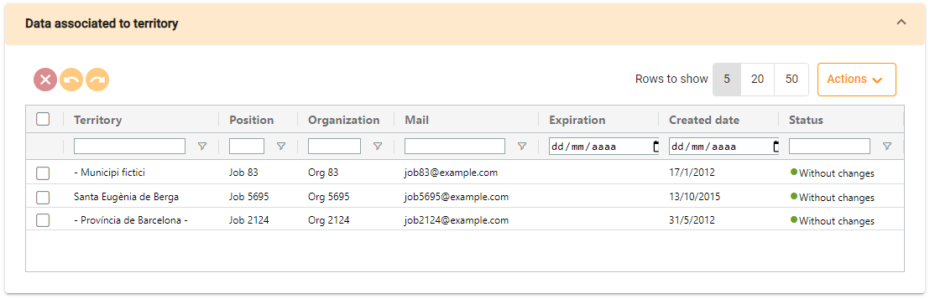

This table will show the data of territories on which the user has permission, you can not add or delete elements on the table (you can edit the fields), it will be done automatically depending on the permissions table.

* + 1. Task groups
       1. Generic table

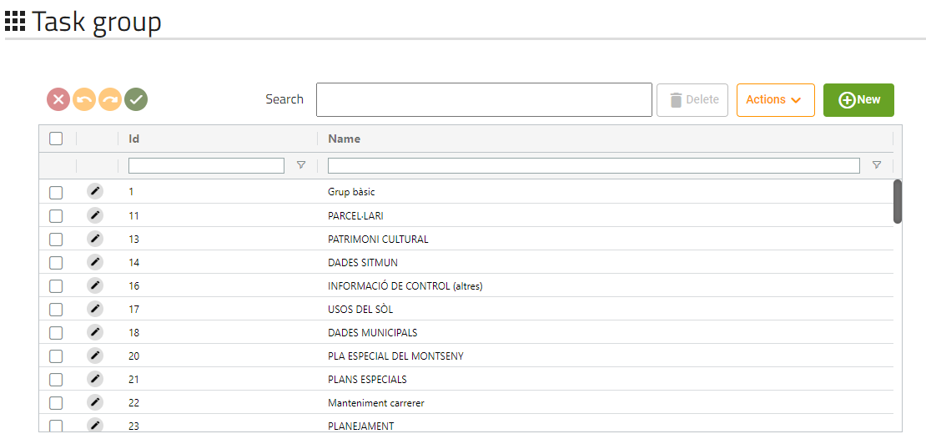

This screen will show us all tasks groups that the application has.

* + - 1. Form

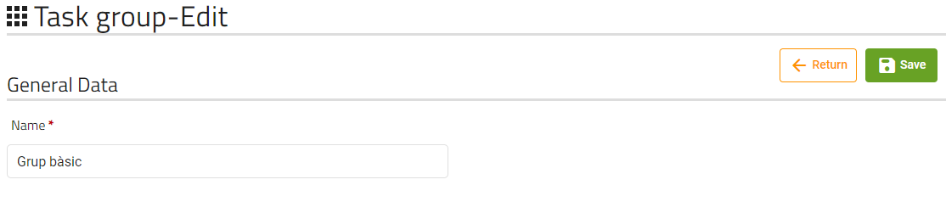

Task group only has the field “Name” to be modified.

* + 1. Basic Tasks
       1. Generic table

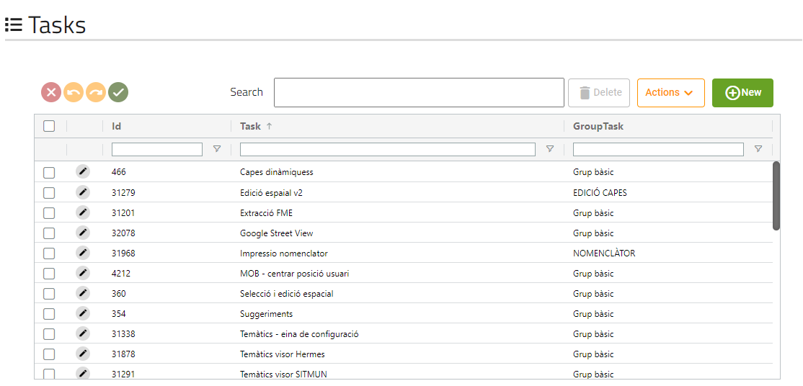

This screen will show us all basic tasks that the application has.

* + - 1. Form

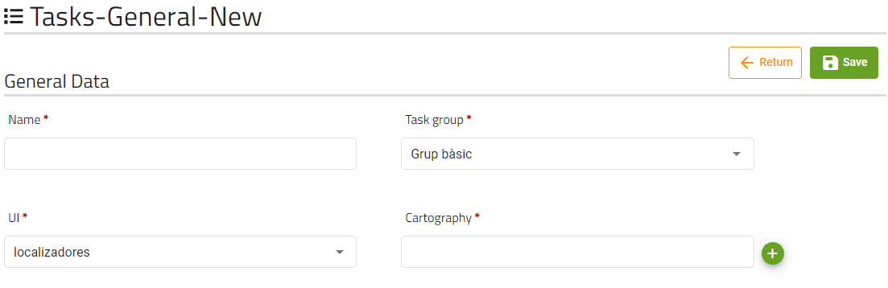

These are the fields that the user can modify of a task.

The cartography field is a read-only field, where the cartography’s name of the task’s cartography will be displayed, clicking on the green button will open a dialog to select a cartography:

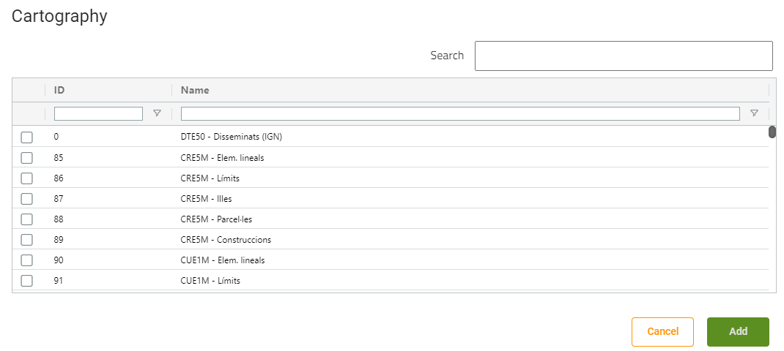

If a cartography is already selected, the buttons displayed will be different:

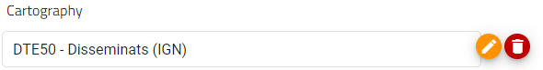

Orange button will allow the user to change the task’s cartography opening the dialog, and red button will disassociate the cartography from the task.

* + - 1. Parameters internal table

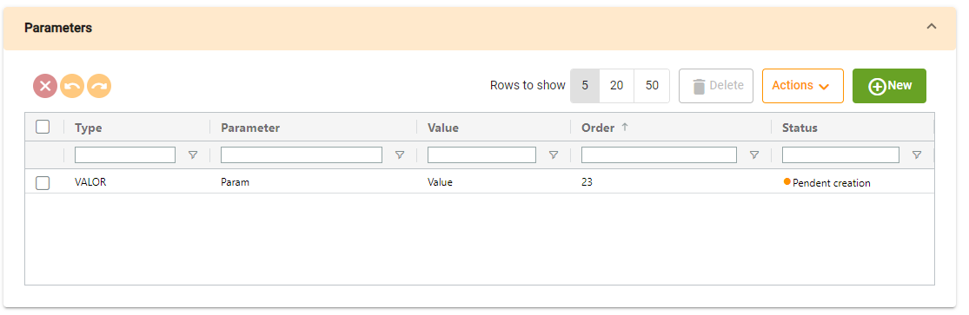

Permissions table will show us the permissions that the task has, if we click on new, a dialog will be opened with the form to create it:

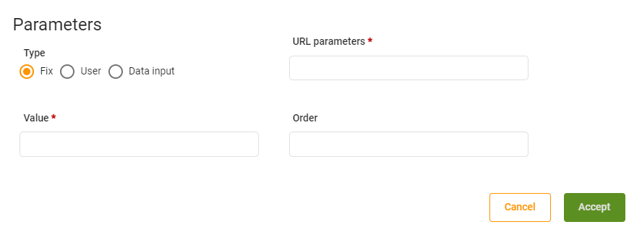

* + - 1. Territory internal table

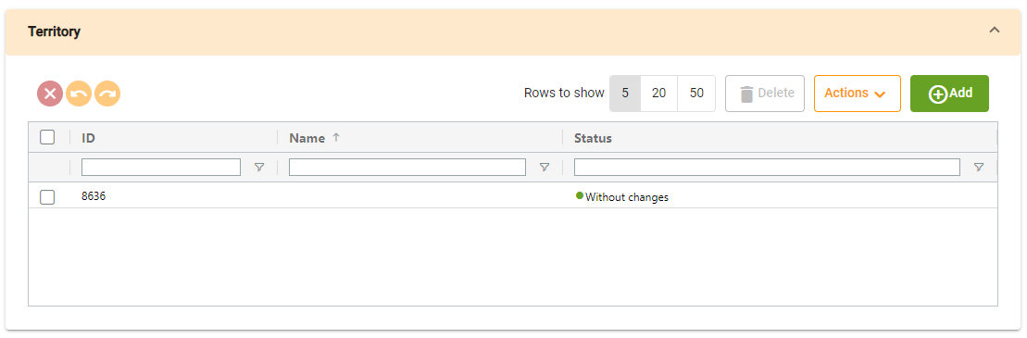

Territory table will show us the territories that are related to the task.

* + - 1. Roles internal table

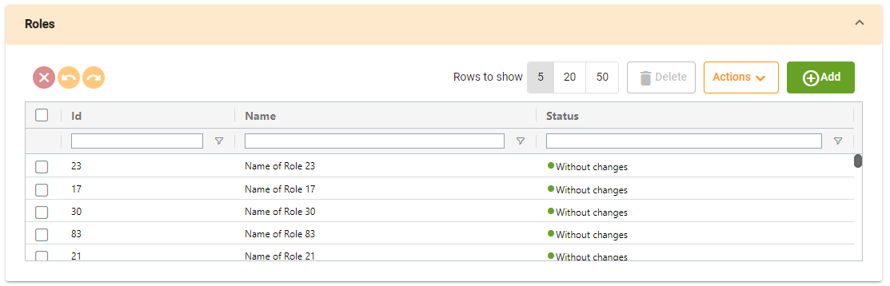

Roles table will show us the roles that are related to the task.

* + 1. Download tasks
       1. Generic table

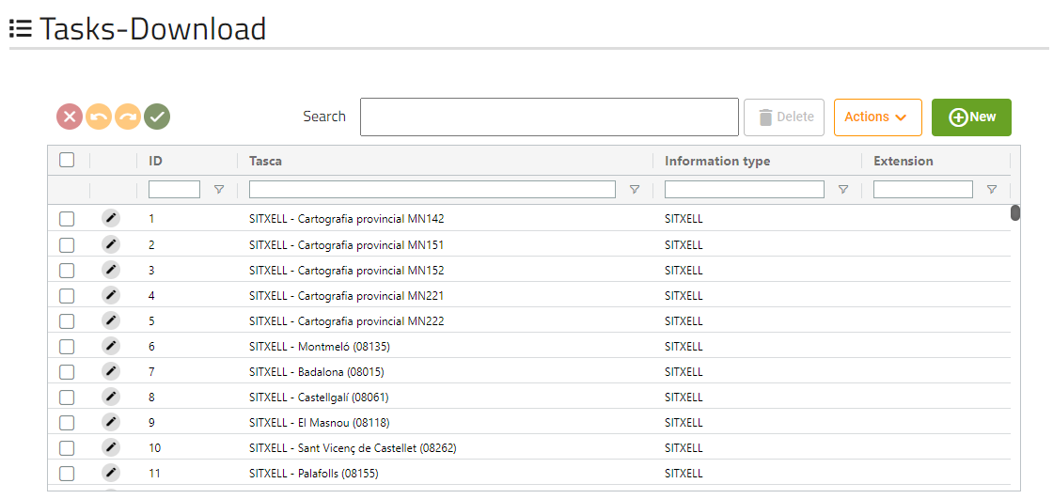

This screen will show us all download tasks that the application has.

* + - 1. Form

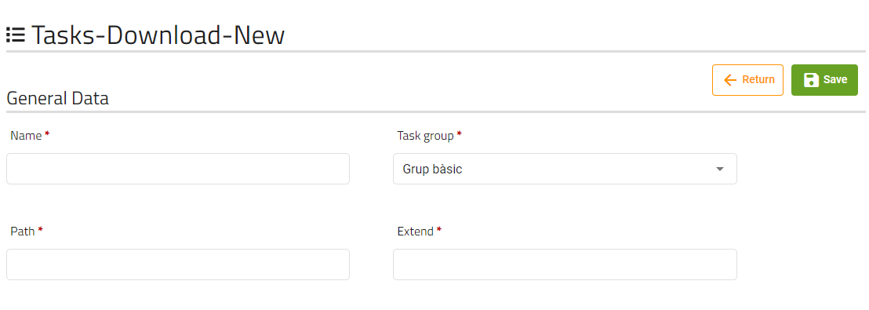

* + - 1. Parameters internal table



Permissions table will show us the permissions that the task has, if we click on new, a dialog will be opened with the form to create it:

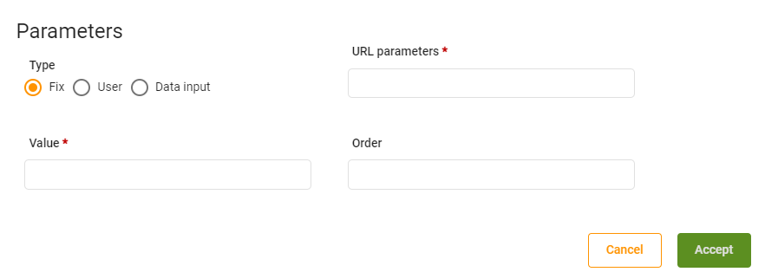

* + - 1. Territory internal table



Territory table will show us the territories that are related to the task.

* + - 1. Roles internal table



Roles table will show us the roles that are related to the task.

* + 1. Document tasks
       1. Generic table

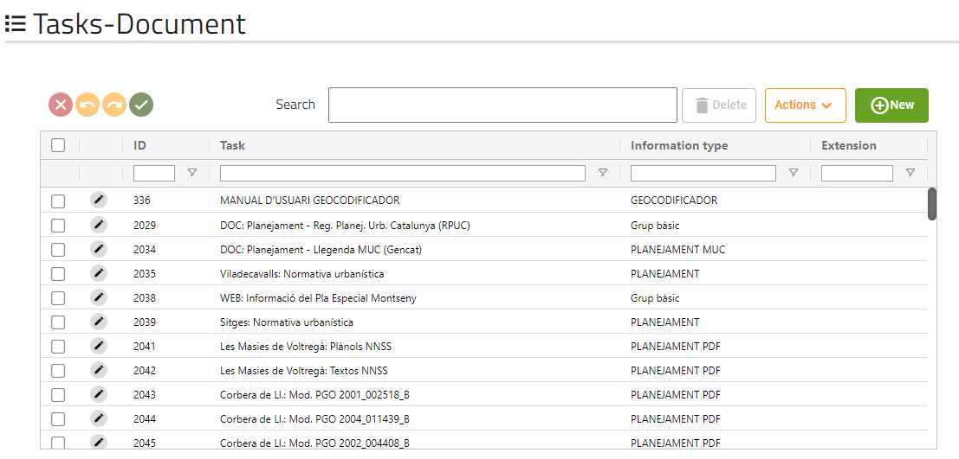

This screen will show us all document tasks that the application has.

* + - 1. Form

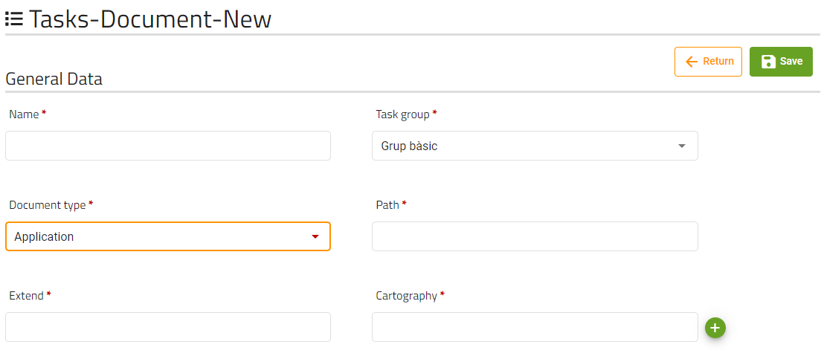

* + - 1. Territory internal table



Territory table will show us the territories that are related to the task.

* + - 1. Roles internal table



Roles table will show us the roles that are related to the task.

* + 1. Query tasks
       1. Generic table

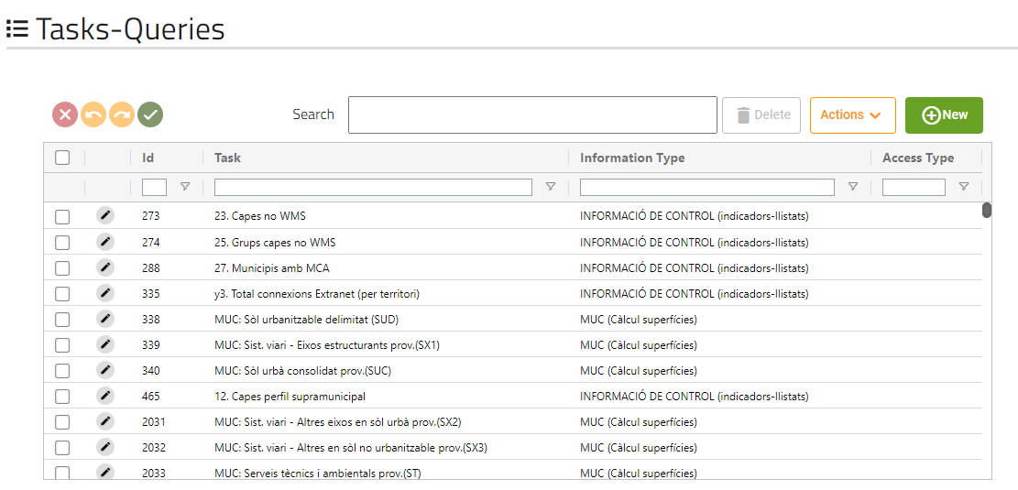

This screen will show us all query tasks that the application has.

* + - 1. Form

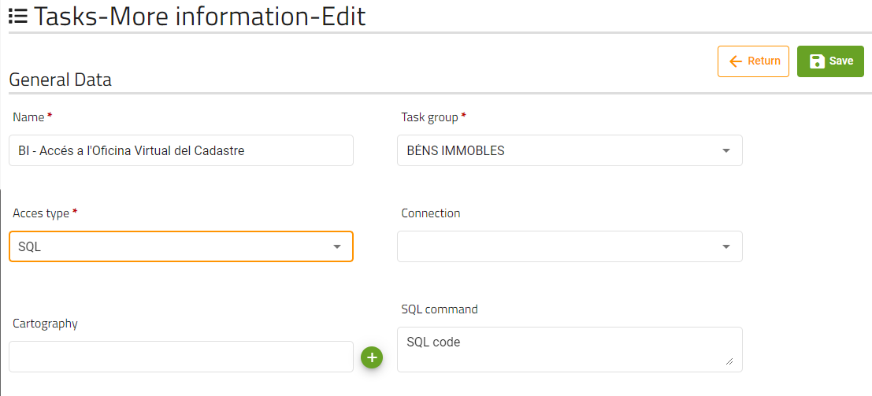

**SQL command and connection display depends on Access type value.**

* + - 1. Territory internal table



Territory table will show us the territories that are related to the task.

* + - 1. Roles internal table



Roles table will show us the roles that are related to the task.

* + - 1. Parameter internal table

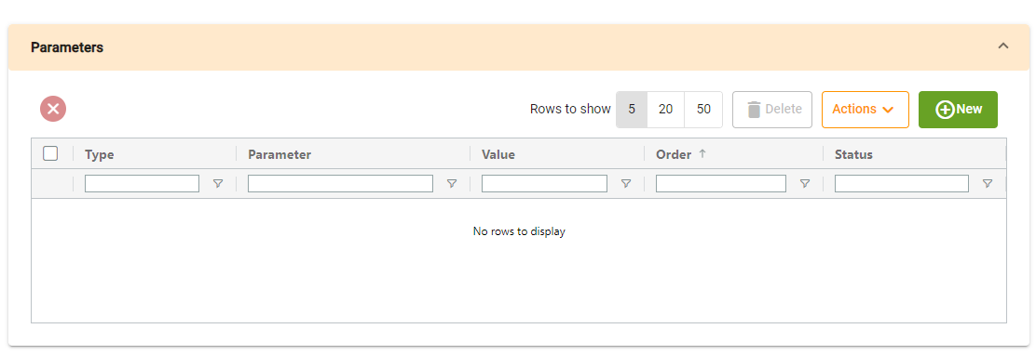

Permissions table will show us the permissions that the task has, if we click on new, a dialog will be opened with the form to create it:

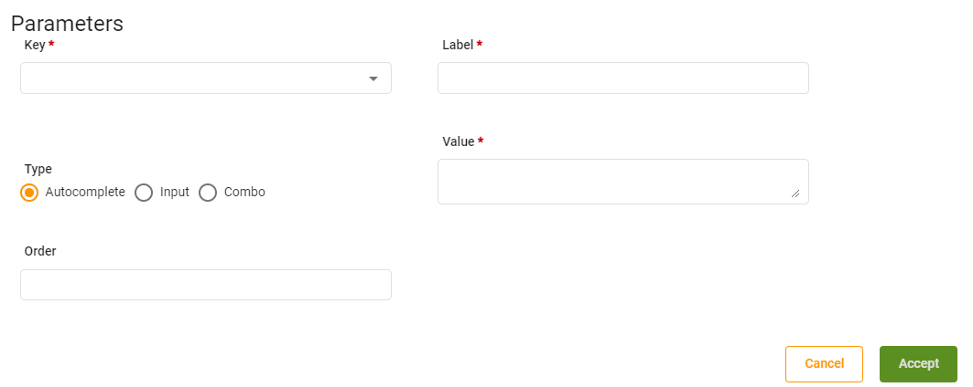

**The key selector depends on main form SQL command field, all values written on value field matching the next pattern ${VALUE} will be shown on key selector.**

* + 1. More information tasks
       1. Generic table

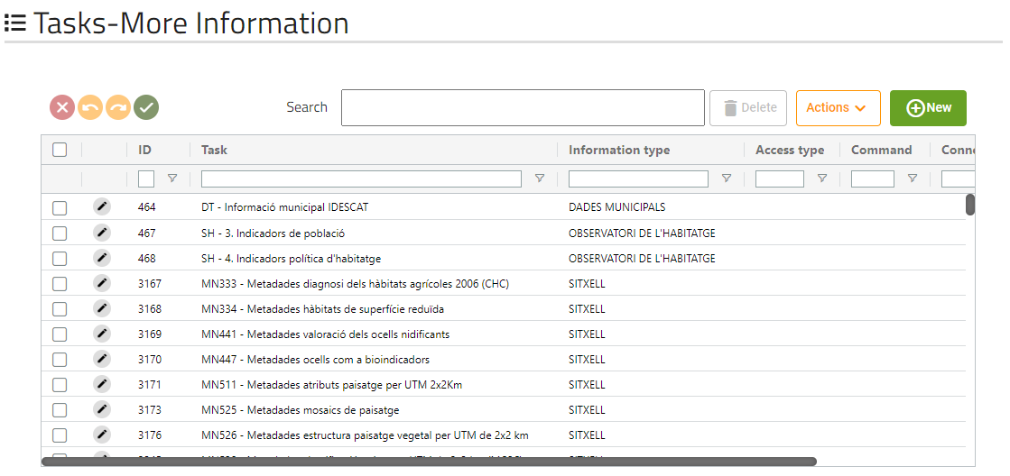

This screen will show us all more-information tasks that the application has.

#### 2.2.16.2 Form

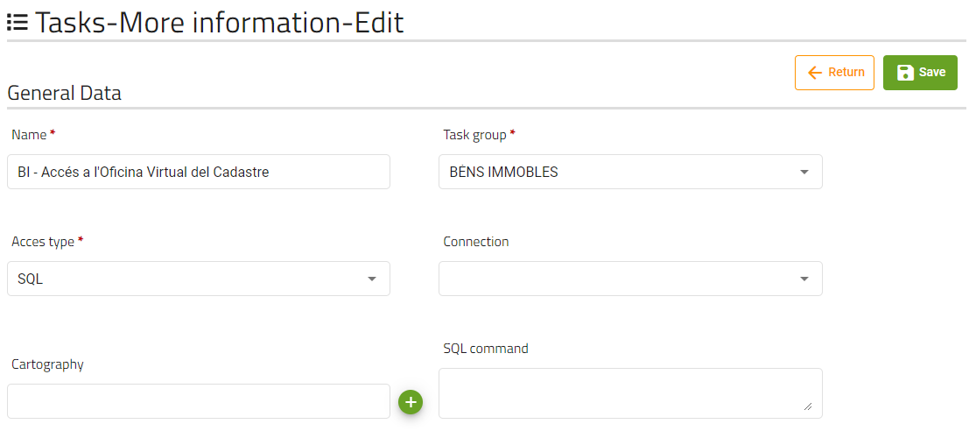

**Label and connection display depends on Access type value**

* + - 1. Territory internal table



Territory table will show us the territories that are related to the task.

* + - 1. Roles internal table



Roles table will show us the roles that are related to the task.

* + - 1. Parameter internal table



Permissions table will show us the permissions that the task has, if we click on new, a dialog will be opened with the form to create it:



**The key selector depends on main form SQL command field, all values written on value field matching the next pattern ${VALUE} will be shown on key selector.**

* + 1. Locator tasks
       1. Generic table

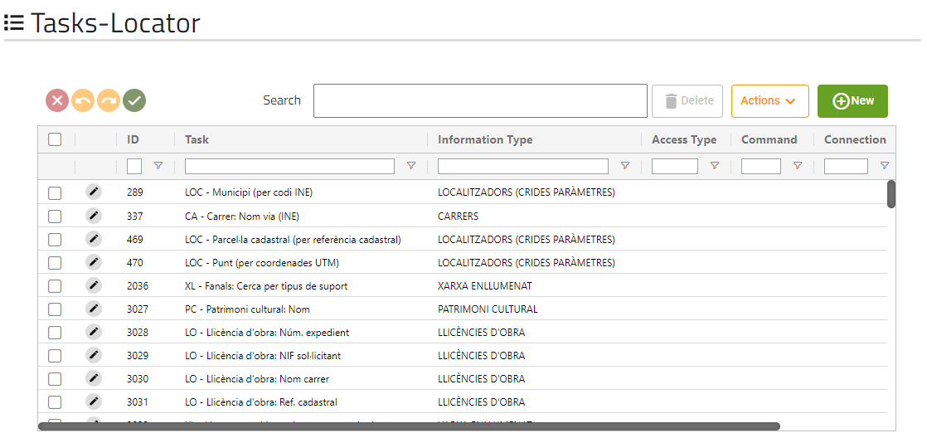

This screen will show us all locator tasks that the application has.

* + - 1. Form

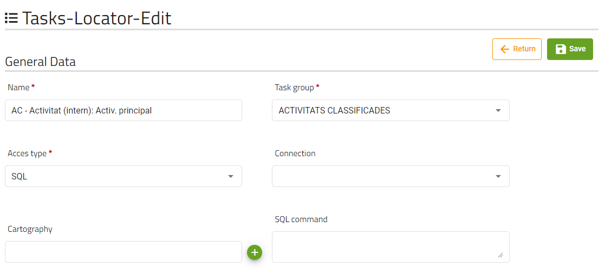

**Label and connection display depends on Access type value**

* + - 1. Territory internal table



Territory table will show us the territories that are related to the task.

* + - 1. Roles internal table



Roles table will show us the roles that are related to the task.

* + - 1. Parameter internal table



Permissions table will show us the permissions that the task has, if we click on new, a dialog will be opened with the form to create it:



**The key selector depends on main form SQL command field, all values written on value field matching the next pattern ${VALUE} will be shown on key selector.**

* + 1. Report tasks
       1. Generic table

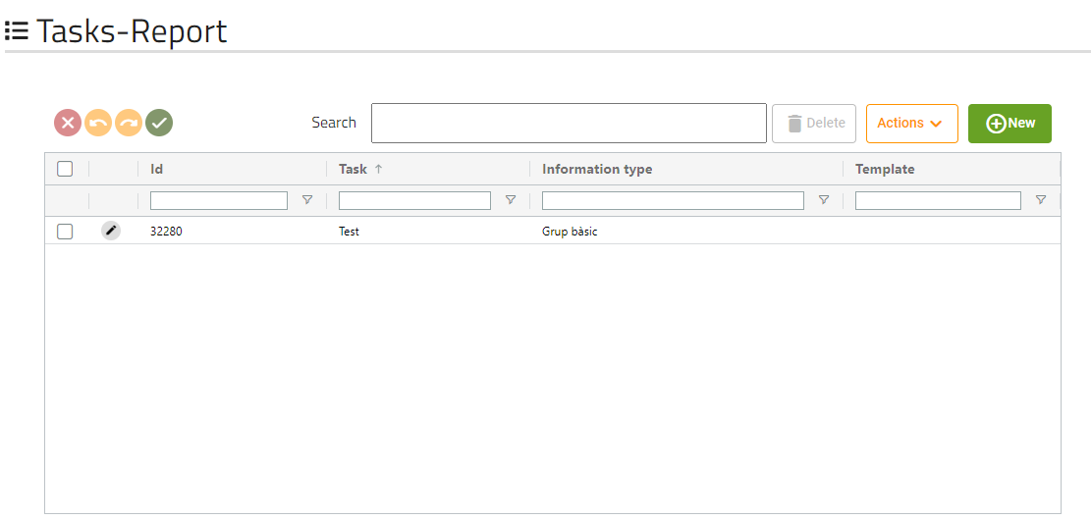

This screen will show us all report tasks that the application has.

* + - 1. Form

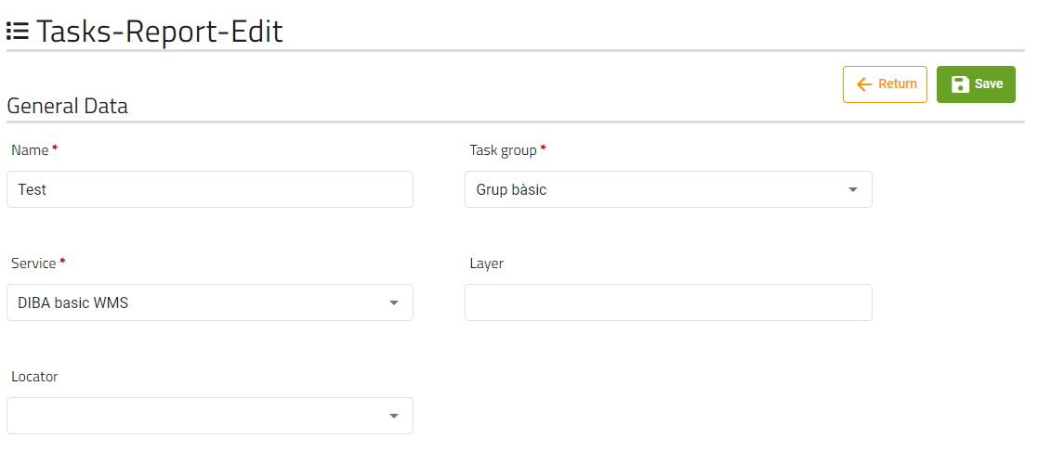

* + - 1. Territory internal table



Territory table will show us the territories that are related to the task.

* + - 1. Roles internal table



Roles table will show us the roles that are related to the task.

* + 1. Thematic tasks
       1. Generic table

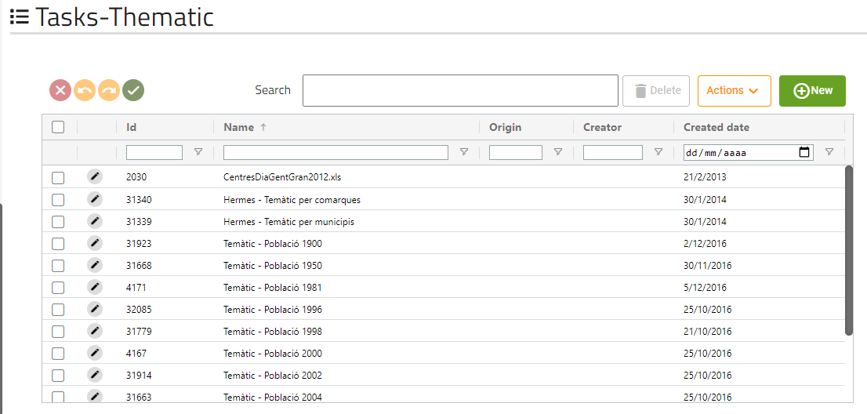

This screen will show us all report tasks that the application has.

* + - 1. Form

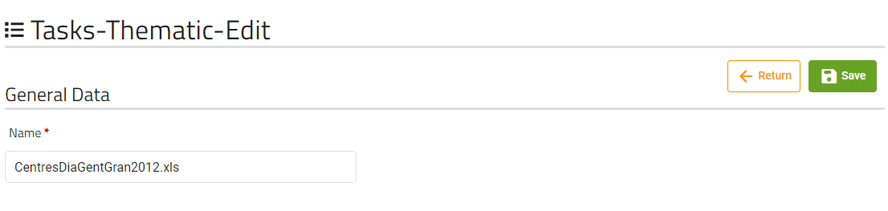

* + - 1. Territory internal table



Territory table will show us the territories that are related to the task.

* + - 1. Roles internal table



Roles table will show us the roles that are related to the task.

* + 1. FME Extraction tasks
       1. Generic table

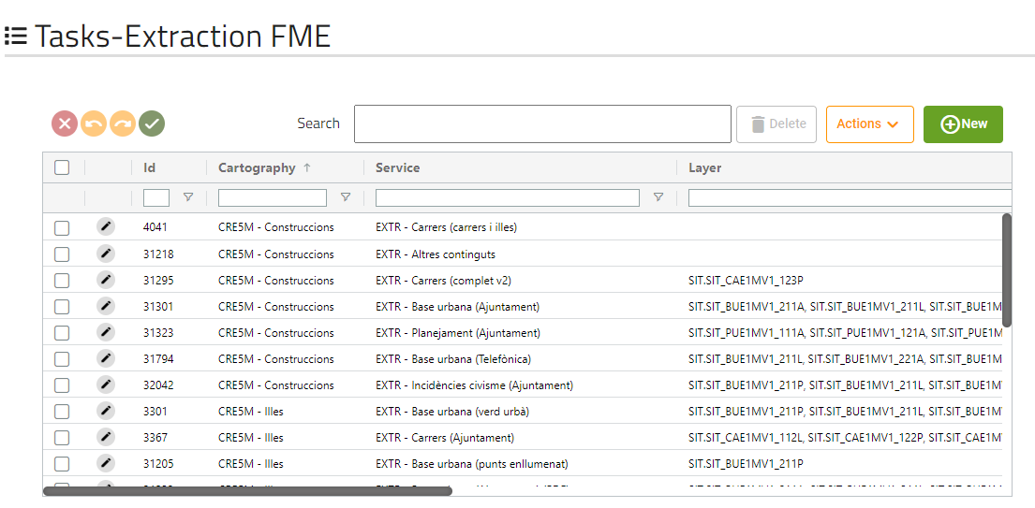

This screen will show us all FME extraction tasks that the application has.

* + - 1. Form

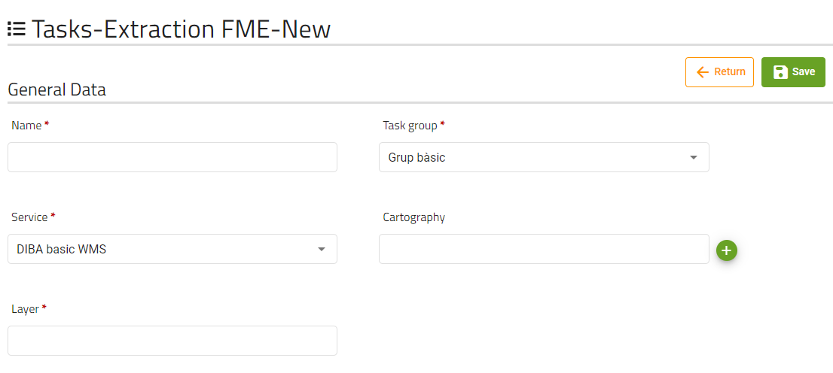

* + - 1. Territory internal table



Territory table will show us the territories that are related to the task.

* + - 1. Roles internal table



Roles table will show us the roles that are related to the task.

* + 1. Applications
       1. Generic table

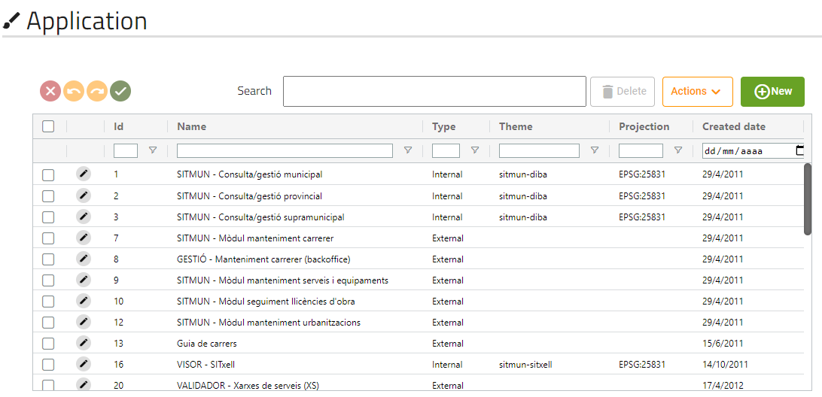

This screen will show us all applications that the application has.

* + - 1. Form

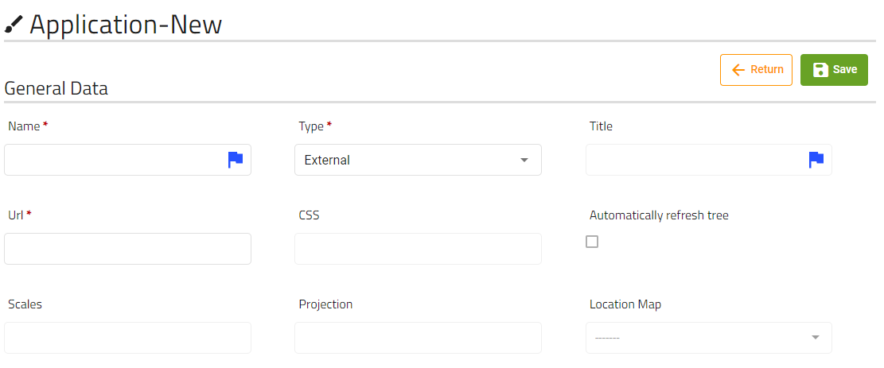

These are the fields that the user can modify of an application.

Scales must be numbers separated by commas.

If type field has “External” selected, only name, type, and URL fields will be editable.

* + - 1. Parameter configuration internal table

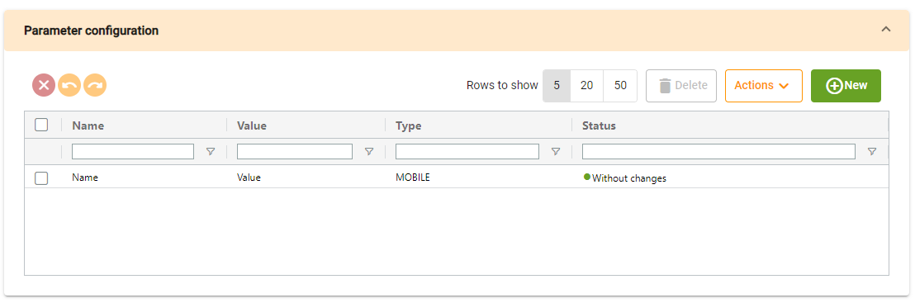

Parameter configuration table will show us the parameters configuration that the application has, clicking on new a dialog will be opened with a form to create the new parameter:

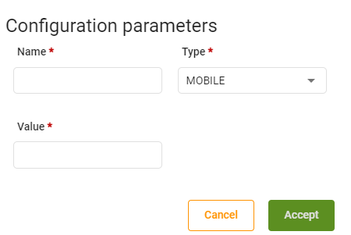

* + - 1. Template configuration internal table



Template configuration table will show us the templates configuration that the application has, clicking on new a dialog will be opened with a form to create the new template configuration:

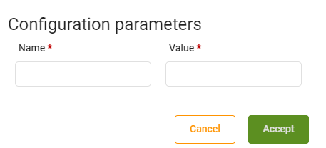

* + - 1. Roles internal table



Roles table will show us the roles that are related to the application.

* + - 1. Background internal table

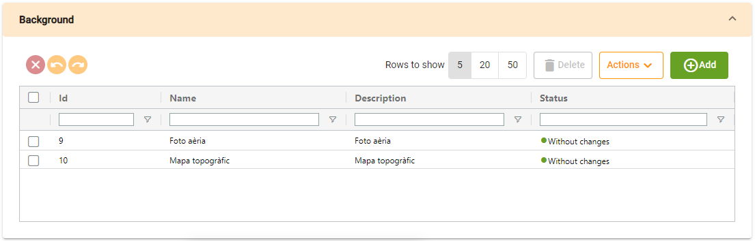

Background table will show us the backgrounds that are related to the application.

* + - 1. Tree internal table

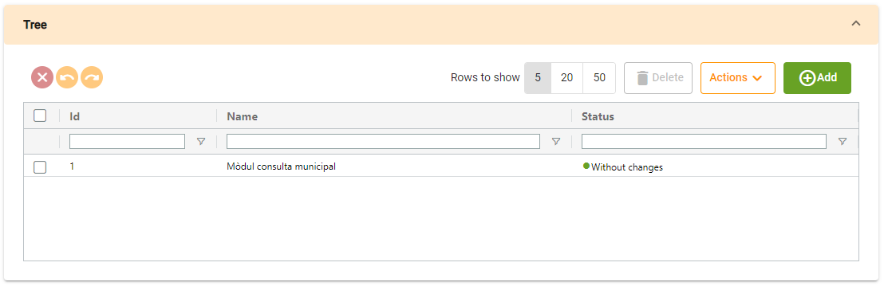

Tree table will show us the trees that are related to the application.