**Overview**

Within my 5 years experience in Sotfware Development Industry I have been created wide variety of applications using different languages.

**ERP Systems**

**Description :**

This is my first fully blown application I have developed back in 2012. It is a application use for Medium or Large Scale Industry , a multi-user systems that interact with actual accounting entries in real time. It can easily generate core financial reports such Balance Sheet, Trial Balance, Income Statement, Cash Flow, General Journal and Books of Account. It can track outgoing payment and purchasing transactions, account payables, track sales and accounts receivable. It can generate purchase orders and purchase invoice, sales order and sales invoice.

Within the course of the development, I have improve this application extensively to the point that it can be integrated with other stand alone applications I have developed such as Laboratory Systems, Lending Systems, Rental Monitoring, Enrollment Systems, Billing and Collection System, Project Costing, Manufacturing, Construction, POS and Hotel Management System.

**Ongoing Deployment of this System:**

MDLab Diagnostic Center**,** Bio Assay Diagnostic Center, PARPAD Builders Construction

**Previous Deployment of this System:**

MBSC, TheOtherWay Corporation, Brightwoods International School, VOMFASS, Bluebees, Hotel Euroasia, Sun Moon Hotel, Janus, GMER Rentals, 3C Realty, Sindalan Realty, Blossom Forth School, Clarkstar Hotel, Clark Nature Park Inc, Spendwisely Lending, Silverspoon, SPOW, ELS Laundry, MBSC Rentals, Clarkview Hotel, AC Global, ABC Accounting.

* 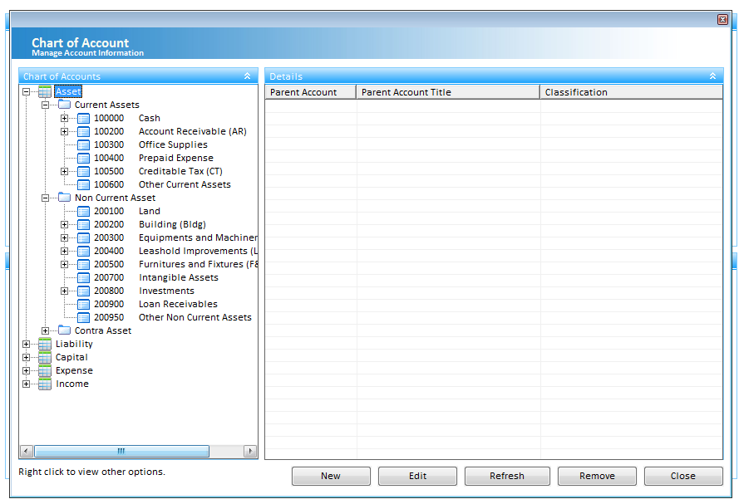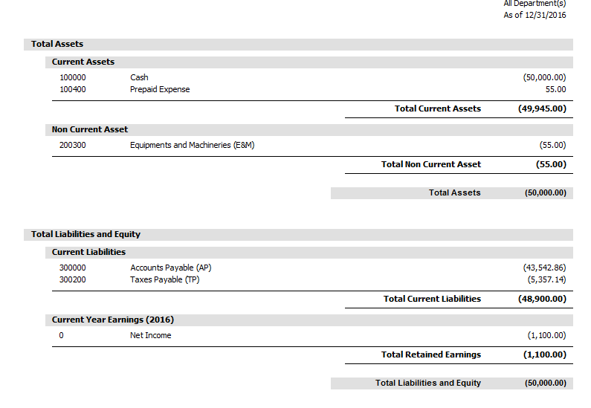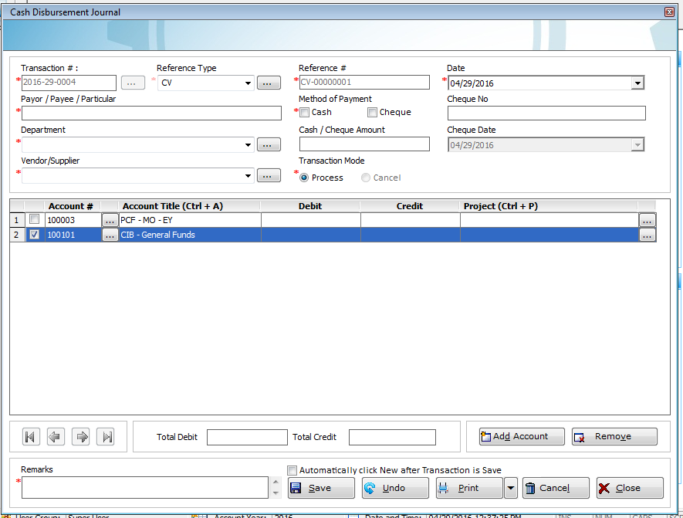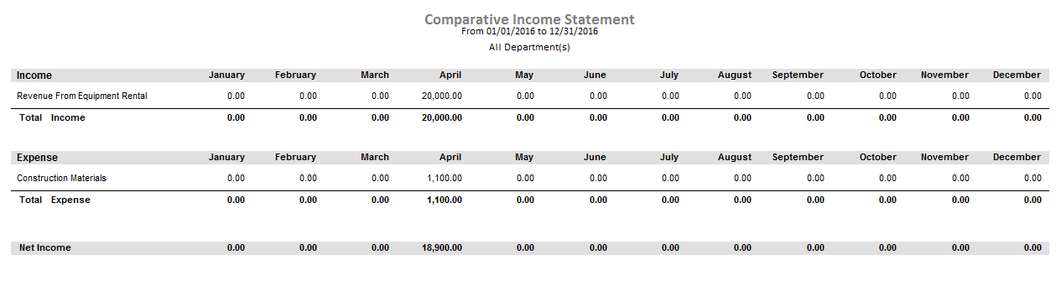**Accounting Module**
* 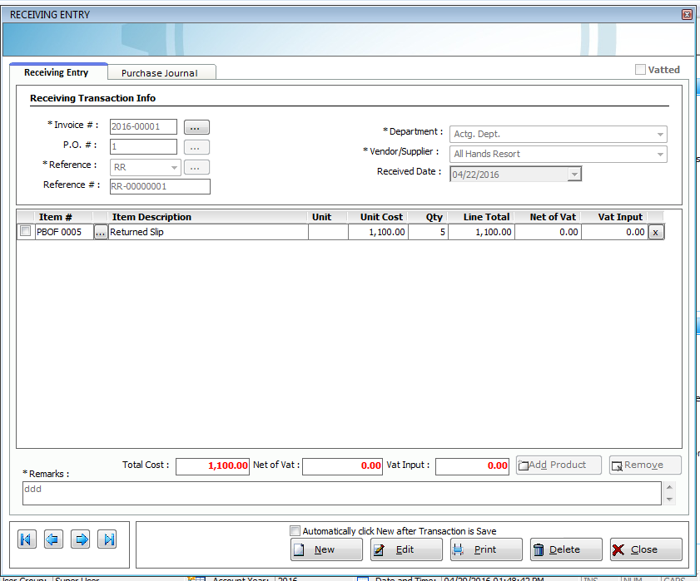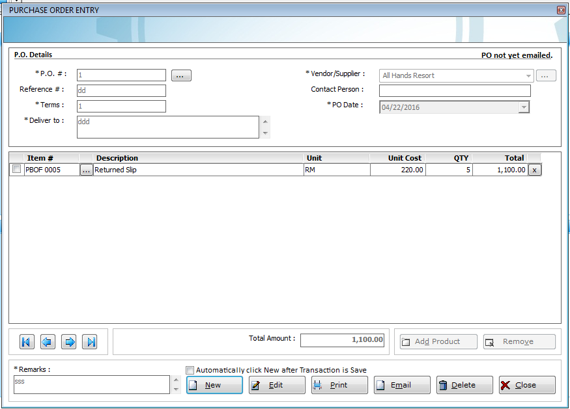**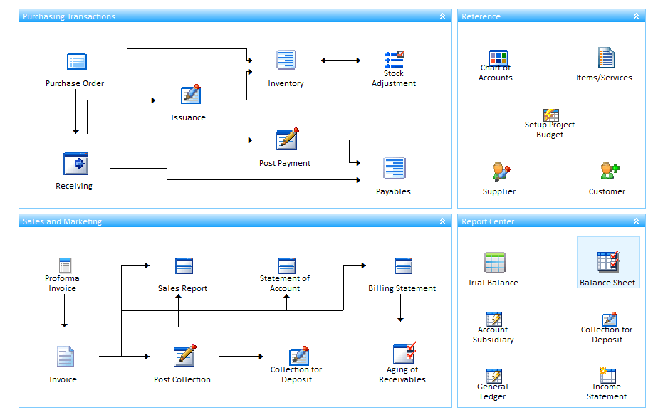Purchasing Transaction Module**

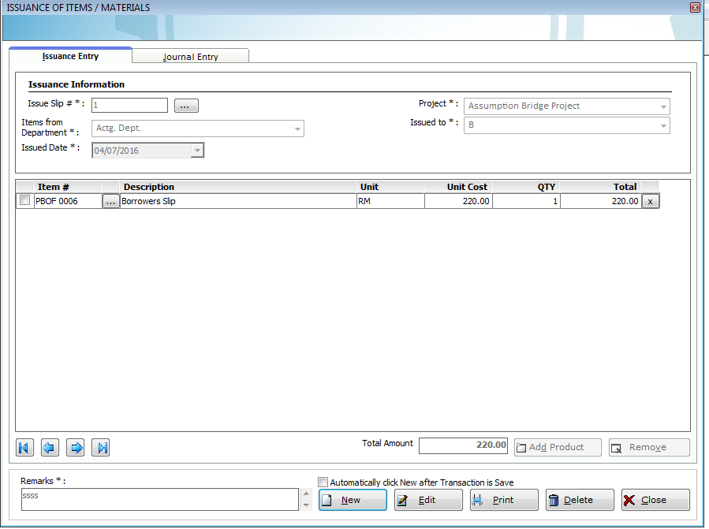

* **Sales Transaction Module**

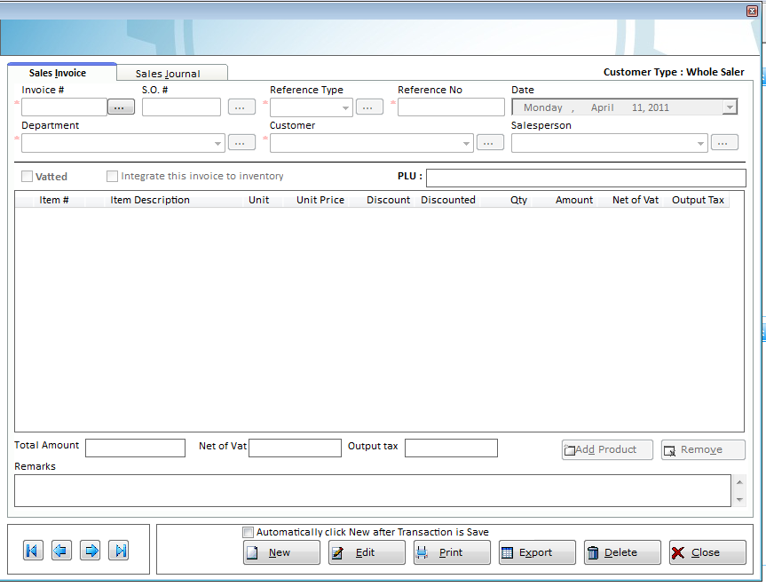

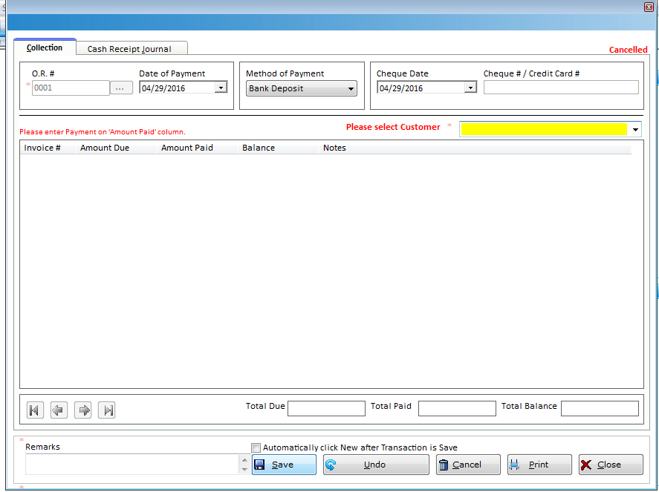

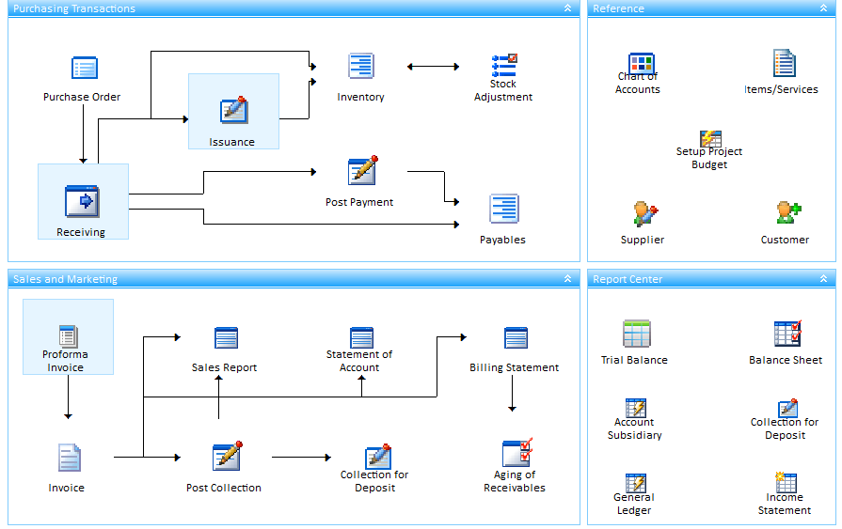

* 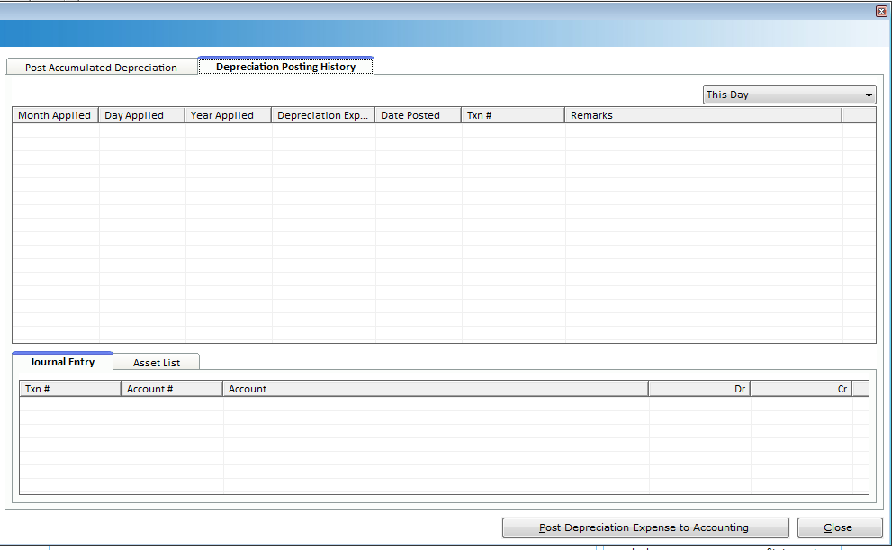**Fixed Asset Management Module**

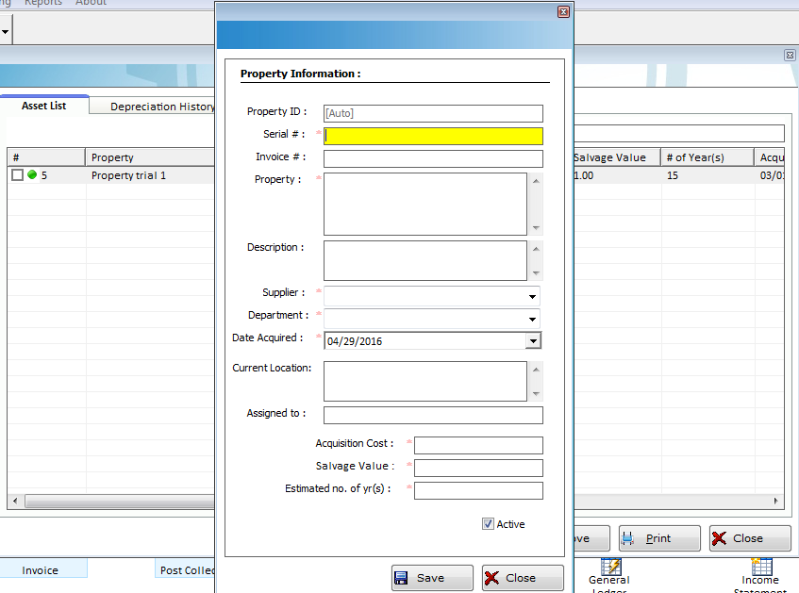

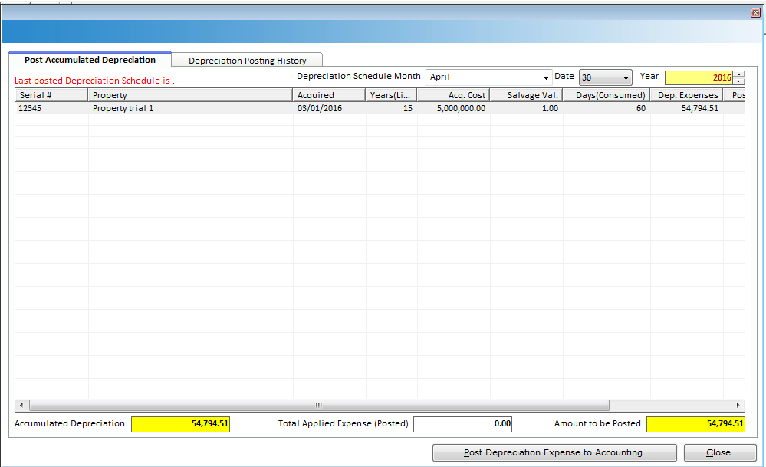

* 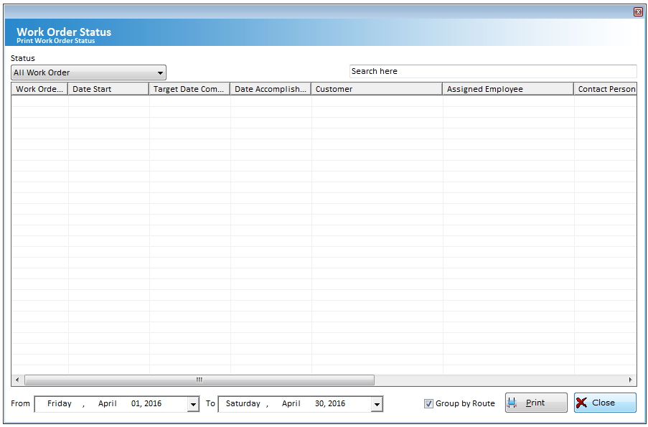**CRM Module**

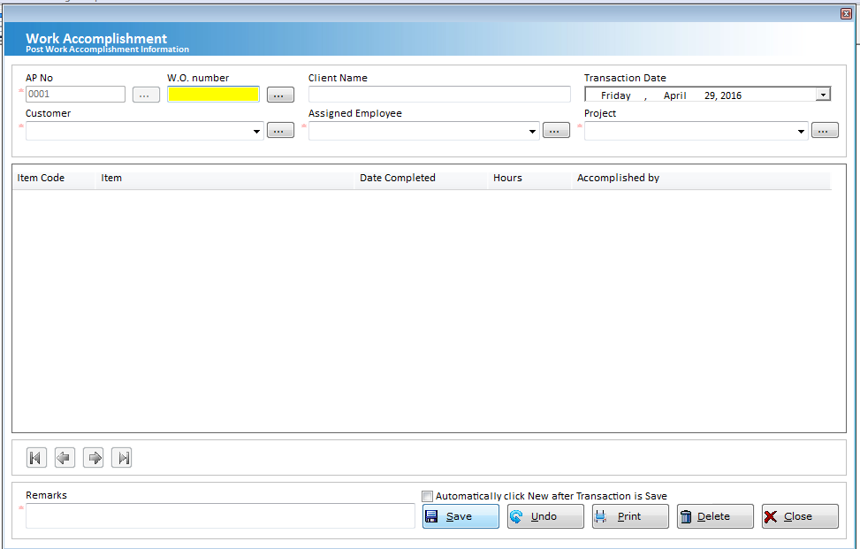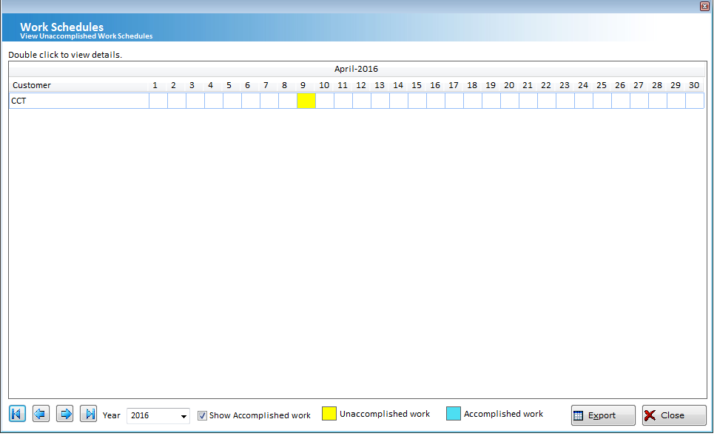

**JCORE Online Accounting System**

**Description:**

A online bookkeeping system I developed back in 2014. It is a purely accounting and used by Accounting firms to maintain Book of Accounts of their clients. It can generate reports such Balance Sheet, Profit and Loss (Income Statement), Trial balance and Journals. It can also track Customer and Supplier Subsidiary journal.

**URL :**

https://www.jcore.jdevsolution.com

**Deployment :**

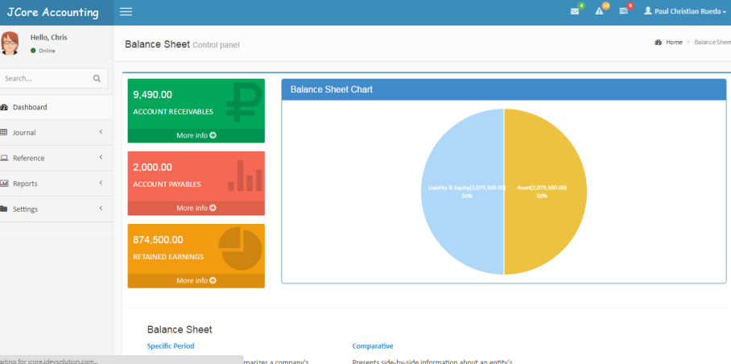 It was used by our Accounting Partners, the SMS professionals and ABC Accounting.

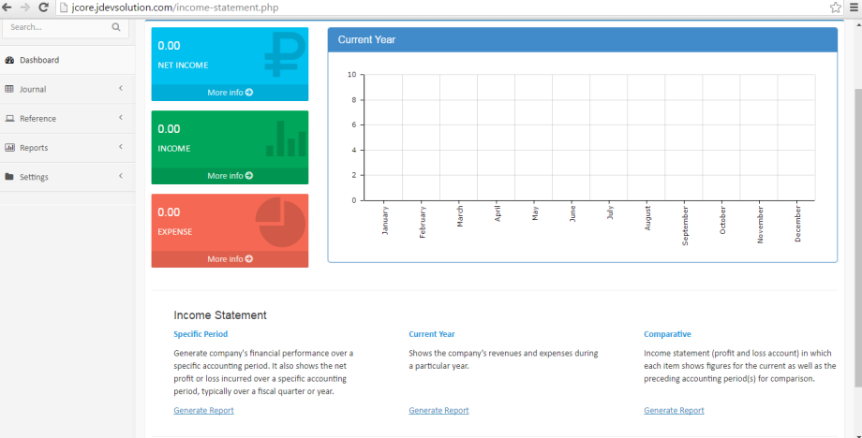

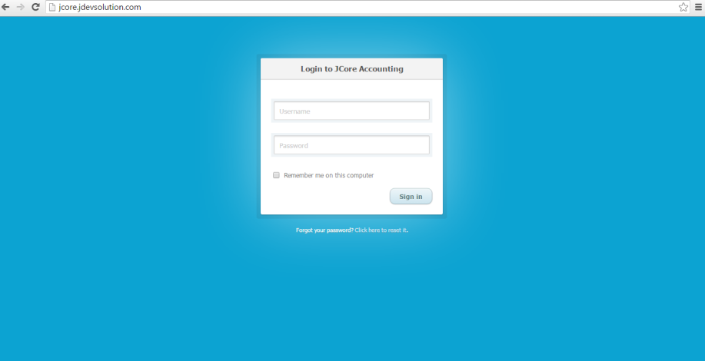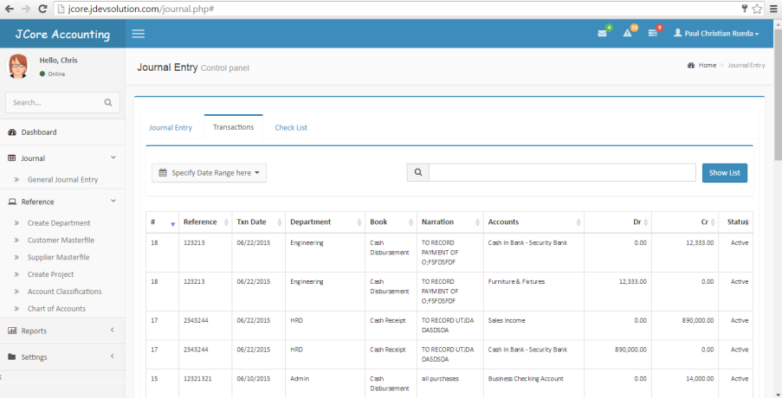

**Enrollment System**

**Description :**

This is a program I developed back in 2013. This program is integrated to Accounting System to track down Income of the school and track down receivables of the student. It has 3 main core process which is the Student Registration, Assessment and the Posting of Payment.

**Deployment :**

Brightwoods International School, Blossom Forth School.

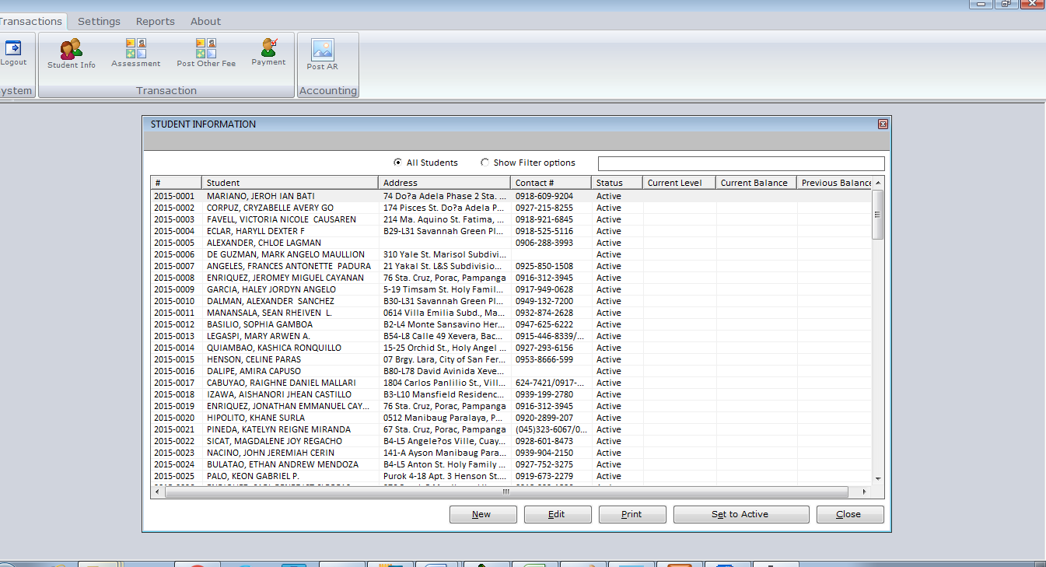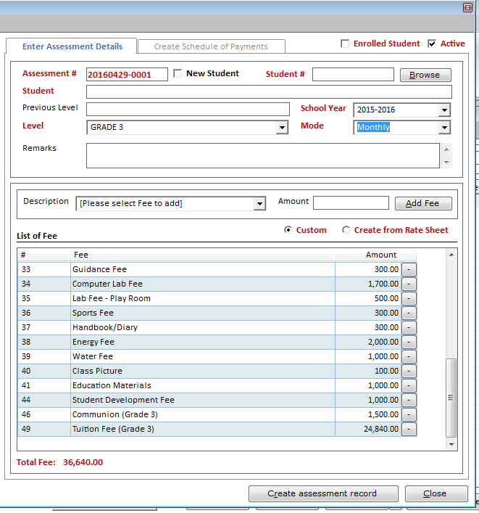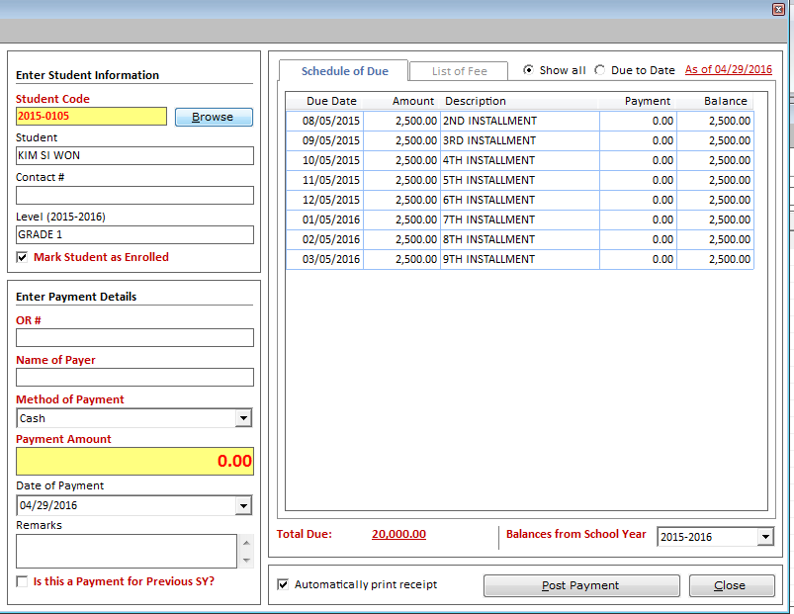

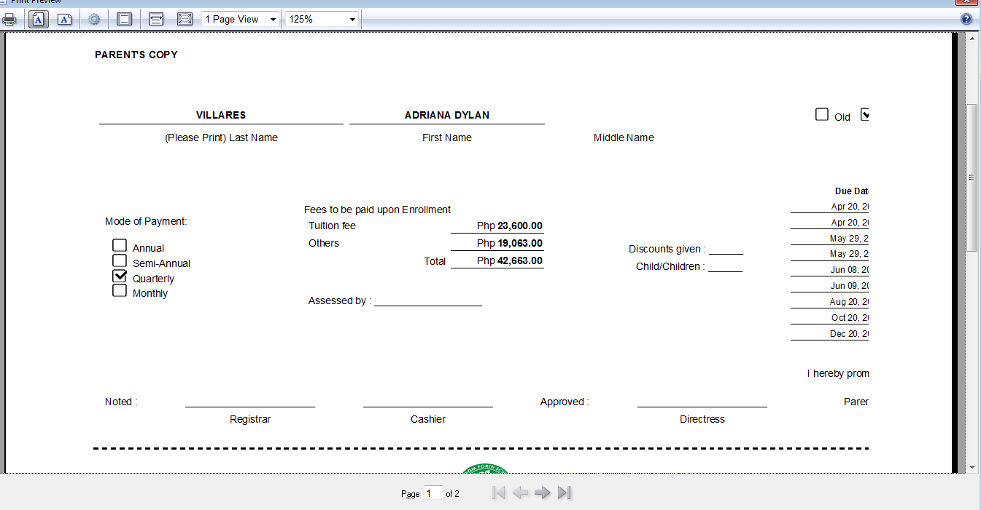

**Human Resource Information System**

**Description :**

This is a team collaboration project at my work, developed last year(2015) together with the Payroll and Attendance Monitoring System. This is a very flexible system specially on reporting, user can design the report they needed and save this as template.

**Deployment :**

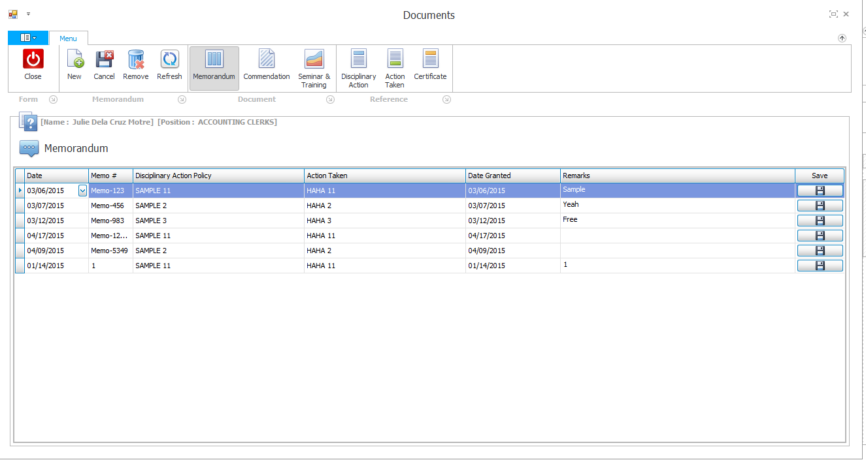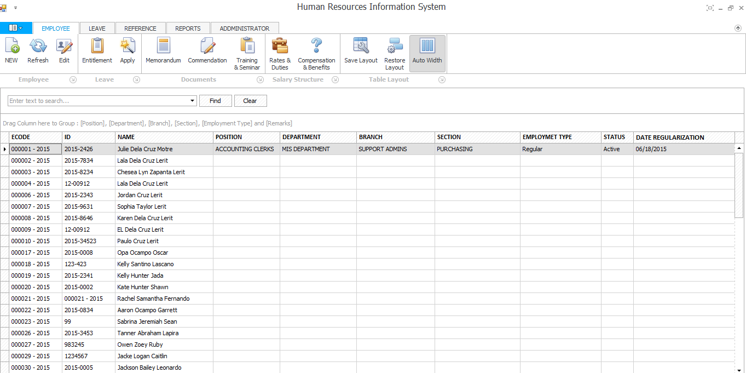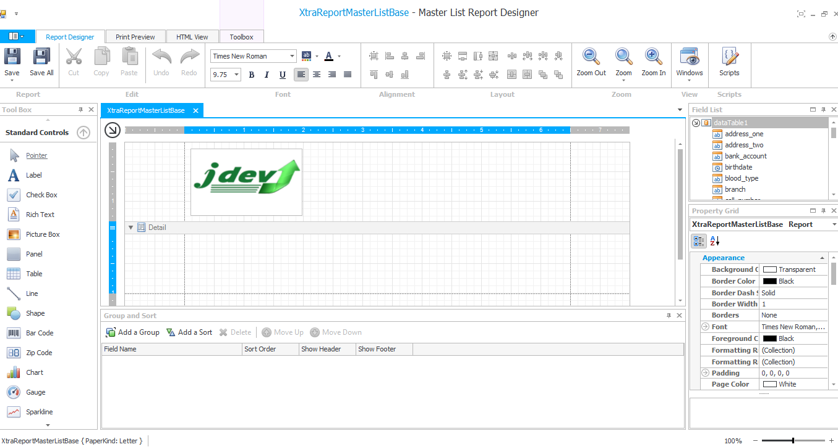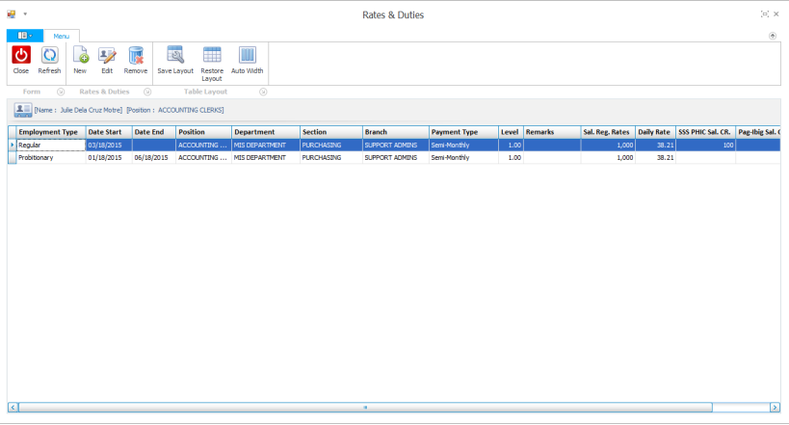 Brightwoods International School.

**Rental Monitoring with Billing and Collection System**

**Description :**

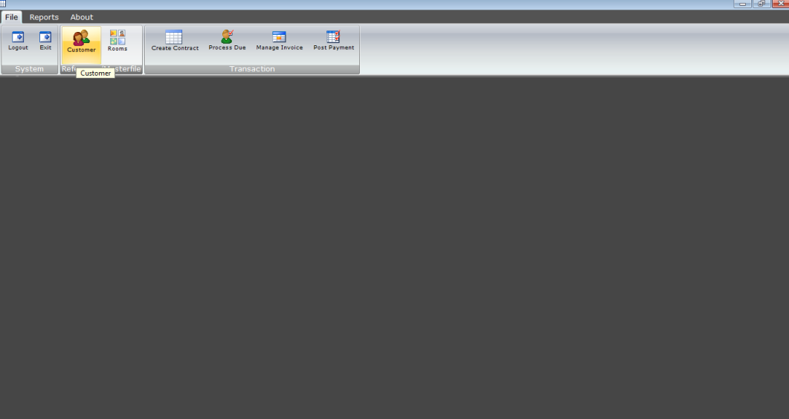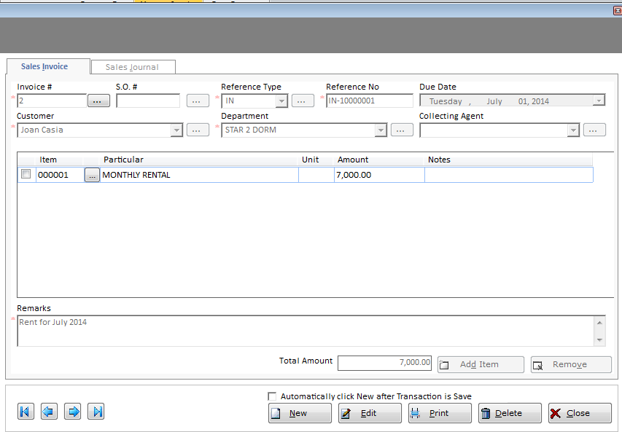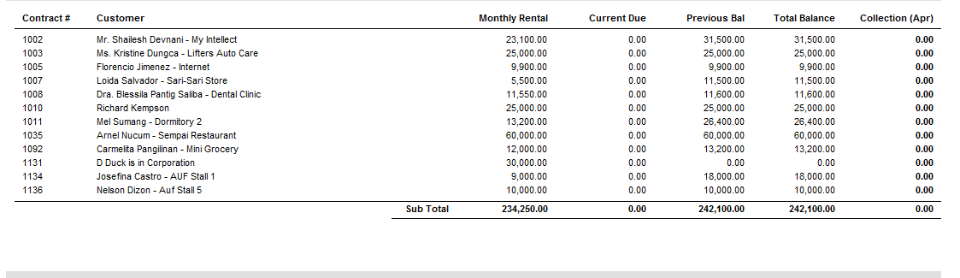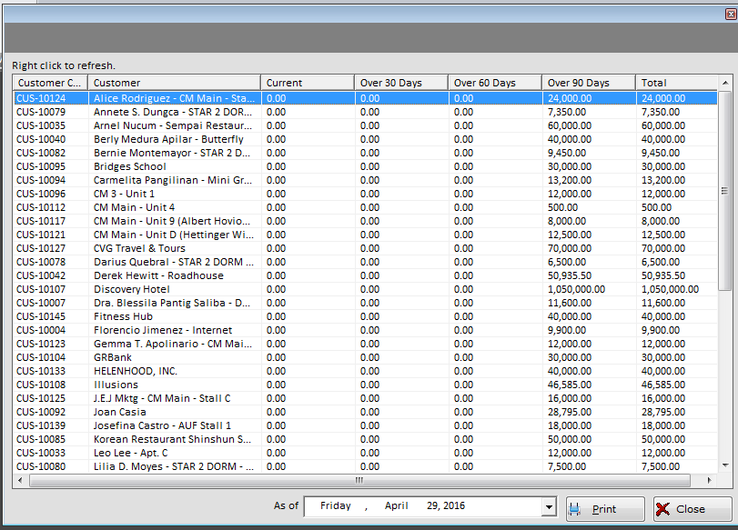A system I developed use by MBSC Accounting Department to monitor their rental properties. It can generate Aging of receivables of their clients. It can also generate Statement of Account of their clients.

**Apprehended Consumer Collection and Billing System**

**Description :**

This is a system we developed together with my freelance team. This system is used to track apprehended consumer billing, their ledgers and payment history. It can generate reports such as collection report from a particular period and delinquent consumer list report.

**Deployment :**

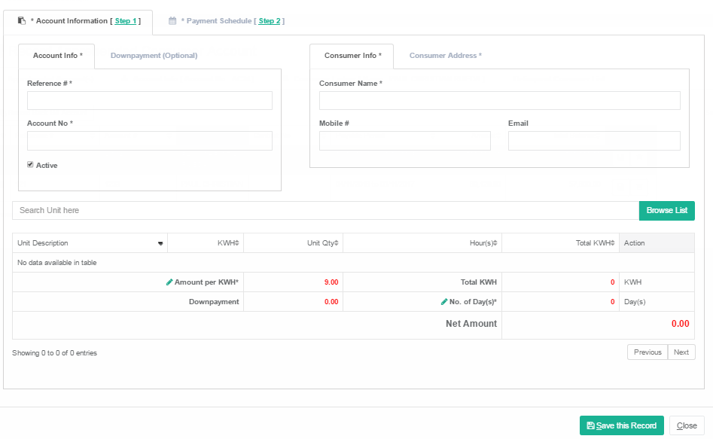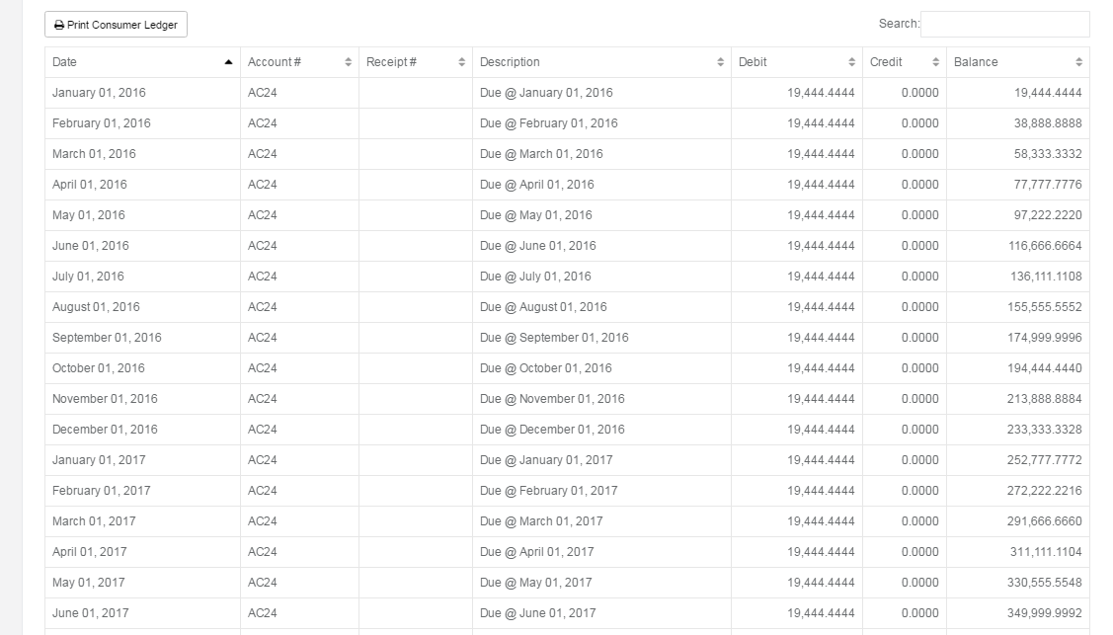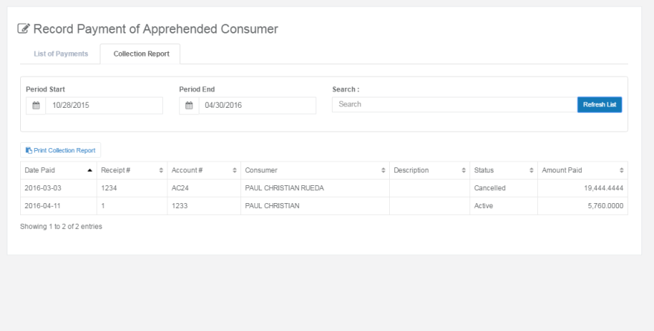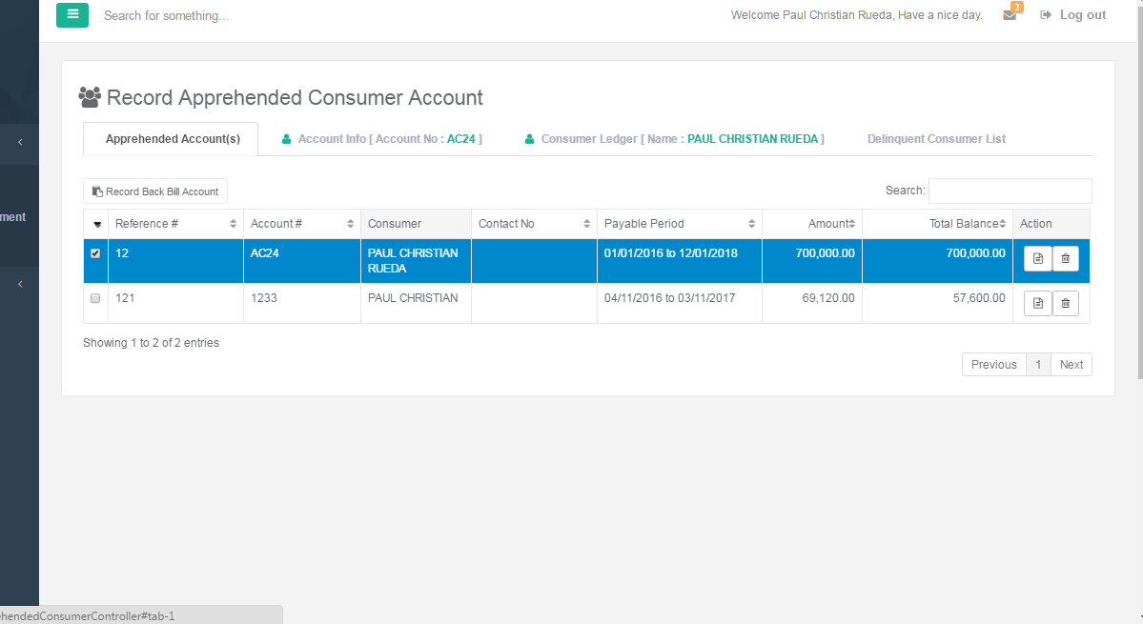Deployment of this system is on progress at PELCO III Apalit Pampanga.

**Laboratory Management System**

**Description :**

This is a program that I developed together with my co-programmer at work last December 2015. It is used to record findings and diagnosis. Print medical forms depending on their department and track account receivables of companies being charge by patient. It has a POS style ui for front desk.

**Deployment :**

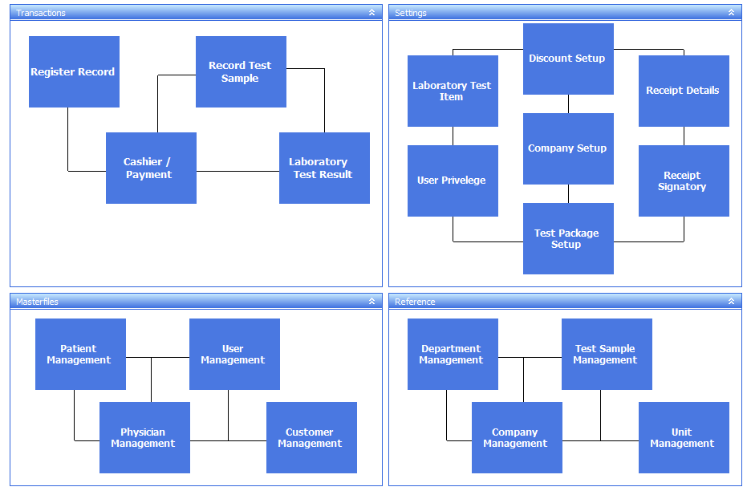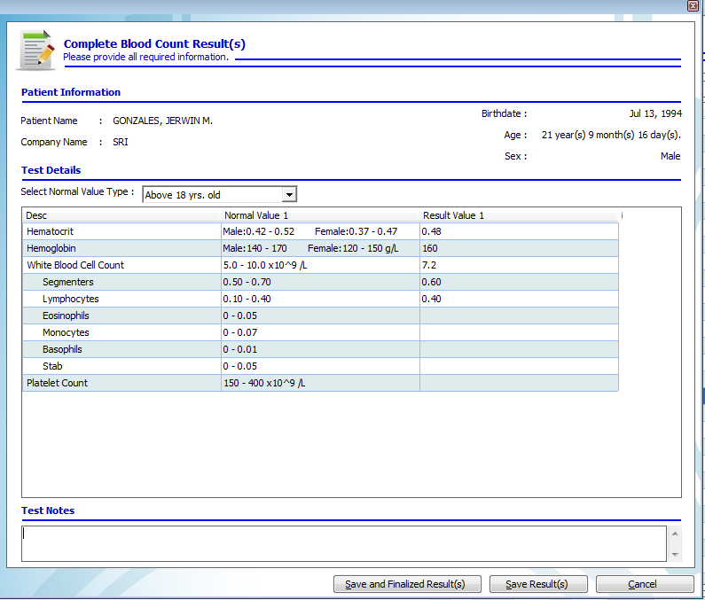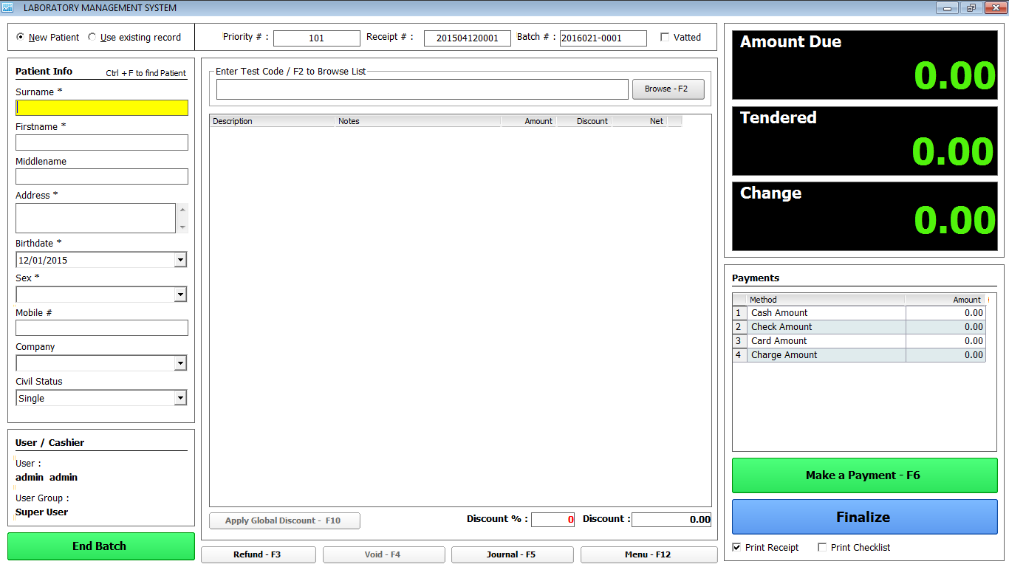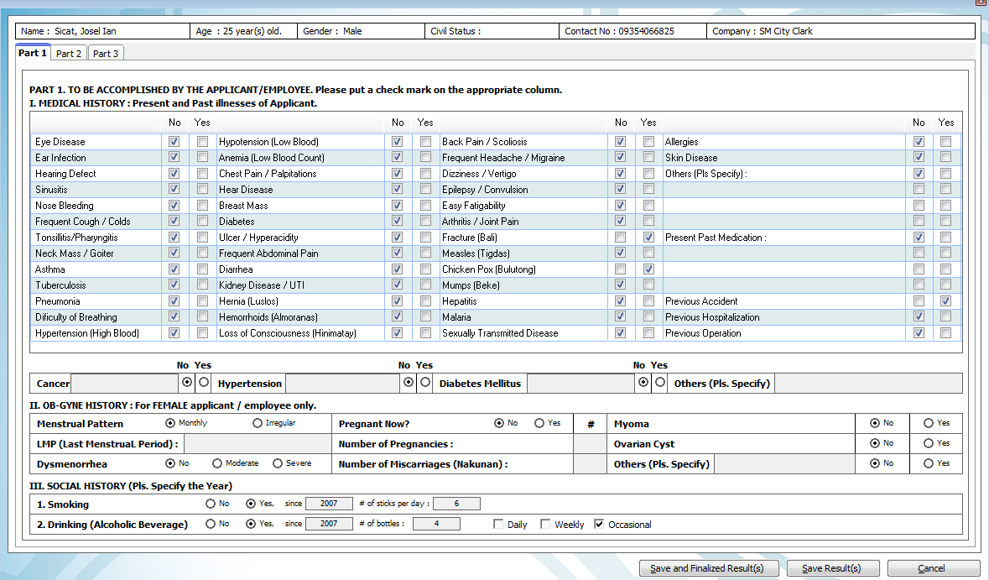MDLab Diagnostic Center, In Bio-Assay Diagnostic Center deployment is still in progress.