Motor Test Report
Motor No: 05
Generated: 2026-08-20 10:36:19

NO LOAD TEST
Stat | VOLTAGE1 | VOLTAGE2 | CURRENT | RPM | TORQUE | BODY_TEMP | COIL_TEMP | COMM_TEMP | FRONT_BEARING_TEMP | REAR_BEARING_TEMP
min | 31.94 | 5.01 | 1.07 | 900.0 | 0.0 | 0.0 | 0.0 | 0.0 | 0.0 | 0.0
max | 32.11 | 6.23 | 1.41 | 3780.0 | 0.0 | 0.0 | 0.0 | 0.0 | 0.0 | 0.0
mean | 31.97 | 5.69 | 1.1 | 3619.66 | 0.0 | 0.0 | 0.0 | 0.0 | 0.0 | 0.0
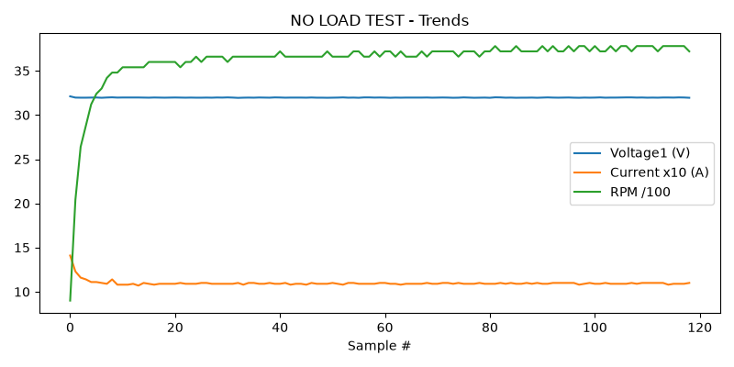

HIGH SPEED TEST REPORT
Stat | VOLTAGE1 | VOLTAGE2 | CURRENT | RPM | TORQUE | BODY_TEMP | COIL_TEMP | COMM_TEMP | FRONT_BEARING_TEMP | REAR_BEARING_TEMP
min | 31.93 | 5.16 | 1.08 | 3780.0 | 0.0 | 0.0 | 0.0 | 0.0 | 0.0 | 0.0
max | 32.0 | 6.32 | 1.11 | 3900.0 | 0.0 | 0.0 | 0.0 | 0.0 | 0.0 | 0.0
mean | 31.97 | 5.72 | 1.1 | 3827.5 | 0.0 | 0.0 | 0.0 | 0.0 | 0.0 | 0.0
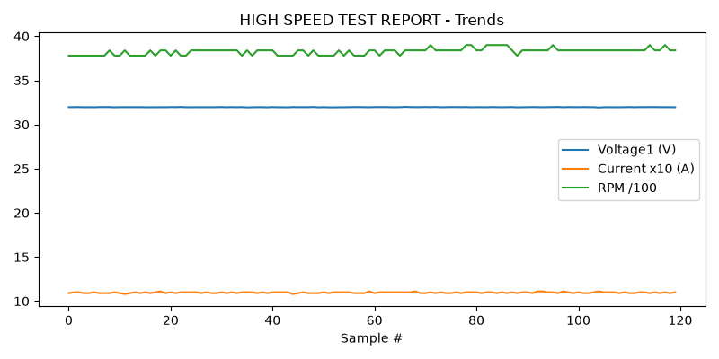

PERFORMANCE TEST
Could not read this sheet: Length mismatch: Expected axis has 0 elements, new values have 11 elements

HEAT RUN TEST
Stat | VOLTAGE1 | VOLTAGE2 | CURRENT | RPM | TORQUE | BODY_TEMP | COIL_TEMP | COMM_TEMP | FRONT_BEARING_TEMP | REAR_BEARING_TEMP
min | 31.98 | 5.88 | 1.09 | 3840.0 | 0.0 | 0.0 | 0.0 | 0.0 | 0.0 | 0.0
max | 31.98 | 5.96 | 1.1 | 3900.0 | 0.0 | 0.0 | 0.0 | 0.0 | 0.0 | 0.0
mean | 31.98 | 5.92 | 1.1 | 3870.0 | 0.0 | 0.0 | 0.0 | 0.0 | 0.0 | 0.0
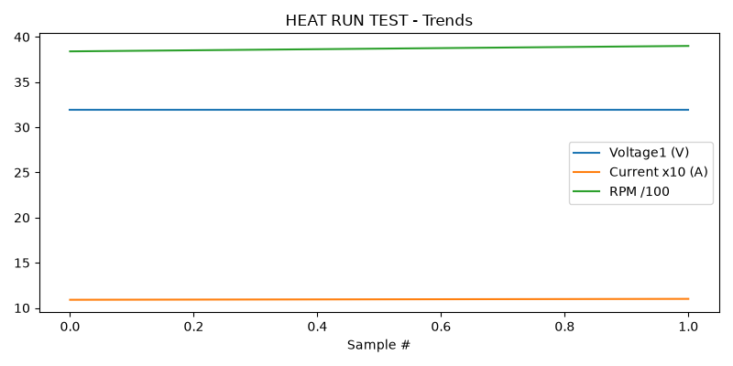

STAGE 5
Could not read this sheet: Worksheet named 'STAGE 5' not found

