Motor Test Report
Motor No: 07
Generated: 2026-08-20 11:51:47

NO LOAD TEST
Stat | VOLTAGE1 | VOLTAGE2 | CURRENT | RPM | TORQUE | BODY_TEMP | COIL_TEMP | COMM_TEMP | FRONT_BEARING_TEMP | REAR_BEARING_TEMP
min | 31.95 | 4.07 | 1.03 | 900.0 | 0.0 | 0.0 | 0.0 | 0.0 | 0.0 | 0.0
max | 32.12 | 6.7 | 1.4 | 3240.0 | 0.0 | 0.0 | 0.0 | 0.0 | 0.0 | 0.0
mean | 31.97 | 5.53 | 1.1 | 3033.49 | 0.0 | 0.0 | 0.0 | 0.0 | 0.0 | 0.0
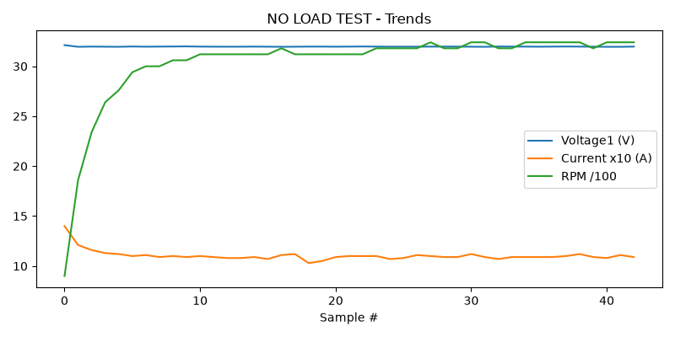

HIGH SPEED TEST REPORT
Stat | VOLTAGE1 | VOLTAGE2 | CURRENT | RPM | TORQUE | BODY_TEMP | COIL_TEMP | COMM_TEMP | FRONT_BEARING_TEMP | REAR_BEARING_TEMP
min | 31.93 | 3.61 | 1.07 | 3180.0 | 0.0 | 0.0 | 0.0 | 0.0 | 0.0 | 0.0
max | 31.99 | 8.77 | 1.13 | 3420.0 | 0.0 | 0.0 | 0.0 | 0.0 | 0.0 | 0.0
mean | 31.97 | 5.33 | 1.1 | 3315.0 | 0.0 | 0.0 | 0.0 | 0.0 | 0.0 | 0.0
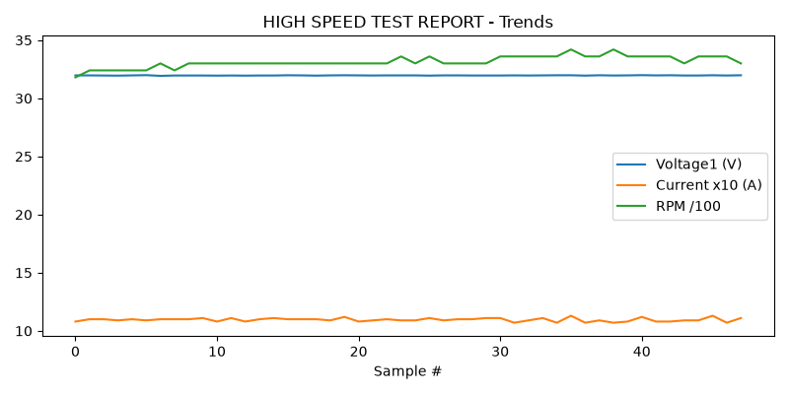

PERFORMANCE TEST
Stat | VOLTAGE1 | VOLTAGE2 | CURRENT | RPM | TORQUE | BODY_TEMP | COIL_TEMP | COMM_TEMP | FRONT_BEARING_TEMP | REAR_BEARING_TEMP
min | 31.95 | 1.98 | 1.02 | 3420.0 | 0.0 | 0.0 | 0.0 | 0.0 | 0.0 | 0.0
max | 31.99 | 15.49 | 1.18 | 3540.0 | 0.0 | 0.0 | 0.0 | 0.0 | 0.0 | 0.0
mean | 31.97 | 5.62 | 1.09 | 3500.82 | 0.0 | 0.0 | 0.0 | 0.0 | 0.0 | 0.0
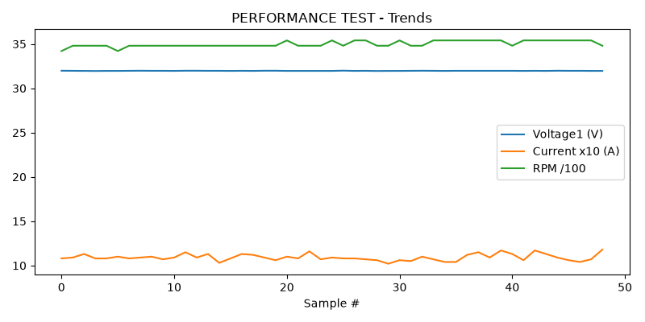

HEAT RUN TEST
Stat | VOLTAGE1 | VOLTAGE2 | CURRENT | RPM | TORQUE | BODY_TEMP | COIL_TEMP | COMM_TEMP | FRONT_BEARING_TEMP | REAR_BEARING_TEMP
min | 31.94 | 3.12 | 1.06 | 3360.0 | 0.0 | 0.0 | 0.0 | 0.0 | 0.0 | 0.0
max | 32.0 | 8.22 | 1.12 | 3480.0 | 0.0 | 0.0 | 0.0 | 0.0 | 0.0 | 0.0
mean | 31.97 | 5.64 | 1.09 | 3435.6 | 0.0 | 0.0 | 0.0 | 0.0 | 0.0 | 0.0
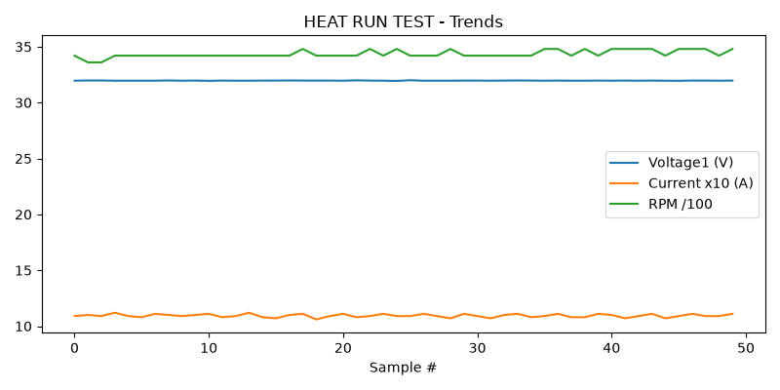

STAGE 5
Could not read this sheet: Worksheet named 'STAGE 5' not found

