Motor Test Report
Motor No: 11
Generated: 2026-08-20 15:03:54

NO LOAD TEST [FAIL]
Evaluation Remark: Voltage avg (31.96V) out of spec [27.0-27.0V]; RPM avg (4788) out of range [12740-13260]
Stat | VOLTAGE1 | VOLTAGE2 | CURRENT | RPM | TORQUE | BODY_TEMP | COIL_TEMP | COMM_TEMP | FRONT_BEARING_TEMP | REAR_BEARING_TEMP
min | 31.93 | 5.55 | 1.16 | 1560.0 | 0.0 | 0.0 | 0.0 | 0.0 | 0.0 | 0.0
max | 32.11 | 7.91 | 1.76 | 5220.0 | 0.0 | 0.0 | 0.0 | 0.0 | 0.0 | 0.0
mean | 31.96 | 6.93 | 1.24 | 4787.5 | 0.0 | 0.0 | 0.0 | 0.0 | 0.0 | 0.0
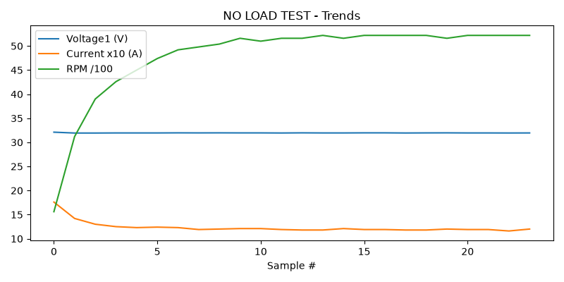

HIGH SPEED TEST REPORT [FAIL]
Evaluation Remark: Voltage avg (31.96V) out of spec [27.0-27.0V]; RPM avg (5214) out of range [8820-9180]
Stat | VOLTAGE1 | VOLTAGE2 | CURRENT | RPM | TORQUE | BODY_TEMP | COIL_TEMP | COMM_TEMP | FRONT_BEARING_TEMP | REAR_BEARING_TEMP
min | 31.94 | 2.76 | 1.1 | 5160.0 | 0.0 | 0.0 | 0.0 | 0.0 | 0.0 | 0.0
max | 31.98 | 17.62 | 1.32 | 5280.0 | 0.0 | 0.0 | 0.0 | 0.0 | 0.0 | 0.0
mean | 31.96 | 7.56 | 1.19 | 5213.75 | 0.0 | 0.0 | 0.0 | 0.0 | 0.0 | 0.0
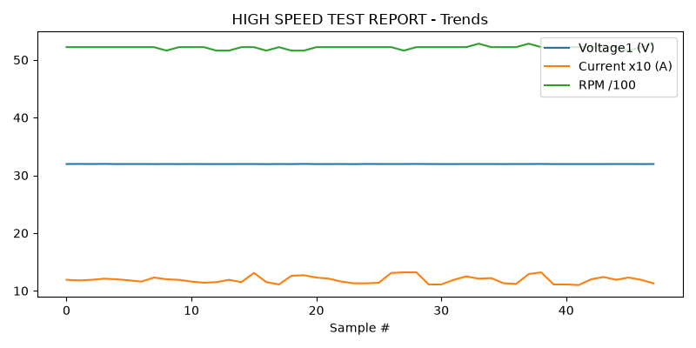

PERFORMANCE TEST [FAIL]
Evaluation Remark: Voltage avg (31.96V) out of spec [26.0-28.0V]; RPM avg (5312) out of range [7400-8200]
Stat | VOLTAGE1 | VOLTAGE2 | CURRENT | RPM | TORQUE | BODY_TEMP | COIL_TEMP | COMM_TEMP | FRONT_BEARING_TEMP | REAR_BEARING_TEMP
min | 31.93 | 6.22 | 1.17 | 5280.0 | 0.0 | 0.0 | 0.0 | 0.0 | 0.0 | 0.0
max | 31.98 | 8.96 | 1.21 | 5400.0 | 0.0 | 0.0 | 0.0 | 0.0 | 0.0 | 0.0
mean | 31.96 | 7.42 | 1.2 | 5311.84 | 0.0 | 0.0 | 0.0 | 0.0 | 0.0 | 0.0
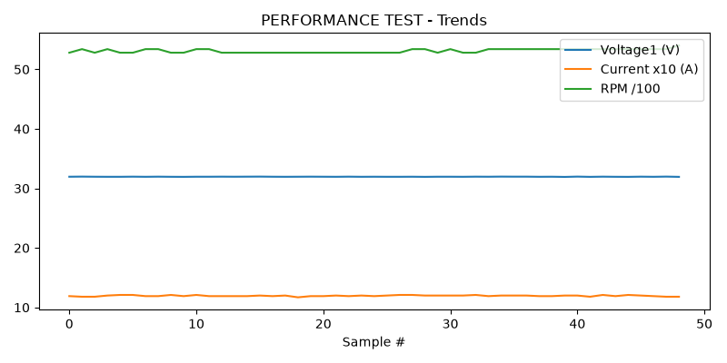

HEAT RUN TEST [FAIL]
Evaluation Remark: Voltage avg (31.96V) out of spec [26.0-28.0V]; RPM avg (5250) out of range [8820-9180]
Stat | VOLTAGE1 | VOLTAGE2 | CURRENT | RPM | TORQUE | BODY_TEMP | COIL_TEMP | COMM_TEMP | FRONT_BEARING_TEMP | REAR_BEARING_TEMP
min | 31.92 | 2.78 | 1.1 | 5160.0 | 0.0 | 0.0 | 0.0 | 0.0 | 0.0 | 0.0
max | 31.97 | 16.97 | 1.31 | 5340.0 | 0.0 | 0.0 | 0.0 | 0.0 | 0.0 | 0.0
mean | 31.96 | 7.51 | 1.19 | 5250.0 | 0.0 | 0.0 | 0.0 | 0.0 | 0.0 | 0.0
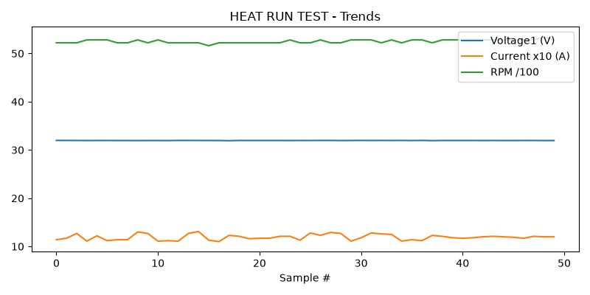

ENDURANCE TEST [FAIL]
Evaluation Remark: Voltage avg (31.96V) out of spec [27.0-27.0V]; RPM avg (5369) out of range [7400-8200]
Stat | VOLTAGE1 | VOLTAGE2 | CURRENT | RPM | TORQUE | BODY_TEMP | COIL_TEMP | COMM_TEMP | FRONT_BEARING_TEMP | REAR_BEARING_TEMP
min | 31.93 | 6.67 | 1.18 | 5340.0 | 0.0 | 0.0 | 0.0 | 0.0 | 0.0 | 0.0
max | 32.0 | 7.97 | 1.21 | 5400.0 | 0.0 | 0.0 | 0.0 | 0.0 | 0.0 | 0.0
mean | 31.96 | 7.34 | 1.2 | 5369.41 | 0.0 | 0.0 | 0.0 | 0.0 | 0.0 | 0.0
