Motor Test Report
Motor No: 04
Generated: 2026-08-20 10:20:50

NO LOAD TEST
Stat | VOLTAGE1 | VOLTAGE2 | CURRENT | RPM | TORQUE | BODY_TEMP | COIL_TEMP | COMM_TEMP | FRONT_BEARING_TEMP | REAR_BEARING_TEMP
min | 31.93 | 4.06 | 1.09 | 840.0 | 0.0 | 0.0 | 0.0 | 0.0 | 0.0 | 0.0
max | 32.11 | 8.25 | 1.39 | 3600.0 | 0.0 | 0.0 | 0.0 | 0.0 | 0.0 | 0.0
mean | 31.97 | 5.74 | 1.12 | 3377.14 | 0.0 | 0.0 | 0.0 | 0.0 | 0.0 | 0.0
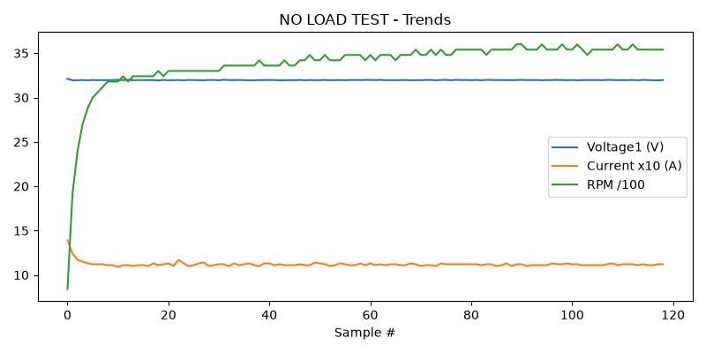

HIGH SPEED TEST REPORT
Stat | VOLTAGE1 | VOLTAGE2 | CURRENT | RPM | TORQUE | BODY_TEMP | COIL_TEMP | COMM_TEMP | FRONT_BEARING_TEMP | REAR_BEARING_TEMP
min | 31.94 | 4.84 | 1.1 | 3540.0 | 0.0 | 0.0 | 0.0 | 0.0 | 0.0 | 0.0
max | 32.0 | 6.84 | 1.13 | 3720.0 | 0.0 | 0.0 | 0.0 | 0.0 | 0.0 | 0.0
mean | 31.97 | 5.71 | 1.12 | 3660.0 | 0.0 | 0.0 | 0.0 | 0.0 | 0.0 | 0.0
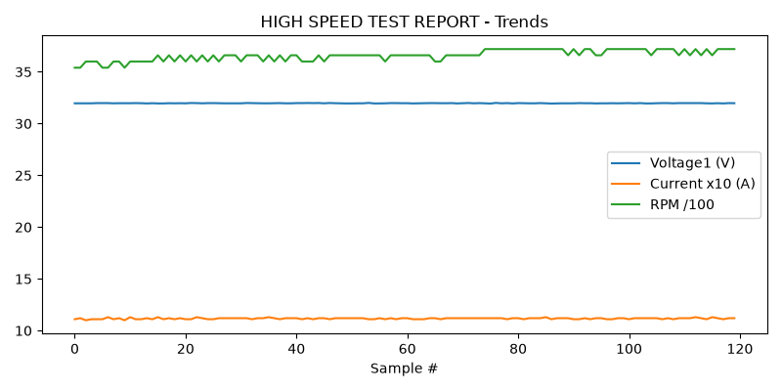

PERFORMANCE TEST
Could not read this sheet: Length mismatch: Expected axis has 0 elements, new values have 11 elements

HEAT RUN TEST
Could not read this sheet: Length mismatch: Expected axis has 0 elements, new values have 11 elements

STAGE 5
Could not read this sheet: Worksheet named 'STAGE 5' not found

