Motor Test Report
Motor No: 08
Generated: 2026-08-20 12:08:23

NO LOAD TEST
Stat | VOLTAGE1 | VOLTAGE2 | CURRENT | RPM | TORQUE | BODY_TEMP | COIL_TEMP | COMM_TEMP | FRONT_BEARING_TEMP | REAR_BEARING_TEMP
min | 31.95 | 3.36 | 1.07 | 900.0 | 0.0 | 0.0 | 0.0 | 0.0 | 0.0 | 0.0
max | 32.12 | 8.18 | 1.38 | 3360.0 | 0.0 | 0.0 | 0.0 | 0.0 | 0.0 | 0.0
mean | 31.98 | 5.48 | 1.12 | 3050.0 | 0.0 | 0.0 | 0.0 | 0.0 | 0.0 | 0.0
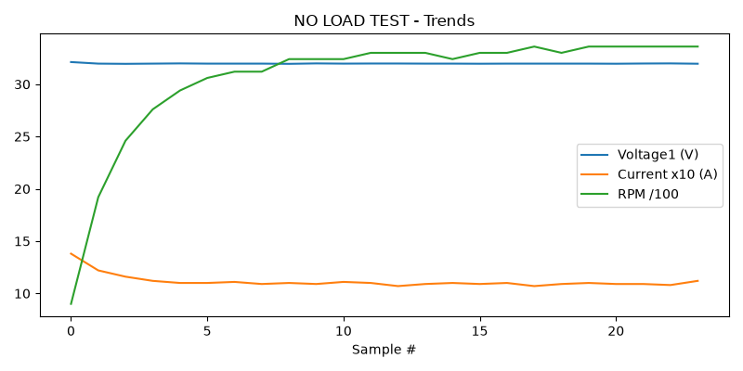

HIGH SPEED TEST REPORT
Stat | VOLTAGE1 | VOLTAGE2 | CURRENT | RPM | TORQUE | BODY_TEMP | COIL_TEMP | COMM_TEMP | FRONT_BEARING_TEMP | REAR_BEARING_TEMP
min | 31.94 | 3.67 | 1.04 | 3360.0 | 0.0 | 0.0 | 0.0 | 0.0 | 0.0 | 0.0
max | 31.99 | 8.48 | 1.12 | 3480.0 | 0.0 | 0.0 | 0.0 | 0.0 | 0.0 | 0.0
mean | 31.97 | 5.62 | 1.09 | 3437.5 | 0.0 | 0.0 | 0.0 | 0.0 | 0.0 | 0.0
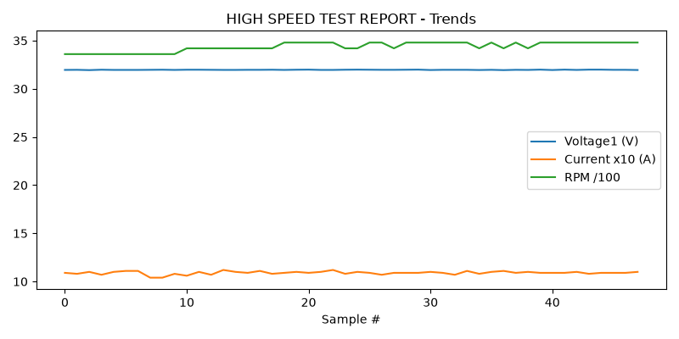

PERFORMANCE TEST
Stat | VOLTAGE1 | VOLTAGE2 | CURRENT | RPM | TORQUE | BODY_TEMP | COIL_TEMP | COMM_TEMP | FRONT_BEARING_TEMP | REAR_BEARING_TEMP
min | 31.94 | 4.27 | 1.08 | 3480.0 | 0.0 | 0.0 | 0.0 | 0.0 | 0.0 | 0.0
max | 32.01 | 7.17 | 1.11 | 3660.0 | 0.0 | 0.0 | 0.0 | 0.0 | 0.0 | 0.0
mean | 31.97 | 5.7 | 1.09 | 3560.82 | 0.0 | 0.0 | 0.0 | 0.0 | 0.0 | 0.0
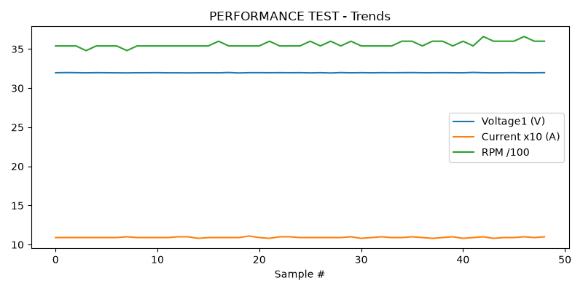

HEAT RUN TEST
Stat | VOLTAGE1 | VOLTAGE2 | CURRENT | RPM | TORQUE | BODY_TEMP | COIL_TEMP | COMM_TEMP | FRONT_BEARING_TEMP | REAR_BEARING_TEMP
min | 31.94 | 4.47 | 1.07 | 3480.0 | 0.0 | 0.0 | 0.0 | 0.0 | 0.0 | 0.0
max | 31.99 | 6.93 | 1.11 | 3600.0 | 0.0 | 0.0 | 0.0 | 0.0 | 0.0 | 0.0
mean | 31.97 | 5.61 | 1.09 | 3542.4 | 0.0 | 0.0 | 0.0 | 0.0 | 0.0 | 0.0
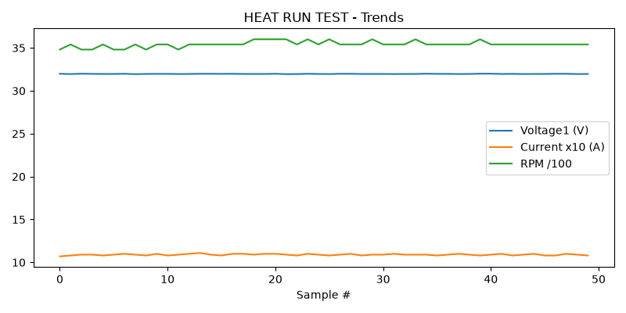

STAGE 5
Could not read this sheet: Worksheet named 'STAGE 5' not found

