Motor Test Report
Motor No: 03
Generated: 2026-08-20 10:03:43

NO LOAD TEST
Stat | VOLTAGE1 | VOLTAGE2 | CURRENT | RPM | TORQUE | BODY_TEMP | COIL_TEMP | COMM_TEMP | FRONT_BEARING_TEMP | REAR_BEARING_TEMP
min | 31.92 | 1.95 | 1.04 | 780.0 | 0.0 | 0.0 | 0.0 | 0.0 | 0.0 | 0.0
max | 32.12 | 15.48 | 1.43 | 3600.0 | 0.0 | 0.0 | 0.0 | 0.0 | 0.0 | 0.0
mean | 31.97 | 5.4 | 1.12 | 3344.87 | 0.0 | 0.0 | 0.0 | 0.0 | 0.0 | 0.0
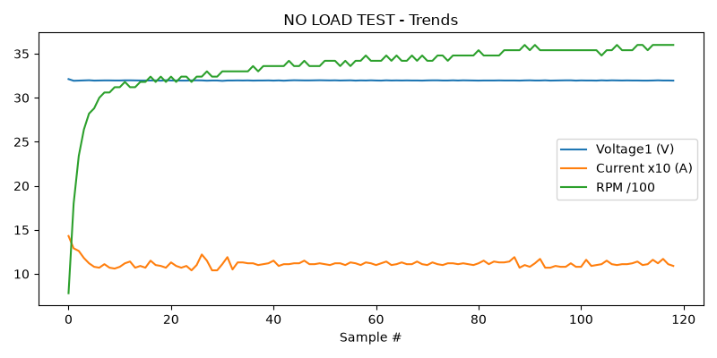

HIGH SPEED TEST REPORT
Stat | VOLTAGE1 | VOLTAGE2 | CURRENT | RPM | TORQUE | BODY_TEMP | COIL_TEMP | COMM_TEMP | FRONT_BEARING_TEMP | REAR_BEARING_TEMP
min | 31.94 | 2.05 | 1.06 | 3540.0 | 0.0 | 0.0 | 0.0 | 0.0 | 0.0 | 0.0
max | 31.99 | 16.1 | 1.19 | 3720.0 | 0.0 | 0.0 | 0.0 | 0.0 | 0.0 | 0.0
mean | 31.96 | 5.54 | 1.11 | 3645.0 | 0.0 | 0.0 | 0.0 | 0.0 | 0.0 | 0.0
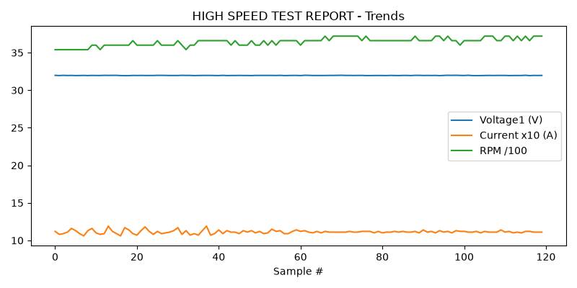

PERFORMANCE TEST
Could not read this sheet: Length mismatch: Expected axis has 0 elements, new values have 11 elements

HEAT RUN TEST
Stat | VOLTAGE1 | VOLTAGE2 | CURRENT | RPM | TORQUE | BODY_TEMP | COIL_TEMP | COMM_TEMP | FRONT_BEARING_TEMP | REAR_BEARING_TEMP
min | 31.96 | 5.5 | 1.1 | 3660.0 | 0.0 | 0.0 | 0.0 | 0.0 | 0.0 | 0.0
max | 31.98 | 6.06 | 1.11 | 3720.0 | 0.0 | 0.0 | 0.0 | 0.0 | 0.0 | 0.0
mean | 31.97 | 5.78 | 1.1 | 3690.0 | 0.0 | 0.0 | 0.0 | 0.0 | 0.0 | 0.0
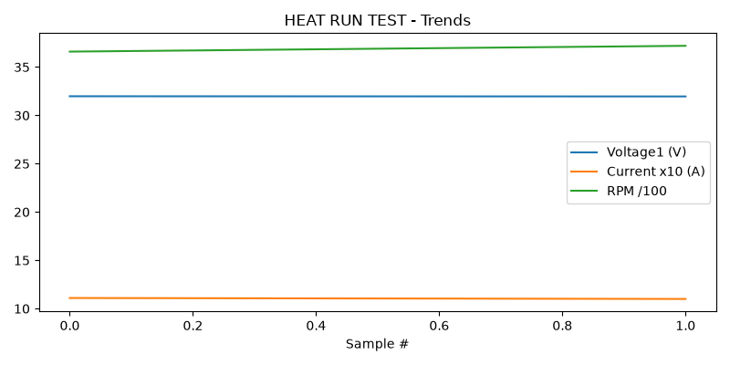

STAGE 5
Could not read this sheet: Worksheet named 'STAGE 5' not found

