Motor Test Report
Motor No: 09
Generated: 2026-08-20 12:27:36

NO LOAD TEST
Stat | VOLTAGE1 | VOLTAGE2 | CURRENT | RPM | TORQUE | BODY_TEMP | COIL_TEMP | COMM_TEMP | FRONT_BEARING_TEMP | REAR_BEARING_TEMP
min | 31.95 | 2.0 | 1.05 | 840.0 | 0.0 | 0.0 | 0.0 | 0.0 | 0.0 | 0.0
max | 32.12 | 16.45 | 1.37 | 3060.0 | 0.0 | 0.0 | 0.0 | 0.0 | 0.0 | 0.0
mean | 31.98 | 6.56 | 1.15 | 2558.18 | 0.0 | 0.0 | 0.0 | 0.0 | 0.0 | 0.0
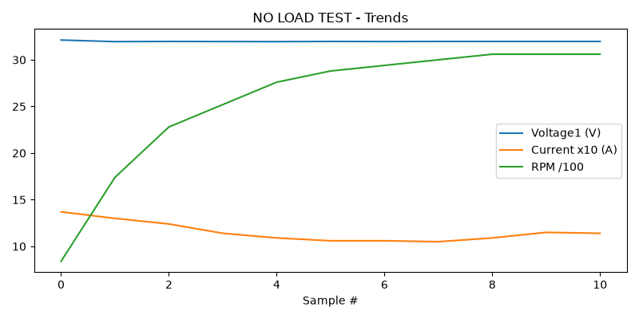

HIGH SPEED TEST REPORT
Stat | VOLTAGE1 | VOLTAGE2 | CURRENT | RPM | TORQUE | BODY_TEMP | COIL_TEMP | COMM_TEMP | FRONT_BEARING_TEMP | REAR_BEARING_TEMP
min | 31.95 | 1.99 | 1.03 | 3060.0 | 0.0 | 0.0 | 0.0 | 0.0 | 0.0 | 0.0
max | 31.99 | 16.73 | 1.18 | 3420.0 | 0.0 | 0.0 | 0.0 | 0.0 | 0.0 | 0.0
mean | 31.97 | 5.43 | 1.09 | 3245.0 | 0.0 | 0.0 | 0.0 | 0.0 | 0.0 | 0.0
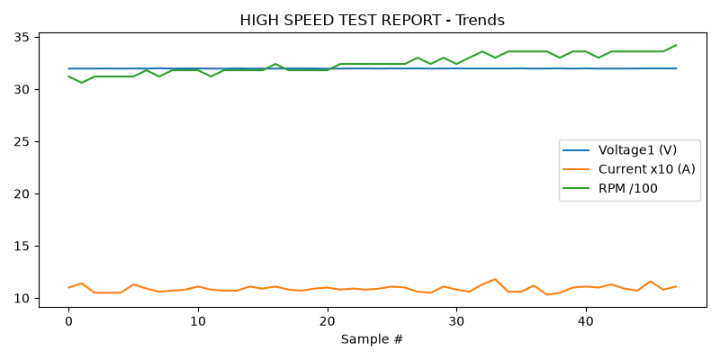

PERFORMANCE TEST
Stat | VOLTAGE1 | VOLTAGE2 | CURRENT | RPM | TORQUE | BODY_TEMP | COIL_TEMP | COMM_TEMP | FRONT_BEARING_TEMP | REAR_BEARING_TEMP
min | 31.95 | 2.02 | 1.04 | 3480.0 | 0.0 | 0.0 | 0.0 | 0.0 | 0.0 | 0.0
max | 31.99 | 16.25 | 1.17 | 3600.0 | 0.0 | 0.0 | 0.0 | 0.0 | 0.0 | 0.0
mean | 31.97 | 5.43 | 1.09 | 3516.73 | 0.0 | 0.0 | 0.0 | 0.0 | 0.0 | 0.0
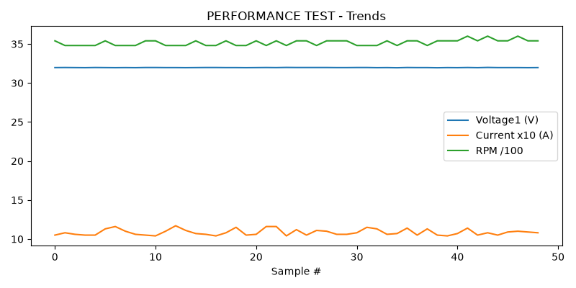

HEAT RUN TEST
Stat | VOLTAGE1 | VOLTAGE2 | CURRENT | RPM | TORQUE | BODY_TEMP | COIL_TEMP | COMM_TEMP | FRONT_BEARING_TEMP | REAR_BEARING_TEMP
min | 31.95 | 1.99 | 1.03 | 3300.0 | 0.0 | 0.0 | 0.0 | 0.0 | 0.0 | 0.0
max | 31.99 | 16.14 | 1.18 | 3540.0 | 0.0 | 0.0 | 0.0 | 0.0 | 0.0 | 0.0
mean | 31.97 | 5.28 | 1.09 | 3456.0 | 0.0 | 0.0 | 0.0 | 0.0 | 0.0 | 0.0
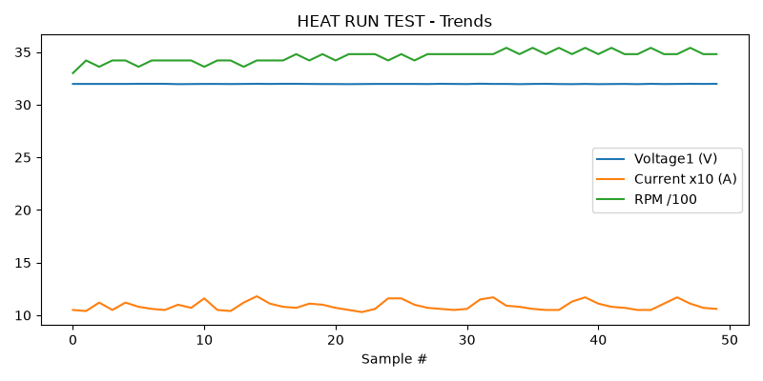

ENDURANCE TEST
Stat | VOLTAGE1 | VOLTAGE2 | CURRENT | RPM | TORQUE | BODY_TEMP | COIL_TEMP | COMM_TEMP | FRONT_BEARING_TEMP | REAR_BEARING_TEMP
min | 31.95 | 3.44 | 1.07 | 3540.0 | 0.0 | 0.0 | 0.0 | 0.0 | 0.0 | 0.0
max | 31.99 | 13.52 | 1.14 | 3660.0 | 0.0 | 0.0 | 0.0 | 0.0 | 0.0 | 0.0
mean | 31.97 | 5.84 | 1.09 | 3567.06 | 0.0 | 0.0 | 0.0 | 0.0 | 0.0 | 0.0
