Motor Test Report
Motor No: 01
Generated: 2026-08-19 17:00:06

NO LOAD TEST
Stat | VOLTAGE1 | VOLTAGE2 | CURRENT | RPM | TORQUE | BODY_TEMP | COIL_TEMP | COMM_TEMP | FRONT_BEARING_TEMP | REAR_BEARING_TEMP
min | 31.99 | 0.0 | 0.73 | 0.0 | 0.0 | 0.0 | 0.0 | 0.0 | 0.0 | 0.0
max | 32.12 | 0.0 | 0.75 | 0.0 | 0.0 | 0.0 | 0.0 | 0.0 | 0.0 | 0.0
mean | 32.02 | 0.0 | 0.74 | 0.0 | 0.0 | 0.0 | 0.0 | 0.0 | 0.0 | 0.0
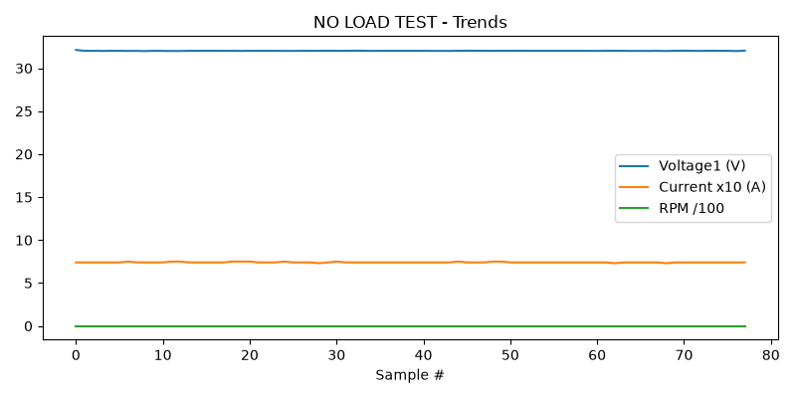

HIGH SPEED TEST REPORT
Could not read this sheet: Length mismatch: Expected axis has 0 elements, new values have 11 elements

PERFORMANCE TEST
Could not read this sheet: Length mismatch: Expected axis has 0 elements, new values have 11 elements

HEAT RUN TEST
Could not read this sheet: Length mismatch: Expected axis has 0 elements, new values have 11 elements

STAGE 5
Could not read this sheet: Worksheet named 'STAGE 5' not found

